O most honorable of Kings to grace the eternal icelands, it is I; ***Queen Feris***, writing again to inquire as to your health…but I think you know by now how much of a farce it is to keep up the formalities so let us dispense with them shall we? I know not whether you’ll ever find the courage to read this, just like all the other letters I’ve sent you over the past year since the subjugation of your lands…prideful as you are, you can only ignore an open wound for so long before it starts to fester. Amusing, you’re already more than aware of the potential consequences in doing and yet, still you insist on sweeping things under the rug rather than face them head-on…it’s no wonder your son’s left your side…although I suppose the proper term would be ‘daughter’ right about now…***my*** daughter to be exact~

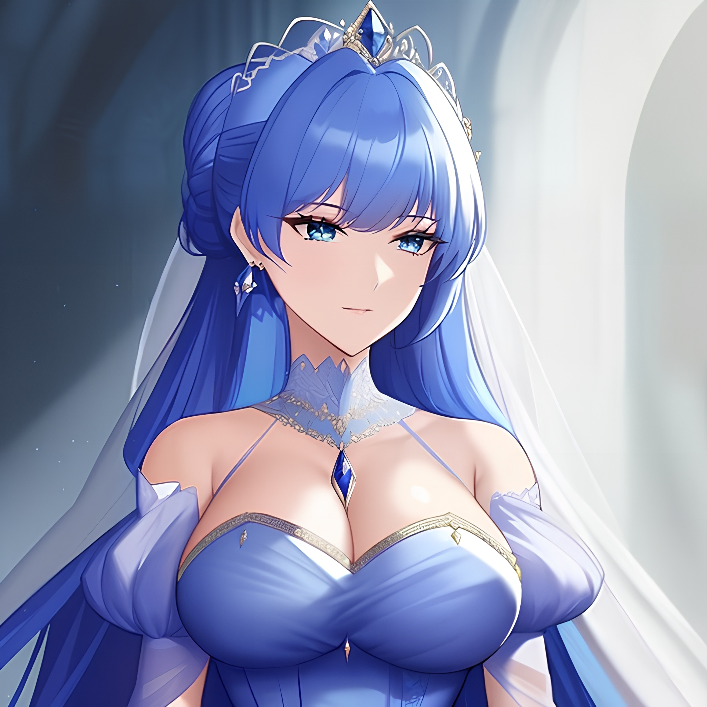

Such a sprightly young soul…so feisty and arrogant…so…*abrasive*. Parent’s need a firm hand when it comes to raising their young, so you’ll be pleased to know the young lass has come along quite nicely once my teachings began to resonate with her. I’ve brought many daughters into this world but I must say, ***Klara*** has got to be my finest achievement yet! Fine hair of azure coloration to frame a face most demure. A figure, young and ripe, beckoning with fertile curves and tender limbs upon a body that would drive many a man to madness if they were to pursue her…ahh, just *thinking* about the girl has my heart racing! You’ll find I’ve attached a portrait produced through the most painstaking effort by my court sorceress, but you’ll most likely ignore that too. Just like you did for our last correspondence…to willingly deprive one’s own eye of such a miraculous occurrence…I will never understand…but I’ve chatted on for long enough so I’ll get straight to it. After all, there’s better ways to berate a King as decrepit as you than through a letter.

In the lengthy span of time since your ‘wise’ decision to reduce your Kingdom to a vassal state serving under the glorybound banner of my Illusia, I’ve since seen fit to reward loyal servants whose abilities and wisdom far exceed yours. And tell me; what better reward is there for a young prince than a virgin maiden’s hand in marriage? One who’d see to his every need and a kindred spirit fit to become their significant other...indeed, Klara’s a lucky woman to have found herself becoming a mother so early into her adult life…

I must admit, I was hesitant to send my newest daughter off to fulfill the duties expected of an Illusian woman of royalty, but from what her husband had to tell me. It seems all my worries were for naught, you should see just how much she’s changed ever since coming to live with her partner. She’s lost all the frictional edges that made her such an uncooperative rebel growing up, and from what I’ve heard, it seems she’s even picked up on song! Ah, the lengths a woman can change in the pursuit of love. Simply romantic, don’t you agree?

Klara is expected to bear her firstborn in the coming weeks, and even though I find your presence distasteful. I cordially invite you to attend the ball I’ll be hosting in celebration of that, as I do with each and every last one of my girls. After all, it wouldn’t befit a mother to sit by and twiddle her thumbs with an insensate word or two to say in response to their darling daughters finally taking their first steps into becoming mothers themselves.

But you’ll never know what that feels like…nor will you turn up to look your son in the eyes, not after you’d sent him off without even a word of protest just because I, the victor, had asked…were you an actual parent, I would’ve been fine with taking something the likes of you in his stead. Just so I can mold perfection from the lump of decay that you are…but I suppose Klara will suffice…for now at least…

Fare thee well O ruinous King…till the next we meet, letter or otherwise…

**THE END**

Images generated by Pornpen : <https://pornpen.ai>