A CURVED PLAN
JANUARY 2022 REQUEST STORY
BY CHALDEACHANGE
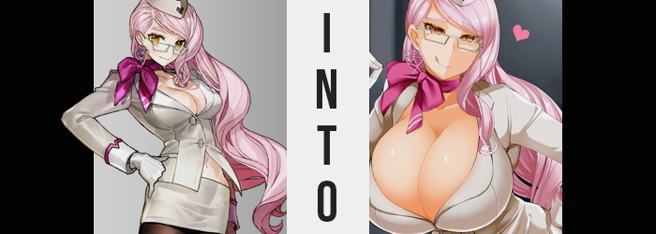

Something had been awry within Chaldea, and it certainly wasn’t a discreet change.

Tamamo Cat had been walking around with some absolutely momentous mammaries and a caboose to match. Everyone had taken notice, because how on Earth could you even think to miss it? None had really questioned it, for what purpose? Koyanskaya of Darkness couldn’t have fathomed. Surely they hadn’t been brainwashed into thinking it was normal? Or… No.

Cat wasn’t the most intelligent of the Tamamos, it wasn’t impossible to think that she would have sought to sweep away her problems with such a crude method. The issue with using magic to brainwash was that it would rub off eventually, and not only would they begin to question her? They would undoubtedly be pissed off about it. That was why most magic wielders worth their salt wouldn’t have dealt with that situation in that way.

But Koyanskaya? Even if Cat had tried, thanks to using Tamamo-no-Mae as a base for her own container she was immune to that spell. What’s more, she could sense the true nature of what had brought about Tamamo Cat’s transformation. Her magical signature carried traces of both the OG Tamamo and Koyanskaya’s Light half. How she had managed to do it, the Koyanskaya of Darkness couldn’t say.

But she had managed to absorb the two of them and had made them part of her body.

It was no wonder that she was trying to hide what she had done, but this Koyanskaya wasn’t having it. Especially not with Cat taking a moment to mock her as she was. “See this body, Koyanskaya-nya? I bet you wish you had a big bouncy body like this! Nyahaha!” How cute. Did she really think that this was going to rub Koyanskaya the wrong way? Well, okay, it did, but not enough to disheveled her from perch of self-imposed sense of superiority.

SNAP!

Without a word, the secretary snapped a set of gloved fingers. And Tamamo Cat? No sooner than she had, the fox seemed to disappear. But she hadn’t, and Koyanskaya knew why. She crouched down so that her index finger and thumb could grab onto something that she readily lifted into the air, dangling above her mouth. “Not so big now, are you? And I can certainly think of a good way to teach you a lesson, you dumb feline.”

What she was dangling above her mouth was Tamamo Cat shrunken down to a single centimeter in height. Proportionally she was still the same, with her jiggling curves swaying about like a pendulum. She was spewing off some insults and demanding to be unhanded of course, but that voice was so tiny that her words couldn’t be made out. “Don’t worry~! This may seem a little crude, but you won’t die. I imagine it’s similar to what you did to the other two.”

Koyanskaya of Darkness opened her mouth and extended her tongue, lowering Tamamo Cat until she could taste her. Cat had transformed Tamamo and Koyanskaya of Light into cookies before eating them, but she wasn’t being afforded the same liberty. She had been consumed raw, and after closing her mouth? Koyanskaya swallowed. She hadn’t lied though. Tamamo Cat would be safe… in a sense. She was simply becoming one with her body, inheriting three sets of assets.

Of course, it wasn’t something that would happen immediately. A moment was needed to process the new material that would be added to her figure! But it also didn’t take quite as much time as she had been hoping it would, changing the plan she’d had in mind where she would return to her room to see it happen with proper mirrors and lighting. Maybe with a camera in hand?

But this encounter had occurred in the back hallways of Chaldea late at night, so it was fortunate that she didn’t have an audience to speak of. “Mm… It’s coming so soon? How inconvenient.” She could feel it, both warmth and pressure, building within the same faculties upon her body that Tamamo Cat had sought to engorge upon her own. And engorge they did without much in the way of delay.

“Oh, my~!” Koyanskaya purred lustfully, and how could she not? The warmth radiating in all of the flesh around her loins was turning her on, and the pressure building felt like it was on the verge of release – which for a woman with masochistic tendencies like herself was the peak of discomfort. “Here it comes!”

And come it did. The lower half of the secretary’s figure got a head start over the upper half, with a weightiness finding the woman’s ass. Koyanskaya’s bottom was already plenty impressive as is, being modeled after Tamamo-no-Mae as she was, but it was quick to find that there was plenty of room to grow. It was as apparent aesthetically in the very beginning, but the woman could certainly feel it in the fit of her clothes. Whether it was her white thong gripping her groin with overwhelming strength or her tights beginning to be pulled so thin that they appeared more translucent; the signs were certainly there.

RIIIIIIIIIP!

So it began – the ripping and the tearing. The waistband of the pink-haired woman’s tights was quite tight, so much so that it didn’t budge much even when a swelling underside threatened to pull it all down. And because it remained steadfast in its positioning, that left the black tights themselves alone to accommodate the growth through whatever means they had available. Which meant they did the only thing they could and began to tear as ample fat burgeoned forth from beneath.

It almost looked like her pink flesh was erupting like a volcano through the black nylon as the holes multiplied, cheeks and thighs alike doing their best to see them obliterated – and as time wore on they grew closer and closer to accomplishing just that. It wasn’t like she had been gifted ass implants however, no. It was all natural, and because of that it jiggled and rippled the bigger it grew. Before long the fit of her pencil skirt snapped, and it felt to the floor to reveal just how massive her ass had become.

Koyanskaya’s hips were practically incapable of holding their size, and to those ends they might have parted several inches wider than normal. “What a huge ass! Even bigger than that stupid Cat’s!” Even with both of her hands it was a struggle to lift even a single cheek, each half almost as big as a small exercise ball. Her thong was fit so snugly too that the front had ground into her pussy, lips struggling to remain hidden rather than swallow the undergarment whole.

Hands didn’t linger there for long, but she did wonder how she might possibly get around with an ass that immense. Other issues had arose for the time being, said issues being the breasts that were firmly planted upon her chest. Their firmness being a growing point of contention, because much like her ass had they were, uh, growing. “And there they go~!”

Positioned in a much more grabbable place than her rear end was, Koyanskaya wasted no time when it came to groping herself once the pressure finally peaked and the mass of her tits began to swell. Because she had some weird kinks, she had no qualms with letting her secretary coat fill up and tighten as her cleavage deepened to udderly ridiculous proportions, and the buttons in the front ultimate snapped clear off so that both mammaries bounced free in all of their heft.

This, of course, gave her fingers easy access to their flesh, and she could not stifle a moan as she bounced and kneaded them within her grasp. There was a very real risk that someone would hear her pleasing herself in such a strange way, but where was the problem with that? Didn’t the risk make it more exciting. She’d certainly get some deserved questions about her figure, though.

After all, either breast had long since surpassed her head in size. They were practically on the verge of becoming double the size of her head, but they managed to stop just short of it. Their weight combined with the weight of her ass would cause some very obvious movement complications, if their sizing alone did not. But for the time being? She was content just squeezing, jiggling, and slapping them all.

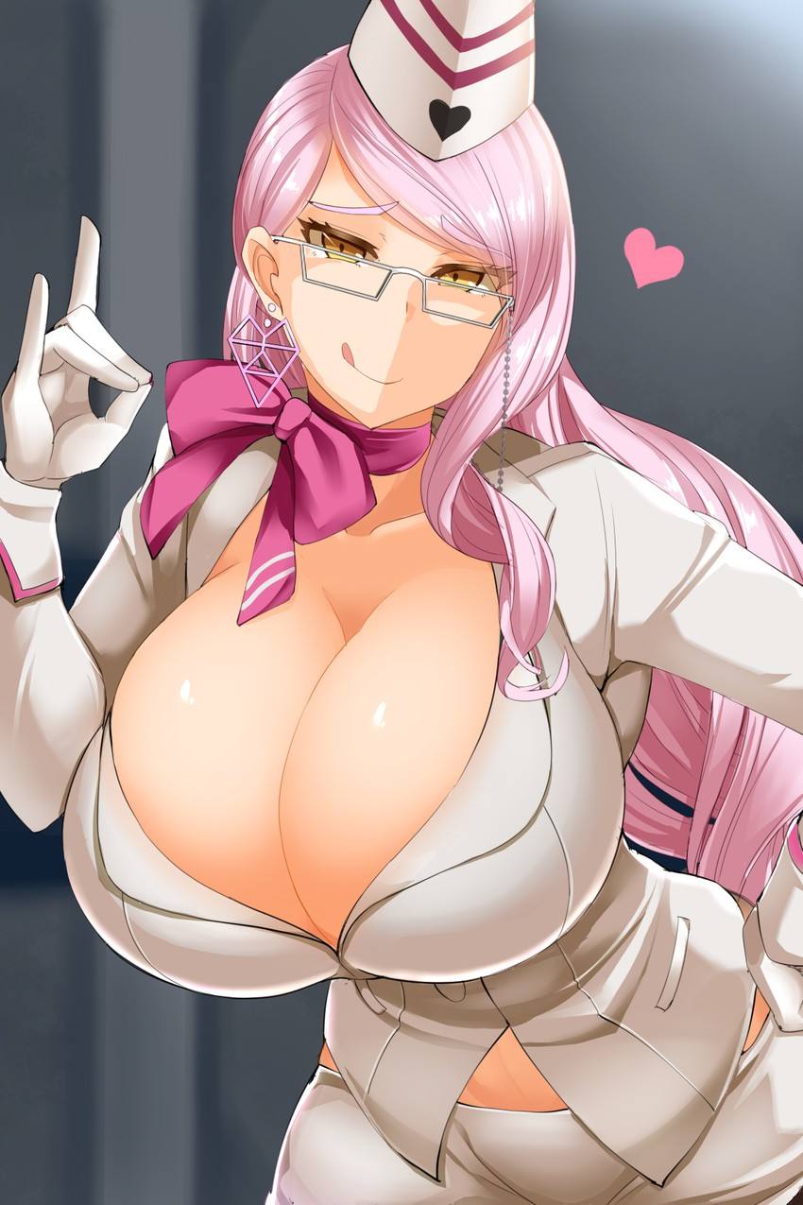
After all, she knew full well that not only could Cat feel her touch firsthand, but so could the other Tamamo-faces that the beast had absorbed before being absorbed herself!

“Hmm… I suppose this is a little too gratuitous after all. Did she really think that having a figure like this was a good idea? How infantile.” Her secretary outfit had been utterly obliterated, L-cups sagging under their own weight alone despite the woman’s youthful physical age. Her coat unbuttoned and her skirt torn, the only thing really giving any coverage was the thong that had been wedged in both her pussy lips and the crack of her ass – so there wasn’t really much coverage to be had after all, was there?

Being a productiveness-minded individual, Koyanskaya could already see the many, many problems that leaving her figure as is would cause. Forget fighting, she wouldn’t even be able to sit comfortably at her desk without resting her tits on her mouse and keyboard. So there were certainly some regrets. “Oh well. I guess I’ll have to fix them before we carry on. But I won’t let the gifts I took from those three go to waste, either.”

SNAP!

With another snap of her fingers – which had kept their gloves despite her overall loss of outfit – her ass and breasts alike shrunk a few sizes. They were still immense, much bigger than they would have been au naturale, but the G-cups they had been reduced to were at least manageable. “Now, I suppose I need to make up an excuse for how this happened…”

“Do you think they would believe me if I told them Cat was just misbehaving?”

It was true, technically.

