GOO FORTUNE
COMMISSION STORY
BY CHALDEACHANGE
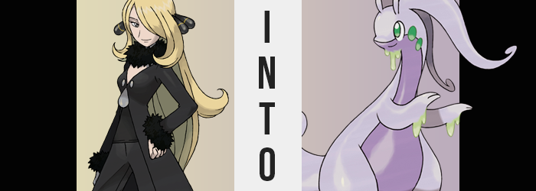

“Yes, I’d like to admit my Kommo-o into your daycare if you don’t mind.”

Unlike many that had been enticed by the offer of a free daycare session for their Pokémon across the Pokémon world, Sinnoh’s Champion, Cynthia, had not come on that day to accept such an offer. A sudden emergency had shut down Sinnoh’s entire box system, and while the cause was something that was being looked into, it left trainers across the region in something of a sticky situation.

Without access to their boxes, it was more or less impossible to change up their parties for however long the system remained down. This meant that they couldn’t withdraw any Pokémon they had put away, much less store any that were presently on their person at that time. And, so, plenty of trainers had sought out the daycares in the wake of this system going down.

In a way, it seemed to work out perfectly for the current daycare system. Perhaps a little too perfectly, seeing as how they were currently being run by Team Galactic remnants behind the scenes, and considering how they needed to lure trainers into their establishments to see these schemes to fruition. Almost like, perhaps, they had been the ones behind the box system going down in the first place?

Never in their wildest dreams had they expected to catch the Champion herself, though. “Ah, yes! A Kommo-o? In that case, could you come look over the space they’ll be using during their stay? We like to make sure everything is to the trainer’s satisfaction.” The woman behind the counter had been courteous and kind – an act designed to get Cynthia to lower her guard and to lead her into the room where all the ‘magic’ happened. And, unfortunately for her, it worked.

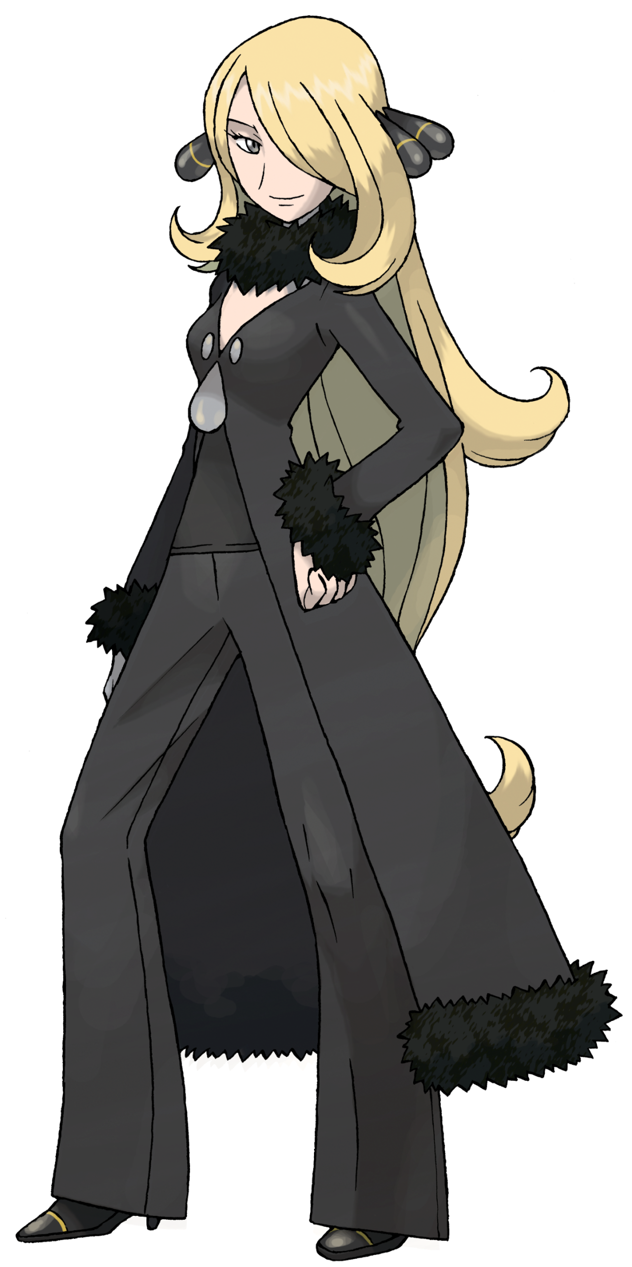
“If it will be quick. I have an appointment I need to be in an hour. Again, thank you for doing this. With the situation regarding the storage system, my hands have been a little tied.” She was none the wiser to the fact that she was dancing in the palms of Team Galactic as she followed the woman behind the counter and towards a room in the facility’s depths. They stopped by a room that contained equipment necessary to care for Pokémon of all types first in an attempt to throw the Champion off even further.

In the meantime, the attendant giggled. “Yes, a shame about the boxes, isn’t it? It has made us a little bit busier, and we’re certainly thankful for that.” She sounded chipper about it all, and Cynthia was ignorant to the true meaning of that happiness right up until they entered a room that looked far different from anything she might expect in an establishment such as this.

“This is…? What is this room for?” Cynthia couldn’t help but ask before she’d even fully set foot in it. The walls were bleak and white, had no windows, and the only thing within was an equally white pedestal in the room’s center. It didn’t look like the sort of room you might find in a Pokémon daycare. It looked like the sort of room you’d find in a laboratory.

The moment she had turned her attention back to where the attendant should have been standing, however, she was gone. And the door behind her? It locked tight. The woman’s voice could be heard, but it sounded like it was coming over an intercom. “It’s time you find out just what it’s for, Miss Champion!”

No sooner than this declaration had been made, the pedestal whirred to life with beams of violet light that scanned up and down every nook and cranny of the room, striking Cynthia herself and leaving her winded somehow as a result. “What…? Let me out!” Try as she might to demand her own freedom, the lack of energy portrayed through her words left the woman sounding less intimidating than it usually did. Something that wasn’t at all helped once she realized her Pokémon were missing. That woman had snatched them, then!?

Cursing herself for not noticing, Cynthia then stumbled backwards towards the center of the room. Each step felt far more labored than the last, but she had to push through it. After all, whatever was impeding her physically was being caused by the purple light coming from that pedestal! If she just broke it…

There was a strange phenomenon taking place that Sinnoh’s Champion had already waved aside, however. The insides of her clothing felt very damp, and it was pretty easy to simply chalk that up to sweating of course. But the liquid began to drip, drip, drip. It poured from her face, down her limbs, and began to pool in her shoes in a way that was undeniably inconvenient. And it was… thick. Much thicker than sweat, certainly.

“Why am I so sticky?” That was the best word she could conjure for how she felt, raising a hand to look at the substance settle between her fingers. It looked transparent for the most part, but as the excess fell from her wrists and chin it bore a somewhat greenish hue. “Urp!?”

Under no circumstance was the goop that now covered her body not alarming, and yet Cynthia soon found herself wrestling with a completely different issue entirely. Her stomach had churned so suddenly, accompanied by a bloated feeling at the very same time. In the beginning she’d wondered if the light had just upset her stomach, but given another moment she was forced to rethink that. After all, her belly had begun to expand.

Forward, outward; you name it, the lower half of her torso was expanding in that direction. The base of her black shirt had no options other than to lift up and stretch out thanks to her stomach first protruding forward as if she was a pregnant woman, only for her hips to pop and widen as the horizontal load became far too much for her legs to bear otherwise as well. “What on goo!? Goo…!? What am I…!?” Goo? Why had she said goo? She was certainly goopy, but!?

The size and weight of her stomach continued to swell, and looking down Cynthia was horrified by the sight. The slime that had coated her body made it easy for her pants to unbuckle and fall before it was too late, but in the end they had little choice other than to get caught around her feet beneath thighs that seemed to be ever closer to the ground.

This wasn’t merely a trick being played based on her swollen torso. In fact, her legs had noticeably shortened a good six or seven inches. Within the woman’s shoes, a compression effect had taken hold of her feet and if she were to lift them now, either foot would have easily slid free of their cloth and rubber prison because what was within them did not consist of regular, human feet.

Her soles had not only pulled in closer to her heels, for example, but it was fairer to say that she didn’t even possess heels in the first place any longer. Rather, there were just nubs that stood for feet proper, and her toes? Once she had possessed a rather standard set of five of them. As they wiggled midst the slime that had filled her boots now, though, there were only two longer toes on either foot.

CRACK!

Cynthia’s weight had finally reached a point where the heels on both shoes finally snapped, and she let out a cry as she suddenly fell. “Dra!?” Of course few would interpret that as being a human cry, and looking at her body as it was, that was surely none too surprising. With every passing moment the human looked less like one of her own people, wholly bottom heavy and growing even more so.

Addressing her stomach again for one moment, there was no longer any sign of a belly button. The skin there was entirely smooth and sported a fanciful sheen, making her appear quite soft. Looking at her shortened legs, it was clear that the displaced meat from her thighs and ass certainly hadn’t gone to waste in the meantime. Each upper leg was as thick and blubbery as her belly, jiggling even as she stood idle even though there was a great deal of strength behind them.

“This can’t goo— I mean, am I become dra Goodra!?” She’d been saying the Pokémon’s name against her will, and so of course she would come to that conclusion without much convincing. It was a terrifying and unreasonable conclusion. Of course she had heard the stories of Bill from the Kanto region turning himself into a Pokémon, but such a thing was happening to her!?

It was fortunate for her comfort that her panties had long since been snapped by the sheer girth of her lower half, for a mighty tail did not take long to erupt behind her once she was appropriately bloated from the belly down. It was an uncanny sensation, feeling something grow out of where your tailbone had once been. But this tail was certainly no meager showing. Much like the rest of her body it was thick and bouncy, just as dense as her thighs for most of the length before curling cutely at the tip.

A trio of green dots were promptly forged across either side of this tail, but simultaneously two pairs of two matching markings had appeared on the sides of the woman’s neck. This was the first time her skin had showed any change in color, but Cynthia knew Goodra to be a very purple Pokémon – and that purple eventually did find its way into her skin.

Her flesh had already been smoothed down by the goop that oozed from the depths of her skin, and from that point on the tone began to shift into two separate shades of violet. A darker shade surfaced from around her mouth and fell all the way to the underside of her tail, while everything else was a most pastel shade. With the change in color it seemed that her genitalia had disappeared. That wasn’t the case though. Still between her legs, her pussy had deepened and been hiding by a flap of skin.

“Goodra! No… need to… goo… human language…” Struggling profusely to move her body with how awkwardly shaped it was, things weren’t helped at all be her arms shortening and thickening all at once. Like with her feet, her fingers fused together until there were only two fingers remained, and her palms practically became one with thickened, gooey arms. Green slime still dripped from the undersides of her hands, of course, and the bloated nature of her arms left her sleeves torn.

But surprisingly? Her shirt and jacket didn’t fall off. In fact they grew looser, for while the lower half of her body was thicker, the upper half had become much thinner. Her breasts smoothed away against the dark underside of her body, and shoulders collapsed until they were wholly absent, and so her arms appeared as if they were coming directly out of her neck.

Cynthia winced, for the strangeness of it all had finally reached her neck and above. To begin with, the neck in question had begun to stretch upward. New bones were conjured from nothing to allow the woman to properly bend and twist this added length. “Dra…!?”

It became harder and harder to speak the human tongue thanks to her face pushing out into what was clearly a snout, teeth given no choice but to bend backwards while her nose became one with this extended face. It pulled out so much that her eyes ended up on the sides of her face, and once they had relocated they suddenly grew several sizes so that they practically occupied most of her head’s sides. With green goo dripping from her snout’s underside, her eyes took a very similar green while seeming ever more cartoonish in design.

She finally stepped out of her shoes and stumbled from her weight, fortunately catching herself as her mind was being transformed to adjust to her new body as if it was completely natural. Each movement was taxing because of how big and bulbous she was, much to her dismay.

The slime thickened across her hair quite promptly in preparation of finally bringing an end to Cynthia’s conformation, and beneath it her golden locks had begun to dissolve with the excess goo running down her reptilian back. But while this left her head bald, that was only brief for four protrusions in two pairs then erupted from her skull. A pair of vertical, purple horns that were short and poked out from just above her eyes, followed by a pair of thicker, much longer horns that wrapped and curved right out behind her. It had been painless, but the pressure had caused a big enough lap in her thought process for her mind to simplify without her even realizing.


“…Dra? Goodra!?” The slimy dragon swayed from side to side, both confused about whether she was human or Pokémon, and not sure how to properly move her new, blubbering mass. There was no doubt that Cynthia was still in there trying to hold onto the last shred of her humanity, but a Goodra’s instinctual needs were proving to be more powerful than that remaining bit of will.

Why was she wearing a jacket and shirt? She couldn’t really recall, but her arms were too short to do anything about it anyways.

Once a proud and confident woman, there was no doubting now that she had become surprisingly meek. Despite seeing that this situation was wrong, she was hesitant to throw about any attacks or make a fuss of any nature to garner the attention of any humans that might be nearby. In fact, in response to the light of a Pokéball going off in the room’s center, she even flinched. “G-Goodra!?”

Slime dripping from her chin, the Goodra’s round eyes widened at the sight of a Kommo-o that had erupted from the light. That’s my Kommo-o!, or so she attempted to rationalize. But… something else took hold. Kommo-o was a dragon, and she was a dragon. A male and a female pairing. It was something she might have resisted in the beginning, yet the pillar’s light soon turned pink, and her reptilian loins soon began to ache. “Goo… Goo…?”

Whatever she was feeling, the Kommo-o must have felt the same. Its rod was revealed, giving off a musk that left the Goodra lost even further in the most primal of her newest instincts. A desire to be mounted. A desire to mate. And before long, Sinnoh’s Champion had been reduced to little more than a trophy Goodra that would be used to birth no shortage of powerful Goomy.

Not once from that point on did she question if she were person or Pokémon. Wasn’t the answer obvious? Humans didn’t lay eggs, did they? But why would she want to be human, anyways? Humans probably didn’t always feel this good.

