Activation Energy - Worksheet

Organic Chemistry Tutor

1. A certain reaction has an activation energy of 50 kJ/mol. The rate constant at 25C is 0.0039 min⁻¹. What is the value of the rate constant at 75C?

2. The rate constants at 300 K and 500 K are 0.018 min⁻¹ and 0.25 min⁻¹. Calculate the activation energy in kJ/mol.

3. The activation energy of a reaction is 65 kJ/mol. The rate constant at 250K is 0.0031 s⁻¹. At what temperature will the rate constant be 0.054 s⁻¹?

4. The slope of the straight line in the graph of ln(k) vs 1/T is -7500K. The y-intercept is 21.7.
(a) Calculate the activation energy in kJ/mol.
(b) Determine the frequency factor. (c) If the steric factor is 0.25, what is the collision frequency? (d) Calculate the value of the rate constant at 300K?

5. Which one of the following potential energy diagrams represents the slowest endothermic reaction?

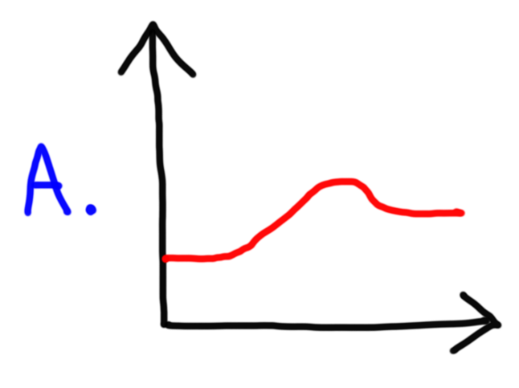

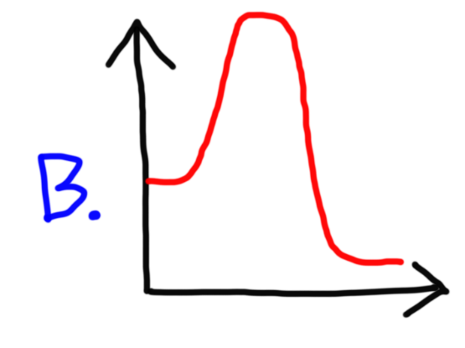

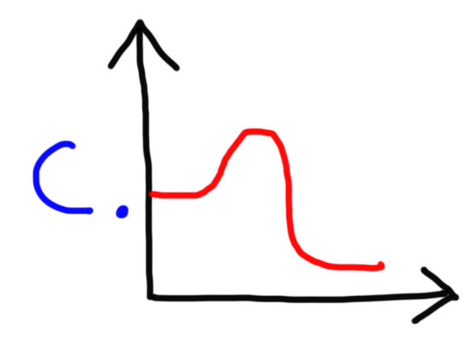

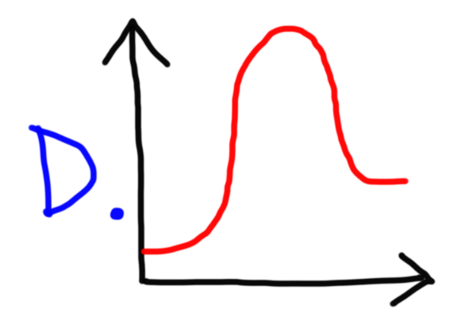

6. The activation energy for the following reaction is 150 kJ/mol. What is the activation energy for the reverse reaction given the change in energy shown below?

A + B C ΔE = -230 kJ/mol

7. According to the collision theory, which of the following factors will influence the rate of a chemical reaction?

A. Collision Frequency
B. Collision Orientation
C. Collision Energy
D. All of the above
E. None of the above

8. Which of the following actions will not increase the rate of the chemical reaction shown below?

IO₃⁻ + 5 I⁻ + 6 H⁺ 3 I₂ + 6 H₂O

A. Increasing the temperature of the reaction.
B. Increasing the concentration of I⁻ in the solution.
C. Adding a catalyst to the solution.
D. Increasing the pH of the solution.
E. Decreasing the volume of the solution through evaporation.

9. Which of the following factors does not affect the rate constant k?

A. Temperature
B. Catalyst
C. Reactant concentration
D. The nature of the reactant
E. None of the above

10. Which of the following statement(s) is true?

I. A catalyst will speed up the forward reaction.
II. A catalyst will speed up the reverse reaction.
III. A catalyst will lower the activation energy of the reverse reaction.

A. I only
B. II and III
C. I and II
D. I and III
E. I, II, and III

11. The rate constant k is 0.0014 s⁻¹ at 300K and 0.0382 s⁻¹ at 350K. What is the value of the rate constant k at 400K?

12. The activation energies for a catalyzed reaction and an uncatalyzed reaction are 20 kJ/mol and 60 kJ/mol respectively. (a) If the rate constant k is 0.0015 s⁻¹ for the uncatalyzed reaction at 300K, what is the value of the rate constant k for the catalyzed reaction at 300K? (b) How much faster is the catalyzed reaction compared to the uncatalyzed reaction?

13. The activation energy of a certain uncatalyzed reaction is 40 kJ/mol. The addition of a catalyst at 300K increases the rate constant by a factor of 8000 relative to the uncatalyzed reaction. (a) What is the activation energy of the catalyzed reaction assuming the frequency factor remains the same? (b) If it takes 72 days for the uncatalyzed reaction to go to completion, how long will it take the catalyzed reaction to run to completion?

Answers:

1. 0.0708 min⁻¹
2. 16.4 kJ/mol
3. 275K
4a. 62.4 kJ/mol
4b. 2.656 x 10⁹
4c. 1.062 x 10¹⁰
4d. 0.0369 s⁻¹
5. D
6. 380 kJ/mol
7. D
8. D
9. C
10. E
11. 0.456 s⁻¹
12a. 251 s⁻¹
12b. 1.67 x 10⁵
13a. 17.6 kJ/mol
13b. 9 x 10⁻³ days or 12.96 min

