BUSTED OR BUSTY?
COMMISSION STORY
BY CHALDEACHANGE
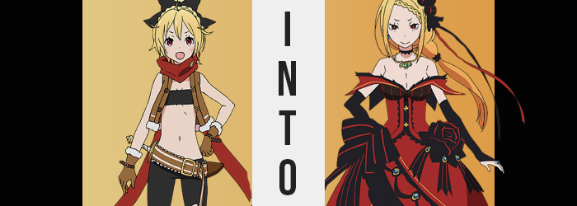

It was very difficult being a King Candidate for Lugnica, and that naturally went double for this candidate in particular. The young Felt had grown up a thief, knowing naught of her lineage and living in the capital’s slums. She did what she had to in order to live, much less make ends meat, which was tragically a fate shared by plenty of the orphaned children that made the capital their home.

But the reality of it all was that she had been the last daughter of the younger brother of Lugnica’s last king. It was something that she had ultimately been made aware of thanks to the meddling of a certain knight that just would not leave her alone as hard as she tried to push him away, and before long? Well, she had been taken into custody as one of the King Candidates.

Felt, though? She hated it. A tomboy in personality, and one that loved the streets at that, she loathed being put on a pedestal and flaunted as some kind of unique political presence. If she’d had it her way she would have forsaken the entire competition and run back to the streets, but Reinhard was constantly trying his damndest to make sure that she couldn’t. The girl was so tired of wearing gaudy dresses and being forced to sit through stuffy meetings!

…And so that was why she had devised a plan. Shedding her dress and changing back into her street clothes, the girl had made a bold escape from the castle through a carriage that was transporting supplies in and out. She knew Reinhard would catch her eventually, but at least for a few hours she wanted to savor the life she had been torn from oh so suddenly. “If I just have a taste, maybe that’ll make it easier to leave…” Or at least that was how she had justified it to herself.


To those ends, Felt had planned a little heist. She had caught wind that one of her fellow King Candidates, Priscilla Barielle, was moving something valuable through the city that day. Felt had only met her a handful of times, but that was enough for her to understand that she did not like that woman. She was self-absorbed and arrogant, the typical sort of aristocrat that made the lives of those living on the streets a living hell.

That was what made her the perfect target for Felt’s little romp. She wasn’t sure what was being transported, but she knew it would be in a specific carriage following a very specific route. All she had to do was lay in wait and then sneak in when the guards involved had broken their ranks during a shift transfer, and then sneaking in would be as simple as smacking a rat with a shovel!

Er… That’s an old street saying!

It had all gone so easily. Perhaps a little too easily, actually. For how much of a fuss the castle guards had made about keeping the transport hush-hush, there had been surprisingly little security escorting it through the city streets. Felt really hadn’t had any issue at all sneaking onto the carriage, much less wading deep into it to find the contents. Had they really not stationed anyone inside of it?

Nonetheless a chest was her prize, and it was a very ornate one at that. “Whatever is inside must be what they were trying to hide, right? I bet it’s cool! Like jewels, or maybe an awesome weapon?” The girl had very high hopes for the contents of the treasure chest, which made her disappointment immeasurable once she finally got it open. Because inside?

“Huh? It’s empty!?” The thief could hardly believe her eyes. There wasn’t anything in the chest. Was there some kind of mistake? Had someone already beaten her to stealing the treasure? Maybe that was why the security had been so poor? “Maybe the chest itself is the treasure?” That wasn’t too farfetched of a theory. Done up in crimson gems upon a black steel base, it kind of reminded her of Priscilla’s dress.

Though that wasn’t exactly a coincidence.

Because she had to make sure there really wasn’t anything in the chest, Felt gripped the sides and then dunked her head into its maw just to confirm beyond a shadow of a doubt. And there really wasn’t anything in there. But… “GYAH!?” No sooner than her face hit the bottom of the chest, a blinding white light shone and forced her to spill backwards in the carriage, temporarily blinded.

She ultimately tripped over something and fell, but what she landed on didn’t make any sense to her. She’d landed on something that was tall, and it was soft? Like a bed? But there definitely hadn’t been a bed in that carriage! And then her eyes opened. “Huh…? How did I…?” Well, she was definitely on a bed. But she also definitely wasn’t in a carriage, either.

She was in a very grandiose bedroom, now half-laying on a bed with a crimson canopy. Felt was quick to force herself upright again. “What… happened? Where am I?” She had never seen this room before, with its mahogany furniture and dim lighting. But something about the aesthetic struck her as familiar. As did the scent of a very strong perfume wafting through the room. “Wait, isn’t this… Priscilla’s?” That’s where she had smelled that perfume before.

…Had she fallen into some sort of trap? That noblewoman!

It had been a trap, but Felt was ignorant to its actual purpose. She was assuming it was just to transport her to Priscilla so that she might be punished, but the noblewoman in question was nowhere to be seen? The thief assumed that escape wouldn’t be as easy as just parading out the door, and there didn’t appear to be any windows to speak of…

But at the same time, while she was paying so much attention to her surroundings, the girl was hardly paying much attention at all to herself. Why would she, really? As far as she was aware she was still in one piece, there was no reason to be concerned about any injuries when she didn’t have any. As if my beauty could be tarnished by a meager trap!

That was when something clicked in the street girl. “…Huh?” Where had that thought come from? Something so arrogantly self-absorbed was not the sort of thought that would ever cross Felt’s mind. She had been raised better than that, even on the street! And it wasn’t like she had this ‘beauty’ to even relish in the first place! More than anything? “Sounds like something that stuffy aristocrat might say…” The one whose room she had suddenly found herself in, in fact.

Felt shook her head to try and rid herself of the thought, but her fixation on what was going on mentally took away from her ability to observe other facets of what was transpiring. Such as the design of the clothing she was wearing, for one. A spell had been put into play you see, and there were multiple facets to it. If Felt noticed and caused a ruckus, then there was the risk of complications arising as a direct result of it. So the spell focused on numbing her from realizing as much as could be helped.

And so the fact that her current outfit, the ensemble she had always worn on the streets, had seemingly melted and was fusing together while covering more and more of her exposed skin? Well, that wasn’t something that Felt exactly clued in on. Wriggling about, even her scarf became a part of a mass that darkened to both black and crimson, before the melted material stretched and reformed into exactly the type of outfit Felt loathed to wear.

An elegant dress. Crimson was the color of its base, while black highlighted it. With a low neckline it appeared designed to show off some cleavage she did not possess, and it also found the back of the girl’s hair tied into a ponytail. It was Priscilla’s dress, but shrunken down to fit Felt. And it would continue to fit Felt going forward, regardless of what happened to her.

“No, I need to get out of my room, and— My… room? This is my room? Of… course it is!” The maiden blinked, her mind going above and beyond to quickly force her to recognize her current reality as the ‘truth’. She was not bothered by the fact that she was wearing a dress because her personality had been altered to prefer wearing them, and even then? She had hardly noticed that the outfit had been changed to begin with.

If she had not even noticed that much, then perhaps it shouldn’t have been all that shocking to hear that she also paid no mind to the reality that her body had begun to stretch upwards. Young as she was, Felt was only five-feet tall, but an upwards of four inches soon saw her limbs and torso climbing – and as they did, her dress adjusted to account for their changing size. Fingers and feet were plagued similarly, with digits stretching longer and gaining lengthier nails. Ones done up with a gaudy, crimson polish that the real Felt would never have been caught wearing.

But clearly the end goal here wasn’t to keep her as the real Felt.

“I… Hm… My responsibilities are…?” With a voice that was much, much deeper than before, the girl’s mind appeared to seize up as new memories flooded her brain. What was strange was that there were more years worth of memories than years the girl had lived, but looking at her face it became evident as to why this was the case. Maturity piled on, taking her overall aesthetic from that of a girl who was just barely in her teens to a woman that had just barely become a young adult. But this change in age came with memories of more adult topics, such as sex, all of the times she’d had sex, her various husbands… “N-No, I was never married, was I?”

If anything, the woman really wished she had never been married.

Were an increase in age all that had happened to her face, then it might have been easy enough to claim she was still Felt, yet… alas. The reds of her eyes darkened several shades, while lashes grew long and adopted mascara to make them appear fuller still. Her facial shape contorted, with eyes widening and her nose lengthening. Overall that face became longer, but the real highlight was her lips. Pink paint found them, and beneath that color their thickness engorged so that they were enticingly kissable.

In the end, her face could hardly be called ‘Felt’s face’. It undeniably resembled the owner of this room, and the owner of that dress. Her face looked identical to Priscilla’s, and that trend wove into her hair as well. Her pale blonde darkened to a rich orange as the length grew out, making the ponytail it had already been tied into look far more significant, while a front braid was woven in the front.

“Hmph. Why do I feel so unusual today? Perhaps I just need some attention.” Which would be a very strange thing for Felt to say, but certainly not Priscilla. That said, while she bore some undeniable similarities to her fellow King Candidate, parts of her visage still left some things to be desired. Things that were quick to become rectified, not that the woman in question even noticed. As far as she presently believed? I am my perfect, beautiful self as always!

Well, she was on her way at least. Because her hips pushed out the sides of her dress with new width, all in preparation of a swell that would then grace her with a figure befitting of a woman of Priscilla’s reputation. That meant expanding her thighs so that her skin was pulled tightly around soft, fatty tissue. It also meant that her rear end pushed the dress’ back out as a peach-shaped ass took form. Thick and grabbable – and as she could recall, it had most certainly been grabbed plenty of times in the bedroom.

The memories of such experiences, newly planted as they were, left her feeling a little aroused.

It was something she felt in her loins as well as her breasts, which ached not only because the woman felt needy, but because they were swelling to meet the standards of the woman Felt had almost entirely become. Priscilla was well known for her massive breasts, and those finally pushed out the neckline of her outfit to show off the cleavage she should have rightfully possess. Once flat mosquito bites protruded forward with a series of jiggles and bounces that provoked a sensual moan from her lips, nipples digging into the braless shape of the dress beneath.

And now, with this E-cup showing of tits, her transformation was complete, both in body and soul.

Nestled in her quarters within the Sacred Empire of Vollachia, Priscilla Barielle was none the wiser to what had just transpired. She could not recall being an ugly little street rat just moments before, nor could she recall the chest that had brought her to this place. In fact, in terms of chests? The only chest that mattered was the huge pair plastered upon her beautiful body. A woman seemingly obsessed with herself, her haughty arrogance left her ignorant to any imperfections that might have arisen.
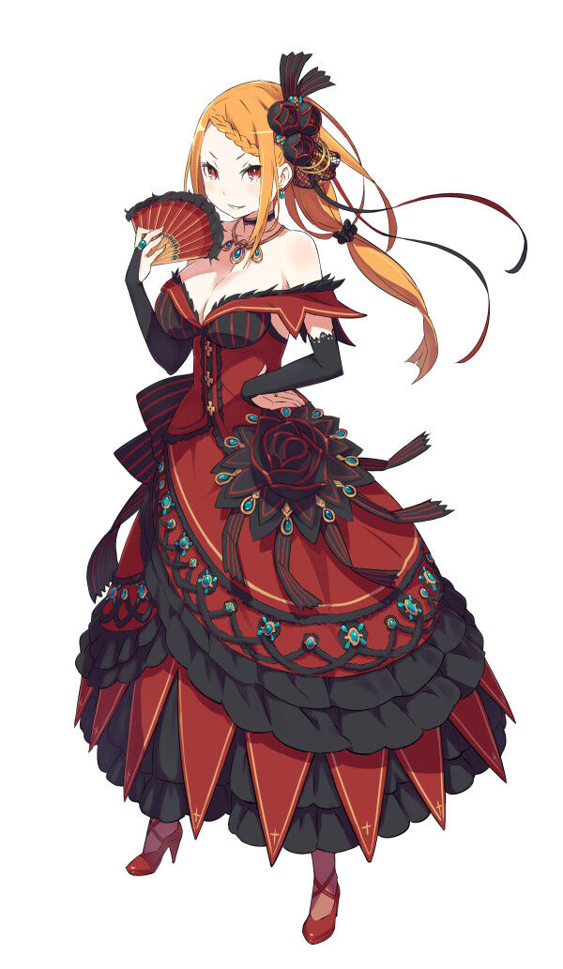
Mind you, the real Priscilla Barielle had been the true target of the trap that had caused all this. Tired of her smarmy demeanor, they had sought to give her a taste of her own medicine by turning her into a meager street urchin. The chest had been placed as a trap to entice such a child, so that the two of them might swap places. The real Priscilla had been turned into Felt and now was on that carriage, on the cusp of being arrested.

While the real Felt had been sent here to fill Priscilla’s heels. Which was honestly ironic, since Priscilla had no qualms about her post as a King Candidate. Rather, she adored the renown. She adored the dressed. And while she wasn’t a fan of the stuffy meeting still, she understood that some sacrifices needed to be made in the pursuit of power.

“Now, what is on the agenda for today? Meetings, I assume?” The woman’s heels clacked against her floor in tandem with the bounce of her heaving bosom after grabbing a piece of parchment from a nearby table. As a woman of her beauty and status, it went without saying that she was almost always busy. It just came with benefits and all that. “Oh? A day free of tasks? Perhaps I should pay the people of Vollachia a visit, then?” She was quite fond of going into town. After all, she was cherished by the people. As someone so beautiful, how could they not cherish a woman such as her?

If she was lucky, she might find a man worth seducing with her body as well. Despite only being eighteen, she had already been through several husbands. But they tried to use her, and Priscilla didn’t like that. But that didn’t mean she tired of pursuing them for her own benefit.

Really, Felt had entirely become the sort of woman she had once loathed.

