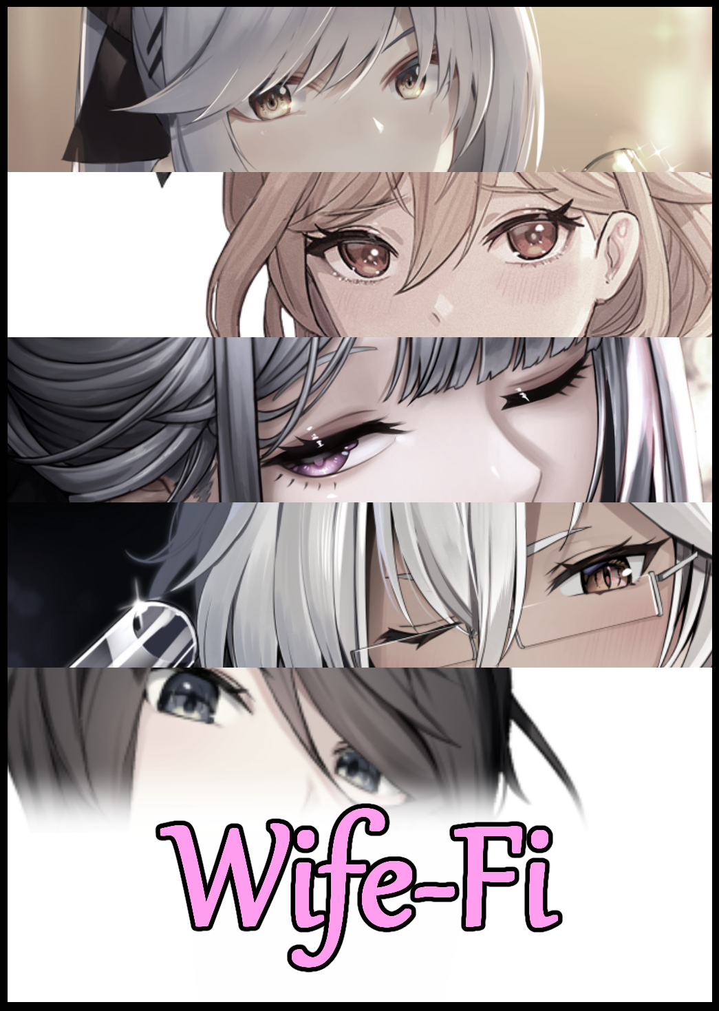

In a modern age where almost anything could be bought off the net without much hassle, scammers were more prolific than ever before. Without an accurate method to ascertain whether a product was genuine outside of buying from official sources, many people eventually fall for one while looking for the cheapest tag to pick from outside the supposed safety net offered by genuine retailers.

But even then, incidents like products being broken right out of the box or shoddy quality wasn't a guaranteed miss, essentially being scammed in some form or another even though one might pay extra to avoid that very same issue elsewhere.

Outside of third party retailers, resellers and official stores however. There existed a far more secretive source of merchandise for both the common consumer and others looking for more eccentric goods that couldn't be found anywhere else. Stuff that couldn't be found anywhere else, oftentimes lacking the proper quality assurance tests and the fact that it was never meant to fall into the hands of the public in the first place.

Despite the inherent dangers of keeping such oddities on hand however, the shifty individuals in charge of distributing their ill-gotten merchandise knew good money was to be made if they could match the right buyer with just the thing they might be looking for. Leading some to amass quite a hefty collection of random bits and baubles. And a few among these hoarders would eventually lose hope in the more mundane pieces they had on hand, selling these off for a moderate sum.

And it would be one of these unassuming items that would eventually find itself in a flea market of all places. Passing from hand to hand until eventually being dumped and forgotten amongst a pile of other second hand goods, setting the stage for a strange series of occurrences once innocuous eyes on the far end of the lane flanked by booths land on the sleek black box glistening in the pile of junk laid out on a stall run by an old man.

"Evening sir…any idea what this is?"

Turning to face the spritely young man who had run up to him, the elder extended a wrinkled hand, snatching the black box off the stand before inspecting it with a keen eye, shrugging his shoulders after just a few seconds spent looking the thing over with narrowed eyes.

"Can't say son…all I know is it's heavy and it's useless. Been sitting on my boy's desk like a paperweight so…figured it wouldn't do good there much longer…why? Lookin' to buy?"

Handing the box over to the potential customer for him to consider the purchase, a look of uncertainty crosses his face as he spins the oddity around on the tip of his finger like a basketball, earning him a cautious frown from the store owner. But after a few more seconds pass with nothing but the hustle and bustle of the surrounding crowd filling the air, the skillful balancing comes to a stop, catching the mystery cube as it slips from his finger with a smile on his face.

"You got a deal, mister…how much for it?"

"Had me worried for a second there kid…considering its heft…I'll let it go for 20."

Passing over two ten dollar bills with a hearty smile on his face, the man steps out from the flea market with a glimmer of excitement in his eyes, making sure to keep his purchase extra safe as he hurries down the sidewalk bound for home..

Born into the world as Rudolph Abernathy, the man seemed to be eternally consumed by the fires of wanderlust. Ever since he was but a kid roughing it out with others in the yard, Rudolph was always looking for his next big hit, something that would get his blood pumping with adrenaline or his mind racing with excitement at the idea of encountering something he hadn't yet seen before. Naturally, such an obsession for even the most mundane of occurrences would naturally lead him to develop impulses some might consider to be negative in nature; like a tendency to hoard bits and pieces of strange items others might consider junk until he figured out what they were. Most of the time, his attempts brought about nothing but the realization that he’d simply picked up a useless bauble whose only selling point was its unique design, but rarely would his efforts bear fruit in the form of discovering something that could either be resold for a good sum at the right place or a nifty little gadget he could use to his own benefit.

To those who knew of Rudolph, the man was an eccentric with a degree in engineering, nicknaming him the Tinkerer for his habit of messing around in his garage the man had converted into a veritable workshop stocked with a variety of tools and material. But to Rudolph, this was the only thing he knew of that could offer the 'zest' he so desperately sought in life. Going to work in the morning, leaving his desk job in the early evening, trekking through the usually bustling market districts in search of anything new before heading back home for a good shower and a hearty dinner. Eventually retreating into his workshop to toy with whatever he managed to pick up before going to bed.

But tonight would prove especially different from all the other times he snuck back there to tinker, even besides the unique find at the flea market, there was to be a special event held at Rudolph's place commemorating the sixth year of friendship he and his five closest buddies shared. Even after going their separate ways all those years ago, the tight knit group never failed to meetup for what would become an annual tradition; a time for old friends to reunite and catch up with what they missed.

For every year since coming up with the idea, the gatherings were held at each of their houses, and now that the sixth was coming up, everyone had agreed to meet at Rudolph's place tonight, and it just so happened to be a Friday evening as well so the partying could be expected to carry on well past midnight, making sure to stock his pantry full of alcohol and light snacks the day before.

As eccentric as he was, Rudolph could still be counted on to host a good gathering. After all, the gathering did count for what little he looked forward to every year that fit his complicated filter for 'exciting'.

Reaching his cozy little suburban home, Rudolph fiddles with the key, flicking the lock open before bumbling inside, setting down his bag and extracting the cube, excitement still burning in his eyes as he speeds straight for the workshop, setting down the innocuous thing on the bench before speeding off to the other side of the room, rifling through shelves and cupboards for his tools.

"Let's see here…blowtorch…nah, too risky…maybe a chisel…no no…wait…need to inspect the shell casing first before I even think of cracking it open…"

The way he saw it, he had very little time left before the first visitor arrived, and if this party was going to be like the last, then he would've preferred it if he could finish tinkering with the box before the first guest arrived. God forbid he forget about it after waking up drunk…or worse if his friends ended up bumbling inside the workshop and got their grubby little hands all over it.

Working as fast as he could, Rudolph spun the cube around in his hands, scanning the reflective surface of the cube for anything that stood out, catching the telltale indication of an indent near the corner of one face just large enough for his pinky finger to comfortably interface with, pressing down gently until an audible click could be heard coming from somewhere deep within the box.

A few seconds would pass without incident, until the thing suddenly springs to life, clattering around the table in a spastic fit as it's casing unfurls to reveal a whole mess of snaking wires, stuff antennae and moving panels, surprising Rudolph as he jumps backward a few steps, unsure of what was happening and too enraptured by the sight of the marvelous engineering before him to say or do anything.

Hinges click, support legs snap to attention, power cells hum to life, and before he knew it, the ordinary box had transformed into a flat, rectangular device with indicator lights on its side and a quad antenna behind it. Beeping rhythmically as if it was in the process of booting up.

"What the hell? Is that…a router? Hmm…portable too…but how's it even work in the first…oh?"

With a buzz from his phone and a peek at the notification, Rudolph could see his phone had disconnected from his home's pre-existing wireless network, attempting to link to the high tech one sitting before his eyes instead, somehow opening what looked like setup software despite not installing anything beforehand, squinting at the name that appears across the screen for a moment before fading away to the usual Name and Password input page typical across all sorts of software.

"Automated…Home Assistant Network…prototype? This better not be a virus…"

As much as he feared a possible virus, the fact that he had just witnessed a small cube unfold and reassemble itself into a wireless router capable of communicating with other devices and even installing a piece of software without prior notice seemed interesting to him. Wondering what would happen if he were to try and take a screwdriver and see how it all worked…did it even use screws in the first place?

Before he could ponder the matter any longer, a knock from outside the front door jolts Rudolph back into action, floundering with his phone while grabbing the newly created router before shutting the door to the workshop behind him with a deft maneuver using crooked feet.

Hopping out into the living room, Rudolph sets the router down carefully on the table before rushing over to answer the front door right as another series of knocks come ringing through, unlocking it before coming face to face with a bearded fellow about a head taller than he was, looking mildly disgruntled behind the broad smile that spreads across his face as he sets his sights on Rudolph, not even waiting for a greeting as he crosses the distance between them to wrap his friend up in a bearhug.

"Finally! What was that all about huh? Could hear you running around in there…don't tell me you're holding out on us now Ruph? The Tinkerer got himself a girl without telling?"

"Haha…funny. You know me; no way am I ever gonna get a girl…anyway, it's good seeing you again Jeremy…still got that whole gym instructor gig going eh? Your hugs are as strong as ever!"

"Ahh…thinking about quitting that gig…but that's something we can talk about later. How about we head on inside and chat? Doubt the others will be here as early anyway."

Seating Jeremy down by the living room table before whisking the router away, Rudolph returns to fiddling with the device in the hopes of finishing the setup, keying in the rest of the password while keeping the network name untouched, setting the cool black rectangle up on the shelf above the television before calling out to his friend on the other side of the room with the intent of testing this baby out.

"Hey, Jeremy? Mind if you help me test something? Y'know, while we wait and all?"

"Sure…is that a router I see? Got a new network on my phone too…this that prototype stuff I'm seeing?"

"Yeap! Password's Omega One Six Four, capitalized and in alphabet not numbers."

"Nice to know you're still rocking that egghead title of yours…what sort of network even is this? 5G?"

"We'll know as soon as you connect, literally just bought this baby on the way home from work earlier!"

"Sheesh…I don't even wanna know where you got it from if you don't even know what sort of network it's running. I mean, it's…woah…hot damn, this baby's fast as fu-ouur old network babe! Nice find!"

"Hah! Knew it was a…wait…what did you say?"

Unbeknownst to Rudolph, the router was more than just a shape shifting cube. Ever since he had activated it, the harmless piece of metal had been listening to his every word, scanning his body's biology and heart rate while keeping track of his emotional state. All in an effort to live up to its namesake as Rudolph's new, automated guardian. Something that bordered on true, sentient artificial intelligence wielding unimaginable power.

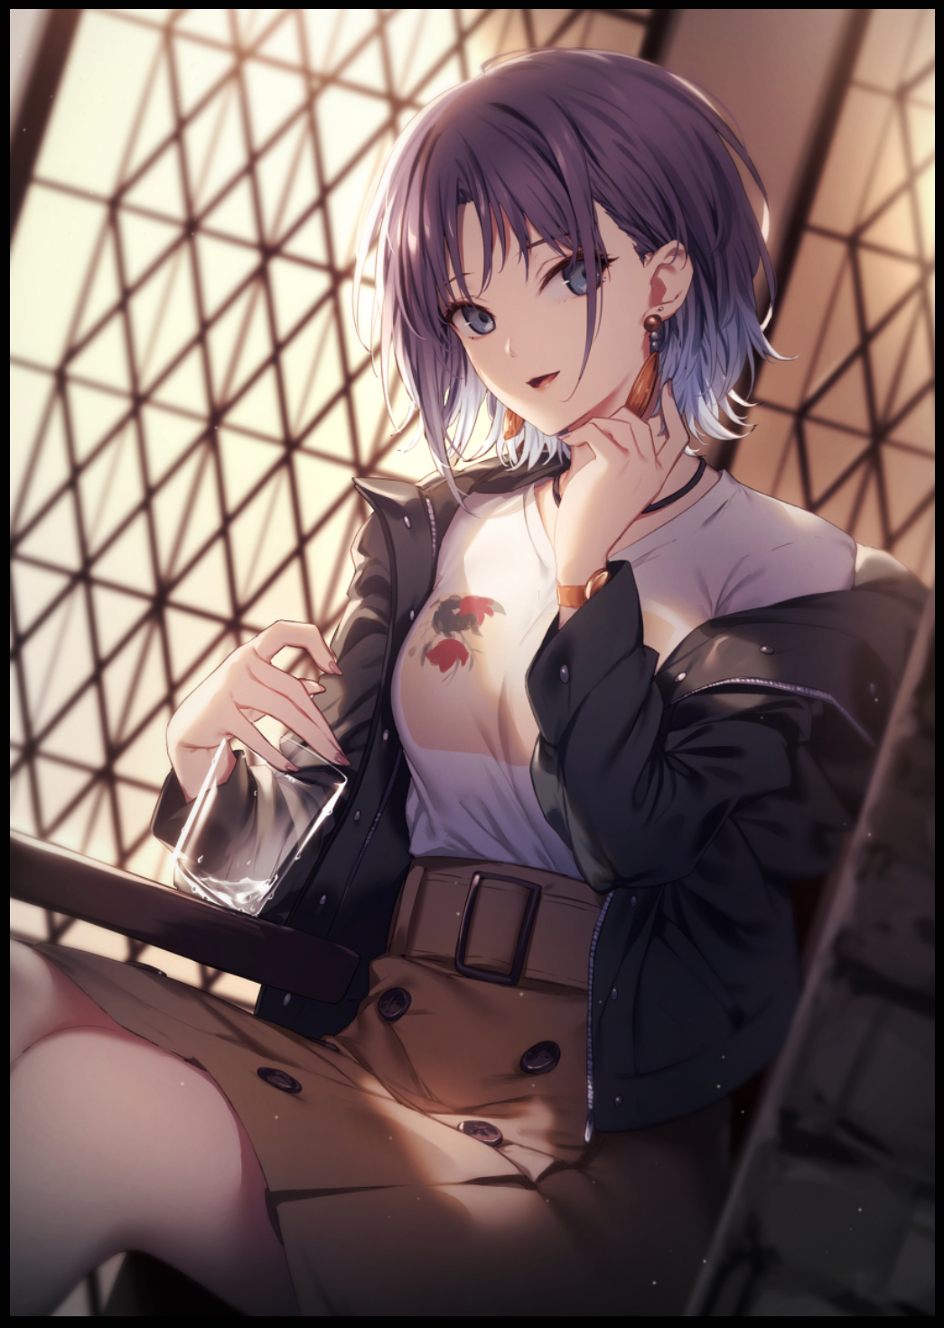
So when it sensed it's masters heart sinking a little upon replying to his friend's jest about having a girlfriend, the router immediately pounced upon the new connection, surging it's metamorphic, reality bending energies through the air, into Jeremy's phone and through the muscular man…

And as Rudolph turns around, another burst of energy runs up his pant leg and up into his spine, flaring synapses so the sight of his friend his girlfriend sitting there by the window looking as beautiful as ever in her usual rogue style casual wear, fiddling with an empty glass of water in one hand while staring at him with gentle blue eyes didn't seem out of place to him. Because why would it? She was here for their friend group reunion after all. And even though Rudolph had the good fortune of seeing Jill's handsome face and hearing her suave voice almost every week thanks to the proximity in which she lived, the others weren't so close at hand like she was.

Plus it wasn't as if he just got together with her, they'd known each other since they met on campus eight years ago. Except for some reason, Jill had gravitated towards him instead of the others. Maybe she saw something in Rudolph he himself didn't, but he couldn't deny how lucky he felt on that Saturday evening a few weeks before they were all set to go their separate ways after graduation.

"Hm? I was just talking about how lucky you were getting that router! Its speed is…well, like nothing I've ever seen before! I can get movies downloaded in less than five minutes!"

"O-Oh…was that it?"

"Ruph? Are you alright? You're looking a little pale there…did something happen at work?"

"Nah, it's nothing…just felt like I got hit with deja vu for a secon-mpf!"

Silenced by his girlfriend's sudden and daring approach, Rudolph's outstretched hands relax before moving to embrace Jill's supple back, running his hands over her small rounded shoulders to pull down her jacket before a knock at the door forces their lips apart and their tongues to unwind, wiping the faintest trail of nectar off her lips while a flustered Rudolph rushes toward the door, casting a sideways glance at his blushing girlfriend who was in a similar rush to get her disheveled clothes back on before he opened it, giving him the briefest glimpse of her shoulder blades pressing up like a tease against her blessed back.

He'd forgotten how straightforward and feminine Jill could be when she wanted to, because for the first four years he'd known her back in university, Rudolph had assumed her to be a tried and true tomboy with a love for rock and sports. But when she had asked him to meet her at the back of the gymnasium after she was done with the last volleyball session she would ever play at school, he got to bear witness to a whole new side of her she claimed no one, not even her parents had seen.

The smoothness of her lips against his, the erotic warmth pulsing from beneath her meager yet delightfully pliable bosom as they rub and mesh against his chest. These once alien sensations were beginning to ingraine themselves within Rudolph's brain as it adjusts to the new reality created for him and Jill by the supernatural force burning unnoticed behind him as the routers indicator lights flicker with activity before returning to normal just as Rudolph opens the door to greet the next…or rather, first arrival since Jill had already been lounging around the notably more grander house with a bit more extravagance and finesse put into the decor since the early afternoon.

Outside the door, dressed in dapper attire with barely anything on his person to bog down the smart clothes he wore stood a tall spindly man smoking on a lit cigarette, dousing the thing before bowing curtly to a grinning Rudolph.

"Evenin' my friends…I wasn't interrupting anything now was I?"

"No you were not…long time no see buddy."

"Likewise Ru…Jill…Bryce and Samuel aren't far behind me by the way. I caught the two gentlefolk while on the way here, said they were having their own shebang of sorts so they'll drop by later."

"Heh, wouldn't expect anything less from those two…Roger ain't here yet either so it's just you and Jill for now…come on in, knowing you Phil, you must've been standing around all day now. Come, we've got drinks and food aplenty!"

The next few minutes would go by with relatively mild energy beginning to build within the house as Rudolph, Jill and Phil sit around the table, catching up on the one year since they'd seen each other with Jill's brutish facade back in play now that they had a guest over watching them. As close as they were, the two hadn't let slip on the fact that they were a thing to the others.

“Seeing how you’re still dressed like a rich prude…I’m assuming everything’s going fine and dandy with the family business Phil?”

“We’ve taken a few hits across the board considering that brief yet damaging pandemic this year but…other than that, everything is as you say; fine and dandy…but how about you and Ru? Are things coming along nicely?"

"H-Huh?! M-Me and R-Ruph? What about us?"

Catching the suspicious raise of a brow on Phil's face, Rudolph clears his throat loudly, interjecting on his flustered girlfriend's behalf before the open can of beans in her hands spills any further.

"I think what Phil means to say is…how we've been doing Jill…y'know? Our lives, jobs…that sort of thing."

"O-Oh…well…I mean, I've been doing well as a gym instructor…lots of students! Fine and dandy!"

"Hmm…if you say so…well? How about you Ru? Still running that desk job of yours? It's a real shame if you are, your engineering skills are better served elsewhere…in fact, you might even be able to start up your own-"

Before Phil could finish his sentence, a shrill ring interrupts him, urging him to his feet as he pulls out his phone with a mild look of disappointment on his face. Bowing apologetically to Rudolph and Jill while moving toward the bedrooms.

"I'm so sorry for the interruption, you don't mind if I borrow a room, do you? Private matters I'm afraid."

"Sure thing, just don't take too long y’hear? Unless you plan to miss out on dinner planning!'

Waving his friend off as he begins to mutter into his phone whilst retreating toward the bedroom, Rudolph sighs before turning his attention back to Jill, who likewise, seemed relieved at Phil's absence giving her the freedom to relax and revert back to her feminine persona.

"Thanks for the save back there Ruph…I thought Phil actually caught on to us!"

"Nah…if he did know, his reaction would've been more…explosive…as quiet and smart as he is, Phil's reaction to the unexpected is comedy gold…"

"Really now? If Phil's as touchy as you say he is…makes me wonder what he'll say when he figures out his friends are in on foursomes behind his back~"

Hearing that made the shiver Rudolph felt earlier run up his spine once more, crashing around inside his head like beads inside maracas to adjust memories and realign thoughts on the fly, changing his would-be query about the mention of that seditious statement in light of their relationship into something else entirely while the image of a boyish Jill corrects itself into a much more girlier version still dressed in more or less the same attire minus the leather jacket with her hair taking on a paler shade of steel blue, lengthening until her boyish cut was subsumed by a silky curtain reaching down long enough to tickle the arch of her perfectly sculpted back.

Blinking once, Rudolph suddenly finds himself shifting uncomfortably, feeling a heavy weight pressing down against his chest upon the insertion of new memories, unaware of the blinking modem sitting innocently in the background while he raises Jill a question.

"Um…Jill? About that…"

"About…*sigh* I thought I told you this before Ruph? We even talked about it, didn't we? I'm perfectly fine with Bri and Sam…we're friends aren't we? And…well…if you really do love…us..I mean, sharing shouldn't be much of an issue…right?"

"R-Right…it's just…you were my first…always will be…so when they came on to me…I just thought you said yes because-"

"Oh shush…we were all drunk anyway…plus it's all in the past now. And really? They? If the girls heard you they'd be hurt!"

"I-I…you're right…it just hasn't sunk in properly I guess…this whole…polygamy thing…and you being a…"

"Well? Don't keep me waiting~"

"Like a big sister I guess…like you care about Brittany and Samantha too."

"Hehee~ Even when we weren't sharing beds together, I'll have you know I kept those girls in line! If it weren't for Scilla being such a lady I'd have lost my mind long ago…speaking of, where are they? It's already well past dinner…Ruph, why don't you try getting in touch with them hm? I'll go see what I can whip up in the kitchen until then."

"Gotcha…oh…and Jill?"

"Hu-amh?!"

Leaning across the table to land a gentle peck on his girlfriend's lips, Rudolph moves toward the front door with phone in hand, shooting Jill one last smile before turning his attention toward the missing duo who Priscilla said she'd seen loitering nearby while on her way here. Oblivious to how…mature…he had become over the course of the last few hours. Gradually losing that spark for adventure in his heart the more changes set in.

Swinging open the front door however, and Rudolph's search for the missing party attendants was fulfilled by the presence of said women hanging around his spacious front yard, talking excitedly with phones in hand.

The taller one with a saturated head of caramel brown tied into a ponytail was Brittany, a bona fide genius and master of computer engineering. Known amongst their batch as one of the campus' most sought after girls back when they were all simple friends studying under the same roof. Brittany hid her smarts behind the exterior of a fun loving ditz alongside the one other person closest to her besides Rudolph. Her childhood friend and partner in crime; Samantha. Studying under the same computer engineering course, the girl was a modest soul, preferring to stay by Brittany's side all quiet and meek, partaking in her friend's hobbies with a serene smile that had become her signature facial expression, framed by a gorgeous head of dark brown hair.

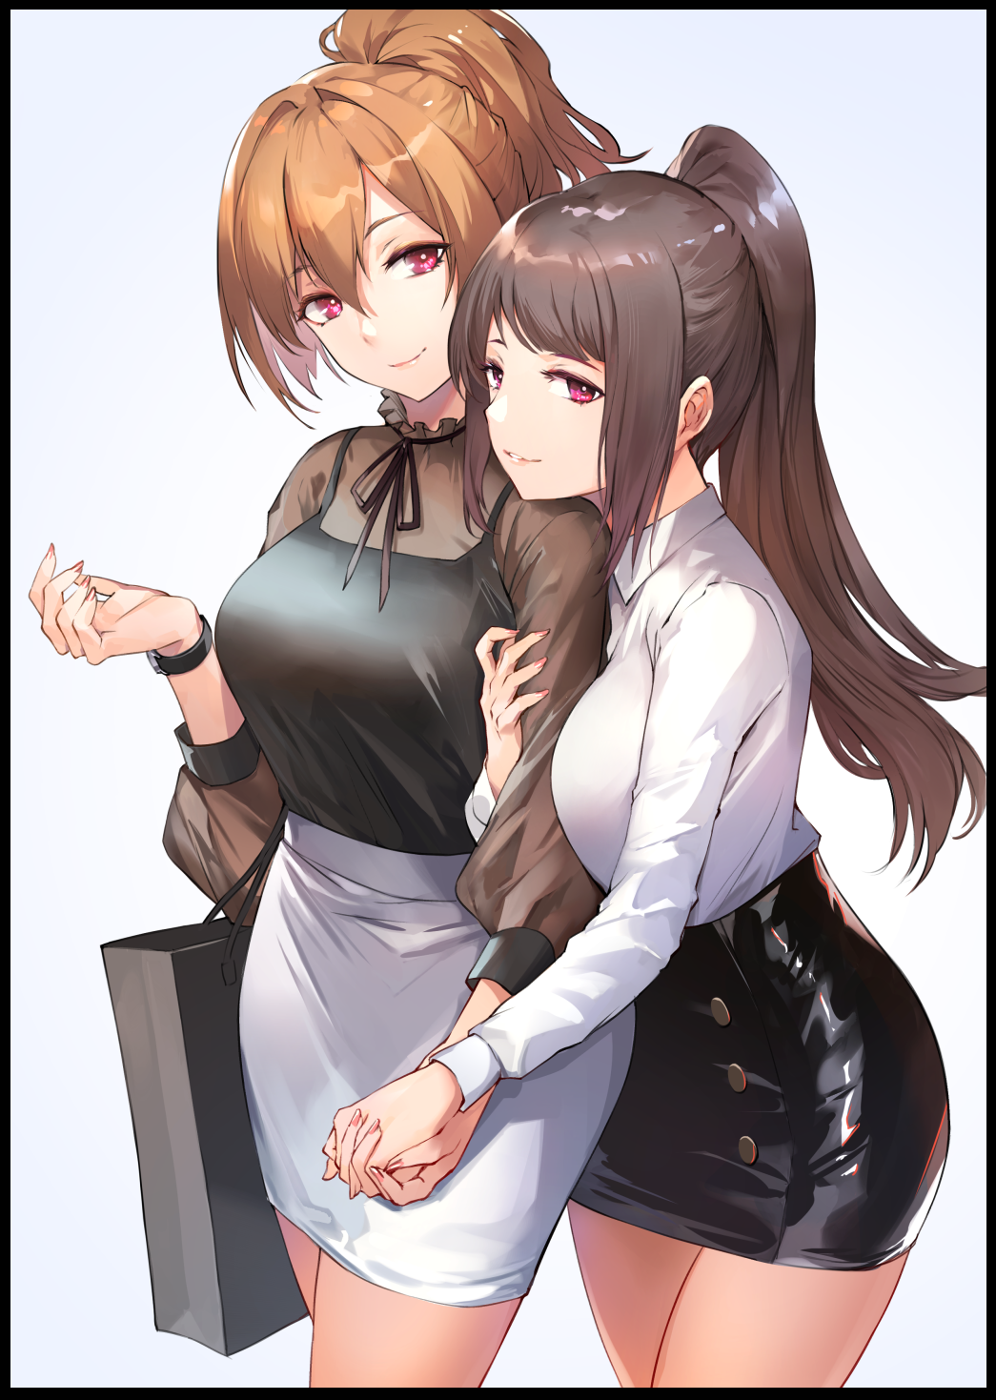
At first glance, the two were like sisters, always doing everything together. And unlike Jill, who had come forward with an earnest love for Rudolph, the two had cornered him on their fifth annual meetup last year at Priscilla's mansion. With all participants having their minds addled by alcohol and their inhibition at an all time low, the women had cornered Rudolph in his room, propositioning him for sex out of curiosity, fuelled by the fact they had let slip on their intrusion into his private life with Jill via bugs and hacking.

Even as Rudolph stared at the women who were still unaware of his presence, he found it hard to believe that he'd somehow managed to get himself a veritable harem…sure, the sex was amazing. But when it came to matters of the heart...he couldn't help but feel like a bastard sometimes, especially knowing how hard it must've been for Jill to process it all when she had entered her boyfriend's room, only to find him buried deep inside two of her closest friends.

Although he suspected Priscilla to have a hand in the way things turned out, he knew he had to thank Jill for accepting a polygamous relationship in the first place. They had discussed housing, names for possible children, even a wedding! Everything a budding couple looked forward to…and she had to put it all aside now they had three other women to share their lives with…

'God damn it…I really should take Jill out sometime soon…she deserves some solo time at least…'

That being said though, he hadn't expected things to work out as well as they had. For one, he only had to suffer some minor bruises from Jill's obvious anger once they awoke the next morning. And although Brittany and Samantha were initially undecided and looked like they were there simply because of the guilt behind what they did, somehow or another, a genuine relationship was built between him and the duo. Leaving Priscilla as something of an oddity considering how she seemed to be working in the background to like things up perfectly for Jill and the others.

Heiress to a big name in the smartphone industry, Priscilla had already hired Brittany and Samantha as her go to computer experts. And now that her company was looking to develop their newest model, she had brought up the idea of taking Rudolph under her wing in regards to his engineering skills.

“Are you still running that hardware store of yours Ru? It's a real shame if you are, your engineering skills are better served elsewhere…you are aware of my company’s latest model, yes? If you’re keen, I have a spot reserved for you on the design team. Just think of the money you would earn if you signed on, it’d surely be enough to cover for you and the girls~"

As much as he appreciated her as a friend and for helping sort out Jill's feelings…he often felt like Priscilla was simply using their friendship to pull strings her way if it meant her company's growth.

'Hell…I wonder if she's ever taken an interest in Roger…poor guy's gonna be swindled if he does…'

Turning his thoughts back toward the present, Rudolph clears his throat, catching the attention of Brittany and Samantha, turning in unison as their expressions soften further at the sight of their boyfriend. Crossing the yard in a second before taking him into a warm hug, with Samantha struggling to get hers in between her two taller companions.

"Glad to see you two made it safe and sound…why didn't you come up and knock? We were waiting all evening for you two…and Roger of course…"

"Well dear~ As much as we liked to come in and see you and Jill…we saw Pri heading in before us…and since we wanted to scout things out abit, we decided to hack in and see what's up inside your sweet little den…and guess what we found?"

"Your WiFi Dolph…it's super strong…like way strong~"

"Exactly! Me and Sammy were burning through firewalls and connecting to servers so damn quick we just…well…lost track of time I guess. If you hadn't looked, we might have spent all night out here leeching off of you!"

Before Rudolph could respond to the duo's lack of care in breaching his WiFi password and potentially leaking private information, his eyes catch sight of another individual standing just down the street, watching him with brooding eyes in a simple jacket and trousers, downtrodden and slouched with a depressive slump. But even though he looked unrecognizable, Rudolph knew him to be Roger, the last guest for tonight's gathering.

'Did he…always look like that…I swear he wasn't that moody last year…oh…'

Patting Brittany and Samantha on the head, Rudolph ushers them inside, assuring them he wouldn't be too long despite their hesitation, wondering what the sudden rush was all about.

"I promise, it'll only take a second…Jill should already be in the kitchen and Priscilla's still in the room on her phone, I'll join you all right quick as soon as I can!"

"Hmm…I don't buy it but sure…we'll wait but you'd better be quick alright? Or we'll drink your house dry!"

"Sure, sure…it's good to see you two again…"

With Brittany sashaying inside, that left Samantha alone with Rudolph, shifting nervously with a half lidded eye cast warily out the door at their eerie friend, who hadn't moved an inch since.

"Dolph? W-What's wrong with Roger?"

"You noticed too? Tell the truth…I don't know…but I think I might have an idea as to what's going on…go inside Samantha…look, I'll just talk things out with him and see what's up, have fun alright? Tonight's the night to kick back and relax!"

Ruffling Samantha's head despite the wince she wore on her face, Rudolph pat's the meek girl on the back in an effort to turn that uncertain frown upside down. It made him feel like a big brother cheering up his little sister.

“Alright…but…help Roger if he needs it…okay?”

Nodding to affirm Samantha's worries, Rudolph straightens himself before walking out onto the yard, headed straight for Roger, who had similarly begun to move now that they had privacy all to themselves. And as he drew closer, Rudolph couldn't help but shiver at the state his friend was in.

Last year, he had been a spritely young man enjoying life. Looking not a day older than he was at the renowned boisterous partygoer back in the old days. But now…he was like a shadow, with the beginnings of heavy bags under his eyes and a sickly pallor to his waxen skin, the man looked more like a drug addict than a rising entrepreneur. Just like Priscilla, Roger was a single son born into a prestigious family. But that was where the similarities ended.

Unlike the tenacious woman, Roger was more…impulsive…easily led around by a string. So when he had come forward to declare his love for Priscilla during their last get together at her abode, the woman had agreed just to see what he could offer. And evidently, he hadn't passed whatever criteria she had set for a partner…but judgment could be reserved for after he heard him out.

"Everything all right man? C'mon inside, I'll fetch you something to drink!"

"N-No need Rudolph…wasn't planning to stay long anyway, just…wanted to ask if Priscilla was…y'know what? Never mind, I-h-hey!"

Grabbing a hold of Roger's arm before he could fully turn to leave, a renewed swelling of strength and will boils within the man's chest as he pulls his friend closer, unwilling to let him go off into the night in his current state.

"C'mon. Just come inside, and have a drink, something to eat…we can chat if you'd like…and then after that, if you wanna go, then go…but not before…"

"Jesus Rudolph…since when did you grow a pair of balls…never known you could be this demanding…"

"Huh…time flies I guess…now c'mon, we've got drinks aplenty and food for days…sneak inside the right once you're in the house, workshop's down that side, here's the key."

"Thanks man…"

"No worries, just hide out there and I'll get some refreshments for us both…oh, and before you go in, here, the password for some new WiFi network I just got going, Jill and the others said it's working fine so if you need it, feel free! You'll know the name when you see it."

Sending Roger inside before diverging paths as he heads toward the kitchen, Rudolph's mildly dour mood was steadily uplifted by the sight of his home lit in warm, orange lights with the familiar voices of Jill, Brittany and Samantha conversing happily at the back, accompanied by the raucous sizzling of cooking oil bubbling in a broth of stew and vegetables, clanging frying pans and the clatter of utensils being tossed into the basin. The smell was heavenly and it made his belly scream to see the delicious food his girlfriends were making, but he had an important matter to attend to first.

Before he could snatch up the bottle of water by the table however, a firm hand and a sharp yank on the collar of his tuxedo had Rudolph stumbling backwards into the familiar interior of his Priscilla's bedroom, coming face to face with the tenant herself as she puts a finger up to her lips in a gesture of silence, complete with a mischievous wink.

"P-Priscilla…since you’re not out there helping the others…what’s up, something on your mind about the call earlier?”

"My, you make me sound like I'm skimping out on purpose! As for the call…nothing more than simple business like I said…forgive me for asking but…how's Regina doing? That was her wasn't it?"

"R-Reg…ina?"

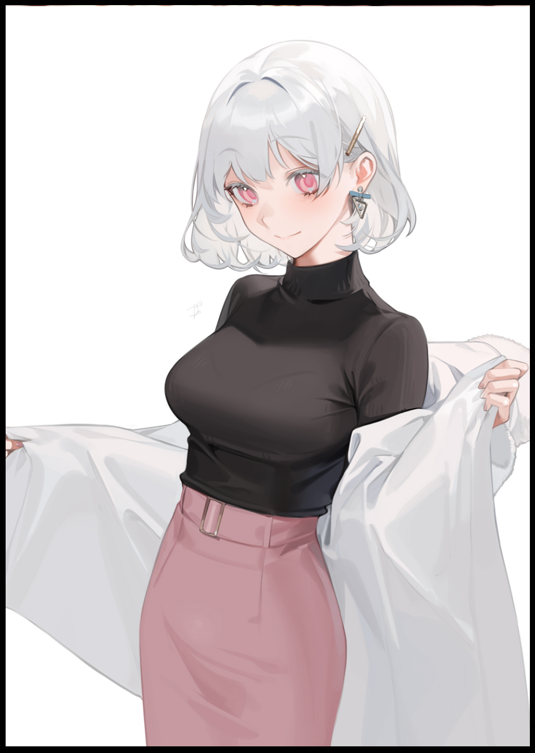
Another continuity error, another corrective pulse, and soon, the router's work was accomplished at a record speed. With each correction made to the world, the powers that governed the little thing seemed to grow more and more used to the process of change, fiddling with everyone's memories in an instant instead of the few seconds it used to take.

In the literal blink of an eye, all doubt was erased in Rudolph's eyes as his gaze refocused on Priscilla who had turned her back on the man, giggling softly under her breath as she begins to shrug off her obscuring, snow white voat, revealing her impossibly tight, curvaceous figure to Rudolph without a hint of shame on her gorgeous visage nor hesitation in the way her slender arms moved, peeling off her coat before hanging it up on the nearby stand, turning on a heel with a cheeky smile on her face that hid the ferocious corporate beast within she only ever let loose when the situation called for it…like say; a boyfriend playing coy with her.

"Come now Ru~ I heard you two talking outside…heard her footsteps inside the house too…and from the looks of it, she must be in the lounge, no?"

"Hehe…yeah…you scare me sometimes y'know?"

"Good…but…tell me; is she still…mad? About me and you I mean."

Frowning a little while thinking back to his conversation with Regina outside, Rudolph couldn't recall seeing a single hint of animosity on the young brunette's face when he spoke to her. Even when the conversation inevitably drifted to the guests already inside the house including Priscilla, not once did the dignified woman show displeasure, keeping that warm smile on her face all the time as she chatted him up, still feeling the warm, damp spot on his cheek where she pecked him.

"No…not that I can recall…she seemed happy when I spoke to her at the door."

"Ufufu…I'd be inclined to agree…if she were here to greet me instead of sequestering herself into the lounge…*sigh*, I suppose we'll have plenty of time to reminisce on the good old days later so off with you, I'm going to change…unless…you'd like to help?"

“Later babe…can't have everything to yourself all the time y'know?"

"You're a scoundrel~ See you soon dear…"

Ripping his eyes off of Priscilla's stunning body that had him raring to go despite his dedication to the harem, Rudolph steps out of his wife's room a changed man, styling his hair back before returning to the marble table, snatching the bottle of vintage wine off the top before making a beeline for the lounge, opening the door gently while taking a look around the moody room with only one oil lamp lit at the far back where the sole occupant of the room sits idly by her lonesome, half lidded eyes gazing at the wavering flame in silent contemplation. A positively gorgeous woman dressed in high class garments, carrying herself with a vastly different air when compared to Priscilla.
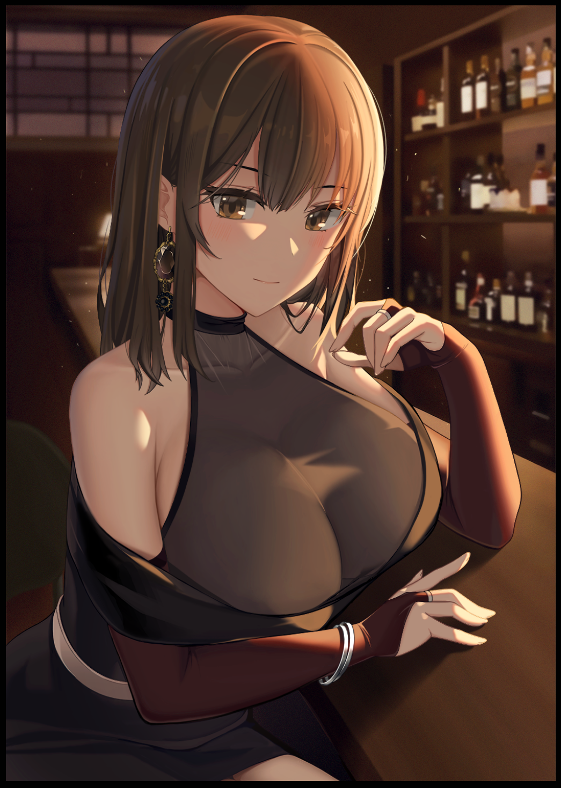
Where the silver haired woman radiated a hidden, dangerous vibe behind her waifish exterior, Regina seemed troubled by thoughts she wore visibly on her shoulder. Even now as her brows twitched upon the sight of her fiance standing by the door, the smile she sent his way seemed an inch away from collapsing into a grimace.

"Sorry…I didn't hear you come in there Rudy…how is everyone?"

"They're doing great…Jill's still the woman in charge…Brittany's as feisty as ever and Samantha's…well, Sam's still learning to grow out of her shell…as for Priscilla…she's-"

"Still the same cold hearted bitch? She isn't working you too hard is she Rudy?"

"Haha…nah, she might not look like she'll budge but…I know a few ways to get her shivering in her heels…but enough about that…how are you doing Reg? Everything going fine? I know it's been hard this past year but…Priscilla hasn't been bothering you has she?"

"No…no she hasn't…the last time we spoke was when…water under the bridge…no point bringing up the past, I'll have a drink if you don't mind."

"Sure thing…"

Pouring a shot into one of the idle glasses on the bar stand, Rudolph joins Regina in silence as the two sit there awkwardly, shifting in place every now and then while sipping on rich bitter crimson.

As hard as Jill's acceptance was after all these years, nothing could prepare him for Regina's involvement in his life. Even though they did their best to keep their marriage secret, Regina's confession due to her mistaken assumption that Rudolph was still single had sparked a flame of contempt in Priscilla's eyes. Even back during their younger days, the two were natural rivals, considering the fact that they were both women hailing from different influential families . It was in their nature to butt heads in everything they did.

And on that day, Priscilla had used her standing as Rudolph's newest wife to goad Regina, belittling her while making it sound like the man she loved had his it from her all this time because he had no intent on reciprocating her confession despite his protest to the latter. No surprise then she'd slapped him and left in tears, bringing their last annual friend meetup to a crashing slump.

It was probably the only time he'd ever shown direct anger toward one of his beloved wives. Even though he didn't want to, he knew he had to make it known that he wasn't something to be possessed just like he didn't want to look possessive over Jill and the others, an attribute he'd taken from his first lover. Even now he still saw the memory of quarreling with Priscilla as a shameful one. Fighting between husband and wife was to be expected, but when Jill, Brittany and Samantha were kept up all night next door while they heard their best friends arguing amongst each other, it added a whole new layer of complexity…three whole layers.

But somehow, he had gotten back into contact with Regina, pleading for her to meet him at the main park downtown during the night for a chance to explain himself, to set the record straight about what Priscilla had led her to believe. Going so far to ignore his fourth wife's warning about leaving him if he were to go along with that decision. But still he would leave, sitting out in the rain until Regina showed herself close to an hour after the appointed meeting time.

She didn't say a word, simply watching from the sidelines under an umbrella while Rudolph froze on a bench with a simple tree serving as inadequate cover. But she was not Priscilla, silently approaching her friend's side before he caught sick, pulling him in close for warmth despite how drenched he was, propping her umbrella up behind them.

From there, she would listen to what Rudolph had to say, still hesitant to believe him even when he brought up the threat Priscilla had shouted after him after he left their home, shutting out anything to do with the silver haired woman while focusing more on his entire recounting of how Jill had confessed, the drunken affair that led to Brittany and Samantha joining in and finally…Priscilla herself unceremoniously being wedded as his fourth wife with little fanfare from Jill, who are this point was fine with it, taking their friendship into consideration over her own joy. To this, Regina had something to say that made her look like a hypocrite considering she was soon to become his fifth.

"That's a bit…cruel isn't it? It's like you're all using Jill to your advantage…"

"I know…believe me…the nights I couldn't sleep after the incident with Brit and Sam…the times I feared Jill would just…walk out on me one day…hell, we weren't even wedded yet back then and…she had so many plans…"

The gravelly tone of hurt in his voice had Regina consign herself to the undeniable truth then; that she unfortunately, hadn’t been the first to confess her love to Rudolph who she only really grew closer to after university. Back then, she hadn’t seen much but a dear friend in the nerdy man with a childish outlook, but the more he matured, the closer she seemed to grow. If it weren't for the fact that they lived in the same city, the many weekend dates they had till now wouldn't have been possible at all…except now she realized why he was so busy all the time besides work…

"You've had four girls all this time…why didn't you tell me earlier?"

"Well…I mean…I didn't want to look like some…neanderthal amassing a harem! Plus you…well…I didn't think you'd come out with a confession…I didn't…"

"Didn't think there'd be a fifth girl after your heart? Well…sorry to disappoint…"

"C'mon Regina…I didn't mean it like that…"

"I know…it's just all so much to take in…you, Jill, Brittany, Samantha…even that bitch…literally in bed together while I was the blind one…Rudy…I don't know what to do!"

But as both parties in this strange and latest coupling reminisce on their individual lives that had led them down the same road at the end, more changes would begin to take ahold of the once ordinary suburban home that had been magically renovated, transported a mile away to the coastal residences where a new high class villa would be constructed, complete with trauma resistant glass windows that stretched from floor to ceiling in the lavish new home, decked out with the latest in home security and expensive furniture. There was even a swimming pool right outside near the cliffs that led down to the beach.

While Regina replayed the moment where Rudolph had suddenly kissed her out of nowhere in her most vulnerable moment, all her friends would undergo another metamorphosis for the last time as Rudolph's feminized friends-turned-wives began to grow older, maturing rapidly into their early thirties while their smart casual wear begins to liquify and transform into extravagant dresses fit for a ball, sticking fast to the voluptuous forms blossoming forth from old shells being shed to fit their individual lifestyles.

While Jill Abernathy's hair remained more or less the same besides an added length long enough for her to do it up into a ponytail, her body would lose most of its musculature and tone as her former profession of gym instructor soon faded for a more lax role as housewife. Gaining pronounced curves in her hips and breasts as they plump up in size and girth, looking more like a refined woman than the curt tomboy she had started out as, unafraid to bear her femininity to all while keeping that rough edge that made the rest of the family fall in line.

Meanwhile, Brittany Abernathy would undergo a more drastic change as her formerly pale skin tone begins to darken into a natural cocoa tint, highlighted perfectly by her once childish demeanor as a thrillseeker taking the backseat in place for a more seasoned, serious persona. Followed closely by her sultry face turning hard edged and boyish as if she'd exchanged most of her feminine wile with Jill's tomboy fire, dyeing her rich brown hair a dull silver white tied into a side hanging ponytail instead of the short rear one she used to sport. And as if to punch in her profession as a tech wiz, a prim set of spectacles manifests over the small crook of her nose, helping her to see as years of staring into a computer screen begin to take their toll on her eyesight

The same couldn't be said for Samantha Abernathy however, who, unlike her friend, seemed to regress further into her shy, meek nature…juxtaposed by her ordinary appearance taking a turn for the better as her flowing brown ponytail turns into a fiery mane of blonde, moving strands tying themselves up into a loose bun strung together by a golden hairpin. Not to be outdone by her fellows, Samantha's already attractive figure begins to turn and shift under a shimmering glamor dress that left very little to the imagination, made worse when her D cup breasts surge forward into perky E's, flopping about with each step much to Brittany's humor as she smirks at the sight of her friend floundering around the living room. The sooner she learned to grow comfortable in these sorts of clothes the better, and with Brittany as her 'confidence coach', the girl was confident she would make a proud woman out of Samantha yet despite the trend with her behavior showing the opposite.

Up above on the second floor, watching over her friends and family with keen eyes sat none other than Priscilla Abernathy, sipping on a glass of martini with grace oozing from her every move, smiling knowingly at the door that led to the relaxation lounge for extra guests to mingle in. With the passage of time wearing down on her, the ice princess seemed to flower perfectly into her role as the empress of her own modern empire. Despite the hardened and ruthless edge she had honed over the years of managing a business as cutthroat as hers with corporate espionage and unforeseen trouble to be had at all turns, there now existed a softer, more motherly side that made her stand out amongst Rudolph’s wives as the ‘mother’ figure. While Jill was perfectly capable of holding her own against the others when the time came for it, none could match Priscilla when it came to finances and pulling strings behind the scenes. A fact that had her smile widening further when thinking about the significance of the event they were celebrating today.

And last but not least, Regina Abernathy; the youngest among the Abernathy women in both age and stature as Rudolph’s final wife. As they sat there dumbstruck under the hold of the still flickering router’s mental influence, the young woman would begin to age just like her friends had alongside her husband as the two accelerated past a decade of life spent together. Growing from young adults into a seasoned couple getting ready to celebrate yet another year of being a joyfully wedded couple within the span of a few seconds.

With Rudolph's chiseled features growing stronger and weathered, so too would Regina's feminine qualities as her immature visage takes on a more sultry quality, slanting brows grantijgnher gaze an erotic side perfect for bedroom eyes like the ones she currently displayed while gazing upon the handsome ruggedness of her husband, taking callused hands in her dainty ones while rising off the leather chair, all while her shoulderless flare unwinds itself, loosening their hold over her bosom as it sags forth into immaculate mammaries holding nectar aplenty for both her voracious husband and her future offspring whenever she would be blessed with them. For some strange reason, and no matter what time of the month they did it, none of the women in Rudolph's company had been inseminated with children. But tonight felt different…right…and with the finalization of Regina's revealing dress that seemed to double over as sexy nightwear, nature's call was never clearer than before. Something that had all five women tingling with need and arousal as they all began to move toward the master bedroom…except Regina, who was busy trying to get her husband to snap out of his daydream.

To her, they had just finished sweet talking one another, but to Rudolph, his mind was still stuck on that pivotal moment in the park where a kiss had ultimately sealed Regina’s fate with him. Unaware of all the developments that came after until they burned themselves into his brain within the span of a second.

"Rudy~ Earth to Rudy~ Anyone there?"

"R-Regina…sorry…I thought…w-we were talking about how…how Priscilla lied to you, was it?"

"Priscilla? Lie? Dear me...that was so long ago! C'mon, we've got more important things to worry about than past squabbles…like starting a family for real~"

"Family…R-Right…sorry babe…I don't know what got into me back there earlier…feel like someone took a jackhammer and socked me over the head with it."

"Alcohol must've gotten to you early…don't worry though, we'll make sure you keep going nice and hard, just like before…and we won't stop till you fill us all up~"

"E-Even Sam? She…I don't want to force her if she's not comfortable with it…"

"Nuh uh! You're not getting away with excuses…drink or otherwise…and believe me dear, Sammy can be pretty wild once you get her buttons going…now c'mon, we've kept the others waiting long enough!"

"Alright, alright! No need to pull!"

While the lucky man headed downstairs to join his new wives who were all stark naked and waiting for him like treats laid out on a silver platter that was the spacious bed reserved specifically for moments like these. The nondescript router responsible for the non stop reality bending begins to sputter on its own before finally fizzing out. With its purpose served and the experimental power core at the center of it all reaching the limit, the powerful reality bending creation of unknown original consumes itself in a roiling ball of distorted space, leaving nothing behind save for an ordinary internet router bereft of the extraordinary powers that had changed the lives of Rudolph and his friends…for better or worse though, none could say.

But from the way his pecker wastes no time in rising to attention upon the sight of the four mesmerizing women lying in bed with the fifth guiding him by hand while slowly ridding herself of clothing, it was clear to see he didn't mind one bit, approaching the giggling sirens as five pairs of warm arms swarm over him, unbuttoning his clothes, stroking his member and rubbing his muscular form, a build honed by Jill's rigorous mentoring and the harsh labors handed down to him by Priscilla.

No longer would Rudolph feel the spark of adventure call out to him anymore. Because with everything he could ever want so close at hand, why ever would he want to go elsewhere? He'd fought through many things to get to where he was, the same went for Jill, Brittany, Samantha, Priscilla and Regina. Even though they weren't aware of the stale lives they had been forcefully ejected from, it didn't change the fact that they thoroughly enjoyed it as it was. Roles had been switched, identities were altered, but for the most part, all of it had been left to the hands of fate for the human actors to sort out on their own.

Rudolph now had a family to start and loved ones who cared for him as much as he did them; A life few could ever dream of living. And he was damn sure he'd enjoy every passing second of it to his fullest…

THE END

