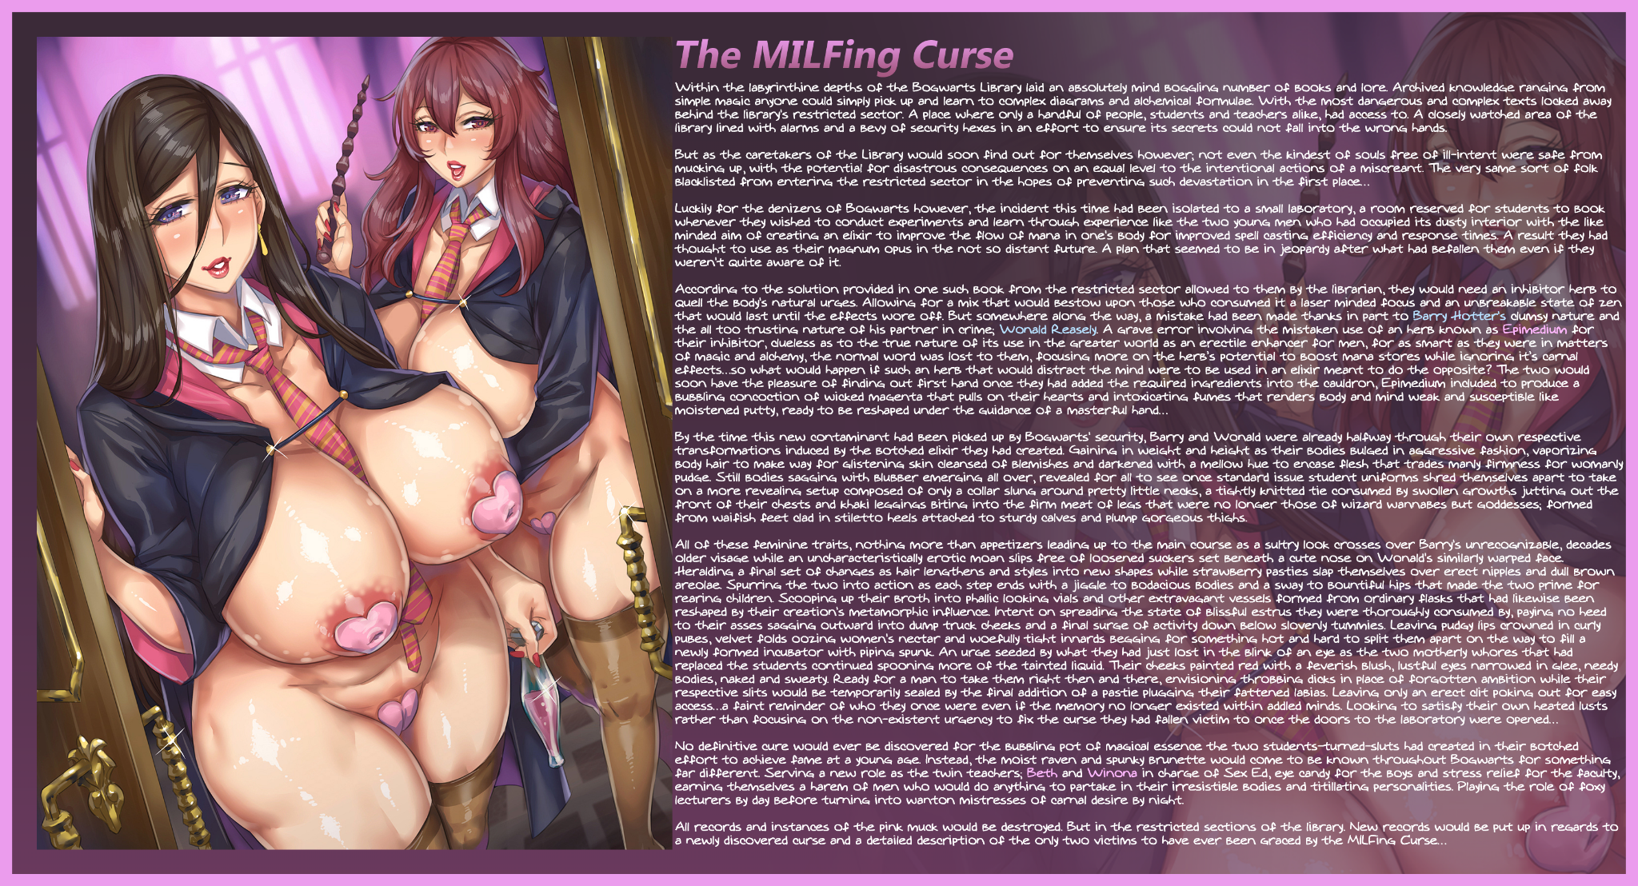

Within the labyrinthine depths of the ***Bogwarts Library*** laid an absolutely mind boggling number of books and lore. Archived knowledge ranging from simple magic anyone could simply pick up and learn to complex diagrams and alchemical formulae. With the most dangerous and complex texts locked away behind the library's restricted sector. A place where only a handful of people, students and teachers alike, had access to. A closely watched area of the library lined with alarms and a bevy of security hexes in an effort to ensure its secrets could not fall into the wrong hands.

But as the caretakers of the Library would soon find out for themselves however; not even the kindest of souls free of ill-intent were safe from mucking up, with the potential for disastrous consequences on an equal level to the intentional actions of a miscreant. The very same sort of folk blacklisted from entering the restricted sector in the hopes of preventing such devastation in the first place…

Luckily for the denizens of Bogwarts however, the incident this time had been isolated to a small laboratory, a room reserved for students to book whenever they wished to conduct experiments and learn through experience like the two young men who had occupied its dusty interior with the like minded aim of creating an elixir to improve the flow of mana in one's body for improved spell casting efficiency and response times. A result they had thought to use as their magnum opus in the not so distant future. A plan that seemed to be in jeopardy after what had befallen them even if they weren't *quite* aware of it.

According to the solution provided in one such book from the restricted sector allowed to them by the librarian, they would need an inhibitor herb to quell the body's natural urges. Allowing for a mix that would bestow upon those who consumed it a laser minded focus and an unbreakable state of zen that would last until the effects wore off. But somewhere along the way, a mistake had been made thanks in part to ***Barry Hotter's*** clumsy nature and the all too trusting nature of his partner in crime; ***Wonald Reasely***. A grave error involving the mistaken use of an herb known as ***Epimedium*** for their inhibitor, clueless as to the true nature of its use in the greater world as an erectile enhancer for men, for as smart as they were in matters of magic and alchemy, the normal word was lost to them, focusing more on the herb’s potential to boost mana stores while ignoring it’s carnal effects…so what would happen if such an herb that would distract the mind were to be used in an elixir meant to do the opposite? The two would soon have the pleasure of finding out first hand once they had added the required ingredients into the cauldron, Epimedium included to produce a bubbling concoction of wicked magenta that pulls on their hearts and intoxicating fumes that renders body and mind weak and susceptible like moistened putty, ready to be reshaped under the guidance of a masterful hand…

By the time this new contaminant had been picked up by Bogwarts' security, Barry and Wonald were already halfway through their own respective transformations induced by the botched elixir they had created. Gaining in weight and height as their bodies bulged in aggressive fashion, vaporizing body hair to make way for glistening skin cleansed of blemishes and darkened with a mellow hue to encase flesh that trades manly firmness for womanly pudge. Still bodies sagging with blubber emerging all over, revealed for all to see once standard issue student uniforms shred themselves apart to take on a more revealing setup composed of only a collar slung around pretty little necks, a tightly knitted tie consumed by swollen growths jutting out the front of their chests and khaki leggings biting into the firm meat of legs that were no longer those of wizard wannabes but goddesses; formed from waifish feet clad in stiletto heels attached to sturdy calves and plump gorgeous thighs.

All of these feminine traits, nothing more than appetizers leading up to the main course as a sultry look crosses over Barry's unrecognizable, decades older visage while an uncharacteristically erotic moan slips free of loosened suckers set beneath a cute nose on Wonald's similarly warped face. Heralding a final set of changes as hair lengthens and styles into new shapes while strawberry pasties slap themselves over erect nipples and dull brown areolae. Spurring the two into action as each step ends with a jiggle to bodacious bodies and a sway to bountiful hips that made the two prime for rearing children. Scooping up their broth into phallic looking vials and other extravagant vessels formed from ordinary flasks that had likewise been reshaped by their creation's metamorphic influence. Intent on spreading the state of blissful estrus they were thoroughly consumed by, paying no heed to their asses sagging outward into dump truck cheeks and a final surge of activity down below slovenly tummies. Leaving pudgy lips crowned in curly pubes, velvet folds oozing women's nectar and woefully tight innards begging for something hot and hard to split them apart on the way to fill a newly formed incubator with piping spunk. An urge seeded by what they had just lost in the blink of an eye as the two motherly whores that had replaced the students continued spooning more of the tainted liquid. Their cheeks painted red with a feverish blush, lustful eyes narrowed in glee, needy bodies, naked and sweaty. Ready for a man to take them right then and there, envisioning throbbing dicks in place of forgotten ambition while their respective slits would be temporarily sealed by the final addition of a pastie plugging their fattened labias. Leaving only an erect clit poking out for easy access…a faint reminder of who they once were even if the memory no longer existed within addled minds. Looking to satisfy their own heated lusts rather than focusing on the non-existent urgency to fix the curse they had fallen victim to once the doors to the laboratory were opened…

No definitive cure would ever be discovered for the bubbling pot of magical essence the two students-turned-sluts had created in their botched effort to achieve fame at a young age. Instead, the moist raven and spunky brunette would come to be known throughout Bogwarts for something far different. Serving a new role as the twin teachers; ***Beth*** and ***Winona*** in charge of Sex Ed, eye candy for the boys and stress relief for the faculty, earning themselves a harem of men who would do anything to partake in their irresistible bodies and titillating personalities. Playing the role of foxy lecturers by day before turning into wanton mistresses of carnal desire by night.

All records and instances of the pink muck would be destroyed. But in the restricted sections of the library. New records would be put up in regards to a newly discovered curse and a detailed description of the only two victims to have ever been graced by the ***MILFing Curse***…

Image by Momofuki Rio : <https://twitter.com/RIOMOMOMOMO>