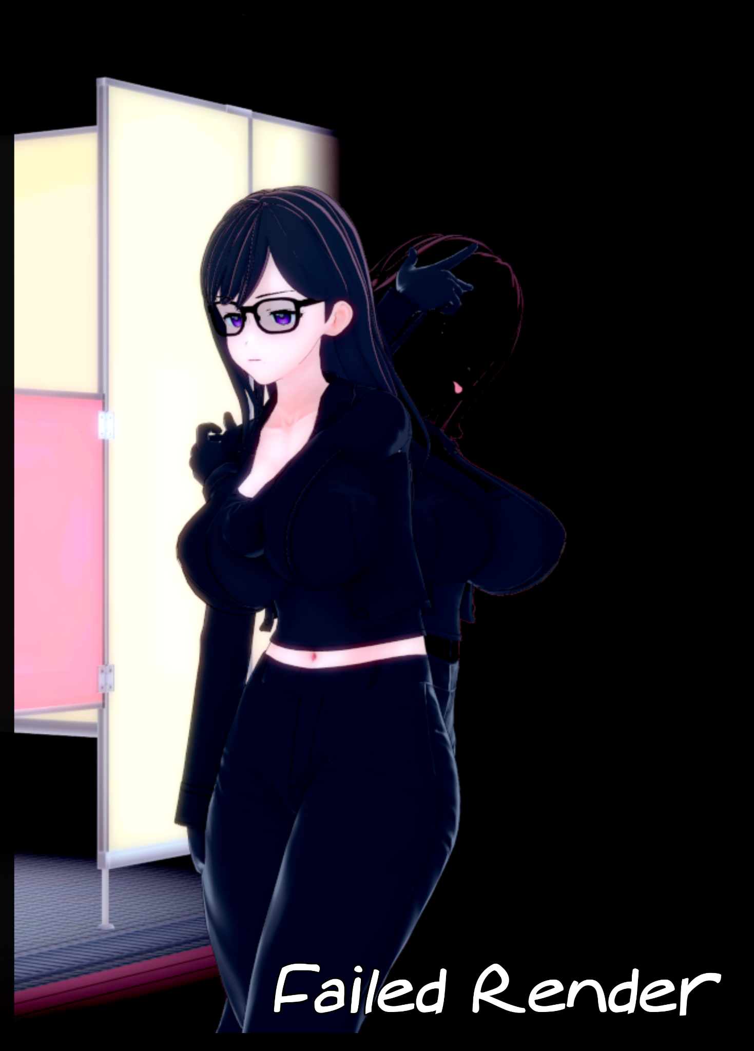

Hizuru Minakata, otherwise known as Ryuunosuke Nagumo by the well read within horror circles, had returned to Hitogashima Island in over ten years for reasons known only to a handful of individuals besides herself, heavily linked to the source material behind her singular best selling novel;

Shadows, otherworldly creatures that behaved and looked much like their namesake suggested, had the unique ability to copy the 'data' of a living being, equivalent to a camera taking a picture to form an almost perfect mimicry of the target with few weaknesses the untrained eye would never detect.

But beneath the human exterior, Shadows were still the same monsters they were before donning their disguise, meaning their former habits didn't just fade now that they had a mask to hide behind. For one, their true body was still the shadow cast by their dopple, which meant that if one were to put their foot down in it, the still silhouette would shift to avoid being stepped on, instantly giving themselves away to be cut down by anyone with a weapon and the skills to match against a regular Shadow in combat while coming out on top, a small handful of individuals that included Hizuru, who had already taken out a few clusters of the creature's on the infested island in a bid to save what little life she could from the malevolent creatures as they sought to kill and replace the people they had copied.

Today however, would not go to plan as the unsuspecting woman steps inside a public bathroom with caution. But simple human sense would not be enough to save her from what would come next as a black hand extending from the darkness cast by the grid patterned floor tiles catches Hizuru unawares, connecting to her shadow in an attempt to devour her outright rather than risk a prolonged encounter with the warrior woman as the raven haired woman clad in dour attire vanishes in an instant with an audible click that sounds like a distorted camera shutter. Leaving the bathroom empty…but only for a moment…

Because within the Shadow's depths, Hizuru had survived, landing on her front in a void of white with a dark space above for a skyline. Grunting with a click of the tongue as she attempts to crawl to her feet, only to be knocked back down to all fours as a spray of cold liquid stuns her, dousing Hizuru's skin in goop that quickly spreads over her sun kissed hide, dyeing it the same featureless black the Shadow's sported as she raises her hands in a futile effort to block the sinister geyser, worsening the transformation as she collapses on her hands with a splat and a bellowing cough, trying to blink with eyes that were no longer there while sealed nostrils struggle to funnel air through her lungs. Hinting at greater physical changes going on beneath the woman's brand new coat of latex skin.

But the elimination of her circulatory system was only just the beginning as Hizuru's broad hips begin to buckle and boil, gaining mass as her toned core sags outward into a plump navel below hanging balloons that had ripped free of her suit, exposing swollen nipples as her undershirt and bra are devoured by her own body, now composed of the invading Shadow slowly taking control over Hizuru's being, forcing her to submit as she continued to kneel, choking and moaning in a flat, robotic voice stripped of her original vocal tones and depth, just as her side swept bangs and long flowing mane of raven hair begin to grow wet, silk strands congealing into messy drabs of tentacle like extensions that barely resembles human hair, shrinking up over her now hypersexualized body into a short bob cut with a wavy tail.

Despite the trouble she was in however, the human refused to give in, even as the Shadow's tendrils seeped into her psyche, seeking to do what it had already done to her body; absorb and subjugate her will.

For all the bravado she put on however, Hizuru was just one human against the unknown. And as her defiant yells are cut short with an uncharacteristic giggly chuckle by a surprise attack from a dangling tentacle piercing her cranium. What little remained of the Shadow hunter was warped and devoured, including the data of her little brother that also served as the trump card she would resort to whenever she needed him to do the heavy lifting.

A pity he wasn't in control now to stop the inevitable…if he even could that is.

With the last of Hizuru Minakata and her deceased brother replaced by Shadow, another resonant pop sounds in the bathroom as a buxom woman, shaded entirely in an eerie darkness with no facial features besides a soft spoken maw, appears where the young author once stood, seemingly surprised by her own appearance as she does a once over in the mirror, running spectral hands over sensitive udders that were far larger than the G cups they once filled before brushing the warm regions between her legs, seemingly entranced by the puckered lips her non existent eyes could see as the Shadow cocks her head to the side in a mix of confusion and glee.

Normally, devouring a human would simply leave a mark on the floor, a mark that would take after their appearance akin to a nuclear shadow burned into whatever surface a victim had been vaporized in front of. But here, it had somehow fused with the dangerous human, taking everything about her as she lifted a plump leg high into the air, loving how flexible and strong she now felt compared to before.

But her self exploration would soon be interrupted by an audible growl coming from her empty belly, instantly filling her mind with the need to satisfy hunger with humans to devour whole, licking glossy lips with a crimson tongue as the tall woman phases through the floor, receding back into her shadow as it slinks out the public bathroom, looking for meat.

In this reality, the heroes that would ultimately put a stop to the true mastermind's plan for Hitogashima could never do so here. For the loss of Hizuru meant a powerful blow for their offensive capabilities while the Shadow's had themselves a powerful new ally wielding Hizuru's combat skills and experience against the humans she once sought to protect…

*THE END*