His Moms Salon  Inspired by a Captioned Image by Tiffany  By Maryanne Peters  Men are so stupid! I should know. I used to be one.  Patrick thought I was a rival for the affections of that slutty girl Susan. Well, I suppose I was. At least that is what I pretended. I just didn’t want him getting with that girl. I wanted him for myself.  But what hope does a gay guy have with a straight guy?  I knew that his Mom ran a salon. I used to walk past it every day and marvel at the beautiful women who would walk out. I was not just a closet queer, but a closet tranny queer too. I just hid it well. I charmed Susan away from him.  But what I wanted was Patrick to make love to me. How could I make that happen? All I had to do was to put the idea into his vacant head. | 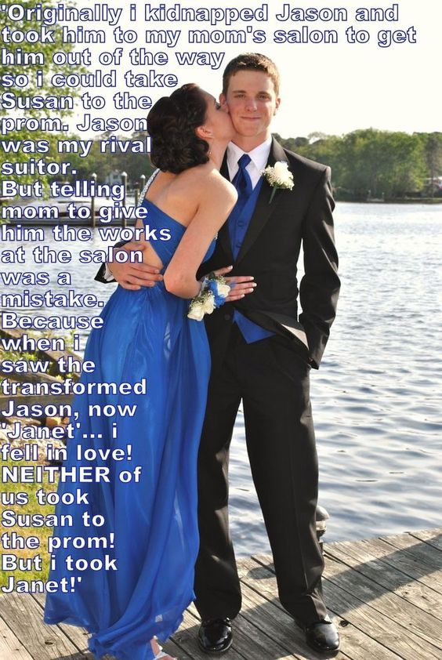

Have you heard the story of Br’er Rabbit and the briar patch? He pleaded with his captors - “Please do anything except throw me into that briar patch”. Because that was where Br’er Rabbit had an escape route. Those dumbasses threw him in the briar patch and he got away.

I had him believing that there would be no worse fate for me that to strip me of my masculinity. I would lose all confidence and cease to be manly. The way would be open for him to take my girl, if that was what he wanted.

But then when he saw me with my body all stripped and smooth and my hair done in a feminine style and makeup just accentuating the natural feminine beauty that was always there, he was speechless.

“What I am I going to do now Patrick?” I sobbed, in my girly voice. “I will never be a man again. This is what you have done to me. And now what? Will you abandon me to the world? What chance do I have looking like this? I am now your responsibility.”

“Hey, don’t worry. Nothing bad will happen. Why, you don’t even look like a guy. Just keep quiet about it. Pretend to be … Janet – that’s a good name. Forget about trying to be Jason.”

“So you will look after me?”

“Sure I guess so.”

“Will you take me to the prom then?”

“Well, the truth is that I think that you are prettier than Susan anyway. Sure, I will take you to the prom. Just so long as you stay Janet, I will be there for you.”

Now the prom is long over and I am still Janet. And he is still there with me.

The End

© Maryanne Peters 2022

Dave’s Dare
Inspired by a Captioned Image by Tiffany
By Maryanne Peters

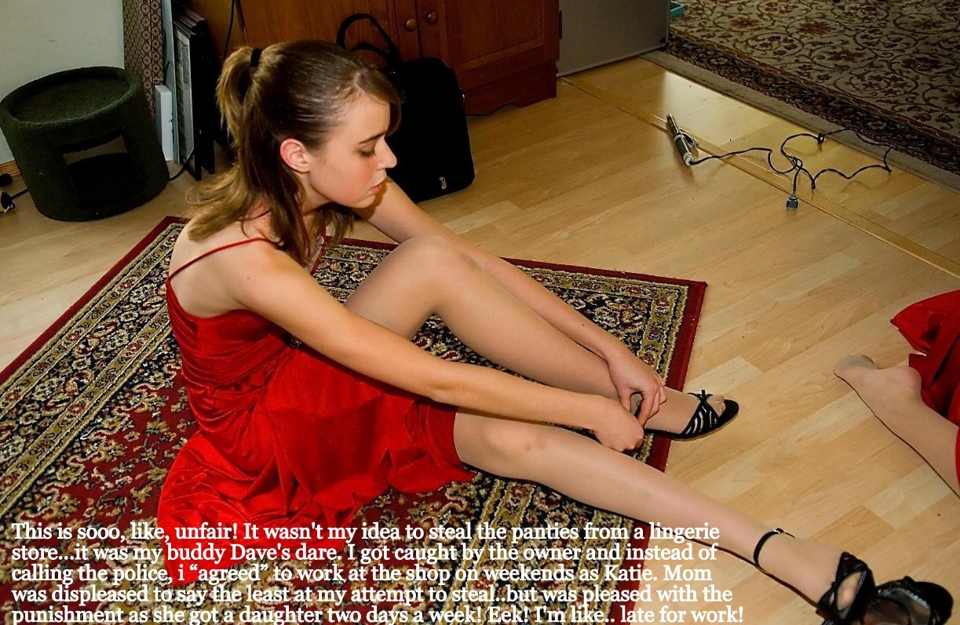

Mrs. Laurel ran the local lingerie store and was a friend of my Mom’s. She was always complaining that she could never get a student to work weekends at the store. She insisted that her staff be female and well presented, but she had discovered that young women these days are not interested in work – they want everything given to them.

“At least young men are ready to work to get what they want, but they would not be suitable,” she said. “Lingerie is a very personal product. I need a young girl.”

She had not met Kane. I had an idea that he might be the right person for the job and he was looking for work. In fact he was doing crazy things for money, like accepting dares to do stupid things. I lined up one for him, but I am slightly ashamed to admit it, it was rigged against him.

He was caught and he was in big trouble. But Mrs. Laurel came up with the idea that we had discussed.

“I need somebody to work on the weekends. I am happy to pay. But the person I need cannot be a young man. Since you seem to be so interested in ladies’ undergarments it appear that might be you?”

Kane could shake his head as much as he liked. I wish I had been there to see it. But it was dress as a girl of face the law, and he was not ready for that.

The fact is that I always knew that he would make a pretty girl. His long hair just needed to be washed and pulled off that feminine face of his, and all that was needed there was a touch of makeup.

He complained that he was not the person to help girls find underwear but Mrs. Laurel said that what he had tried to steal showed that he had taste, and as for his flat chest he was like many girls his age.

“Maybe you will fill out eventually,” she told him. She did, but not without some help.

But from then Mrs. Laurel had her shop assistant on the weekend, and because I was the only other person that knew and because I told “Katie” that I felt bad about the whole dare thing, I agreed to take her to work on Saturdays and Sundays, and bring her home too, although not always directly.

“This is your fault for coming up with that stupid dare,” he told me.

“Well, its your fault for picking it up, and its your fault for being caught.”

“Just don’t tell anybody about Katie and what we get up to together, pleeease Dave.”

It will be our little secret, Katie.

The End

© Maryanne Peters 2022

Unbelievable  Inspired by a Captioned Image by Tiffany  By Maryanne Peters  I think that it was the wig that did it. It was one of those lace front wigs that makes it look and feel like you have a full head of lustrous brown locks spilling over your shoulders. The wig was fitted early in the afternoon and just light makeup, so I had the whole afternoon to get used to having long lovely hair.  I also had the advantage of wide set eyes and she persuaded me that my eyebrows needed to be severely removed from the middle to be set above those eyes. I had the hair and the eyes and a small mouth and chin.  I had never thought of myself as being a boy with a girly face, but when the hair and the eyes removed the last trace of the boy, it was just like I became her. | 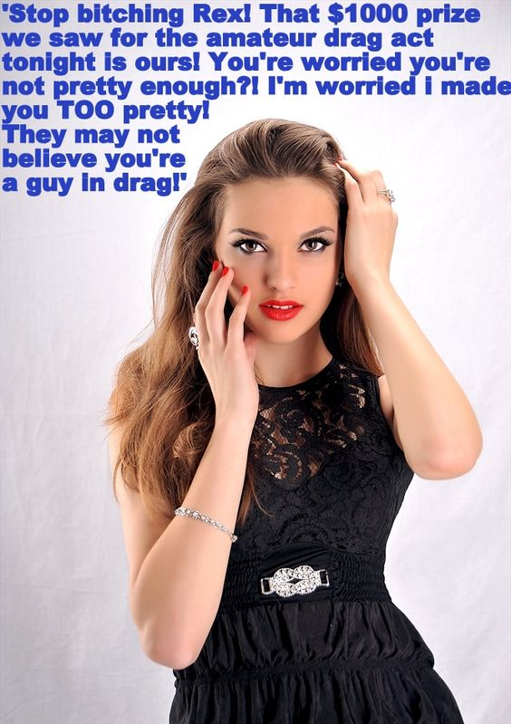

But it was mainly the hair. It looked so good that I wanted to show it off. I just put on a colorful blouse and went out in my jeans and trainers to start, but as I had already agreed t lose the hair on my legs and arms for the contest, I was persuaded to wear a dress.

But the hair was spectacular. I could shake it, pull it over my shoulder or lean my head back so it dangled down to my butt. I could part it in the middle, or one side or just drawn it back with my fingers. The wig was so firmly planted that it was like my own hair. I could toss it and flick it, and watch the effect that I was having.

Yes people were looking at me. Not just guys – I noticed them. They were the ones wondering who this pretty young stranger was, and looking at me with lust I could almost feel. Perhaps that should have unsettled me, but it didn’t. I was thinking –“Look and weep, you losers. What you see you can never have.”

But girls too. The envious ones with the thin or mousy hair, or hair short because that was practical. My hair was not meant to be that. It was meant to be beautiful. I was meant to be beautiful.

Before the contest I was confident I could do drag, but I was worried about being on the stage. Those reservations had gone. I now understood that a beautiful woman is always on the stage. She is there to be seen and admired – a star performer every day of her life.

So the drag show was a doddle. The only thing was that I was the only one where they insisted on a physical examination. They wanted to see my cock and my nuts. I was almost embarrassed to pull them out because they looked so ugly against all the beauty that was me.

I won the prize for the best amateur. It was $1,000.00 in cash plus I received an offer to join the troupe as a performer initially part time.

“But you will have to lay on the makeup a bit more,” I was told. “To be honest you look more like a woman than a drag performer.

There was one man in the audience who agreed. He sent up a message offering to help me with my transition, whatever that might be.

They pointed him out at the back. I smiled and tossed my hair into my face and little and then drew the curtain of hair away slowly. I swear it looked like the guy was having a heart attack.

I have to say it – I am not looking forward to taking this wig off. I could get used to looking the way I do.

The End

© Maryanne Peters 2022

Behave Like a Lady, Dad  Inspired by a Tiffany Captioned Image  By Maryanne Peters  It was a fantasy that I had always had. I always wanted to attend my prom as a girl. But things were not as liberal 20 years ago. Instead of choosing a life in skirts I chose to marry a woman and live as a man.  When my wife gave birth to our daughter, I suppose I saw the chance to live my feminine life through her. People told me that she looked like me, and I could see it. It seemed like she could be the woman that I could never be.  I suppose that I tried too hard and pushed my wife away. She never related to our girl the same way I did. That say that mothers have a stronger bond, but that was not true for or daughter Clemmie.  She would even seek my advice on fashion. I think that I always had a better eye than my wife. Even when I could not wear it, I followed all the looks. Clemmie could wear them for me. I could look at her and see myself dressed. It was a constant delight for me. I was living my true self through her. | 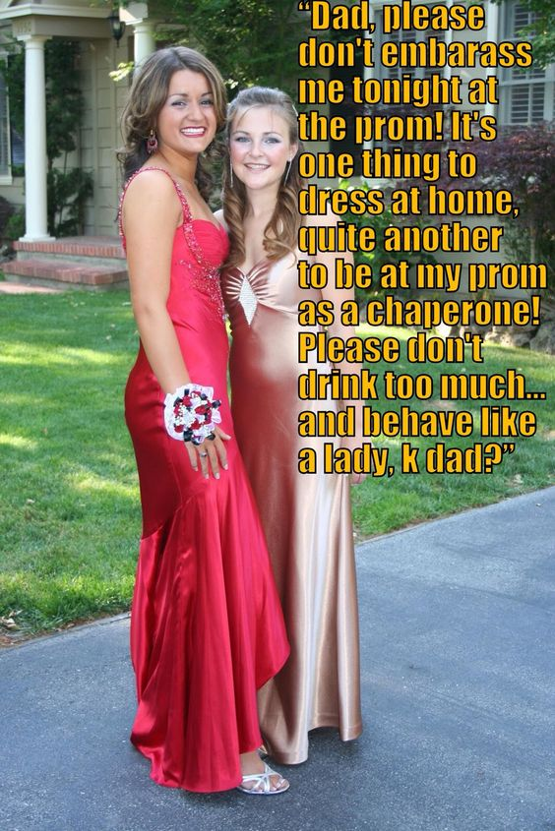

When my wife left with the pool guy, she basically walked away from both of us. For the first time I confided my innermost secret to Clemmie, and she encouraged me to dress at home. As she went through high school our relationship because about as close as any parent child relationship could be. She still accepted my advice, but she was also able to advise me as I ventured out upon my journey into womanhood.

She encouraged me to grow my hair, and then she wanted to share puberty with me through hormones. She had her own friends, but at home she and I were even closer friends.

I still resisted coming out at work, even though it meant hiding my shape and making my long hair look masculine through the day. For me becoming my true self was something that I did at home, with my wonderful daughter Clemmie.

“You are going to have to step out into the world one day, Mom”. That was what she called me. That is who I was now, at least at our place. “I will be graduating high school soon and steeping out into the world myself. You need to do the same – you need to come with me.

The prom. It was something that I had dreamed about as a boy dreaming of becoming a girl. It was a crazy idea but it seemed like the opportunity to take a turn in my life just as my daughter was ready to. We started to plan things together. She spoke to the school about it.

“My Mom never went to a prom, and can she go with me?”

“We need chaperones so of course,” was the response.

We bought gowns and shoes, and before the prom I took some days off and did the works, culminating in having our hair, makeup and nails done on the day. And of course, the compulsory pre-prom photos. The corsage was supplied by Clemmie – she is so thoughtful.

It turned in to the best day of my life, at least until that point. I was a proud parent and a proud woman and I was just happy to be there among the young people watching them have fun. Of course the kids had there hook ups and Clemmie introduced me to her nice young man. Of course I never imagined that I would “hook up” but it turned out that I was wrong.

Clemmie had warned me not to get too drunk. The fact is that I had not drunk in volume for years simply because I had no social life. But there was a bar for the adults, and the punch had something in it, and my inhibitions sort of fell away in the festive atmosphere.

Bryan was one of the parents, a widower also with a daughter at the prom. We got to talking and I may have behaved a little suggestively. It was just that it was really my first outing as a woman and I felt so sexy and womanly that I just had to project it. Clemmie had warned me – “don’t just behave like a woman, behave like a lady”. I had to pull myself together, and I did.

It is just that when you come on to a guy and then suddenly become restrained, you drive him crazy with desire. Brian came on so hot and heavy before I knew it we were out the backing kissing and groping like teenagers.

Sorry Honey, I guess I have let you down a bit, but it seems that we have both graduated. I am officially a woman now, and from now out I won’t be anything else.

The End

© Maryanne Peters 2022

Neighbor  Inspired by a Captioned Image by Tiffany  By Maryanne Peters  I knew all about Bill almost from the moment he moved in next door. He introduced himself as just a guy living alone, but his clothesline was full of women’s underwear. I remarked about it over the back fence but said that I was cool with a guy’s fetish.  “I do drag,” he said. “I could never be a convincing woman - I mean, look at me! Somebody small and slim like you might get away with it, but not me. I just squeeze into an outrageous frock every week or so, and otherwise just wear the underwear under my work clothes.  I was accepting of it, and the truth is that Bill was a great guy. He was the kind of neighbor who was there for you but not constantly in your face. Somebody you could count on to lend you a hand or loan you a tool, but not to walk in unannounced and unwelcome. | 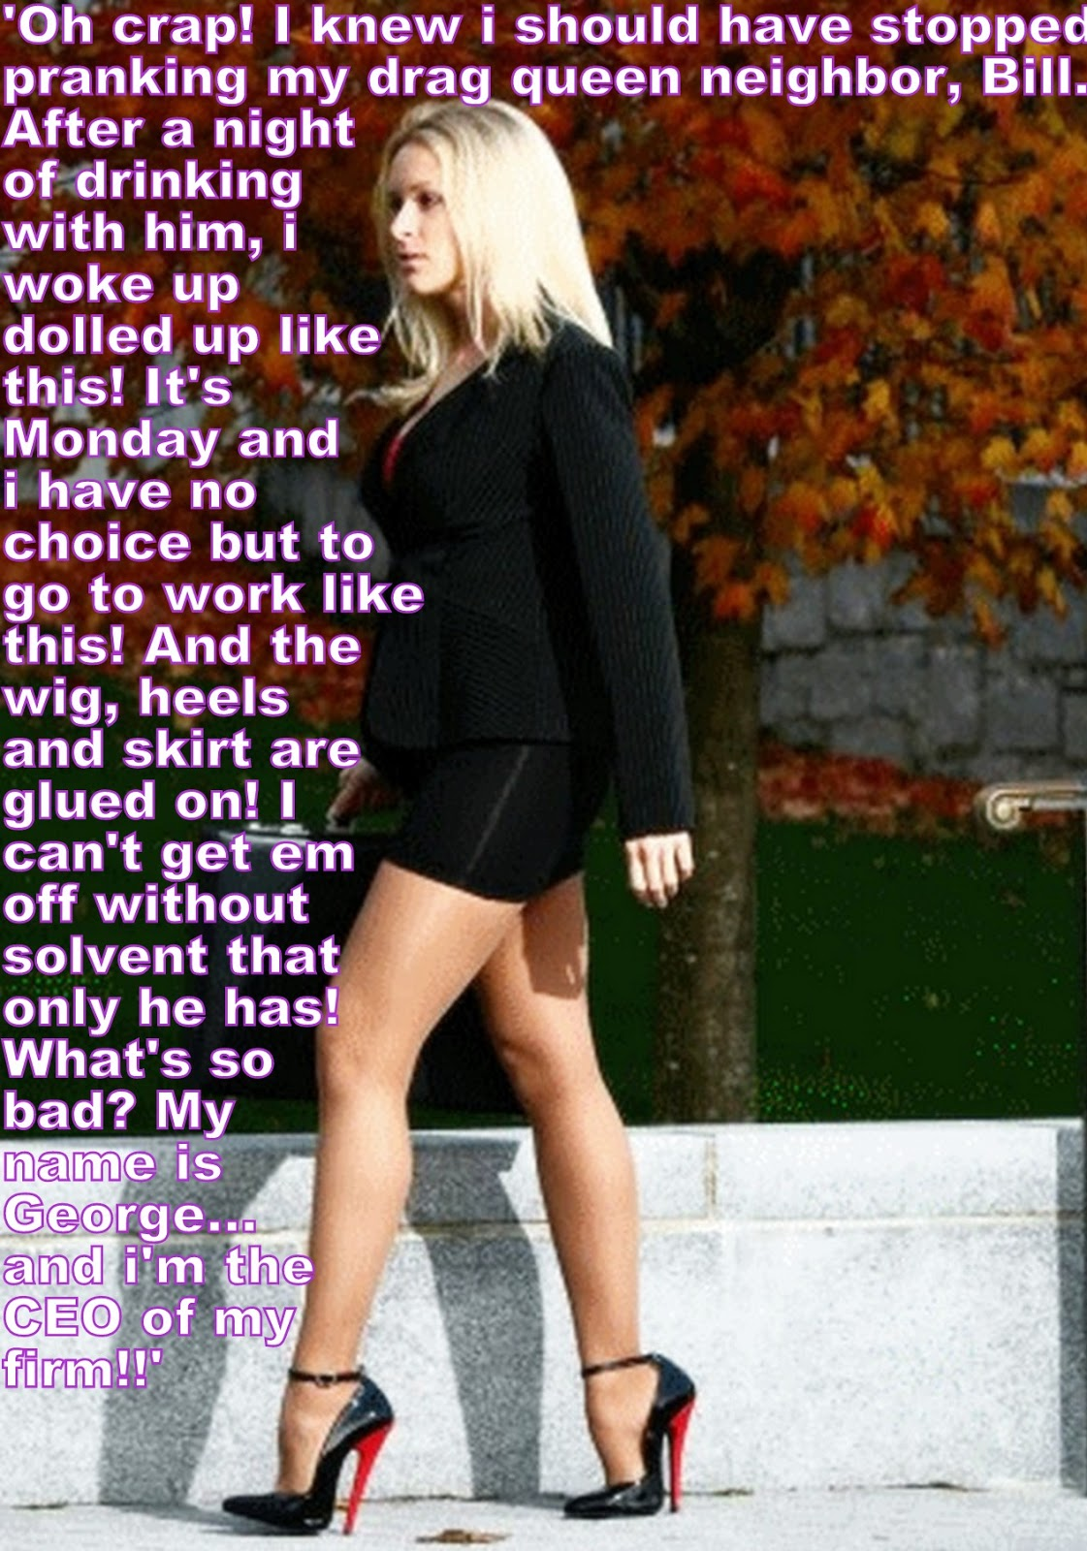

We got having a fairly regular get together on a Sunday, at my place or his. Sometimes things went a little too far and we drank a little too much. I have to admit that one Sunday I got Bill very drunk and he ended up getting into serious trouble at work the morning after. In fact it happened twice. I suppose that I deserved a bit of payback, but I was not expecting what I got.

Anyway, like I said Bill had always said that he could never pass as a woman but I could, so I guess he nursed some idea that it would be fun to see me dressed as a woman. He may have even suggested it but I always refused.

“Definitely no. You’re the weirdo in this neighbourhood,” I joked. He knew I was joking. We were pals. Despite his underwear and his regular pastime, we were friends.

Anyway, we were at his place and I got drunk. I was never worried about what might happen to me at work. It is my company, so I can turn up late if I overdo things. But in this case I swear he put something in my drink. How else could he have done what he did? I mean, not just gluing me into everything, but plucking my eyebrows and waxing my legs.

The blonde wig was glued on so solidly around all the edges that if I had tried any harder to pull it off I would have torn the flesh away. Same with the latex breasts and those ridiculous shoes. And there were latex panties too – something in the form of a woman’s crotch with my dick point down next to my asshole. Would you risk tearing that away?

Sure I could have cut off the clothes or worn a coat over the top, but then totter on down to the office in those shoes?

Or stay home and try all the solvents that he said in his note would never work? Or go to hospital and say – “Hey, my friend glued me in to this outfit – can you get me out of it before my meeting?”

Yes, he left a note. I came to sitting up in his massage chair dressed exactly as the photo shows. So the obvious answer is to call the office and say that I will be off sick for a few days. I could wait for Bill to turn up and say – “Okay Buddy, you got me. Now get the solvent in here and free me from this.”

But I had a meeting. It was a new customer – perhaps the most important customer the company had ever had. I had to turn up, and I could not turn up looking like this.

I stared in the mirror as if to confirm how ridiculous I must look. And I kept staring. It dawned on me that Bill was right. I did not look ridiculous – I looked gorgeous. I did not look like a guy at all. I looked like a beautiful woman.

I called the office and said that I was sending somebody else to meet the customer – a my new customer relations manager, Georgette. The office was in disbelief. I was regarded as a control freak unable to delegate, and now the most important deal going was to be passed on to a woman?

It was not like I had a choice. The meeting had to go ahead, and I had to close the deal. Nobody else could do it.

How I managed to walk around in those heels I will never know. How I managed to keep my cool down and my voice up are other mysteries, but I felt confident enough to walk in there and do what I had to do.

The complication is that the customer is probably the best looking man I have ever shaken hands with and he thinks Georgette is the best looking woman he has ever done business with.

“You’ve got the business,” he said. “Provided that I deal only with you, and hopefully every day.”

Bill! What have you done?

The End

© Maryanne Peters 2022

