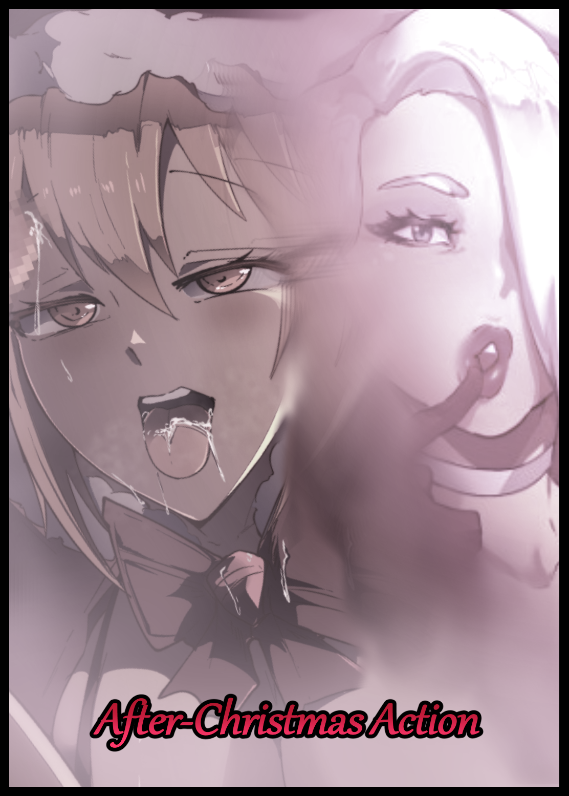

**“Goddamnit…how friggin’ cold can it even get around here? Stupid blizzard…just gotta come blowing in and mess up all my plans…”**

Muttering and cursing away under her breath while cocooned under a warm blanket, a young woman fusses to no one in particular. Sheltered from the brutal snowstorm battering the outside world, one of the most severe storms in the recent decade that didn't look like it was about to end anytime soon despite raging on for a few days now, keeping unfortunate folk like the sulking brunette locked down tight.

And being stuck at home during the winter was a downer, especially when it meant she would never get the chance to celebrate Christmas with any of her friends or family, forced to wait it out with a dullard of a boyfriend she was inching ever closer towards breaking up with the more time she spent with him…

Born with a fiery disposition and a wanderlust for new experiences like no other, ***Serena*** was what most people would consider to be a tomboy. Carrying that enthusiasm in her heart until she couldn't feel it anymore once the time came for enrollment in higher studies, around the same time she'd met the dwindling flame she used to be infatuated with, a bright eyed youngster going by the name of ***Chris*** who had since become a stubble sporting, lazy eyed wage earner slaving away in some stuffy office space downtown while Serena made do with a nice paying job as a reputable graphic designer, a precarious job threatened by half-assed artificial intelligence programmes that could do what she did in less than half the time.

So to be slapped in the face so soon after with a terrible blizzard predicted to ravage the nation until the next week or so…to say Serena was in a foul mood would be an understatement. It was bad enough that she couldn't go out but to be stuck at home with someone who preferred sleeping the days away instead of doing *something* to celebrate Christmas…it only served to reinforce the dour mood she felt yesterday when her celebrations were basically dumbed down to sending messages and well greetings before popping a bottle of expensive liquor and downing it overnight…hence why she had woken up late into the next day right by the fireplace, splayed out cold over the couch with a terrible hangover and a dreadful chill she was lucky to have woken up in time to alleviate before things got bad.

*'Then again…freezing to death inside my home might not be so bad of an idea after all…it's all downhill from here anyways…'*

Groaning in frustration again upon the reminder of her earthly woes, Serena wiggles over like a big, woolen caterpillar, flopping over onto her side to gaze at something else besides the ceiling in an attempt to take her mind off of things, finally settling on the mock Christmas tree nearby, beneath which laid a whole bunch of empty presents to be discarded after the damned storm would finally decide to come to an end.

Red irises locked on to the scarlet painted faux boxes and their ivory wrappings laid out all over the base of the tree as thoughts of hypothetical children running around on Christmas, excited and hysterical to open their presents filled Serena's mind. Would this insufferable winter have been any better if she had her own children to spend it with? Some of her oldest friends were already happily married and laden with a child or two, so maybe it wasn't the fact that Chris had lost his drive but…maybe she'd missed her chance with him in the first place after spending so much time meandering about with no progress in their relationship…

Thinking about it only made the migraine from her binge drinking return stronger than ever, eliciting an annoyed click of the tongue from the young woman as she huddles up even tighter than before, furrowing her brow into a deep frown while a breath of condensed air spews forth from tightly pursed lips in the form of a brief cloud that fades just as fast as it appears, giving Serena's haggard eyes something to follow after…and something *new* to look at as her teary eyed vision focuses on something in the background that she could almost swear wasn't there before.

**"Is that…a *Santa hat*? Huh…that wasn't sitting there before…"**

Forcing herself up into a seated position after some minor difficulty with alcohol induced dizziness, Serena, clad in her custom made cocoon, hobbles over toward the deflated looking thing lying forgotten on the shelf above the fireplace, examining the velvety material that made up the hat with intrigue and wonder in her eyes.

By all accounts, it was just an ordinary piece of Christmas apparel. But the hat…or rather the fabric that composed it, seemed to exude warmth as if it were a living entity with its own bodily processes that gave it the ability to produce its own heat to stay warm. But that wasn’t all it did, for the simple act of holding it seemed to put Serena at ease, finding her nerves soothed and the racking pain in her head eased till it was a barely noticeable throb. At first, she seemed convinced that she had just been imagining things, expecting her ailments to return at any moment.

But they hadn't, and as she began to move, Serena realized she wasn't hobbling anymore, walking perfectly fine and stable on her own two feet as if she hadn't been thoroughly soaked in alcohol the night before with only trace amounts of lethargy leftover to remind her of that fact. Leaving the flabbergasted woman in awe as she scurries back over to her original position on the couch, sitting back down before examining the innocuous hat.

No matter what she did or how she flipped the thing, the hat was…just a hat…one with the supposed powers of healing it would seem.

**"But…there's just no way right…the hangover's gone just by holding this thing…what if…"**

Deciding to test the waters to see if she was just freaking out and her drinking induced problems had simply receded right at the same moment her hands had grabbed the hat, Serena holds the crumpled hat at arms length away from her like a rancid sock before letting her grip loosen, releasing one finger at a time until all that remained to secure the Santa hat were her index finger and thumb…but still she felt no different.

**"Thought so…really should find something to do if I'm thinking this is some magica*-agh!*"**

Until the last of the smooth red fabric leaves her hand, causing Serena to croak as her prim posture immediately crumples in on itself in tune to the falling hat once all the energy in her rejuvenated form vanishes in less than a second, leaving the brunette a sickly mess as freezing chills, joint aches and a sickening need to hurl assaults her body, almost as if the brief moment of respite brought to her by the hat had been reversed into a negative force all at once upon its removal from her person, making her feel the consequences of straining herself when she should be lying down after being led to believe she'd found an easy way out.

Slamming her hand over the crumpled hat by her side, Serena sucks in a breath before panting as if she had just returned from a run around the neighborhood, savoring the cool air circulating in her lungs after she felt like she could've choked to death after her lungs had decided to tighten themselves into a narrow passage far too small for air to pass through, glancing nervously over at the hat whose power she no longer doubted after realizing what it's unnatural property really was.

It hadn't healed her at all, not curing her body of its ailments but rather, stalling them for as long as it remained bound to the subject's body. Suspending them in some unique form of selective stasis, where upon its removal, all the accumulated effects would immediately surge back into the victim's body…and that sounded terrifying to Serena as she clenches the hat in her hand, unwilling to let go after experiencing that brief moment of excruciating pain at the hands of what should've been a simple hangover…multiplied by a number she didn't want to know.

No matter how many times she blinked or pinched herself with her spare hand in an effort to convince herself that this must've been some lucid hallucination wrought about by her depressed and alcohol soaked brain, the hat remained in her hand, so did it's unnatural warmth and soothing make, only serving to instill fear and discomfort instead of its intended effect as her mind drifts back toward the consequences of depriving herself of those unwanted sensations.

**"B-But if that's what it feels like after a few seconds…oh no…"**

Wondering what to do next after realizing the gravity of the situation she had put herself in, Serena returns to the spot where she had found the magical hat, looking all over for something she might've missed, anything to try and remove the hat clenched in sweaty palms without the repercussions. She could've tried to outlast that brief surge of pain, but now that she was frantically searching the living room up and down, it was like a silent commitment to stick to the hand she'd been given, too afraid to put the hat down and endure after being greeted with the consequences of doing so, fearing for her life.

But besides the hat, nothing foreign could be found with everything else being where Serena had remembered them to be the previous day. Stuck with a festive headwear whose blessing now threatened to be her end if she wasn't careful. Serena had heard horror stories of people's lives being cut short just because of an immense feeling of pain or discomfort being too much for their bodies to handle…and if she continued past an hour with this thing, there was no doubt in her mind that fate would soon be her own…

Over the next few minutes, Serena would busy herself by looking up her problem online. A laughable path to follow seeing as how she, like everyone else in the world, hadn't thought something like this to be real, coming up short when her queries only brought up useless discussions on random geek forums and stupid fashion tips listed by clickbait sites…nothing related to a pain preventing hat that threatened to blast it's wearer with all that accumulated woe if they ever took it off for even a second…a thought that had a lightbulb going off inside of Serena's panic stricken mind as she brings the hat up to face height.

**"Wearer…*Wearing*! it's a hat…so what if I did just that? Put this thing on?"**

Reaching up and over her head with extra care taken not to snag the fluffy band of the Santa hat's rim over her low hanging ponytail, Serena takes a moment to adjust the thing before slotting it into place, making for quite a satisfying fit overall before she lifts her hands away, freeing them from the duty of having to constantly hold on to it now that it was secured atop her head. But keeping it on her head to relieve her hands wasn't the main purpose for this venture, it was to see if, by removing it now that it sat in its rightful place, the effects would in turn be placated. An incredulous possibility gleaned from her youth reading adventure novels and watching one too many treasure hunting flicks where complicated puzzles turned out to have the simplest solutions…and in this case, she could only guess that the unusual hat that had mysteriously appeared to her on this snowy evening wanted to return to its rightful place…

A wild try, a swing in the dark essentially. But Serena was at her wits end. With nothing to go on and no one who could help her without admitting her to a mental hospital, she could only count on herself to do what was needed if she wanted to get out of the hole she had inadvertently thrown herself into…and whether she survived to tell the tale of otherwise, the frustrated woman vowed to track down whoever it was that had placed the hat there in the first place…some sort of sick joke they had for a Christmas gift no doubt!

*'Oh god I hope this doesn't go wrong…alright then…calm down…deep breaths…here…goes…nothing!'*

After a dramatic moment spent conducting breathing exercises, Serena finally musters up the courage to throw her head forward, bracing herself for a possible wave of excruciating pain to assault her once the thing came flying off…but there was nothing, no stinging in her joints, no overwhelming lethargy, no organic fire to burn her alive from the inside…just the tremble of her body as unsupported flesh jiggles to her sudden movement alongside the mild cinching of tight clothes. Had she successfully freed herself?

Opening her eyes in mild excitement, Serena's heart falls in her chest upon realizing the hat wasn't anywhere to be seen on the floor in front of her, turning around in the hopes that maybe it had flown off from the momentum of her headbang and gotten stuck somewhere. Unnatural warmth keeps the tickle of cold air against her unusually exposed body from being noticed…

**"Strange…why does everything feel so…*open* all of a…sudden…"**

But in that brief moment as Serena turns on her heel, a hefty sway from her bosom directs her eyes downward, glimpsing the unusual sight of pale skin around her petite chest, dark red areola free for all to see, tipped with nipples that had grown hard in the cold, barely hidden away by the twin straps of a v-shaped thong bikini showing clear beneath the fluttery folds of an inadequate top that only concealed her smooth, rounded shoulders. Taking the place of the singlet spattered with bits of liquor and sweat she had gone to bed with last night, doing little to cover the rest of her up resulting in a gratuitous showing of her body, growing aware of the little red rectangle that was all the cover afforded to her loins, tingling between legs that, just like her top, were left equally exposed after her pants had been replaced by crimson stockings, finished off with a fluffy white cotton hem to complete the offensively lewd Santa outfit she had suddenly been adorned in after putting on the hat…a hat Serena could no longer remove from her body as it stubbornly resists the gloved hands trying to dislodge it by force to no avail.

**"W-What in the hell?! Stupid hat! Give my clothes back you perverted piece of shit!"**

With suspense and mild fear replaced by panic and righteous rage, Serena's quiet voice rises to a hollering scream, muffled to her neighbors ears by the ongoing storm but heard loud and clear by the one other individual living in the home with her that had, until now, gone unnoticed. Roused from his slumber with a jolt, looking around in a dark room in confusion to what sounded like a scuffle as his Serena's boyfriend picks up on her vulgar rant, all while her bombastic attempts to remove the hat created a ruckus that made it sound like she was fighting off a home invader…enough of a concern for the lax man to draw his trusty firearm from the nightstand next to him before quickly speeding off downstair, being careful to stick to the walls for cover, descending unnoticed as he bursts into the living room, pistol drawn, finger on the trigger.

**"D-Drop your…! Wait…S-Serena? What's with that…oh lord…"**

**"C-Chris?! No! D-Don't look! It's just a…a misunderstanding!"**

Escalating the situation with the sudden arrival of her boyfriend with a gun dangerously aimed right at her. Serena scurries away, trying to hide herself from Chris' wide eyes as his hand falls to the side, finger out of the trigger guard, his mind blanked out by the sight of his girlfriend wearing such a *daring* getup, failing to find a hiding spot as she comes to a stop in the middle of the living room, doing her best to cover up her nubile body with her hands as if to avert Chris' eyes, keen ones she could feel burning a hole into her mind as they ogled her like a juicy slab of meat.

Beneath her notice however, Chris' attention was not unwarranted for the spontaneous outfit change wasn't all the hat had in mind for the panicking woman as her body itself starts to change once flesh bubbles while fat roils beneath matte smooth skin starting to take on a glimmering sheen as an outbreak of sweat brought about by another release of mind numbing heat silences Serena's stammered protests and excuses, falling silent while her breathing starts to become erratic, panting with a notable increase in wavering spouts of steam caused by her internal temperatures rising to a peak thanks to the rapid biological changes occurring out of sight…and out of mind…

The moment the fragile couple's eyes had met, something like a spell seemed to have gripped ahold of their minds, compelling Chris to walk forward with a slow, lumbering gait, no longer concerned with any possible intruders as a limp hand drops the gun on the couch as he passes it by on the way to his lewd girlfriend all dolled up for an overdue Christmas celebration while Serena in turn could not find the composure nor willpower to form a single word, chattering teeth being the only sounds she made while her wavering vision drifts from Chris' steel blue eyes down to the rapidly engorged tent pitching itself in his pants. The sight of which causes Serena to shiver as her untouched flower spasms in response, sending an electric pulse right to her brain and the depths of her teats, spurring their growth as unconscious jaws move to bite her lower lip to stifle an airy moan from leaking out of her mouth once her breasts, spurred by that signal, start to swell and sag forward with a healthy heft, steadily pushing past the B cup range as the thongs hiding them from view slip free, giving her erect nipples a good rub as they come loose.

She had never felt this way before, just as much of a stranger to the pleasures of the flesh as Chris was. At the back of her mind, she knew that the hat was responsible for all this. But yet, the only thing on her mind was the sheer embarrassment of being stared at so hard by the man she had once lambasted as being a terrible boyfriend by her standards. She wanted to tell him to snap out of it and to help her get that stupid thing off her head…but she was also starting to *love* the way Chris' unmoving gaze never once left her body, as if a desire had been seeded inside her brain, a wanton lust to focus entirely on her, and her alone.

*'O-Oh…god…he's getting so hard…so…****big****…because of me?'*

Before she knew it, her boyfriend was now directly in front of her, towering over her by just a marginal difference, the two of them looking like zombies as they took a second or two looking at each other with heated expressions of undeniable lust, their virile bodies longing for the other's touch with Chris' pecker at full mast while Serena's swollen breasts, surpassing the C cup range now, rubbed against his chest, not stopping their bountiful growth anytime soon like the rest of her body as far surges across her lithe form, bestowing her with abundant curves and thick, undulating layers of blubbery fat, making the twenty something year old woman look like a motherly waif instead as her once trained legs become chunky drumsticks especially plump around the thighs. Between which lies a growing fountain of transparent fluids as her puckered vagina starts to overflow with her desire to be filled. A hunger that would be answered as Chris gently directs her to kneel with a hand on her shoulder, leaving Serena face to face with his straining erection, nostrils flaring beneath a cute button nose as they savored the scent of raw manhood wafting into them, further stimulating Serena's already overwhelmed brain while the formerly lean lips of her mouth bloat into fat, kissable cushions that couldn't quite close properly.

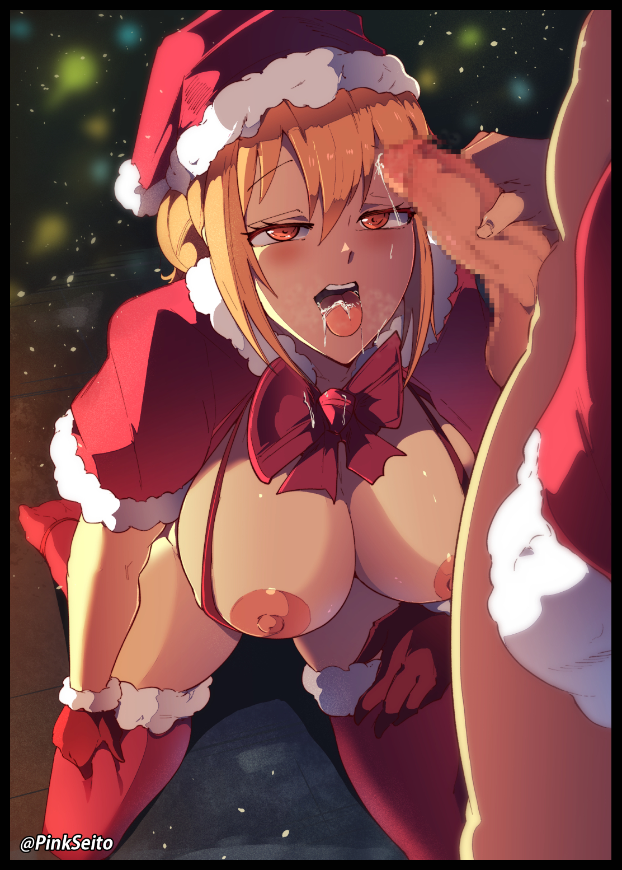

Serena could not muster the strength to resist now that her body was gripped in the firm embrace of animalistic estrus. Her snatch was so wet, aching to feel the girth of Chris' dick until it struck the entrance to her stimulated incubator. Her mouth felt so dry, yearning for that delicious essence inside said pecker to quench that thirst. Her needy body, dying for the touch of a man as sensitive skin pricked and tingled with electric lust.

It all served to override any sense, any rational line of thought. No longer able to focus on the accursed hat that had started this mess once the same force that had touched her reaches out to claim Chris, stripping him of all his clothes and replacing his t-shirt with an open sweater that matched her own, leaving the matching couple to adore the other's features before the real deal could begin, starting off with an experimental lick from Serena's curious mouth, giving Chris' salty rod a taste before unflinchingly lurching her neck forward, gagging with a sensual groan as her first taste of cock ends with a surprising deepthroat from a newbie to the arts of sex, unable to stop herself from enjoying the gleeful bliss of feeling her boyfriend's throbbing sausage fill up every inch of her oral cavity before knocking against the back of her throat, igniting an azure glow from somewhere deep inside her eyes once her boyfriend grabs her head, picking up the pace as he begins to piston in and out of her mouth, forcing the most titillating noises in existence out of Serena as her arms resist what little will she had left to protest, resting on her thighs as she obediently kneels before Chris, allowing him to use her mouth like a cocksleeve all while her body continues to grow and expand with each cycle ending with a choking "Gluck!" from Serena and a hefty bounce from her chest as it ignores common sense in its relentless growth, overshadowing a motherly tummy that looked like it had already hosted children many times before despite her virgin flower, looking much more inviting than it had been before as the slanting slope just below a jutting belly leads down to impossibly plump labia lips, framing frayed folds of velvet all while even more drastic changes soon begin, interrupted by a stifled scream as Serena's head twitches, jerking back and forth while her slender neck bulges in erotic fashion, accompanied by the meaty sounds of thick liquid flowing down her throat, shoved along by muscle as *Ugh's* and *Glug's* made known the mind numbing pleasure she felt from the process of Chris emptying a satisfactory load of cum into her belly, rolling vapid eyes into the back of her head while a now pale blonde head of hair begins to tumble down the front and sides of her face…

*‘Oh my gosh…that…that felt…so good…cum…****Chris’ cum****…I could..definitely go for seconds~’*

A face that was starting to look as old as the rest of her body now looked once creases around her lips set in alongside noticeable bags around foxy looking eyes that had lost their innocent roundness. A change that didn't seem to startle Serena, whose mind was too intoxicated by lust and the reinvigorated adoration she now felt for the man in front of her to care as she takes his hand, allowing herself to be led up towards their bedroom with a trickle of spunk still sliding down posh lips, all while her outfit begins to change to accomodate for the added mass of her now rotund body, standing a good head or so higher than Chris by the time they reach their destination.

With a tight leather choker snapping itself around her neck, matching earrings fashioned in the shape of snowflakes jingling under both ears and the outer coat fusing with her gloves alongside a thinning of the scandalous thong bikini now coming in a shade of neon grin and a mocking bowtie attached right at the tip of her clitoris, Serena now looked like a bona fide cougar getting ready to bed a younger man she had found off the street if one was ignorant to their relationship. Although with the aid of the still active spell, neither seemed bothered by this change.

Even though Serena and Chris were somewhat aware of what was happening, the euphoric bliss of making out for the first time in a long time since they started dating was enough to override their concerns. Chris certainly couldn't complain about his girlfriend's former appearance but he hadn't felt confident in the spark between them, thinking of himself as an inferior partner after she seemed to lose interest in him…that is, until he had caught sight of her dressed so scantily in the living room earlier. Common sense would've made him rush over with a blanket or demand she put something on, but something about her getup had him silenced, following the instinct of his calling to ravish the maiden before his very eyes, afraid all the time that she would shun him if he did so…instead, she had acquiesced, proceeding to give him his very first and most enjoyable blowjob ever. It was like putting his dick inside of a cloud…if there even was a fitting way to describe such an experience.

As for Serena, she no longer wanted to fight back against whatever it was the hat had done to her. She had been initially repulsed, disgusted by the wanton thoughts entering her brain as the auto pilot directed her to kneel…but once she had her boyfriend's dick inside of her mouth, it was like a neural link had been established. Allowing Serena to understand why Chris hadn't been so active in their relationship all this time while fighting back the enhanced stimuli of providing for his unused pecker. She could feel the worry he felt for her after overhearing her depressive rant about the threat of losing her job. She felt his self loathing everytime he caught sight of her sulking behind his back…and most importantly, she could still feel his love for her, stronger all the more for it despite her dwindling affection for him…and it had made her tear up then and there, masked by the climactic explosion of sour cream that filled her mouth right as the realization hit her.

And as dirty blonde silk transitions into flowing trails of platinum silver to frame the motherly face of a grown woman dressed to impress her lover for a holiday that had recently come and gone with a getup that made her look like Santa Claus’ missus. Serena was more than ready to make up for her misunderstanding as Chris' strong arms easily hoist her into bed with him, presenting herself without shame despite the increased age gap between them, leaving the formerly matched couple looking like a married mother well past her prime looking for love in the arms of a younger stud…almost as if her misplaced grievances had been given form in the shape of an elderly figure that had moved on, just like she was about ready to do so if nothing had been done…something she now aimed to rectify as the magical hat's influence over the two of them finally loosen, allowing for Serena and Chris to do as they desired, with the latter immediately trying to stop things from going any further, meeting his girlfriend’s now matching eyes in shame.

**“O-Oh god, I-I’m so sorry Serena, We need to get you help. I didn’t know what ca-*mph!*”**

**"Hush dear…I know how hard you’ve been working to try and keep our relationship going…the feelings you just couldn’t put into words…and I’ve been a bad girl too…so…let’s both take things seriously from here on out alright? And besides…ugh…”**

Pushing away from Chris, Serena sidles up over the headrest, presenting her virile body with the occasional grunt from the stimuli of having her privates rubbed by the sheets and the shameless ‘equipment’ she had on alongside the weariness of her aching joints thanks to the added years weighing her down, all while her boyfriend would watch in stunned silence as the silver haired MILF prepares herself for his own enjoyment before parting her legs, revealing an untainted snatch with pulsing folds yearning to feel the touch of his rejuvenated rod just like he had done to fill her mouth minutes earlier, swallowing his doubts as he moves forward, running hands along her sturdy thighs and cushioned hips before coming to rest directly in front of her, close enough for Serena to feel the tip of her boyfriend’s pecker kiss her pussy, giggling in a way she never could have thought possible for herself as she in turn, reaches out to poke at his beer belly.

**“Looks like someone hasn’t been working out at all hm? This might just be a blessing in disguise to help you work off some of that weight!”**

**“Heh…speak for yourself…but…what if…what if you’re stuck like that Serena?”**

**“Hush dear…we’ll worry about that if and when it comes to it…so hurry up…and stick it in me already~”**

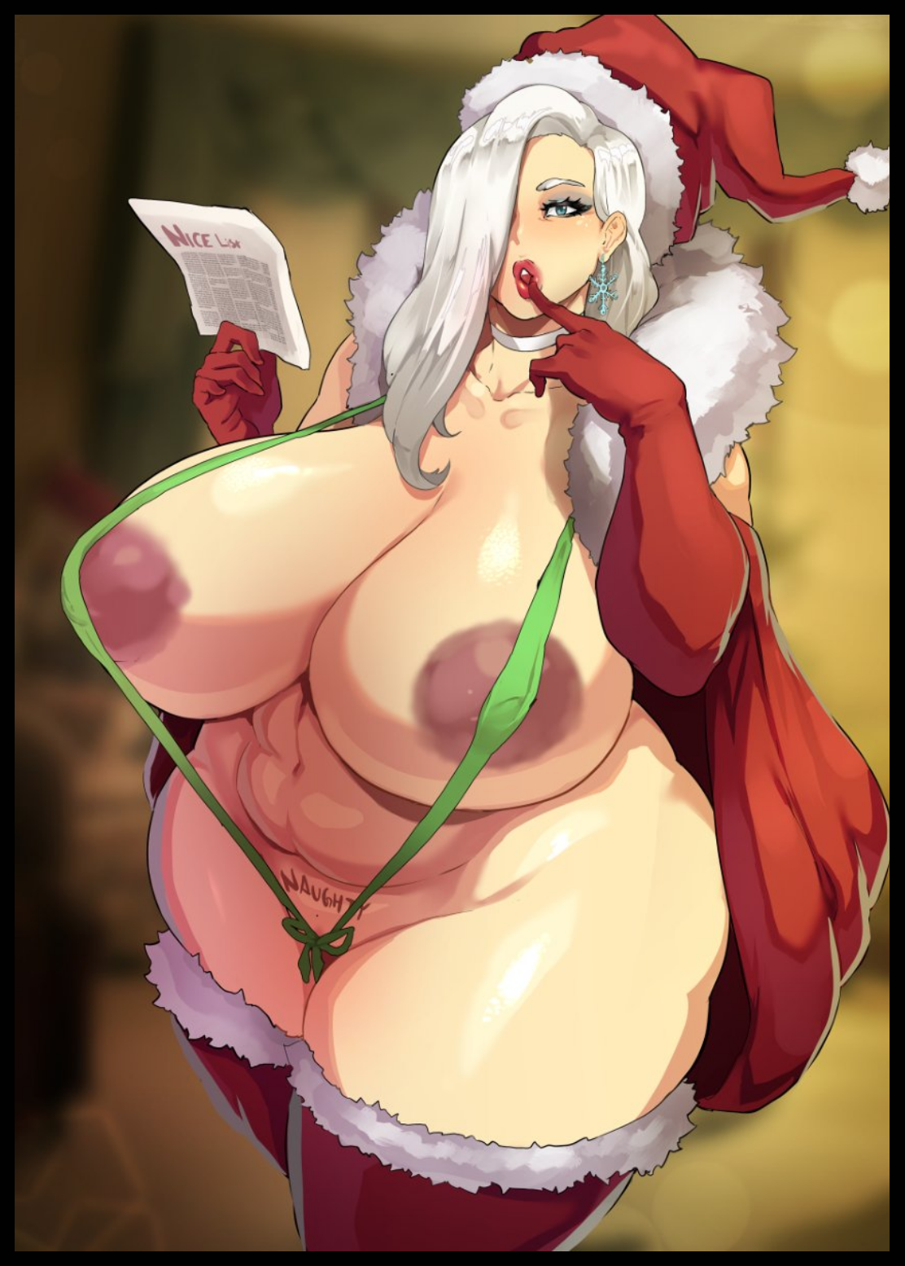

The next few hours would be some of the best in the couple’s lives as they soon began to work into a rhythm, giving each other their first time in coital bliss as mature lady and young man become one in the sheets, tussling in every position imaginable, not stopping for even a moment as Chris takes his girlfriend through a raunchy ride that would only end with the emergence of dawn’s first light breaking through the windows, illuminating the interiors of the dimly lit bedroom that stank of sex before the bourgeois woman cries out in a two-toned voice; blending her current, sultry self with that of her younger form as the morning sun begins to restore Serena’s youth, ending with a frail leg raised high in the air, her overly tight vagina plugged tight by Chris as they remained that way for a good few minutes locked in a throaty kiss that left them oblivious to the reversion, parting ways with a stomp and a jiggle from Serena as her lithe, naked body, drenched in sweat, collapses onto the bed, followed shortly afterward by Chris, tumbling into position by her side, too tired and spent to even say anything. A couple whose flame of yearning for one another had been successfully rekindled after a ‘simple’ heart-to-heart.

And by their dangling legs, lying forgotten on the floor amidst discarded clothing that had likewise reverted to the singlet and pants they once were, was a Santa hat. Persisting for a few more seconds before it fades away, crumbling into dust particles that vanish in the wind, leaking out from the cracks in the windowsill, flying high above clear skies to return from the mischievous hands they came from…

After that day, Serena would become more receptive to Chris’ feelings , especially when the man had taken his lessons to heart; becoming a more straightforward man who wouldn’t be afraid to discuss things with the one he loved, helping her with her job that thankfully had seen some hope in the form of AI work protests alongside making plans for their future together, including the family they would soon rear together after news had come of Serena’s pregnancy a few weeks after that risque relationship mending encounter in the bedroom, both of them never able to forget the surreal events of that night. With Serena even recounting the tale of how she thought she would almost die to a killer hat, a hat that had unexpectedly become the savior of their relationship, leaving them both wondering sometimes about the authenticity of their shared experience.

Was it just a fever dream the two had just so happened to be embroiled in after drinking too much? Had lonely desperation brought them together? They couldn’t be sure.

But from then on, everytime December rolled around, The sight of another Santa hat would serve to make the two of them, Serena in particular, think back on that night. Cementing their renewed bond on an annual basis. With the soon to be mother unable to help the thought of someone else out there in the world being touched by the magic of Mrs Claus just like she had…

THE END

*Image Sources*

Image 1 by Pink Seito : <https://www.pixiv.net/en/users/29857217>

Image 2 by Jujunaught : <https://www.pixiv.net/en/users/50833100>