MMO SUMMER III
COMMISSION STORY
BY CHALDEACHANGE
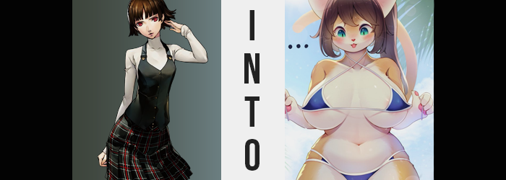

Makoto felt a little bad that she was late, but she fortunately wasn’t going to be as late as Haru.

That was the mentality that she had when she had reached the Sakura household that afternoon, finally arriving after getting out from underneath the weight of her part-time job. To be fair to Haru, mind you? She was in a similar situation. Responsibilities could be a real pain in the butt, and that was becoming clearer to Makoto as she grew older and older.

Regardless, this situation was worth it. Futaba had holed herself up in an unhealthy manner again due to her video games, and the girls had decided to handle the situation themselves. They had planned on showing Futaba a good time, having a girls afternoon and evening to reacclimate her with social interaction and hope that would get her more active again. Makoto had her doubts about this, but it was really better than trying nothing at all.

And so, with the door unlocked, Makoto ventured into the Sakura home. “Hello? Futaba-chan? Ann?” She had thought to call ahead so that she didn’t appear too abruptly, but for some reason Ann hadn’t been answering her phone. Arriving in Futaba’s bedroom though, it was easy to see why. That phone was just laying on the floor, with no sign of either teen around. “Hm. Did she get Futaba to go outside that easily? But then again, I can’t imagine Ann would just leave her phone…”

Because the model was always worried about missing calls for potential jobs, she brought it everywhere without exception. Ann had even told her she brought it into the bathroom whenever she bathed, just in case. So what would lead her to leave it on the floor of Futaba’s bedroom of all places? “Something’s weird here…” The detective’s sister didn’t know this for sure, but it was more of a hunch. Something in the air felt different, almost like Mementos? Or no… Maybe it wasn’t quite like that? Nonetheless…

Her attention eventually turned to the computer that was on in the corner of the room. This was also strange, because Futaba always went on about how she didn’t like to leave it running when she wasn’t there. As someone who was a notorious hacker, it didn’t quite make sense that she’d leave it on and unattended like that. So naturally it became Makoto’s first point of investigation.

“This looks like… an MMO?” Makoto herself wasn’t really a gamer, but she did learn terms through osmosis within their group, seeing as many of them were. It looked to have some sort of character creation screen up, with a relatively bizarre character on screen. “Is that supposed to be a cat girl?” There was a woman on screen with all of the hallmarks of a cat, but she was clearly shaped like a human woman. And one with a huge chest at that.

Still, curiosity got the better of her and she leaned in closer to look. Only for that to be her undoing. “Huh!?” The screen began to glow brightly, temporarily blinding her while the light filled the room. There was an unusual tugging feeling that grabbed her, and the next Makoto knew? It felt like she had falling. As for Futaba’s bedroom? Well, it was left empty once more.

“Ugh… Where am I?” The air had changed from the cool, air conditioned space of Futaba’s room to something much hotter and more humid. She was… outside? And on a beach, it seemed, placed behind some bushes while the hustle and bustle of others could be heard splashing in the water some ways down the beach. Based on the plants and the sky, this wasn’t Japan. But at the same time there was just no way she couldn’t be in Japan, right?
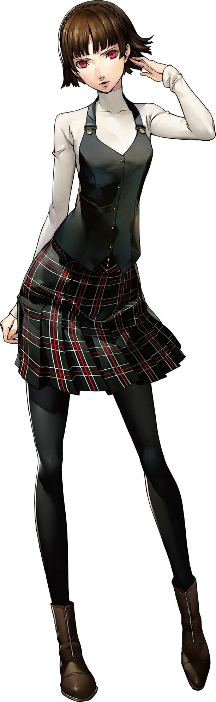
She picked herself up, feeling sand in places it shouldn’t have been. “Wait, I’m nude!?” She was in her birthday suit, and this realization prompted her to duck back down beneath the bushes. Not only was she somewhere impossible, but she had been stripped? Why? For what purpose? Her only thought was that maybe this was the Metaverse and that something had gone very wrong, but at the same time she had no evidence to support this either. Maybe it was a dream? It certainly felt nonsensical enough to be a dream.

But Makoto knew something else, too. She was a smart girl. If she put her mind to it, she could figure things out! She just needed to analyze her surroundings and recall the circumstances that had led her to this situation in the first place, and she would be able to figure out a solution. And so despite the embarrassment she felt for being naked, and the worry that she might be found by someone, she tried to calm herself and do just that.

Except… it didn’t go as planned. Not at all. She kept getting distracted, thinking about unrelated nonsense that didn’t make sense. Things like what she might have for lunch, or if she should pick a more revealing swimsuit – things that it wasn’t the time for, and things that she wouldn’t even have considered under normal circumstances. This left her feeling frustrated.

“Why can’t I concentrate right meow!?” But even in expressing her frustration, Makoto had been given plenty of reason to take a pause. “What did I just say? Did I meow?” She certainly hadn’t meant to, but in the end she had blurted it out as if it was completely natural… There was so much about the situation that she had found herself in that was concerning, and Makoto was left feeling powerless about what to do.

Unfortunately for her, this was only the tip of the iceberg. In her quest to find her friends, she had ended up exactly where she needed to be to locate them. The issue was that neither of them would have been in the right mind to come back if she had even found them, if they could even remember her at this point. But then again? In Makoto’s case, she’d been a very similar situation given a few minutes.

The teen had been doing her best to ignore it for some time now, chalking it up to the fact that there was sand in parts of her body that she didn’t feel comfortable describing, but her body felt very, very itchy for some reason. It had been easier to ignore when the feeling had been more isolated, and yet over the course of the period since she had arrived, it had spread further and further across her body. Until whether it was her hands, her feet, or even her face – it was all a little itchy.

“What is—!?” Frustrated for a number of reasons, she ultimately lashed out at herself and whipped her head down to see if she could see the cause. She’d wholly been expecting a rash, or considering how things were going? Maybe some sort of bug that was crawling all over her and biting her. At least those explanations would have been easy enough to process, even though they would have naturally been alarming in their own rights. Instead? “…Huh?”

Makoto, for but a moment, wasn’t exactly sure what she was looking at. The color of her skin appeared off, with her arms seemingly slightly browner, while her torso somehow appeared paler? But what she initially mistook as a change in her skin tone was, more shockingly, not that. “Nya!?” It was so surprising that she cried out once more, though a cat-like noise escaped her lips again.

“Fur!? I’m growing fur!?” Shocking as it was that fine, soft hairs had been sprouting out across the entirety of her body, Makoto wasn’t a girl that would have cried out so loudly even when shocked. This, if anything, indicated that the tact needed to quiet herself to not draw attention was gone. A side effect of the fact that her mind was growing dimmer and dimmer as her fur grew thicker and thicker.

But it very much was fur, and it very much covered her entire body. The front of her body – her torso, her inner thighs, and the bottom of her face – were all left clad in a downy white, while the rest was an equally soft and fluffy orange. The beach had already been hot and humid enough, but with a coat of fur covering everything except her pussy and nipples? Well, she was even hotter.

So distracted by this fur, though? The fact that it was only one part of a much more substantial set of changes was initially missed by the teen. After all, it should have been hard to miss how her ears were growing, their shapes distorting into flatter, triangular shapes clad with orange fur that rested higher on her skull. Or, for that matter? The emergence of an additional appendage at the base of her spin, for a five-foot long tail erupted and begun to swish hypnotically from side to side.

“This nyan’t be happenyan!” The peppering of cat-like sounds midst her sentences was becoming more common, though looking at her body’s continuously changing shape, it certainly made a lot more sense by this juncture. Both her hands and her feet were not immune to change either, evidently, for her digits thickened and pink pads appeared on the undersides of all of them. So that they looked like mixes of hands and feet with the paws of a cat. Complete with retractable claws that replaced the fingernails that had been lost when she had grown furry.

Was she becoming a cat!? The more bizarre this became, the more suspicious Makoto became that this was some manner of dream. Even as her face was pulled slightly forward, with her nose dampening and inheriting a shape that was an upside-down triangle, flowing naturally into lips that better resembled the :3 of a cat, she wanted to think she was dreaming. But it wasn’t, and she knew that despite her own internal denial. She now stood there as a cat girl version of herself, still trying to cover herself up with adorable paws. Everything about her was adorable, really.

But it wasn’t going to stop with cuteness alone.

This MMO was notorious for how all of the characters were unabashedly sexy.

“What should I do meow!? I’m a kitty! I can’t even summon my Purrsona…” Not that she could remember how. Try as she might, her knowledge in that area appeared to have dwindled. Just as it had in just about every area, unfortunately. As the young woman pondered this, her brown hair both grew longer and softened several tones in color. Before long it was silky smooth and fell halfway down her back.

Which was all the more impressive, seeing as Makoto wasn’t even the same height she had been just a moment ago. In fact, five whole inches of growth had seen her spine and limbs elongated, leaving her to look uncannily lanky for but a brief moment. Or at least until some more desirable meat began to decorate her frame, thickening her overall body shape until it looked more proportionately correct for her own height.

That said, it didn’t carry any consistency. For a second it looked as if she might have retained her usual proportions, height aside, and yet the flesh beneath her furry exterior began to swell and jiggle in specific, sensual places. For one, her hips were pulled farther apart, almost knocking Makoto onto her face seeing as how she was still crouched beneath a bush. “Meow!?”

Those hips had parted about a handful of inches, and looking down at herself it didn’t take Makoto long to realize why this was the case. Because she watched the weight in her legs surge, fluffy thighs bloating, and bloating, and bloating to excessively thicc levels, each thigh almost as thick as her torso when you factored in the fur as well.

It extended to her ass, to boot. Or to booty, perhaps? Nonetheless, she grew much more bottom heavy, her caboose stretching and bouncing as cheeks made ample use of the space left by widened hips. They protruded inch after inch, surpassing what might be considered a bubble butt and reaching a realm that would have made a very captivating twerking show.

“I’m growing so thick and bouncy and totally sexy!” There was almost a passive purr that came across through Makoto’s words now, and it added an extra layer to how much of a dumb airhead she came across as by this juncture. Forget critical thinking or fearing her own transformation, her thoughts had been simplified so much by this juncture that she had started pawing at her own thighs just to watch them jiggle. Did she feel good being this attractive?

Her paws quickly found something else to play with, though. Her chest surged forth in a similar fashion to her thighs and ass, fur struggling to contain tits that wasted no time in peaking past the size of her head, with pink nipples that were just as big as her eyes. With her paws she shook and jiggled them, but it was surprisingly hard to twerk these nipples between the fingers of her paws. Which ultimately led to a sigh of defeat from the well-endowed cat woman.

No sooner than she withdrew her hands, though, did a blue bikini cover her essentials. Along with a blue ribbon that tied her hair into a side ponytail.


Twinkle Fluffybottoms. Embarrassing as it was, this was the name that came to the woman’s mind when she thought of herself. She couldn’t recall her old name, either, although she had not lost the grip on her old memories yet and could still recall the life she had led before. Nonetheless, she was now a soft, fluffy, and extraordinarily well-endowed Cait Sith, a cat-like race in this game world that she had been sucked into.

The Cait Sith were a cute and attractive race with silly named befitting of a household feline, and while they were crafty, they also weren’t all that typically intelligent. “Nya!? This is purrfect, just what am I supposed to do meow!?” Whenever they spoke their sentences were always littered with cat puns according to the game’s lore, too, which made a lot of sense considering how prevalent they had been throughout her transformation.

Fortunately, her fears of being naked were addressed and she did suddenly find herself clothed, albeit in a blue bikini with small, triangular cups that didn’t even completely cover her nipples. On the other hand, though? All of Twinkle’s shame had been eviscerated. Since she was so sexy, and her race so coveted for their looks, she didn’t feel that same fear of revealing herself as she had before.

In fact, as her energy built further, she eventually bound up from behind the bushes with a triumphant “NYA!”. She was clothes now, so she could try and figure out how to get back to her old world! Wherever that was! It almost felt like her memories of that place were getting farther and farther away from her. But on the other hand? She was sure if she asked around at the beach party, she’d get some answers!

Unfortunately things didn’t pan out that way, and it only took the Caith Sith one conversation with a hot woman to completely forget about her goals. Instead, she started cutely flirting with everyone she could. And as the day wore on? Well, there were plenty of people who wanted to sleep with a Cait Sith…

Meanwhile, about an hour later. Haru Okumura arrived at Futaba’s home…

