FOREST STONE
JUNE 2021 REQUEST STORY
BY CHALDEACHANGE
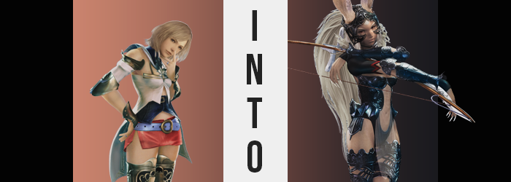

“And that’s all of them. I didn’t expect there to be so many panthers this close to Eruyt Village…” With a flick of her blade, the residual blood from almost a dozen wild panthers flew free from Ashelia’s sword. She’d taken a hunting quest within the Golmore Jungle at the urging of Nera in the Viera village of Eruyt so that she could kill some time while Vaan and the others delt with another task, and it had certainly been eventful.

There were more panthers about than the princess had been informed of, and they’d shown up much closer to the village as well. Apparently the Viera had been worried about their approach, but for an experienced warrior like Ashe they hadn’t posed much of a problem. There were a few close scrapes in there that had come about because she’d grown so used to fighting in a party, but it would all be worth it in the end.

The pay that Nera had promised her was ample, and one of the panthers had even dropped a rather impressive, ruby jewel. Taking it as a cherry on top of a hard day’s work, she ultimately rushed back to Eruyt Village and claimed her pay before retiring to the inn where she would meet up with the others the next day.

“I still have to kill this evening though. I wonder if I should just retire early?” Pacing back and forth in her inn room, Ashe then pondered her plans for the evening. The sun had already set, and Eruyt wasn’t especially active so late at night. Her options were either: entertain herself or go to bed. “Oh, that’s right! I picked up a stone after the hunt, didn’t I?”

She’d stuffed it in the pouch she hid beneath her top and had forgotten all about it until now, even after changing into this comfortable negligee she had purchased in the capital during her last visit. The woman was quick to fetch it from where she’d strung her daily wear, cupping it between both of her palms as she wandered over to the oil lamp on the desk.

During the trip however, something went awry. The ruby stone glowed without warning, and from that glow a shock was transferred to her body. “Tst!?” It didn’t especially hurt, but the surprise was enough for her to drop the item onto the wooden floor. “Was that not a normal stone, then?” And here she’d been hoping to sell it!

Ashelia couldn’t place the cause at first, but only a handful of seconds after she had been shocked, she sensed that something was awry. It was easy to chock it up to her keen sense for danger, but the real reason she’d noticed came from a more fundamental place – the fact that she knew her body better than anyone else, so even the slightest moment of peculiarity could be sensed.

Yet even though the woman could tell that something was wrong, it wasn’t until a remarkable shift to one of her more mundane racial features had completed that there was any noticeable recognition on her part. For Ashe’s Hume ears had been tugged from their natural positions at the sides of her head and were being yanked upwards in more than one sense of the word.

For the higher they climbed upon her skull, the ears themselves were stretched. Cartilage pulled thinner, tips rounding; it was a feat that could only be accomplished with the blessing of added cells, for there wasn’t enough matter in her regular ears to force this growth. As they rose higher still, the outer cartilage was decorated with tiny hairs – furs – black speckles upon the exterior upper halves, while white decorated the lower.

These leporine ears were so long that they measured about a foot to themselves, the mesh insides of their cone-like shapes complimented by tufts of white fur at their bases. Her hearing had been sharpened considerably as a result, but it was their weight that eventually drew Ashe’s hands to touch them with surprise. “These ears!? They’re like those of the Viera!?” There certainly wasn’t any room for doubt there, because Viera were the only race in the world to keep such long and fluffy ears akin to those of a rabbit.

“Tch!?” As fingers had run up and down the lengths of these ears with both curiosity and confusion a like, the girl had been forced to recoil as a sharp pain dug into the cartilage on the right ear. It had come from her hand? Pulling both palms down to her eyes, Ashe tolled them over to reveal the cause: the nails on her fingertips had lengthened dramatically. It was another Vieran racial trait, one she had seen on Fran numerous times. What struck her as exceptionally odd though was a chip in the nail on her left pinkie. Had she not witnessed Fran with the exact same chip the last she had seen her? Curious…

But she had to put that curiosity aside. “What is happening to me!? Surely this wasn’t caused by the stone?” To begin with, she had never heard of any techniques or magics that might alter one’s race, even as more evidence continued to mount to blow this misconception out of the water. For her eyes were still fixated on her fingers, which made it easy for her to see how her skin tone was darkening. “Gods, it’s getting worse?”

Dalmasca’s former princess was by no means a pale maiden naturally. The heat of Dalmasca and the surrounding area had forced the people that lived there to evolve to have a slightly darker skin pigmentation than most. The issue was that even then, this slight tan paled in comparison to the skin tones of most Viera; at least those that called Eruyt their home.

So, suffice to say, the way the woman’s complexion deepened pushed her natural skin color towards a shimmering bronze. It wasn’t developed in patches or anything of the sort, but rather a consistent bronzing that darkened her from head to toe without her permission. There were portions of her body that did become darker still, but this was largely reserved for how her nipples shifted from pink to dark brown, and her pussy carried with it a similar color.

Ashelia’s nose wrinkled next as what felt like a sneeze welled up from within. Just as quickly as it came though, it passed – and it had claimed her nose’s rounded structure in the process. Instead, the bridge and tip of her nose had flattened almost like a rabbit’s own, and this altered definition bled into the surrounding features so that she seemed even more Viera-like.

This included a chiseled but slender jawline of course, as well as their angular cheek bones and narrowed eyes. Her eyelashes grew long almost as if to make up for the roundness lost by the eyes themselves, and her lips swelled as if she had been stung by a bee. They were plump and inviting, sporting a natural sheen that made them quite alluring. Other than that, her eyebrows had thinner only for their sandy blonde hairs to be overtaken by a brighter white that stood out against her bronzed skin.

White hair was quick to become a staple from this point on, washing through her short haircut and even growing longer far down her back and past her waist. Once the inevitable growth spurt required to match a Viera’s statuesque stature kicked in later, this hair would undoubtedly rest just at her bottom, but for now it was thick, wild, and excessively long.

“’Tis a peculiar transformation… Hm? Whence did this manner of speech become mine own?” Not simply the woman’s choice of verbiage, but even her voice and accent had undergone a dramatic shift that strongly resembled, if not were a perfect match for, Fran’s own. This was indicative of what was going on mentally, that Ashe was losing herself to the forces that were transmogrifying her body. “Recognition or no, change marches on.”

The ‘Viera’ noted this because a cracking in the bones of her feet forced her to lift each tootsie as they rearranged. Viera were not as flat footed as Humes, and so two of her toes were lost while either foot crunched and lifted upwards near the back where her heels would typically touch the floor. They no longer did, all of her weight now supported by the three toed, three clawed segments in the front.

It was around this time that Ashelia began to doubt the necessity of her negligee. Or, at the very least, she pondered whether or not it might soon be a hazard. Quick to pull it over her head, it was guided with ease even past her new ears as if she had always been accustomed to working around them, her thick, white hair spilling back down behind her once freed from the cloth that was cast to the bed.

“A better idea, I fathom.” Remaining nude for what was to come just felt instinctually correct, and one could now see the messy bush of white hairs above her pussy with all laid bare to see. Evidently, her assumptions had been correct, for she soon found herself molded by the excessive height all Viera women were blessed by.

Up the princess grew, her confidence growing as a greater strength was conveyed by her stretching frame. Muscles rippled, presenting her with a body that was keenly designed to be a powerful huntress. Strong arms, capable legs, toned abs; she received the complete package along with the nine inches that boosted her upward. This wasn’t even including her ears, which amounted to another eleven inches that made her total height 7’1”.

Incidentally, Ashe herself had not realized that her body’s age had progressed according to the internal clock of a Viera, not the Hume blood she’d once possessed. Despite looking like an adult in her later 20s, perhaps, she was fifty years old at minimum.

It was hard to find fault in her repurposed flesh now that she’d had a taste of just how strong she now was. She flexed the fingers of one clawed hand in front of her, getting a sense for just how strong her grip now was, all while playing ignorant to how her bare nipples just stood at attention. Muscles had made her chest appear a little smaller from the outset, but their fat soon jiggled as weight saw their abundance sharpen. D-cups blessed her breasts before long, a sensual sizing meant to compliment the strength she exuded otherwise.

Ashe’s steps fumbled a moment upon her Viera feet as a sudden jolt to her posture forced her knees to buckle. The cause? Her hips had widened in tandem with an extraordinarily narrowed waistline, giving her a tall and narrow hourglass figure by birthright. This was all further complimented by thighs that expanded with meaty, supple tissue – and that trend continued to her rear.

For, while largely disguised by the fluffy, white hair that dangled past it, her tight ass was growing similarly. Ashelia’s booty had once been impressive for a girl of her height, yet that appeal had initially been lost as she’d thinned and grown. Now? She was blessed with a means of redemption, for the bronze buns of this, well, bun, stretched to contain the tender tissue that rounded out her derriere.

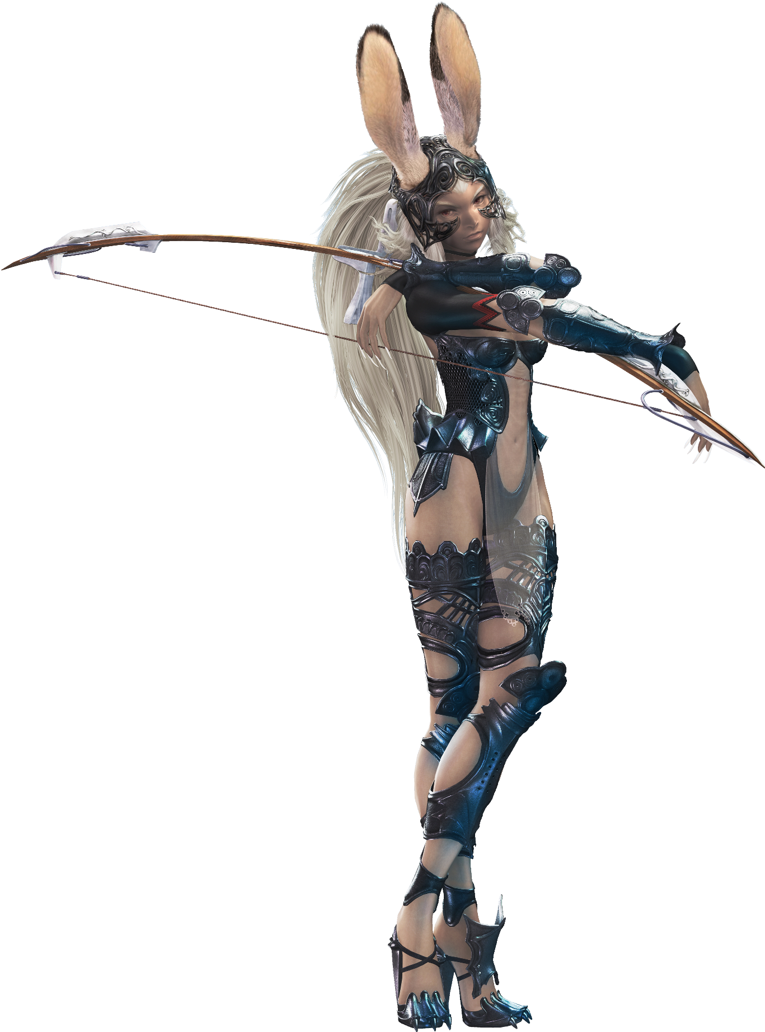
Before this day had began, she would have been far too embarrassed to think about strolling around with her ass out, but with her mental alterations had come a decreased level of shame. Why should she feel anything other than pride about this strong, beautiful body? She could strut out of the inn naked now if she needed to and wouldn’t at all care for the gaze of any onlookers.

“Well this is a conundrum. I’ve become Fran in all but memory, then?” Even then, the Viera was not entirely sure that this was the case. She could quite clearly remember that she was Ashe, and yet whenever she thought about Ashe it was as if her memories were framed from someone else’s point of view – Fran’s point of view. But in terms of appearance, attitude, and skill with a bow? She had become a perfect copy of Fran through and through. “No, I’m… I am… ‘Twould be folly to think of myself as Ashelia as I am now?”

It would, would it not? She was not her. She had no relation to the royal bloodline. She was merely Fran, a Viera cast aside by her own people. Any recollections to the contrary were merely discarded. “’Twas odd that I was thinking of myself as another just moments ago, yet… Why am I in Eruyt’s inn? Whence did I arrive? Where are my garments?” Ashe’s clothing was hanging on the door, and there was a negligee messy strewn across the bed, but Fran’s traditional garb? It was nowhere to be seen.

“It will be a trick to make sense of this, I imagine.”

…Was she just supposed to bound to Nera’s and beg her for a change of clothes while nude?

Well, it didn’t bother her any to do so.

