DENDRO TOUCH
COMMISSION STORY
BY CHALDEACHANGE
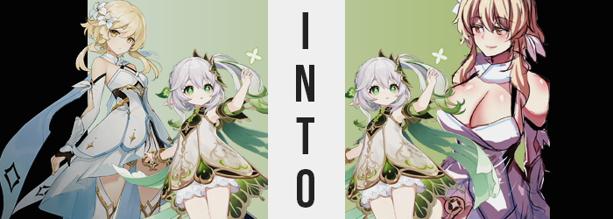

A lot had happened in a short period of time, and the Traveler was left flabbergasted even as she came to after what felt like a sudden absence of consciousness. There had been a great deal of danger suddenly, and not only had she been at risk, but… “Nahida!” That was the word that had escaped her lips when her eyes shot open, hand reaching out at nothing.

The details of what had transpired came rushing back to her. They had met with Tighnari and Scaramouche had showed himself to her in a vision? Then Lumine could recall that they had been attacked when trying to leave. Nahida had placed her consciousness in Katheryne’s body, and they had impaled her? Or maybe they hadn’t? The final few moments had come and gone so fast. Lumine had lunged to protect her, their hands had touched, and now…

“Wait… Could this be?” When she awoke though she was nowhere familiar. Instead she had been separated from Paimon and looked to be trapped inside of some sort of Dendro barrier? While the lavished walls of what seemed to resemble a Sumerian palace surrounded the steps down to the sole entrance. Based on what she was looking at, comparing it with things she had heard? “Is this the Sanctuary of Surasthana?”

The place that Nahida had been trapped within. She had heard the Archon speak of her prison and how she couldn’t escape, and Lumine had made it a goal of hers to help break the small god out. “But if I’m here…” Then did that mean that Nahida had escaped? She was floating there but she could turn herself around to see that nobody else was present within the barrier with her.


So had she succeeded in freeing Nahida? Well, she couldn’t exactly call it a victory could she? Not when she was now the one trapped. It was only a matter of time before a member of the Akademiya came in to check on their caged Archon just to find a blonde-haired girl floating there in her place. “Is there a way for me to get out of here?” Because if there was then she probably had a time limit before she was discovered.

Of course there isn’t. I’ve tried so many ways, and yet…

“Yeah, I guess… Wait! What was that? Nahida?” It had felt like the Dendro Archon had just spoken in the back of her mind. Were they still connected somehow? But she didn’t hear a reply after she questioned its existence. Which made sense because to begin with? Lumine was wrong about what had happened. She believed she had heard Nahida’s voice, yet… The thought had actually been her own. Which meant there was something much, much more serious at play here.

The fact that she had almost been in agreeance with the conclusion as if she had experienced it firsthand was just as concerning, honestly. Was the cage she was trapped within doing something? Were there thoughts of Nahida’s lingering within? A million possible ideas ran through the Traveler’s head, and not a single one of them was on the mark regarding what was actually happening. Because how could she even expect to understand the truth when it was so bizarre?

Nonetheless, fixated on the strange happenings in her mental landscape as she was, changed to her appearance that would otherwise be difficult to notice without looking for them began to pop up. Beginning with a very stark change in the colors of her eyes. Much like her twin brother, Lumine had a pair of yellowish gold eyes… And yet? A forest green clouded them, ultimately overtaking even her pupils – though what befell them was stranger still.

Because her pupils? They expanded into a four-pointed star shape before their blacks lightened to a yellowish green that was substantially lighter than the green of her irises. There were eyes that Lumine had gazed into before, when she was trapped in Sumeru’s endless day. Over and over that hell had gone on, and she was only saved because of the girl that possessed eyes just like these.

“No, there must be a way out of here. But considering my many calculations…” The young woman soon began to murmur to herself, mind racing at a much faster pace than the Traveler would have ever thought possible considering her own ability before. As her mind raced, going over every possible means of escape – including plans that were so complex that she could never have possibly thought of them even in a million years – the hair that framed that brain of hers began to lose its color.

The roots of her blonde hair was sapped of their color, leaving instead a shimmering silver that should have been just as familiar to her as what her eyes now looked like. This color eventually dyed her mane all of the way to the tips in the front, which bangs growing to much fluffier heights as they wrapped around the sides of her face. But in the back? While this hair thickened, the tips there did not remain silver. Instead a green not unlike that of her irises dyed them, fading into the silver a little further up.

Not that Lumine even realized. In fact, her expression was one of deep thought as she closed her eyes so that she could better focus on a solution to her imprisonment. “I’ve been trapped her for so long, there isn’t a way to escape internally. So why do I think there might be something I overlooked?” The way she was speaking sounded less and less like herself, and that was reinforced by just how squeaky her voice had become – almost sounding more like a child’s by the time she began to speak as if she had been trapped in the Sanctuary of Surasthana for hundreds of years.

Though with her eyes closed, it truly rendered her ability to identify any oncoming changes with any urgency. Especially now, as while she floated midst the cage meant to house the Dendro Archon? Her body’s entire build began to compress in every capacity imaginable. Although it did start by addressing the curves of maturity that gave her the shape of a young woman.

That is to say that the little wealth her figure had was quick to evaporate. Lumine’s breasts, which were on the lower side of the C-cup range from the get-go, were robbed of the girth they held and eventually flattened into non-existence, skin tightening around them and nipples shrinking down into near nothing as well. While the weight of her ass and thighs? They were treated similarly, and both areas thinned until there was nothing present of consequence.

Had Lumine been rooted with her feet on the ground then she might have noticed what came next, but since she was simply floating there? Well, a change in perspective was hardly of important with her eyes closed – particularly with her clothing changing now as her body did. Her dress was shrinking because she was shrinking, with arms and legs withdrawing inwards along with her torso crunching inward. Shoulders and hips narrowed, and her thighs ultimately did look plumper now that she was so small.

But in the end she was hardly larger than a small child, now clad in a dress of white and green, with bloomers replacing her underwear. Toeless shoes revealed tiny tootsies, and a clip pulled silver and green hair into a side ponytail in the back. “Um… Hm…” The girl herself even seemed to be stumbling upon an answer to her questions, for green eyes fluttered open just as her face found its childlike roundness. There was absolutely no longer any resemblance with the Traveler she had once been, but it was also difficult – yet not impossible – to perceive herself that way.

And finally? Pointed ears poked out from behind her silver hair, finalizing the physical aspects of her unwanted transformation.


“Oh no… I understand what happened now.” Like a bell chiming within, clarity struck the Dendro Archon Kusanali, otherwise known as Nahida once her outfit her been repurposed to better suit her tinier frame. Being the God of Knowledge, this repository of understanding had surfaced midst an ego that was the Archon’s, but also very vaguely that of the Traveler. Well, at least enough for her to understand what she had come from. Or who, technically. “I… or the previous me, must have intended to swap our consciousnesses. But instead I switched our very existences? How is that possible?”

Incredibly intelligent, a number of theories and calculations were running through her mind – things that would have been impossible for Lumine but now came naturally to her. She held her chin with chubby fingers. “Did someone interfere? …Did the Doctor figure out a way to counter my abilities?” It just felt easier for her to think of herself as Nahida now. Because otherwise it felt as if she was subconsciously pushing against an incredibly strong current.

“Maybe I can contact her…”

“Oh no! This wasn’t supposed to happen!” Elsewhere, the original Nahida had hidden herself after suddenly finding her body – not just her consciousness – free of its prison and in the very same place she had just been functioning within Katheryne’s mind. During the attack she had meant to transfer her consciousness into Lumine’s mind in order to subvert the damage that was clearly intended to be inflicted on her person, and while she had managed to escape Katheryne’s mind? There had been an unseen development. She had switched places with Lumine altogether? Before Paimon could realize, she had retreated beneath a staircase.

This wasn’t right though. Knowledgeable and experienced as she was, Nahida knew her own abilities better than anyone. But now that the Doctor knew what she was up to, could he possibly have altered her abilities via the Akasha system? “Does this mean that Lumine is in the Sanctuary of Surasthana, then? I suppose that makes the most sense…” Could she use her abilities to reverse this, though? She couldn’t leave the Traveler trapped there!

“But something’s wrong… My powers? No, in general. I don’t feel… right.”

It was odd. Being a god, Nahida didn’t exactly come down feeling sick often, if ever. But she could feel a warmth flushing her cheeks and pulsing through her body, indicating that something was very, very amiss. Like something had invaded her body that most certainly shouldn’t have. “Erm… Wait a moment… What is happening here? Why am I…? Am I growing?”

The archon was not as ignorant to herself as the Traveler had been, and she immediately took notice of her eye level rising – and quickly at that. It prompted Nahida to look down, not only at herself but the clothing she was wearing, for both areas caught her attention when it came to superimposed and unwanted alterations. It was so shocking that her mouth was rendered agape, arms growing longer as the fingers on her hands lengthened several inches longer as well. But her legs and feet were doing the same, and she could also feel a pull on her tummy as her torso heightened.

Before long? Her height was comparable to that of the girl that she has switched places with. “It can’t be…” She held out an arm, almost enamored by its length considering how long she had been trapped in that small form, and rolled her wrists to view her new hands. She took a step, stumbling slightly because her hips had also widened to accommodate her new size, just as her shoulders had likewise expanded in their reach.

Fingers, though, eventually tugged at her dress. Or what had once been her dress. Because while it was loose around her chest and lower body, it was an exact replica of the white with blue accent gown that Lumine wore. Including the detached collar, boots, and the flower ornament she kept in her hair. “Wait! Oh no! Could I be… Um…? Could it be a case of…? Huh?” For a brief moment she thought she had found the answer, but the knowledge slipped through her fingertips.

So much knowledge was slipping, leaving her intellect as only a fraction of what it had once been.

It spurned panic, but that panic was also quick to calm. Why was she worrying so much? She’d never been capable of such complex analytics! …But that wasn’t true! Was it? This internal turmoil would consume her for the next few moments, which discounted her ability to take note of how her hair was painted with a soft blonde and shortened to just above her shoulders aside from the longer tufts that hung down from the sides. Or that her eyes took on a golden glow while her facial structure matured into the identical design of the owner of her new dress.

But just as it became clear what her fate was meant to be, a curveball was thrown. One that initially bolstered her height another couple of inches despite already having matched up identically with Lumine. “Ah!?” Her voice even perfectly matched her new face, but the lips squeaking with surprise appeared weightier and thicker than before. Her dress suddenly felt very tight.

Her curves – or Lumine’s curves, technically – had yet to grow in for some reason. And it seemed as if the reason had been to avoid stopping and starting again. Because the white panties beneath her dress were suddenly having one heck of a time sitting on her pelvis comfortably. It was no surprise though if you factored in what was actually happening.

Everything from the waist down, it seemed, was bloating. Her thighs went first, bloating to a size comparable to those of the Traveler. Rather than stopping there, though? They continued to engorge farther, skin tightening around their succulence until a shimmery sheen was made all the more evident. Growing so ample that they pushed into each other beneath her loins, their overall mass then forced even her hips to part wider still.

Well, it was sort of a joint effort between her thighs and her ass, really. Because the cheeks of her rear received the same treatment, inflating almost like balloons well past the pronounced yet average look of Lumine’s usual rear. Instead? They pulled her panties and wedged them deep within protruding cheeks, the mass lifting the back of her skirt so you could make out the underside of her ass whenever she took a step.

“No, this isn’t right. I’m not supposed to be… Lumine…” Hardly holding onto her ability to rationalize her own identity, hands idly wandered to the neckline of her dress. Because much like her ass and thighs, her A-cup breasts were quick to meet the requirements of the young woman she was becoming… only to surpass its schematics in size.

Excessively so, and without her dress changing further to accommodate them if her skirt was any indication. Nahida’s nipples had turned full-on erect, and from that juncture engorged themselves until her areola were as big as her golden eyes. Steadily, once they had peaked at Lumine’s usual bust size, their weight continued to accumulate and that ultimately forced her posture forward as she continued to better support their weight.

The straps of the woman’s dress, which bound its top to the collar around her neck, very quickly found themselves burdened by the growth below them. With her tits erupted into and past the realm of E-cups, her neckline was being pushed out so that her cleavage had become a shiny canyon. But it went farther than that, ultimately finalizing their sizes at G-cups. A cup size so excessive that they almost rivaled her head in size.

It took the woman a moment to finally stand up straight again, and only because the muscles in her back had tightened and strengthened so that she could bare the weight of her new figure. There was no way that she could swing around a weapon with proportions like those without unfortunately and inevitably crashing onto the ground.

But that was also the least of her worries at that point. She was still fixated on trying to recall who she was supposed to be.

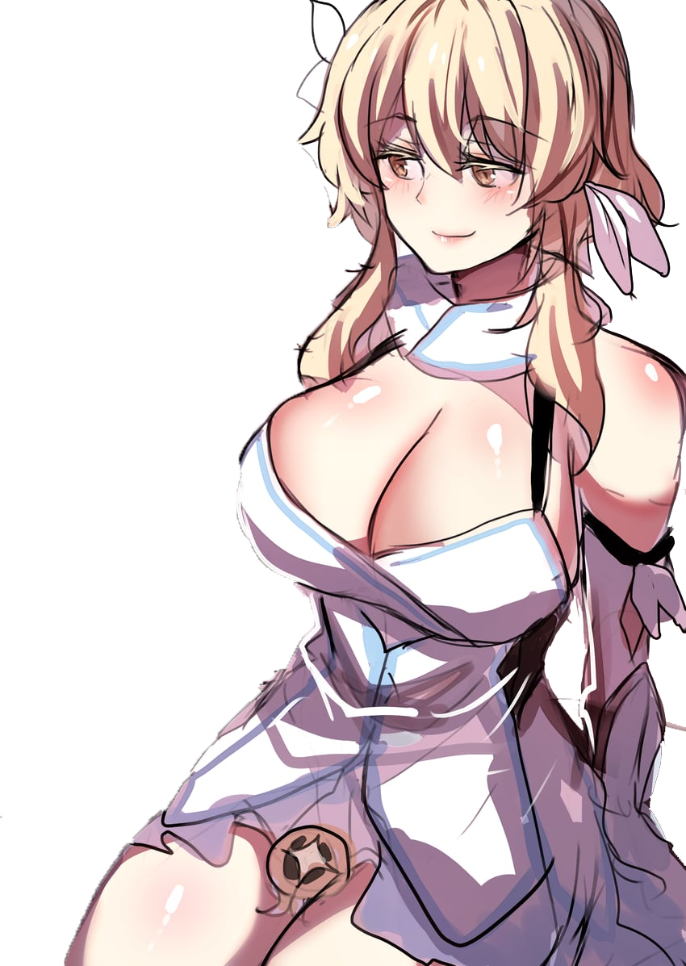
“Uh… This isn’t really right either, huh?” It would have been wrong to call her Nahida now, but was calling her Lumine even correct either? Fundamentally she was the Traveler in appearance, and largely her body was now undeniably so. But the swell of her breasts, ass, and even a little bit when it came to her height all differentiated her from the teenaged girl whose place she had swapped with. “Why is my body so heavy? I can’t exactly fight like this…”

But that was the point. With the real Traveler now trapped in the Sanctuary of Surasthana as the Dendro Archon, and the real Dendro Archon now a Traveler who was physically unfit for optimal combat, the goals of the Fatui would be much, much easier. But while this Lumine could vaguely recall that she had been Nahida, a sudden voice in the back of her mind suddenly forced her to forget. Because it forced a contradiction.

“Lumine! Can you hear me?”

It was Nahida communicating to her telepathically. But if Nahida was talking to her, then how could she also be Nahida? She clearly wasn’t, right? That was where the contradiction forced a correction. “Yeah! I’m okay Nahida, what about you?” They had just been separated after she had been incapable of protecting them due to her body, right? If she could have been just a little faster!

But on the other end, hearing herself called Nahida triggered a similar change in the new Archon’s mind. “I… Erm… Wait, I’m pretty sure I was just about to ask you something important…” Had she? Something more important that whether or not she was okay after their encounter? “Well, if you’re safe… Please find Tighnari! I don’t think I’ll be able to speak with you… much longer…”

And all went quiet.

