SEIROS’ SWORD MAIDEN
COMMISSION STORY
BY CHALDEACHANGE
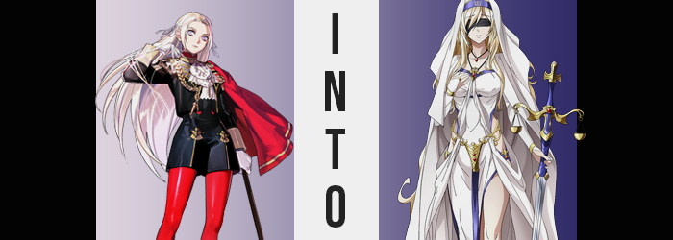

It was probably a little too common to find Edelgard von Hresvelg wandering through the vacant hallways of Garreg Mach Monastery so late at night. The princess of the Adrestian Empire was the kind of young lady who enjoyed clearing her head with a brisk walk in the cool night air, and inherently there was nothing wrong with that. She certainly wasn’t the only student of the school who partook in this practice well after all of the academy’s facilities had closed, but she may have been one of the only ones who did it with the things she did on her mind.

Sins. Both things she had done and things she would one day have to do. While Edelgard did everything in her power to bury those feelings, to make sure that absolutely no one in the academy aside from Hubert could possibly learn of them for such a thing would completely undo all of the work that had been done. Because she was the Flame Emperor and her goals involved taking down both the Church of Seiros and the woman who led it, Archbishop Rhea.

Plenty of Fodlan’s people saw the church as a beacon of hope. In many ways it was, but even the most beautiful tree could be plagued with rot. Shading dealings with other nations, assassinated dissenters, housing the ‘problem individuals’ beneath the school itself, locked away from the rest of the world. These were just a few of the many systematic misdeeds that the church had been at the center of under Rhea. Edelgard didn’t know what her goals were exactly, but she knew that they were not good for the continent’s people.

And uprooting the weed that spread this rot was the only way to fix things. At least that was how the princess saw it. That was why she had put on the Flame Emperor’s mask, and why she committed atrocities under that name. She didn’t want to, but the woman had long since steeled her resolve. If it meant the world would be better not only for her people, but for all of the people of Fodlan, she would become the necessary evil. Sometimes change couldn’t be made without first lighting a match, and she would embody all of the flames that came about because of that light within her.

“Hmm…” Edelgard didn’t dare murmur a word of what she was thinking about while passing beneath stone arches that filtered out the light of the full moon aloud. She was considering plans that would be going into action soon. Some things still had to be done before the war on the church could be declared, and the necessary moves required additional collaboration with Those Who Slither in the Dark. They were an organization that she loathed even more than Rhea herself.

But at the same time cooperating with them was necessary… for now.

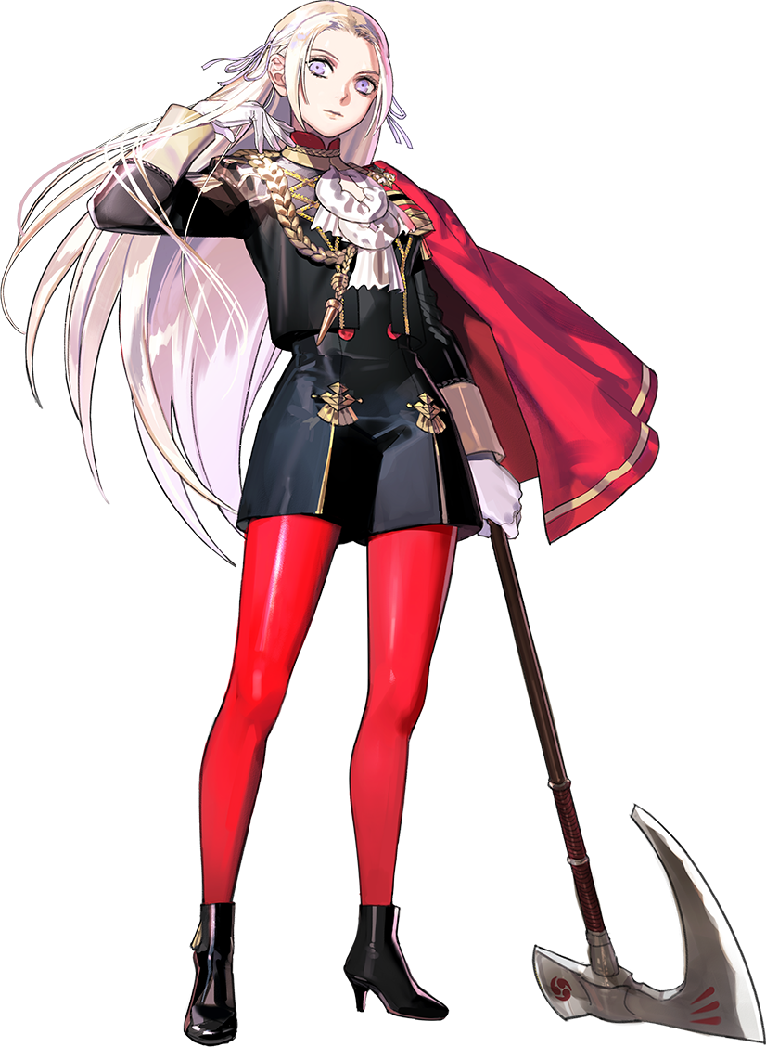
While passing under another arch, it finally struck the princess that she may have wandered a touch too far. “These are the gardens, are they not?” Only the moon above lit up the grassy ground and cobblestone steps before her. She knew Garreg Mach Monastery’s layout like the back of her hand. She had to if there was to one day be a siege of sorts on the church. The gardens would be an important position to hold – or take depending on what side of the siege she was on.

For the time being, however, this was too far from the dorms. She had no business being out so far, and if she went wandering midst the gardens and someone saw her that would likely be far more suspicious than just watching her wander around elsewhere on campus. “I suppose I should… Hm?” Before she could completely get herself back on the path onto the school campus she was distracted by a glint of light a short ways into the garden.

“Is that a weapon?” From the distance she was at she could tell it was a silver blade with a blue hilt. It wasn’t until she got closer still that she recognized the shape of the guard. It was golden and had one half of a set of scales on either side. “A blade for maintaining balance?” With the symbolism of those scales of justice in mind, that was the conclusion that she came to upon looking at it. But it was such a decorative and important looking blade. Why was it sitting out in the gardens unguarded. “A trap?”

While possible that someone had set it there maliciously, it may have been just as likely that a guard or merchant had accidentally left it laying around. If that was the case then she should probably turn it in, right? No, perhaps it would simply be safer to report it to someone more qualified to deal with it? That way if it was a trap there would be less risk of it affecting her. While pondering her options she turned the hilt over in her hand.

…In her hand?

She had just been thinking about how it would be bad to pick it up, yet it had taken Edelgard almost fifteen seconds to recognize that it was already in her grasp. “When… did I pick it up?” Why had she picked it up? But now that it was in her hand it didn’t seem like any sort of trap had been triggered. And the blade somehow felt a lot lighter than she had expected. But a trap had been tripped. The woman herself just didn’t realize it herself, at least not immediately.

Whether or not she had noticed it, however, there were early warning signs that managed to escape her initial notice. Not this was particularly surprising. One life lesson to take away is that you’re much less likely to notice something if you aren’t looking for it in the first place, and Edelgard has no reason to suspect something might be happening to her body. There was no warmth nor any tingling, no real indications that anything was happening to her early on. Although ultimately this could be blamed on the fact that what did change early on wasn’t the kind of thing that would be easier to feel than it was to see.

“I should… drop this.” That was her initial thought. Just moments ago she had decided to take it with her but now she couldn’t muster the mental strength to put it down? It didn’t even really matter if she carried it now or not though. The trap was already in action and she would return to pick it up again if she mustered the will to actually drop it. Which she did not. “Er… Perhaps I should take it to someone to look after, after all?” But she almost didn’t want to part with it. Like the blade was her own possession.

Was that true? It remained to be seen. But what could be seen was a growing difference in Edelgard’s hair color. To begin with the silver wasn’t the color she had been born with but instead a side effect of cruel experimentation she had endured. In the end it didn’t seem to matter however, for the silver brightened with a different hue. A platinum blonde that shone similarly but was clearly different enough. Her mane lengthened similarly, but since Edelgard’s hair was already quite long she didn’t really notice. This hair reached her butt normally but now it reached just below her knees while it was also rendered thicker at the sides.

“Hm?” Ultimately she did seem to notice her lengthened bangs, but just as quickly as it crossed her mind her brain went on to process different thoughts. “Should I… bring this blade back to Lady Rhea?” If you knew anything about Edelgard’s plans then this was a very odd remark for her to make. And it seemed like the princess herself caught it as well. “What am I saying? Why would I bring this to her?” And why would she utter her name with such familiarity. The thought made her feel ill…

Yet what was this fluttering in her chest?

Around this time the coloring of her eyes shifted to a pale blue – another change that would be very difficult for her to perceive, so it was unsurprising that she ultimately appeared to seem befuddled by a different, more pronounce alteration to her body. Edelgard was always attempting to project strength, but one thing truly held her back in that area. It was obvious enough; she wasn’t very tall. It didn’t matter how muscular she got, that wouldn’t affect her height.

But even then, that was only fixed with an added two inches to her height. Which didn’t sound like a lot in the grand scheme of things, but it was still easily perceived from her point of view. After all, her crimson tights were slightly yanked down while her shorts were pulled up. In a similar vein her tucked top could be felt pulled out, whereas scarred skin was revealed between her gloves and sleeves as arms were now a touch longer.

“Am I imagining things?” She glared at that gap between her glove and sleeve, looking at the damaged skin from the experiments she had suffered in the past. Yet her blued eyes arched at the sight of that skin. All of the scarring was… smoothing away? Before long her pale complexion was completely void of scarring – across her entire body. “I… Did I have scars? Oh dear.” She couldn’t remember for some reason.

Her expression tightened once more for unrelated reasons, but this changing expression did highlight that her face appeared different too. While biting her lower lip with apparent discomfort the thickness of that lower lip nearly tripled to give her a plump, mature pout. On the whole her facial structure lengthened and her cheekbones were risen. Her nose lengthened an inch and bore a more defined point. And when it came to her blue eyes? They narrowed in shape, but lashes fluttered much longer whenever she blinked. Altogether it created the impression that she was older. Perhaps seven or eight years older, putting her in her mid-twenties.

But what had caused her expression to contort in the first place? “Why are my clothes so uncomfortable?” By the time her lips had filled themselves her voice had deepened in kind. But it seemed that her clothes were still causing her issues beyond a mere, minor height jump. “Why am I wearing the Black Eagles uniform anyways? Is this another of Lady Rhea’s pranks?” Pranks? Was she on such friendly terms with the Archbishop? No, she hated her didn’t she? But how could she hate the woman who had helped raise her?

The details about her relationship with Rhea and her overall background came secondary to the growing physical discomfort she felt. The waist of her short was already at its limit, as hips had swung a handful of inches thanks to related growths in the surrounding area. Her thighs were one of these areas and this was quite obvious while looking at her crimson tights.

They were already fraying, stretched to their limits and incapable of the seductive, supple girth that bloated those strong thighs. Tiny tears allowed some of this flesh to poke out, but overall it wasn’t like those tights were completely shredded. In a similar fashion her rump had bounced merrily with added weight into her cheeks, a plump peach shape jutting back to force her shorts to complete capacity.

Another problem area was the woman’s chest. Edelgard’s tits were supposed to be slightly above average in size (at least compared to her height) but that was changing. It was unfortunate that the button-up nature of her uniform was stifling them, because if they had been free they absolutely would have jiggled and bounced with each new inch applied to her bust. In the end they managed to pop off the top few buttons, but her cloak’s ornaments concealed the fact that her tits were now F-cups.

“My body… My clothes… My memories? Something is wrong, but what?” The woman’s clothing clearly didn’t fit, and yet at the same time she was wrestling with a newfound affection for Rhea. No, was it newfound? This affection felt so old, so rooted in her soul and distant memories. Who was she? Who was she supposed to be? Clarity returned gradually but not in a way that favored the woman’s past self. She squinted. The world around her began to dim. She could barely perceive shapes before long but had very limited perception through blue eyes that now seemed even duller in color.

She knew she was blind and so it didn’t alarm her.

Nor was she alarmed when complete darkness took her. A black blindfold had been wrapped around her eyes, a small part of a greater, magical outfit change that had relieved her from the discomfort her Black Eagles uniform had wrought after her body had transformed. She was left clad in black robes that elicited a resemblance to the clothing of a nun, with a matching veil atop her head and golden sandals. Blue and gold alike lined this beautiful ensemble in all the right places, matching perfectly with the blade she now clutched as if it was an extension of her body.

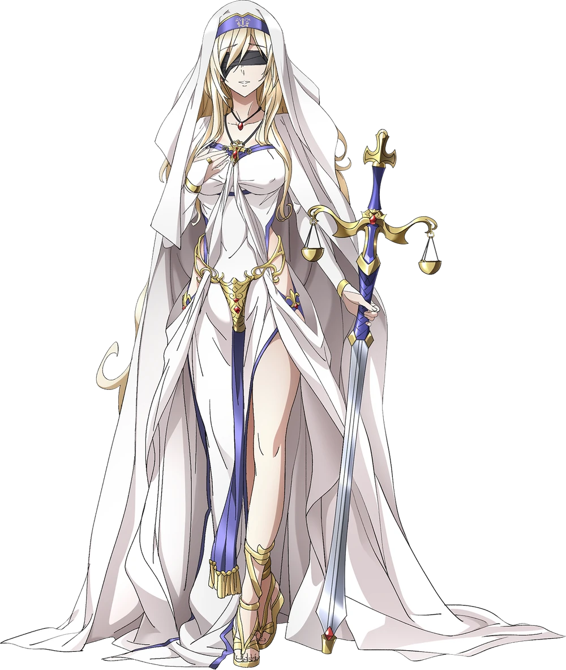
For how confused the woman had been when her transformation had begun, the calm that the Sword Maiden now exhibited was almost eerie by comparison. Of course, forgetting her past life altogether was a good step in delivering that calm. It was difficult to be anxious or upset about things you couldn’t remember much less even have an inkling of forgetting. But where was this Sword Maiden’s place in this new world? From where she stood, nothing had changed to reflect her own changes.

“I suppose I should return to the Archbishop’s side… My evening walk was an uplifting one.” She didn’t look like she was in very high spirits but she definitely felt like she was. Gripping her blade she began to move down the cobblestone pathway back to the school and church. She lived in the main building along with the archbishop in fact. Which was a very big change from her past life.

The Sword Maiden harbored absolutely no ill will towards Rhea whatsoever. In fact it was the opposite. She looked up to the archbishop and would do anything in her power to keep Rhea safe. She was loyal to a fault and saw absolutely nothing wrong with her version of Fodlan. She had been raised with the church, grew up as part of the church, and would now continue to protect the church until her dying breath.

Which might have been a very long time from this eve. The Sword Maiden’s appearance in history had been traded for the existence of the Flame Emperor and Edelgard herself. If there was to be a war in Fodlan now it wouldn’t be because of the Flame Emperor’s antics. She just simply didn’t exist. Edelgard didn’t exist. Whether that was for the betterment or detriment to the continent would remain to be seen, but it wasn’t like anyone would know better anyways.

“Another early morning tomorrow as well. Lady Rhea needs me to check on some bandits…” And by ‘check on’ she wasn’t talking about a friendly conversation. The scales on her blade were indicative of the justice she would deal, and for those that stole, pillaged, and raped unchecked? That justice could only be doled out with the sharpest edge of her blade.

That much was absolute.

