Homebreaker

A Short Story

By Maryanne Peters

I used to say that I could wrap Daddy around my little finger. I suppose that is what most daughters say. He basically gave me everything I asked for, but really it was just because he could afford it. Somethings he would never let me have. A sex life seemed like one of those.

I met Neal at the rehab centre. He was not there for the treatment, he was supporting another guy, called Jake. Jake seemed rough, but Neal was a pretty boy. By that I mean that he was a beautiful man, but not that manly. He was staying with this guy Jake in some shithole because he was new in town and knew him back in the Mid-west. He got caught up in helping Jake through a bad patch. I guess I realized that he was just a good person. I told him that when I was out of rehab I had been promised an apartment in the city.

Maybe that is when he started to show interest. I don’t like to think that. He seemed genuinely interested in me. He said that he liked the way I dressed – my style. I like to think of my look as a different thing, but really it isn’t. Still, any girl likes to be complimented.

We went out a few times. We had drinks and he steered me away from drugs. He was used to being a support person, and he was good at it. He was suggestive and persuasive, and he was not judgemental. I thought that he was good for me.

He was such a friendly person that all my friends liked him too. In truth I had gone out with a succession of assholes, and Neal really broke the pattern. Everybody described him as being “a really good guy”, and I guess that he was.

We had sex a couple of times and it was great. I was not sure that he was ‘The One’, but he was certainly the one for now. I wanted him to move in with me, but that is where my father stepped in.

“You can have another girl in your apartment, but no man is moving in,” he said. “If a man moves into the apartment I am paying for, you are both out.”

I really have no influence over my father. He is too strong a person. I kid myself, but I know no amount of begging and pleading is going to change things. Father’s are meant to stand their ground. Daughters just have to work around them.

The doorman, George, was on his payroll, so at first, we started by just addressing how to get past him.

“If women are allowed then I can dress in drag and we just walk straight in,” said Neal. It was his idea, not mine.

I wanted him living with me so badly. I suppose I am just like that. I had just got the smallest taste of him but suddenly he was like a drug I just had to have. I looked him up and down. As I said, he was not a big guy, but not scrawny either.

“It might just work,” I said.

The lobby was brightly lit, and George the doorman was no fool. The look would have to be good and it would have to be consistent.

When Neal moved in, he wore a long casual dress and a wig with bangs to hide much of his face, and just some good makeup that I helped apply. It really meant that he did not need to make any serious changes to his appearance. He was just supposed to go slowly past, but to my surprise he greeted George the doorman.

“Hi, I’m Nell and I am moving in to keep an eye on Beth,” he said, in what sounded to me like the perfect woman’s voice – a little husky but entirely feminine.

“What are you doing talking to the guy?” I said after we got in the elevator. “And where did the voice come from?”

“I have been practising,” said “Nell”.

The problem was that “Nell” started to push things – almost to the point of being reckless. It was true that the same dress could not be worn, but that does not explain why Neal thought it necessary to shave his legs and wear skirts.

“No woman wears long dresses and pants every day,” he said.

“Plenty of woman do,” I responded. “Some women don’t have legs that look as good as yours do.” It was true – I mean women do hide their legs, and maybe more women would if they knew a guy’s legs could look as good as Neal’s did.

He didn’t like the wig either. He had longish dark hair and he said that maybe he could style it a bit.

“What about your eyebrows?” I said.

“Yeah,” he said. “I will need to take advice on that from an expert. Maybe the hairdresser that you go to – the salon where your Dad that pays the account.”

“It’s just to and from the apartment,” I said. “Don’t find yourself looking gay.”

“Do you think that my masculinity is that fragile?” he scolded. We had only just walked in and he was wearing a shortish dress under his coat. He crossed his legs. It looked so womanly it made me shiver a little.

He went to the salon the following day, and what walked back into the apartment left me dumbfounded and very angry. Not only did he have his dark hair washed and conditioned and cut in a very feminine style, but his eyebrows had been plucked and he was wearing full makeup. Only his square jaw revealed that it was him.

|  |  |
| --- | --- |
| “What have you done?” I cried out. Neal checked himself out in the mirror.  “I think maybe those ladies went a bit too far, but George says that he likes my new look. He said that it suits me, and even longer hair would suit me better. He really is a nice guy.”  He was standing there primping. My boyfriend.  If the idea was to keep a big lock of hair in front to conceal the plucked eyebrows when he was not dressed as a woman. Well, that didn’t work. The only thing that did not make Neal look like a raving queer was having me on his arm. But he seemed not to care. | Related image |

It used to be that he changed from Nell to Neal as soon as we were well clear of the apartment, but he seemed more reluctant to find a place to become male again. Then one night he simply said: “I can’t be bothered changing. I spent a while getting my makeup perfect. I just want to go out tonight at Nell.”

I have to say that because we had been out with two other couples the night before, I did not object to having a bit of one on one time with my guy, so I agreed, even though my guy did not look like one. It was just the two of us sure, but us constantly being hit on by pairs of guys looking to pick us up.

Rather than just growl at them in his male voice, Neal insisted in saying in his now well-developed female voice: “Can’t a couple of lesbians enjoy an evening together without harassment?” That seemed to make some guys even more interested.

My father called to ask whether it was true that I had another woman in my apartment. George was doing what he was supposed to do.

“She has the other room, Daddy,” I said. It was a lie. It was a two bedroom apartment, but we shared a bed and were fucking like bunnies in those days. “Her name is Nell,” I explained.

“George has already told me something about her. I am in town tomorrow and I would like to meet her,” he said. “Maybe take you both out to dinner. My special treat.”

“Sorry Daddy, but I am not sure she is available,” is what I said.

But Neal was furious. “Do you think that I could not convince your father that I am a woman?” he seemed genuinely offended. “Let’s meet him for dinner tomorrow.”

When I still expressed reluctance, Neal said: “I won’t wear male clothes until I meet him.”

I finally agreed, but I have to say it: I felt something strange … I think they call it “a sense of foreboding”, although I don’t really know what that means. I just had an idea that Daddy meeting Nell was not going to be good for me, and in the end, I was right.

The first surprise was that Nell turned up a little late, and straight from work. To my knowledge Neal had the job, not Nell, but it turns out that for a few days he had been turning up as Nell and everybody just accepted it. If you knew him, you might understand how that was possible. As I said, he was “a really good guy”.

|  |  |
| --- | --- |
| Daddy and I were at the bar in the hotel where he always stays, and in walks Nell looking fabulous, with her hair up! I thought: There was no way it was all her hair. I mean, it was not a dressy style, but it was classy, like a professional woman. Next to her my Boho look just made me look sloppy. To be honest I was pissed about it.  My father said: “Nell, I have heard all about you, and all of it is good.”  Not from me, he hadn’t. Nell was always talking to George. Maybe even flirting with him a little. It was obvious that any time we came and went through the lobby he was tipping his hat at her. |  |

Then Nell says yes to the offer of a wine and asks for some special French wine and that gets Daddy going on about France and stuff. And they are chattering away until we are just about to go and I call Nell to join me in the ladies’ room.

“What’s with this look?” I said, not holding back.

“Do you like it?” she says, checking it in the mirror. “I just thought that if I dress up he take us to a really good restaurant, instead of a steakhouse.”

Which is exactly what he did. It is the kind of thing that makes Neal infuriating, but perfect at the same time. And most of the night, that seemed the recurring theme.

Nell raved on about how well I was doing and how proud Daddy should be. Like, anytime Daddy tried to talk about her, she steered it back to what a good daughter I was, or to letting Daddy talk about himself. I guess like most men, except maybe Neal, when you get them started on themselves they just keep talking.

Nell is just sitting there looking fabulous, nodding that coiffured head intently, or smiling and laughing at his old jokes as a first-time listener can. And I can see a kind of spell working on Daddy. I saw it, but I didn’t believe it. I mean, he was my father, married to my mother and living in the country; and Nell was my boyfriend!

I just tried to shut it off. I just tried to shut them off. I pulled my phone out, as you do when you find yourself the third wheel in a conversation. I just fingered away at any shit I could find.

Then Daddy says: “That’s great news isn’t it, Beth?”

You don’t like to appear rude, so you say “Sure. Great”. So that is what I did.

Nell is looking at me as If I have gone crazy. And as my father is off paying the bill, she says to me: “How we are we going to this then?”

“What?” I said.

“We are cruising the Bahamas with your parents and some others, leaving next month!”

There is an obvious answer: Cry off. Death of parent. Serious illness. Chronic seasickness. Nell could choose. So, what she chose was that we were going. She had never been outside the States. She had never even been to Florida or Hawaii. She wanted to go. She just needed to be able to wear a swimsuit.

I told you that things were not going to work out for me. I never saw Neal dress as Neal ever again.

Nell started to take drugs to soften her skin, develop a bust and reduce the size and function of her male organs. I did not fully understand it until it became obvious but given the dosage that was only a few weeks. It meant that we could no longer function as man and woman, but Nell did her best to pleasure me. I suppose that is why I found it hard to call things off between us, but that is what I should have done.

I mean, where was this going to go? Was Neal going to suddenly reveal himself and tell my father than we had been tricking him all this time? If we were going to do that, then it had to be done at the restaurant that night, before we agreed to join the cruise.

It was not a cruise liner. It was a small charter vessel with 8 couples, including Nell and me in a twin. There was no hiding things, although Nell succeeded in concealing everything except her blossoming boobs.

My mother and I spent a lot of time drinking. Mom said that it was because neither of us was getting anything. She was dead right at that point, but weeks before things were very different between Nell and me. And it clearly showed that things were not good between my parents.

How much of that was down to Nell, or whether she was just there to take advantage of what had already happened is open to discussion, but by the end of the cruise, Daddy had announced that he and Nell were a couple, and he and Mom would be getting a divorce.

I had the decency not to shout it to the entire boatload, but I felt like it. Instead I took Dad to one side and I said: “But Dad, Nell is a man.”

“She has told me all about her deformity, Sweetie, but I can assure you, Nell is every part a woman as far as I am concerned.”

It is just as hard now as it was then. Now they are married is still grates that I have to look across the table at my father’s beautiful wife and see the person who once pounded me with a penis now discarded somewhere, so that my father has somewhere to put his.

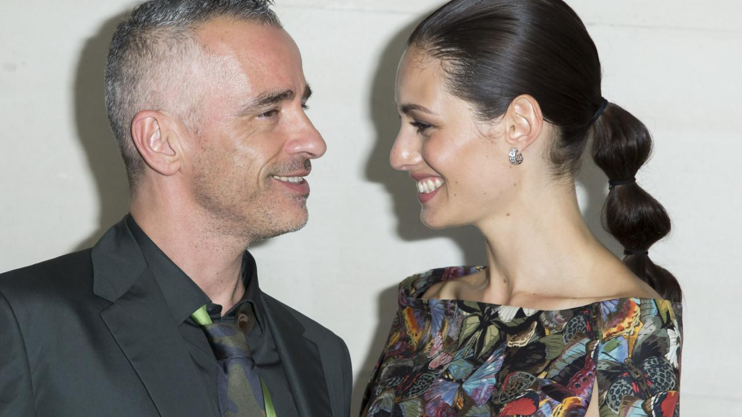

The End

© Maryanne Peters 2019