**Mamiya Inori**

**The Prayer of volition**

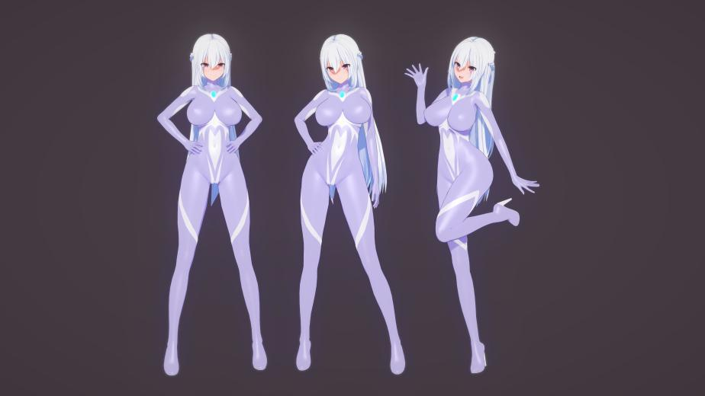

Kanamori High School-Hokkaido Sapporo Campus-Senior student-17 years old

Barefoot height 161cm-Wearing high heels after the transformation height 168cm-Weight 49kg-G cup  
Transformation lines：In the name of the light that traverses galaxy——Reply my prayers, Advent！

Megalization：Let the starlight cross galaxy！

Ultra skill：Descending——Enlightening Star！

Inori is kind and lively little canine girl,she is a little too naive and kind, but also not introverted,she is a dynamic girl.But no matter how hard she tried,her academic performance was at an average level.inori's teachers and friends thought she was a kind but weak girl,but in fact,she was able to keep that spotless and pure heart with a belief in justice that was tougher than anyone else.

Even after gaining the miracle power of Ultra-girl,Inori thinks she is only doing her small part to protect the innocent,not doing something as great as"justice",but whether she claims to do so or not,when she protects the weak,The justice has been done by her.

Although Inori is a kind-hearted girl, she has excellent reflexes and is good at sports, after transforming into Ultra-Girl, she also uses physical arts as her main means of combat, and at school, Inori is also very enjoy herself to participate in various sports activities.

But when she was playing tennis or basketball,the other boys would always pay more attention to her two bouncing breasts-even if they were called "perverts" by the other girls,boys in their teens could never ignore the presence of such strong body lines and couldn't help but stare at Inori's ample breasts!

Weak Point

Because Inori character is too good,she is easy to be used by the bad guys,and when she is absorbed energy,the pleasure coming from the body for the kind Inori is extremely humiliating and painful,she is difficult to resist the enemy in the absorption of energy for a variety of humiliation.

Inroi's excellent reactive nerves make her athletic,but also makes her whole body(neck,waist,armpits,inner thighs,knee sockets,etc.)very sensitive,especially her clitoris,when showering,Inroi are trying not to touch her overly sensitive clitoris,when her clitoris is accidentally stimulated,Inroi will not even be able to hold the shower head.

Even if Inori choose to transform can not solve this problem,transformed into Ultra-Girl,her sensory nerves will further become more sensitive…

**Mamiya Ouka**

**The Blossom of Memory**

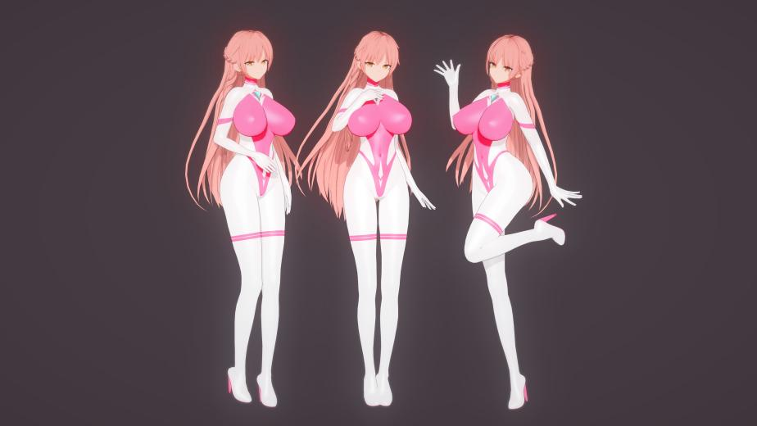  
Kanamori High School-Hokkaido Sapporo Campus-Senior student-17 years old

Barefoot height 162cm-Wearing high heels after the transformation height 170cm-Weight 52kg-H cup

Transformation lines：In the name of the dream that intersects reality——Deliver my blessings, Raise！

Megalization：Let the dreams intertwined！

Ultra skill：Drifting——Fantasy Phantom！

Ouka is a gentle but a little slightly arrogant and perfect female class president.Although Ouka and Inori are twins,Ouka grew up believing that she was the older sister who needed to have more initiative and responsibility.In a family where her father was absent because he was always busy with business trips,Ouka often played the role of the parent and took many of the responsibilities on herself.

In school,Ouka is highly regarded by teachers and students alike.Ouka is the perfect goddess in the eyes of her classmates,the smart and hard-working class president who always scores perfect marks in exams in the eyes of her teachers,and the gentle older sister in life who is outstanding and trusted by all her friends.

What others don't know is that Mamiya Ouka is also a deep sister lover.For example,in PE class when boys peek at Inori's breasts and even point at them,Ouka will often find some reason to get the teacher to excuse the boys.Ouka has a strong sense of reason for almost everything,and deconstructs and reacts to it with a genius of logic and analysis,but only when Inori is involved does her sensibility have a chance to overcome reason…

Mamiya Ouka is not as athletic as her little sister, her body is a little more voluptuous than Inori's,and a pair of proud and beautiful breasts are more exaggerated.When fighting evil as Ultra-Girl,Ouka is also not as good at close combat as her sister.However,Ouka has more abundant Lumen energy,and is good at using and manipulating energy in a variety of ways,so as to finally achieve her meticulous battle plan.

Whether as an older sister or as an Ultra-Girl, Ouka's excellent ability and strong character make her appear extremely reliable, but too much burden also makes the actual external softness and inner strength of Ouka's body and mind like a taut string, this reliability in the eyes of others but gradually she has developed a paranoia that does not allow herself to relax…

Weak Point

Ouka,who is very articulate,has a particularly sensitive mouth,and because of her quiet and virtuous character,the shame of being backed in will be especially strong for Ouka,and the pleasure will be multiplied if she is guided by her enemy to develop her ass…

Mamiya Ouka with her brilliant mind and incredible ability, both in school and in life she has always been smooth sailing,almost no experience of failure,if she suddenly suffered a strong setback in fact will be very easy to emotional breakdown.Ouka's subconscious mind is very fearful of failure,and her constantly tense spirit is actually vulnerable.Therefore,it seems to be clear-headed,but Ouka is not resistant to mental-type attacks on abnormal.

Although she does not show it to the public, Ouka has excessive perfectionism and obsessive-compulsive disorder, as well as overindulgence in her sister, if someone can use Inori as blackmail ~ the consequences can be imagined…

**Mamiya Yukina**

**The Luna of Gentle**

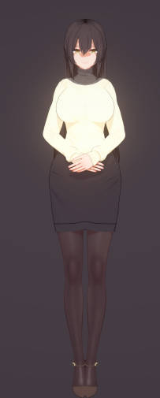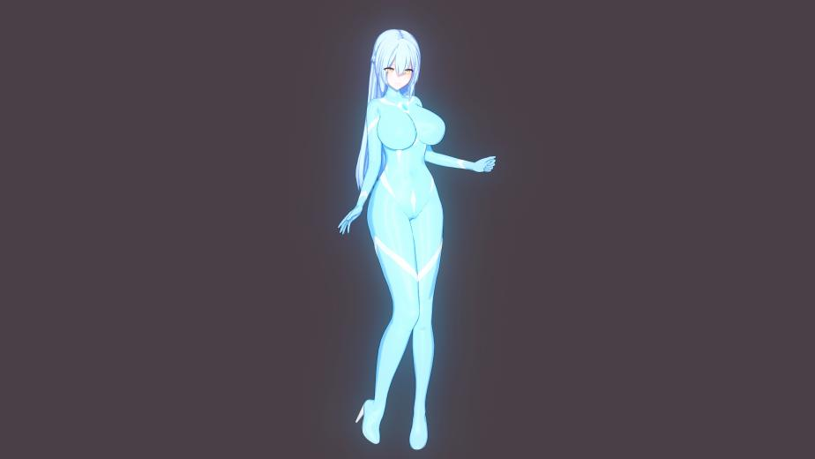

Housewife-43 years old

Barefoot height 164cm-Wearing high heels after the transformation height 172cm-Weight 54kg-H cup

Transformation lines：In the name of Luna that guide the way——Illuminate my hope，Reveal！

Megalization：Let the Luna guide the way！

Ultra skill：Shining——Lunar Alignment！

The mother of the Mamiya sisters, quiet but not delicate, understanding,she is a typical Yamato Nadeshiko type of woman,Yukina's eyes are bright and flexible,her voice is clear but not flamboyant,she speaks eloquently but not cunningly,she acts with integrity but not monotonously.

Yukina was born in Tokyo,gained the power of Ultra-Girl during her high school years (in the year 2020,which is in fact the time when the Goddess of Creation gave the miracle power to the world,and Yukina was the first Ultra-Girl on Earth) and has been exercising her mind and will.As a seasoned Ultra-Girl,Yukina has a great deal of experience in battle,and it can even be said that she is the strongest Ultra-Girl in all of Japan,a superlative in the entire scope of the Earth,and thus has never lost a battle against evil.

After graduating from a prestigious university with a graduate degree,Yukina met Mr. Mamiya (Kunihiko Mamiya),a congressman from her local constituency,during her internship in Hokkaido,and formed a beautiful family with him.Yukina respected her husband's choice and retired to become a warm haven for her busy husband,And she gave birth to a pair of lovely twin sisters.

Yukina's husband travels a lot,Yukina as a full-time housewife,has been raising her two girls almost alone.Yukina's example has led Ouka and Inori to be nurtured well and to become two outstanding girls.By coincidence, her two excellent and kind-hearted daughters also gained the power of Ultra-Girl,and they began to take over Yukina's protection of the town,Mrs. Mamiya chose to take a back seat and rarely took action herself.

Her spouse——Mr. Mamiya,is an honest member of the House of Representatives of the Diet.Mr. Mamiya is dedicated to improving people's livelihood and works diligently every day,often traveling for months,and working overtime is a daily routine.Mr. Mamiya has always been devoted to his work,even to the point of neglecting his family, but because he is too meticulous,he has offended many superiors,and although he is well-known among the public,he is still not promoted in his middle age.Mr. Mamiya is very satisfied with his beautiful and gentle wife,his well-behaved daughter and his happy and harmonious family,but he does not know the hidden identity of his wife and daughter as Ultra-Girl.

Weak Point

Excessive breast milk: Yukina has been nourished by Lumen energy subliminally since she received the blessing of light as an Ultra-Girl during her teenage years, so Yukina's body and appearance are kept very youthful and beautiful.

However,this"maintenance"also brings some troubles.Ordinary human women will finish breastfeeding after a period of time after giving birth,but Yukina,because of the maintenance of Lumen energy,even the physiological cycle of breastfeeding has been prolonged,and she has not weaned for more than ten years after giving birth to Ouka and Inori,and her milk is abundant and sweet,rich in Lumen energy.

Yukina was happy at first because she didn't have to worry about the girls competing for her milk,and the two sisters loved their mother's delicious and healthy milk after all.

But after the girls grew up a bit and no longer needed to breastfeed,Yukina's beautiful breasts continued to produce milk,and Yukina had to express some of the milk herself every once in a while,otherwise the milk would build up in the mammary glands,making the nipples swell up and get hot and uncomfortable.

Although she had thought about asking her husband to help her relieve her breast milk,the couple had not had intercourse since the birth of Ouka and Inori,initially because of labor and breastfeeding,and later because Mr.Mamiya was busy with business and left early and came home late,hardly spending the night at home,and it seemed that Mr.Mamiya's sex drive had greatly diminished due to his excessive work.

Occasionally,when the couple slept together at home,the hot electric sensation in Yukina's breasts would spread almost all over her body to her belly,and her private parts would be quietly wet,but the virtuous Yukina was concerned about her husband's exhaustion,when she saw Mr. Mamiya fall asleep as soon as he touched the pillow,she could not bear to wake him up.In the end,every time Yukina had to take advantage of her husband's work and her daughter's school to squeeze out her breast milk secretly.

As Yukina is a conservative and reserved lady,she is quite resistant to her"lustful"nipple masturbation,and only when her milk has reached its limit and has affected her daily life will she be rusty and masturbate on her own,she will only squeeze out a little bit of milk at a minimum and never indulge in her lust.

So in fact, most of the time on a daily basis,Yukina wobbly huge breasts are in a state of milk accumulation,which is one of the reasons why after her two daughters grow up Yukina chooses to take a backseat and seldom go out to fight the evil invasion herself.

Yukina received the Ultra-Girl power when she was 18 (in 2020)

She married at 25 and gave birth to Ouka and Inori at 26

She is now 43 years old（Year 2045）,but her body is as young and hydrated as it was when she was 20,thanks to the nourishing Lumen energy.

Ultra-Girl hunter——Gudaff,27 years old (Year 2045)

Looks……Ok？Feels to be 20 years old.

The purpose appears to be to NTR Yukina and play with her emotionally and physically？

In fact, his real purpose is not only that, but also the precious Lumen energy!

When i say Lumen energy……I mean……All the energy of the three girls!

Ouka：Tsk,He pretended to be moral,but I could feel only lecherous eyes under his sunglasses…

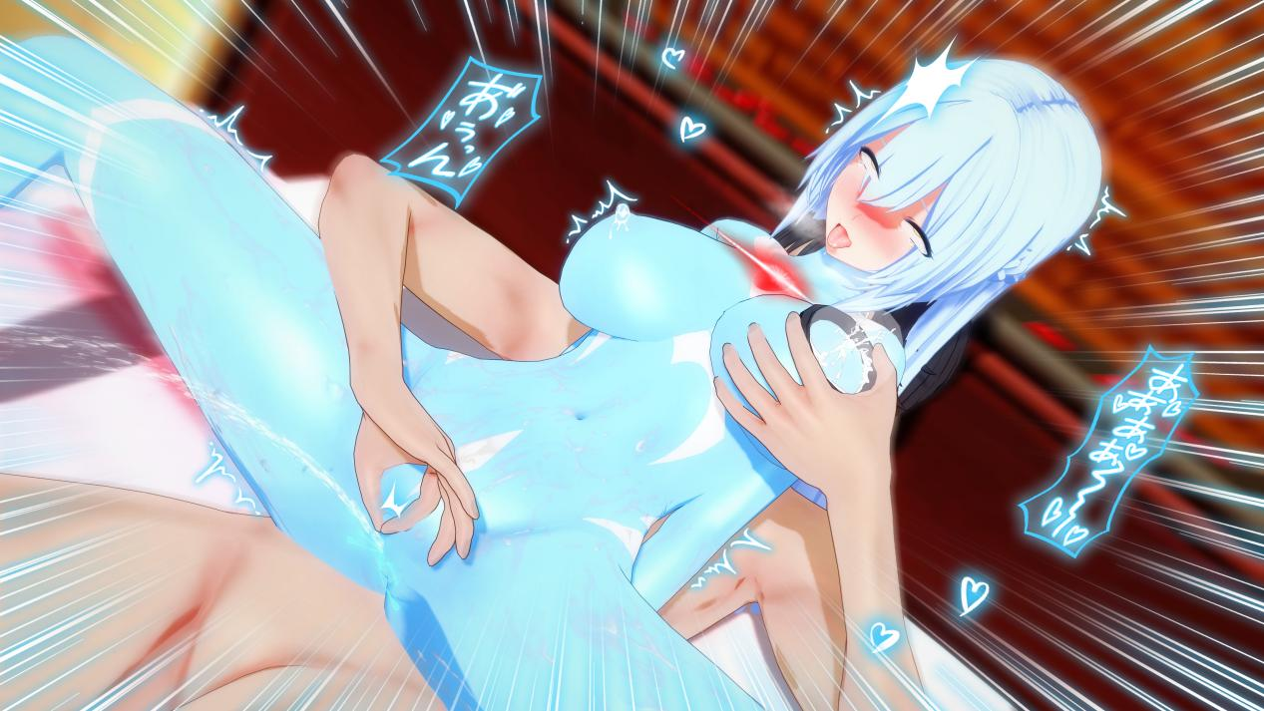

Fan Trolling：Anime is really something full of infinite possibilities  
Ouka's breasts are already the same size as her mother's  
  
Mrs. Mamiya,is your genes a little bit too strong?

Although Anime and real life are completely different  
But when I think of Lady Ouka becoming a housewife,there will be further development……There should be……right？  
Just thinking about it gives me a special kind of joy.