SARDEGNAN HOLIDAY II.
COMMISSION STORY
BY CHALDEACHANGE
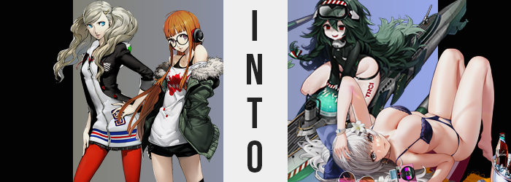

Something had been very awry with their fellow Phantom Thieves.

It had only been through several days of observation from Ann Takamaki and Futaba Sakura, but things had gotten rather strange when the girls had realized that the contacts for their dear friends had been changed entirely in their phones. It hadn’t even been a subtle change, because the names that were recorded in their place certainly hadn’t belonged to anyone Japanese.

The names were expressly Italian, and that was reinforced by the fact that whenever they called or texted them, the responses they received were in Italian as well. But what was (arguably) strangest of all was that regardless of which number they called, it was a woman that answered on the other end. There had been men among the Phantom Thieves, so…

There also hadn’t been any clearcut way for them to figure out what had happened. These phone numbers, Futaba found, still led to the phones of their friends. But no matter where they went in their home city, they couldn’t find any of them. It was almost like they had disappeared entirely! The investigation ate away at all of their free time. No one other than themselves could even remember them? There were no traces of them ever existing in the first place?

Was it a trick of the Metaverse? Had someone done something using it? That was the only thing they could think of, but after several days of wracking their brains? They had decided that it was better to stay together, and so Ann remained at Futaba’s house, using the spare bedroom – which begged the question why Sojiro had never let Ren use that room, honestly?

“So Ren is Pola, Makoto is Libeccio, Ryuji is Zara…” Sitting at the desk she had been afforded in the spare bedroom, Ann was jotting down which name in her phone led to which number. Apparently Futaba was going to stay up all night scouring the corners of the dark web, but really? They had no leads. Nothing about this made sense. Apparently the numbers weren’t even in Japan anymore! Unless the Phantom Thieves had suddenly been kidnapped by a gang of Italian women, somehow forgetting Futaba and herself in the process, she really couldn’t imagine what might have transpired.
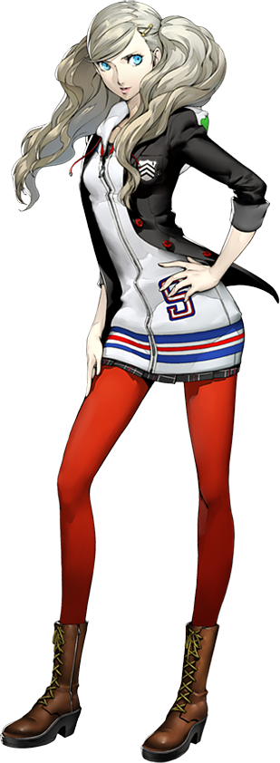
With a defeated sigh she soon pushed herself away from the desk. She had to use the bathroom, and she had a question for Futaba as well. It was mostly about the security of the house. If someone really wanted to kidnap them, would regular home security be enough? But they hadn’t managed to convince anyone that they were in danger either, seeing as no one believed that their missing friends had even existed in the first place.

Opening the door, Ann stepped through it with the intention of rounding the corner. Yet her senses were assaulted twofold. One by a bright light shining from above, and the other being something hot and grainy against her feet. “Ow!”, she cried with surprise on both fronts, but after she got her bearings once more she realized. She was no longer in Futaba’s house. “H-Huh!?”

The bright light was the sun, even though it had definitely been nighttime just a second ago. The burning feeling? Her bare feet on hot sand. Ocean waves crashed against a nearby shore, and palm leaves rustled nearby in the breeze. She was on a beach!? And it didn’t seem like any beach you might find in Japan, either!

For how understandably shocked she was, however? The next sound that left her lips was not another cry of surprise, nor even a questioning remark. It was a laugh. A really, really creepy laugh that took even her by surprise. “Hehehe…!?” It was so surprising that she stumbled back. “Wh-What’s funny about this? Where am I!?” Could it have been the Metaverse? But she was still wearing her uniform, not her Phantom Thieves costume?

“Is this where the others went? No wonder we couldn’t find them…” This made the most sense, right? Everyone else had disappeared without a trace, and considering how suddenly she had ended up on this beach? But then why had their contact information changed? Why had their phones been answered by Italian-speaking women? There were still elements to this mystery that made no sense.

But there were clues Ann was missing, if only she had turned her attention inward.

To begin with, her appearance had begun to appear increasingly disheveled. Even with everything that had been happening she had made a point to take good care of herself physically. Ann was a model after all, a single day of bad care could lead to her not looking good enough for the camera. And yet… Certain aspects that should have been well kept appeared increasingly less so.

Take the teen’s fingers, for example. Manicured and painted nails lost their color, chips and cracks forming in them until it became increasingly clear that this wear was from biting her nails – which wasn’t a habit that Ann had whatsoever. There was also the matter of her platinum blonde hair. It was usually curly in all of its fluffiness, but strands had begun to dart in more dramatic directions. It left the style looking downright messy, all while deep bags appeared beneath her blue eyes.

While her complexion worsened, frayed and thickened locks of hair were set even more awry as some of the strands began to darken in color. It wasn’t like they crept towards a normal color like black though, not at all. These strands were a dark green, and one by one her mane lit up with this forest-like coloration. “S-So what do I do now? Wh-Where are the others? Hehehe…” When she spoke of the others she was referring to her fellow Phantom Thieves, but she unknowingly had been thinking of different people altogether when those words had crossed her lips with a stutter.

Ann’s eyes, already sporting those dark and tired circles, lost even their bright blue colors as a more menacing, exasperated crimson settled into place. This inadvertently highlighted a change that had otherwise gone unnoticed – while the girl was fairly pale already, her skin seemed even whiter than before, and the dark red eyes contrasted them sharply. There was also something else about those eyes though. They were rounder, like the Caucasian blood that ran through her veins was alone, without the influence of her Japanese half.

Her posture seemed a little shaky, but then again? She just appeared generally shaky. Where was all of this anxiety coming from? Even if she was worried about her situation, she shouldn’t have been this worked up, right? After all… “W-Was I left behind?” Spoken through lips that were thinner, between cheeks that were rounder, Ann’s voice came across as soft and, honestly? A little bit unsettling in sound. It almost suited her tired and disheveled appearance a little better, and this included a face that was rounding with childish weight. She looked younger.

“N-No… Was that the problem? I was… looking…?” For her friends, right? It was clear that the girl’s personality was changing, but so were her memories. While her goals were vaguely similar, the people she pictured that she was searching for, as well as why she had been separated from them in the first place, were concepts that were altered beyond her noticing. But it did serve as ample enough distraction as some notable changes plagued the rest of her body.

Namely? Ann’s figure. She didn’t believe she had a particularly sexy figure even if she was a model, but when it came to her chest that became increasingly true. The little weight that her bosom sported faded away, the front of her shirt flattening in response to their absence, bra cups loose beneath the cloth.

Though to compensate? Aspects of her figure below the waist began to flourish. Her thighs in particular were prompt in packing on additional mass, skin pulled taut around them as they practically tripled in size, bright red tights stretching to accommodate this growth. On the side of her left thigh? The letters TRCI were tattooed upon it in a stylized font – a clue about the identity she was inheriting. But the weight that bloated her upper legs wasn’t quite finished yet, for it brought volume to her perky rear as well.

Lost in thought about the idea that, perhaps, she was forgetting something, the girl didn’t pay much notice as the world around her began to grow larger. Though this wasn’t technically true, for it was simply a case of her body’s height rapidly regressing. Almost like someone was pushing down on her head from above, limbs and torso all shortened in tandem with hands and feet in tow.

The childish look of her face certainly made some sense by the time she had fallen to about 4’5”. Her body was short and child-shaped, and while her uniform dangled off of her shrunken form now? A black swimsuit could be gleamed sticking out from underneath. It was a two piece bikini with a translucent, black throw overtop – all completely displayed as a sudden shift in reality removed her previous clothing and bestowed upon her head of long, messy green hair (as her hair had not shortened as she shrunk) a white, straw sunhat.

Small as she was (though her large rear and thick thighs certainly compensated for it), Torricelli had a difficult time looking over the hill that led to the top of the beach. Rather than wonder about what had just happened to her, for she had no memories of living as a half-Japanese teenage model, the very small woman was instead looking for the people she had come to the beach with. Namely her fellow Sardegnan shipgirls.
It was strange to find her going to the beach with others in general though. “Hehehe! Did I get… separated?” There was something inherently creepy about her. The way she spoke and giggled was part of it, but she even dressed in a dark and unsettling way. Like a creepy girl you might find in a horror movie, even if it was simply goth fashion sensibilities paired with an anxious personality.

She was on the verge of going to find her friends when something in the corner of her crimson gaze caught her attention. A sea turtle in a pool of water at the sand’s edge. Small legs carried her as quickly as possible, where she collapsed down on her knees and began to play with the unsuspecting reptile. “A-Aren’t you a cutie?”

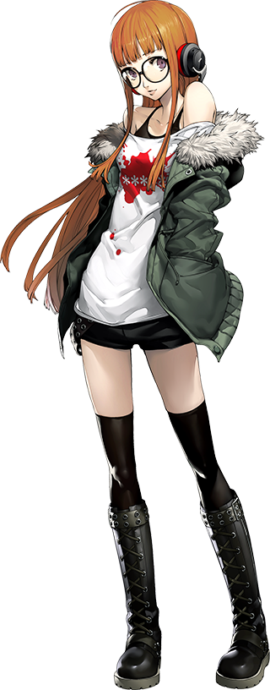
It had been a while since Futaba had heard from Ann, and since it was her first night staying over at the Sakura house, the girl eventually came to the conclusion that she should probably check on her older friend. The whole reason she had given Ann the spare room was that she didn’t want to disturb her with the clacking of her keyboard, and since it was the room right next to hers, if anything happened she would still be able to check on her.

Before she could do just that, though? Her phone vibrated. It was a message from one of the numbers that had been traced back to their missing friends. “This one was Yusuke’s, right? Littorio…” Since the messages were always in Italian, she had stopped reading them since she couldn’t do so without a translator. This didn’t even cross her mind upon reading it though. “Why did you go out on the boat without me, sister? Huh? Who’s sis…? BOAT!?”

Not only had she just read a text sent in Italian as if it was completely natural, but upon looking up from her phone? She was no longer sitting at her desk. She was sitting on the driver’s seat of a boat! It was rocky since there were some light waves, and she could see a beach nearby, but… “WHERE THE HELL AM I!?”

This outburst of hers was more than warranted, but at the same time Futaba was a very dramatic individual from the onset when she wanted to be. So shocked, she had dropped her phone on a nearby seat to flop around in a panic. “W-Woah!?” But gave doing so a second thought as the boat began to rock back and forth. “Wait… This isn’t the Metaverse and doesn’t this look kind of like Europe?” At least from what she could see of the shore. “Could it be this is where everyone else ended UP!?”

The teen felt like she had stumbled upon the source of the mystery. Her friends had to be here somewhere! And yet what should have been a moment of celebration quickly turned into one of surprise, as she hadn’t shouted ‘UP’ intentionally. The word was, however, fitting considering what had prompted the shout in the first place. She had been knocked entirely off of balance.

…Because her eye level had suddenly jumped significantly.

Not only that, but her clothes were tighter. Thigh highs had slid down to her knees and the base of her shirt had lifted up, but Futaba wasn’t so clueless that she didn’t notice the underlying cause of all this. “Did… Did I just get taller?” She knew the answer. It hadn’t been subtle at all, seeing as she’d grown about five inches. The rest of her body hadn’t grown to accommodate this new height though, and so she looked rather lanky?

Why was this happening though? Was it just a distraction? She needed to focus on finding her fellow Phantom… thingies? “Wh-Who was I looking for again?” No, no, no! They were important, right? Her friends? Her friends! But why couldn’t she remember what they looked like? “Eep!?”

As much as she would have liked to dwell on the holes in her memories to get to the bottom of what she was forgetting, her changing body kept pulling her mind away from doing so. Because now? Her shorts felt tight. Like very tight, and leaning forward it wasn’t all that hard to see why. Her hips, for one, were being forced a handful of inches wider. This alone was enough to prompt the front button of her shorts to pop right up, flying into the water that surrounded the boat.

“I need to get these off!” Because the tightness was still growing, Futaba struggled to slide her fingers into the sides of those shorts and began to push them down. Except they kept getting caught on, well, everything. The curvature of her ass had blown up into excess, cheeks full and soft, triple their usual girth. The peak of her shorts was getting caught on their hump, but even after she eventually freed them? The base of her shorts got caught on thighs that engorged to such a thickness that they touched each other between her parted hips. “THERE!”

She almost fell over as, with one final downward push, her shorts were forced all of the way down her legs. Strangely? Her panties didn’t go with them, but then again what was wrapped around her loins wasn’t the panties she had put on that morning. It was a black bikini bottom with straps reaching up and underneath her shirt. But strange as it all was? “Phew. That was uncomfortable. Why was I even wearing those children’s shorts?” She couldn’t even remember wearing them?

Not her shirt and tank top, for that matter. And her attention was quickly drawn to them as a narrowed waistline acted as a precursor to the inflation that followed slightly higher up. Her small chest received a treatment that was quite the opposite as to what had befallen Ann, with breasts inflation almost as if they were balloons being filled with water. It wasn’t water that filled them though, natural fat deposits increasing as nipples grew to meet her eyes in terms of size.

The base of her shirts were lifted higher and higher, and Futaba went to pull them up and over her head – evidently not thinking much of how her body was becoming more bombastic with each passing moment anymore. The bottoms of the shorts got caught on her F-cup tits no sooner than she tried to lift, but with a bit of force? She finally removed them, breasts bouncing heartily as they dropped back down.

She knocked her glasses off her face while lifting the shirt over her head, but she didn’t notice. After all, her vision was a perfect 20/20? Why would she have needed glasses? “Is something truly amiss? Perhaps my dear sister would know…?” Her voice was huskier, but who was this sister? Hadn’t she been an only child her whole life? Not to mention that without her shirt on, the black latex reaching up from her bikini bottom had a clear purpose. Both sides met over her bellybutton, and that strand reached up to the cups of a skimpy, black bikini top.

Futaba was certainly better dressed for a day on the boat, the sun kissing smooth, shimmering skin. The color of it had inherited a touch of tan, yet more dramatic color changes were present upon her head. Her purple eyes took on a glassy blue for once, but a white silver also swept through a head of hair that became softer, longer, and fuller. Like she had been taking much better care of it.

Long, manicured fingers pushed some of this hair over her shoulders, blue eyes not even sparing a single strand a glance. But those eyes themselves were rounder and fuller in shape, taking a Western appeal like Torricelli’s – part of a broader facial change that left her face longer and narrower, with shiny, kissable lips that sat in a passive pout.

A blue bow pulled all of her hair into a ponytail, and tinted sunglasses rested on her forehead with a floral decoration. Yet her swimsuit felt… ill-adjusted.

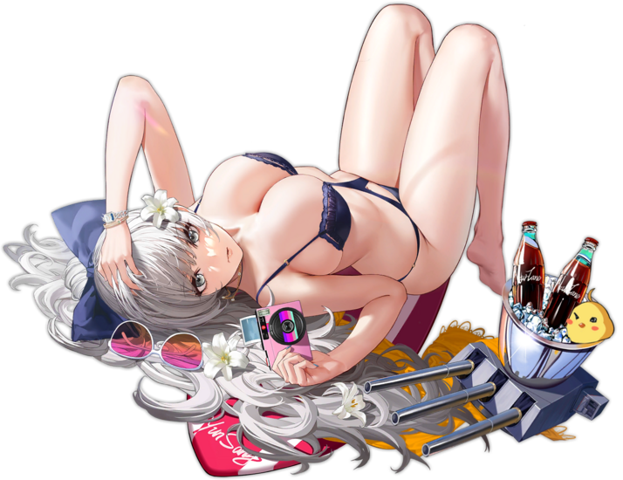
Adjusting her swimsuit, for Vittorio believed it had slid naturally and not because her body had just undergone a very dramatic change, the young woman finally reached for the phone she had put down and the text that had been sent to her by her sister, Littorio. “Dearest sister… You all slept in, so I went ahead. But I will come back to get you. Make sure Torricelli is with you as well.” She spoke the words that manicured fingers furiously typed in tandem. What would she do with those fellow Sardegnan shipgirls that she had come to this island resort to vacation with?

Still, full lips presented an amused smile. She loved her friends dearly, so she would forgive them for sleeping in that morning. And if any of them had complaints about the delay on her part? Well, there was an innertube in the back of the boat that she could dangle them on! Graciously, of course! “I suppose I should get back to shore, then?” As much as she wanted to continue to sunbathe out on the sea where the breeze was cooler, this vacation was for all of them.

Plus they had only been allowed to rent a single boat, so it would have been rude for her, elegant and kind as she was, to hoard it all for herself! But she did worry about some of their party. Torricelli had a habit of keeping to herself, so Vittorio had been trying to get her to socialize with the others more.

Funnily, this was the opposite of Futaba’s relationship with Ann.

