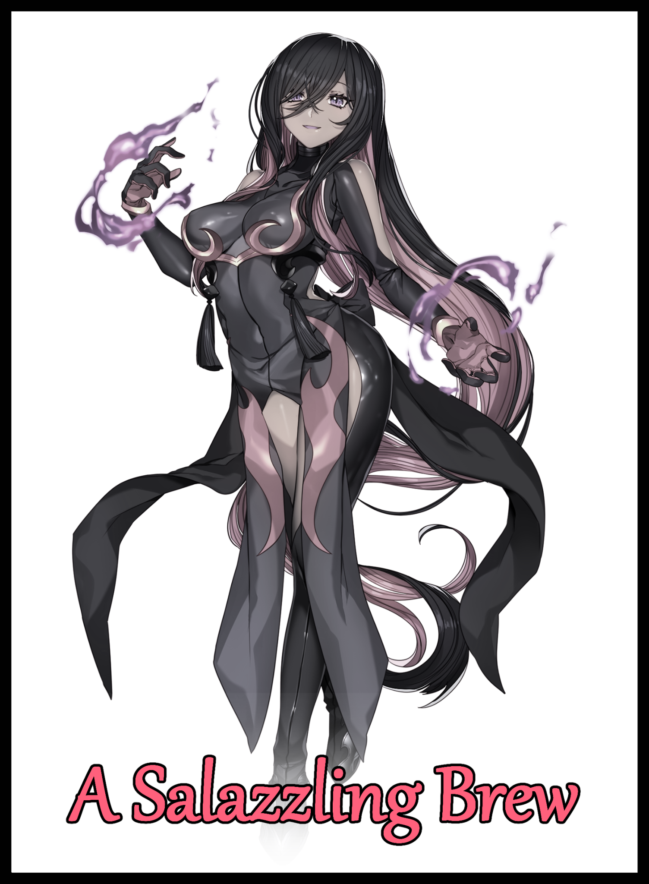

In the far flung land of Alola, there existed a certain group of ruffians not too dissimilar to the other named gangs across the world. Although many were now defunct following the thwarting of their respective plans by nameless heroes who came together in defense of their home and people, this group's reasons for disbanding were far different from the others.

Now that the former band of misfits and outcasts had gone their separate ways, the tropical archipelago had more or less returned to a state of relative peace. Free to rebuild from the damage caused by the massive influx of Ultra Beasts thrown out of wormholes that were forcefully opened as a result of the recent region spanning event that the former Team Skull had unwittingly involved themselves in.

Free to do as they saw fit, many Team Skull members would find their fortunes forming rescue teams, aiding in odd jobs or simply leaving the region altogether without their beloved leader Guzma to unite under.

With his days of terrorizing Alola as renegade team leader hung up and forgotten in favour of a fresh, clean start on life. The former Team Skull head would instead devote himself to bettering his skills as a Pokémon trainer while flaunting his skill in an effort to gain recognition just like he always wanted, returning to his family's home, training both his skills and fury under a prominent figure in the region while keeping a constant eye out for the people he had come to know all throughout his life; Former Team Skull members, local faces and new ones from abroad.

And among those faces, there existed arguably one of the few souls who knew the former Team Skull leader like no other. What drove him forward, the closely guarded secrets he held next to his heart and the reasoning behind the manipulation that led Guzma to blindly follow after a certain woman…

Currently following in Guzma's path as a reformed Pokémon trainer, Plumeria's daily routine had gone from managing the clueless Team Skull mooks she treated like family back in the days of old to operating out of a camper situated on Route 13, pushing herself to be a better trainer while helping out with whatever troubles the locals might have to deal with.

Unlike her allies however, who got to deal with rampant Ultra Beasts displaced from their extradimensional home or repelling an enemy once thought defeated, the retired Team Skull Admin had to make do with trifling matters like making sure the areas near the coastline remained free of Pyukumuku, harmless Pokémon whose only crime was being overly abundant, resulting in them swarming inward while competing with the local fishermen for food. But they did fetch her a good sum of money every now and then, especially when they resisted her attempts at kicking them back out to sea thanks to the slime they produced being a core ingredient in the creation of some of the world's best sunscreen lotion.

She used to feel a little bad every time she had to squeeze one of the wiggly buggers tight lest they slip free. But after getting socked in the face by one after forgetting how they could launch their innards that were in essence a bundle of muscles and organs in the shape of fists they could use to beat unwary predators black and blue, that sentiment had faded somewhat alongside weeks of repetition leaving her desensitized to the whole thing. Plus it wasn't as if she was harming them anyway, compared to her Pokémon's rending claws and gnashing fangs, soft, human hands were like heaven in comparison.
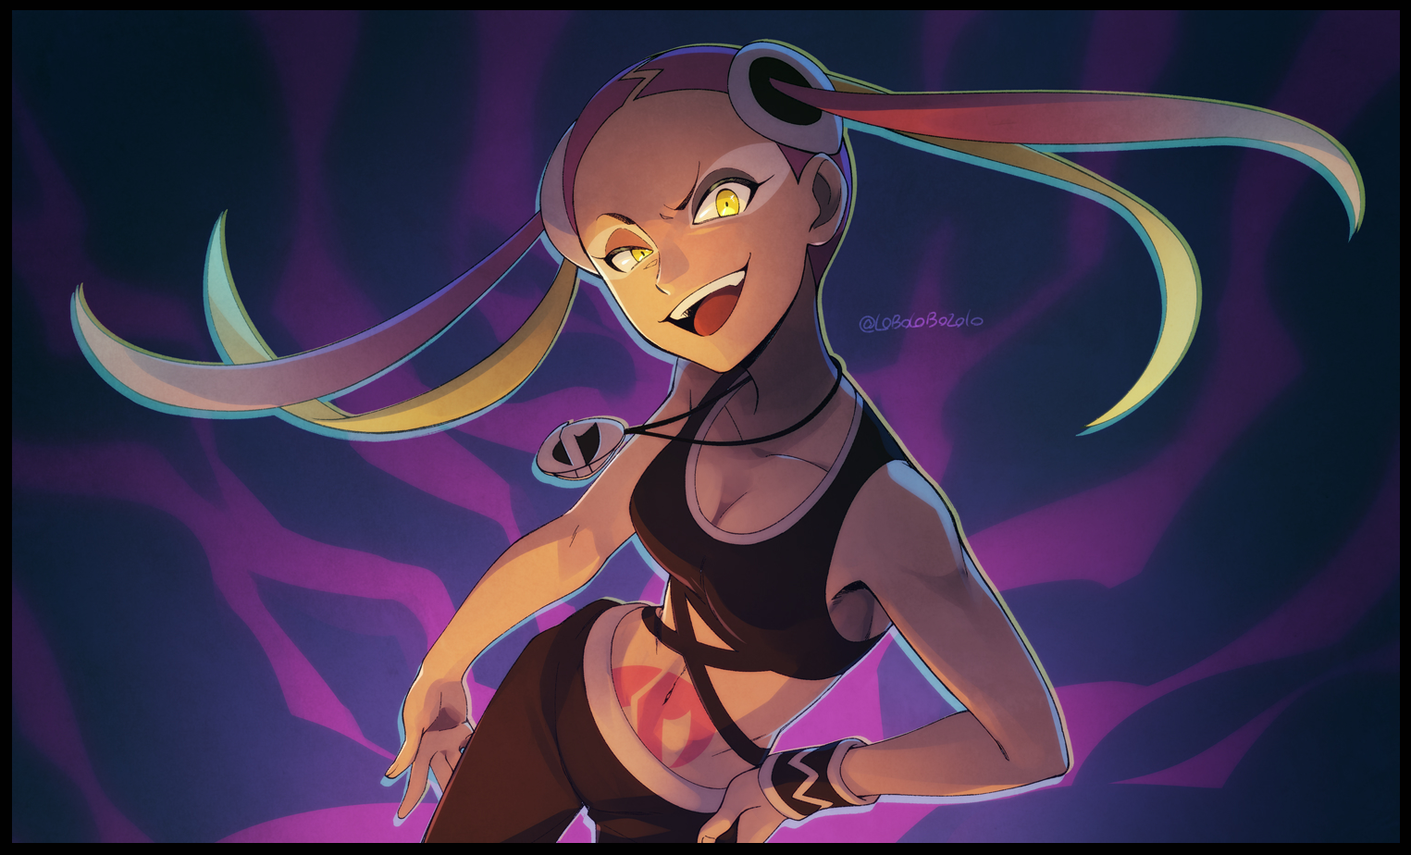
A fact that had her self deprecating thoughts roaring into full gear whenever she was reminded of her current predicament serving as Ula'ula Island's de facto janitor of the shorelines. Sure, it made for a well paying distraction. But as the days went on, Plumeria was beginning to grow more and more troubled by the fact that she just didn't seem to be improving at all in terms of her skills as a Pokémon trainer. Even during the rare moments where she got to participate in subjugating Ultra Beasts appearing on Ula'ula, most of the fighting was handled by the island kahuna and his comrades. Leaving her with little else to do besides lending support with what few hits she could get in with her Pokémon.

For about two months now, she had been challenging the current Alolan Champion for their title, spurred on by the advice of Ula'ula kahuna; Nanu and Molayne. Two members of the Elite Four she'd proven herself against multiple times whenever they stood before her as obstacles before being allowed to have a go at the Champion themselves.

Sometimes Plumeria would come painfully close to victory, while at other times, her party would suffer a crushing defeat right at the start. But she had never been able to win, not once ever since she had met the childish individual who was now sitting atop the figurative throne of Alola as its most renowned Pokémon trainer, something she, Guzma and the rest of the now scattered Team Skull sought to achieve even now.

Despite her weak willed heart weighing her down after every defeat, Plumeria still wasn't willing to give up on the hope that she would come out on top some day. Earning the recognition she desperately craved after turning over a new life, making it a point to do the best she could all while Guzma's own progress occasionally graced her ears from gossiping fishermen and passing trainers. And every word she heard only served to paint a smile on her face.

But Plumeria would soon find out that even clean roads had their fair share of potholes and cracks looking to trip her up with every step in ways she could never imagine were possible in the first place as she awakens with a huff and a drawn out sigh, gazing out over the warm orange horizon with dawn's first light glinting off of the distant crags and boulders that dotted the shoreline.

Even from her vantage point up the reddened hillside, the experienced trainer could already see the writhing mass of glossy grays and dull magenta sensors milling about the sandy beaches. A fresh batch of Pyukumuku ready for her to beat back into the ocean, kicking off the sheets before groggily rising to her feet, trailing a fuzzy mane of multicolored hair that was rarely ever seen out of its usual quad tail style all while muttering under her breath.

"Why does there have to be so many of you guys every single time…give me a break already would ya…"

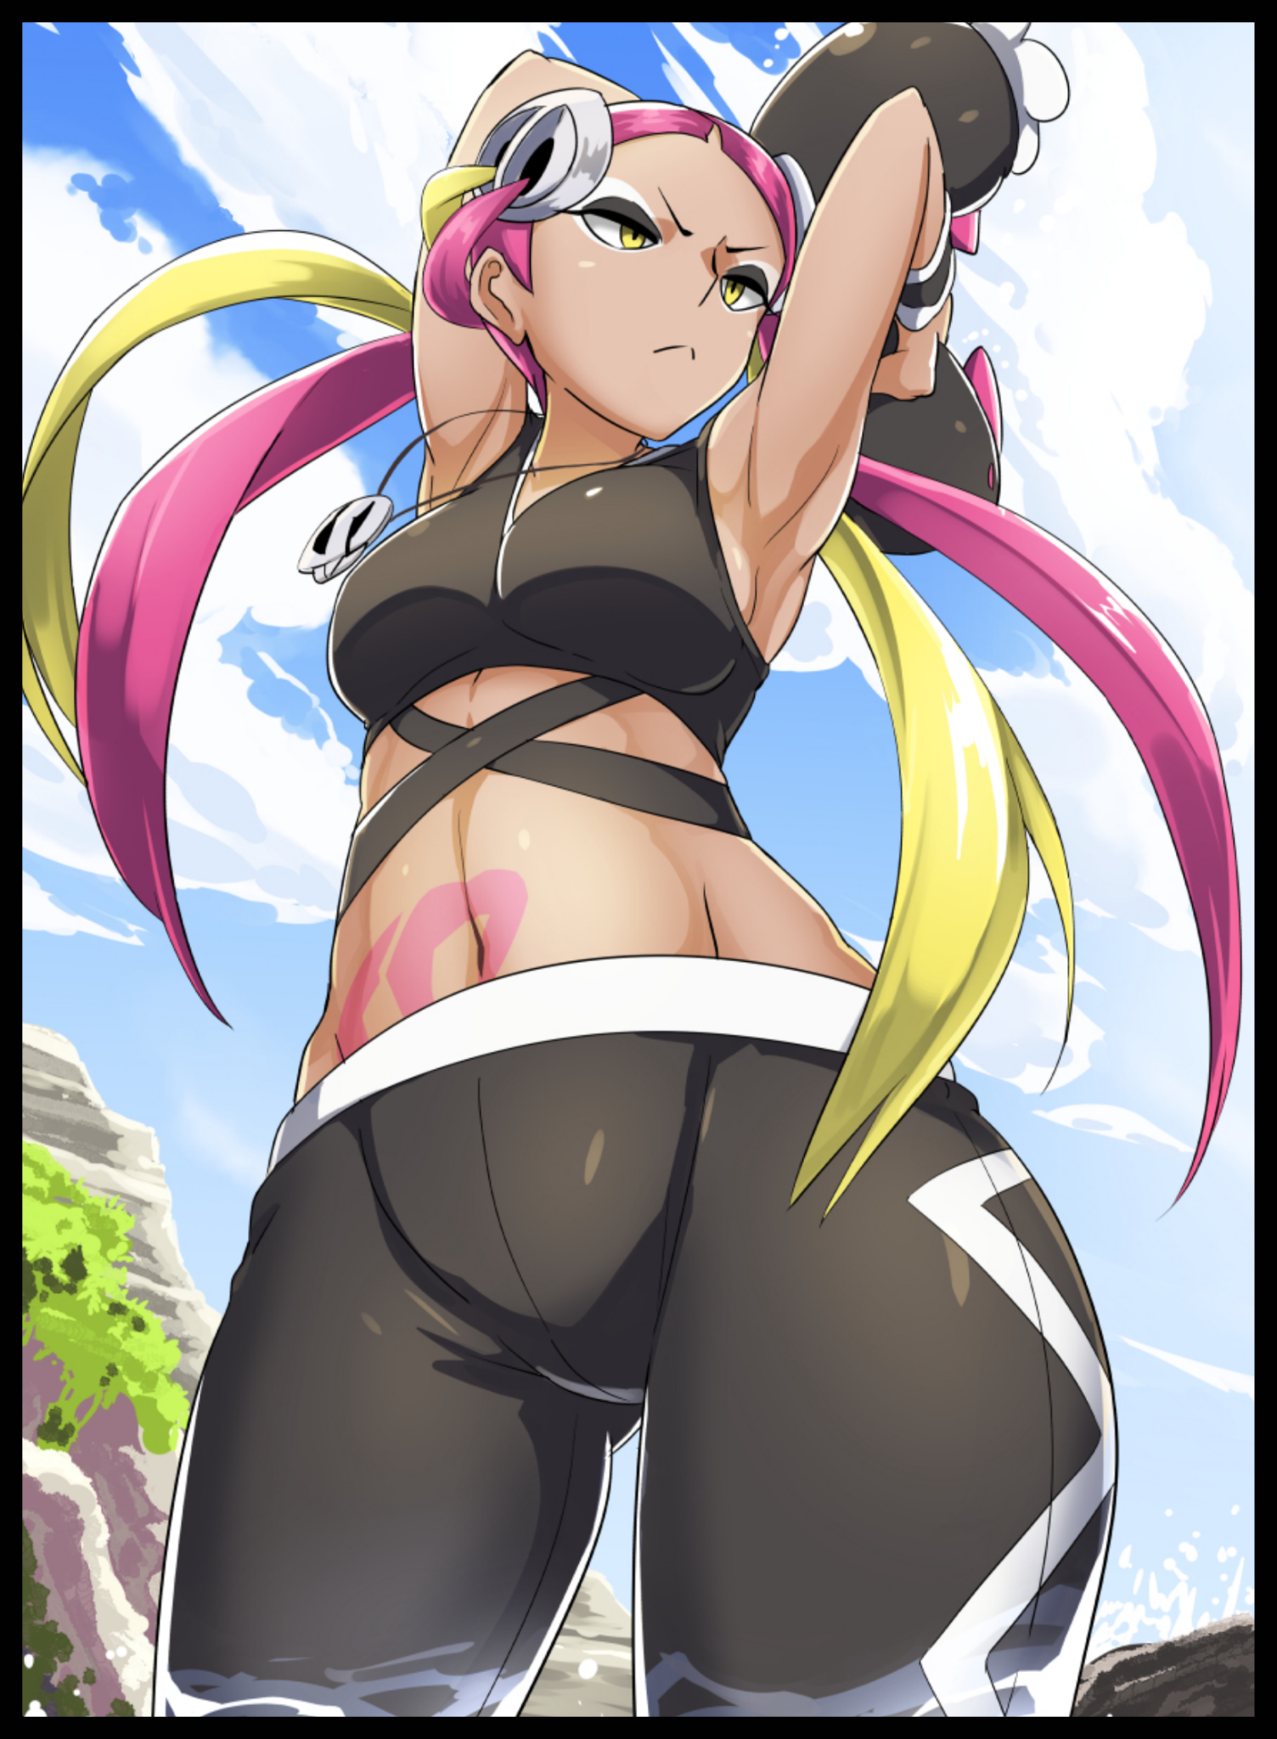
With the sun about to rise fully over the horizon, the formidable trainer was ready to get to work, exiting her camper dressed in her usual dark gray crop top and pants, the signature look she'd sported ever since she was Team Skull's sole Admin. Although she quite liked the look, Plumeria had been planning to revamp her getup in light of the group's disbanding. No reason to keep their insignia branded over her navel considering its negative standing in Alola. Even Guzma had begun changing his look little by little ever since.

But as she watches the writhing sea of wild Pokémon threatening to flood the beach again so soon after she'd dealt with them the day before, Plumeria knew to hold off on such thoughts until after work was done, popping open the Ultra Balls containing her tight knit team of five, setting them loose on the wriggly horde to do their usual morning routine of running around the shoreline scooping up handfuls of the wild sea cucumbers before launching them back out into the deep blue sea, engaging in small skirmishes with the occasional grumpy Pyukumuku.

Not to be left out, Plumeria herself participated in the cleanup, albeit at a slower pace than her Pokémon considering she didn't have their size, powers or agility, wiping sweat off the brow of her forehead while watching Gengar haul off four handfuls with shadow arms in tandem with Crobat's powerful winds sending groups of them flying off into the distance while Muk and Toxapex worked like a slow moving wave, shoveling Pyukumuku with claw and slime that left none behind.

But someone was missing, and as the mildly alarmed trainer swung her head around the beach slowly, Plumeria's eyes barely managed to catch sight of her last Pokémon's sleek, gray tail vanishing behind a bend at the side of the beach flanked by orange red boulders
Had she found a small Pyukumuku hidey hole?

A few seconds passed, and then thirty, until finally a minute was up. But there remained no sign of her Salazzle returning, drawing concern from Plumeria as she let slip the Pyukumuku in her grip. Returning her Pokémon to the safety of their Ultra Balls before wading through the knee high water towards the bend where her serpentine friend had vanished into.

"What do we have here…a cave…huh…"

The last words left Plumeria's mouth as more of an exclamation of frustration than disbelief. She wasn't angered by the fact that she'd missed a cave opening right by the shoreline she'd been patrolling for almost more than two months now but rather the claw marks and indentations that still remained carved into the stone wall around the dark opening. Too old to have been made by her Salazzle, too wide and deep for the Pyukumuku to be the culprit.

"Oiii~! Salazzle! You hear me?!"

Whatever had left the marks was big, and if it had slunk inside the narrow opening, was either flexible enough to do so…or had attempted to claw its way out of the cave to no avail, meaning that the opening was not a natural formation…and now one of her Pokémon had vanished into its depths without a trace, leaving Plumeria severely worries for her Pokémon after its failure to answer her calls.

'Crap…can't go back now…what'll happen to her if I take too long…ahh that idiot!'

Bracing herself against the side of the opening, the disgruntled trainer hoists herself free of the water below, hopping up to the cave opening with minor difficulty before venturing inside, feeling her way around the cramped passageway with careful steps forward, inching her way deeper and deeper inside until the daylight behind her had become a speck, the sound of waves crashing against the shore turning into a subtle roar that barely reaches her ears, listening out for the soft pitter patter of her Pokémon's footsteps amidst the dreadful silence that had replaced the seaside ambience.

By the time her hands were able to spread out fully around her, a low magenta glow was beginning to light the way forward, coming from somewhere deeper inside the passageway as it widens into a corridor until finally opening up into a circular chamber lined with strange growths and web like strands extending all around her, piercing the stone walls like support ropes hanging low, originating from a strange pool of alien liquid radiating familiar sprites and particles Plumeria had seen more than her fair share of to recognise, or at least make an educated guess as to what she was looking at.

"Ultra…energy? No way…why's there so much here?"

There was so much concentrated energy gathered here in a single spot, enough for the usually invisible particles to manifest as a still pool of mesmerizing magenta, fluctuating with occasional pulses of raven purple, refracting off of Plumeria's amber eyes as her attention slowly drifts toward the heart of the pool instead of searching for her still missing Pokémon. The colors seemed eerily familiar to Plumeria, so much so that her mind was beginning to fill with audacious ideas that just didn't seem possible.

If her Salazzle was still nowhere to be seen despite venturing into the heart of the opening she had disappeared into…and there was no other way forward…then the pool…could she have somehow slipped and fallen in?

"No…that just ain't possible…is it?"

But in the midst of her thoughts, Plumeria doesn't notice the subtle bubbling disturbing the still surface of the effervescent pool until it suddenly, a particularly large sphere begins to form, growing right under the rockface the oblivious trainer stood under, taking note of the growing vibrations from the stone beneath her feet at a point too late for her to go anything, side stepping with a mild curse escaping her lips just as the ground explodes, spraying the air with a liberal amount of liquid Ultra, splashing over the surroundings without much effect…

"Gagh?! W-Whathe...N-No way, you've gotta be kidding me!!!"

…Except for the unlucky human in the chamber, collapsing onto her back with a startled yell once all feeling in her legs had vanished, struggling into a reclined position only for her anger to turn into horror at the sight of her mangled legs; the left side dissolved down at the knee into gray purple goo while her right hand detached completely near her thighs, still being consumed by the rogue spray of Ultra energy that had erupted from the ground.

And it wasn't just her legs, being a spray of fluids, there was no way for Plumeria to avoid being hit without taking cover. And in an open space like this? That meant her entire body had come under fire from the sudden eruption, groaning with a strange warping effect in her voice while raising tentacle-like fingers up to grasp at her oozing fringe sliding down her forehead in magenta strings, collapsing onto her back once her elbows eventually give way, softening into beige putty as her body begins to lose to whatever this was; overexposure or something else entirely.

"D-Damm…eet..c-cahnt…l-let…"

With a gurgling groan and as much strength as she could muster, unlatching the sleek belt that held her Pokémon, shielded by the blast behind her still solid rump before tossing it as far as she could towards the entrance away from the pool. With another rumble, she didn't want to risk the safety of her precious team lest they too suffer a ghastly fate.

She had grown careless, and now she was about to pay the price for it, opening sagging eyes wide as an otherworldly chill seizes her spine, sending Plumeria flying upward through the air in a vaguely humanoid shape as another eruption of Ultra liquid douses her completely this time, eating away at her hair, removing her slim, curvy physique from her body losing its rigid shape until even her face was rendered featureless once eyes, nostrils and lips had closed shut forever, tossing the liquefied Plumeria right into the middle of the now frothing pool like an ingredient being dropped into a bubbling brew, a warped human silhouette gradually coalescing with the concentrated Ultra energy around her until Plumeria's body had faded entirely, leaving nothing behind besides her Pokémon, a fading gasp in the still wind and that hypnotic pool…

Except this wasn't quite the end for the aspiring trainer, for her thoughts remained strong within the not so inanimate pool. It could sense the strong bonds Plumeria had forged with both man and Pokémon alike; the worry for Salazzle that spurred her to brave the cave alone, the regret she felt for not having achieved her goals and the fear every living being felt when met with the concept of being forgotten after death. And with its recent catch still maintaining her sense of self in the collective consciousness it had gathered over the years, Plumeria's 'soul' would end up resonating with her Salazzle. Rushing to comfort her trainer in her greatest time of need, resulting in an unexpected outcome that sees a resurgence of activity from the pool as webs of living liquid surges forward, climbing out of the edge before forming into an ovoid far from the edge.

And from it, the gray magenta fluid would begin to rise in thick globules, forming the vague outline of a human skeletal system with a slightly elongated tailbone; the blueprint upon which a new body would be constructed over as more strands of Ultra liquid begin to layer themselves over the pale, matte coloration of actual bone overtaking the pink skeleton, forming vibrant red muscles, pale pink swathes of flesh, veins and other necessities for locomotion, molding dainty little toes, wrapped up in tawny brown skin leading up to toned calves and well fattened thighs, a combination the former Plumeria definitely didn't have before as more mass builds around the midpoint, forming leathery scales that encased the entirety of a bubble butt, tapering off down the thighs with a vacant space left empty between the plump folds of a virgin vagina. Glistening folds protecting a tight passageway leading up into a renewed womb that quickly vanishes behind a warm, supple belly bereft of the tone built up by its predecessors efforts to grow stronger. All while a cute, stump of a tail twitches to life beneath a gentle, flowing spine, barely long enough to be useful besides drawing attention to herself.
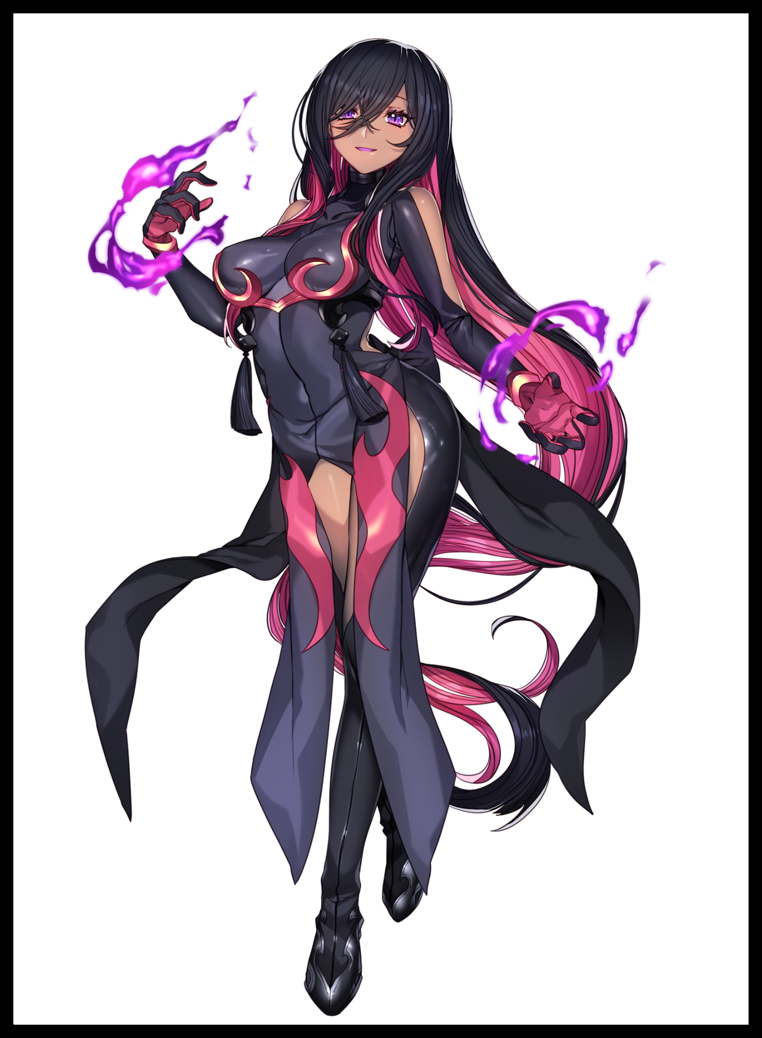
By the time nerves and glands began to form into what would soon become petite breasts, Plumeria's consciousness was already being funneled straight into the not so human brain taking shape in the skull of her new body, granting her the reprieve of being in a flesh and blood body once more as the tickle of alien fabric and cool air assaulting her sensitive skin eases her mind out of the temporary abyss she had found herself in upon the loss of her original self.

Except this time, she could feel a faint warmth rushing in to join her in the crevices of her mind, a warmth that sounded like a second voice making it hard to focus on what exactly it was she was trying to think about amidst the strain of getting used to her new body once nerves linked to waifish arms clad in contrasting pink-black gloves attached to a strange rubbery sleeve with generous cutouts exposing creamy smooth shoulders trigger, letting loose painful grunts from soft, pouty lips as searing fount of phantom fire begin to shoot forth from her palms, irritating her skin until they gradually acclimate alongside the new, flame producing organs situated at the base of her wrists. Flicking her diminutive tail out of a new base, animalistic instinct taking control of Plumeria's struggling humanity.

All while new clothes of foreign design to Alola continue to drape themselves over the reborn woman's distinctly older and voluptuous body. Concealing her privates while silken hair begins to sprout from her scalp, replacing the former blonde-pink shade she used to sport with a lustrous midnight black sheen laced with neon pink undertones, growing into a far curlier and longer mane than Plumeria's old head of hair, reaching down long enough to drag over the rough cave floor beneath her heel clad feet. A far cry from the tomboy getup she sported as quad flaps unfolded from bubbling masses around handlebar hips, laying themselves down over the exposed cameltoe outlining her steaming pussy from how tight the leotard beneath the dress was while the other remaining curtains rush to cover up their mistresses exposed butt cheeks. Completing Plumeria's overhaul once sultry eyes far removed from their former narrowed slits flutter open, revealing mysterious eyes that seemed to burn with her original amber yellow alongside a new shade of mysterious purple. Taking in the world around her with wonder in her eyes.

Everything seemed sharper, as if her vision had grown more acute, being able to focus in on certain points of interest in her environment like the retreating tentacles of Ultra fluid returning to the pool they had emerged from, colored a calm shade of ocean blue now that the two impurities had been ejected instead of being assimilated. But now the two were one, and as Plumeria finally gets the chance to explore her new body, so too would she realize that she couldn't quite recall what made her so depressed all the time ever since the disbanding of Team Skull, igniting a wisp of pink flame with a simple flick of her wrist, watching it dance while brushing aside an extended fringe of soft hair hanging down over her left eye.

A strange sort of confidence was building within her chest the longer she stared at the flame, unaware of the mischievous smile spreading across her now gorgeous face cleaned off the makeup she used to wear while her tense body gradually relaxes, taking on a stance reminiscent to that of the former benefactor that had used her friends in Team Skull to do her bidding; the display of a woman who knew she had the world in the palm of her hands.

But Plumeria was not the sort of person who wished for overblown things like world domination or pushing others around. Instead of grandeur, the desires influenced by Salazzle, who had been fused with her trainer, were more simplistic, aimed toward two things, one of which she knew she had already achieved without depression to weigh her down. And now that she had literal power and beauty to go with it, Plumeria was more than happy with her place in life, sashaying over towards the discarded belt of Ultra Balls lying by the cave entrance before bending over to pick them up, dusting off the spheres with a soft hand while cooing apologetically to the Pokémon within in a motherly fashion her old self would never have spoken in.

"I'm so sorry my dears…did I worry you? There, there, everything's all right now~"

Despite sounding nothing like herself, Plumeria couldn't help but enjoy the gentle tone of her new, sing-song voice dripping with a mature air, taking an exceptionally strange pride in it just like she felt with her body. Beauty, strength, agility, all of it was hers…except for one other thing related to a certain man she used to serve under, feeling hot and bothered the moment his sullen face and pale, wild mop of hair crosses her mind, wincing a little as a sudden spike of arousal sends her nipples flaring into hardened nubs while the gash between her legs lets loose a soggy spray of ejaculate hindered by the absorbent material of her leotard. Unknowingly releasing a burst of pheromones into the air meant to serve one specific purpose…

"Guzma…where are you now I wonder~"

Searching her memories while her mind continues to fill with giddy thoughts of the current target of her affection spurred on by instincts gained from her new Salazzle genetics. Plumeria last recalled hearing of Guzma being on Melemele Island training under the leadership of Halu just a little ways Northeast from her current position on Ula'ula. Just a short ride on a boat, a little walking and she'd soon be able to show off her new and improved self to the man she just couldn't seem to get out of her head no matter how much her old self said about her feelings for him.

And although human reason told her that polygamy wasn't quite right, the Pokémon side of her was soon hungering for the current Alolan Champion as well, considering the thought of adding them to her harem once she had Guzma close at hand. Would he mind? She had no idea…but did she really care that much. Not when she could simply make him understand if he were to resist.

"My, my…naughty me~"

Leaving the cave behind with the shrill clopping of her heels against the stone fading away, Plumeria would soon forget the fact that her Salazzle was forever fused with her. Because in a way, she had found her companion, both souls saw the world through one shared pair of eyes, and both were in agreement on their new goal instead of continuing to hone their skills and synchronization as Pokémon and trainer, not when the two were now reborn as one…

THE END

