ULTIMATE GAMBLE
COMMISSION STORY
BY CHALDEACHANGE
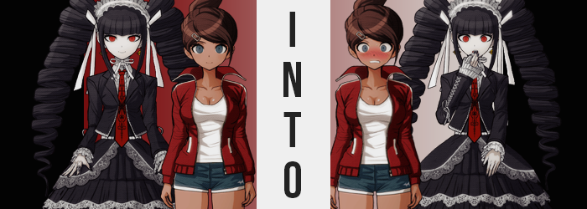

“This was really the last room she was seen in, huh? I really don’t want to go in there. But I don’t really have a choice, do I?”

The swimming jock, Aoi Asahina, was pacing back and forth in front of the girls’ changing room entrance in Hope’s Peak Academy. They were still in the middle of the killing game of course, which made Aoi’s hesitation seem a little cruel. After all, she’d just heard a scream ring out from within the changing room, but she was too scared to barge in and make sure whomever had cried out was safe!

“Stop being a baby, Asahina-san! In we go!” She eventually found her courage by motivating herself in what was perhaps the silliest way possible with a fist bump into the air, before slamming the door open and barreling in. She’d honestly expected to hear the PA system go off with a notice about a discovered body almost immediately upon entry, but as the door closed behind her? “Huh? There’s no one here?”

There were a lot of lockers, but all of them were open. She couldn’t see anything in any of them, much less a person – living or dead. “That’s… odd. I didn’t hear wrong, did I—?”

CLICK.

HIIIIIIIIISS…

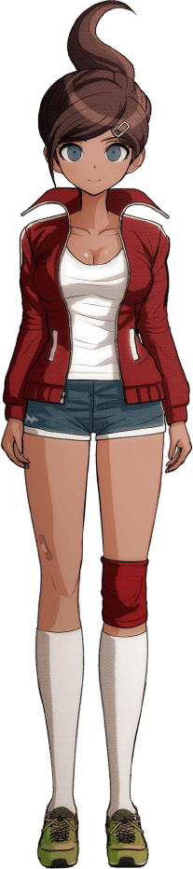
Two sounds quickly consumed the silence of the room in quick succession. The first was undoubtedly the clicking sound of a door locking, and there was only a single door in the changing room that could lock. While the second? A loud, high-pitched hissing that didn’t have an immediate cause from Asahina’s point of view. Not at least until she coughed.

“What’s-? The door locked, and is this gas?” The swimmer could make it out faintly now, an off-color to the air around her that was a little white. Her lungs had struggled to take in that air for a moment, and thus she’d coughed, but she didn’t really seem to be having that issue any longer. But that wasn’t to say different problems weren’t arising as a result of the inhalation.

Aoi covered her mouth and moved towards the door with the intention of trying to break out, but she’d already inhaled enough of the substance for its effects to surface in full force. It began with a full body weakness that made it very difficult to reach her destination, much less strike the door with enough force to break – and the swimmer considered herself to be a very fit individual.

Where the problem lied was while she knew herself to be fit and strong, the actual state of her own body didn’t quite seem to be in proper agreement with that assertion. Because all of that strength that she supposedly had? Well, it had been slipping away ever since she’d inhaled the gas in the first place. While Aoi’s arms were strong, the change wasn’t as noticeable there, and her arms looked just a little thinner.

But where it was absolutely noticeable was in her upper legs, for she undeniable had possessed the leg strength of the Ultimate Swimmer up until just moments ago. Now? It was substantially more deniable, what with her legs’ muscles softening into what could almost be considered to resemble a bouncy gelatin without any firmness to their design. It left her already thick thighs to look even thicker, but that would only be a passing boon for so long.

“Ack… Why is it so hard to move? I almost feel… tired…?” It was even difficult to talk, though trying to speak through a hand that was hiding her nose and mouth from the gas certainly didn’t help. Still fixated on the locked door (something she confirmed by trying to turn the knob), she remained ignorant to both the true cause of her weakness as well as the more dramatic changed that soon wracked her form.

Now, Aoi’s complexion was tanned, and since birth it had always been that way. She’d been blessed with this slightly darker complexion, something people often associated with her from time to time. It didn’t go away if she stayed out of the sun or anything like that, but… Freckles that were not darker in tone, but of an astoundingly pure white – whiter than likely was normal for most humans.

At first it was just a band of these ‘freckles’ across her nose and upper cheeks, but given time they covered not only more of her face, but they were apparent on her exposed arms, thighs, and were certainly spreading beneath her athletic wear as well. These spots didn’t grow or swell, but they multiplied with such vigor that it was inevitable that they would overlap, and before long, her entire complexion was a pasty white. In fact, her nipples were even a dark gray now as opposed to the browner hue they’d sported prior.

“Hm? Wait a moment… I-I mean, what!?” At first, she’d decried what she could see with her own eyes (the paling of the fingers cast across her mouth and nose) in a much more measured and proper way than made sense for Aoi, but she quickly corrected herself and cried out with the same amount of energy as was expected of her. “What’s up with my skin? MY NAILS!?”

She had a bad habit of nibbling on her fingernails, but before her very eyes they had grown longer… and darkened considerably thanks to a black polish that had spread across them. This was just as true of both hands as it was the nails upon her toes, and in both cases hands and feet demonstrated altered shapes. Fingers seemed a little longer and bonier, for example, while her heels ended up sharper with daintier toes. Any callouses one might expect an athlete to sport had disappeared from her pale skin as well, adding to the vibe that she was no longer an athlete at all.

“My skin looks like a ghost! And my nails… They almost remind me of… of… Someone very fashionable. N-No, I mean, a specific person… Myself? No!” Why was there a part of herself that wanted to accept this? And why did they not want to view the name she was trying to say as a person separate from herself!?

The young woman had given up on the notion of covering her mouth and nose now. The gas was thinning, and even if it hadn’t been the harm had clearly already been done. Even now, the dark brown of Aoi’s hair was darkening even further. And not only just that, for the raised ponytail in the back had collapsed in no small part because the length just wasn’t there to lift it in the first place. Her hair was shortening so that in the back it was very short, while in the front? Her bangs straightened across her forehead in layers while longer strands at the sides framed her face and fell past her chin.

Aoi winced, and as she did so the grayish blues of her eyes were overwritten with a bright crimson that flashed in their place. The lashes of her lids lengthened while her brows thinned and darkened, and this all crowned off her face’s design taking on a thinner, more refined look. Gray gloss even touched upon her slightly less thick lips, giving her face an overall noble look.

But, as she was realizing, her mind was losing its focus on thoughts that could be considered good and proper. A complicated understanding of how to con others and what risks could benefit her the most had taken root, overwhelming her athletic knowledge just as the body type that could make use of such knowledge showed signs of finally fading for good.

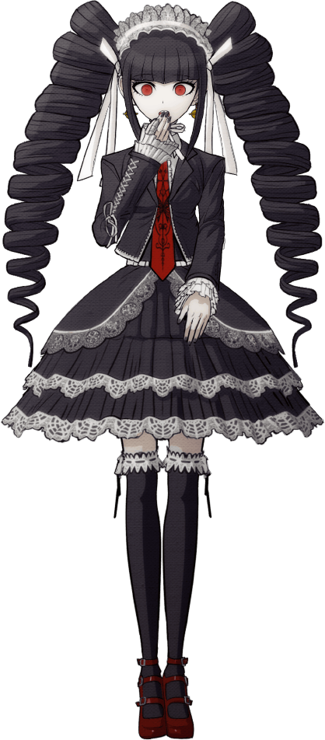
In fact, all of the excess weight to her body thinned while her height jumped two inches. Her thick thighs? They emptied, and so her legs ultimately to be rather dainty with narrower hips that struggled to keep her shorts in place. She ended up just looking lankier, particularly without the weight of her ass to give her lower half the BOOM it needed. This was tragically true of her bosom as well, for the front of her top deflated to leave a bosom that was tragically half the size it had once been. Paired with narrowed shoulders, it almost appeared like her open jacket and shirt might slide off at any moment.

The young woman used black-painted fingertips to stabilize a head that felt like it had been spinning around on her shoulders, clothes below dangling off of her delicate frame without the usual curves to hold them in place. “My word, just what is it that befell me…? Ah, I see I’m still speaking like her.” For a brief moment, the newly fashioned Celestia Ludenberg had wished she was only dreaming, but it seemed it was all real.

Her once tanned skin was a ghastly white, and the hair atop her head was both short and black. There was no denying who she was, but it didn’t match with her memories. She was Aoi Asahina, or she was supposed to be. “Right, I am Celestia Ludenberg. Erm…?”

No, that wasn’t right?

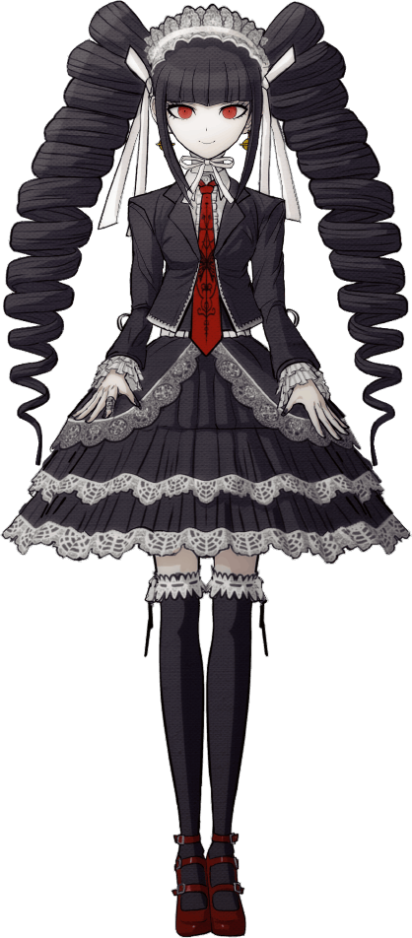
If you rewound a bit, you could easily trace the actions of the mastermind behind this little plot. After all, she’d been in the changing room at the very same time – not to mention that she was the very source of the scream that Aoi had heard. It had all been part of a carefully laid plan, one put in motion when Monokuma had approached her the day before.

He’d offered the mastermind a tool. A special gas that could take the essence of one person and enforce it on another, effectively turning them into a body double. In a killing game where the identity of the killer was key, it was honestly the perfect weapon for avoiding scrutiny. With a double in her place with the group, she could freely kill from the shadows.

And who among the remaining students was crafty enough to use it in such a way as Celestia Ludenberg? The original, of course. As Aoi Asahina fell to the gas as planned, she had been locked within a secret room Monokuma had constructed. On her side it was completely transparent, allowing her to watch the scene within. But on Aoi’s side, it looked like a regular wall. “Hm?” As she watched from within the space though, something struck the gambler’s eye.

Was something amiss with the back of her hand? The color looked too dark.

“What’s going on with this gaudy…?” The gambler hardly had spoken up about her concern before she realized the obvious cause. Some of the gas from the adjoined changing room had crept into her hiding hole!? After Monokuma had promised her it was secure? Was it an error!? No… knowing that bear? She’d been tricked.

The tanned color that was spreading not only across her fingers, but across her entire body was the very same tan she had just watched drain from Asahina’s body in the next room – with context, it didn’t take Celestia very long to piece together what was happening here. “Damnit…” Out of frustration she bit her lower lip, and in doing so realized that her lips felt a little fuller than normal. Not only that, but as her face’s complexion tanner, the makeup she wore was whole erased. From the grayish lip gloss to the mascara that made her lashes look so long, her face was left completely plain by comparison.

Of course this was true of any other paint upon her body. The black on her finger and toe nails, for example? It all cracked and flaked off, with the full lengths of these nails clipped off and fell as if she’d been biting them all along. Her now tanned fingers shortened a little, and her feet swelled ever so slightly – but more significant was the quality of the skin in both areas. The bottoms of her feet had hardened, and the same was true of her hands while not as extremely. They were hard callouses that suggested she jogged and lifted weights fairly frequently when Celestia never cared about such things.

“But there isn’t any harm in working out a little more, is there!? …No, no. I don’t care about that!” What the gambler had blurted out hadn’t been intentional, and absolutely sounded like something the transforming swimmer in the next room might say. For someone as refined and proper as Celestia (pretended) to be, such brutish hobbies were beneath her!

And she would claim that even if her body had begun to show signs of training, which it absolutely had. Raw strength had found its way not only into her arms and legs, but had tightened up her tummy and the space behind her meager bosom as well. While it simply made her arms seem a little bigger around, what became of her legs was a different beast altogether.

Her thighs had thickened and at an alarming pace to boot, swelling right around while her newly tanned skin was pulled taut around both the muscles of a trained athlete and a squishy fatty layer that had just been ripped from the original Aoi Asahina. With Celeste’s puffy skirt it was hard to see them for the most part, but the spot of bare skin before her thigh-high, black stockings demonstrated this growth without a shadow of a doubt.

The white lace trim of her stockings pulled and, eventually, had no choice but to tear thanks to how thick her thighs became, and what remained attempted to pull as tightly as it could upon her thickened legs. This could be seen down their entire lengths, where flesh looked to be trying to erupt from the confines of their black lace prisons. But, on the other hand, her height had actually dipped two inches without her even realizing.

“Everything feels so tight! It’s ghastly, I’m going to look indecent…” Another outburst had erupted from her lips once her thighs met in the middle, but the tightness was something she felt in areas beyond her thigh highs. It had wriggled into her skirt, for her hips had been wedged several inches wider – for they were making space for what grew behind her.

In fact, Celestia’s tight, little ass bulged with a newfound perkiness that was both firm and squishy at the same time. It drew from both her new athleticism and Aoi’s naturally bombastic figure, and before long her black, lace panties were practically inhaled by her tan cheeks, giving the young gambler a rather uncomfortable wedgie.

“Nn…!? These clothes are too darn tight!” This time, when she cried out there was no attempt to steady her temperament back to what it should have been. Her voice was even different now, having traded out her own for that of the woman in the conjoined room. The cause of her outburst? It was mighty apparent if you just looked at her jacket and gleamed what was occurring her.

For with her bottom half filled out, the upper portion had decided to finally follow in its footsteps. Her nipples, now brown, had bloated and grown erect – but what was of greater focus was the jiggling weight that surged beneath them. Her breasts burgeoned with mass, and the tight Gothic Lolita jacket and dress shirt beneath were not prepared for their mass. It didn’t take long for the jacket button over her tie to pop off, only for the dress shirt beneath to follow suit as tanned flesh was exposed beneath her neck.

Her tits had easily overcome the lackluster sizing of her brassiere, and the strap had snapped off in the back while ripe flesh jiggled free and into the open. The gesture made Celestia blush uncharacteristically intensely and she drew an arm across them in response. She had to shield her massive tits no matter what! “These things are huge, just like… like MINE No… like… not mine? But they’re mine, right?”

Yeah, she was just as screwed as her intended victim now.

As a dark chestnut swept through lengthened raven locks, and her crimson eyes faded to a more mundane, greyish blue, Celestia struggled to put together a solution to this problem. Her once tactful mind? It felt dull. Any hope she had of tactfully guiding herself out of this situation was gone, for her intellect had plummeted along with her good look. But hey, she had no doubt in her mind she could swim at record speeds now! She knew all the techniques!

Her thick lips were quivering now, and this quiver invited her facial structure to signify the final set of changes. Darker skin loosened and plumped around the cheeks, while her plain looking eyes rounded to demonstrate her expressions much more keenly. Any refinement to her visage was gone, and she looked like a much more generic, dumbfounded teen.

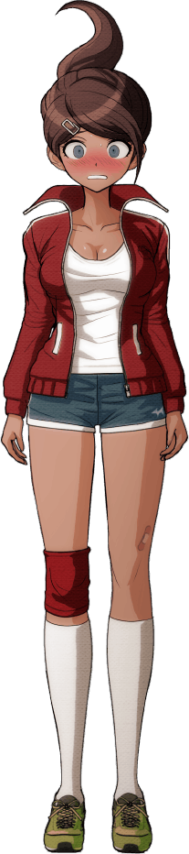
“H-How could this happen to me too!? This is way too weird! How am I supposed to move around like this!?” Having little other choice at this juncture, Aoi Asahina spilled out from the concealed door that led to the secret room, taking the Celestia Ludenberg in the changing room by complete surprise. The original Celestia would have had more tact than this, but now cursed with what some might consider Aoi Asahina’s idiocy, she hadn’t thought that far ahead.

The ample curves of the swimmer’s body left her tanned breasts exposed from within what was once Celestia’s dress, her brown hair dangling loose behind her. Though she was quick to cast her arm over her chest once more once she remembered she wasn’t alone. The new Celestia, fortunately, was intelligent enough to put two and two together. “It was you? You were the one that did this to me?”

Even though the gambler appeared to know what she was talking about, she couldn’t bring herself to say, ‘transformed me into Celestia’. Neither of them could admit to such a thing happening, which would certainly complicate them trying to convince others that they’d switched places.

Though something occurred to her, and the new Celestia pushed past the old one and into the room she’d emerged from. Her head had felt too light, and so she found them. A pair of black, curled hair extensions laying on the ground. She’d never worn them in her life, yet she knew exactly how to clip them onto her head.

“Of course I am! Who else would— Hey! Those are yours! I mean, yours! They’re… yours!” The new Aoi had been trying to claim that the extensions were her own, but she kept blurting out that they were the other woman’s. The two of them were absolutely trapped within their new forms, and their mouths wouldn’t allow them to expose this secret to anyone. But, of course, Monokuma knew.

“It seems we have much to discuss, Asahina-san.”

“I am Asahina!”

“…Unfortunately.”

