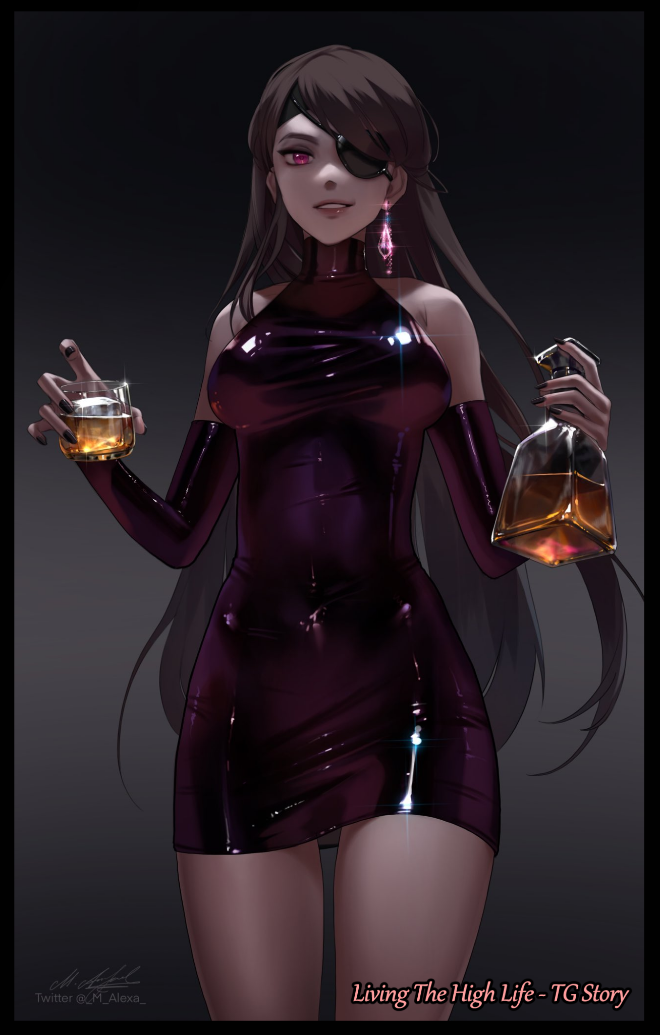

**"So…this is it? This thing; the project that's kept you like…busy for…how long now?"**

**"5 years…and yes, this is all there is…what? You can't seriously be expecting something more? This is the result of peak scientific knowledge!"**

**"Y-Yeah, I get that but…it looks sort of…plain. Don't you think so?"**

**"It's a skinsuit, that's that. Efficient for the purpose it's to serve. We aren't trying to impress any shareholders now are we? And besides…no one's going to be able to see it when the camo tech kicks in."**

In a cold metal chamber with a heavy septic odor hanging in the air stood two men. One, a blonde gentleman dressed in dapper attire while the other, a broad shouldered brunette, was a man of science. From his presentation to the scientist's robes that adorned his body, it was an unspoken declaration of his ownership over the place, and that the other was his guest despite their differing appearances.

When Owen had approached the certified genius before him with a certain idea and a special compound in hand, he had been mentally prepared to wait months, maybe even years for his request to be fulfilled because he knew no one on Earth had ever seen what he had discovered on a certain night spent stargazing in his private estate

If anyone could crack the code behind the alien mineral with a seemingly organic nature to the way its cold gray shell ripples and flexes like a beating heart, it would be the eccentric before him who many other less than reputable men were quick to insult whenever his name cropped up in discussions.

Nash was his name, short and sweet. An underdog with an inspiring story, the man was a self made brainiac boasting a successful career under his belt despite the infamy he had gained amongst his more jealous peers in the scientific community. Not like he cared of course, they could spend their time seething while he worked his brain on more pressing matters.

Not the usual sort to take up jobs with the rich and the powerful, Nash had initially refused Owen's visit until the man brought up the topic of an alien mineral, one truly foreign to Earth. If he allowed him inside, then he would give him the privilege of being the first human alive to study such a prize. But with one added condition;

**"I want you to see if this thing can be utilized, in any way, shape or form…and most importantly, if it's replicable."**

But Nash wouldn't back down to what he saw as a one sided bargain, shooting a demand of his own back at the pleasantly surprised tycoon.

**"That's an interesting idea you've got there…but if I'm gonna do that for you, I want the final say on what it's used for. Deal?"**

Knowing full well he could trust in Nash's brilliant mind, Owen had agreed right then and there, opening the door to the man's apartment once the digital lock beeps to allow him entry. And once he showed the prized rock to Nash, he knew then that he'd made the right choice for choosing him over the many contemporaries out there.

Wasting no time, the excited scientist immediately escorts Owen into his lab to get started on analyzing the organic stone. Not even allowing for a second to pass after getting the thing under a powerful microscope before mouthing off scientific jargon that the lesser educated man had no hopes of understanding. By the time his excitement had died down enough for Owen to interject, the afternoon sun was at its highest, bathing the excited scientist in an obscuring shower of orange as he proudly puts forth a proposal for the best way to use this new mineral.

**"This thing constantly mimics a state between a liquid and solid, and from a little test earlier, it seems possible to direct what form it takes after through the use of electrical signals…I believe that, with a little bit of time and work, we can make it take after whatever form we wish it to. But with the limited sample size, I'm afraid it'll only work on a smaller scale…so I propose a suit of sorts that allows the wearer to take on whatever shape or form they desire. Like that one character from the comics!"**

Needless to say, Owen had agreed to it just as fast, shaking hands with the veritable madman before exchanging contact details and a celebratory lunch where the two would converse over minute topics regarding each other's lives and more interesting ones like how Owen had come into possession of such an astonishing find. It was a conversation that served to seal the deal when both men were assured that no foul play was involved. Owen simply wanted to see the possibilities offered by this mineral and Nash had simply been the best fit for the job in his eyes.

Over the next five years, the project would see varying bursts of success alongside minor setbacks and lengthy delays. But the most troubling moments were when Nash would occasionally vanish without saying anything. Only ever signaling his return with a simple text or call to say that things were rolling along just fine. But from what little he could see of the project whenever he could come over, Owen saw little concern for worry. Sure, the atmosphere felt like they were working on a school project rather than a breakthrough invention, but it certainly did help alleviate any excitement and stress when it was so under the nose that most of the time Owen would actually forget it was even a thing until Nash sends over the usual monthly document detailing any advancements or obstacles in the project, complete with recordings of the prototype in action as he watches the experiments gradually go from changing fire ants into ginger ants to rats into hamsters.

*'As long as the target is roughly of the same mass as the desired outcome, they can be molded by the substance I've embedded into a gel weave. With an automated response, all that's needed is contact with a living subject for the material to bond with their hide. And to remove it…just two taps on the back and there's that! It's looking good Owen!'*

But now as he stands there alongside the jovial man, Owen couldn't help but let his shoulders droop a little in disappointment at the lackluster product of five years of hard work and engineering before him; a skinsuit that…looked nothing like the stuff one would think of when envisioning something made out of alien material. No sleek lines across the surface, no strange gizmos. Just pink latex shaped into the form of a deflated human being. It made the expensive liquor and shot glasses he had brought over in preparation for a celebration seem that much more underwhelming.

**"I was just…expecting something more grand y'know?"**

**"This isn't some superhero sci fi world sadly…but I do get what you mean. It doesn't look like much until you put it on. That's when the magic happens."**

**"Speaking of…have you tested this thing? How do we know it won't just backfire horrendously?"**

**"Well, that's what I've got you here for my friend. I need you to supervise the first test run."**

**"Wait…are you saying you mean to-"**

**"-wear it? Of course! I made the thing after all so it makes sense that I would be the one most fitting to test it!"**

While Owen had more things to say on willingly volunteering oneself for the testing of a potentially dangerous product. The indignant look in Nash's eyes were more than enough to stifle Owen's protest before he could vocalize them.

**"This thing…it'll work like in the videos? Auto equipping, double tap ejection, that sort of thing yeah?"**

**"Yep, I've got the console over there hooked up to the suit so feel free to enter the name of whoever you want the suit to turn into just as long as it's human, it'll utilize my mass to take on whoever it is you end up choosing."**

Glancing over in the direction Nash motioned towards, Owen's mind was already spinning with doubt amidst the calm of realizing it was just a simple touchpad linked up to a database of sorts with actual 3D scans of real individuals loaded up beside the names. It looked like some fashion catalog a rookie UI designer cooked up for a side job which only served to deepen the doubt on whether or not this thing was going to go according to plan like Nash thought it was as he steps up the podium where the suit was hanging. And with a single hand reaching out to grace its slick surface, watches as it leaps forward enveloping that singular digit before working its way up the entire arm, then a torso, legs until Nash's entire head vanishes under a pink blanket of artificial hide plastered against him so hard his facial features remained vaguely visible against the cocoon.

Owen had seen it do the same to the aforementioned creatures. But the impact had been lost by the cold gray substance the earlier renditions were and their animal subjects. To see it happen to a live, full grown man…it gave the man a shiver.

**"Woah…Nash? Everything alright in there?"**

At first glance, the thing seemed incredibly uncomfortable to wear. Owen seemed unsure if anyone could even navigate a small room without bumping into furniture wearing that thing.

**"Yeap, right as rain. You're giving me that look again aren't you? C'mon, I told you already; the suit's foolproof, totally safe to use. And in the off chance something does go wrong, remember; a killswitch on the console will undo the suit's bond to my body…well? Get a move on. Suit's safe but that doesn't mean it's comfy!"**

Sighing before strolling over to the console, Owen browses through the list of viable candidates, raising a brow at the meticulous nature behind the simplicity. The need for guessing which body type was suitable was eliminated by the message on screen; informing him that the choices had already been narrowed down thanks to the suit sending the specifics of Nash's body back to the console. But what was there intrigued Owen.

*'Wait…aren't these…women? Is that even possible?'*

But as curious fingers trace the polished glass over the mugshot of an attractive woman fit to appear on the cover of a gravure magazine, no such error appeared to tell him otherwise. Only a simple 3D turntable of the woman's full appearance with a great figure to go with her stunning visage. There were even options for clothing and accessories that affected the render in real time with an accurate depiction of how the final result would look like.

**"Owen? Need help with the console? I know it looks complicated but I can come over and give ya some pointers if it's too hard for you…"**

**"Yeah, yeah I got it…just…choosing what you're gonna be wearing…you really thought this through huh? There's just so much to choose from!"**

**"Heh, just a little bit of help from net scouring AI and some groundwork…where do you think I've been all those times I ghosted you?"**

**"You were out scanning underwear for over three days at a time?"**

**"Hey, can't hurt to go all out right? Besides, this thing’s got a veritable database of outfits to pick and choose from, saves us the time and money of having to go out and get new clothes.”**

As much as he wanted to pat him on the back for all the hard work, some of this stuff seemed…excessive. There were even bits and pieces that could come together to form some impressive cosplay. But that sort of stuff wasn't Owen's thing. He preferred his women dressed in sparkling skin tight dresses with a flair of fierce elegance and sinister intellect to them that told everyone they weren't just helpless damsels to be taken advantage of.

By the time he was done with customizing the base model, Owen had decked her out in high society apparel, complete with all the aforementioned flare and an added eyepatch just because he found it cool. With a color ranging from brooding magenta in her dress with a hem short enough to tease what laid between firm thighs to brilliant magenta sparkling in her earrings, the final product was a domineer of a woman straight out of Owen's dreams. All that remained was for him to hit the enter key, and watch the fireworks….or lack thereof in case it failed.

*'Well…here goes nothing!'*

Thumbing the glass, Owen takes a step back with bated breath as his head instantly draws upward to watch Nash's still mummified form…a second passes, then another. Before Owen's anticipation begins to falter and wane after a good 10 seconds go by with nothing happening.

Until a sudden spasm runs through the man's body, beginning with a twitch in the ankle, a spastic twist of the hand, a jolt to the shoulders and then his neck twisting to the side followed by a bit back groan as Nash's broad shouldered form begins to tighten inward, compressing to the tune of an unheard beat while color and texture paints itself over the glossy pink. Dull black leather manifesting over closed serene lashes, matte ashen peach skin spreading across an attractive hourglass figure, drab yet silken locks of hair in mahogany shade tumbling down a gorgeous face with filled in lips and a lean nose with a cute arching indent, a dark sleeveless dress composed out of tensile latex fit for clubbing stretched taut around broad hips and a cinched in waistline from which a hefty set of breasts begin to protrude, filling out the empty top nicely with swollen nipples tipping warm, creamy flesh that just out nicely with a healthy firmness and a youthful perkiness to its appearance. It was a strangely morbid sight that seemed off without a sound to be heard besides the ambient hum of the surrounding machinery. From the way thick arms were being shrunk and cut down into slim dainty extensions tipped with petite hands and the obvious widening of gaunt hips into handlebars, there should've been the cracking of bones and the squirming of tortured flesh, but whatever the alien element was doing, it did so with precision and silence.

With the indentations of v-bones pressed up tight around a toned navel with the absence of a bulge between a pair of long curvy legs ending off in waifish feet clad in dark stilettos, Owen's digital creation had been replicated perfectly onto Nash's frame as her eyes flutter open, no doubt surprised by the fact that her body had been replaced by that of a woman's as curious hands run over her belly, coming to a stop over where her newly grown womb laid alongside another tracing the hypnotizing contours of her figure. Only instead of feeling out of place, she seemed more curious by the extent of the changes as her very much male mind carelessly lifts the hem of her skirt to inspect a fully functional cameltoe wrapped snugly in lace panties while smacking a firm rump with a resounding clap and a hearty jiggle. And as she opened her pert lips to address a flabbergasted Owen, the voice that filled the air was just as perfect as the woman it belonged to.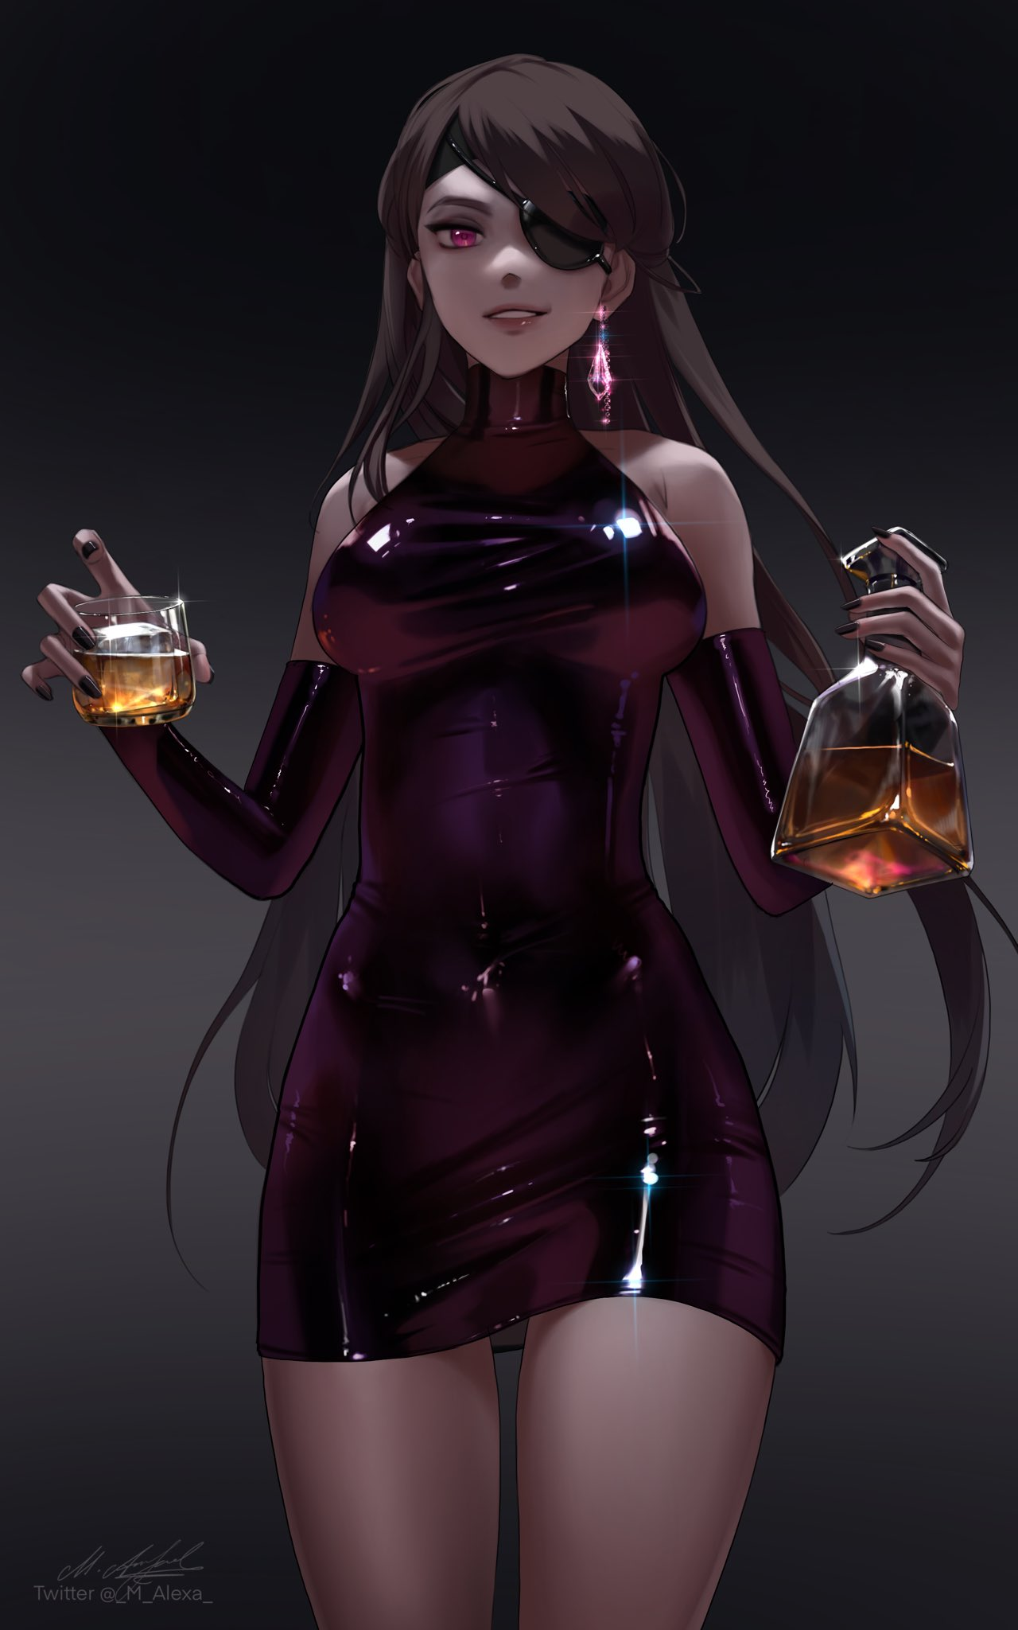

Husky, yet young. Dripping with salacious honey that hinted at more for whoever the words were addressed to alongside subtle hints of an accent, hinting at a vast ancestry of foreign folk befitting her exquisite appearance.

**"Interesting choice…I was expecting you to fool around with the options and make me some obese manlet but…I'm definitely not complaining~"**

**"N-Nash? You feeling alright? That looked…rough."**

**"Yeap! It's still me in here so don't go getting any funny ideas…that was honestly a little anticlimactic y'know? I was expecting a little pain, maybe a tiny bit of pleasure? But it was over so fast I barely felt anything besides a tickle in my bones…anywho~"**

Sauntering over towards the table where Owen had set down his stuff with a sway to her step, Nash rifles through the bags before pulling out the bottle of liquor and its accompanying glasses.

**"What're you…"**

**"Whaddya think? Celebrating of course! You saw for yourself how quick that was, and nothing bad happened to boot! Besides, it wouldn't hurt to stay like this for a while, right? Besides, your number two seems to agree with me~"**

Looking away in embarrassment as a feminized and admittedly beautiful Nash begins to pour a second from the popped bottle, Owen missed the moment the woman's crimson eyes widen before a cramping hand loosens its grip, sending the expensive liquor crashing to the floor before her hands fully enter into an uncontrollable fit.

**"S-Shit! This isn't something I've seen before!"**

**"Nash?! What's going on? Your hands…they're…"**

**"I dunno! This hasn't happened in all my other tests! Wait…I think it's stopping…"**

After a few seconds of furious trembling and worrying finger contortions, the two watch as Nash's slender arms slowly come to a stop, palms glistening with sweat and a heated tint to the skin around the wrists…

Until a sudden pop sends the pair jumping in fright. Something Nash tries to defuse as she waves it off with a laugh, ignorant of Owen's wide eyed stare focused on her back where a plume of wavy gray begins to trail into the air before vanishing.

**"D-Don't worry…think I might've stepped on a piece of glass or something…"**

**"Uhh…Nash? I don't think that was glass…there's smoke coming from your neck…"**

**"Smoke? From my…neck? Oh dear…"**

Before either can say another word, Nash's voluminous head of hair begins to recede, shrinking away until all that remained was a neatly trimmed bob cut trailing off into navy blue treads that slants at an angle to bring emphasis to a face rapidly losing its mature gravitas for a younger look that only retains faint traces of its predecessors authority. Trading maturity for spunk as narrow eyes widen ever so slightly while crimson irises soften into cold cyan pearls.

**"N-Nash? You're changing again! Get the damn thing off!"**

**"I can't! The eject function isn't working! Y-You try it! Maybe it needs someone else to do it…Hyahh! Where're you touching?!"**

**"It's just your neck! I think the suit's fried!"**

While Owen continues to flounder around Nash before rushing off to the console, the former queen had already been greatly changed by the rampant suit, stripping her of more height while what little muscle remained in her body mellows out into supple layers of fat and lean flesh, softening regions of her body that were once toned and solid into pliable pillows. A firm ass ballooning into a heart shaped bubble butt, impressive breasts further inflating into enticing melons while her thighs begin to jiggle with each flustered step. And the mature alto from before? Eliminated for one that was more airy and high pitched in comparison as a feathery choker snaps itself around her slim neck.

By now, Nash had dropped about 5 to 10 years in age. Looking more like a young adult and less like the experienced, mature minx she had been only seconds ago. Though that wasn't to say it detracted from her looks, definitely not with a killer figure much like the one Nash now sported with arguably more pronounced curvature and flair than her old pre-selected form evident in the way her plain latex dress begins to extend downward while retracting in certain locales focused on her armpits and thighs, revealing far more skin while draping lower down the middle like a loincloth to add some brevity to the increasingly widening windows centered around her thighs while a semi transparent leotard slips free from the mass of shifting fabric, crawling over sensitive skin that flares up against their touch, painting a fierce blush over her cheeks from the alien pleasures of the female form beginning to make itself known in her mind. Alerting her to something being very wrong here, something much worse than the suit acting on its own as she turns to move toward the console Owen was still trying to figure out before tripping on partially reforming heels that now matched the ornate design her new attire adopted, complete with gilded bronze, contrasting whites and expensive silks composing firm blue-brown waves of expensive fabric.

Shoving Owen aside after regaining her footing with a sudden viciousness to her attitude that wasn't present before, too panicked to argue, Owen gives his associate room, watching as Nash begins typing away at the console before her renewed temperament begins to get the better of her, causing her mind to drift while losing track of innumerable calculations and error codes she should've known like the back of her hand. Only now that knowledge seemed lost to her, and the more she fretted over it, the more furious she became. Forgetting her predicament and focusing more on old problems once thought lost to her mind; spiteful back talking by jealous scientists, borderline mental abuse from all the jeers and leers just because she came from a background of nothing with a troubled mind that preferred to work in isolation.

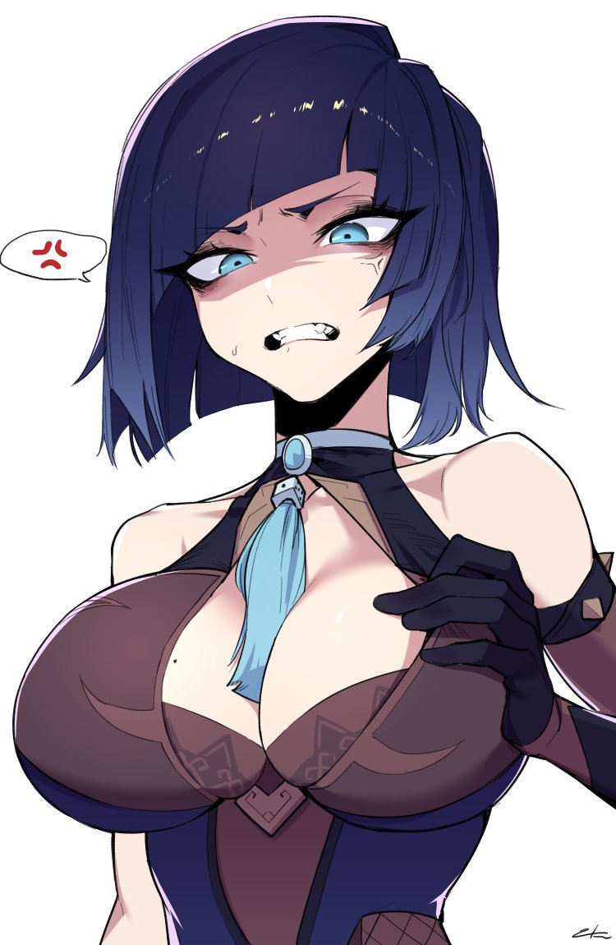

With Nash's mind now fully consumed in unrelenting anger thanks to the removal of her calm, calculating mind thanks to a little tweaking of her brain, a gloved hand formed into a fist slams down, shattering the glass and ruining the machinery beneath, putting out the display with a disheartening fizzle while Nash's frown turns into a furious glare, yelling out in a display of anger Owen had never seen in the 5 years of working with her.

And from the venomous spew of vitriol, the man could pick out certain phrases that seemed to correlate more towards her personal life than the machine's faults as she raises her first yet again before bringing it down in one fell swoop, this time sinking it all the way down to her elbows before pulling out a fistful of sputtering machinery and frayed wire, tossing the mess aside like a child taking her tantrum out on a teddy bear…a very expensive teddy bear that also served as the control system for the suit that had made her this way. Making her recall past trifles with infuriating precision, targeting the anger and self deprecation and amplifying it tenfold.

*'All my work…all that time spent working on advancements in science you scum haven't seen before…was it all for nothing?'*

More importantly however, the fist that was sinking itself into the gaping hole was drawing dangerously close to the jagged edges of broken glass and shattered metal. While he wasn't as much of a genius as Nash was, one didn't need a brain to realize how easy it was to injure oneself if they were to land a punch only to miss a hair's breadth from their mark, imagining a gaping red wound as glass slices apart delicate flesh and soft skin…

**"Fucking machine! Why do you gotta fuck up right when we were gonna celebrate huh?! Just couldn't cooperate like all the other assholes, trying to blame me again for being too much of a smartass?! Degrading me! The fuck! Get off of me!"**

**"Nash! S-Stop! You're gonna harm yourself if you keep doing that!"**

**"Harm?! I'll show you the meaning of that word if you don't let go now!"**

**"Snap out of it! This isn't you!"**

With her reduced stature, Nash's strength was no doubt left in tatters, and adrenaline could only carry one so far before they began to burn out. Finding a foothold in the form of sloppy footing, Owen manages to pull the rampaging woman away from the console…but not before a flailing foot catches on the weak aluminum construction of the base, puncturing the exterior with an ear rending crack before the loose heel shoots inside of it like a rogue projectile, disemboweling the malfunctioning device that also frees Nash from her sudden fit of unrelenting rage as her struggles cease and her eyes return to normal. Glancing over at Owen's worrisome face peering over her shoulder before returning to the ruined machine, shoulders slumping upon the realization of what she had done as the machine’s hold over her mind fully dissipates, calming Nash down before an embarrassed look crosses her face, especially after realizing how hard Owen had been holding on to her and the intimate distance between them.

But it did serve as a reminder of what had happened to her…what was still happening to her. Spurring her to lift her partner's hands off of her wrist before he tightens it again, forcing her to look up at him.

**"Y-You good?"**

**"Yeah…I think so…please tell me you didn't hear a word of what I said…"**

**“I’d be lying if I said no but…I’ll try to forget it…”**

**“Good…now let me go, I need to…check on the damage and see what's salvageable.”**

Freeing herself from Owen's grip and hobbling over towards the console, Nash lowers herself to inspect the damage. Pulling out her heel before letting out another devastated sigh as she rises to her full height again, turning back to an expectant Owen who seemed relieved to see she was more or less back to her normal self again.

**"So…what the hell just happened? That look on your face isn’t good though…"**

**“Well…that’s more or less the correct assessment; it's bad…losing the control system is one thing…but the suit…"**

Gesturing weakly at herself before continuing, Nash slides loosely to the floor before placing her hands on her knees as if unsure of what to do or say next, a bitter look on her face. Leaving Owen to finish her sentence for her as he connects the dots in his mind.

**"...it's…what? Bonded with you or something? I-Isn't there something we can do to get it off of you?"**

**"Maybe…but not in our lifetime. Finding applications for it is easy, removing it however…when you brought me that stone years ago, I knew then we were dealing with something way out of our league, the risks were there…I just never told you about them. Forget about replicating it by the way, it's in a league of its own…and now *it* has me…"**

**"Risks…is that why you volunteered to test this thing? I heard you y'know? Why are you still doubting yourself? You've proved yourself better than them, no need to keep hanging over the past."**

**"Ahhh…I thought you said you were going to forget it…it isn't as if I didn't okay? I…more or less don't give a rat's ass about what they think of me…but after years of living a lifestyle, do you really think someone can drop it in an instant? Besides, a year or two from now…I probably will whether I like it or not."**

**"What's that supposed to mean…is it because of the suit? We stopped the console, didn't we? I mean…you're stuck like this but…oh no…"**

Tapping the side of her head with a wry smile, Nash leans fully against the console with closed eyes as if in acceptance of her fate. A fate she knew Owen was more than aware of judging by the sullen look on his face mixed with a tad bit of confusion, as if trying to calculate how this was even possible.

**"Yeap, my mind's being affected by this thing…I mean, I'll still be me but…my brain is leaking like a damaged hard drive. What I know is already being muddied and I'm guessing the suit's trying to plug it up with the 'correct' mindset someone that looks like me should have…and if I'm right…ah~ there we go."**

Flexing her hands, Nash grins as she watches her shoulder length gloves recede back under her skin in hexagonal patterns, leaving a hand bare and fully exposed for the two to marvel at the shimmering nails that tipped her slender fingers as she raises it up to the light. But while Nash seemed amazed, Owen looked slightly disturbed at his friend's calm attitude to her predicament as she turned her attention to putting her loose heel back on.

**"H-How are you so…relaxed? You're not a man anymore…a-and you're losing your mind? We should be finding ways to help, not testing what else this thing can do!"**

**"Cmon, I told you already, we don't have that level of tech. The best I could do is give it a host to work with alongside a control system that's useless now. Remember the smoke? I think that was the module linking it to the suit…besides, you're the one who did this to me in the first place y'know? Not like I mind by the way…male, female, I'm pretty open to the idea of living life on both sides. Who knows, maybe once the mental stuff kicks in, I might even enjoy it…you are gonna be there right?"**

**"Excuse me? Be there for what?"**

**"Taking responsibility! Your cockbrained thinking drove you to turn me into a girl right? Like I said, I don't mind being given like…a totally hot bod, but at the end of the day…you were the one to pull the trigger, in a manner of speaking. So…hup! Here's what I have in mind…"**

Pushing herself off the ground before crossing the short distance between them with confident steps and broad strokes of the hip, Nash leans forward, giving Owen no chance for reprieve as she wraps her delicate hands around his shoulder, pulling him in close enough to press her perky bosom up against his chest while raising a long leg up to prod at his groin suggestively with a knee, smiling upon sensing his hard on responding to her call. Compared to the way she seemed embarrassed and miffed to have been held by him, it was as if Nash was a completely different person altogether.

**"Good to know you're being *honest* even if your mind still isn't~"**

**"N-N-Nash? This mind degradation of yours isn't getting worse is it?"**

**"Oh please! You make it sound like I'm gonna end up as someone else entirely…but that's besides the point…what I wanna ask is this; how far are you willing to go to make up for your mistakes?"**

**"How far am I…all the way of course…I'm not gonna just cut you loose if that's what you're implying. We aren't just business partners…five years was long enough for us to become friends…and I don't leave my friends hanging!"**

**"Ohh? Well said…a lil bit on the clichéd side of things but…well said nonetheless…well then, I'll get packing then…"**

**"Packing? Wait what?"**

**"Packing so I can move over with you! You are some big shot so I'm guessing you've got plenty of room back home, don't you? Besides, with the way i'm dressed, I'll blend in perfectly~"**

Prying her hands off of Owen's now larger frame, a rejuvenated Nash bounces off towards the door leading out of the lab before turning to face the dumbstruck man with a wink and some final words before slipping out the door.

**"Oh! And uhh…*Natalie*…I think Natalie's a better name to call me by…"**

Left alone to gather his wits before gazing at the spilt mess left behind by the shattered shot glasses and bottle of liquor, Owen rubs his forehead before muttering under his breath, wiping down his eyes before walking out the door to rejoin his unwitting partner. While he was relieved for his, or rather her safety. Owen was beginning to question just what on earth was going to happen in the future once this mental change the newly dubbed Natalie was going through had run its course. Already he could see drastic changes in her behavior and even minor alterations to her speech pattern.

But the idea of living with someone, much less a woman, sounded daunting to Owen who had been living a solitary life besides having the occasional cleaner come by every so often whenever he was too busy with managing his business to tend to his abode.

'*Maybe I'm thinking too much…if anything, it's definitely gonna be an interesting time…'*

Setting aside his concerns as he moves to help Natalie who was already busying herself with a box and stuffing it with her belongings, Owen's mind and bodily strength becomes burdened by the duress of moving around box after box, loading it into the man's convertible until the former Nash's house remained barren. Save for the larger furniture that would need another day to move. And before the day was over, the two were back at Owen's private estate far outside the city limits. To him, it was nothing new. But to Natalie, the sight was enough for her to crack a wry smile with a visible air of excitement radiating off of her, clearly impressed.

**"Damn fine place you've got here! Any empty rooms I can use? The couch is good too…unless you want me to crash with you?"**

**"There's a guest room you can use, near the second floor staircase…and no thanks…I like my privacy as it is, thank you very much."**

**"Aww, such a killjoy…but for real though? Thanks a lot for doing this…I'll see you inside?"**

**"Yeah…sure…feel free to use the shower, I'm sure that whole thing with the suit wasn't pleasant at all. Just leave the boxes to me.\***

**"Really? But I-"**

**"Trust me, I can handle it…but you'll have to unpack it all yours-"**

Owen stood frozen for a moment, not noticing how Natalie bounded away from him towards the house with the keys to the front door stealthily snatched from his hand. Instead his mind remained glued to deciphering the soft peck he had felt against his lips, the momentary sensation of another pair gracing his own. Tracing a finger over his mouth where he had felt those warm cushions land on for less than a second. Until his daydreams were cut short by a frustrated yell in the distance. Granting him reprieve from thought as he moves to the back, withdrawing a box and setting off for home.

**"Which key is for the front door?!"**

**"Shouldn't have taken it if you can't figure it out!"**

He was indeed correct about one thing; Natalie's entrance into his life would prove to be a very interesting turning point going forward.

Not long after the Owen's housemate had nestled well into her temporary roost in his guest room, the man would begin to see more significant changes occur to Natalie, both physically and mentally. For instance, her mannerisms were starting to regress, losing most of her maturity for a reckless sense of abandon, like buying things on a whim or mouthing off insults every now and then whenever she saw something she disliked. If it weren't for her already impressive savings earned from her time as a multi award winning researcher, Owen was pretty sure she'd have run herself dry by now. Designer bags, a new phone, even a fur collared coat she would wear almost every hour of the day besides bedtime. And thanks to her ability to manifest whatever clothes imaginable to go alongside it, pretty soon the actual coat would be left to hang inside her wardrobe once she had learned to fully recreate it with her own flair, applying the same markings that adorned her navy blue apparel she barely altered save for a lengthened loincloth. It was almost hard to believe that the posh lady spending most of her time in front of a mirror trying on various outfits and snapping selfies was even a man to begin with.

The other, more worrying change was in her attitude. Just like she had told Owen before, her overall intelligence continued to drop as the days went by, gradually affecting her personality as well when she eventually lost focus and concentration in holding back the creeping habits and terrible manners plaguing her mind. Owen remembered Natalie being grumpy and annoyed when she still held a grip over her original calm, analytical self. But after the change, her frown was permanently replaced by a sultry look. It was a literal overnight change that initially had Owen wondering if something particularly good had happened to her, but he knew otherwise after asking her about it despite her previous warnings telling him to bear with how unpredictable she could become over the transition period.

**"Was I grumpy? I guess I sorta remember being angry and stuff but I think that's just my period…awww come on! Don't be such a stinker…I mean, sure, I still remember the accident but…it sucks being angry all the time!"**

Reflecting upon it now, Owen was beginning to feel disgust both with himself and against Natalie which only served to drive the stake of regret deeper into his chest. On one hand he knew it was all his fault, but he just couldn't help but click his tongue at the snobby woman his former associate was slowly turning into. She didn't ask for this, yet, she seemed to acclimate extremely fast to her current situation without a lick of concern about her altered gender and severely dumbed down mental capacity. While he shot himself with metaphorical bullets of self doubt and regret, bullets of spite were directed at Natalie as she spent each day caring more and more about her looks and what the latest trends were with less regard about returning to normal. There was even a day where she had asked for the keys to Owen’s car, wanting to take it out for a spin. And with the man stuck in his seemingly endless dilemma, he of course, relented to her pestering, tagging along to make sure she didn't crash the thing while he wasn’t looking.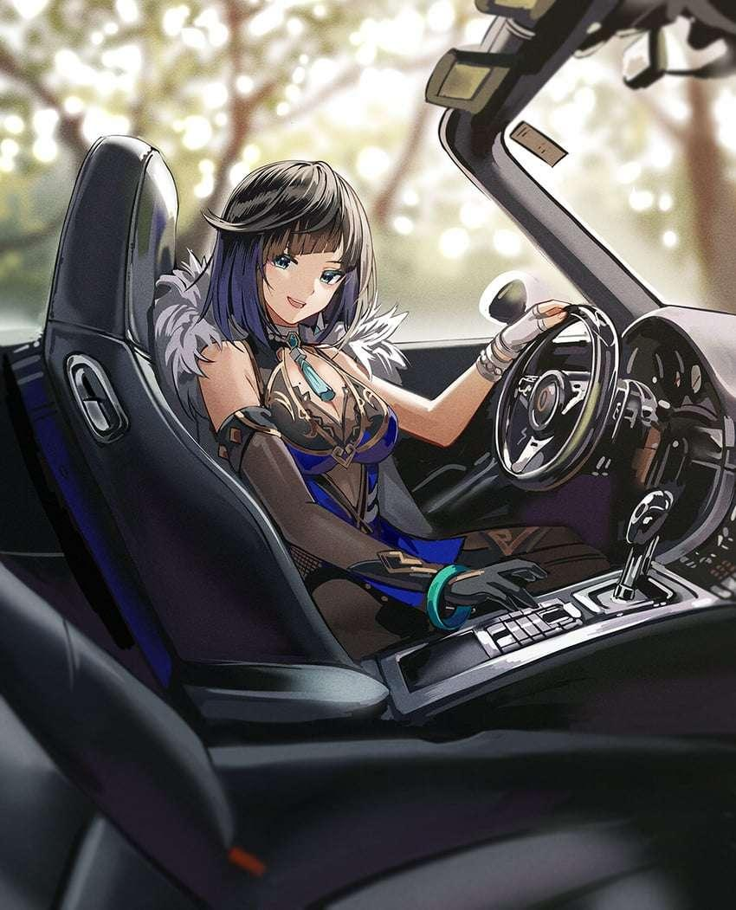

Surprisingly, Natalie turned out to be a pretty good driver if a bit on the wilder side. It seemed that in her new state of mind, thrill seeking was now a part of her new interests.

Eventually, a stalemate would be reached in Owen’s mind. Deciding to focus his thoughts elsewhere once the mental strain became too much to bear. He wouldn't bother himself by thinking about what Natalie should be doing but rather, what he could do for her. Taking her out on weekends dates, buying whatever she wanted, taking her wherever she fancied. All while ignoring just how haughty and…'mature' she had become. And if anyone raised a fuss about her behavior, he would always cushion her from blame despite her protests.

He would bear with her behavior by assisting her in it. Maybe she would come to her senses or maybe she would simply grow into it, either way, Owen had figured this to be the best outcome for both him and Natalie.

Unbeknownst to the defeated Owen however, Natalie wasn't as simplistic as he figured her out to be. Behind his back, she too was beginning to feel more than conflicted about her place in her friends life. When he was out of sight, it was so easy to slip into her new habit of perusing social media and mocking who she now saw as plebeians, posting pictures of herself on a new Instagram account she had set up under her new alias.

But whenever she saw Owen, the reality of how she was acting would set in like an unshakable chill. And although she knew her old self would've been more than disgusted by what she had become, a part of her saw no issue with it…which only made her more indecisive when she realized Owen had been kind enough to stick his neck out for her; offering shelter and aid for her whenever she needed it. All from his own pockets. She had her own fortune, he knew it, she knew it. But even then he had accepted her request to stay over at his place until the suit, or rather the alien material that was now ingrained deeply into her very being, was done running its course.

*'But where do I even go after it's finished…'*

It didn't help that Owen was starting to become something of a mute puppet. Seemingly giving up on doing anything to stop her and instead, trying to defend her actions? Many times now she had wanted to tell him off about his insincere actions but her hesitation would end up staying her hand. It was a frustrating loop that left her spent and tired.

Like Owen, Natalie needed something to de-stress. And although the attractions of her new body were open for exploration, the young woman had abstained from the pleasures of the flesh. Instead choosing to leave the estate one day without telling Owen, intent on visiting a place she knew he would have no interest in going to;

A newly opened casino on the far side of town. She had seen posts on social media about the place and since she had all the money in the world, she didn't see much reason to go cheap that night. If one wanted to take a weight off of their shoulders, skimping out wasn't the way to do it. And so she would silently make her exit on a busy night for Owen, slipping out the back door and hopping into the cab she had booked beforehand, speeding off into the night with her troubles temporarily behind her.

Tonight wasn't one where she would pick fights with others, it was a night of relaxation, and that was what she would do.

And after a brief ride through the glimmering streets bustling with people going about their own business, Natalie soon steps out before the massive building, constructed and themed after Chinese architectural design and history. She didn't know much about the place or the people who ran it, but from the grandeur of its entryway to the many well dressed folk pouring in while the jingle of slot machines and the boom of a raucous crowd within echoes through into the night, she was sure she had made the right choice as she saunters past the entrance, instantly feeling more than a few eyes latch on to her as she crosses the ivory carpeted floor towards the main hall where many of the highest paying customers dwelt.

Young studs checking out the place while giving slots a go, middle aged businessmen looking to unwind over drinks at the bar, geezers socializing around a poker table while a patient dealer watches on , ladies going about their business with envious eyes casting sideway glances at her. There were just so many people, so many attractions to immerse herself with, she just couldn't take her pick.

Until a sudden tugging on her coat alerts her to a change in attire, turning around to realize her coat had become a furred mantle of sorts trailing twin tails behind her while her dress morphs into a form fitting bunny suit that retains its make with the exception of her undershirt gelling together to form leggings that rise high enough to wrap around her belly while her loincloth simply loops down between her legs, connecting to the rear flap before wrapping up snugly against her snatch. A highly revealing getup that only serves to embolden Natalie as a subtle weight pulls down on her head; a floppy pair of rabbit ears connected to a headband to complete her bunny girl costume.

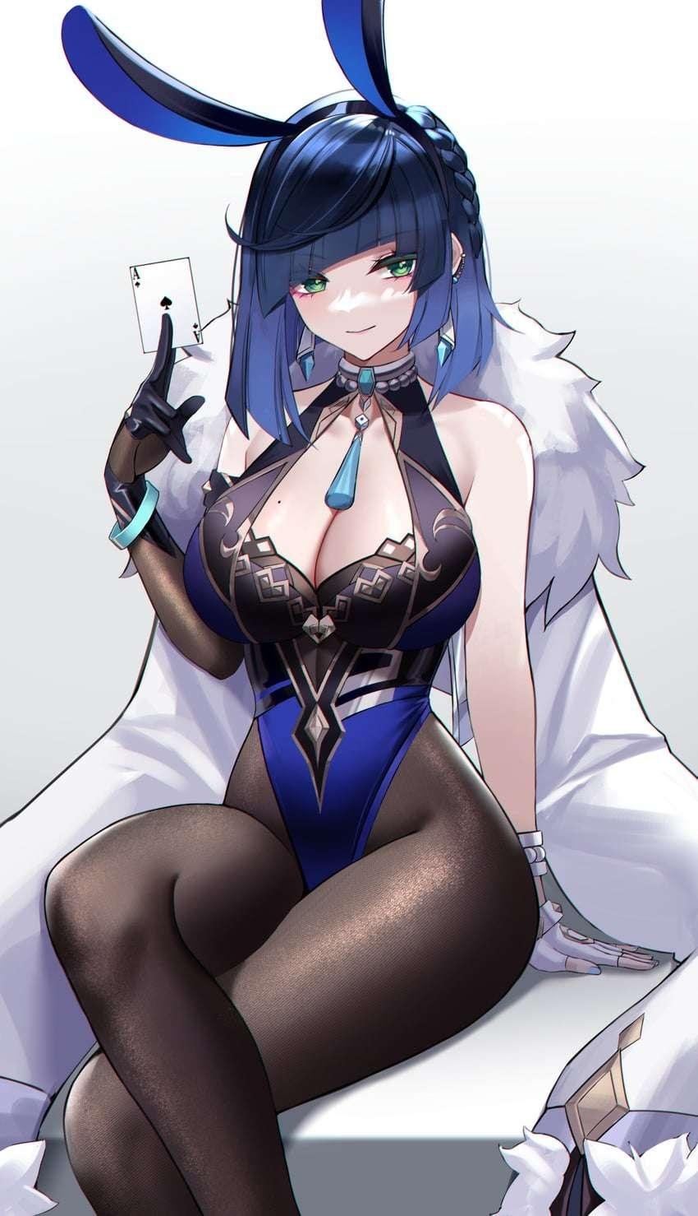

Although her outfit was considerably more…elegant…than the other bunny girls roaming the hall, Natalie could tell from the eyes of the men undressing her ever so lewd form that it didn't matter in the slightest, she even doubted that anyone had seen her brief 'wardrobe malfunction' considering how focused they were on her body rather than the cloth that covered it.

*'Totally not what I was expecting…but maybe this'll work out better than I could have ever hoped for? In fact~'*

Spotting a vacant tray of drinks yet to be handed out, the casino's newest and definitely legitimate eye candy begins to roam around the casino floor, making her presence known by casually approaching her 'customers' and whispering sweet things into their ears. And with a girl like her offering drinks in such an unabashedly seductive manner, who could refuse? For a brief moment, her mind drifts back to Owen, wondering if he even knew she had left the premises before giggling, turning her attention back to a particularly greedy man reaching out to grab at her exposed rear, slapping away his hand with a gentle touch before sticking out her tongue with a coy look and a murmur of approval from the growing crowd of people looking to catch a glimpse of the rumored Azure Beauty quickly making the rounds around the place.

**"Sorry Hun, but I'm afraid this ass is way above what you can afford~"**

*'And I'm pretty sure he'd kill me if he knew I was here~'*

After making plenty of rounds and spending most of her time around well paying studs who didn't mind slipping her some freebies while she entertained them all with her suave brashness and 'magic tricks' involving her hidden ability to manipulate her clothing to replicate the floating card and dice trick, Natalie's night of fun would be cut short by security who would eventually catch on to someone impersonating the casino's staff, probably some jealous girls who couldn't stand the fact she was hogging all the fun, grinning all the way even when confronted by two burly guards who were a part of the group partaking in the comfort of her company to escort her out of the building. And like the gentlemen they were after having participated in a short drinking competition with her, neither one laid a hand on Natalie as she waves farewell to her short lived fanbase.

**"Ufufu~ You boys can't really blame me for providing better entertainment than those skanks now can you?**

**"Sorry little lady, but around here, the boss' word is absolute…you have a good night now y'hear?"**

**"Ciao~ It was a pleasure getting to know you two!"**

Spinning on her heel before sneaking down a dark alleyway where she was sure no one was watching, Natalie wills her original outfit back into existence, removing the skin tight sensation of the bunny suit pressing against her heated form upon her regular dress and loosely worn coat materializing over her. The visit felt short…woefully so. But a brief glance at the distant clocktower told her two hours had already passed since her arrival at the casino. And with only a few minutes left till midnight, she was sure her cover had been blown long ago if Owen hadn't already gone looking for her.

But it was enough for her to long for more of it in the future. It was unlike anything she had experienced before in her life. Far more exciting than discovering something new in the medical field and alot more rewarding than empty praise from the scientific community for her advances and contributions.

*'I've known this since the very beginning but…damn if this isn't the best I've ever felt in so long…'*

Since she had a literal shit storm waiting for her back home however, Natalie was more than ready to take the long, scenic route back home. Strolling through the gradually emptying streets of a tired city while admiring the warm oranges refracting off of every shimmering surface. She rarely left home as Nash, and now as she roamed the lonely night, it made her wonder what she would have felt if this walk was taken as her drab old self so stuck in pursuing the next big discovery to prove his peers wrong and that he was indeed the best of the best. Would he have simply treated it like any other walk? Or maybe there would be some sort of random moment of clarity that leads into another idea completely divorced from the evening's beauty.

*'Two months…and the suit's still stuck to me…but what has really changed? Me and Owen? Owen…damn it…'*

Sighing upon the remembrance of her friend's recent behavior, Natalie glances skyward while continuing on her steady path home, long since leaving the city's borders and now well on her way up the forested trail leading to Owen's estate. Her carefree attitude had been going for far too long now, she knew he had her best interests in mind…but from the five years she spent working with him, she was also familiar with how much of a stickler he was for etiquette and work. No doubt he was fighting the decision to scream at her by putting his regrets first. By making it his fault, he had no justification in forcing her to obey his house's rules or his own beliefs for that matter.

Let her become some rich snob, if that's what she wants then so be it, had probably been his state of mind for the past few weeks.

*'Stuck up ass…you should've just come clean ages ago…'*

She needed to let him know that it was all right, that the responsibility she had hinted to him way back when she first changed had implied something else entirely,a meaning that was temporarily lost to her after the Nash of that day had morphed completely into Natalie. Whether it was because her male self had fully accepted her new feminine state, she wasn't sure, but the memories of her old self coupled with what she had heard from Owen telling her that she was already better than those who talked down to her from their comfortable stagnant positions served to sow seeds within her psyche, seeds that would eventually flower into a subtle throb, then a demanding want for her friend who shared her desire for mankind's advance…for all the good it did for them when things turned out the way it did…

But what if it didn't have to be this way? Natalie definitely didn't need to be treated like some failed experiment nor did she need to be coddled. And the same could be said for Owen.

*"I don't need you to play overprotective father with me…"*

By the time she had made up her mind and renewed her resolve, the familiar eaves of Owen's home were in sight. And not long after that, the reinforced oak door with which she had been given a spare key to use whenever she pleased. Bracing herself before popping open the lock and twisting the knob, Natalie nonchalantly walks in as if nothing was wrong before realizing the television was still on, frowning a little before turning the corner of the empty entrance hallway into a darkened living room where a sleeping Owen remains, knocked out cold with his laptop still on hand and the news broadcast filling the room with minor ambience. He looked so tired, so lifeless…falling asleep while working…leaving him in quite the vulnerable position for evildoers like the wide eyed woman standing over him.

And as a wry smile creeps over the mischievous woman’s face upon the realization of that fact, Natalie’s shadow descends upon the slumped figure of Owen, carefully prying the laptop away from him before placing it on the sofa, whisking the unconscious figure of her friend away in the direction of her bedroom, gazing down in a mixture of greed and anticipation for what was to come…

*EPILOGUE*

*‘What the hell went wrong with us?’*

That was the question buried deep inside Owen's mind as of late. An unshakeable thought that was disrupting his ability to perform to his best. Coupled with the growing guilt of assuming he was to blame entirely for the accident that left his companion irreversibly changed, his nights were beginning to grow longer while his time spent awake in the day grew shorter.

And now after about two months living with his altered friend, the extra thought that she might despise him was beginning to finally chip away at his innermost convictions. It was bad enough that he had to explain the failure of a project he promised would revolutionize science as man knew it to a board of disgruntled codgers, but just the idea of the reason behind said failure growing a hatred for him was too much to stomach.

All he wanted was to find some way to clear the air between him and Natalie, maybe even find a way to go back to how things were when she was still Nash. But despite all her past words of affirmation that she would still be the same person she'd been born as, he just couldn't see it in Natalie. Envisioning a terrible yet familiar nightmare where the old form of Nash stands still in a blank void before ripples in space and time seem to distort his friend's form…until all that remained was Natalie, spitting at him with spite as she turns to leave him behind. In this dreamscape, she always left him behind. No matter how much he ran, she only ever got further and further away…

But this instance seemed strange, different. Instead of a frown, she was…smiling…just like she did that time when she had purposefully landed a kiss on his lips. Moving forward on her own two legs, crossing the previously untouchable boundary between them until finally she reaches him, standing close enough to feel her warmth and smell the pleasant rosemary radiating from her in soothing waves.

He didn't question nor did he resist when the phantom clone of Natalie takes his shoulders in her gentle grip, pulling him in with serene eyes closed shut, peachy lips pursed tightly together….

Until a heavy weight crashes down on his groin and lower stomach, jolting him awake from the dream right before it could get good and coming face to face with…

**"Whoopsie! Lost my footing there for a sec…good morning sleepyhead! Slept well?"**

Natalie in the flesh, grinning down at him with her firm legs straddling his lower half in a highly compromising manner…and the room wasn't his, it was her own!

**"Natalie? W-Whats..going on? W-What time is it?"**

**"Oh just a little past 1…in the morning…I was out and I thought I'd find you either asleep or waiting to scold me for being a bad girl but…instead, I find you fainted over work…"**

**"Fainted? Please, it was just-*mngh?!*"**

Dexterous hands grasp ahold of his cheeks and then suddenly warm lips once again pressed up against his, taking the opportunity to slip a sopping wet tongue into his mouth and cutting his excuses off mid sentence. It was sudden, and he felt irritated, but thanks to his dream and constant want to return to that particular moment in time, the brave kiss serves to relax Owen's tense frame as his shoulders slump while his arching back slowly reverses course, laying down on the ground, ignoring Natalie's wandering hands pulling up his shirt and tickling his navel, not when the hypnotizing aroma of lavender was this rich in his nostrils…

By the time the two of them part lips, the heated expression of wanton vigor painted over their respective faces suggested both were raring to get things going. But before Owen can say anything else, a hesitant look crosses the nervous woman's face before she shuts her eyes and shakes her head from side to side, as if coming to a decision before turning to face a silent Owen with a foxy smile.

**"Hey…Owen?"**

**"W-What is it?"**

**"Remember back when I asked you to…take responsibility? Well…I wanna call in that favor right now…"**

**"Call in? F-Favor? Haven't I already been-"**

**"No, no, no! You've got it all wrong…I mean…sure, you've been trying to take care of me in your own way…but I've seen what it's doing to you…and now, I wanna make things clear…"**

Pushing herself off her knees before slowly raising up the hem of her dress with shivering digits purposefully pressing the fabric up tight against her lower regions to emphasize just how needy she was down between alluring legs, Natalie leers at Owen’s look of realization, meeting his confusion and shock with lust.

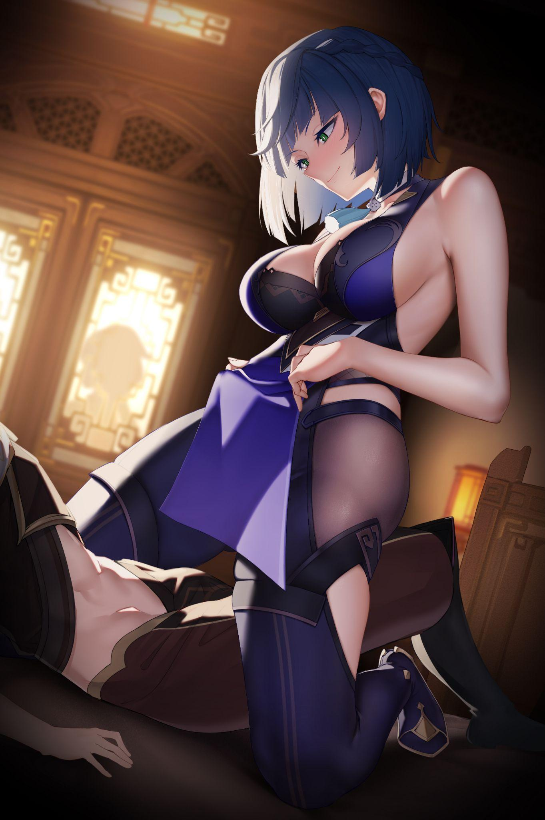

**“I didn't think you were to blame…not for one second…and I’ve had it with you trying to babysit me…so I'm only gonna say this once…you ready?"**

Nodding slowly while swallowing the lump of spittle in his throat, Owen was more or less fully awake now, partly wondering if this was all just some rabid dream, the peak of his insanity conjuring an obscene illusion of his friend spreading her legs for him…

But from the painful throbbing in his pants and the increasing warmth emanating from his unwitting partner kneeling before him, he knew this wasn't a dream…staying silent as he gazed into Natalie’s sparkling blue eyes.

**"I want you with me Owen…no more of that estranged friend nonsense. I’m not a failure…and you aren’t my guardian…well…I mean…technically not…but you get me, right?”**

After a momentary silence, Owen scoffs, before breaking into a laughing fit.

**“Jeez…didn’t you say you were supposed to lose your brains or something…could’ve just said an ‘I love you’ and be done with it…But…I get you…and I'd…love to try it…if you'll have me of course."**

**"Silly, of course I will…now~ Where were we?"**

With her pseudo confession answered in kind by a still drowsy Owen who couldn't quite believe how the night was turning out, an overjoyed Natalie, masking her happiness behind her composed face, lowers herself over her partner's groin, ready to seal the deal between them. From now till the next they awoke in each other’s sweaty arms, the two would hold each other not as awkward associates but endearing friends who would share in each other's respective lives, with Owen getting his business back on track while Natalie would take on a job as a high profile gravure model and gambler. Although it wasn’t quite like what she imagined living the high life to be like, the lucky woman couldn’t quite complain, not when it could have ended up in many, less than spectacular outcomes…

*THE END*