UPDATED Beth route patch 2.2

* In the beginning of the game after talking with summer and getting your phone the first mission is to talk to Beth. She is located in the kitchen.

Talk to her twice. First to her and Jerry and afterwards you can ask her two questions.

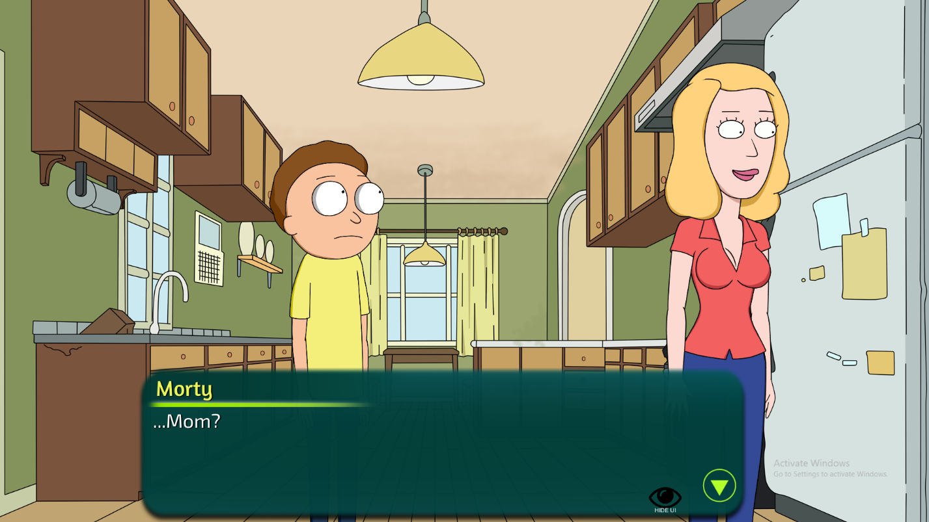

* After the chat the time changes to night and you should go to the living room and find her drunk. Then when she asks to watch a movie together.
* On the very next night you can go to the bathroom and find her there, showering.
* After getting the curse and app from el diablo in the mall and the arrival of Morticia and Rick in night time you should visit the living room. There you would find Beth and ask her to watch a movie, but this time she isn’t drunk and you have to buy wine from the mall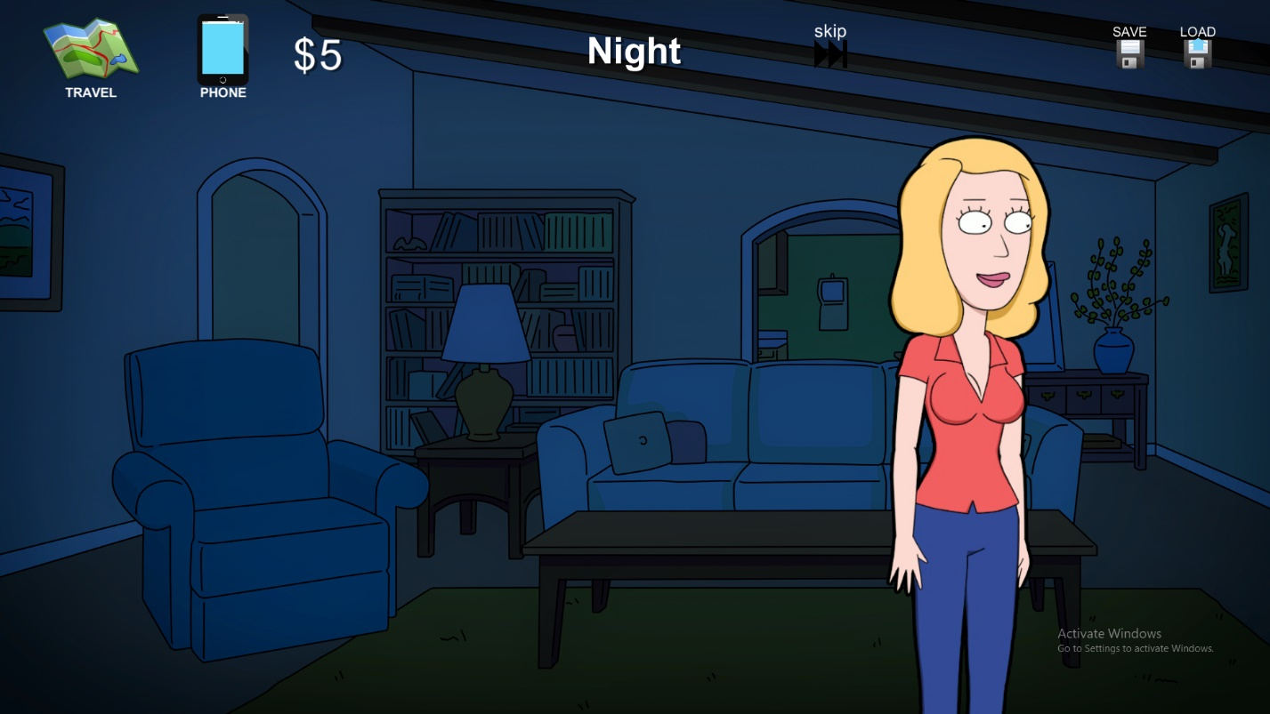
* First to buy the wine you need the money. Go to the garage and talk to rick he will give you enough money to buy the wine
* After buying the wine and going home at midnight she will be in her bedroom and you should ask her to watcher a movie
* On the next night you can find Beth in the kitchen and ask her for another movie
* After the movie you have to go to bed and that will trigger the next event and watch another movie
* At midnight the next day you can find Beth at her bedroom and ask her to watch yet another movie and at some point she will to feel her breasts and to that you should do what she says
* After that event the time is set to midnight and you should go to bed early
* On the next day at night you should go to bed early AGAIN
* After the scene the time is set to midnight and its time to watch another movie. She is waiting in her bedroom
* On the next at Night you should talk to Beth at the living room about last night.
* After that go to bed early again.
* On the next day gather 80$ from Rick and make breakfast for Beth.
* BONUS: If you go to the bathroom and take a shower in the morning when Beth is located there it will trigger an event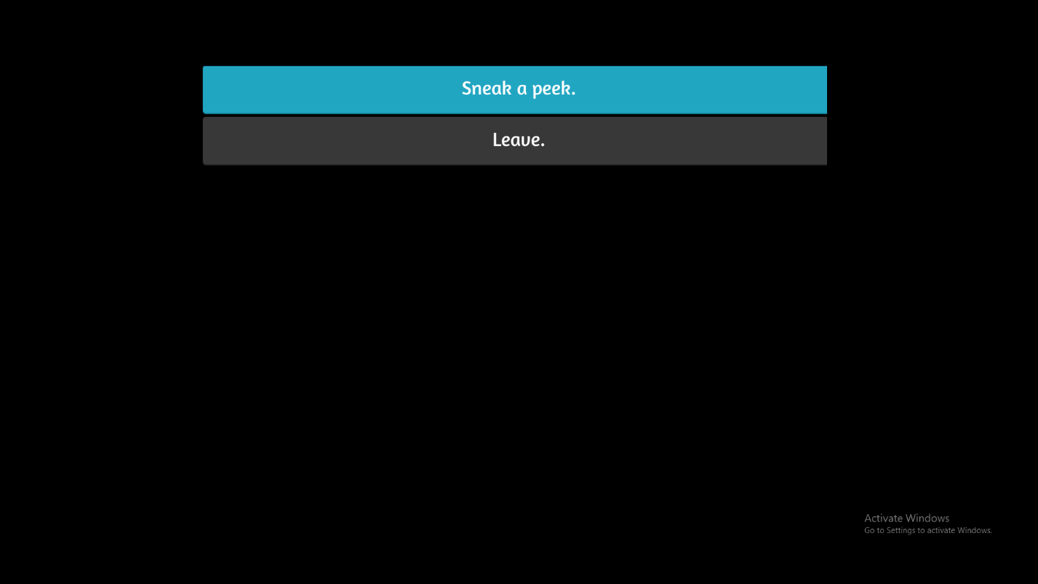
* BONUS: Art class event:
  + In the morning talk to Beth (in her bedroom or kitchen) and ask her where is she going
  + On the next day in the morning talk to Beth about going to art class again. She is found either in the kitchen or her bedroom.
  + After the event find Beth and talk to her about taking the photos