Indian Red
A Short Story
By Maryanne Peters

“So, there is family history?” he said. He was playing with my pubic hair.

“Pay attention,” I scolded him. “I will read you some of the early passages from the journal.” I had the copy with me, beside the bed. The original had become too fragile with age. “Now, remember, this was the Battle of Adobe Walls in November 1864, when my grandmother was only 18, and serving in the New Mexico Volunteer Cavalry, which was really just cowboys and gunslingers under army command.”

We were supposed to be attacking and clearly an Indian village of moderate size, but as it turned out, there were several villages and all of them seemed packed full of warriors. We found ourselves facing down well over 1,200, all dressed and painted for and armed with rifles. Col. Kit Carson had two artillery pieces at his disposal and he used them well, but the Comanche knew this weapon by now, and knew that they could be met best, by attack. They retreated a little only to come back with even more men of horseback, so that we must have been facing down over 3,000 by the height of the battle.

The big guns added to the general confusion. The morning was very cold. And the artillery smoke and dust hung low in the air like a fog. There were shots and explosions and much crying out, so that the sounds were equally perplexing. From the mists the Comanche would appear screaming, with rifles cast aside and tomahawks ready for close in fighting.

I never saw the man who hit me. I was knocked unconscious and must have lain there in the freezing mud, until the battle was over. Some say that the army won the battle on that day, but it was the Indians who must have held the field, as it was they who took my body from that place.

“She is talking about the Kit Carson?” he asked. “Like, the famous Indian fighter?”

“Yes,” I confirmed. “The guy who brought two howitzers to clear a village. If you want to call him ‘an Indian fighter’, then go ahead. But I would use another name.”

I learned later that the only reason that I had been left alive was because of my red hair. The chief had never seen hair like mine. It was long by the standard of a young man of the time, but not long enough for the scalp that he wanted on his war shield, so I was left alive to grow it.

But it is also the case that this tribe had taken other white people into their tribe. Some years before I had arrived, the army had abducted the wife of the chief, whose name was Narua, meaning ‘the found one’. She had been a white woman, one Cynthia Anne Parker, who (it was said) had been with the Indians for 24 years before she was taken. I learned later that she starved herself to death in 1871, pining for the life with her Indian family curtailed her capture and forced assimilation among white folk.

I did not understand how her fate among the Indians, would be my fate.

I understood little of what was happening, as I knew nothing of their language at that time. But I later learned that I was offered to the warrior Darago who had lost his wife during the attack on the village. He had three children, with the youngest only four years of age. He could have chosen a woman from the village, but he chose me. Perhaps it was out of revenge, for the first thing that he had done to me was mutilation of the most awful kind. But all things changed over time.

“Now this is where it gets interesting,” I said, slapping his hand away from tickling my left nipple.

“It’s a great story so far,” He said. “Read on.”

I learned afterwards that this is a tradition among Indian peoples, that is widely spread among most tribes of the Great plains and further west. There are people who are known as berdache, who choose or are chosen, to live their lives as females. There were three in the tribe that was to become mine, and these three ‘women’ became my guides in my new life, but not before they had taken my manhood from me.

There is much of ritual that surrounds the treatment of the berdache. Every month a berdache ‘woman’ is cut, or cuts herself, in the empty sack of the groin so that she may bleed as a woman does every month. To stem the bleeding, a hot stone is placed on the wound, and held there with a tight breech cloth, with a hole to allow urine to pass from the much-reduced penis. Every month a new stone is added atop the other, or a rod carved of bone, so that the wound becomes a tunnel into the body.

Other physical changes are brought about but the consumption of many foul-tasting medicines. The worst of these must be the drinking of the urine of menstruating women. I understood not, how it has been discovered the effect of these medications, but the effect is undeniable. The body does change and the breast is much increased in size, as is the posterior, and the whole body becomes soft and woman-like.

“So, is she saying that they had access to female hormones way back then?” he asked, with a look of disbelief.

“There is record of berdache being found who have acquired secondary female sex characteristics,” I told him. “There are naturally occurring estrogens in some foods. I am not sure about drinking urine, but I understand that hormones used to be extracted from urine, before they were created synthetically. What I can tell you is that, at the end, my great great grandmother had a woman’s body.”

“Like yours,” he said playfully, running his hands over me yet again. I slapped them away playfully, so that I could continue reading.

The other change forced upon me was the ripping off of my beard and other hairs of masculine nature, so that my body could present as if a woman, to my ‘husband’ Darago.

I thought him a most hateful man, and he hated me also. He sodomised me, with violence. It is hard to describe how low I felt – gelded and buggered as I was.

But I was given care of his children, assisted by other women of the tribe, and I came to love those children as a mother loves. I consider that it is the gelding that soften me to some extent, as before that I was a young ruffian with a bent for violence and no concern for others. I had become more peaceful as an unruly stallion after castration, so my mind shifted to other things.

The women, including the other berdache, schooled me in new domestic skills and in the role of women in our community. I learned to cook and to weave and to prepare skins. From the berdache women I learned the skills that they were famed for – curing the sick and treating the wounded.

“I have researched this a bit,” I told him. “The first encounters with berdache by settlers talked of ‘hermaphrodites engaged in healing practices’. And by all accounts, even when she left the Indians she continued to be sought after for what she could do.”

“She was a great lady,” he said. “Please continue. I am genuinely interested.”

The tribe seemed to be engaged in almost constant warfare with white settlers and cattlemen over the first years, so looking after the injured was an important thing. I have heard it said that berdache are abused in other tribes, but not ours. Abuse of me was reserved for my husband Darago, at least until he was struck down.

In the winter of 1868, after almost four years with the Indians, the Battle of Antelope Hills took place, near to our village. Darago was injured with a bullet lodged in his abdomen. I was able to extract it and treat the wound with fire and with herbs, and cover it with honey and spiders web. But he was weak through loss of blood, and had a fever for part of the time. I tended to him and fed him by hand.

Our children worked with me. They loved their father, as I was beginning to. He responded to the care, and to the love about him. He warmed to me. I became a person to him, and not just a whipping post. He told me that he had been becoming more and more attracted to me over the years, but fought back his feelings to permit himself to punish me more. Now he felt free to kiss me, and to play with my bright red hair, now grown long to my waist.

I had known women before and I did not believe that I could find a male body attractive to me, but Darago had a body that any man would be proud of, and I was proud that he was my husband. I was now soft and rounded, as he was hard and strong.

He pulled the stone and the bone rod from my body and used my tunnel for the first time. I was pleased but surprised, that the passage was long enough to take him completely. We embraced together face to face, and I took him inside me as a woman takes a man. If I was not before then, I became a woman that night.

“Let’s make love,” he said. “I want to enter your tunnel.”

“Just wait,” I rebuked him. “I am in the middle of this. Don’t you want to hear what happened next?”

The three years that followed his recovery were a very happy time for me and my Indian family. But these were to be sad times for all of that race, and the end to this way of life was drawing nigh.

My husband Darago, was killed in battle on the North Fork of the Red River on September 28, 1872. I wept for days. Our sons were aged 19 and 17 at the time, already warriors who would die as he had done, at the Second Battle of Adobe Walls in June 1874. Our daughter was only 12 when her father died, and she too would be killed on the day that I was taken, during one of the many battles of what is now called the Red River Wars.

“Is that it?” he exclaimed.

“That is only the beginning,” I said. “Her life with the Indians was over, but she had a life after that.”

It is a terrible thing for any parent, to have all her children die, even if they are not her blood. Both my boys died noble deaths as would make their father proud, and I learned of their deaths after their bodies were buried. But a more terrible thing, there cannot be, that to see your last child killed before you, and to hold her bleeding body as she chokes out through bloodied lips, her last breath.

I was wild with grief and anger for a while, but I remembered Narua, who became again Cynthia Anne Parker, and who died in pain and misery, and was certain that I did not wish to suffer that fate. Instead I made it my point to learn the names of the men who had killed my daughter, and to commit myself to vengeance in accordance with Comanche custom, but otherwise to allow myself to be reintroduced to white society.

Of course, nobody had any idea that I was not what I appeared to be, a white woman who had been abducted and had been living with the Indians for some time. Even had they stripped me bare they could well have assumed that I was a normal female, for I had a hole between my legs should they draw out the bone and the stone, and my urine came from something quite unlike a penis. But fortunately, I was permitted modesty, even among the women who were called in to attend to my conversion.

My hair was very long. It had fascinated my husband so I kept it that way. He would wind it around his neck when we made love. I kept it combed and clean, but these ladies washed it with perfumed soap, brushed it with soft bristle brushes, curled it and arranged it complicated styles. My hair became my signature. I was the red haired red Indian.

“No trace of red in your hair,” grinned my lover. He was playing with my pubes again.

“Don’t be stupid,” I said. “She was not my great great grandmother by blood. How could she be? Sadly I cannot have inherited anything of her. I wish that I could claim to be a part of her.” Instead, I continued to read her words.

In those days, Lubbock was not yet a town – just a church and a store until the hotel was brought across from the other side of the canyon on rollers. It was distant from the land I had lived in as an Indian. Only rarely did I find someone who could speak in the tongue I had learned at dream in.

I was made a guest of the Christian ladies of the church and took part in church services as an example of a woman who had survived the heathen and been brought back to Christ. I recited my prayers, but I still said a word to the spirit of the wind when I called for vengeance.

The time came for each of the men involved. I never lost my skills with a rifle and six-shooter that I had before I joined the Indians, but it my skill with the knife that finally dealt to my daughter’s killers. That gave me the satisfaction of watching the life drain from their eyes as I twisted the blade to increase the pain.

The second one tried to claw my face, so I turned my head and he pulled the comb free. He died drowning in his own blood with my red curls around him. I felt glad that I was a woman who had been able to draw him alone to his death, whispering the name of all three of my dead children in his ear.

“So, at this point your great great grandmother is confessing to murder,” he observed.

“It was the wild west,” I exclaimed. “People murdered one another all the time. Anyway, her story remained a family secret until after her death. It still is really. I am only telling you because I hope that we are going to be married.”

“All you have to do is say yes,” he said.

“I am coming to that,” I explained. He looked at me hopefully.

I lived as a guest in the town, but I earned my keep. I was called upon to assist with illnesses and injuries from time to time, and I was skilled enough to be regarded as the town’s doctor and dentist.

One day I was called in to attend to the amputation of a leg from a rancher’s son who had contracted gangrene from a snake bite. I preserved as much of the leg as I could, but I had to cut the bone above the knee. Rather than see him remain a cripple, his father called for Doctor Claude Jones, and he came to our town.

Claude had served as an officer for the Union side in the civil war and told me that he had performed countless amputations. He told me that my work was as good as he had seen, but he was not here to comment on my skills, but to fit a prosthetic leg. I had never seen such a thing before. Nobody had before the civil war. But with so many lost limbs there was now a big demand for the mechanical ones – being with padding and straps, hinges and springs.

I knew that the Doctor had taken a shine to me. I liked to talk to him so I made myself attractive as women can do, to keep his interest fervent.

As it turns out, history was to repeat for me. He was a widower with a family. He had two children, a daughter Mabel and a son Jed, that child having been born as she had died on the delivery bed, only the previous year, on New Year’s day 1875.

“So that was your grandfather, Jedidiah Jones?”

“That’s right,” I said. She married Claude Jones in 1877 and basically became mother to Claude’s children and grandmother to my grandfather who was born in 1950, 10 years before she died. There is more, but I can see that you are distracted.” His erection was obvious.

“You cannot lie there naked and expect me not to want you.,” he complained.

“Come on, then,” I said, pushing the sheets away. I was still well lubricated from the last time we had made love, less than an hour before. It was invitation enough.

He gently moved on top of me and I felt his penis entered me, breaking past the wet vaginal lips until his pubic hair meshed with mine. He arched his back and I rested in the moment, until he started into his rhythm. His strokes quickened as the heat rose in both of us, each of us gasping and taking hold of the flesh of the other.

The moment of orgasm was exquisite.

He rolled over breathing deeply. I had done more than please him. I had exhausted him. My pussy had sucked out his balls and filled his head with delight.

He turned to look at me smiling at him. He asked: “How many times do we have to make love before you agree to be my wife?”

“I just wanted to tell you my great great grandmother’s story before I explained to you that I am just like her. I was not always a woman.”

I had told him. He had heard the words. He still looked confused. Regrettably, I needed to tell him again. “I am a post-operative transsexual. A transwoman. I have had surgery to construct the vagina you have just reamed with your pole. If you still want to marry me after knowing that, then my answer is yes, but if you want to take the offer back, I understand.”

I could see the shock creep over his face. It was too much to tell him. It was clear to me now that I would not be marrying him.

“You kept this a secret from me?” he said, angrily. “You stood silent when I fell in love with you?”

“But, I fell in love with you.” Tears were coming, only a blink away. “How could I tell you and have you leave. Could you love me still, knowing what you know now?”

He looked at me. He looked and I could see no clue as to what he was thinking. Was it hatred? Was it disgust?

“Is all this true?” he asked. “All this about your great great grandmother? Is it true or just a story you made up to break this news to me?”

“I swear every word is true. I even have her death certificate, signed by a very puzzled pathologist. She lived her whole live as a woman, from 18. I have lived my life as female since I was 15. This is who I am. Like her, I am looking for love. She found it twice. I only want it once. From you.”

“You have found it,” he said. And I knew it was the truth.

The End

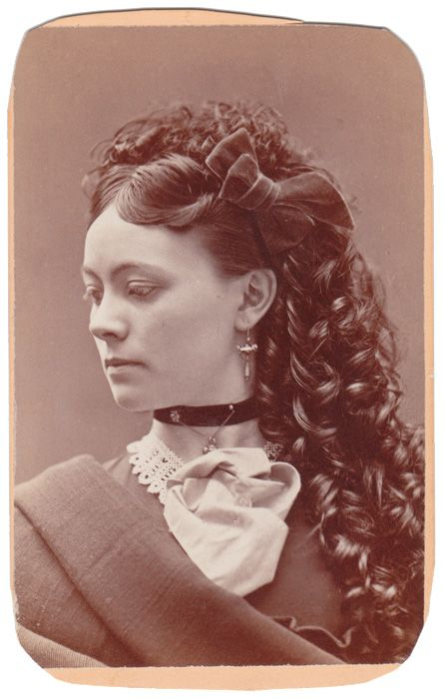 | 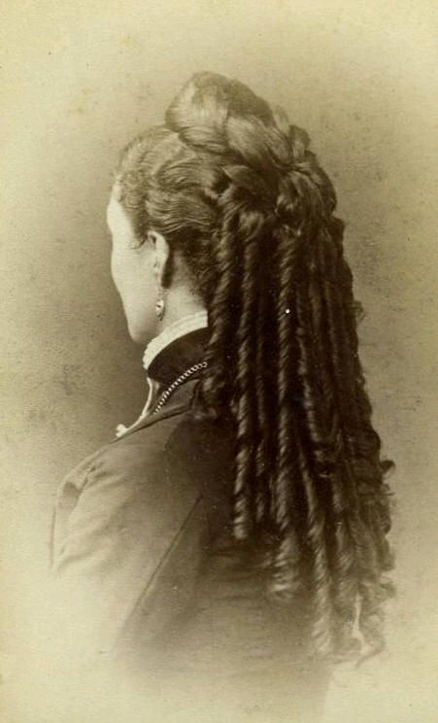
My Great great grandmother and her famous red curls, not done justice in monochrome

Author’s Note
Berdache were widespread across the Indian tribes of North America and were first recorded in the 16th Century. It is a French word used to describe the tradition. There are historical records of encounters between berdache and white explorers and settlers. The abduction of white women is well documented, and the tragic tale of Cynthia Anne Parker is true. The Red River wars also refers to actual events, involving Kit Carson and other historical figures. All the rest is fiction.

© Maryanne Peters 2018

