FELL THROUGH
COMMISSION STORY
BY CHALDEACHANGE
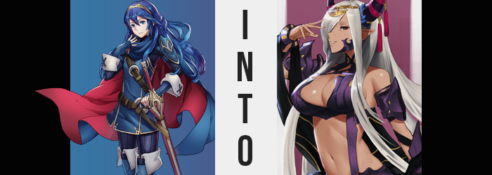

The worst days had a bad habit of beginning with the most mundane of experiences.

Lucina, princess of Ylisse, already knew this well. She had come from a future where the world had been destroyed by the efforts of the Fell Dragon, Grima. There had been plenty of mornings back then when she had wanted to open with her usual routine, but things took a turn for the worst – and sometimes for the tragic. You could never expect these things. They were usually out of your control, and yet…

The girl had transported herself into the past to avert a future where such daily tragedies could be averted. Perhaps not altogether, because life had a mysterious way of presenting its trials to you unannounced, but she could at least stop Grima from making things worse. She had been willing to abandon her world to secure a future where this wasn’t the case. That was how bad things had been back in the fallen world.

And much like those days, this day had begun in a similar fashion. Lucina had awoken in the Shepherd’s camp, she had trained and eaten, and eventually a request for aid had come in from a nearby village. Apparently bandits had been making the nearby forest their home, using it as a base of operations to terrorize the surrounding communities. On paper it had been an extremely simple job. And even in reality that had been the case.

The mistake had actually been on Lucina’s part. During the skirmish that had followed, her battles had led her farther and farther away from the rest of the group. So when the trees finally quieted and the sounds of combat had faded? She had been separated from the others quite a ways. “That’s unfortunate. At least I can easily recall where we set up camp.” The princess saw fit to turn the experience into a positive. This way she could scout the area and make sure there were no bandit remnants.

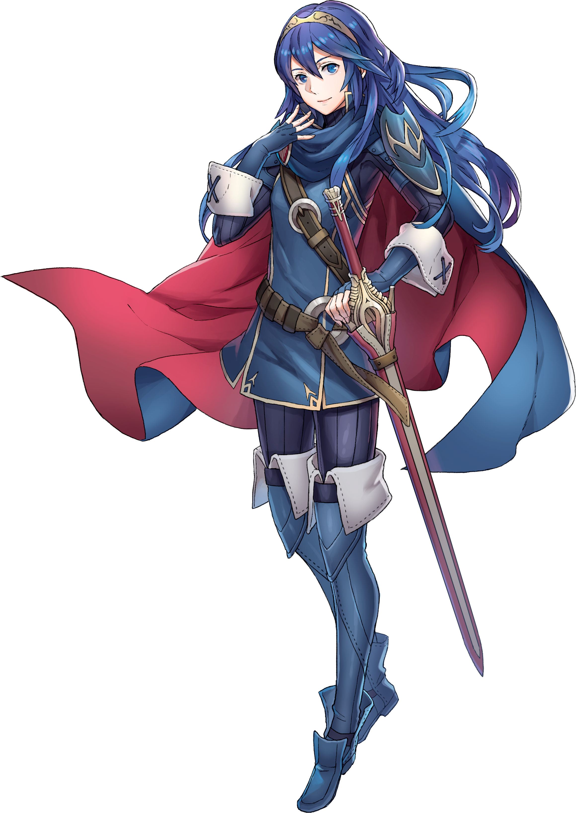
It was the middle of the day and the sun was high by this point. She savored the warmth of the light that filtered in through the trees and the cooler breeze that teased her skin. All in all, perhaps she was fortunate to have had this moment to relax rather than head back with the others. It was nice to be out alone sometimes, not that she would have preferred a life like that whatsoever.

“Hm… It doesn’t seem as if there were any additional camps about. That’s good news.” About an hour of exploring at her leisure had led to this conclusion. She had checked nearby enclaves and caves, but nothing stood out as a threat to the nearby locals. At least she could confirm this to the others when she returned – that there was absolutely nothing left to worry about.

And yet as she passed a clearing covered with fallen leaves, Lucina realized she may have to re-evaluate that assessment. In the middle of the clearing was, of all things, an unmapped Outrealm Gate. These gates connected their world to others, and they could be harmless or volatile depending on the situation. Considering the surrounding area reeked of death, she was wary that this particular gate fell into the latter category.

But so long as she didn’t pass through it, no harm would come to her. That was the understanding she had, and so she approached to get a better look at things. “I should examine this as much as I can before I report back to father.” Her intentions were muttered under her breath, but once she drew close? Those intentions were immediately sidetracked as something was expelled from the gate.

Landing in crumpled leaves was a dark-colored tome. It was just a book, harmless in its own right. But Lucina’s good sense guided her not to pick it up – just in case there were risks involved that she wasn’t aware of. And yet you could have the best intentions in the world, but sometimes there were forced beyond your control that prevented you from following through with them. Case in point?

It almost felt as if she had blinked, and the next thing she knew? Not only had the princess walked up to the tome’s location, but it was in her hands. It was as if she had blacked out momentarily and her will had been wrestled from her. “What!? Why did I pick up my tome!?” She was most certainly shocked, but not so much that she hadn’t caught what she had just uttered. “My tome? No, this doesn’t belong to me, does it?” She had never seen it in her life, and there was a menacing aura that radiated from it. Yet despite her brain screaming to her to do so?

Lucina did not drop the book. Rather, her body clutched it tighter.

It certainly didn’t take a genius to comprehend that something sinister was at work here. “I need to let it go!” The most Lucina could do was shake the hands that clutched the text out of hopes that it would loosen and be dropped, and yet fingers held on for dear life. There eventually came a verbal retort as well. One from her own mouth. “Never!” She had practically hissed in the midst of this shout.

The young woman’s eyes went wide. Why was this happening? She couldn’t even comprehend what was happening. Yet there had been an early yet discreet indication that something was amiss. In her left eye where her brand should have been? That symbol slowly faded away until both eyes looked exactly the same. As if to say that she was no longer worthy of such a marking.

“Ngh… AHHHH!” A momentary discomfort prompted her to stumble forward. Her head was throbbing and it was terribly painful. One of her hands reached up to try and sooth the source of this discomfort, a pair of sudden pressure points on parallel sides of her skull’s top, yet since the other hand refused to unhand the tome it wasn’t a particularly effective attempt. Eyes were wide and sweat dripped down her face; that was how much it hurt.

The sound of something tearing unsettled her, and she almost felt nauseous once she realized that what had torn was the skin atop her head. There was no blood nor wound though, yet the hand that was raised to her head felt her tiara slide past it onto the floor for it was pushed away. By a pair of horns that were now weighing down her skull. From what she could feel, their shapes curved up towards each other and were very smooth, but the one on the right was only about half the size of the one on the left. “H-Horns!? Why!?”

Realistically, the one things that had horns, at least in humanoid form, were monsters and demons. But as she felt her blood begin to boil another possibility crossed her mind, almost like it was answering the questions racing through the back of her mind. There was another possibility when it came to humanoid beings with horns. Dragon. At the very least? Now that her horns had grown in, she was no longer in immense pain. But the heat her blood was producing was generating a completely different feeling.

Arousal.

Lucina did not act on that feeling just yet though. How could she when she was so horrified? There were other things she should have worried about at the time anyways, such as a tugging at her ears that slowly stretched her cartilage backwards until either ear was then tipped with a point. It wasn’t as consequential as the eruption of her horns, but it certainly contributed to the inhuman appearance that those new physical accessories already portrayed.

“I’m…” The girl licked her lips, sampling the salty taste of the salt that had passed them moments before. She was still sweating profusely, but this time it was because of her body temperature. Her blood wasn’t literally boiling but it did burn as it was corrupted into something much more draconic, and a presumed side effect of this was a change in Lucina’s skin pigmentation. A healthy pink skin tone darkened several shades, melanin blossoming at the blood’s behest until she not only sported a natural tan, but the nipples beneath her tunic had browned as well.

This change of skin color was the first to go unnoticed by the princess, or at the very least if she had noticed, she didn’t outwardly react to it like she had her horns. No one could truly blame her, not when you considered the state of her mentalscape. There was something creeping and clawing up from deep within. It terrified her, and yet she could not help but recognize it as a part of her. It brought her to think back to everyone she had killed in the past and it erased any of the guilt she felt. Shivering, an even more terrifying thought crossed her mind.

It wouldn’t be that bad to serve a great and powerful Fell Dragon, would it?

“NO!” She fiercely rejected this thought, and yet it lingered. What’s more, as she shouted she had opened her mouth wide, revealing that her canine teeth were longer and sharper now – almost like fangs. Once those lips returned to their resting position, they didn’t exactly fit as comfortably either, for a good reason. Those tanned lips were more swollen than before, giving them a more mature look that bled into the rest of her facial features while likewise sapping away her perceived identity visually.

Little by little, a fundamental maturity seeped into the look of her face. Raised cheekbones and a sharpened chin really highlighted this, but a more natural beauty saw her brows thin, her nose grow slightly, and her eyes narrow. Lucina’s eyelashes fluttered longer, and they did little to conceal a bloody crimson coloration that flitted into her irises, replacing their previous blue. “I won’t be a servant of the Fell Dragon…! As much fun as that sounds like… Mm, I suppose I could have my way with whoever I want to, couldn’t I? That doesn’t sound too… That sounds awful!”

Projected through a sultry, wanting voice, the mental struggle she was enduring was pulled front and center. She sounded distraught one moment and into it the next, but the entire time? Her lips remained pulled upright into a smirk. She was beginning to find fewer issues with the proposition that was being forced upon her, and even tanned fingertips had begun to tease her chest and loins in response to the arousal that had begun to build earlier.

“Who could say no to all of that power though?” She certainly felt powerful, and that strength and confidence only swelled as her body swelled. Initially it was simply in the upwards direction, with several inches of added height to her spine and limbs granting her a more imposing visage. As she grew, not only did her hair grow in kind, but the bright blue that she had been said to have inherited from the Hero King, Marth dulled to a dirty silver. Bangs were strewn across her right eyes, long and silky locks otherwise hanging with menace.

As she was taller, her tunic had lifted a little and her pants had slid down. That meant her tummy was visible, but it also meant there was an easier access point for the older woman to slide a hand down into her pants (showing silver pubes sticking out in the process). This ‘power’ that she felt went hand in hand with her arousal, and now that she was captivated thoroughly by her transformation the tome had already fallen from her grasp. There was nothing left for it to do.

Lucina huffed in between moans. The power she felt continued to grow, but so did a sadism that seemingly swelled along with her figure. Under the touch of her one hand, for example, the weight of her chest had begun to swell. Nipples erect, they became puffier themselves, which in turn made them easier for her to grasp and twerk as her back crashed against a nearby tree. Her tunic tightened around them, yet they still jiggled and bounced even after culminating as a pair of DD-cups.

Meanwhile, the fingers probing her moist pussy within her pants found their space crowded thanks to growth that plagued fit of her clothes. Those fingers could no longer function as productively once tanned thighs grew so abundant that they were practically rubbing against her hand in the process, and her pants became exceptionally tight as her ass swelled behind her, rump rocking and bumping against the tree she behind her that she was using to support herself as she masturbated.

By the time she had finally climaxed, there wasn’t a single pure thought left in that pretty little mind of hers.

“OOOOHN!”

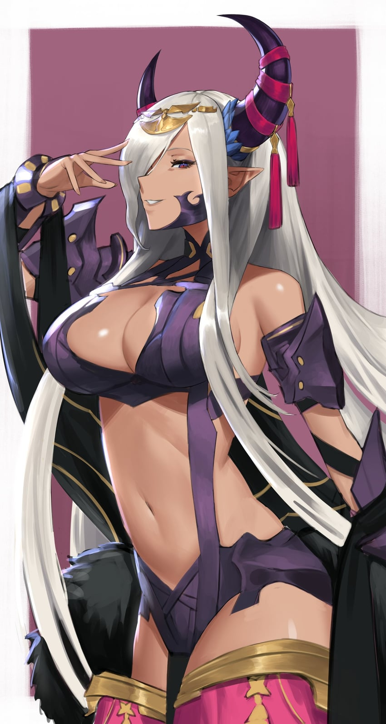
The Dragon Mage licked her lips sensually – although there had been little about her transformation that hadn’t been sensual when all was said and done. “Now, these clothes just will not do, will they?” While it had been strangely erotic to have her old clothes dig into her flesh as she had grown, the woman now took issue with her old outfit in terms of style and the fact that her panties had been soiled by her orgasm. But it was quickly rectified with a snap of her manicured fingers, all of the cloth exploding into light to leave her nude.

That nudity was fleeting, for skimpy, purple armor covered her bare essentials while highlighting her tummy and the heft of her tits. Thighs were largely exposed aside from the dark cloth hanging from her waist, and a golden bangle bridged horns that were now adorned with crimson rings of cloth. It was more like a battle bikini than anything, adorned with fanciful decorations. Yet everything about the woman looked sinister.

But then again, that was because Zephia was a sinister woman. A loyal subject of the Fell Dragon, yet not the same Fell Dragon that Lucina was familiar with. For all the girl had done to fight her transformation and the impulses that had come with it? Well, perhaps it was crueler that she wasn’t actually gone. Lucina had been incorporated into Zephia’s entire being. She could still recall being Lucina and she had all of Lucina’s memories. But she also knew of another life as well.

“Hm… I suppose I should return to my husband and father, shouldn’t I?” A mischievous smile played upon the dragon’s voluptuous lips as she began to saunter away from the gate. Robin was her husband, or at least he had been Lucina’s. But she still knew this, and so she saw him as hers. Rather than yearning for the comfort of this family, though? Her mind swirled with twisted ways she might make their lives miserable. She cared oh so little about killing and torture, particularly if it was done in the name of her Fell Dragon.

There was a nagging thought at the back of her mind when she considered the idea of a family though. Memories. A girl with blonde hair done up in drills, as well as another child with hair split between black and white. That was a family worth preserving. And when she returned from this mission she had been sent on? She could return to having that family. But first?

“I cannot wait to drown this world in Lord Sombron’s darkness!”

