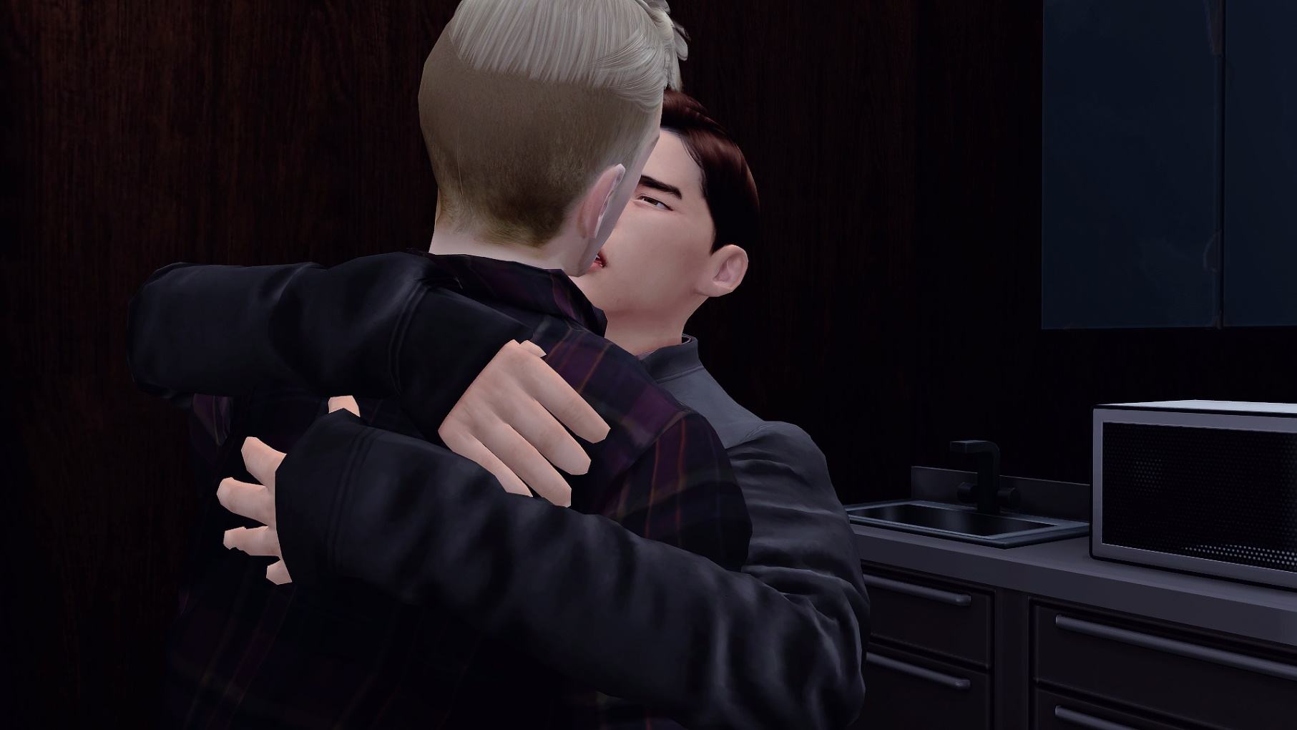
[Picture Short Story] Lucas’s recalls his past at Cipher

Craig tightly hugged me without hesitation, “Come back to Cipher Lucas- ” he slightly paused trying to make me look at his eyes, “there hasn’t been another secretary like you since you left, I need you there.”
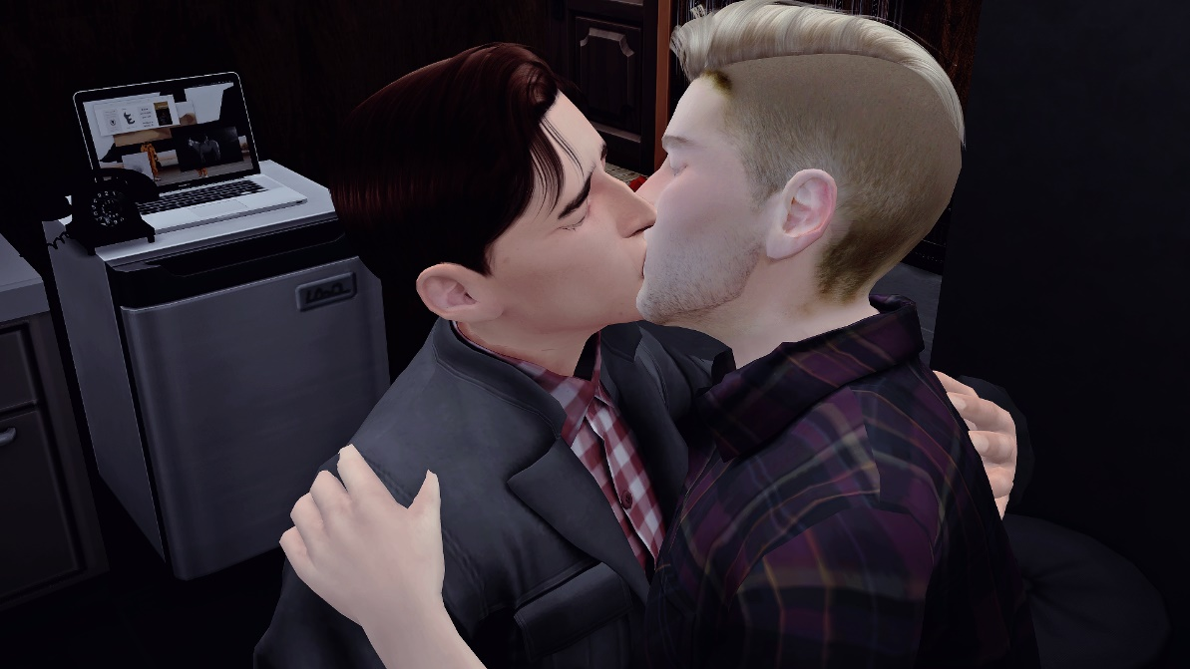
I tried really hard not to make eye contact but, his face was right in front of mine and I could feel my cheeks getting red and my heart aching. Craig has always flattered me in a way that makes me feel stupid special. Like I don’t think he understands that I hold him very high for being such an accomplished, smart and wealthy guy. So, to throw those compliments at me… it just makes me feel like I’m on top of the world and that I really am the best at what I do.

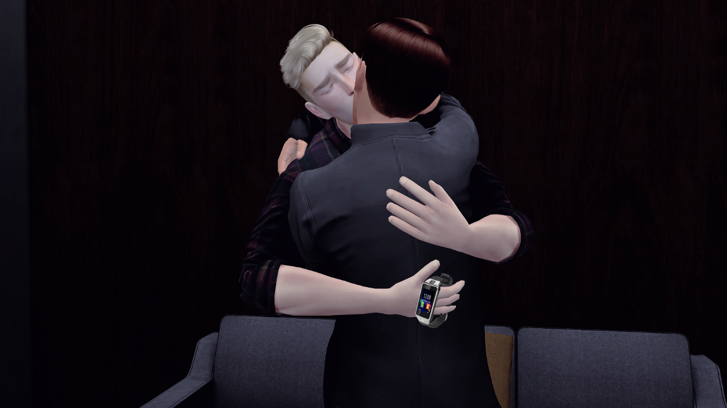
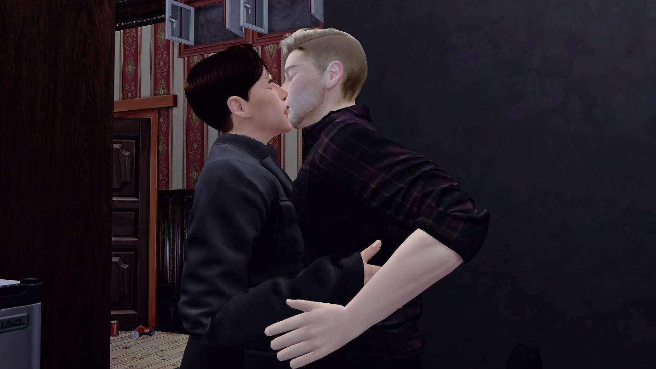
He began kissing me with his soft lips and holding me even tighter and I could feel his Burberry perfume burn my nose hairs as it entered my nose. It was a pleasant- sweet and bitter smell, a familiar one he’d wear whenever he would leave late from the office.

I tried to push him away but, my will power was weak. My body wanted to hold him tight and continue kissing him but, my mind was telling me to stop doing this to myself. This guy doesn’t think of this as anything more than blowing a load, so why don’t I just push him off and tell him the real reason why I left Cipher. Why I couldn’t bear being there anymore, next to him, seeing him every single day and fucking him every other night.
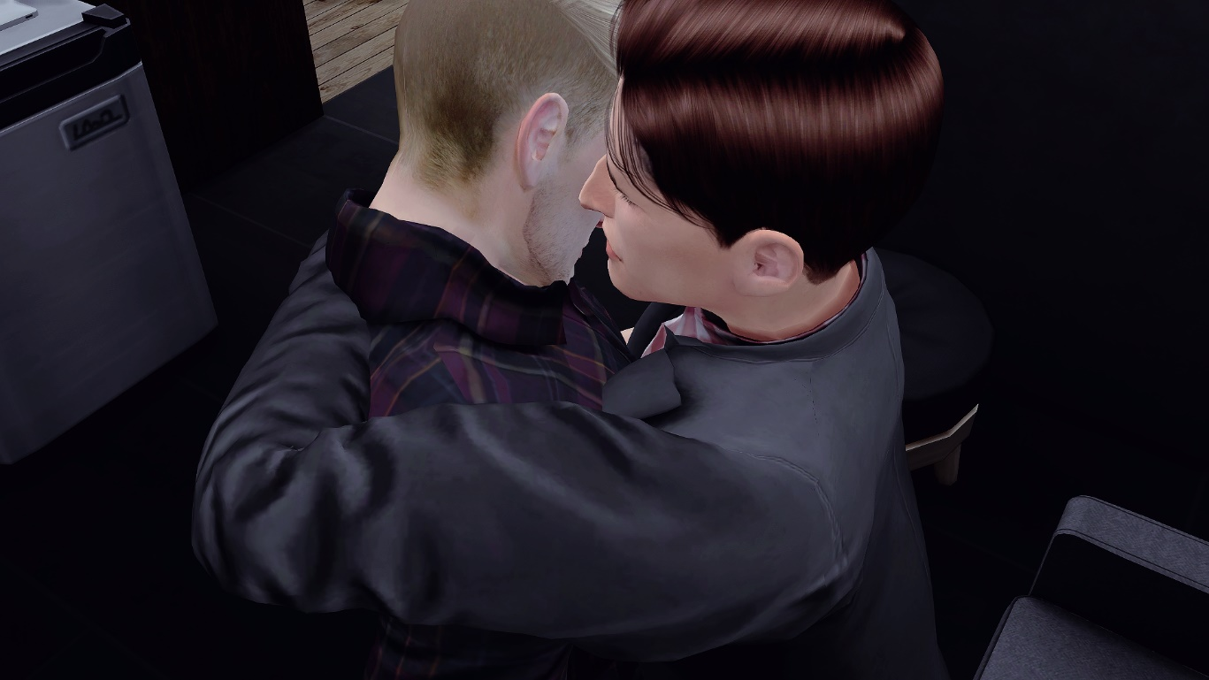
I began to think about how John has been the only guy I’ve been having sex with lately and finally let out a “Let’s stop, I’m at work and someone could see us” but he responded, “Your dick is hard, let me suck it.”

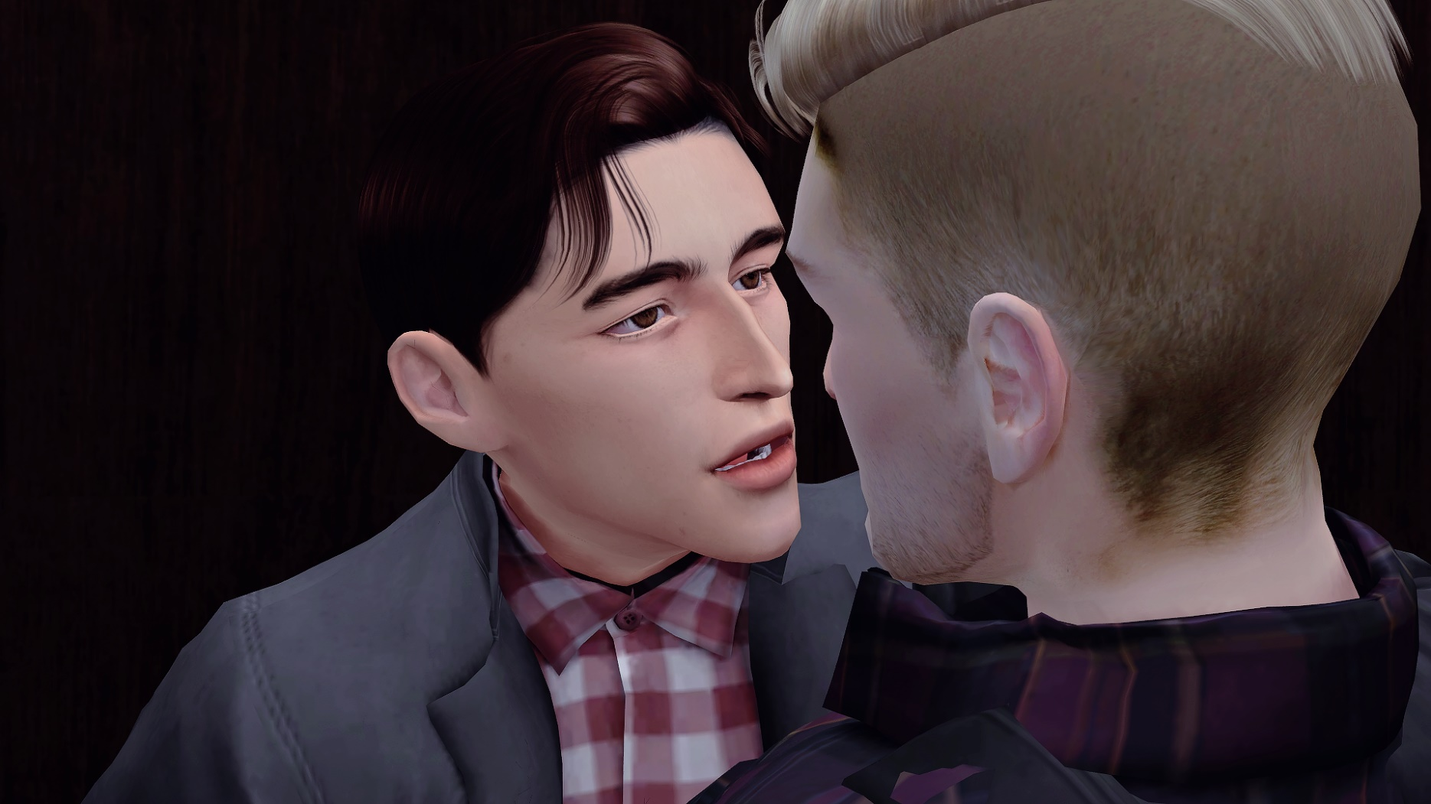
I transferred the smart watch from my hand to his while our chests were still together and told him “some other time” but he responded, “I’ve been craving you really bad Lucas, when are we going to fuck again?”

This would have been the perfect moment to tell him but, I just couldn’t bring myself to admitting that I had fallen in love with him after we agreed it would be nothing more than just sex. We had countless nights discussing the philosophy of having sex just for pleasure and how that was something that was ok but, my heart betrayed me in the end.
I couldn’t tell him that after the last time we had sex I had fallen in a state of depression with a broken heart after trying to change how things were. He straight up rejected the conversation and I told him to forget I had said anything but, it hit me really hard. I still want him to acknowledge me and to be around him but, AT THE SAME TIME I don’t want to be around him. I just don’t understand myself and right now there’s nothing more that I want than to stick my dick inside him and watch him moan and desire me.
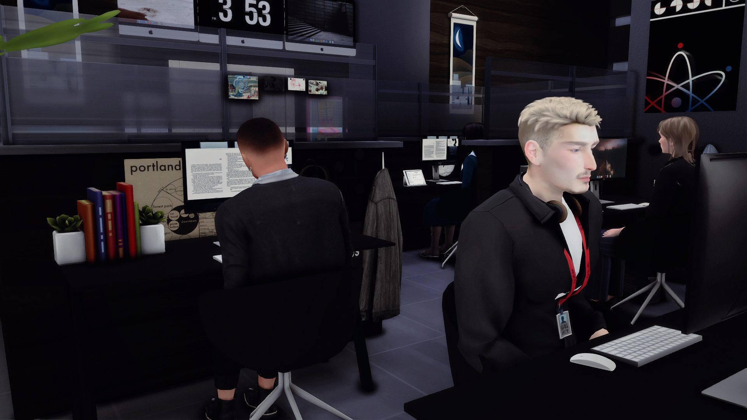
I want to be able to just have him as a friend who I can fuck and not feel anything for because sex with him is incredible but, I HAVE TO get my mind straight first. I mean I’ve had sex friends before and after knowing him but, why is it its different with him? And why is the same thing starting to happen with John?
I guess I really have to think about these things because having a broken heart for months almost made me spiral out of control and forget what’s important to me. I even stopped visiting my mother. I mean Looking back, I DON’T EVEN know how I fell in love with Craig. Sometimes when he’s around I feel like I’m gonna to go to work the next day at the office even though it’s been more than 7 months now.

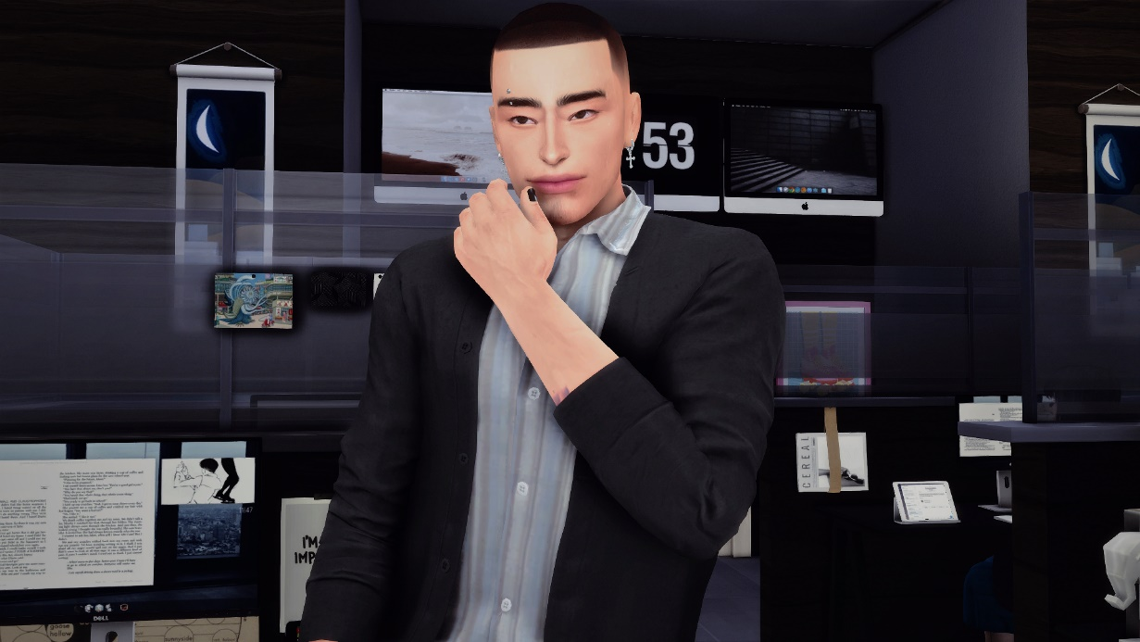
I guess because of this I can consider working there a highlight in my life because I really do miss it. I remember it like yesterday, sitting in my cubicle right behind Rui and next to Vicki and Li Yinping.

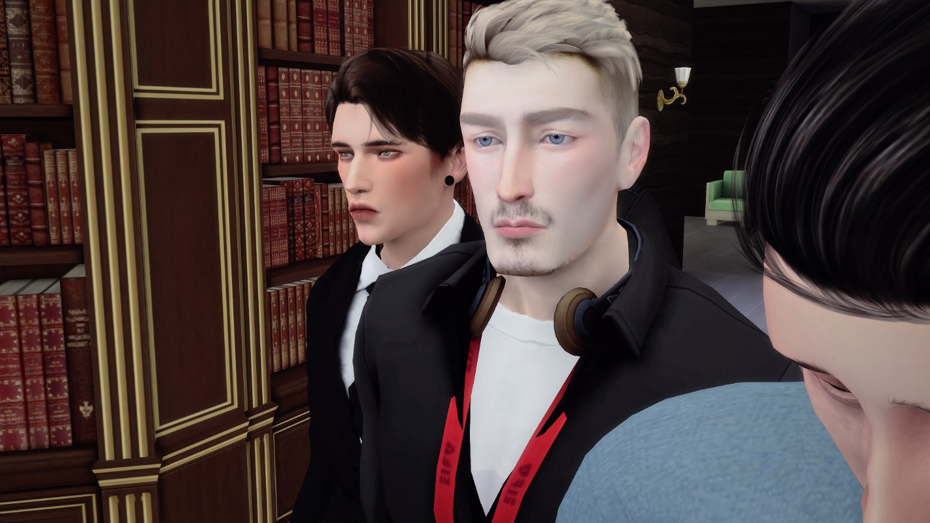
Maaan I miss Rui being behind me, his stupid jokes, and his personality. He’s the kind of guy I could talk to for hours…I wonder if he improved his accent like he always wanted to.

Also, I wonder how Zachary is, I haven’t spoken to him in months and he was such a close friend. I mean he stopped texting me after he started going out with Li Yinping but, I never made the effort to keep in contact. I guess even people who are that close with you can get tired of you once they don’t see the effort. But I was just too depressed. He hasn’t even been at the bar. Is he maybe mad at me?
I think If John starts working there, they’d probably get along really well.

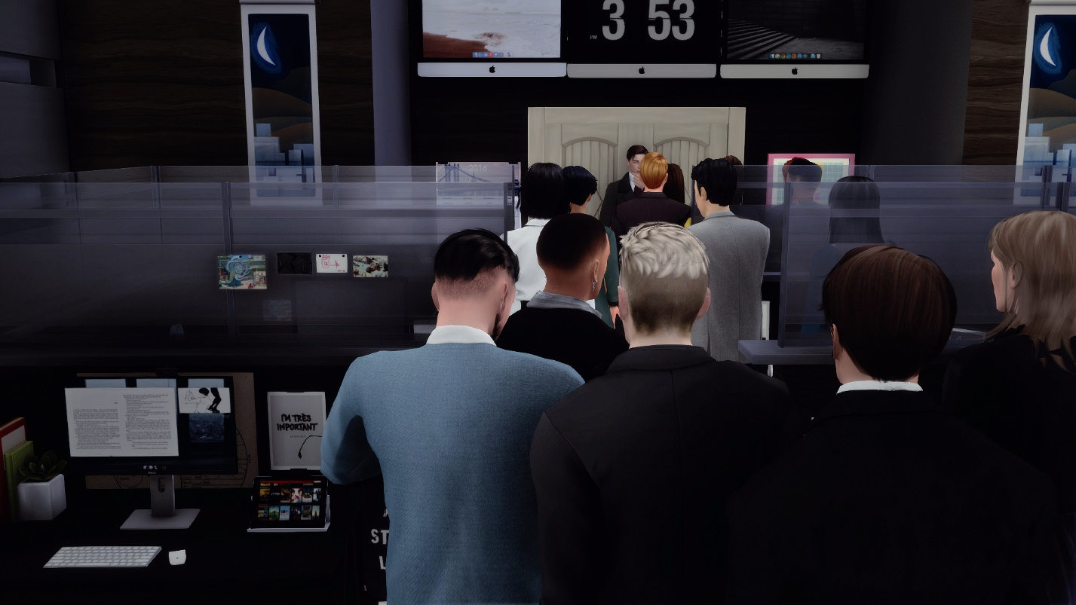
But, aside from the money what I miss most of all is being useful and feeling like I contribute to something great. Being acknowledged and praised by Craig for doing great work, even though I was just a side worker and not part of the grand operation.

I mean everyone praised me, but Craig’s opinion was above everything everyone said. This wasn’t only because he was the boss, he was smart, dedicated and over all a very hard worker. He would stay at the office leaving late at night to make sure everything was done and if I needed help or just wanted him to take a look at something, he’d always make the time to come and sit with me.

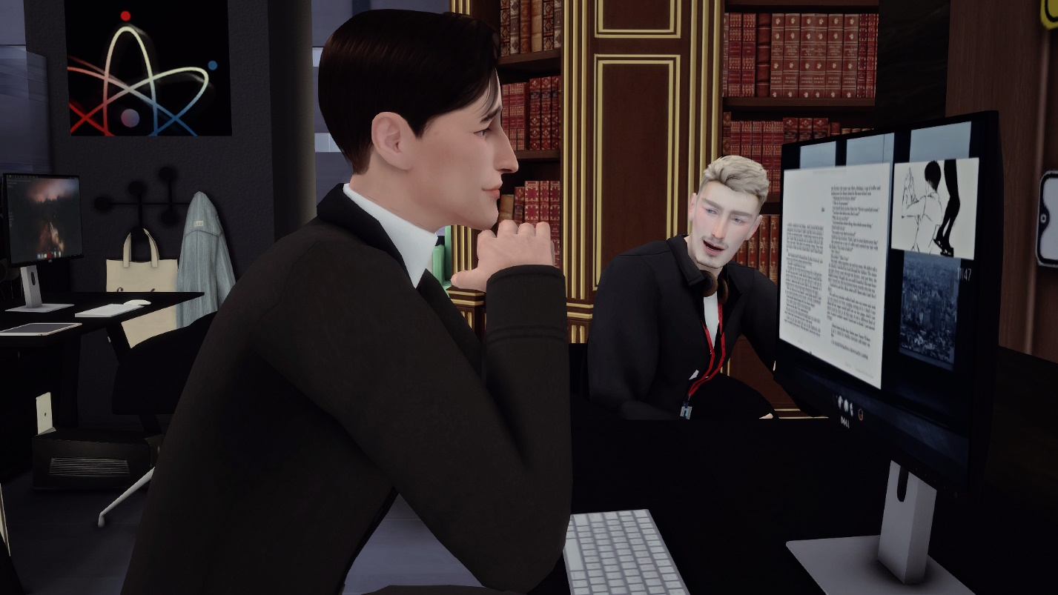

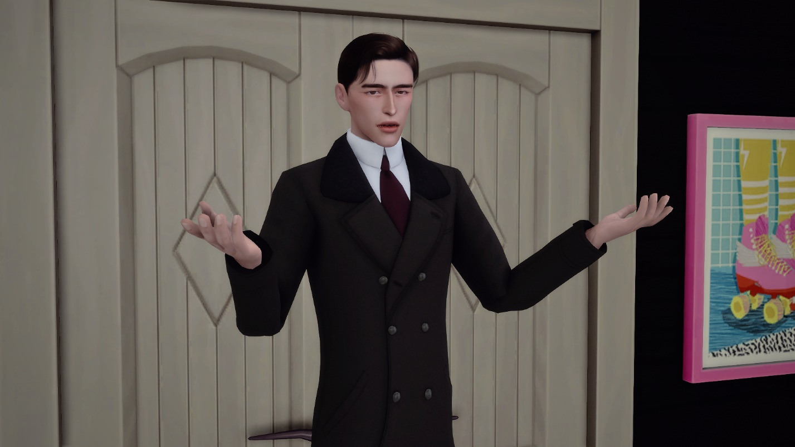
I guess all of that coupled with his soft looks, his soft voice, his personality, and his smile-

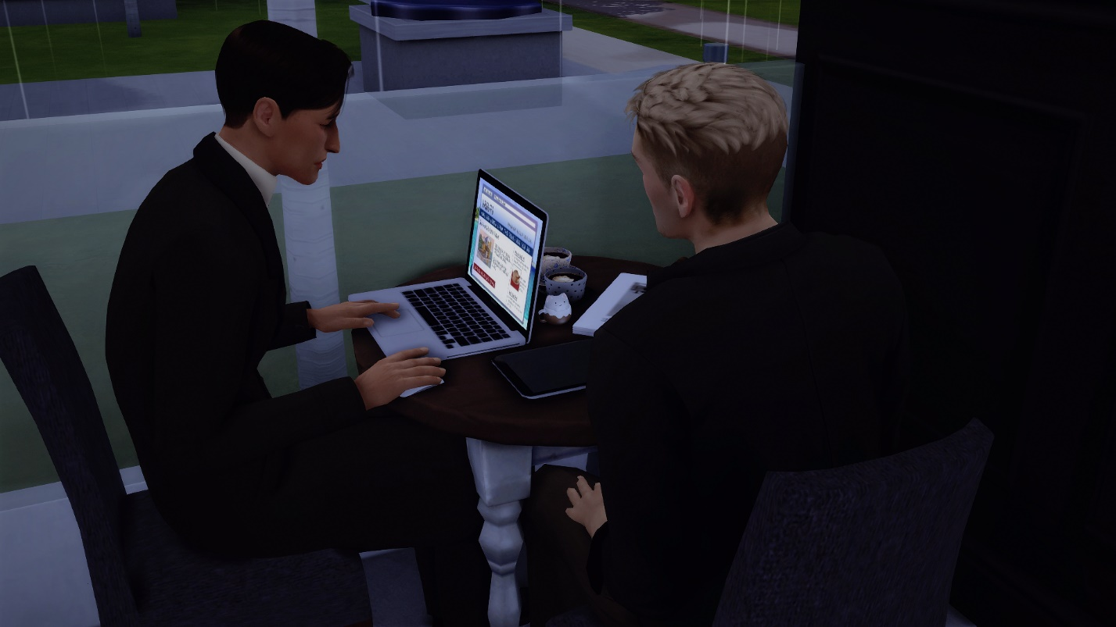
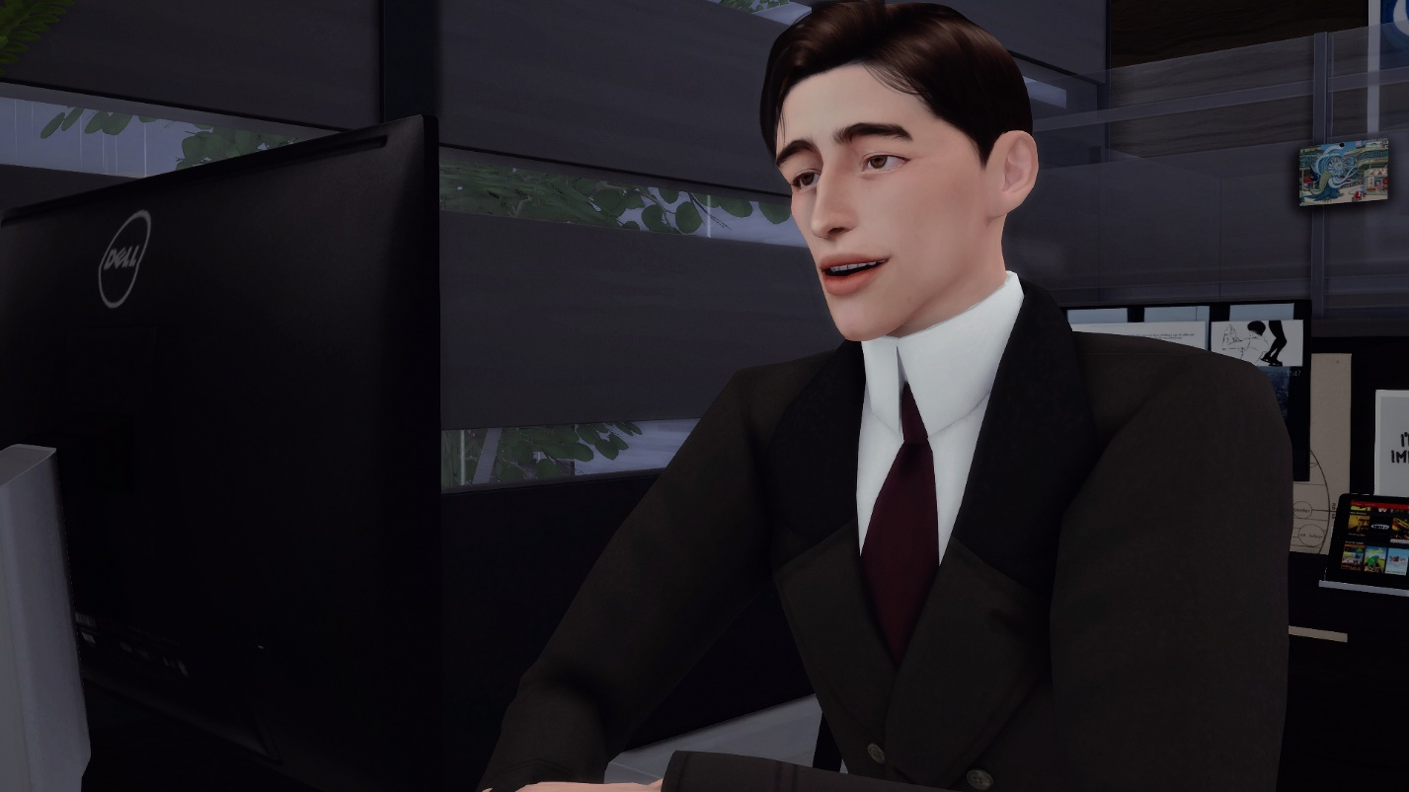
was the main reason why I finally wanted to try it with a guy, with him. I mean I always found some guys to be incredibly attractive and wanted to try but, with Craig it just made me way too curious.

And it was crazy to me how once I got a little closer and asked him about the rumors of him sleeping around with a lot of people, he straight up told me it was true and asked “Do you want to try it with me?”
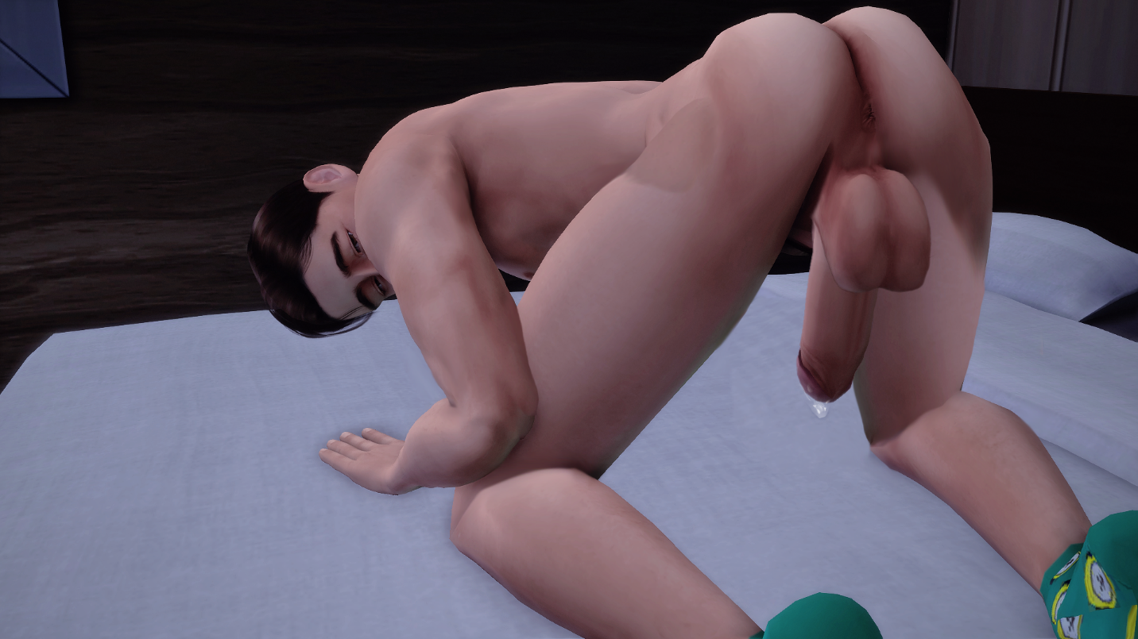
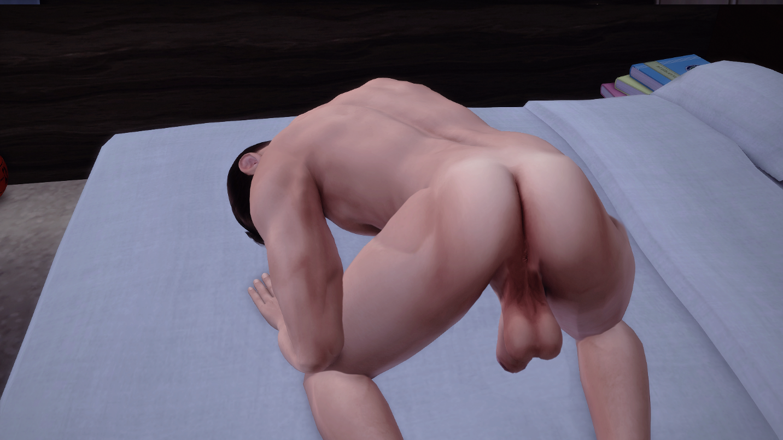

Before I knew it, Craig’s beautifully plump ass was right in front of me. Powerful, smart, and successful Craig was in a vulnerable state for me. He looked me in the eyes and asked me “You still want to do this?”
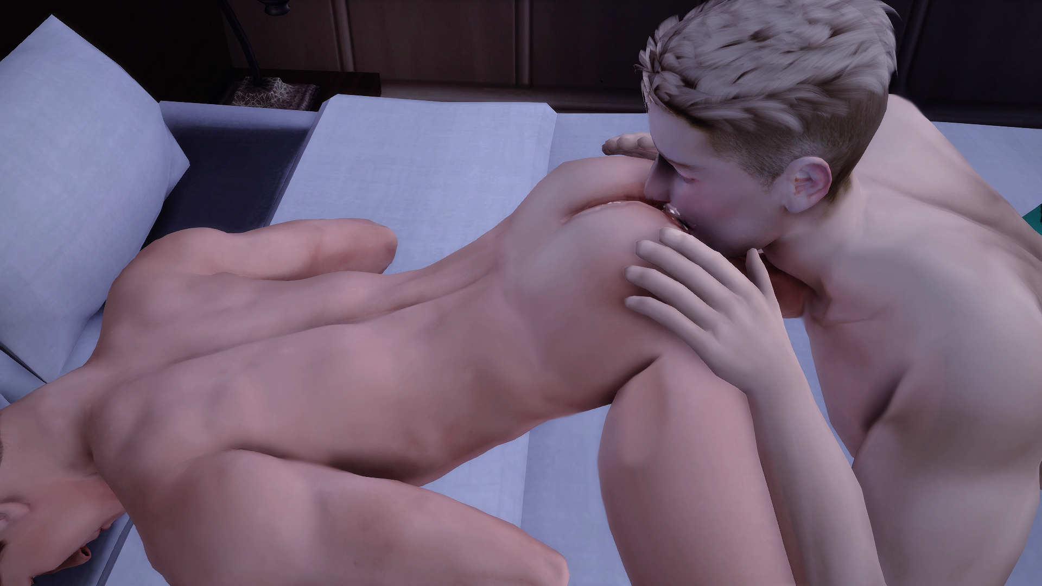

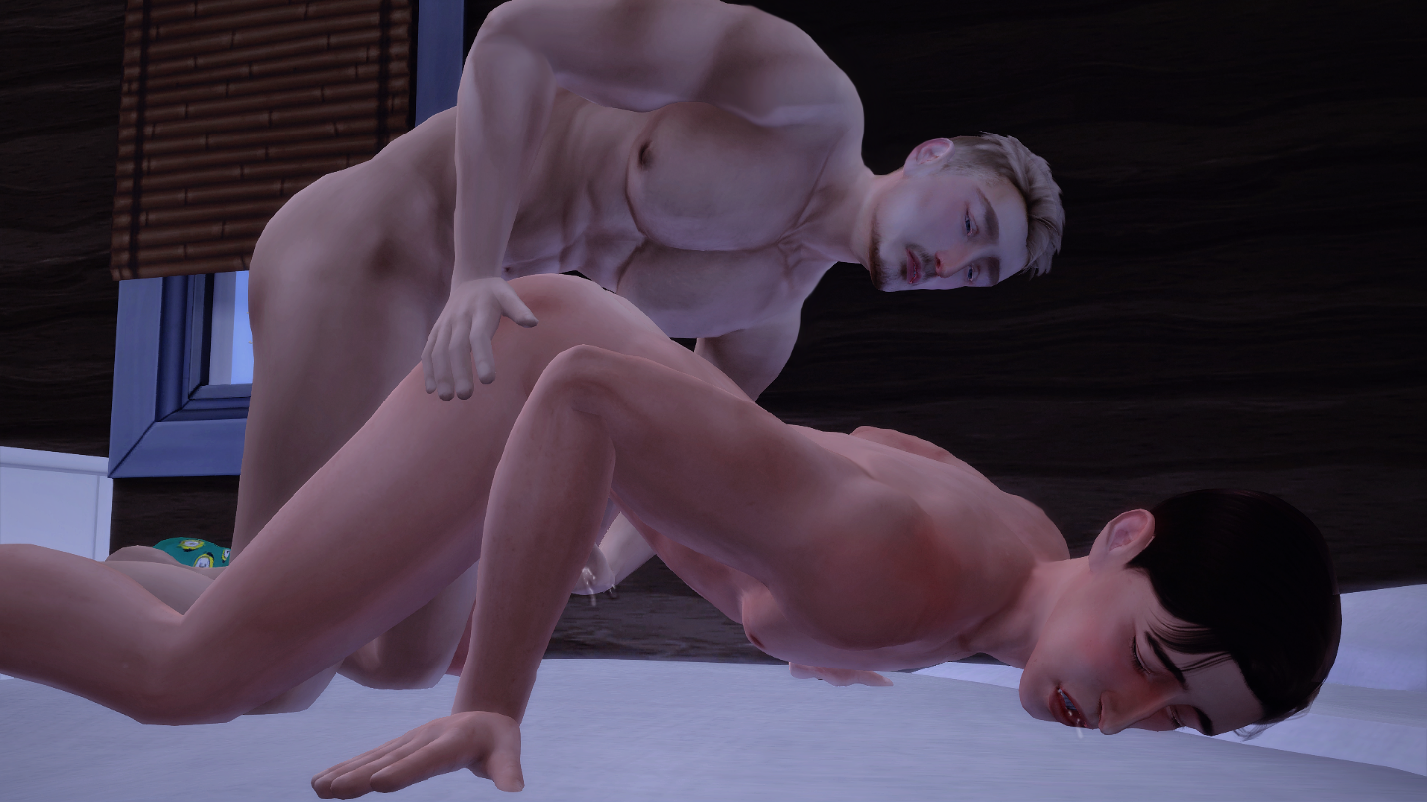
I immediately began to eat him out, then fucked him like crazy. It was so fulfilling every time I heard him moan in pleasure so much so that I became addicted.

And I’d like to think he was addicted too, even though we had spoken about it just being sex. We would do it in his office, in the storage closets, and pretty much anywhere else we could if we were alone.

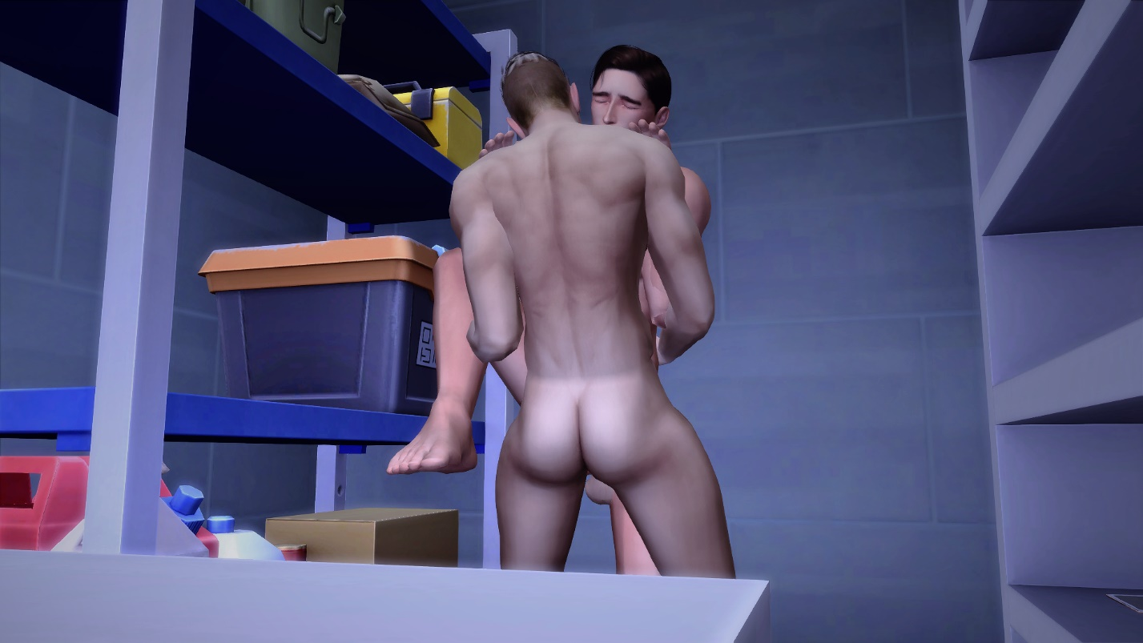
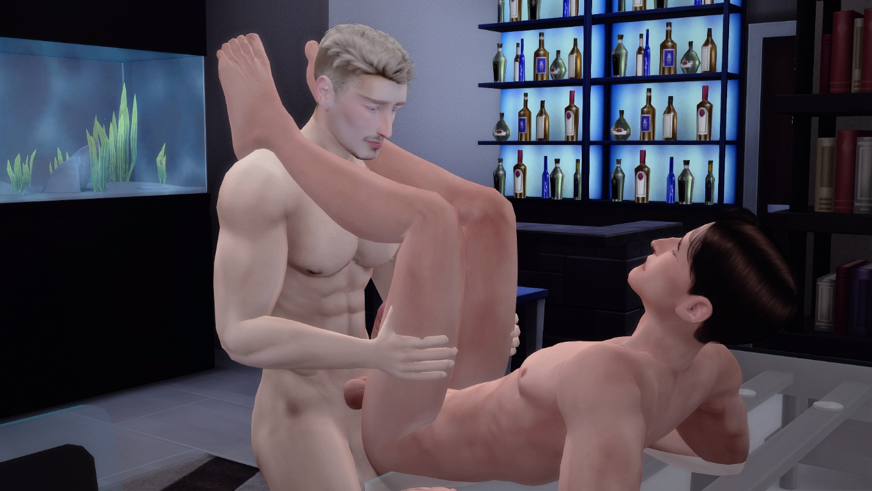
In between all the sex and time we spent together I began to fall in love with him. But, thinking real hard, I just can’t pin point when or how this started to happen.
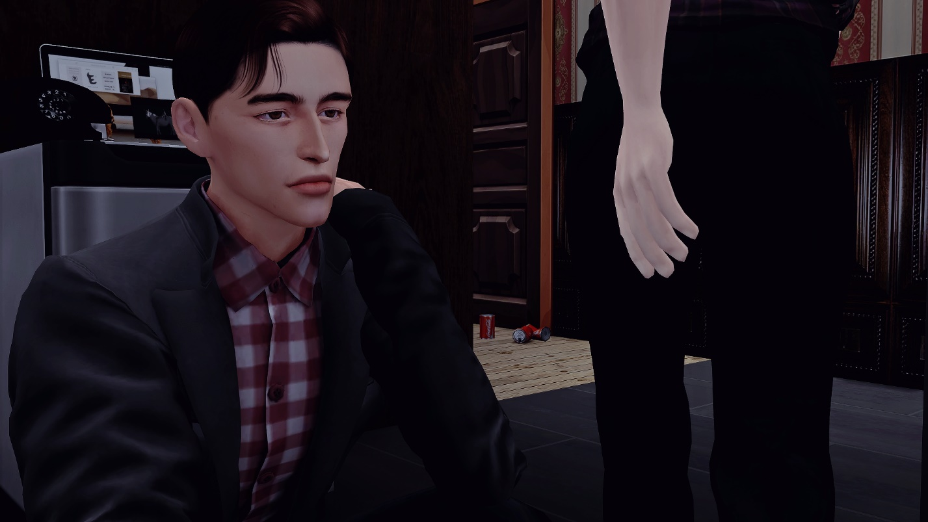
.

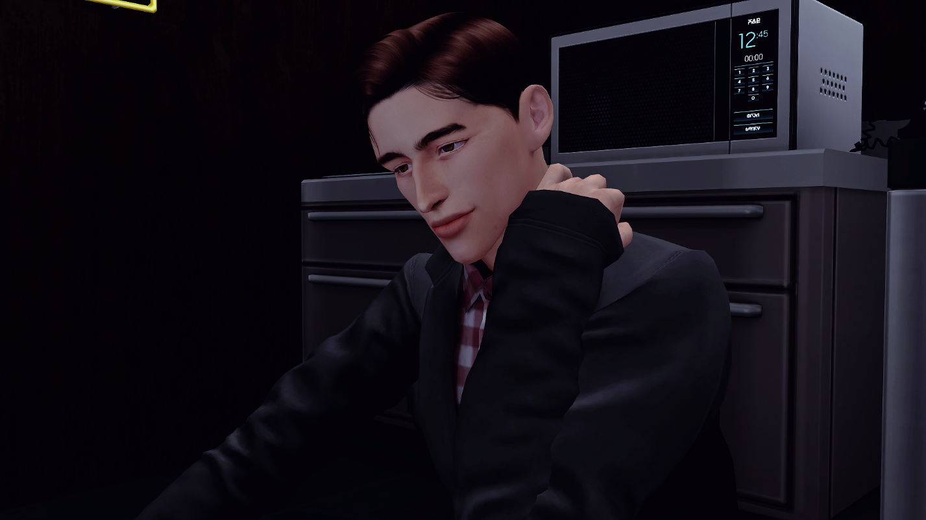
I just hope me and John can get on the same page before I start getting in too deep like I did with Craig.
But back to Craig’s question about when we’d fuck again, I responded to Craig with a “I don’t know” while telling him to come back to the bar with me.

Craig nose laughed letting air out of his nose and told me smiling “hang on, I need my boner to go down before I go back out.”

