A ROSE BY ANY OTHER NAME
MAY 2021 REQUEST STORY
BY CHALDEACHANGE
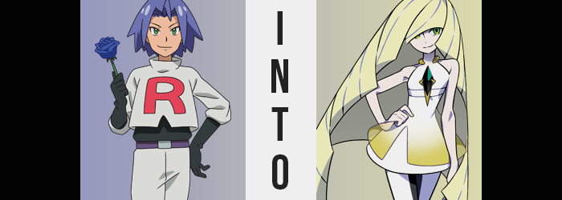

“Hm… Perhaps exploring this deep into the Aether Foundation was a bad idea after all?” James of Team Rocket was in the midst of a conundrum. He wasn’t sure how, but he had ended up separated from his teammates Jessie and Meowth while trailing that brat Ash Ketchum during an unscheduled visit to the Aether Foundation on the seas outside of Alola.

He wasn’t sure why the kid had even been beckoned out here alone but capturing his Pikachu would now and forever be Team Rocket’s ultimate goal. If he was away from his friends, then wasn’t this a preferred chance to strike?

What was strange was that he was certain his two companions had been behind him in the beginning. It was as if they’d just disappeared into thin air without so much as a cricket. This left the man alone trailing after the eternal ten year old, keeping a safe distance in dimly lit hallways and creeping around corners like some sort of cartoon villain.

…Which was exactly what he was, technically speaking.

Down the next hallway James went, Ash seen near the hall’s end, when suddenly? A steel box seemed to fall on the boy, panicking the man and prompting him to run in pursuit. “Hey! What’s up with this thing? You okay, kid!?” Gloved fist banging on opaque steel, it wasn’t like this was the first time he’d jumped to rescue his arch-nemesis. What was a villain without a do-gooder to oppose him at the end of the day?

Or so he’d tell himself, but the truth? James, Jessie, and Meowth all had standards despite their villainy. At best he’d expected to hear the boy banging back from the other side, but instead? Silence. Silence, and-

CRASH!

Another steel box fell from the ceiling, this time falling around James himself and forcing him to jump back, ultimately landing on his rear. The box’s inside was surprisingly lit up with white lights above, but other than that it looked just like it had from the outside. “What— Are these security features!?” The Aether Foundation was fairly high tech, so that was a plausible enough. But hadn’t Ash been invited? He wouldn’t be here otherwise, would he?

This question wasn’t one the man was allowed to dwell on for long, for a loud hissing sound promptly saw the box filling with a bright yellow substance. “Gas!?” It was thick, but not so thick that he couldn’t see. Even so, he’d sloppily covered his mouth and nose with his sleeve in a way that offered minimum protection, meaning he’d already inhaled some of it.

And some was enough.

“MM!?” The cry that the Rocket man made through his sleeve contained a mixture of shock and, strangely enough, unprompted elation as a tingling soon rippled through his body. If he had to best describe it, it was something akin to being shocked by Ash’s Pikachu – What? Are you surprised that he might find that pleasurable? No one would actively put himself in a situation where he got himself electrocuted for hundreds of episodes without deriving some sort of joy from it, right?

Regardless, it brought James to one knee, and his arm involuntarily fell from his mouth and nose as a sudden weakness took claim of his bodily functions – giving him no choice but to inhale a gas that had begun to thin, suggesting its work was done. And one look at the man was enough to support the theory that this was actually the case.

A bright yellow not unlike that of the gas itself could be seen swept throughout his head of blue hair. Initially, the strands were so few that they could have easily been misinterpreted as some highlights, but after just a few moments? The reverse was true instead, strands of blue so few that they looked to be highlights among a platinum blonde.

And that platinum blonde? It looked smoother and softer than ever. Likewise? Longer. James was a man who had no qualms with styling himself to look like a woman, but while his hair had been a little longer than most men might style it at, he never allowed it to really grow past his shoulders. But whatever had been in that gas, it was quite brazenly breaking this trend.

Golden locks tumbled down his back at great speed, somehow layering itself spectacular during this tumble so that each “layer” appeared to be completely disjointed from the last, styling so firm that each segment looked closer to a piece of sheet metal by design than a construct of hair alone. Every sheet swept to the right, it all coned around his body before touching the ground with his knee still planted, almost looking like the man was being protected from behind by unusual hair armor.

“What the!? What is this!?” Still incapable of making much movement, he could at least see how this hair had framed his face – as well as both feel its heft and smell what could be best described as a dump truck’s worth of hair care products that had been used to give the mane that shape and consistency, as well as maintaining the several blue streaks throughout. “I didn’t sign up for some sort of weird costume contest! JESSIE! MEOWTH!” James’ anxiety bubbled up and desperation could be heard in his voice. Who styled their hair so gaudily?

It’s only natural that I’d style my hair to represent peak fashion!

And where had that thought come from?

Even as he cried out and attempted to wrestle the control over his body once more, however, any resemblance to himself was being smoothed away. One need not look any farther than his face, which was presently having all of its rougher edges smoothed out. From a collapsed jawline to a button nose, it appeared that an undeniable beauty was destined for the young man; something just as readily sold by how his lips pinkened and pursed, forced into a natural pout by added weight.

For but a brief moment, what might have been interpreted as a pair of crow’s feet might have been discerned in the corner of his eyes. But it was only for a moment before the skin of his face appeared to soften and lighten dramatically just as it did all over his body as if concealing the fact that his body’s age had just been forcibly launched to around forty. James’ eye naturally widened as well, as did lashes flutter like the wings of a butterfly with how lengthy they had become. A brilliant emerald shone among irises that were typically teal, completely selling the fact that, from the neck up, he looked like a beautiful woman that was older than she appeared.

“Wait. If something is happening to me, then what’s going on with the brat next— Hm? My voice?” A lump in the center of his neck, his Adam’s apple, smoothed out in tandem with his voice growing in pitch and subsequent sternness. James’ charismatic manner of speech was seemingly degraded, tone becoming more businesslike and less nonsensical – which of course contrasted his usual demeanor. For but a brief second, he’d been concerned about Ash even, only for thin brows to ruffle and a scowl to play at his lips.

It was his stature that declined next. The Team Rocket member’s point of view lessened but a few inches, leaving his uniform baggy but not so much that it was at any risk of falling from his body. And even if that risk had been there? It would have really only affected his pants for just a moment before they’d find themselves caught on something.

…You can see where this is going.

His legs wobbled despite his knee-bound posture, and for just a moment he thought he was going to fall over without any means of movement to his name. The cause? Something had forced the width of his hips to widen, abruptly jolting his knees in and against each other and catching on the waistband of a pair of pants that were meant to house the lower half of a man. They weren’t at all ready to accommodate the growth that had come, nor the growth that would follow.

Such as the formation of a rather pronounced, but exceptionally tight booty. Even though his ass didn’t become ginormous however, it was still a rather significant jump in both shape and size considering how flat that ass had been before. Plumper cheeks were so tightly gripped by his boxers that the tension in the front, around his dick, was enough to make him want to squirm uncomfortably if he could.

Something that was not at all helped by thighs that bulged into relatively perfect proportions as well. They clenched around his penis, forcing a whine from his lips in response. But mentally? His thoughts came across as rather… inconsistent. It hurts so much! Since when did I have such a hideous thing between my legs!? Almost like he couldn’t remember having a dick. There’s nothing beautiful about a penis!

This anger was answered in kind, and any memories of possessing a dick were ultimately muffled as her genitalia reshaped to better suit her growing beauty, neatly trimmed pubic hairs and all. This wasn’t to say James had forgotten about being a man entirely, but the voice that was guiding his thoughts and actions from within? She didn’t even want to entertain the notion more than she had to.

Fortunately for her, her womanhood became even more unmistakable as her torso underwent its own transition. Breasts pushed up against the underside of the Team Rocket uniform, neither particularly large, but both undeniably firm and bouncy if given the chance. If anything, she was fortunate to have a bosom so small because despite her age, they had shown no sign of drooping. Throw in how her waistline dipped, and how fair her hands and feet became, and what was left was, well…

The administrator of the Aether Foundation, clad in a Team Rocket uniform.

“Ugh, what a gaudy ensemble.” Speaking of said uniform, her lips pursed after speaking distaste at the Team Rocket uniform that hung from her petite frame, the blond-haired woman finally able to rise and inching over to one of the box walls. It was here that she reached out towards a terminal that had opened up in response to a censor that recognized her face. She knew full well what she was. A product.

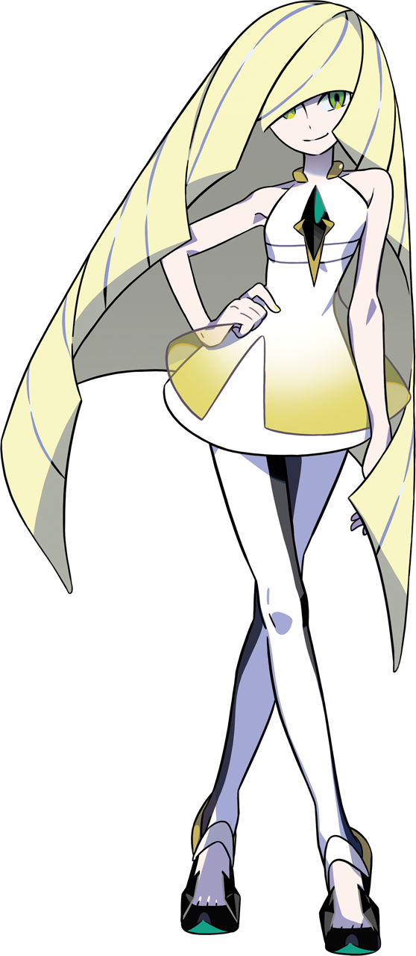
A copy of the Aether Foundation’s administrator, born from the life of some hideous man. She could recall his memories, which made it all the more disgusting, and it was a struggle for her new personality as Lusamine to push them down. But her new persona was far, far too overpowering for her old self to even make so much as a squeak, and as more memories belonging to the woman that she had become took root, it became an easier task.

She scowled as she typed in a password and the steel box around her rose. A perfect copy of Lusamine created by a man that claimed to be from another timeline. A man who wore a rainbow R upon his chest. This plan had been put into place in case the original had grown less useful, and unfortunately, she had. A clone was forged from a time of peak menace, meaning this Lusamine cared little for much of anything short of her pursuit of the Ultra Beasts.

“And in this one is the bait.” With the box she’d been contained in now lifted, she could see the box that the boy had been trapped in plainly. He’d been invited here by the rainbow man without his knowing, labeled a threat to his plans. Lusamine understood that he’d been used to draw her old self in so that she might be created, but this doubled as a way to get rid of him as well. After all, as she typed in a code into the box’s exterior, and it finally lifted?

There was a girl laying unconscious inside, clad in Ash Ketchum’s clothes. But she didn’t see her as Ash Ketchum. The woman saw her as her daughter, Lillie. She’d known what to expect, but with a hand on her hip she still rolled her eyes. Would this daughter be as disobedient as the last? Was it wrong to think that, knowing that fundamentally neither of them was the original Lusamine nor Lillie?

Even so, she reached down and scooped the girl up in her arms before heading up to her lab, where she knew Giovanni was waiting. “There better be a change of clothes for me there.”

But what had become of Jessie and Meowth? What of the original Lillie, who had been invited aboard as well? Perhaps these were stories for another day?

