GENSHIN IMPACT: METEOR MASH
CH9: TO THE MEWSIC
BY CHALDEACHANGE
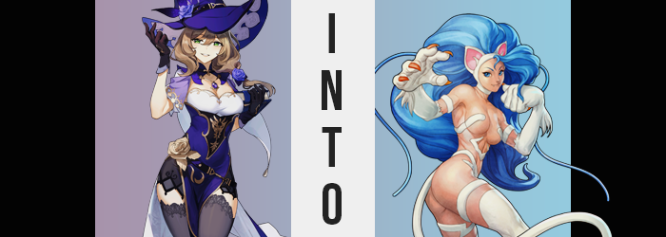

Lisa Minci didn’t really have much of an interest in the meteor shower that raged on outside, and unless a beautiful woman invited her it hadn’t really been an event she would have chosen to witness in the first place. Instead she was up late in the library of the Knights of Favonius headquarters, taking stock of a new set of tomes that had come in that afternoon.

Good help is hard to find, or so the saying went. This was especially true when it came to staffing the library in question because Lisa was so picky with her help. Finding staff on its own was a simple feat – there were few in Mondstadt that didn’t desire to help the knights in some way. The issue was in Lisa’s tastes. She was harsh with new hires and wanted to see things done a specific way.

And so, of course, turnover was terrible. She was only working so late because she was going through another rut where she didn’t have enough staff to carry out the amount of work that needed to be done. But Lisa? She didn’t mind. It wasn’t like she was a social butterfly or anything, she was fine burying herself in her work. Time was precious after all. Especially to her.

The library was so vast and filled with shelves that sound didn’t carry particularly well. And so the sound of, say, a tiny stone flying through the wall and landing on a nearby bookshelf wouldn’t – and didn’t – catch the librarian’s attention. In fact, it had hit with such force that it had embedded itself within the cover of a book.

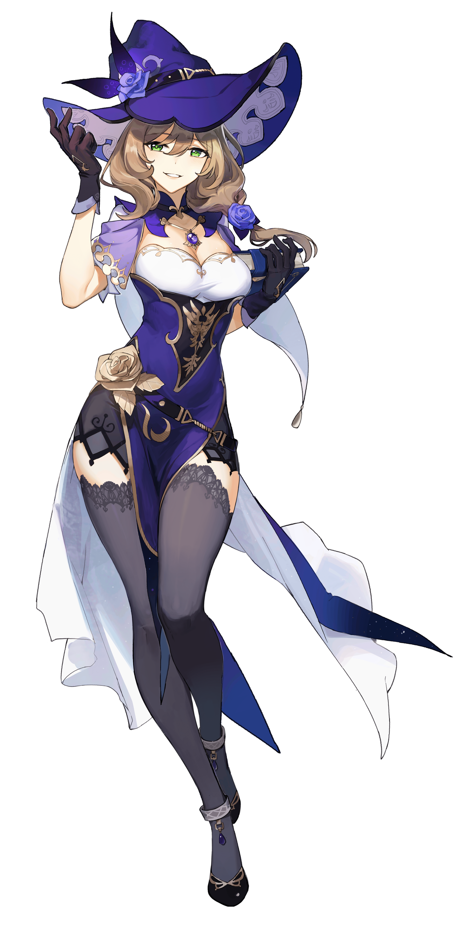
It was a short ways away from Lisa herself, but it was still close enough to affect her in a way similar to how these meteors were affecting everyone they came into contact with. “Hm… Just a few more and I’ll be ready to turn in for the night. I imagine I’ll be getting up extra early to grab a coffee at this rate too. Ah, to be young again.” She was merely speaking to herself as she flipped through one of the remaining books. She had to make sure they were all shipped properly and that they hadn’t received any counterfeits before boxing them to end up on the shelves tomorrow.

Lisa like to talk about how old she felt, but she was only in her late twenties. It was just a convenient method to complain, nothing more. On the other hand maybe she really was getting old. At least if the fact that a bright blue light had begun to glow from a nearby book shelf. A light that would undo the very fabric of her very existence.

While many of the victims that had succumbed to the meteors’ power hardly noticed a thing by design while they were changing, in Lisa’s case there was an inevitability that she would at least notice at first due to how they first manifested. She was flipping through the next book she had to review when…

RIIIIIIIIIP!

Much to Lisa’s own surprise, something had torn cleanly through the tome… after tearing cleanly through the tips of her gloves. “Ah!?” What looked to be sharp spikes were instantly identified as sharp, brown claws – certainly not befitting of any human hands. The tattered book fell to the desk when she stood and recoiled in shock, and in that same instance five more claws erupted from within the tips of her heeled shoes. “Oh my!”

She was hardly afforded a chance to even consider comprehending what had just befallen her, for the situation worsened rapidly. Both within her gloves and her shoes, a pressure of the likes she could not place was building dramatically. It almost felt like her hands and feet were going to burst out of the clothing containing them, and ultimately? With more ripping sounds, they did.

In a way it was like her boots and gloves had exploded, tatters thrown about as the prizes inside showed themselves in all of their glory. Her hands and feet were the prizes of course, but now clawed the eruption had hailed through the force of expansion alone. Whether it was her digits or her palms and soles alike, they had thickened to a point that they no longer could be called ‘human’, instead taking a beastlike girth that was only enhanced in monstrosity by a thin, white fur that ran across them.

“Paws!?” That was the best term Lisa could find to describe them even though they resembled something between thick paws and human hands. She didn’t realize that the term had come to mind because it was the exact term her memories were being distorted to acknowledge them as, of course.

But the fur that had sprout across both hands and feet didn’t appear to be content with afflicting those areas alone. It crept past her ankles and wrists, crawling beneath her clothes to populate her arms and legs in their near entirety. In the process, her limbs broadened in scale ever so slightly, forcing tiny rips to allow tufts of white fur to escape from her thigh highs.

“Why would I not have paws though? Cats have paws, correct? But, no? I’m not a cat. I’m a human.” Evidently, noting her own transformation had not done the librarian very much good. So quickly was her mind wrapped up in conflicting realities that made her turn a blind eye to the reality before her. “But I can’t properly hold a book like this, can I?” As if to demonstrate to herself, she picked up another text with her claws. Even trying to turn the page ended in pages getting stuck to her claws, which then led to it getting torn to bits. “Another!”

With a strange, rhythmic energy that was uncommon of Lisa, she then picked up another one and tore it. And another. And another. What had begun as an attempt to convince herself that she was a lover of books had ended up becoming something of a game that ran on a slowly simplifying mental faculty. She felt hyper and easily distracted, and wasn’t the feeling of books tearing satisfying?

It was leaving quite the mess, though.

In the meantime, the fur had become something of an encroaching menace. It had spread up to the base of her thighs on her legs as well as just past her elbows on her arms. Otherwise, thinner strips had surfaced elsewhere on her body. Bands across her thighs’ peaks and her upper arms, strips that ran atop her hips and across her groin, and strips that run from her back across her nipples - all unseen thanks to Lisa’s outfit.

Where the fur was more evident was her neck, for it had begun to sprout all across it. Given time it climbed the sides of her face and forced her hairline backwards, yet it also stole away something very important: Lisa’s ears. She was rendered momentarily deaf, at least until replacements were forced from the white band that ran across the top of her head. It was just that, much like her paws, there was little human about them. Triangular with pink innards and lined with white fuzz, each ear was inherently catlike.

Because I’m a cat!

The librarian, once the type to overthink, was mindlessly waving a white paws at scraps of paper that fell from the sky – not at all registering her worsening condition. The pupils in her eyes had turned to slits once their overall shapes had narrowed and the color had shifted to a bright blue. Her face’s overall shape was left imperiled, nose growing pointier and cheekbones turning slender to give her skull a shorter look. Adding to her feline aesthetic was her teeth, for upper canines lengthened to the point that they had stuck out from the woman’s lips.

“Wasn’t I feeling strange or something before?” Lisa’s voice carried a much more melodic hum, and her tail had begun to swish from side to side as if to a rhythm itself. Wait… Tail? Just as white as the rest of the fur on her body, a cat’s tail had crept out from underneath the skirt of Lisa’s dress – a properly working appendage and one she could control the moment she became conscious of it.

Like a splash of water, the blue that had pooled in the woman’s eyes soon found new ground, now afflicting the length of her hair. It swept through her brown locks like a crashing tidal wave, simultaneously pulling out new length and an intensely excessive volume that blew the witch’s hat right off her head. Thick and wavy, all of that hair was incredibly heavy and kept tugging her head back a little. While her ear band hand more or less dismissed her band, a single growth eventually did escape through before evolving into an equally thick and fluffy tuft that was cast above her left eye.

The woman was now tapped her foot-paw on the floor. “I don’t really feel strange though. Guess I feel a little stifled.” And by her clothing of all things. Of course, the transformation of her limbs had caused a great deal of that, but something else was now contributing. Every muscle in her body tensed up in tandem without warning, and when it finally released? Lisa’s body expanded, for she was gaining weight.

And not bad weight. In fact, it was pure, unadulterated muscle. Arms swelled thicker and her tummy tugged in so that she sported an impressive pair of abdominals – and even her pectorals grew to make her breasts seem even larger than they already had (much to the displeasure of her dress as they bounced free of their prison).

The most dramatic of Lisa’s muscle growth came beneath her waist though. The woman already had a dramatically shapely figure, particularly when it came to her thighs and ass. But, bolstered by raw strength no typical mage should possess, these area swelled to appear even keener. The back of her panties blew out thanks to the size of her ass practically doubling, obviously wishing to escape the confines of her dress.

While her thighs? They doubled thanks to the raw strength necessary to bound around the environment like a wild beast. All of this muscle was built beneath the fatty tissue her thighs already possessed though, and so the end result was a pair of ample upper legs that were thicker than her head was wide. Each possessed the strength to kick through a wall, and yet there was a playful jiggle to each and every movement.
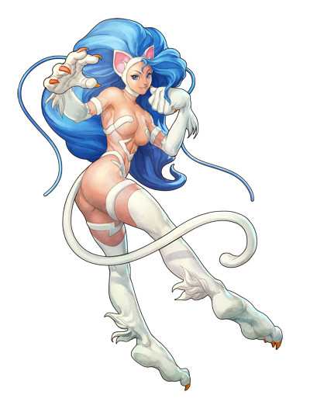
And then, with one final flash of the stone, she was stripped nude. Clothes didn’t reform in the place of her dress at all because her final form was one that was meant to be mostly naked. Her fur covered all the naughty bits!

“Woohoo! W-Wait!? Did I do this!? I’m gonna get in biiiig trouble!” Felicia the catwoman looked around the library with no shortage of panic. After all, a ton of books had been torn up by her claws and she couldn’t even remember doing it! There was no doubt that her claws had been the culprit though, not based on the size of the apparent claw markings. This was really bad! Despite being a catwoman, the knights had hired her just to do some normal book filing! Had she blacked out and fallen victim to her instincts!?

A number of worst-case scenarios came to mind. She was also affiliated with the church as a sister, and if they found out about this she would be in even more trouble! The last thing she wanted was to be berated by Barbara or Mercedes! Oh, she’d feel so bad! “But I guess it’s too late to really do anything about it now, huh? I wonder if repairing magic is a thing? I guess Miss Lisa would know, but… Muh? Actually, where is she?”

Wasn’t she supposed to be working late?

