ZORANETICS
BIWEEKLY STORY #112
BY CHALDEACHANGE
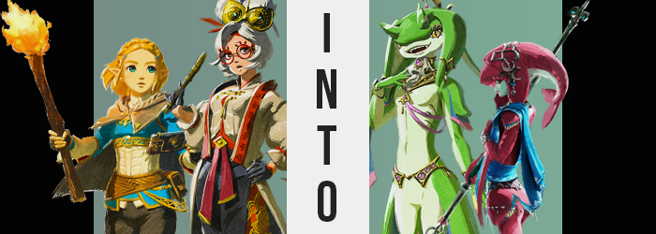

“Oh, right… You said you were taking Link down into the tunnels, right?”

With the defeat of Calamity Ganon, peace had finally returned to the Kingdom of Hyrule. It was a hard won peace, and one that had been followed up by years of rebuilding. Considering all that had been taken from? The people of Hyrule had managed to do quite well under the guidance of the returned Princess, Zelda, and the next generation of Champions. For the first time in one hundred years the people were finally able to move forward.

Of course there were still issues to be dealt with, and among them? A recent discovery. A tunnel system had been unearthed beneath Hyrule Castle, and from it a dark gloom had begun to leak out into the world above. Those that came into contact with it eventually became ill, so it was naturally a huge concern. One that Princess Zelda and her trusty knight, Link, had planned on undertaking.

It sounded dangerous to send their only princess into such conditions, but she was strangely resilient to the gloom’s effects. Well, was it all that strange considering the powers she had once wielded against Calamity Ganon? She’d be alright, especially with Link’s protection. At least that was what Purah of the Sheikah believed. “If so, I have a nifty knew invention you might want to bring!”

“Oh?” The short-haired Princess Zelda was ever the curious one even now. Purah had invented some magnificent things in the past, and while they weren’t always useful there were times when they were extremely so. “If it’s something that might help down in the tunnels then I would be happy to see! What is it this time, Purah?” She followed behind the older woman in her lab, trying to stand on her tiptoes to get a look over her shoulder. Oh, she was reaching for—

“A new Purah Pad app for analyzing ancient artifacts!” The inventor held up would looked like a regular Purah Pad, an improvement on the ancient Sheikah Slate that she had made in the Calamity’s wake. Zelda, looking to be encouraging, clapped her hands as if she were celebrating this proclamation. She didn’t know what it would do, but she could tell she was about to get an explanation. “By using the camera, it conducts a scan that tells you what civilization an item belongs to as well as records the DNA of any who have touched it! For example…!”

Zelda still didn’t comment, instead beaming with support still. This sounded useful, but she’d let Purah finish! Even now, the elder woman was pointing the Purah Pad over at something propped up against the nearby wall. Wait, she recognized it? “The Zora lent us their Lightscale Trident for research purposes, and so if I take a snapshot here…” CLICK! “And allow it time to process… Hm?” Purah seemed uncertain though. Had something gone wrong? The princess wondered, but she didn’t need to ask for an answer.

Because the Purah Pad in question suddenly began to glow, shell and all, before exploding. There was no shrapnel, no damages. It was almost like it had disappeared into thin air. Wait… “Purah?” But so had Purah.

“You’re kidding!? That took me so long to make! What was with that temporal disruption anyways!?” She honestly hadn’t been sent all that far. She’d disappeared with the light, a side-effect of the Purah Pad’s energy running haywire. But she was only on the deck outside of her lab that led down to the ground. She was just outside the door of where Zelda was in the evening air, though pieces of the Purah Pad were scattered all around her. “What went wrong?”

The screen before the ‘explosion’ had displayed the DNA of two Zoras. That wasn’t all that surprising as the Lightscale Trident had once been wielded by the Champion Mipha, and it was the fiancée of her little brother that had delivered the spear to her. Was that what had caused the problem? Two sets of DNA? It was true that the other tests had only carried one imprint. “Hm… And then there’s the matter of my body.”

She’d definitely noticed it. She felt a little tingly.

In fact she had felt that way ever since she’d been caught up in the Pad’s blue light and teleported the twenty feet that she had. That wasn’t a normal thing to feel after being teleported, she knew that much. “A side effect of the terminal breaking mid transport? Or was it related to… the… data…? Huh?” She’d wanted to ascertain the cause, but the effects ultimately derailed her. While subtle at first, she certainly noticed something peculiar. Namely that the world around her was getting larger while her clothes? They became heavier.

“No, no, no! I am not getting smaller again!” She was, and this invoked recollections of the fact that she had already been turned into a small child once. Purah did not want that to happen again, yet signs certainly pointed to something similar! She’d just been returned to a youthful yet older enough body that her breasts and butt were perky and abundant! And yet both of these areas seemingly melted away as she became smaller. Not erased, but definitely smaller than they had been prior.

Fortunately, she was able to breathe a sigh of relief, for things didn’t become nearly as dire as she’d first assumed. “It… stopped? Phew!” Her losses had only taken her down to just above five feet, but the losses to her figure were more devastating. A more youthful glow plagued her facial features too, bringing her perceived age somewhere between her most recent age and the age she’d been reduced to near the end of the Calamity. Late teens at most.

“But why in the world did it make me younger again? I suppose a reasonable explanation might be… be…?” Something seemingly hung Purah up. She was certain she had been on the cusp of an explanation, but it was almost like it had just fallen out of her head. What’s more, she couldn’t even remember what the device scattered across the wooden floor was called. “I… I… Oh my…” But for some reason, she could certainly recall the procedure through which you fashioned a set of Zora-made armor!

Her mind came to swell with knowledge that didn’t belong, as knowledge that should have been there slipped through her proverbial fingertips. Her head pounded from the sensation, but not solely from it as changing physical characteristics began to show. The top half of the young woman’s head appeared strangely swollen, and not in the way any Hylian’s head surely should have.

Her forehead bulged forward, and while Purah’s hair was not erased, it appeared to thicken and mend together, strands binding into a solid growth that stretched out behind her as a ruby red emerged against both the silver of her ‘hair’ and the bulge of her forehead. There was something inherently off-putting about the sight, as what was once her hair was shaped not into a ponytail but a finned tail that flopped behind her, the hair on the sides of Purah’s stretched face becoming additional fins that hid her ears – or the tiny holes on the side of her head that had once been her ears.

A row of shark teeth filled her mouth, too.

“The Zora…!? I’m becoming a… Zora?” A softer voice carried less alarm than one might expect considering Purah’s usual personality. So much so that it hardly sounded like Purah’s usual personality whatsoever. These words were expressed through lips that were both thinner and redder, eyes parted slightly to the side by the ‘snout’ that had pushed forward from her forehead. This red growth was scaled, as was the entirety of her head fin, and lighter circles of red were dotted above golden eyes almost as if to mirror eyebrows. On the other hand, while red scales came down to disguise the small nostrils of what was now her nose, everything below it on her face was decorated with cream-colored scales, just as the underside of her tail was.

Her poor glasses had been pushed right off her face, too.

Purah didn’t even realize she was becoming a Zora because of her changes. She just knew, vague memories of Zora’s Domain and of what her body was becoming giving her only enough information to help her not feel out of place. And so the scales continued to spread; cream down the front of her body, consuming her small breasts and stripping them of her nipples, as well as sealing away her bellybutton aside from a small indentation. The cream colored scales likewise hid what rested between her legs beneath a fold and colored the fronts of her thighs, to just above her knees.

“My!?” The woman gasped as her height sank further, but this time because her legs alone grew smaller. Several inches were removed from her lower legs, giving her thin yet rounded thighs some focus comparatively while ruby scales wrapped around them and crept towards her feet, just as they likewise had plagued her arms and soon to be hands. Purah’s response to all of this had become so passive though, and her mannerisms so proper. Almost like a princess.

A sound similar to Velcro being ripped apart could be heard as parts of the woman’s body seemed to peel off, and colored skin peeked out from beneath what had parted. Additional fins had emerged on her shoulders, hips, and even above a small but firm bum. These resembled decorations and a skirt, but they were also very much a part of her body. “And of… course…” Her breathing felt unstable, and while she retained the ability to do so through her mouth, the instability had come about because of the gills that opened on the sides of her chest. They would allow her to breathe underwater, but above? They felt a little parched.

All that really remained of her Sheikah self at this point was the shapes of her hands and feet. Otherwise? She looked like a Zora playing dress up in a Sheikah woman’s clothes – clothes that sat on her smaller body in a somewhat indecent fashion since they were too large. Red scales crept over fingers and toes alike, and webbing soon bound them together for the ease of travel under the waves. When it came to her toes specifically, the smaller four were bound closer together and were rendered smaller, while the big toes? Orange webbing between them and the nearest toes was obvious because these big toes not only pulled farther away from the rest, but doubled in size and gained a white nail that was closer to a claw than anything.

A thought crossed the new Zora’s mind. “My name is… Mipha? No… It’s Mipha, is it not? It’s not supposed to be Mipha, but Mipha.” Well that would certainly cause some problems. Try as she might, she could not refer to herself as Purah. What’s more, the preferences of the girl she had become had led her to start stripping out of her old outfit, until her small Zora body was completely bare. Her people did not like wearing more than necessary.

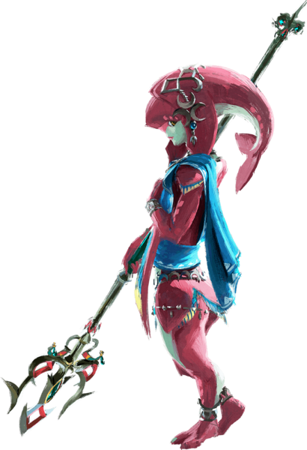
“Oh dear… The color of these scales, this small body… I truly have taken the form of Princess Mipha, have I not?” It wasn’t just her small yet beautiful Zora body that made this obvious. The prim and proper way that the woman spoke was the very same as the long passed Zora Princess, and her subtle yet delicate mannerisms properly mirrored hers as well. And yet while a changed personality and vague feelings guided her, she did not hold all of Mipha’s memories.

This Mipha still knew of her past life, and she couldn’t vividly recall anything from the real Mipha’s. The princess’ personality had overwritten her own, and her life knowledge had shifted – rather than know about her inventions and things like that, she knew how her Zora body functioned and about spearmanship – but nothing personal. “And my old name… I cannot say it.” She’d learned that during the transformation, and it held true now.

“I suppose I should attempt to see if I can find someone who can help? Oh, perhaps the princess?”

Zelda had been with her, after all.

Zelda had not heard the sound of Purah’s voice outside of her lab, and had instead decided to poke around the lab itself first before deciding her friend had been whisked somewhere far away. She knew the energy that the pad contained was mystical, and considering the teleportation functionality of the pad the idea that she might have been warped somewhere wasn’t a difficult to comprehend one. “There shouldn’t have been that much energy in it though. Not enough to send her far by itself.”
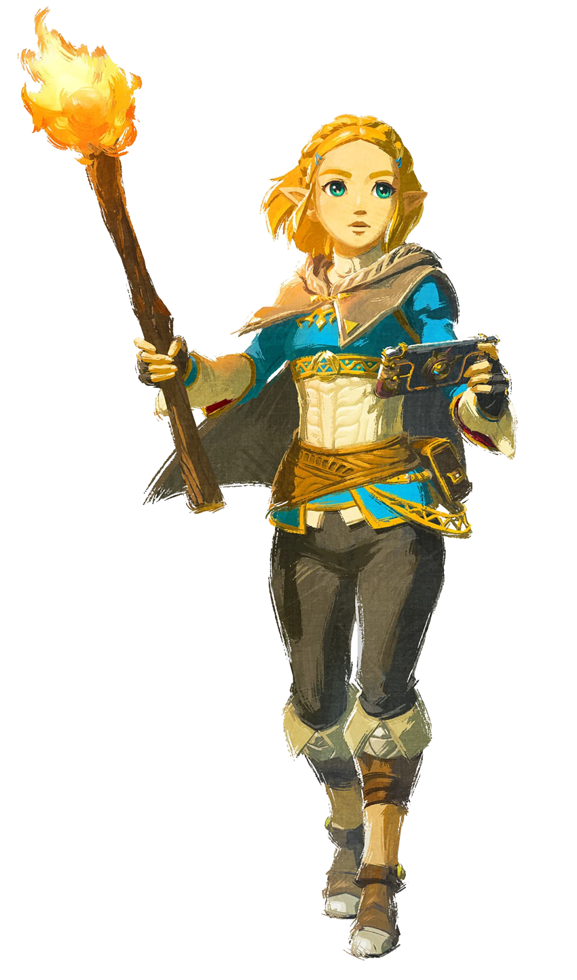
At least that was how she reasoned it as she peeked into one closet, and then the next. There was no sign of the scientist whatsoever! She could have been anywhere in the vicinity though. “Perhaps I should wait here until she comes back? I’m certain she’s in no danger…” But she was curious about what had led to her disappearance in the first place. For an app of that nature to lead to the Purah Pad breaking down? Not to mention that light that she had bathed in as the pad had detonated.

Even now her body still tingled. In fact, was the feeling stronger?

“Maybe finding Purah should be a priority after all… This strange sensation hasn’t gone away.” And she hadn’t even been directly in contact when the Purah Pad when it had run amok, she had just been unfortunate enough be within the blast radius. So for her to feel these effects… Had Purah felt them too? Without any context, Zelda didn’t know if this necessarily was anything that was cause for concern. She quickly found a reason for this to be the case, however. “…Hm?”

What the princess noticed was twofold. On one hand, she definitely felt like her eye level had been heightened? A nearby desk seemed lower than she remembered it being, and it wasn’t like the desk itself had shrunk. On the other hand? She could feel her tunic top slipping upwards, showing off her navel. And yet despite that? Her pants somehow felt far too baggy around her knees. “Is my body… changing?”

Her uncertainty almost felt a little unwarranted on the merit of the fact that this being the truth was immediately obvious. It wasn’t just in terms of height. Her torso was broadening, as did her shoulders, to the point that she scrambled to remove her top before it became painful. “This is impossible, and yet…” It clearly wasn’t. By the time she got her top over her head, looking down she could see how much broader her torso was and, incidentally, she could tell that her breasts were just a little bit larger as well.

Arms and hands were longer too, her height having been escalated to about 5’6”, and yet… Kicking off her boots and pants, she could see just how unusually shaped she was. Her growth had not been consistent, at least not for a Hylian. Her torso was much too tall on its own, and her arms had lengthened to match, but her legs? Her thighs were short and thick, but everything below her knees was even shorter. Zelda, experienced as she was, immediately realized what her body, clad only in panties, resembled in shape.

“…A Zora?” Not only did the shape of their people come to mind immediately, but something in the back of her mind seemed to know this was true. In fact, a whole bunch of knowledge about the Zora people and their bodies came to mind that Zelda hadn’t actually learned herself. Still examining her body, it continued to change, and this somehow left her feeling at ease despite how dire the reality of the situation actually was in the first place.

The princess’ body began to shimmer all on its own, as neatly stitched scales began to spread across her skin. However, while they had a similar distribution to Mipha’s in terms of patterns, the colors themselves were completely different. The most prominent color was a deep, beautiful emerald coloration rather than the red or blue usually seen upon the Zora of Zora’s domain. It spread down her arms, back, and the back and bottoms of her legs. It was likewise the color of scale that would clad her hands and feet until they were distorted into the same vaguely misshapen forms of the water-faring folk, complete with the webbing that would heighten her ability to swim.

A paler green is what decorated her torso, likewise, erasing her nipples and hiding her pussy beneath a fishy fold. Gills appeared below her breasts on the sides of her torso, while fins grew out from the emerald flesh around her shoulders, elbows, and hips – though the lengths of these were longer than Mipha’s, and carried a mix of blue and pink that were quite stunning in color.

“I’m… a Zora? My, this truly is quite the twist… I wonder what darling would think…” Not thinking too hard about what she was saying, Zelda turned emerald hands around before her eyes, the sensation of scales creeping up her neck and into her face noted, but there was no distress about it on her part. Rather, a large part of her anticipated the changes to her skull, which saw her head both flatten and widen, mouth stretching larger to demonstrate razor sharp teeth within.

It almost appeared as if the princess’ infamous blonde locks were lengthening, and yet that wasn’t quite the case. They fused and solidified much like Purah’s had, with emerald-green scales forming around the fins they ultimately became. Slightly longer, they dangled over the sides of her head to conceal the fact that her Hylian ears had not only shrunk, but had disappeared entirely so that only a pair of holes existed to be heard through. The back of this ‘hair’ became a tail, but it was thinner than Mipha’s, lacking the fins on the end. Also different from Mipha, two horns poked out above eyes that not only shone with gold now, but also contained slitted pupils.

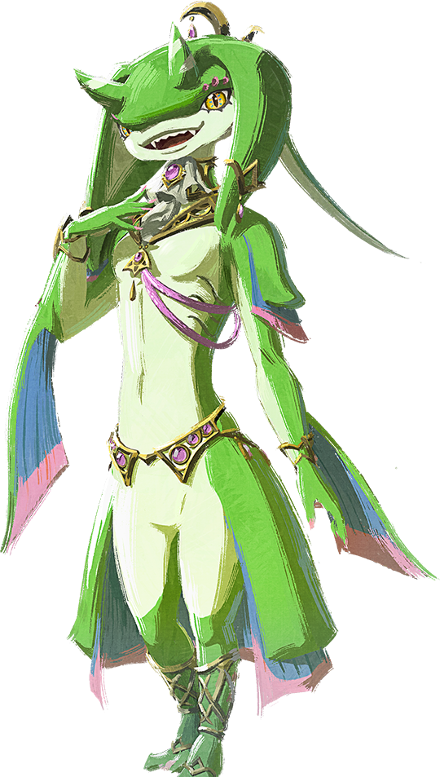
“My name is… Yona?” The tall, green-scaled body that Hyrule’s Princess now occupied was one that she was not familiar with, but the little she had been given to work with in terms of memories helped her at least understand this identity she was given. As she’d later realize she wouldn’t even be able to refer to herself as Zelda anymore, even though she could clearly recalled that life she’d lived. “A green Zora… Ah, so I must be from another domain?”

She’d never seen one of this color before, and yet she likewise felt like she was all too familiar with it from staring at her own reflection. Vague feelings with vaguer memories, substantiating a false familiarity. What was clear in Yona’s mind was her name, as well as knowing how this new body of hers functioned. “If my darling saw me like this…?” Wait, who? Come to think of it, she’d made a comment along the same lines during her transformation, too.

But she had an answer when the door to the lab swung open and a short, ruby Zora woman walked in. Yona recognized her immediately both from her past life’s memories and the blurry ones from her new existence. She was so stunned that she didn’t reply immediately, mouth slightly agape to show off sharp teeth. Princess Mipha? But no, if she had been turned into Yona, then… “I… suppose this confirms my suspicions then. I don’t really understand it anymore, but Yona’s DNA and my own…” ‘Her own’ referring to Mipha’s, of course, but Mipha could not differentiate. “They might have been uploaded into that strange device and transferred into us through that blast.”

“So you’re… Princess Mipha? No, that isn’t what I meant to say. How silly! If only my love was here, he’d understand.” Yona had meant to call her Purah, but that wasn’t what she had said. And her face showed confusion towards both that and the mention of a partner once more. She could feel genuine affection welling up inside of her as she referred to him, despite not knowing who he was.

“Oh no… Lady Yona… You’re engaged to Prince Sidon.” That was the answer that Mipha gave, and it left Yona panicked for a moment. At least until she blushed. Thinking of him, that made some sense, didn’t I? Her heart was beating quickly and she felt like she wanted to see him oh so badly. Mipha picked up on this. “But we should attempt to find someone who will understand who happened to us, shouldn’t we?”

The princess raised a good point.

