SICK HACK-ER
BIWEEKLY STORY #136
BY CHALDEACHANGE
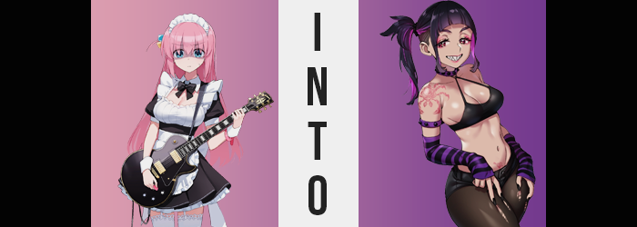

“How did I get roped up into this…?”

Hitori Gotou, known by most simply as ‘Bocchi’, bemoaned the situation she was in as she paced about in the bathroom of the live house, STARRY. The club was known for its music events, and she had performed on stage there several times since she had ended up joining Kessoku Band along with the others. That said, she usually used some magic tricks to stave off her anxiety. If hiding in various objects and costumes could be considered a ‘magic trick’.

But this case was a little different. Kessoku Band wasn’t performing. For some reason, Kikuri’s band SICK HACK was performing at STARRY last minute despite usually being stationed at the FOLT live house in Shinjuku. But how did that tie into Bocchi’s involvement? …She wasn’t really sure, actually. Eliza Shimizu, the guitarist in the band, had apparently heard that Bocchi was talented and had asked her to fill in.

Not that she could really avoid saying yes. She’d already been working a shift at STARRY that evening, but the teen’s anxiety levels were already at their limit because of the maid costume she’d been forced to wear! Why did the band performing before SICK HACK make a request that all of the staff dress like maids!? “Just because they’re maid themed…”

In the end, Seika had coaxed Hitori into agreeing and had been pushed off with a change of clothes meant to ‘match the band’s vibes’, but… “Urk!?” The clothes in the bag… “There’s no way I can wear these!?” There was no shirt in the traditional sense. A black, cropped tank top that looked like it would only barely cover her chest, incredibly short shorts, torn black tights, black and purple striped arm warmers, and even a choker. “They probably don’t even fit…” And she was not about to try them on to see.

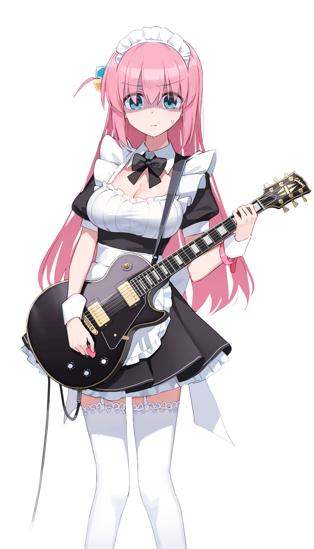
At the bottom of the bag was something even stranger though. A pair of wooden sticks that she pulled out to hold in either hand. “Drumsticks? Do these clothes belong to their drummer?” She wasn’t being asked to fill the drummer’s place, was she? She didn’t know how to play the drums! No! In the end she simply concluded that the clothes were just being lent to her from the drummer’s wardrobe, and that the sticks just so happened to be in the bag.

“But how am I going to tell them no…?” Even if it meant clashing with the rest of their band she most absolutely and definitely would not be putting that revealing outfit on! She was just a high schooler! She couldn’t be giving people the wrong impression at her age! Regardless of whether or not she wanted to, though? Bocchi didn’t really have a choice in the matter.

Because the drumsticks she was still holding began to glow a dark purple.

Bocchi’s reaction to this was probably the most ‘Bocchi-like’ thing in the world. “EEK!?” The thought hadn’t even crossed her mind that they might be LEDs or anything like that (and they weren’t anyways) so she launched them towards the nearby sink and… missed. They bounced off the counter and hit the ground with a thud, where the glow seemed to fade. “Ph-Phew… But what the fuck was that!?” Wait a second. “What did I just…?” She had said something wrong, right? She’d cussed, right? It wasn’t like her at all to use such bold words.

But speaking of things that came to suit her? “EEEEEEEEEH!?” Her eyes had flickered to STARRY’s bathroom mirror for just a second, but it was more than enough for her to recognize something very alarming. She was wearing makeup. “Wh-Wh-Who put this on my face!? When!?” From the pink eyeshadow to the mascara, to the pink gloss on her lips. She hadn’t, but… The fuck? Did I not put it on myself this morning? “N-No! I don’t remember doing…?” She kind of did, though.

Hitori didn’t even have any means of noticing the other ‘artsy’ additions to her body aside from, perhaps, the black paint that was spread across her fingernails. The maid costume she was wearing covered most of her body, but beneath all of that cloth? A couple of permanent tattoos had been painted onto her pale skin. The first of the two was a small one, nestled beneath her bellybutton but above her pubes. It was a heart with an arrow through it.

The second tattoo was much bigger, on the other hand. It was etched atop her right shoulder in the same ink color, but it was a rose. Well… the center was a rose. From it a pair of eyes, claws, and a set of legs emerged so that its overall shape looked like a crab trying to climb down her arm more than a mere rose. If the teen had been able to see these markings, then she probably would have fainted on the spot.

“Should I just wash the makeup… off?” That made the most sense, but Bocchi noticed another difference before she could even try. And it wasn’t one that could simply be ‘washed away’. Unless you could change your eye color that way? “HOLY SHIT!?” The bright sky blues of her irises had been wiped away, only to be replaced by a dark pink that almost bordered purple. But more than that? Not even the shapes of her eyes appeared the way she remembered them. They were a little narrower, but there was also something about them that felt… older?

Bocchi squinted at her own reflection. “Hah! Well, I am twenty six!” This ‘fact’ should have been wrong, but she declared her with such an uncharacteristic confidence… until she didn’t. “Wh-What’s this shit I’m spewin’!? And why do I keep talkin’ like… like…?” Had her voice always been so deep and raspy? No, but yes? The young woman couldn’t seem to decide, and simultaneously missed how the rest of her facial features shifted and matured. Like glossed lips becoming nice and plump, or her jaw taking a sharper line that added an intensity to her mugshot.

One that would pair well with the shark-like teeth she’d display the next time she smiled.

“Ugh, this is fuckin’ confusing!” Her bad mood wasn’t helped much by a craving that welled up from deep within. She didn’t just want something. She needed it. And even though she didn’t immediately process that this was a nicotine craving, she would begin thinking endlessly about having a cigarette pretty soon. It was honestly so distracting that the woman turned away from the mirror. Not that she seemed to be fretting as much about her transformation now anyways.

Would she have batted an eyelash at her pink hair darkening at this point? Maybe a little bit, but memories that had been gradually altered to match her new body were making it difficult to really feel much concern about things now. So pink washing away to be replaced by a dark purple with lighter purple highlights probably wouldn’t have alarmed her that much. Nor did the feeling of it being tugged up into a little side ponytail even so much as make her wince.

The woman clicked her tongue. “Tch. Weren’t we doin’ a show tonight too?” On that note? Why were her drumsticks on the ground? She bent over to pick them up, her ass soon hoisted into the air because of it. “Ngh!? Fucking wedgie!?” Only discomfort awaited her, because her lower body took this opportunity to change itself.

Her hips had pushed wider so that her panties were pulled tighter, and in tandem her ass cheeks had swelled up a size or two – so that cloth was pulled tightly in between jiggling cheeks. Muscle and fat alike saw to it that her thighs became shapelier too, and the thigh highs of the maid uniform struggled to conceal a mass that had doubled. Was it weird that she could picture Kikuri’s head between those thick thighs of hers? Maybe!

The strap of her bra ended up causing a bit of discomfort by the time she had stood up again too. Bocchi’s breasts had swollen too, but only a single size. What was more fascinating about her tits was how much puffier her nipples had become, with her areola almost doubling in coverage. This felt like it was necessary in the end, because each nipple had to support a black bar-shaped piercing that ran through them. She fucking loved when her girlfriend tugged on them!

…Was that why they were so puffy!?
“What the fuck was all that about?” Asuka Gotou groaned, shaking her head so that her black hair swung around in its high side ponytail in the process. “Feels like I had a splitting headache, ugh.” But things seemed to be improving, right? That was for the best, because she really didn’t want to go on stage and hit the drums when she was already suffering from splitting head pain, but it also wouldn’t have been the first time if she did. The problem with being in a band with Kikuri Hiroi was that the gal liked to party.

Well, it was more of a problem with being the girlfriend of Kikuri Hiroi. Which Asuka was.

Asuka wasn’t as big of a drinker as her partner was, but she had been known to drink herself silly now and again. If anything, her main vices were with cigarettes and weed instead – the latter usually used to calm her nerves due to a subtle anxiety disorder she had. Not that it was easy to tell she had one. “WHATEVER! WE’RE GONNA LIGHT THIS JOINT THE FUCK UP!” …Because she was an extremely loud woman who didn’t care how disruptive she was.

“Ugh, I still gotta get changed, too. Why the hell was I wearing a maid uniform?” And one that was clearly way too small to boot. “Maybe I should keep it though? Might be fun for some roleplay later?” In the bedroom with her girlfriend, at least. It didn’t take her long at all to strip it away and change into her tank top, shorts, tights, arm warmers, shoes, and thong. Now that so much of her upper body was bare (most of her tits and all), her sick tats were way easier to see.

“Alright! Good to go! Hold on world, Asuka Gotou is comin’ to kick your ass!”

And it was probably for the best that the world’s memories had all changed to reflect her new life as well.

