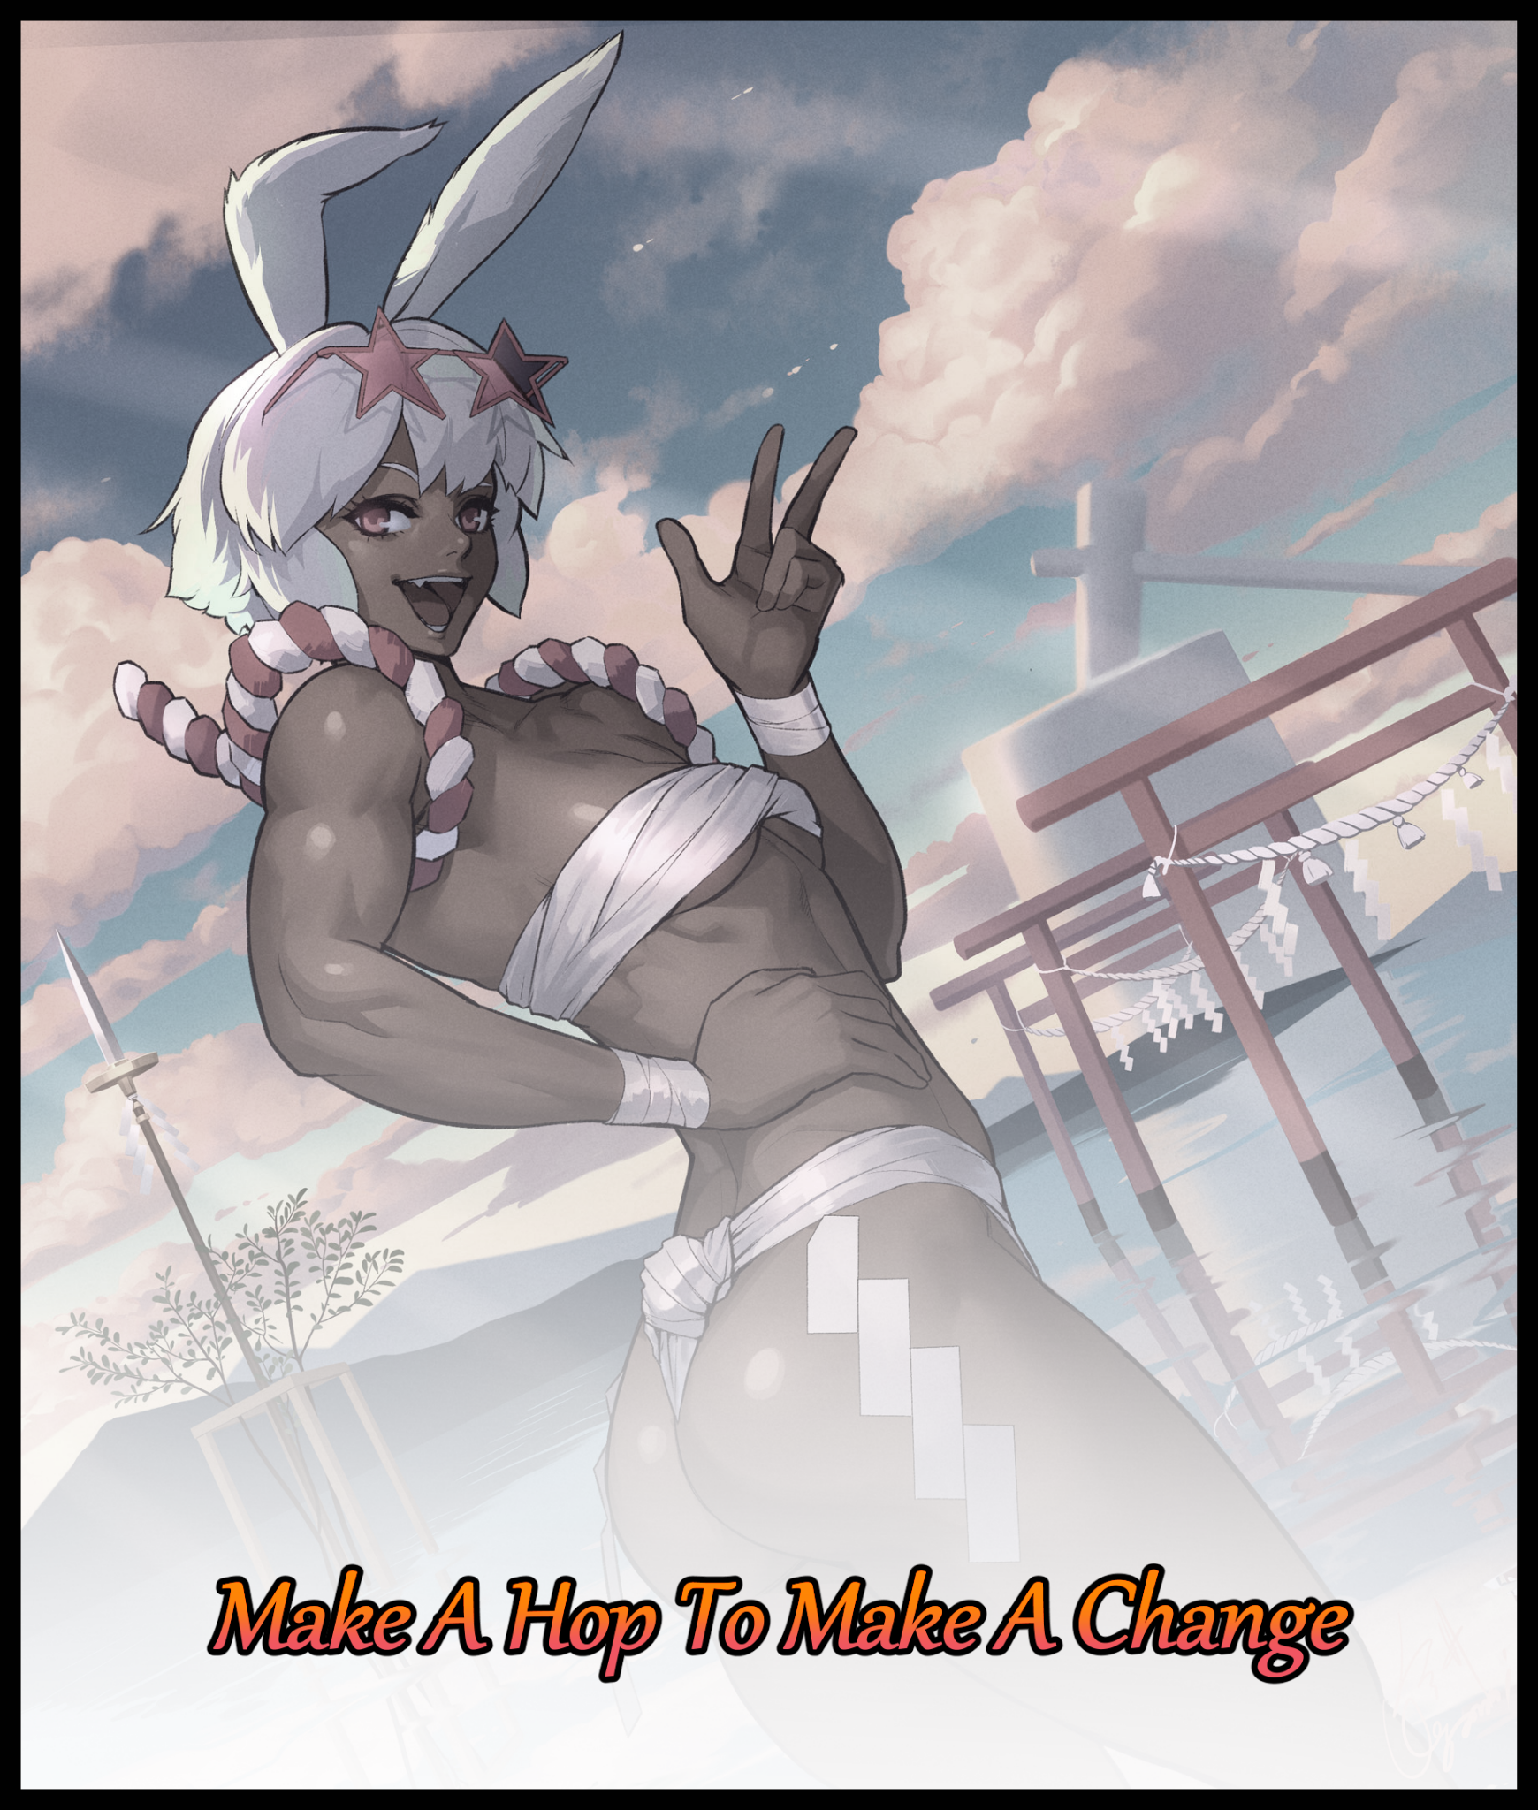

A relic from a bygone era stuck in a time that had long since passed it by. That was more or less an accurate condensation of the many thoughts and emotions that weighed heavily on Eric’s mind with every passing second.

Born to strangers who had left him on a doorstep, Eric had been passed from many hands, too often to plant his own roots at any given time in his youth. And without friends, a proper background, exemplars to learn from or an education, there was little wonder as to why he’d take up a seedy lifestyle following an encounter with strangers of ill-repute when he had been a naive adolescent kid. Taking quickly after the first people who seemed to show genuine interest and care in him…

Eric had worked hard for little to nothing besides scraps, hoping to garner respect with the men who had taken him in, too young and inexperienced to realize he was being used as free labor. A few years later and he was working directly with some of them, none the wiser to the harm they inflicted on a regular basis to the local populace as he continued to partake in all manner of crime, including the more morally dubious ‘jobs’ involving human trafficking, especially a certain race of demi-humans that had recently integrated into their society…something he wasn’t even aware of until he’d been given the task of tailing someone presumably out for New Year’s shopping with the goal of robbing him blind once the opportunity rears its head. Instead, Eric’s would-be victim had asked him to join him ‘for dinner’ after unexpectedly singling him out while they waited to cross at a traffic junction, grabbing his wrist with a vice-like grip before he could run.

The stranger spoke with a suave air of confidence. His voice, steady and soothing, claiming to know a great many things about Eric, and that if he wanted more out of life, he could either follow him, or return to blissful ignorance back the way he came…letting him go to make the choice himself. Undeterred and piqued by the man’s strange charisma, Eric had chosen the former as they settled inside a cafe with front row seats to the outside world.

That was when the stranger would enlighten Eric to the true weight of everything that he’d been doing over the past twenty or so years of his existence on this Earth, the revelation of which only made the following words sink even deeper once the wannabe gangbanger had let himself be enthralled by the man’s every word coupled with a nifty visual wake-up call in the form of the glass window in front of them; showcasing a world that Eric never really did get to savor…and most likely never would as the man pointed out various folks from all walks of life going about their own businesses, all while he spoke about certain individuals and their troubles, past and present. The many things they had to do to turn the tables without taking shortcuts or skirting the law as if they were open books, their secrets laid bare before him. But it wasn’t just the people, the entire world seemed so different from the vague memories he had from a squandered youth; gravitational technology, demi-humans and a sense of serenity he never really got when running with the gang despite over two decades of being with them…

“If you wanna see change…y’know it’s not too late? With a simple wish, you might just get a brand new start to the new year…”

Before Eric knew it, the man seated next to him had vanished after leaving him with those parting words. And with the sun already well on it’s way down the horizon, there was little else the thief could do but go on his way, meandering through frigid streets, his mind deep in thought about everything the man had told him; about everything he’d missed and the myriad paths he could’ve taken to change things around forever closed off to him…it was infuriating despite how little he understood, unable to shake the emotion that was regret off of his shoulders as he walked the streets towards a silent beachfront dotted with strange architecture and distant landmasses. Contemplating the last words imparted to him by a mysterious man whose eyes glimmered with infinite knowledge…

By the time his boots left tracks in the sand and with precious minutes left before the arrival of the new year, Eric had uttered his wish for a redo, and in doing so, had made himself known to the unknowable forces that governed the world as invisible tendrils extended down from the heavens above like ethereal fingers, reaching out to initiate his desire for change as an otherworldly glimmer begins to surround the spindly thug’s tingling body upon contact.

With only a few seconds left, the changes were almost immediate as Eric continues his trek, gaining added mass across his malnourished form in addition to gentle curves in the form of subtle dips bestowed by a tightened waistline and greatly expanded waves of undulating flesh shaped by broad hips, bulging muscle and rippling fat as invisible arms mold his spine into a shapely S, granting a slender torso added emphasis to it’s sleek contours and enticing indents as tone imprints itself across smooth skin healed of scars and cleansed of dirt, leaving darkening hide that shifts from a tanned beige to an exotic hue of alluring khaki. Emphasizing it’s clarity once condensed moisture and shimmering sweat comes together to form a glistening layer that keeps his heated body cool and composed, highlighting the throbbing biceps and an erotic six-pack marked with a sexy belly button once his clothes blink out of existence, leaving the newly born female as naked as the day she was born once petite breasts raise themselves from bony pecs while a flaccid member shrinks back up inside a warm stomach, leaving a tight, virgin vagina exposed between head-crushing thighs, it’s puckered lips throbbing with visible spouts of steam emanating from deep within it’s organic innards as organic processes work overtime, forming egg-producing, hormonal glands to flank a new chamber nestled perfectly within her core; a mother’s pride and joy…a sign of the role she was to play in the future as a fresh egg inserts itself into Eric’s womb, forcing a throaty sigh vocalized by the husky yet effeminate baritone of a brusque woman out of healed cushions framing a lean mouth hiding fanged molars and pristine teeth, atop which sits a curved peak framed by wide almond shaped slits. Curious eyes of crimson furrowed by doubt and worry as a strange dulling sensation washes over her mind in tune to an oily head of brown slowly beginning to lengthen down to the petite nape of her neck, cleansing itself just as her body had while the finishing touches manifests inside her head…

Alongside her original life, an entirely new one seeds itself, shocking synapses and making her brain hurt as memories of childhood in a foreign land entirely distinct from that of mankind blooms forth. And in it, she had everything she never had as Eric, experiencing…no, remembering her life as a Lago by the name of Nanao. From her influential place in her people’s society as the daughter of a political head to her brash, outgoing persona that made the task of finding a mate particularly difficult amongst other Lago, who’s worldly views remained somewhat trapped in the past as their males desired soft spoken females with equally meek personalities, something Nanao definitely was not as memories of training and picking fights with gangsters took root within her head, contrasting that of Eric as the parallel lives ran side by side inside the silver haired Lago’s brain filling her in on her purpose all the way out here in a foreign country as a delegate, someone who could influence change for the better as a fluffy sphere wiggles free atop a fine ass alongside the last of the Lago’s signature traits in the form of an erect pair of rabbit ears poking out atop Nanao’s head in a dizzying experience as nerves realigned themselves while her former pair of audio receptors melts away beneath a silky smooth head of furry hair,

With the distant boom of fireworks going off in the distance heralding the arrival of a new year. Eric as he once was had been forever erased in the physical sense of the word, leaving the powerful Lago woman behind as she continues walking along the beach in Eric’s stead after regaining her composure. His memories however; his life, everything he had done to wrong the world, would remain within Nanao to serve as a reminder for the new chance she had been given at life. And with the knowledge of the local criminal hideouts, activity and whatever else working in tandem with her influential position, the chance to right those wrongs couldn’t be any better, a hopeful thought that keeps Nanao busy as the skies above her flare with astral fire, speeding ahead until…

“M-Milady? Y-You shouldn’t be running around without any clothes on…at least…at least wear these…they were all I could find in the car so…”

Turning her head just in time for the first rays of the morning sun to crest over the hill, Nanao winces at the sight of a tiny human man standing behind her with a bundle of her custom made Lagonian bathing clothes in hand…she knew he was considered tall amongst his people, but to her, he was like a child, and with a fittingly meek soul to match, Nanao’s very female mind didn’t even flinch at the many existing memories she had shared with him ever since arriving here. Samuel, her personal attendant, her best friend and in secret; her crush, unable to deny that particular tangent of her new life as she steps forward to take the clothes from him with a boisterous laugh and a hearty whack on the back, sending a wave of pain down her attendant’s spine while a tingle of electricity shoots through her’s, ending with a throbbing pulse in Nanao’s unsoiled flower as she turns her back to Samuel, putting on a risque show in the middle of the deserted beach as muscular hands demonstrate how dexterous and caring they could be, gliding over the trained, exquisite body of a Lagonian female as they tighten ropes, forcing bandages to bite into tender skin, emphasizing a hidden ‘plumpness’; a quite literal soft spot to Nanao’s amazonian form before slotting the star shaped shades she remembered buying from a mall yesterday into her hair, grinning wide at the sight of her enthralled attendant…and the not so hidden bulge in his pants…leaving her giddy and off guard as she shoots him a kiss before posing mischievously, uttering a new years greeting in a voice she hadn’t even thought possible until now, getting immediate results in the form of an embarrassed man struggling to find the right words to say before his shoulders slump, simply going with the easiest reply one could give in return;

“Happy New Year to you too Milady…did…something happen last night? You look…’fresh’...if you don’t mind me saying so.”
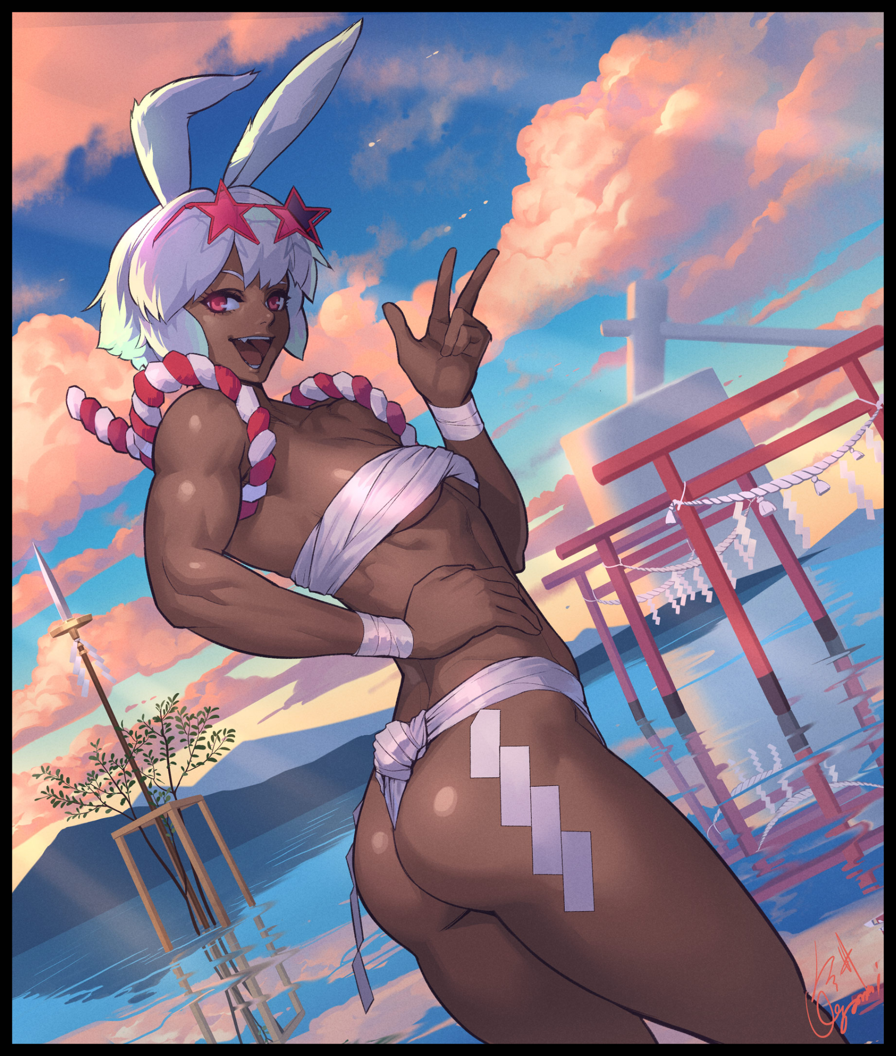
Putting a hand to her hip, Nanao beckons with the other, offering to tell Samuel ‘all about it’ if he would follow her out to the shoreline for a little dip, all while wearing a minxy smile on her face with a perky twitch her ears and a wiggle of her wrapped tail before setting out towards the cooling waters, not even waiting for a reply as her sharp ears pick up the sounds of an exasperated sigh…and then approaching footsteps from her right…

There was a lot of work to be done moving forward for the Lago, but no one could blame Nanao if she took a little time off to enjoy some familial fun in the sands now right? And besides, the first day of the new year should be kicked off with a bang…and as her raging hormones told her, now was as good a time as any to make a proud statement to her family that there was indeed someone out there who could love her, simply for who she was…and nothing else…

THE END

Image Sources

Image 1 by Ogami : https://www.pixiv.net/en/users/23367665

