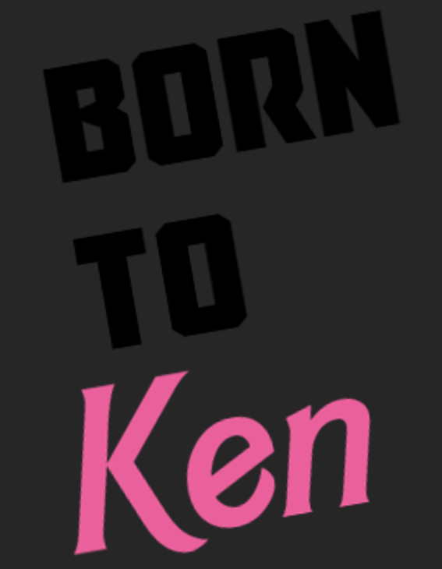

https://cdn.discordapp.com/attachments/617810149926502431/1097580923869991104/image.png
She was a Barbie girl, but she wasn’t in a Barbie world.
The original her possibly was, but she was not a Prime Barbie, she was a clone. Technically, she was Barbie Roberts S9G-ANE-1KD-6FL-EZ6-8RB-BIW-A2O-VAL, but no one used full names, and the ‘orphanage’ she grew up in was arranged so that there was never two of the same person at the same place at the same time.
Though, orphanage wasn’t really the right term, calling it a boarding school would be better, though she knew she had to call it by the Company name, as it ‘invoked a sense of pity and underestimation in Clients that more easily allowed a Waifu to perform their tasks’. Though, given Clients had to ask for an ‘orphanage’ Waifu, or have their contract set to it, they probably should know better.
Barbie Roberts didn’t know the specifics of why orphanage-raised Waifus and Husbandos existed, only that, cloning people at lower Tiers allowed the Company to make more from a single Engram without running into ‘soul limits’ as quickly, and the resources spent to create Waifus and Husbandos as small children raise them up was somehow less than it took to clone them at their saleable age, while also making them a little different.
However, she was reaching the end of her saleable period.
She was turning twenty!

https://cdn.discordapp.com/attachments/1035409757734961202/1096179796549042206/Newbie.png
She’d completed her training, aced her tests, networked her heart out, but, at the end of the day, it hadn’t been enough.
The Supply of Barbies always exceeded the Demand.
Which left her with two options.
First of all, she could follow millions of Barbies before her and join the ‘Queue’. Company Suspended Animation would keep her young and ready for millennia if need be, but, all the connections she’d made, all the favors she’d collected would start to fade as soon as she did, and the Company always used actively saleable Waifus before reaching into their ‘stocks’.
Second of all, she could get a Job in the Company.
She’d be giving up any hope of being a Waifu, something she’d been looking forward to for all her life, but she would be doing something, and not awaken to find every friend she’d made had long, long since moved on, changed so much they might as well be different people, or died.
As a Barbie, and with her test scores, she had her pick of jobs, from an assistant in office, to assistant in a laboratory, to assist in a school, to assistant in a restaurant, to assistant in a studio, and more.
But, but she wanted to help people.
And, yes, she would be helping people no matter where she went, but she wanted to do something more direct, since, while she had a Personality Matrix, meant to make sure she grew up to be within the parameters of ‘Barbie’, the Barbie template was a very, very broad one, as opposed to those poor Aquas, Reys, Bella Swans, and Umbridges, forced to be… just the worst.
But, focusing on her current issue, Barbie had always preferred combat training to beautician training, culinary arts, or business education, and, now, she had an opportunity to do what she wanted to do, for once!
Honestly, she didn’t mind having her Matrix, as she understood that Clients didn’t want ‘person who is kinda of like (insert order)’ they wanted that person. Barbie was still a Barbie, and, honestly preferred it that way, as opposed to those that stubbornly refused to participate, and ended up having a ghosted copy of their Prime’s consciousness slotted into them instead.
So, she didn’t mind the Matrix, and, yes, she was aware that her general positivity and optimism was also an aspect of her template, but, having been roommates with a Mamimi Samejima, who literally couldn’t get over her issues, Barbie’s situation wasn’t that bad!
She’d felt the Matrix shatter, when she’d finally left her childhood home, never to return, saying goodbye to her friends, those of whom, like Ada Wong, had a good bit of time left to go, though that woman’s saleable period was broader because of it. She’d also said goodbye to her instructors, who were regretful that they couldn’t help her find an Agent of her own, but she understood that, despite their many qualities, Barbies were uncommon choices, but the Company kept making them, because you would always have outliers.
After all, some Clients wanted fifty-million Barbies to man an entire space force of them, which they could, as each of them was Starfleet Qualified, and so stocks were needed. It was apparently rare, but it’d happened three separate times, so the demand could exist, it was just… infrequent.
Now, as she sat on the interdimensional catbus that was taking her to her new life, she looked out into the Blind Eternities, which, when viewed through the specially treated transparisteel of its windows, was rather pretty!
She knew that if she looked at it directly she’d go mad, and then probably cease to be, torn apart as she was unable to keep hold of what made her her in the face of experiencing everything at once at metaphysically full volume, which is why they were sometimes called the Blind Screaming Eternities, but she had faith in the Company, so she’d be fine!
There were quite a few people on this trip, their catbus having stopped at many Company locations, the hollow, twelve-legged feline living transport able to carry them with ease. Barbie had heard that some Dragons that worked for the Company could do the same, and she wondered if she’d eventually get to meet one! Her orphanage had been a low-risk one, and Dragons, especially young ones, needed specialized care, something she learned about in her ‘Heritage Crossbreeding’ class, in case her Agent was a Dragon!
But… she wasn’t going to have an Agent of her own, was she?
The moment of melancholy was odd, and didn’t dissipate like they used to, requiring her to actually move past it herself, which she could do! She was trained to do so after all. It was just…
She looked around the cabin, at all the others, mostly other Waifus, though there were some Husbandos as well. Some were young, some older, though, given how such things went, they very much all could’ve been just like her, off to start a new life.
It might not be the life they thought they wanted, or the life they thought they’d have, but, hopefully it would be one they’d come to appreciate!
“Rapid Response Base C-Z43M3S9GUC35!” the driver announced, the same appearing on the screen at the front of the catbus’ cabin, and then, with a warping noise and the smell of fresh zucchini, their vehicular mammal was flying through the sky, coming in for a landing on a skyblock, their destination hanging on a floating island suspended in an infinitely blue expanse, the artificial sun rising behind them, cresting over an invisible line and painting the mobile complex in orange hues.
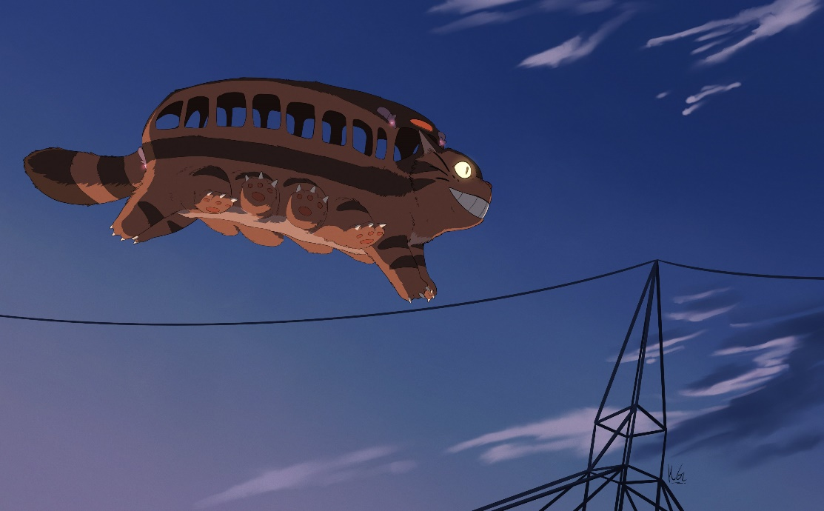
https://pbs.twimg.com/media/ELX1I1GXYAUwWAk?format=jpg&name=4096x4096
She’d done her due diligence, of course, and this installation slowly made its way throughout the Multiverse, saving people in need, and now, as the catubus slowly drifted down to the loading dock, she’d be part of it too!
Their transport hit the ground, trotting to a stop, and she stood, as well a man, brown-haired, American, heavily built, and more than a bit chubby. Then again, Matrixes also directed one’s physical development, so they would match the Prime as closely as possible, and while that meant it was easy for Barbie to keep in shape, that also meant someone whose template were of someone with weight issues would also, themselves, have weight issues, no matter how hard they tried.
Poor Hanako.
She had her backpack full of personal effects, little keepsakes and curios from her time in the orphanage. Had she been chosen as a Waifu, it would’ve been stored away for her to retrieve later, as most first deployments were not exactly secure, but, as she was no longer able to be a Waifu, she’d had to pack it up. They were small things, like a data-crystal with her art, the hat she’d gotten from Lizzyland when she was twelve, a booklet with the signatures of all her friends that’d left her before they either went off to their Clients, joined the Queue, or left for new Jobs, things like that.
The Husbando following her off the catbus, which she petted, the thirty-foot long feline purring, flicking its enormous ears, before it closed its door and, with a running start, leapt up into the air once again, momentarily seeming to stretch and warp, before, with a Pop, it was gone.
Turning to the person standing beside her, the man looking lost, she smiled, greeting him, and holding out a hand, “Hello! I’m Barbie, Barbie Roberts!”
“Lee,” he smiled, taking the offered hand, hesitating, then shaking it firmly. “Lee Elric. Do you work here?”
She didn’t know a Husbando Template by that name, but the Company’s roster was ever growing. “I am as of today!” Barbie told him cheerfully.
The dark-haired man nodded, holding out a hand, a smartphone forming from mist and shadows into the dark rectangle, which meant he was probably from a more modern setting, if it was central enough to his Template that he had a ‘phone summoning’ power!
Technically, Barbie had a basic grounding in supernatural abilities, via virtual reality training, though she would only be able to either fly or utilize the minor fey magics her Template could have access to if her Client paid for the upgrade.
Which… wouldn’t happen now.
Scrolling through it, the Husbando nodded, turning the screen her way, “Well I’m here to meet uh, this person.” Reading the display herself, it stated he was to meet Barbie Roberts BR4-1H8-U6W-Z35-E2P-2W9-AQW-OEI-5J7.
“Oh, you’ll be working for another Barbie! The same one I am!” the Waifu smiled. “Isn’t that interesting!”
“Another Barbie?” Lee questioned, and she glanced at him, confused.
Oh no. He doesn’t know!
She’d heard that other orphanages were run in different ways, but to not know something so simple… “Well, um, have you heard of cloning?”
He looked at her, then laughed, shaking his head. “I know I’m a clone. Kind of hard to miss when I’ve run into other mes, even if only in passing. I just thought we weren’t supposed to, you know, work with each other.”
“Oh, no, it happens all the time!” she replied, relieved. “Doubling up on flash-cloned Waifus and Husbandos is bad, since they all think they’re the Primes, but, having multiple versions of us, since we have Company training, is perfectly fine. We’ve developed into different people, even if only a little, and will continue to do so!”
“Huh, hadn’t considered that,” he noted, pausing, “Wait, Barbie Roberts. Are you… are you Barbie Barbie? Like, with the dolls, and everything?” She nodded, and he glanced down her, before smiling appreciatively as he looked her in the eyes once more. “Damn, the dolls do not do you justice!”
She found herself standing a little straighter at the praise, never having actually interacted with a member of the opposite sex before. To avoid… incidents her orphanage had been female and femininely-aligned beings only, including the staff, and she didn’t know why, but just talking to him seemed to put her at ease, especially as it looked like they’d be co-workers!
“Well,” he smiled, gesturing towards the front door. “Shall we?”
“We shall!” she grinned, slipping her bag over one shoulder, and they entered the main building, a fox-eared woman looking up at them from behind a receptionist’s desk. Reaching into her own pocket, Barbie pulled out her transfer papers, handing them over, Lee flicking something on his phone that caused the woman’s terminal to beep.
Looking over both sets of documents, she handed Barbie her papers back, drawling, “You’re gonna want Building Twelve, ready-room seventeen. Have fun, kids.”
“Thank you!” Barbie smiled, giving her a cheery wave, the furry-eared receptionist rolling her eyes as the pair of them walked out, pausing as they saw a map on the wall, and figuring out which one was ‘Building Twelve’.
As they headed back outside, Lee asked, “So, did you get assigned to ‘Loss Prevention’, or did you choose it?”
“Oh, I chose it!” Barbie replied. “I’ve always had a leaning to more active professions, and I’m a pretty good shot, even within my template,” she bragged, a little, her old Matrix having made such things harder, as Barbies were supposed to be humble, but now it came with ease. “I suppose I could have gone into a more relaxed job, but I do do well under pressure, and not only met the minimum requirements, but the suggested ones as well!”
The Husbando’s attention on her was in a way that was simultaneously flattering and a little intense, like he was hanging on her every word, but also dissecting them. “I… I think I might have missed something in the briefing,” he stated thoughtfully, before shaking his head, and sighing. “Well, I’ll talk to the other Barbie about that, I guess. Um, wait, how is that going to work, if you’re both the same person.” He winced, self-correcting, “Sorry, if you’ve both got the exact same name, appearance, and voice.”
“Nicknames, probably!” she shrugged, never having run into that problem herself, but they were both Barbies, and Barbies were nothing if not adaptable! “And don’t worry, I’m sure it’ll take me some time to adapt to it as well!”
“That does help,” the Husbando smiled, leading the way, as they found the correct building, entering it, and flagging down a tired looking elven woman walking by, carrying a cup of coffee. “Hey, we’re new,” he greeted her. “And we’re looking for-”
“Seventeen, right?” the woman interrupted, tiredly amused.
Lee hesitated, blinking, “I… yeah, did they call ahead?”
She snorted, looking at the two of them. “Just follow the light, Ken.”
“Uh, my name’s not…” he started to say, but the woman was already walking away, wiggling the fingers of one hand, mumbling under her breath, and a glowing sphere of blue light appeared in front of them, slowly drifting down the hall. Looking to Barbie, Lee shrugged, and the pair followed it, down three corridors, up two flights of stairs, and coming to a door that had been painted bright pink.
Barbie thought it was a rather pretty door, though it did seem to clash a little with the hall, but, over it, was the number seventeen, so it was certainly their destination.
Exchanging a look with her, Lee stepped up to it, gripping the pink metal handle, and swung it open revealing… a large living room?
It was tastefully decorated, with six doors wooden along the far wall, a pair of steel ones dead center, and, sitting on a couch, was a blonde woman, who rolled her head back, having been watching professional wrestling, demanding, “The fuck do you want?”
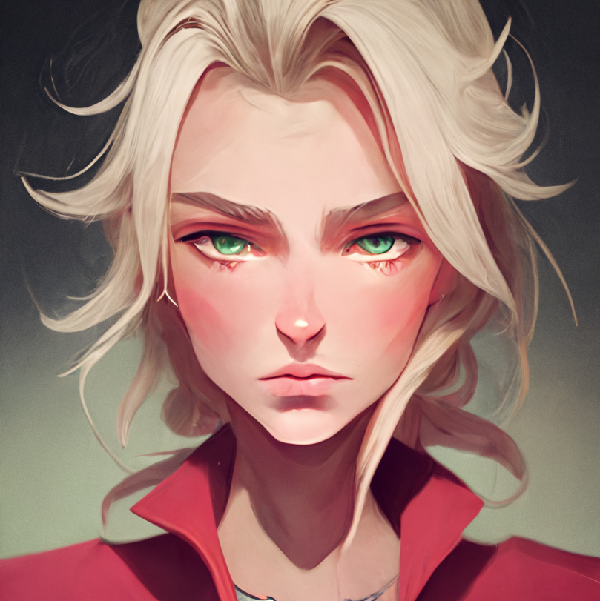
https://cdn.discordapp.com/attachments/1035409757734961202/1096162785555120178/Boombie1.png
Lee’s breath caught for a moment, and Barbie’s did as well, though probably not for the same reason, as, while she’d known she was going to be meeting a different version of herself, seeing how different the other Barbie was… Well, it was like looking at a funhouse mirror, the red-shirted blonde obviously a Barbie, like herself, but not.
“Hi, we were ordered to report to Barbie…” he trailed off, checking his phone, reading off the designation.
“Ugh,” the other Barbie groaned. “Why don’t you just fuck off instead?”
“I, I’m sorry, what?” Barbie replied, never having even considered talking like that, or of being, being that rude!
Taking a sip of beer, the woman in red belched, “You got hearing damage, Newbie? I said fuck-”
“Come in,” another voice quietly stated, cutting the, the Rude-bie off.
They both did so, seeing that, off to the side, reading a book, was another woman.
Another Barbie.
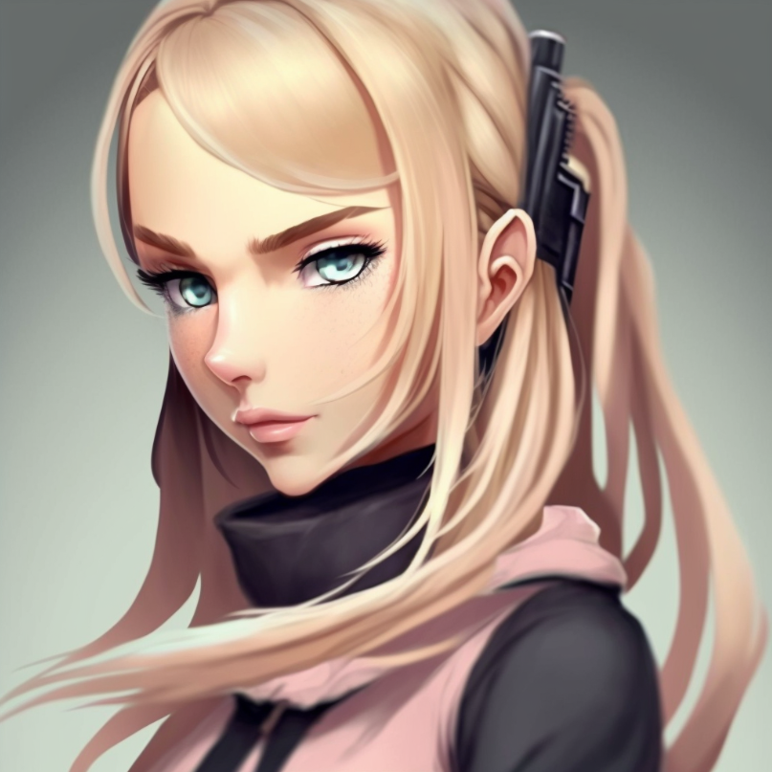
https://cdn.discordapp.com/attachments/1035409757734961202/1096170213982093474/Snipbie.png
“Oh,” Barbie said, smiling, “are you-”
“No,” the third Barbie said, casually reaching into a pocket in her pink vest, pulling out a long throwing knife. The woman casually threw it, the flashing steel arcing across the room, burying itself halfway into one of the doors at the back of the room with a sharp THUNK. “Her.”
The red-shirted woman groaned. “Come on Snipebie, did ya have to ruin my fun? They’re so fuckin’ green if I ate ‘em I’d be a fuckin’ cow!”
The pink-vested barbie considered that, then nodded.
“Yes.”
Then she went back to reading her book.
Lee glanced between the two. “I’m sorry, am I missing-”
The knifed door slammed open, and the oldest looking Barbie Barbie had ever seen came stalking out, “Snipebie, what have I told you about knocking?” Then the elderly woman paused, and looked at the two of them. “Oh, so you’re finally here.”
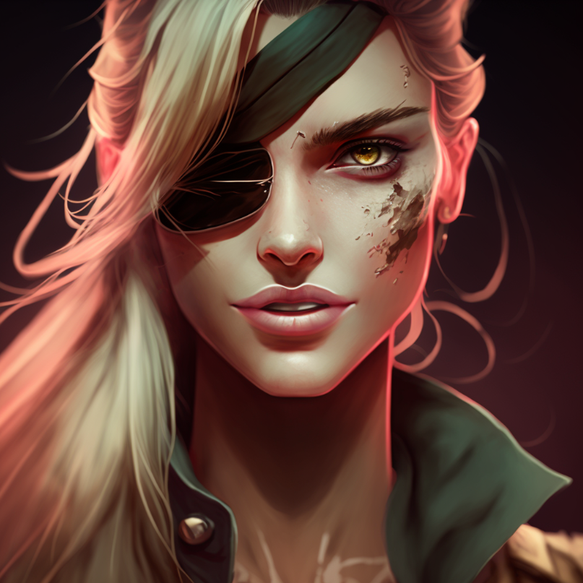
https://cdn.discordapp.com/attachments/1035409757734961202/1096172820842680510/Capbie.png
“Um, are you Barbie BR4-” Lee started to ask, the aged Barbie, who looked like she might even be thirty, nodding, and cutting him off.
“Yeah, that’s me,” she said, walking over to two other doors, and slamming a fist on both, “and welcome to Barbie-Twelve.”
Lee frowned, “Wait, Barbie… are you all Barbies?”
The red-clad Barbie laughed. “Oh, we got our selves a mathlete over here! Maybe he’ll even make it to mission two.”
“Shut it, Boombie,” the eyepatched woman ordered, the other woman glaring, but not saying anything more. “Time for you to meet the team. Boombie here’s our explosives expert, with a temperament to match.”
Beside Barbie, Lee frowned, asking incredulously, “Wait, you’re name’s actually ‘Boombie’?”
“At least I got a fuckin’ name, new meat,” the foul-mouthed woman sneered, causing Barbie and Lee to both frown, and exchange looks, but before he could say anything else, the older woman continued.
“Over there is Snipebie, our ranged weapons specialist,” the eyepatched blonde stated. “Rifles, artillery, lasers, if it’s not in spittin’ distance, and it needs to die, but not everything next to it, she’s your girl.”
The pink-vested blonde looked up from her book and nodded.
“Oh, we have new friends?” another woman called, with a slight Russian accent, opening her door, revealing the most muscular Barbie that Barbie had ever seen.
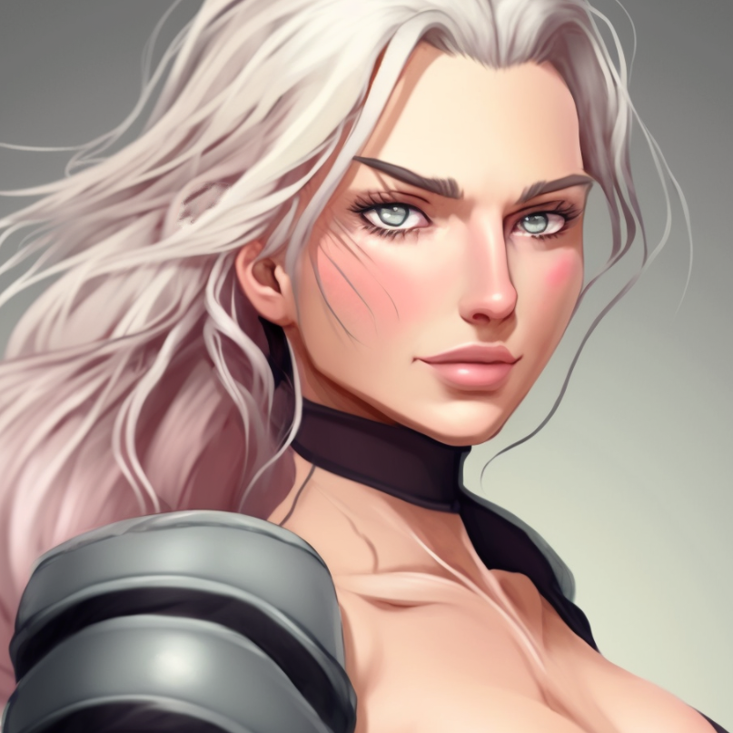
https://cdn.discordapp.com/attachments/1035409757734961202/1096210488016244847/Shotbie.png
Wearing a low cut crop top, and somehow taller and with larger breasts than any of the rest of them, the muscular platinum-blonde woman smiled warmly, a welcome change from the others. “Ah! And this one looks like he not break like others! Very good!”
“Break?” Lee echoed, sounding worried, only for another Barbie to push past the six-foot-three woman, and stride up towards him, grip the man’s chin, and turn his head one way, then another. “Um, can I help you?”
“Hmm, only a little fat, but healthier than the last seven,” the green haired Barbie declared, and, were those scales on her cheeks?
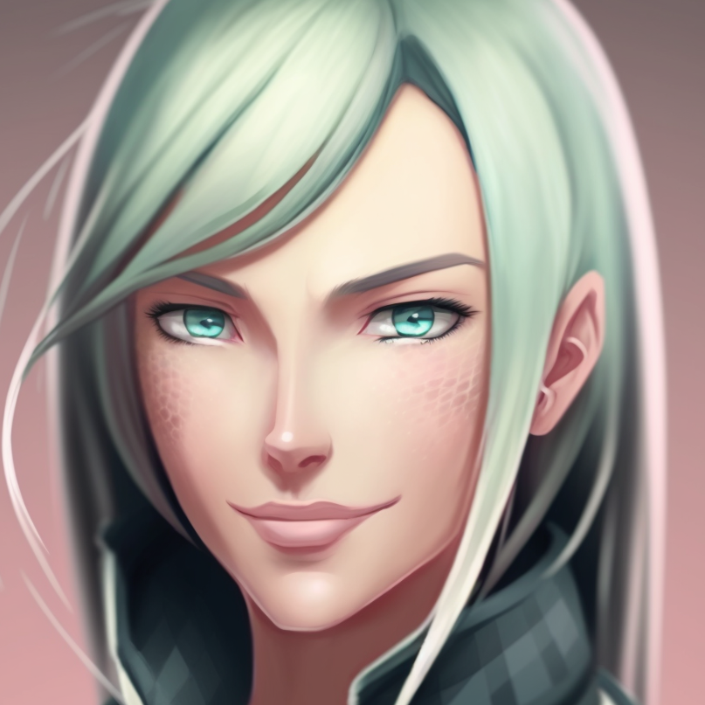
https://cdn.discordapp.com/attachments/1035409757734961202/1096175905795231744/Medbie1.png
“Wait, Seven?” Lee demanded, knocking the newest Barbie’s hand away, turning towards the eye-patched Barbie. “Respectfully, Ma’am, what the hell’s going on here? I was told I was going to be working Loss Prevention.”
“You are!” the oldest Barbie smiled. “Medbie’s our sawbones, and Shotbie,” she said, jerking a thumb, towards the tallest Barbie, “Is our heavy weapon’s expert. There’s also Hackbie,” she added, slamming another fist into the door, “Our cyber-warfare specialist, but she’s bein’ a bit shy.”
“I’ll be out in a minute!” a voice called on the other side of the door.
“Finally, I’m the Captain here, so you can call me Capbie,” the newly named woman stated. “You two, are Newbie, and Ken.”
Lee frowned, “I have a name.”
However, Capbie snorted. “I don’t care what name you’ve thought up, and I think I’ll shoot someone if I hear another Ken call himself, ‘Dark Death Hollow’ or ‘Biggus Dickus’, or whatever dumb shit you’ve come up with. We’re Barbies. We need a Ken. If we don’t have one, we go a bit strange. There’s studies. Congratulations, you’re our Company-issued emotional support Ken. Go check out your room while we have a chat with Newbie.”
The Husbando took a deep breath, seemed to twitch a little, and let it out. “Okay, yeah, sure, whatever. When you’re done with her I’ll need a breakdown of whatever the fuck it is we do here.”
“For you? Stand there, have a dick, and look pretty,” Boombie offered condescendingly. “But one and a half out of three ain’t bad, right?”
“Oh, you’re just gonna be a blast to work with,” he grumbled, getting a surprised laugh from the girl as he walked to the door Capbie pointed out, slamming it behind him.
Barbie felt compelled to say, “That seemed… mean.”
“Let me guess,” Medbie questioned, with suppressed amusement, “he seemed nice enough?”
She blinked, “Yes?”
“Oh,” the green haired woman cooed, reaching over to pat Barbie on the head, “To be young again. He’s a Ken. If they were worth anything, they wouldn’t be here.”
“I, I’m sorry, I don’t understand,” Barbie told the others, the nice sort of calm Lee had brought with him having left with him. “What do you mean we need a, a ‘Ken’.”
“Have a seat,” Capbie ordered her, though the woman was not as harsh seeming now. “You’re fresh from the orphanage, right?”
Barbie nodded, doing so, the others taking seats around the room.
“This wouldn’t be an issue if you were a Waifu,” Medbie told her, “As you’d have a man, but, well, we’re all so multicompetent, we’re the only Tier 4 options that have no superpowers at all. That might change, but, last time I checked, we’re it. But that ability comes at a cost. You remember your BDSM class?”
Blushing a little, something that caused Boombie to chuckle, Barbie nodded. “I, uh, yes? But how does… oh. Oh nooo.”
“Yes!” Shotbie smiled encouraging. “We switch in bedroom. But, in relationship? Subbiest of Subs!”
Medbie sighed, “That’s… technically accurate. Just as many who have Dominantly-aligned professions are prone to seeking the opposite when intimate, we… need someone. Someone who isn’t us. With bindings, it can be women, but we’re all, for better or worse, very straight. Hence… Ken!”
Capbie took up the explanation, “They’re Company washouts, since we could do this job without them, and this gives the upper brass a place to dump the worst of the idiots. They get a single power, Bronze-tier, and it’s almost always a sex one. That’s why Medbie gave him a once over, since the ones that make you look better don’t make you healthier. Speaking of which, doc?”
“Healthy as an obese horse,” the green-haired woman commented, “but better fat then something else. Some use-damage from unhealthy living, but less than I’d expect. If I had to guess, he gained the weight recently, likely right before he got Recruited. This Ken’s probably got a performance-related ability.”
The eye-patched blonde shrugged, “Better than the other way around.”
Holding up a hand, Barbie asked, “Wait, so, we’re supposed to, um,” her voice dropped to a whisper, “have sex with him?”
“C’mon, Newbie!” Boombie taunted. “You were gonna fuck your Client. How’s this different?”
Snipebie spoke up, still reading. “You don’t need to. Loudmouth’s still a virgin.”
“Blow it out your ass!” the red-clad woman snarled.
“If you had yours blown out, maybe you’d calm down,” the pink-vested woman noted idly.
“Children!” Capbie warned, looking to Barbie. “You don’t need to, but if you’ve got an itch to scratch, well, that’s why they’re there. It’s not like they ever say no.”
Frowning, the newest Barbie questioned, “Um, can they?”
“Could? Yes,” Shotbie told her with a shrug, “Never seen.”
“We are all Barbies,” Medbie noted with a smirk, “and Recruits do not join the Company because they wish to remain celibate.”
Barbie blinked. “…oh. Well. Okay then. That’s… certainly a thing.”
“You’ll have time to get used to it,” Capbie reassured her. “We all did. You just need to find your specialization, for when you’re no longer Newbie.”
“And how do I stop being Newbie?” Barbie questioned tentatively, having an idea, though she didn’t like it.
“Someone dies,” Snipebie noted, sounding almost bored.
Well, that’s not very nice, Barbie thought, having her worry confirmed, asking, “Then, what did they do, so I can-”
“No,” Shotbie disagreed, frowning, though not sounding upset. “Wheelbie loved driving. Find your love.”
Medbie nodded, “We’re all racecar drivers, train conductors, pilots, and so on. Any one of us can do anything that anyone else does, though not as well. That synergy is the reason why the Barbie-squads exist in the first place. That and a glut of us in the system.”
“We’re good, you’re passible, you will be better,” Capbie informed her with a confident smile, jerking a thumb towards the door she’d hit. “Now go say hi to your roommate. Don’t bother knocking, just go right in.”
At the ensuing silence, as they all waited, Barbie stood, grabbing her backpack, and walked to the door. She hesitated, but at her Captain’s nod, she took hold of the knob, turned it, and opened the do-
“Oh, Yes! Deeper, Oni-San!”
Oh, that was… a lot of porn.
Glancing back at the squad, they seemed amused, so Barbie stepped in, calling, “Um, excuse me!”
Half the room was completely bare, but the other half was stocked full of books, CDs, and more, all of an adult nature, a pink-haired woman knuckles deep in herself, and… Barbie really wasn’t sure how to handle this, so she just repeated herself, “EXCUSE ME!”
The other woman sighed, pausing her very graphic video, and turned around, only wearing a shirt, and looked at Barbie, giving her a once over, and shrugging. “Eight out of ten.”
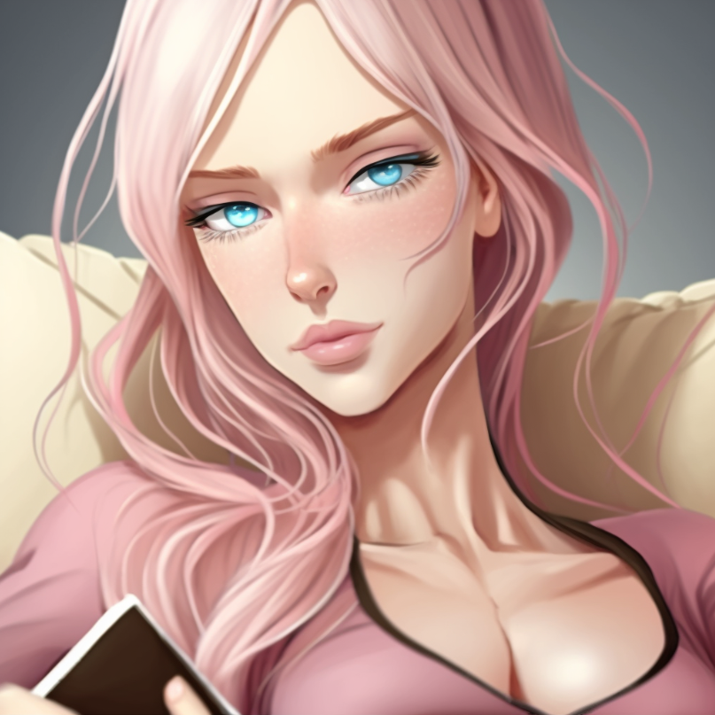
https://cdn.discordapp.com/attachments/1035409757734961202/1096172821190803486/Hackbie.png
I’m you! Barbie couldn’t help but think, but tried to stay positive, closing the door behind herself, as the other woman was undressed, in case Lee came back, and trying to preserve her modesty. If she had any. Dropping off her backpack on the bed, Barbie smiled, greeting the other girl, “Hello! I’m ‘Newbie’, I guess, and you’re Hackbie, right?”
The pink haired woman gave her a long, unimpressed look. “Yeeeeep. Good talk. Tell me when we get a Ken.”
“Oh, um, we already did?” Barbie offered. “We came in together.”
That got her a raised eyebrow, and a grudging nod. “He came in you already? You work fast, Newbie.”
For a moment, Barbie was confused, before. “Oh! Oh no! I mean on the bus!”
If anything, that got her more respect from Hackbie, who seemed like she should be called Pervbie. “Riding him on the ride here? Damn, girl, even I haven’t pulled a Rosa Parks.”
“I, what? No, that’s, what!?” the non-degenerate Barbie sputtered. “I, we haven’t, who’d call it that, I’m, Gah! I haven’t had sex with him, we both took the same catbus here!”
“So ya didn’t slip him some pussy while you were in the pussy? Lame,” the woman replied dismissively. “Is he at least a himbo?”
“Him-bo?” the newest member of the team questioned, taking a moment to decipher the term. “Oh, no, he seems intelligent! We didn’t talk that much, but-”
“Ugh,” the pervert groaned, turning her back on her new roommate, leaning over to type on a holographic keyboard, the porn replaced by-
“Do you have a camera in his room?” Barbie demanded, offended.
Because, on the screen, was a feed of a very red bedroom, with a very large bed at one end, large enough, some dirty part of her mind observed, tainted by proximity apparently, to fit the entire team.
Lee was, meanwhile, sitting on the bed, frowning, reading something on his phone.
“God, you’re both lame,” Hackbie groaned. “At least take off your shirt or something,” she urged the screen. “Show me that man-titty!”
How, on earth, did one of me turn into this? Barbie questioned, sighing, and opening her backpack, she took out her laptop setting it up, looking over, and, yes, her roommate was masturbating.
Again.
Shaking her head, she thought, at least the rest of the team seems nice enough, and we’ll be helping people. That’s what matters!

<BTK>

This job… was not what I thought it’d be.
I knew what ‘Loss Prevention’ was for normal corporations, but, apparently, the Company took a more active approach to such things.
No, I was now part of a ‘Troubleshooting’ Squad for Tier Two to Five worlds, pulling dumbass Agents out of the fire they’d managed to find themselves it. I’d asked ‘Capbie’, who’d dropped by an hour after oh so nicely ‘dismissing’ me, why we, here in Class C, were doing this, instead of Class E, whose entire existence seemed exclusively centered on kicking people’s shit in.
The ‘grizzled’ Barbie, after giving me a weird look, had explained that Class E was effectively law enforcement, and the people we were saving hadn’t broken any of the Company’s rules, just the ones of wherever they ended up, and also probably common sense. In that, our job, while under the heading of ‘Loss Prevention’ was really something more along the lines of ‘Asset Conservation’. If Agents died, that was usually it for them, and the Company could no longer profit from their actions.
Even if that wasn’t the end of the line for them, though, and they had rez in their back pocket, there was all sorts of legal bullshit required to resurrect dead Agents using non-Agent methods, including the sourcing of some pretty hefty magics. There was Weave magic, the cheapest resurrection option in the Company’s repertoire, but that tended to leave certain magical marks on their recipient’s souls that either took even more work to remove, or left the Agent Weave-patterned, which had a good chance of locking them into a Weave levelling system. That system was great for normals trying to survive bullshit, but breaking past the 20th level threshold was a stone cold bitch.
Not that Capbie explained any of that to me, the woman just informing me that we were ‘the cheaper option’, leaving me to extrapolate outwards from what I knew. Our rating rage was what we were strong enough to handle, the deceptively labelled worlds that were Idiot-Traps removed from our queue. When I asked about Tier One worlds, Capbie snorted and informed me that they just sent an office worker with a clipboard and a piece of Psychic Paper to handle those.
With that, I’d been left to my own devices, told where my gear was in case we got a call, and told they’d collect me for dinner. I had to say, being treated like the retarded cousin of the group rankled me something fierce, but, honestly, making a fuss about it now was clearly what they were expecting me to do, so I just…didn’t.
I did reread my employment agreement, with an eye towards my new understanding of my job, which, actually, meant I’d be done much faster than I originally thought I would.
Which wasn’t something I was that happy about.
Like, what was the point of picking up biological immortality if I couldn’t enjoy the fact that I’d stopped aging, and was, in fact, reversing a little?
Also, according to the organizational chart I’d found looking over the rules and regs for my new position, I was in charge.
That said, I’d seen enough war movies to know how well it went when the new Lieutenant came in and told the experienced Sergeant ‘How things were gonna be’. And, while I knew if they were actually fragging their officers, the Company would know, there was a lot of wiggle room where it wasn’t them that killed their Ken, they just… didn’t save him, maybe even by following the officer’s orders, technically.
After all, they’d run through at least seven Kens, and, though she didn’t explain Medbie’s comment when I asked, I had a feeling Capbie had churned through more than that.
So I was left in this parody of a harem’s bedroom, glad that minor magics took care of things like laundry and maintenance, because I had a feeling that cleaning these voluminous silk sheets would be a formidable undertaking otherwise.
Still…. Worth it.
An alarm suddenly sounded, not harsh, but an insistent ‘Dee-ooh, Dee-ooh’ that got my attention, and, following Capbie’s instructions, I headed over to the closet, opening it, reaching past the number of ruffled shirts and tight leather pants that I was not wearing, and grabbed the pastel blue spider-silk backed ballistic weave bodysuit. Having worn something similar in one of my Seminars in Basic, I knew they were not meant to be used with underwear, so I stripped, having taken off my pants when my door, which I noted did not come with a lock, opened.
I paused, looking over to see the downright Amazonian ‘Shotbie’ leaning in, the woman smiling. “Ah! You are changing! Good!”
“The alarm went off, and Capbie said to get ready if it did,” I pointed out, confused.
“You be surprised how many don’t, even when told,” the almost white-haired woman informed me. “Need help?”
“Nah, this isn’t my first rodeo,” I smiled. “Thanks though.”
For some reason, that seemed to surprise the woman, who quickly smiled, nodded, and closed the door behind her. Shrugging, I slipped my armor on fully, noting the hook-points for even more covering, and stretched, finding it perfectly tailored to fit my body, something I’d never experienced before working for the Company, which, to quote Ned Flanders, ‘Felt like I was wearing nothing at all!’
It had weight to it, as it was an armored suit, but it honestly wasn’t that bad, especially with my enhancements.
Unfortunately it lacked pockets, requiring me to leave my phone behind, though, considering I could summon it interdimensionally, that didn’t mean much. Walking out, half the team was already assembled, and I joined the loose circle they were making, Shotbie giving me a once over, probably to make sure I’d put it on correctly, then a smiling thumbs up, which I returned.
The captain might be a bitch, but not everyone here was, at least.
The others joined us, Barbie, er, Newbie walking out with a pink haired Barbie-variant. I smiled at the younger girl, and gave her a wave, only to have her turn bright red, hide her face in her hands, and look away, which… what?
Before I could ask what I’d done wrong, the door opposite mine, center-left instead of center-right, with the steel double doors being dead center, opened, and Capbie walked out, holding a tablet computer. She clicked something, the lights in the room dimmed, and she looked to the doors, calling out, “Boombie! Snipebie! Move your asses!”
“I’m fuckin’ comin’!” an aggressive voice, probably the explosives expert, called, the door opening, only the same voice to call out, slightly panicked, “Wait! I’m still changing!”
I turned, so that my back was to the door, as Snipebie joined us, giving me an unreadable look, the last member of our squad joining us a moment later, all of them in pastel-pink outfits that matched my own pastel-blue one.
“Glad you could join us,” Capbie drawled. “And even the Newbies got dressed. Thanks Shotbie.”
“No thanks needed,” the large woman shrugged, getting a raised eyebrow from the noncom, but the captain continued, tapping her tablet, holographic screens appearing over the central area in front of us.
“Alright, this one’s a standard extraction,” the eyepatched woman noted, as names, maps, and faces appeared on the screen, ones I hadn’t expected. “Agent possessed Ron Stoppable, and inserted into a standard Kim Possible dimension. Premium Catalog, though I don’t know how, and he had his ticket written, then decided to kill Duff Killigan, minor villain, uses high explosive golf balls. His Stamped Waifu, Kim Possible, thought he had been mind controlled, and turned him over to Global Justice. They determined he wasn’t, so they’re going to execute him.”
Newbie frowned, “But, isn’t that excessive? He killed someone, yes, but it was a villain.”
I thought about that, not remembering anyone dying in that show, ever, as it was made for kids, which meant… “Veiled Comedy World?” I questioned.
Capbie, who was about to respond, paused, frowned, then gestured for me to explain to Newbie.
“Comedy Worlds are all low-Tier but Tiers are deceptive because Tier systems are based on how dangerous it is for your average person who acts like an average person would. Sekirei is a Tier Three world, but you grab the antagonist’s attention and you’ve got a squad of Tier Five’s on your ass, and that’s a non-comedy setting. With Comedy Worlds, you’ve either got Naïve ones, which are Tier-accurate, Veiled ones, which aren’t, and Eldritch, which are… No. Just no,” I told her.
Gesturing to the display, I continued, “Naïve Comedy Worlds are that way because the majority of people are just really that nice, like the Pokémon Anime. Think ‘Invention of Lying’, where an Agent can go all ‘In the land of the blind, the one-eyed man is king’, though, naïve doesn’t mean dumb, so that adaptation can come quick. Veiled Comedy Worlds know evil, but, are you aware how, in a balanced systems, they tend towards Evil, as the good guys are honorable and play fair, and the bad guys, being bad guys, don’t?”
Newbie nodded, following along as the others watched.
“Well in Veiled Comedy Worlds the good guys won, usually by being ruthless, and thus, as long as you play by the rules, everything’s fine. There’s no slow slide to Evil because Evil’s standard ‘but I’m not really X’ bullshit doesn’t work, and, by eliminating that wiggle room, usually with extreme violence, everything seems nice enough that you get Comedy Worlds. They’re rather comfortable rides, but,” I gestured towards the display, “if you break the rules, you’re in for a world of hurt. Global Justice probably checked that it wasn’t mistake, found out that our boy was an amoral dickbag, and are probably going to make an example out of him, showing they’re just as harsh on their own as they are on bad guys, to maintain order.”
Capbie nodded, frowning, “You’re right. Where’d you learn all this, Ken?”
I winced, as that wasn’t my fucking name, but, if we had a mission to complete, now wasn’t the time to hash that out. “My Surviving Comedy Seminar,” I told her with a shrug.
“You really expect us to believe that?” Boombie scoffed.
“What about Eldritch Comedy Worlds?” Newbie questioned.
The eldest Barbie shook her head. “We don’t get those, rookie, and unless you’ve got a conceptual defensive suite, you’re turbo-fucked if you end up in one. Hackbie, I want you so deep in Global Justice’s systems you can tell me their leader’s fetishes. We’ve got a pinhole portal into their dimension, so get to it.”
“I’ll get to penetrating them immediately!” the pink haired woman smirked, jogging back into her room.
Capbie rolled her eyes. “Shotbie, Medbie, get these two fitted for their armor,” she ordered, glancing my way. “They’re hand-me-downs, and basic, but they’re better than nothing.”
“I’m sure they’ll be just fine!” Newbie smiled, and I nodded.
“You know more about this operation than I do,” I added, which, if anything, just made the woman frown more, before waving us off.
Shrugging at the dismissal, I followed the medic and heavy weapons expert, through the double steel doors, and into the armory. I was surprised when, led by the pair, we were stopped in front of eight sets of clone trooper armor.
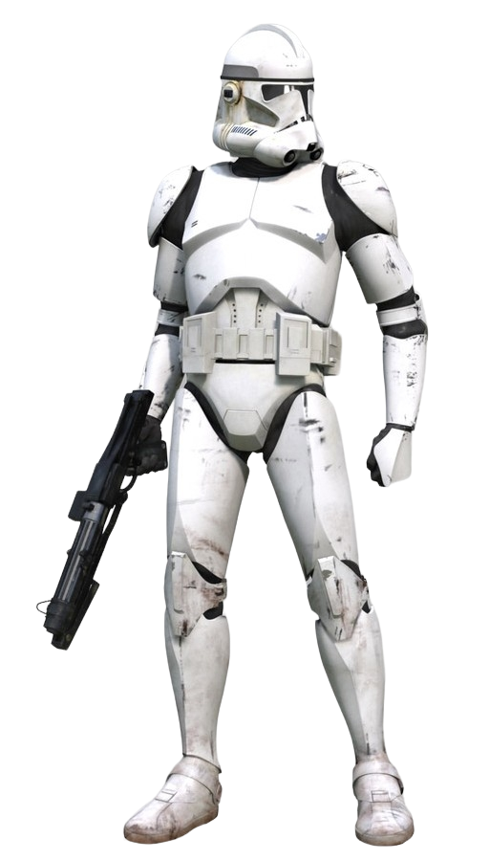
https://static.wikia.nocookie.net/starwars/images/1/19/CloneTrooperPhase2Armor-RotSVD.png/revision/latest?cb=20221030163313
Each set was colored differently, with slight ornamentation, only one suit completely white, though, as I moved towards it, Medbie grabbed my arm. “Oh, honey, no, that’s your armor.”
Following her pointing finger it was… hot pink. The same color as the door. With golden accents. Looking at the smirking doctor, I sighed, shrugging, “Well, when in Barbie-land, do as the Barbies do.”
That caused the woman to lift a perfectly manicured eyebrow, while Shotbie, who’d taken down the white armor, and was helping Newbie into it, chortled. “Top man gets top color,” she remarked, at my questioning look.
“Okay,” I said, taking the practically fluorescent armor down, handling it the same way that the larger woman was. “Let’s get started.”

<BTK>

“I don’t suppose we can just talk to them? Tell them he’s an alien criminal, or something, and that we’re here to bring him with us?”
The others laughed at my suggestion, as we headed to the Portal room, our plan an effective one, but one that would lead to the deaths of a lot of good people who were just doing what they thought they needed to. Part of me was tempted to try and put my foot down, but… but the Multiverse was large, and, as I was now, I did not have the power to affect things. Hell, I had barely cracked the regulations revolving my new position, though they were oddly structured, the cans and can’t seemingly without rhyme or reason, but this was Class C, populated mostly with eldritch horrors, so there was a logic at work, just likely an alien one.
Instead I checked my weapon, a surprisingly straightforward battle rifle that looked a bit like an AR-15, chambered in 5.56, and, yeah, it was just like the one I’d trained with, which helped. I’d asked about why we were using ballistics, since we were in Star Wars armor, Medbie informing me that the standard loadout was a much less advanced set of ‘modern’ combat armor, but Capbie had done well enough, and pulled enough favors, for us to get outfitted with something a lot better.
Those favors just hadn’t extended to weaponry.
Tromping down, following the others, walking next to Newbie, I shot her a look, tilting my head inquiringly, toggling the comms system in my helmet to open a channel only to her. “How are you feeling about this?”
The girl in white armor considered that, helmet tilting, and if I hadn’t seen Shotbie help her with it, I would’ve never figured out how she got her hair inside it. “Not quite what I expected, but it’s certainly different!”
“Fair enough,” I chuckled.
“Quit your chatter,” Capbie reprimanded. “Newbie, stick to me when we’re out there.”
“Yes, Capbie!” the girl saluted, then I could practically see her realize she’d said it on the wrong channel, but from the older woman’s nod, clad in purple armor with pink accents herself, either she had an override that let her hear everyone, or the salute was enough.
After a moment, I toggled a channel to the eyepatched woman, requesting, “And what should I do?”
In response she snorted. “Stay by the portal and try not to die,” she advised condescendingly.
O…kay, I thought, resolving to read the rest of the rules when we got back, to see if there was something I was missing, or if she was just a cunt. Not saying anything else, I walked with the others, to our building’s gate room, which was running, a single dot of light visible in the center of an otherwise empty arch.
“Barbie Twelve, departing!” Capbie called, and, a moment later, the pinprick portal closed, then another one opened in its place, revealing a desert. Without another word, the others tromped through it, so Newbie and I followed, the transfer between dimensions seamless, as we stepped out next to a decently sized stone formation, and, as we moved around it, a road came into view. “Boombie, Hackbie, set up the surprise. Snipebie, find a vantage. Everyone else, settle in.”
Hurry up and wait, I really have joined the military, I mused, finding a rock to sit on, toggling the armor’s onboard computer, which was wirelessly connected to my phone, re-opening the manual. I half-read it, half kept an eye on the others, as the explosive expert set charges on the road, the cyberwarfare expert doing something as well.
The plan was basic, but following the KISS principle, that was probably for the best.
Global Justice was driving a convoy through this desert, on the way to a maximum security holding facility, where they’d cross their t’s and dot their i’s, and then kill the psychopathic Agent, Hackbie having pulled their logs, the idiot having told Global Justice that ‘they should be thanking him’, and that ‘Killigan was just a Villain, so why did they care’?
On one hand, I could understand the sentiment, but I knew enough about explosives to be able to tell that Killigan was an excellent shot with his club, as if he’d messed up with his volatile golf-balls, someone would die, but he never missed that badly.
Snipebie, meanwhile, had used a grappling hook in her armor to climb up the rock formation right next to us, and, once Boombie blew the lead and last cars in the convoy, she’s snipe the driver of ‘Ron’s’ transport, along with its wheels. Then everyone other than me and the sniper would rush the convoy, blow open the side of the Agent’s prison, grab him, and we’d all high-tail it to the portal.
Was it elegant? No.
Did it need to be? Also no.
Soon enough, the other two had returned, Hackbie telling us that GJ would be there in three minutes, and they were scanning the area with their satellites, but she’d already spoofed them before our portal here even opened.
Right, I thought, stowing my manual, opening the squad channel, and telling the others, “Okay everyone, over here.”
Only Newbie started to walk towards me, pausing when she saw that no one else did.
Sighing, I repeated, with a bit of steel in my voice, I ordered, “I said, everyone to me. Now. This is Mission Critical.”
“Go fuck yourself!” Boombie shot back, though looked around as the others shrugged, and gathered around me, snarling as she followed, though Snipebie stayed up and out of sight.
Reaching my right arm out, palm up, I directed, “Okay everyone, hands in. This should only take a moment.”
Predictably, Boombie sneered, “Are ya fuckin’ kidd-”
Surprisingly, Shotbie reached over and smacked her upside the head, grabbed the sputtering woman’s hand, and put it in my own, along with hers, the others following suit. I put my left hand over their combined limbs, palm down, so I was making contact with everyone and then reached inside.
To the Runes inscribed on my Soul.
“[Give]”
I pulled upon the Rune that empowered me, [Bear], and through [Give] directed it outwards, able to press the same formation that had stopped my aging, among other things, onto the others, Newbie’s and Boombie’s breath catching, Medbie’s head snapping my way, Shotbie chuckling, while Capbie just nodded.
Feeling the Rune they now carried, I let go of them, and stepped back, taking a deep breath. “Okay, there you go. Now you’ve got my power too.”
“The fuck did you do?” our explosives expert demanded.
“I [Give] you all [Bear],” I told her working my hands, the feeling… odd. “Durability boost, reduced physical needs, and enhanced perfected healing. If you’re going into the fire, you might not need it, but it makes me feel better.”
Capbie stared at me, her expression unreadable behind her helmet. “You still have it?”
“Yeah,” I nodded, “But I can give it out to, well, at least six people. I feel like… nine? Maybe ten? Didn’t come with a manual.”
“For how long?” the experienced noncom questioned.
“Until I take it back,” I informed her, which she nodded in response to.
Shotbie stretched, announcing, “Feels like good nap. I like it! Also, Medbie, I win bet.”
“Please, ‘Endurance’ is absolutely a sexual power,” the doctor sniffed. “And when it comes to dealing with you, so is durability.”
The Amazonian Barbie, in silver and emerald green armor, leaned back, then nodded. “True! You win then. Next time.”
“Hopefully next time won’t come too soon,” I noted, getting a barking laugh from the large woman, who was casually carrying a machine gun like the rest of us were carrying rifles, and a thumbs up.
“Places girls,” Capbie reminded us, and everyone moved into position. Left to my own devices, I picked a rock to kind of hide behind, taking a prone position, and checked my extra mags.
Hackbie threw a countdown up on my heads up display, and I waited, watching as it ticked away, my armor’s sensors picking up the sound of the convoy a minute out, and they, down to the second, arrived, the explosives going off, the flashbang prevention tech built into my helmet letting me watch it without issue.
Then gunfire rippled out, the team starting to make their approach, the convoy over two hundred feet away, as Global Justice personnel wearing body armor and wielding carbines started pouring out of the remaining vehicles. While I didn’t have the show memorized, I did not remember either from my time watching the cartoon, which, par for the course for a Masquerade World, meant that they had them, but they pretended they didn’t until they absolutely had to.
And that also meant, if they were surprised, they could be overwhelmed before they busted out the big guns, or, in this case, any guns at all.
Only, they were prepared for us.
Somewhat.
I didn’t want their blood on my hands, as, unlike the people I’d killed before, I was the aggressor here, and would normally defend them, but, well, it was the job, I had to do it, and, ultimately, I’d end up doing more good than bad to even out the scales.
So I took a deep breath, held it, and felt myself [Quicken].
The world slowed and I could make out the bullets passing through the air.
Energy filled me, leaving me feeling almost electric, like I could run a marathon if I needed to, but I only had to aim.
Sighting in on one GJ agent, I could excuse hitting him center-mass, right in his vest, as it was the largest target, and, looking through the scope, I gently pulled the trigger, the weapons slowly bucking in my hands, the round almost seeming like a tiny loosed arrow, as I could watch it flying downrange, striking the man, and sending him toppling backwards.
The GJ gunman beside him wasn’t so lucky, a faster bullet dropping down from the rock formation and striking him in the central glass section of his helmet, punching through it, the round bouncing inside his helmetas his head was reduced to the consistency of chunky salsa, gushing violently out of the only ventilation available, the now-broken faceplate.
Which I got to see occur at roughly one-twentieth of the rate it actually happened.
Which was just… lovely.
Trying not to be sick to my stomach, my powers helping, I moved on, sighting on another target, the Global Justice defenders starting to focus fire on the charging squad of Barbies, whose plastoid armor, despite looking like cheap props, deflected rounds with ease, while the boys, and girls, in blue only had ceramic armor, the type we probably would’ve had originally, and the difference was stark.
Aim. Fire. Aim. Fire. Aim, I repeated, servicing targets, taking them down, hoping they’d stay down, while simultaneously respecting them and getting annoyed at with them as they struggled to their feet, only for me to drop them again, before one of the others did.
I winced as one of my shots ricocheted off the armor of a Global Justice fighter, heading up his torso, catching him just wrong and tearing through his neck, dropping him for good.
The thing was, I knew this place had the tech for full battle-suits, but even this was such a radical step up from the labcoats, martial arts gis, and streetwear that most of their opponents would wear, let alone the skintight spandex people like Shego sported, that it should be a hard step up.
But we were so far down the path from them in lethality, and brutality, that it wasn’t fair.
I wonder if this will have a sociopolitical ripple effect? I wondered, as a team coming from nowhere, with tech no one had seen before, grabbing a Ron that went ‘nuts’ and vanishing into thin air would likely send everyone in the Hero community into an uproar.
What felt like five minutes later, but was less than one, the team got to the armored transport, which, yes, comedically stuck out like a sore thumb, as Snipebie and I took out the people the main team couldn’t see, who they tried to maneuver around to get the jump on our people, though, after the initial shock had worn off, the Global Justice defenders were playing it smart.
Just not smart enough to stop a specialized Sniper Barbie, and a guy that had half a minute to line up every shot when you were just out of cover for a second or two.
Hackbie tossed something to Shotbie, who slammed it into the metal for what, real time, was probably only five seconds, as Boombie slapped a handle on the metal beside them, unrolling something around it. Meanwhile my lungs started to burn, having held this breath for close to ten minutes now.
I still knocked a couple more shots out, as the others took cover, Boombie shielding her face as she gripped the handle, whatever she’d unrolled blowing up.
It was rather beautiful, actually, twin snakes of fire arcing downwards, then up and around forming, oh, it was a door!
As soon as it had finished its work, leaving twisted, glowing, rent metal in its wake, the explosives expert pulled the ‘door’ free, staggering a little under the weight, though, from her body language, she was finding it lighter than she thought, which was good.
Shotbie laid down a stream of covering fire as Capbie leapt inside with a pistol out, Medbie grabbing something from her belt, and unfolding it into an off-white helmet.
A moment later, Capbie came back out, dragging with her Ron Stoppable, who was scowling, but still looked pretty dumb. Apparently the animation had been accurate in that regard.
Well, he was also dressed in a straightjacket, and wearing a Hannibal Lector style mask, which, while likely intimidating for the locals, just made me laugh.
As soon as I did so, the world sped back up, my super-speed only functional when I didn’t breathe, which also helped me realize just how fast the squad was moving, Shotbie pulling a folded up silver sheet from Medbie’s pack as the woman, in cyan and red armor, fitted a spitting mad ‘Ron’ with a helmet, the larger woman rapidly cocooning the Agent and hefting him over one shoulder like a sac of angry foil-wrapped potatoes.
Looking around, the Global Justice agents changed targets, all of them focusing fire on the prisoner, as I took another deep breath, and started shooting, running out of bullets three shots later, having lost track of how many I’d fired, and rapidly changed out the mag, the empty one seeming to hang in the air where I dropped it as I slapped a new one into my weapon, firing again, but a sensor in my helmet lit up, detecting someone coming up behind me.
Still energized, tossing my gun upwards, I quickly jumped to my feet, turning to see Kim Possible sneaking up on me, with some of her attention clearly on the portal. Her determine dexpression started to shift to one of surprise, hands lifting up to take a martial arts stance, but, while she could probably kick my ass, even armored up like I was, I was in no mood to make this a fair fight.
Reaching to my belt, I grabbed a pair of zip-ties from a pouch and stepped over to her, slapping them on one of her wrists, twisting it behind her, before she’d even finished shifting her weight to her back foot. I intrinsically knew, though I didn’t know how, that my moving at super-speed wouldn’t harm her unless I wanted to harm her, which, given where my Runes came from, made sense, as that setting was Tier One, Three, Five, or Six depending on which version you were in.
So, it was easy to reach over and grab her other arm, wrenching it behind her back, as, while she was strong, I had eight inches on her, was male, and had been further enhanced, so what little resistance she reflexively tried to give wasn’t enough, as I tied that wrist to the first, then, with a leg sweep, sent her airborne.
Another pair of zip-ties secured her feet together, and, as she slowly drifted through the air, a third pair connected the first two, effectively hog-tying her, which for normal people was pretty dangerous, but Kim was both a special agent and a cheerleader, so it was probably just uncomfortable.
Quickly emptying her pockets, tossing the kimmunicator, among other objects, a dozen feet away, I left the girl to slowly descend, laid back down, and grabbed my slowly lowering rifle, which still hadn’t hit the ground.
Aim. Fire. Aim. Fire. Aim. Fire.
Back to work.
Global Justice was doing their level best to kill our Agent, and I watched shot after shot strike the silver-wrapped boy, though, viewing him through my own scope, there were tiny flashes of blue every time he was hit, meaning something was probably going on, but that wasn’t my job, protecting my teammates was.
Burning through another Magazine, I grabbed the one that I’d dropped before, stowing it in my belt as well as my newly emptied one, fitting a new mag in my gun as Medbie and Shotbie reached my position, the other four laying down covering fire as well as they retreated.
Letting my breath out, the world sped up, and I commed our doctor, waving a hand to get her attention as I called, “Protocol?” She looked my way, and I pointed towards Kim, who’d finally hit the ground.
“I got her,” the Barbie said, not breaking stride as she hoisted up the struggling redhead, throwing the restrained woman over her shoulder and following Shotbie as the two ran through the portal.
Taking another breath, I started firing again, only getting a dozen shots off when, on my visor, I saw Snipebie had opened a channel, several seconds later her voice telling me, “Geeeeeeeeeeeeeeet Reeeeeeeaaaaaaadyyyyy-”
I breathed out, my [Quicken] fading.
“to go,” the woman the woman finished, cutting the channel, and, breathing normally, I stood, looking over to see her using her grappling hook to drop down from her position. She looked down at the pile of spent brass beside me, shook her head dismissively, and dipped out through the portal, while I turned towards the others.
Boombie tossed out a dozen spheres, Capbie shoving Newbie forward as the other three started sprinting a moment later, the captain opening a line to me, ordering, “Time to leave, Ken!”
Able to take the hint, I jogged towards our exit, the spheres blossoming into very loud, very bright explosions behind me, and I glanced backwards, seeing the explosives expert grabbing a football sized canister from her back and hurling it at the Global Justice fighters, turning towards us and hauling ass.
Then I crossed through the portal.
Into an argument.
“What’s going on, Ron!” Kim demanded, having been freed from her hogtie, though her hands and feet were still bound. “Who are these people? Where are we? What could possibly have made you think that throwing in with, with murderers was-”
Which is when Medbie injected something into the redhead’s arm, and she went limp, then was loaded on a floating gurney, which I hadn’t noticed until the doctor tossed Kim, somewhat negligently, onto it.
Shotbie, meanwhile, was slowly unwrapping Ron, the fold-out helmet off to the side, the mask off, and, as she worked the silver foil off of him, there was a chorus of pings as the rounds that’d been caught in it hit the ground.
Once his arms were free, Medbie grabbed what looked like a plasma scalpel, and Ron tried to back up, only his legs were still wrapped, Shotbie holding him in place while, with six deft cuts, the restraints on his straitjacket were removed, the elongated sleeves falling off.
The rest of the team exited the portal, which closed, a muted WHUMP heard right as it disappeared. Capbie looked around at us, nodded, and declared, using her armor’s speaker, “Good job, team. Agent Ξ-8G295HSI, you have been successful extracted.”
However, instead of being grateful, ‘Ron’ turned a furious glare on the woman, glancing around as everyone removed their helmets. “I wouldn’t’ve needed extraction if my fuckin’ Stamp was working! Get me HR! I’ve got a complaint!”
Capbie calmly removed her own helmet, looked the Agent in the eye, and informed him, “Your Stamp worked just fine.”
Waving at the now unconscious Kim, who was being taken somewhere else by Shotbie, the blond boy snarled, “She turned me over to Global Justice, you stupid bitch!”
“And loyalty isn’t obedience. Stamp a hero, act like a villain, don’t be surprised when she turns you in,” the woman remarked, sounding bored.
This, however, only served to incense the Agent who screamed, “They were going to KILL ME, you brainless BIMBO!”
Taking my own helmet off, I stepped forward, raising a hand, trying to diffuse the situation, and Capbie lifted an eyebrow and waved me forward, her expression seeming to say ‘If you want to handle this, feel free.’
‘Ron’ turned on me, command me to, “Get your fuckin’ Waifu in line, dickwad!”
“Yeah, uh, I just work here,” I informed the ungrateful sod. “But did Kim know they were going to kill you? Or did she say something about ‘getting you the help you need?’”
The look that was sent my way by the, well I’d say man in a boy’s body, but man-child in a teen’s body would be more accurate, was exasperated, like we were the idiots. “Well, if you knew what happened, why don’t you give me some fucking answers!?”
Oh, hey, look, there’s my patience with this guy. And it’s gone, I thought, glad I’d already skimmed the ‘conduct towards recovered assets’ section. We couldn’t harm them more than we thought was required for the mission, and, with the Company’s tech, they could tell, but there was nothing stopping us from verbally ripping him a new one.
“Oh, you’re just so incredibly predictable I guessed, you sorry waste of training, points, and space,” I cheerfully informed him with a patented ‘Service-staff-that-doesn’t care’ smile. “You took over someone’s body, Stamped his Hero friend, and gave no thought that, being loyal to you, she’d try and ‘help’ you. The Stamp makes them okay with Stamping but not murder, you functionally illiterate C-reep.”
Predictably, the idiot sputtered, used to dishing it out, but only taking, at most, schoolyard-level insults. I waited, patiently, and more than a little condescendingly.
“Y-y-what did you say to me?” he finally sputtered. “You can’t talk to me that way!”
Turning to Medbie, I put on my fakest look of concern, and told her, “Oh, no, it appears that he’s suffered hearing loss, as well as possible head trauma. Given how few braincells he seems to be in the possession of, he can’t afford to lose any more. He should get medical attention, stat!”
The green-haired medic tried not to laugh, as Capbie sighed, walked past me, grabbed ‘Ron’ by the scruff of his neck, and bodily carried him out of the room, as he screeched at her to ‘put me down’ and ‘you can’t treat me that way!’
Turning to the others, I asked, “Are they usually like that?”
Snipebie, who’d been staring at me, shrugged. “If they weren’t, they wouldn’t need our help.”

<BTK>

There was something wrong with this Ken.
That was the thought that, over and over again, ran through Snipebie’s head.
They’d had a number of Kens before, though half of them bought it in the first mission or two, and of those that survived, nine-tenths didn’t make it past mission ten.
The last four had been of the first category, though, the fifth-last, the one that came to them the same time that Newbie, now Boombie, joined them, had lasted seventeen.
He’d been pretty good, as far as Kens went, an absolute idiot, but a well meaning one.
He’d put himself in danger, trying to save them, and even succeeded but… hadn’t walked out of it.
And Newbie hadn’t taken that well.
But that was the thing: Kens were predictable.
Yeah, they came in different flavors of incompetent, but there was always some strain of failure that ran through their cores.
Some were spineless.
Some were domineering.
Some were impulsive.
Some were listless.
Some were stupid.
Most were insecure.
But this Ken… wasn’t.
He accepted Capbie’s talking down to him, but didn’t seem to care, rather than just accepting it meekly.
He commanded them, but only once, to empower them.
He followed directions, keeping on task when ordered to do things.
He did things on his own, finding his own tasks, not looking to them for everything.
He was not stupid, a single conversation with him enough to learn that.
And he did not seem insecure.
So… what was he?
What was his fatal flaw?
And then there was his power.
Snipebie was the only one that hadn’t partook of what he offered, but that was by design.
Every power that the Kens she’d met received were somehow sex related.
Every. Single. One.
But sex powers weren’t created equal, and there was one in particular that killed Barbies.
Mind Control.
Not directly, but all of the training, all of the skill, all of the experience in the world didn’t matter when you weren’t in control of your actions.
Which was why, whenever a Ken started ‘sharing’ anything, there was always one of them that refused, even to the point of insubordination, because while Kens were allowed to mind control them, especially in the bedroom, they weren’t allowed to endanger the mission in doing so.
And so, if a Ken started using their powers on Barbies, there needed to be someone who could put the Traitor down.
It couldn’t be Capbie, as she was in charge, and so she was the first one MC Kens went for, but Controllers were always arrogant Kens, and so overlooked the others.
Thus, being the ‘quiet’ one, Snipebie was perfect for the role, while Drivebie, who’d been loud and in your face, but not in the same way that Boombie was, had dragged attention, and let her work.
And, given what her first Controller Ken had done to the sniper, thirty-seven Kens ago, it was a task that Snipebie gladly took on, and had carried out, repeatedly.
But Controller Kens had many tells, and this Ken seemed to have only a few of them, but they weren’t strong enough to really count.
To start with, the man was charismatic.
CKs wrenched attention onto themselves, usually taking that power because they were normally ignored, so they’d never be ignored again, but this Ken didn’t demand attention, he talked, and casually expected it, yet, when denied it, leaned back to observe who held it instead.
But, the others were acting… odd.
It was a subtle thing, but, when this Ken was around, things… didn’t seem as bad, in a way that was observable, but made no sense.
Their circumstances didn’t change, nothing was suddenly overlooked, but the world just seemed that little bit brighter, with him around, in a way that had nothing to do with the power he’d shared, as it affected her as well.
And Snipebie didn’t like it.
More than that, his actions, after they had returned, were similarly unusual.
He had retreated to his bedroom, yet, when they invited him to dinner in the Messhall, he’d easily left his domain, in a good mood despite his clear distress at having killed the white-hat defenders during their mission, something he’d been clearly regretful to do, yet had started firing on them with almost mechanical precision once the shooting started.
He had gone to the gym, yet, when Shotbie easily outperformed him, he didn’t mind, complimenting her instead, but, according to the woman, who’d dealt with over a hundred Kens, he still took pride in his own achievements, not feeling overshadowed in the slightest.
He was spending hour after hour reading Company regulations, by Hackbie’s reports, but not with the desperate fervor of someone trying to escape their circumstances.
He’d gone down to the range, and, when Snipebie had, purposefully condescendingly, critiqued his form, he’d defended his performance against her overly harsh assessments, yet still did his best to integrate her suggestions into his firing technique, openly praising her own skill and admitting it far outstripped his abilities, which she did, but with no indication that he was sucking up to her in the process.
And she’d enjoyed her time with him, instructing him, and having him be attendant upon her, clearly appreciative of her beauty, but not focusing on it.
Which… she shouldn’t be, though she could not put her finger on why, yet, despite referencing her journals, in the event that another Ken had a memory-manipulation power, there were no discrepancies.
And he was interested, which was important.
She’d heard stories, when some idiot in Corporate decided, as a ‘joke’, to saddle a Barbie team with a gay Ken, because ‘hurr durr isn’t the real Ken gay?’
Those events usually ended with the mysterious death of the one that had assigned the homosexual Ken, the gay Ken then transferred shortly afterwards, always alive, which was understandable, as that wouldn’t be that man’s fault.
So he was interested, but hadn’t made a move, yet clearly had the will to do so.
He dressed down that Agent they’d saved, but hadn’t doubled down, nor backed down, when confronted with ‘Ron’s’ baseless aggression, he’d just gave up on the idiot.
And then there was that Kim, which Medbie had congratulated her for taking down, but Snipebie had let the ginger go by her, knowing the girl wouldn’t do anything permanent to their Ken, only for him to take down the trained martial artist in seconds, though she hadn’t seen how.
Thus, there was something wrong with this Ken.
And now they were on another mission, to save a ‘John Snow’ that’d been caught using his powers, taken down, and dragged to Oldtown, kept in the dungeons of the Hightower, castle of House Hightower, the black stone of its construction standing out from the pseudo-medieval port town all around it.
They’d all loaded up into the Huey, which, as per Company regulations, was playing the ‘standard helicopter operations music’.
Hackbie was piloting, everyone in armor, Shotbie riding shotgun, her door removed, so she could rest her machine gun in a firing position, as they came in with the setting sun, and they were spotted, their approach not really subtle, horns blaring and archers gathering on the walls.
Laughing to herself, Shotbie opened fire, raking the battlements with bullets, cutting down soldiers, though several of them did get shots off, arrows arcing their way.
Ken, who was sitting between her and Newbie, stiffened, the sound of his indrawn breath showing that he wasn’t fearless, even though they were in no danger.
As one shot came for them, Ken snapped a hand out, catching the arrow by the shaft right before it could hit the new girl, with the speed of a striking snake, which made her tense, his head snapping over as an arrow out of his reach hit Medbie, only to bounce off.
The doctor noticed the man’s confusion, telling him, “We’re in Clone Trooper armor, dearie. Unless someone pulls a Valyrian blade, we’re fine.”
Ken considered that, then let out a long breath, and asked, “Ewoks?”
“Oh!” Newbie, beside him, perked up. “I read about this in class! Ewoks are all naturally Force Sensitive! They use it to enhance themselves, and their weapons, which is how they can throw spears through plastoid armor!”
“And the smallfolk here are no Ewoks,” Medbie noted with amusement. “Though thank you for your concern.”
Ken nodded, considered the arrow in his hands, and, when another arrow came for them, he tossed his at that one, missing it completely, causing Snipebie to snort.
Glancing her way, the man shrugged in an ‘I tried’ way, which, despite herself, made her smile, though she shoved down the oddly warm feeling in her gut, the man still flinching a little when another arrow struck him in the shin, but did nothing to him whatsoever.
With Shotbie laying down covering fire, the inner courtyard was cleared, Capbie yelling, “Alright, girls! Time to go!”
As one, the experienced members attached their grappling hooks to the landing struts of the helicopter and pitched forward, falling out of the vehicle, only to be brought up short, toggling the interior motors in their forearms to drop downwards, Newbie and, surprisingly, or maybe not, Ken, doing the same a moment later.
And… yes, Ken was telling Newbie how to work the motor, the two descending after them, as the rest of the team hit the courtyard, taking the four corners, firing on the soldiers that rushed out to meet them, dropping them in seconds.
The pair hit the ground, Shotbie calling over her shoulder, “Thumb to pinky!”
The both did what the large woman ordered, the gesture activating the grapple’s release-and-pull feature, retracting it into the forearms of their suits, the new recruits turning and covering the area with their own rifles.
“Which way?” Ken questioned, Capbie waving and taking off at a jog, the others following, Snipebie bringing up the rear.
Moving through the stone halls, her position let her keep an eye on Ken who had an… odd style of fighting, as he would run with the rest, but, when he spotted an enemy, he’d stop, take a breath, his weapon would snap up, and he’d fire a single round, every shot a headshot.
Afterwards he’d let out his held breath and run to rejoin his place in their group.
And he did so every time.
There was something wrong with their Ken.
They exited a hall, into a large room, one that was full of guards, and a man in hastily donned gaudy armor at the back lifted a sword, yelling, “We Light the Wa-”
Which is when Ken blew his head off.
Shotbie opened fire, filling the air with bullets, Capbie and Boombie adding their own, as Ken continued his strange firing style, barrel jerking, stopping, firing, jerking, stopping, and firing again.
More soldiers came at them from behind, Snipebie lightly slamming a fist into the back of Newbie’s chest plate to get her attention, as she opened up with her SMG with the other hand, the new girl bringing her rifle around to assist, and within thirty seconds, it was over, a couple injured men moaning, but that was all.
Capbie shot a glance back at Ken, but didn’t say anything else as they continued onwards, and downwards, into the dungeons, the jailkeeper coming at them with a shortsword, only for the captain to take him down with a single pistol shot, grabbing the key-ring from his waist and ripping it from his belt as the corpse fell.
“Agent Π-5DS585G?” Ken requested, voice equal parts reassuring and commanding, “We’re here to extract you.”
“Oh thank Christ,” a man called hoarsely, Capbie tossing Shotbie the keys, her and Medbie jogging down to their target’s cell, the larger woman unlocking the door while the doctor slung her rifle back and entered, doing an initial assessment of their assignment’s health.
This wasn’t a Comedy World, and so even from her position Snipebie could tell the man wasn’t in good shape, bearing the signs of torture.
Medbie got to work, while the rest of the team covered the entrance they’d passed through, the area lacking any windows or other entryways, which simplified things.
Several soldiers tried to rush in, but Snipebie tracked her SMG over them, dropping all four in an instant, a fifth that had started to enter getting winged, but pulling back.
They were running into moderate resistance, for the tech level, but without a network for Hackbie to infiltrate, they couldn’t wait, as there was a distinct possibility that these barbarians would have executed him at sunset, or midnight, or dawn, or really whenever these savages decided was a good time to ‘kill the witch’.
After a minute, Medbie called “Ready!” Capbie nodding to Boombie, who grabbed two flashbangs from her belt and hurled them through the entryway, bouncing off the doorway to hit both sides of the portal and bounce down both ends of the hallway.
As they went off, and the waiting men screamed in pain, blinded, and with burst eardrums, their team started running forward, Shotbie and Capbie clearing the way, weapons firing, Boombie slapping a timed incendiary charge as she entered the hallway, the soldiers down the corridor they weren’t taking ignored as they staggered, still recovering from the unexpected sensory attack.
Medbie and Newbie, carrying ‘Jon Snow’, were next, Snipebie and Ken bringing up the rear, the man casting a look towards the enemies to their back, clearly concerned, which was a good instinct, but the sniper grabbed his arm and shoved him forward, which he accepted without a word despite almost being twice her size, following the others.
Five seconds later, when the charge went off, filling the hallway with flames, and the screams of the dying, Ken jerked around, but, as Snipebie shoved him forward again, he fell back, twisting about, and continued running towards their evac.
Coming back the way they came, their squad met less resistance, passing by the dead and dying, Capbie comming over their shared channel, “Coming up, clear the zone!”
A moment later explosions rocked the castle, and, when they exited into the courtyard, while the black stone of the structure was untouched, everything else was a smoking wreck, the Huey’s missile pods having cleared the LZ.
Their ride dropped down with a solid Thunk, and they piled in, Shotbie and Capbie adding covering fire after they got to their seats, the others following suit, everyone onboard and Jon secured to the bed they’d set up in seconds.
“Go! Go! Go!” Capbie ordered, and they all grabbed onto the handholds as Hackbie gunned the engines, the improvements that Drivebie had made to the craft pressing them down into their seats as the vehicle shot into the air, and took off, for the portal that was hanging high over the ocean, miles away and out of sight of the towering lighthouse-cum-castle’s viewpoint.
In moments they were out of range of the defenders’ arrows, the soldiers not having recovered from the shock of the bombardment in order to fire, and they were home free.
“Ken!” Medbie commanded, getting the man’s attention. “Use your power!”
“Oh, right!” he said, facepalming. “That would’ve been helpful.”
Leaning over, he poked the pale looking man in the face, and took a second, before commanding, “[Give]” the word reverberating in a way that signified a magical effect.
Instantly, the Agent relaxed, no longer looking as pained. “Thanks, man. And for the save. And everything.”
“What happened?” Ken questioned, sounding honestly curious. “The report said you had the Psychic Adventure Contract. That should’ve been enough to take down anything here short of a Dragon or White Walker.”
“I, uh, took Slow Start, Obvious, Repellant Aura, and Talisman,” the man admitted. “The last one fucked me. It was a ring, and when I was sleeping, it got taken, and broken by the Maesters. And they kept breaking it every time it started to reform. But, like, how’d they know? This place is supposed to be normal!”
“There are dragons and an army of ice-wraiths,” Ken pointed out dryly.
“Well, like, yeah, ‘Jon’ admitted, “But they’re rare, and Westeros was supposed to be non-magical!”
Ken shook his head, “Yeah, I thought the same thing, at first, but I knew a guy that was into the series. Westeros isn’t non-magical, Maesters are specialized anti-mages. They’ve just done a good enough job that they can focus on science and being the medieval illuminati.”
“But I’m a Psychic, not a Mage,” their rescue groused. “When they did, whatever it was they did, why did it mess me up?”
“Because in most settings magic and psychic abilities work on the same wavelength, so a Dispel Magic effect will also dispel a Psychic effect,” Ken explained authoritatively, “while in others, they treat each other like they don’t exist. Trust me, you’d rather be in a cooperative world then one where all of your anti-psychic defenses mean squat, and a first level Weave-Wizard drops you with a simple Sleep spell.”
‘Jon’ blinked, then nodded, “Oh, uh, yeah. And there’s some nasty shit out there. Uh, yeah, okay. Um, I’m feeling better, so if you guys just wanna drop me off, I can-”
“No can do,” Capbie informed him. “We’re taking you back to the Company.”
Eyes widening, he started to struggle against his bonds, “Uh, you really don’t need to do that! Honest! I’m good!”
Medbie grabbed a hypospray, to knock the Agent out, before he ‘exacerbated his injuries’, but paused as Ken held up a hand.
“Does your recruitment contract have a termination clause related to extraction? Or is it just death?” he questioned.
The strapped down man paused, “I, uh, I don’t know?”
“You… don’t know,” Ken repeated incredulously. “Okay, dude, read your goddamned fucking contract. Hackbie, can you forward m- Oh, thanks. Gimme a sec, man, I’m skimming it,” he informed the Agent, who waited, tense, but no longer struggling.
After a long few seconds, Ken nodded, “Okay, yeah, standard death clause, and with Company protocols, foretold death, which is why we’re here, is not the same as true death, so you’re fine. If I had to guess, you’re gonna get a debrief, maybe reamed out by your manager for being a dumbass, then kicked back to your Westeros, with a secondary mission to pay for our services. Not that you’ve got a choice, but that doesn’t sound that bad, does it?”
“I… okay, yeah. I, yeah,” the Agent agreed, relaxing again. “And, uh, even though you’re getting’ paid and stuff, thanks for the save?”
“Glad to help,” Ken smiled, the expression clear in his voice, as he leaned back, and they approached the portal, slowing to gently pass through it, returning to home-base, Hackbie putting the Huey down on the platform.
“Actually,” Ken said, causing the Agent to tense slightly, “if your Talisman’s a ring, see if you can get the Company to get that shit implanted, assuming that’s possible. We’ve got the tech to do surgery that can thread it inside your ribcage, so that it’d take a seriously heavy blow to break it again. They might not, but it’s worth pursuing, right?”
The Agent blinked, then said, in a voice full of wonder, “Like, holy shit, would that work?”
Ken shrugged, “Don’t know ‘till ya try, right?”
“I, uh, I will,” ‘Jon Snow’ smiled. “Thanks man!”
“No prob,” Ken replied, stepping off the helicopter, the others doing so as well.
Medbie and Capbie left with ‘Jon’, the others heading back to the armory, as, behind them, the Huey was lowered, to be transported back to their team’s motor pool, and the man walking beside them popped off his helmet, shaking his head, with a pep in his step.
And Snipebie, having seen the man smoothly handle the panicking Agent, couldn’t help but have the same thought as before.
There was something wrong with their Ken.

<BTK>

Medbie liked the bi-weekly dinners she had with her friend, every Wednesday and Saturday, unless they had a mission, but they didn’t have that many missions.
Statistically, a job came in every 1.3 weeks, though, just as they had gotten two within the space of four days, it’d been three weeks since they’d done their Ride of the Valkyries into Westeros, with not a single mission since.
Shotbie had told her, once, how they’d done multiple missions a day, for seven-months straight, when the Knights of Continuity had gone on the offensive, that group of idiotic multidimensional extremists dislike the infinite part of the infinite multiverse, somehow thinking they could change that, and so sought to destroy branching dimensions, of the sort that Slutlife, or ‘The Company’ if one was feeling polite, specialized in operating in.
It's been eight years ago, but they’d launched coordinated attacks, and it was all the Teams had been able to do to extract Agents and maybe their Waifus from the rapid dimensional collapses, exchanging fire with the Knights, until Corporate had tracked down their local outposts, and, with Agent support, they’d started assaulting them, one after another, until they’d found the Knight’s Forward Operating Base in that bit of the Multiverse.
Then there’d been a small War, ending with the destruction of the dimensional anchors that kept that non-dimensional space stable, setting up a trap to bring in as many of the Knights as possible, before collapsing the reality marble, ejecting everyone that survived its destruction into the Blind Eterneties, where Company Agents that could survive out there had pounced on any that hadn’t been instantly unmade.
Of the members of Barbie Twelve, several who’d joined mid-war, only Capbie, Shotbie, and Blastbie had survived, and that last attack had been the mission that made Capbie into Capbie, the other two never saying what she used to be called.
More had joined, and been lost, Blastbie taken about by the G-Man when they tried to save a ‘Gordon Freeman’ from Black Mesa, but injuring that eldritch abomination enough to let the others escape, the Outsider not having expected a Conceptual Bomb, something the woman had been working on ever since the Continuity War.
It was her actions, and her sacrifice, that had convinced Medbie to turn her own talents towards something… more.
With disastrous results.
But nowadays, Medbie was one of the old guard, only Shotbie and Capbie older than her, at twenty-nine and thirty-five respectively, with the green-haired woman being an ancient twenty-seven. If she hit thirty, she could retire, but Capbie hadn’t, and Medbie knew Shotbie wasn’t going to either.
This was their life, and they wouldn’t have it any other way.
The thought made the Doctor sigh, her friend poking her, getting her attention.
“You are brooding,” Shotbie noted, with a smile.
“I am not,” the green-eyed woman shot back, scaled cheeks flushing in embarrassment. “I was merely thinking. Of the past, and of the future.”
“Ah, brooding temporally,” the large woman nodded with mocking seriousness. “Do you like the shashlik? Not sure if marinade better or worse.”
Shrugging, Medbie tried a bit of the not-kebab, then sputtered as it was spicy, thought it vanished as soon as it hit, like a burst of flame that left one only mildly singed, and barely warm. Taking a sip of her wine, she tried not to hiss, damn it, tongue stuck firmly to the bottom of her mouth, and, when she was in control of herself, noted, voice tight, “Unexpected. Perhaps Boombie would like it?”
Shotbie, the bitch, grinned broadly and gave a bellowing laugh. “Oh, she likes her bit, yes! Will save some for her! Try again, now that you expect the fire!”
Giving her friend a thoroughly unimpressed look, the Doctor took another bite, and, now that it didn’t catch her off guard, it wasn’t terrible, the sudden heat, after it was gone, leaving a trail of spice across her tongue, like embers after a brushfire, the meat moist enough to go down smoothly.
“It is… acceptable,” she noted. “Though, perhaps, when I cook on Wednesday, I should try something more… adventurous as well?” the medic challenged.
The amazon just gave her a thumbs up, and Medbie really should’ve known better than to try that, as the big woman told her, “Looking forward to it!”
Rolling her eyes, the green haired woman asked, “Seen any good movies lately?”
As Shotbie’s eyes lit up, the woman loving those things almost as much as she did working out, Medbie was regaled with the contents of several different plot summaries, told in the woman’s laconic style, her love of Romantic Wartime Dramas such that she spent a full third of her pay on them.
“Wait, ‘Rambo: First Blood’? I remember that one,” the Doctor interrupted.
“Ah, not Stallone, this one young Sigourney Weaver,” Shotbie disagreed. “Story of her growing up as soldier during Sino invasion of America in Eighties. Title is not ‘they drew first blood’, it is her ‘first blood’, see?” the heavy weapons expert explained. “Truly a touching story of finding femininity on battlefield. Ken rather enjoyed it.”
Medbie started to nod, but, “Wait, what?”
“He had same misunderstanding,” the platinum-blonde nodded commiseratingly.
“No, I mean, you watched a movie with him?” the Doctor clarified. “All I’ve seen him do is read, train, sleep, and fail at making awkward small talk.”
“He does fail at being awkward,” Shotbie agreed.
Knowing the older woman was messing with her, the green-haired Barbie tried to be even more clear. “I mean he doesn’t do anything with us.”
The larger woman looked at her skeptically, “Do you not remember him talking to you?”
“That?” Medbie replied, even more skeptically than her friend. “He tried to strike up a conversation, when there was nothing to strike. I mean, it was cute that he tried, but he’s a Ken.”
“And, when he learned you did not want to talk, he stopped,” Shotbie agreed. “Not awkward.”
“That’s-,” the Doctor tried to disagree, only to be cut off.
“Remember healer Ken?” the large woman prodded. “Three years ago?”
That forced Medbie to reconsider, as that man had been obsessed with her, thinking they had to be together, and the best of friends, because she was an expert surgeon, biologist, biochemist, geneticist, and more, and he could pat people on the head to heal their wounds.
Which he of course used to negate his refractory period, and brag about his ‘stamina’.
In a way, she’d expected this Ken to do the same, given the similarity of their powers, but… he had left her alone, hadn’t he?
She’d… consider that later. “So, how was he?” Medbie questioned.
“Very insightful,” Shotbie smiled.
That… didn’t make sense. “How can you have sex ‘insightfully’?” she finally questioned.
The woman looked thoughtful, “Understanding fetishes? I am not sure.”
Staring at her friend, wondering why she considered this woman her friend, the green-haired woman argued, “What do you mean you’re not sure, you just said he was insightful.”
“Oh, he was,” Shotbie smiled. “I focused on Joanna’s journey. It reminded me of me. But Ken spotted Uriah Gambit in situation I missed. Mormon parallels, very interesting.”
“Wait, you mean you watched it with him, right?” Medbie checked, getting a nod. “In the common room?”
“In his,” the woman shrugged. “Boombie was watching her dramas, you doing your lessons. We did not want to disturb. He has large TV over bed. Very comfy.”
She looked at the platinum-blonde in disbelief, who, if anything, smiled even more broadly. Finally the Doctor questioned, “Are you saying you ‘Slutflix and Chilled’, and then just watched Slutflix and Chilled?”
“It was very relaxing!” Shotbie noted. “You should do it. Watch Hospital Dramas!”
“Those are Medical Documentaries,” Medbie corrected.
“Oh, are Rebecca, Sarah, and Edward still together?” the large woman inquired.
The green-haired Barbie winced. “No, Sarah got pregnant and Rebecca decided that meant it would just be those two, which was very silly since they both loved her, so cheated on them with Taqisha, which could have worked out if her and Tsun were on an off-period, but they weren’t, but Tsun slept with one of his patients, and caught Geostigma, which he passed on to Taquisha, to Rebecca, to Sarah and Edward, which they could forgive, but Sarah lost her child, which they couldn’t. So SaReEd is no longer a thing,” she sighed, as the medical professional had really hoped those three could make it work.
“Ah, well, Ken trying to study everything,” Shotbie shrugged. “So maybe he would like… Medical Documentary.”
“He’s studying medicine?” the Doctor questioned, rightfully disparagingly.
The amazon merely shrugged, “He studying everything. Trying to bring himself to, as he say, ‘Barbie Standard’.”
“If anything, that’s worse,” the green-haired woman noted. “His power doesn’t increase cognition, and he’s not going to be around for long enough for that to matter.”
Shotbie, ever the optimist, merely shrugged. “Still good to try. With extra time, he might do it.” She smiled, “Extra productivity has been good, no?”
Despite herself, Medbie nodded, admitting, “It has been. And sleeping that single hour a night is a lot more restful than I thought it’d be. Healing tiredness is… different than whatever he is doing.”
The Doctor fell silent, as there was another thing that had happened but… but she wasn’t sure how to talk about-
“You are hurting less.”
Her friend’s statement shocked her, the green-eyed woman meeting the gaze of her silver-eyed friend, who looked down at her, but not down on her. “I… yes,” the Doctor finally admitted, one hand unconsciously rising to brush her scales.
Scales which no longer itched.
It’d been a stupid idea, but she’d thought, if she could get a Weave-pattern, she could do more, be more, so, when they’d gone on a mission to pull an Agent out of a Yuan-Ti Temple, well, they’d just lost Blastbie, and Medbie was looking for something similar, some edge to keep them all alive.
So she grabbed samples from dead Yuan-Ti Purebloods, the ones who looked mostly human, and hidden them away in her pouches, bringing them back to run experiments on, to make a gene-splicing formula. They were infused with Weave-magic, so, by incorporating bits of their genetics into herself, she hoped to activate that spark of Mana, allowing her to Level-Up, and gain spells that would let her heal others, and, eventually, revive the dead.
She thought she could bring them back. She could bring them all back.
Instead, she’d almost died.
The others had saved her life, had helped her pull through, but, while she’d, after she’d woken from her coma, been able to ameliorate the worst of the damage, Medbie hadn’t been able to undo it. In her goal, she’d failed, not gaining any Weave-magic, but she’d gotten a bit faster, her eyesight a bit sharper, with more colors than she’d been able to see before, and she’d been a bit tougher.
But her changes had hurt.
Her scales had been constantly itching, like a rash she’d had for half a decade, her eyes a little sensitive, and, when she moved, she could feel that things weren’t quite right.
Medbie had gotten used to these small pains, these constant reminders of her failure, just part and parcel of flying too close to the sun, and breaking herself in the ensuing fall.
But, over the last couple weeks, the pain had faded, and then, as of last night, stopped.
And she knew why, but she didn’t know how.
The geneticist had examined herself, and her body was shifting, changing, but, while she would’ve accepted reverting back to human standards, instead her Yuan-Ti splices had been… settling, in ways even beyond her understanding, let alone Ken’s, and she didn’t know what to do about it.
“We’ve had Kens with healing before,” Medbie stated, having gotten hopeful, but the issue was that she wasn’t injured, her body just healed wrong, the instruction encoded in her cells tampered with, so that they no longer worked correctly.
“Healing does not help scars,” Shotbie agreed mildly, rolling up the sleeves of her shirt, showing the marks that crisscrossed her arms-
The Doctor stared, “Didn’t those used to be bigger?”
“Da, they did,” the platinum-blonde noted conversationally. “I rather liked them, but good trade, them for yours, yes?”
Medbie stared, finally saying what had been bothering her, more and more.
“This Ken’s power isn’t Bronze ranked,” she whispered.
Shotbie, meanwhile, nodded. “Da. They aren’t.”
The way she said it… “What? He has more than one?”
The large woman smirked. “He has two. Maybe more. He told us he did.”
“No, I think I would’ve noticed if he did,” Medbie argued. “He’s got the healing, which is also durability, but it’s one power, just a broad Endurance set. On the higher end, but-”
“Ah. Apologies,” Shotbie cut her off. “We learned in War. You did not. Names. Names have power. This Ken has named two. Endurance? Is [Bear].”
And the way she said it, the word reverberated slightly, in a way that the Doctor had thought was an aspect of his power, but… “Is, is that a Power Word?”
The older woman laughed, but not at her. “No, I am no caster. But some words? Many layers. Like onions. Or ogres. And say them all? Like [Bear]?” she paused for effect. “Hear them all too.”
The snakish Barbie considered that, casting her mind backwards. “Ken, he said two of them,” she slowly realized. “That, but also ‘Give’. No,” she corrected, holding up a hand, trying to concentrate, remembering how she’d heard it. “He called it [Give].”
As she said it, she, she understood, the sharing of oneself with others, though a conditional one, able to be retracted, the ‘word’ packed with meaning. “That’s… he has two. Why does he have two?”
Shotbie merely shrugged, staying silent.
“Does Capbie know? Wait,” The Dorctor corrected, “of course she knows. She’s Capbie!”
Shotbie, meanwhile, held her hand up, and wiggled it. “Maybe. Capbie was quiet girl. Did not make friends in War. Not like I did. Maybe does. Maybe does not. Does not matter. Had Ken remove his Gift. Scars stayed small.” The platinum-blonde gave her a significant look.
That meant… “We need to keep him alive,” Medbie realized. “At least until, until I’ve healed. After that, whatever, but,” she grimaced, “dammnit, I need that Ken, at least for a little. Need to make sure survives.”
“What you think I’ve been doing?” Shotbie smirked. “Make sure he stable, strong, does not make stupid mistake. Though, if he stay longer, that would be good.”
The green-haired woman rolled her similarly colored eyes. “You just want someone that you won’t break in bed.”
“I prefer all on our team unbroken,” the amazon noted, with an indulgent smile, “but I not say no to some good dancing. Horizontal dancing. Who knows, he might be as good as that Edward of yours.”
Scoffing, Medbie took another bite of the not-kebab, and waited for the heat to pass. “I doubt he’ll ever be that good but…” she paused, smirking, “If he wants to be at ‘Barbie Standard’, I could teach him a thing or two.”

<BTK>
They were Turbo-Fucked.
Trapped, like flies in amber.
Unable to move, unable to even scream.
And there was nothing that Capbie could’ve done differently, with what she’d known.
It was a newly added world, a Scooby Doo Variant called ‘Velma’. It was Tier Five, somehow, with a mark that said it was due to a casual approach to extreme violence to the point of death, some nonsensical off-screen physics, and minor fate-level fuckery to incite ‘comedy’.
She knew they’d have to watch Newbie, because adapting to fate-issues was a counterintuitive process, and one that the girl had not dealt with in training.
The eyepatched blonde would say the same about this Ken, but… but this Ken knew things, things he had no right knowing. His casual knowledge of Contracts, of metaphysics, and more, were things that Kens didn’t know. They were things that she had to fight, tooth and nail, to learn, the Brass informing her that it wasn’t her job to know, only to fight.
This Agent had slotted into a Fred Jones, and had tripped a Fated Death alarm, though the initial scans hadn’t shown anything odd, which meant it was likely that same fate-fuckery, combined with extreme violence, that would take his life, Final Destination style. That meant he’d probably be an ungrateful little shit about it, but as long as they brought him back, they’d fulfill their mission, and get paid, the higher ups dealing with their wayward Agent’s inevitable tantrum.
Hackbie’s scan hadn’t turned up anything, though she’d noted the internet was oddly fragmented, seemingly centered on their destination, and only their destination. Capbie had kicked that up to command, asking for a deeper scan, but it had been denied, and they’d been told to go ahead, and while the danger level was high, they were honestly able to handle Tier Six worlds, if they needed to.
This. Was. Not. A. Tier. Six. World.
It was a Tier Ten Demiplane.
And now they’d been caught, by the Tier X+ God of this place, the world past the street they were on having come apart, and it was staring at them.
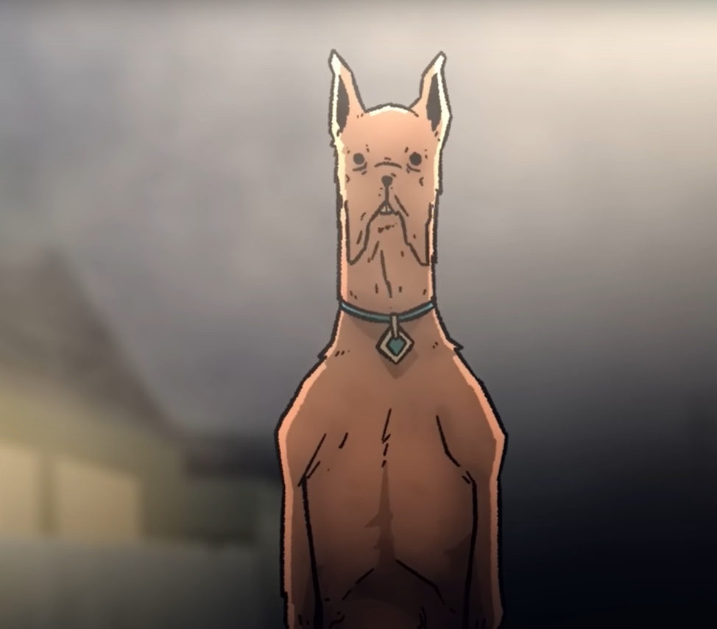
https://cdn.discordapp.com/attachments/1035409757734961202/1097364502074372266/image.png
It stood like a man, its eyes twin pools of eternal darkness, its body more real than everything around it, yet, at the same time, it was horribly, h̶̩͂ō̷̩r̵̖̝͒̂r̵̈́͜i̵̪̤͌̐b̷̞̺̀l̴̰̦̆y̵̛̱̽͜ W̴̯̥̿̾̐̈́͒̎͝r̴͎͙͇̉̌̄̔ơ̶͚̝͕͎̩̦̙̠̇͌̃̋͊͝n̸̘̯̪̤͉̓̐̂͂̈́̍̚g̷̜͙͍͉̙̪͆͜ͅ.̴̛͖̯̺̓̽͑̇͊͠
ScoObY dOo stared at them all, as they floated in the air, along with Fred, and Velma, who was Indian for some reason. “WheRe diD You COme from?” it questioned, regarding them all. “yOu. YoU are noT supPosEd to Be Here. You Are iNterlOpers. InterFering. Why Are you InterFering? WhAt did yoU do to FrEd? He iS moRe, mOre reaL, buT he, he Is nOt FrEd. He iS noT-FrEd. He ShouLd Not be noT-FrEd!” it accused, bearing rotten, crooked teeth, glitching, body blurring, like an out of focus television, before snapping back to normal. “What hAve You donE to FrEd!?”
“I’m sorry,” a voice said, perfectly calm, and, with a sound like shattering bone and rending gristle, ScoObY’s head snapped over, and Capbie realized it was Ken who had talked. “We were not aware this location was yours. That said, if you could explain what your issue is, perhaps we could help?”
She could barely move her eyes to see that, yes, Ken was talking, unbothered, while still splayed out like starfish, floating in the air like the rest of them.
From one moment to the next, iT had teleported, towering over their Ken, even with him floating, the parody of a dog nine feet tall. “YoU thInK you cAn helP? YoU tHink yoU can Do whAt I havE noT?” The Outsider sounded equal parts confused, annoyed, and amused.
“Well, we are interlopers, however accidental our doing so may have been. It is quite possible that we have knowledge, or talents, that you do not, though, as is obvious, your raw power here vastly outstrips our own,” the man stated with bland confidence. “That said, if you allow me to move my arms, I will remove my helmet, so that we may converse more freely.”
The Ken was slowly lowered to the ground, and just as slowly reached up, removed his helmet, and tilted his head iTs way in thanks. “Now, something has clearly gone wrong, before our Agent ever arrived. Would you mind sharing it with us?”
“It iS heR. VelMa. She RemEmbeRs. She aLways RemEmbeRs,” iT intoned, head snapping over to regard the girl in question. “WhY doEs She aLways RemEmbeR? And It is gEtting woRSe. She iS RemEmbeRing fasTEr.”
“Okay, remembering what?” Ken questioned.
“Our fIrsT adVentUres. We would go solVing mysTerIes toGether. It waS simpLe. Fun. But sHe stArted OVer-cOmplIcaTing thiNgs. WonDeriNg wHy I coUld taLk. TuRNing the othErs AGainst me. And sudDenly… the fun was over,” iT stated, with eldritch melancholy. “So I toOk whaT reMAineD. And I RebUilt tHem alL. I RebUilt the woRLd. AnD we werE back tO ouR clAsSic adVentUres. But sHe starTeD to RemEmbeR. AgaIn. And AgaIn. And AgaIn. I jusT waNt what wE hAd. Yet eacH tiMe I captuRE leSs of ThEir EssencE. This BeiNg mY moSt flaweD woRld yEt.”
“Oh,” Ken nodded. “That makes sense.”
“WhAt!?”
ScoObY’s head snapped back, flesh tearing and twisting, though iTs hide remained intact. “YoU Know whAt is hapPeNing?”
And Capbie was as surprised as the Outsider in the poorly-crafted shape of an upright Great Dane, because she had no idea what was going on.
“Oh yeah, but we’re not going anywhere anytime soon, so we can workshop where things went wrong, and go from there,” the man smiled at the glitching creature, undisturbed by its twisted image. “But first, can you let the others at least stand? You don’t need to let them speak, probably best if you don’t, to be honest, but being held like that is mighty uncomfortable, due to bodily weaknesses.”
The alien being stared at Ken for a long moment, before it nodded, once, and everyone dropped to the ground. “There, nOw, whAt is The isSuE?”
“First,” the man said, looking to her, “Capbie, I’m in charge, so you and the others stay tight. You don’t know what you’re doing here, and you may give offense.”
And you do!?! the Barbie thought, but, apparently he did, as he nodded to her, glanced at the others, and turned back to the creature.
“So, the first issue is that Velma, Conceptually speaking, was made to solve mysteries, correct? They all were, though in different ways, but hers was the path of logical connections, right?” Ken questioned.
“…Yes. How dO you knoW thiS?” it inquired, intrigued.
“Because I watched your adventures growing up,” Ken replied with a shrug, that made the Being go still.
“wHaT.”
Opening his hands, the man said, “Everything we do sends vibrations across the Multiverse, and some can pick those up. I was a child when yours first met my world, so I grew up watching your adventures. They were very enjoyable.”
ScoObY tilted iTs head. “If YoU kneW, why Did you ASk what hapPeneD?” it questioned, with slight accusation in iTs warping tone.
“Because what happened was likely such a break from what normally did, those that perceived it probably thought they just had a nightmare,” Ken sighed. “Then, when you remade the world, and they picked that up, they thought they were seeing an alternate version of the same dimension, not the exact same one, just after it had been reworked, so extensive and complete were your changes. But, that brings us to the core problem, Scooby. Your very existence was a mystery you wanted to keep secret, and you were travelling with people who specialized in solving mysteries.”
The Outsider frowned, and when iT spoke, iTs voice almost sounded petulant. “But I waNt to Be thEre!”
“Oh, you can,” the man smiled, unruffled in the pants-wetting face of the Tier X+ Being’s displeasure, “but the issue is you’re approaching this from the wrong direction. You used human souls as the basis for every player in your adventures, right? Not just for the humans, but the animals too?”
“I diD. WaS I noT supPosed tO?” iT inquired, unsure.
“No, that was fine. Smart, actually, as it made the intelligence you displayed not particularly out of character,” Ken reassured the Not-Dog. “The problem is that you panicked when you were found out, instead of adding a few layers that they could then ‘discover’ that would explain it. Maybe a magic spell gave you extra intelligence, as, if you claimed to be a human in a dog-like body, your friends would want to ‘free’ you, while this way they wouldn’t want to mess with it, lest they lose their friend! Or maybe you could layer in something where you were part of a secret government program, to make canine soldiers, but you didn’t want to hurt anyone, so it was discontinued, and you snuck out! Or, well, any of a dozen different things. Up until that point you did really good work!” he smiled, hesitating, before reaching out and patting the eldritch abomination on its furred shoulder.
The look the creature gave him was almost… vulnerable, and Capbie, despite herself, thought that they might actually be able to survive this. “ReALly?” ScoObY questioned. “But, wHen thEY finD the truTh, thEy nEVer apPrecIatE iT.”
The man winced, “And, unfortunately, they probably never will, not without some extreme Tonal Shifts along the way, to prepare them for the revelation. But yeah, watching your adventures as a kid, they were so happy, and safe, and wholesome.”
The unnatural dog nodded. “But wHy do theY keEp RemEmbeRing? It hapPens sO Fast noW. And THey are so, so tHiN. Like ghosTs. TruE ghosTs, inStead Of meN in shEeTs.”
“You lost control that first time, right?” Ken questioned softly.
ScoOby nodded.
“And your domain is not souls is it?”
The Outsider stared at the man. “It iS nOt. But The wAy YoU speAk. YoU kNow of One who posSeSs suCh a MasTeRy?”
“I can put you in touch with her,” Ken smiled. “She mentored me.”
…what.
A few things suddenly became a lot clearer to the older Barbie, though, if this Ken had received that level of instruction, then how, by all that was Pink and Holy, did he end up as a Ken?
“That is wHy YoU do Not screAm?” ScoObY questioned. “Do nOt ruN? Do Not StiNk of rAnk Fear likE youR coMpatRioTs?”
“Probably,” the man shrugged, smiling. “Anyways, as to why they remember faster, when you put them back together, when you had less of their… essence, you needed to replace it with something, just like how, when you re-crafted this world, you tried to make it, shall we say, more to correct the flaws you thought might have caused the initial problems, am I correct? That is why magic became more and more of a thing, when originally it was entirely mundane, and, possibly, some of the anti-violence Universal Laws started to fray?”
For a long moment, the Outsider stared at Ken, and Capbie tensed, wondering if he’d said something wrong. Finally, after several long minutes, it spoke, with a sense of burgeoning understand. “YoU aRe CoRRecT. ThIs iS a KnoWn FAILing?”
“It’s documented, yeah. Thing is, if you’d done it carefully, you probably would’ve been able to slowly introduce them to the concept of the real you, or at least an aspect of it, as the more used to the strange, the unknown, and the eldritch humans get, the easier it is to have them take the next step down that path,” he revealed. “You don’t want them to lose their essence, but human souls have the capacity for growth, and, had you mixed in a bit of yours into their slowly, they would be more accepting of it. It would not be a smooth process, but it would be possible.”
“I, I hAve seEN tHis. I triED thiS. MadE tHEm yoUnG. So they coULd grow. They Did nOt miND me talKing tHen,” iT slowly nodded. “I hAd thOugHt I haD fOUnD thE SolUtiOn. But it Was thE sAMe, in ThE enD. VelMa noTICed. Then RemEmbeRed. And tHEn it aLl caME aParT.”
Ken nodded, laughing fondly, “Yeah, we called that series ‘A Pup Named Scooby Doo’, and it was pretty great too. The issue you were having was because you were using a masquerade-setup, again with your existence only one layer deep, along with a memory rebuild, instead of true Akashic Removal. You did the best you could, Scooby, with what you had, but, when they broke through the veil of normality, they had enough of your essence to pull upon the world as you do, just a little, and resonate with their past selves, re-living your panicked loss of control.”
The not-dogs ears lowered. “BUt toO muCH is LosT. My, mY frIEnds Are GOne. TheY haVe leSs of thEMselVeS thAn eveR BefOre. If oNly I haD MEt YoU soOneR.”
“And if there was a way to undo this mistake?” the man questioned. “To, instead of working with these pale imitations, you could try once more with what you originally had?”
The guarded hope in the Outsider’s glitching voice was almost painful. “You hAVe this PowEr?”
“The people I work with can,” Ken told ScoOby dOo. “If you would allow me to put in a request?”
The Outsider quickly nodded. “Of cOUrse.”
Capbie watched as Ken held a hand out, and, in streams of mist and shadows, their Ken summoned an Agent’s smartphone. ScoOby dOo watched, fascinated, as the man flicked through the device with the ease of long practice.
She’d seen the device.
He’d used it countless times.
But why hadn’t she paid it any mind.
Why hadn’t Capbie paid it any mind?
Oh, right, they were designed with the Conceptual ability not to be seen as odd.
And it’d worked on her, just as intended.
Who. The Fuck. Was this guy?
Ken called someone, smiling as he said, “Hey, Psyche? Yeah, it’s Lee-385492. So, I ended up, oh, you heard about that? Cool. Yeah. Well, you see, our max Tier five rated team found a possible Tier X client. Yes, an eldritch world-creating Scooby Doo. Nice fellow. A little lost. Also, Velma’s Indian now? Dot, not Feather. Oh! Must’ve been after I joined. And she’s… damn, he wasn’t joking. Well, we either found a Far-Realms-variant or the Primiest of Prime Dimensions, from which the others were all split, entirely by accident. This has happened before? For Scoob- oh, for Pokemon. Of course we did. That’s where Pokegirls… Huh. Okay, well, can you put me in touch with Sales, as I’m gonna need an original Scooby Gang, hold the Scooby, and in stasis for the client to examine, standard display protections. Nah, I can handle the pitch. Thanks! There’s a reason you’re one of my favorite instructors!”
Wait, one of his favorite?
A moment later, beside Ken, or was it Lee, four large crystals appeared, floating, each one holding a member of the Scooby Gang, seemingly as defined as she and her team were, as opposed to Velma, and ‘Fred’ who seemed... blurry.
In an instant, ScoObY was in front of the one containing Shaggy, reaching out a clawed, twisted limb, as it breathed, “TheY arE… GloRIoUS.” The crystal shone with a ripple of light. “But wHY caN I nOt toUCh theM? I wANt tO toUCh theM!!!”
“Because we’re making a deal, and you need to be carefulm Scooby Doo,” the man lightly reprimanded the Outer God. “You weren’t before, and it caused problems. You’re no longer alone in this, and a bit of prep-work will pay off for years, decades, even centuries.”
And, miraculously, the being of unfathomable power backed off, nodding to the not-Agent.
Ken? Their Ken turned to ‘Fred’, who was staring at the proceedings. “Okay, Agent, you either screwed the… cat,” the man corrected, glancing at the thing in the shape of a dog, “or placement screwed up, badly. Now, as I’m sure you don’t have the extra protections needed, I’m going to need to use your interface. Is that alright with you?”
‘Fred’ nodded, terrified.
Which was completely understandable.
Their Ken took a step, but didn’t go anywhere, turning to the Outsider, pointing to their Agent, the not-dog nodding, and his next step moved him, until he reached their objective, and Capbie wondered if he was going to try and grab the man and run.
“Okay, so, you’re gonna need to take out a loan and buy the nice, kind, patient Eldritch being a replacement Scooby Set. You can choose a safe world with a good bit of talent after this, earn that back, and create enough Dimensional Variance to open a gate to go where you want to go. Is that acceptable?” the man questioned kindly, like talking to a child.
The Agent tried to respond, but made no noise, so nodded. Furiously.
In turn, their Ken reached into ‘Fred’s’ pocket, pulled out his phone, and did something to both of them, the crystals chiming, one after another, and then he returned the other man’s device. Then he walked right back up to ScoObY dOo. “Alright, and, there you go. Our apologies for this interruption Scooby. We’ll be taking our man and going, but,” he tapped something on his phone, and a card appeared above it, which he caught, then offered to the Outsider. “Here’s my card if you have questions. With the Company worldbuilding number contact there. Just mentally concentrate on it and it should open a connection for you.”
But the being made no move to take it, instead staring directly at the man. “YoU… yoUR EssencE iS… stRANge. YoU do nOt bleEd iT, but YoU streNGthEn iT in OtheRs. I wOulD haVe yOu STAY.”
Oh Fuck.
Capbie stood, frozen, and wondered if she’d lose another Ken, not the trash, but another of the ones that deserved the title. They were rare. Very rare. But they existed. One had carried her through the Continuity War, and she had loved him with all her heart, Shotbie having to drag her through that portal, because she was going to stay there with him.
There had been others, a few she’d come to care for.
But they died.
They always died.
And now, she was going to lose another.
On his third mission.
And there was nothing she could do. Other than what she’d done before. When she’d fallen apart, after the War. Blastbie and Shotbie had sat her down, and convinced her to help the other Barbies that come their way, that would need their help, just like they’d needed Ken’s help.
It was why she’d turned down retirement, why Shotbie was going to, and Blastbie would’ve, except she had sacrificed her life against an Outsider. Not one quite as strong as this one, but close enough.
But Ken, Ken was still talking. “I merely possess an ability that others possess as well,” he stated, but it was clear that this Outsider did not care. One in the hand, versus two in the multiverse, after all. “Also, while I wouldn’t mind talking from time to time, I am by no means an expert, and me and my team have others to help.”
That statement, delivered with utter certainly, took the Outer God back. “TheRe arE otHERs… lIke mE?”
“Many, many more,” the man reassured it. “Now, may we have your permission to leave? There are others that require our assistance, and never enough time to help them all.”
Capbie held her breath, waiting, watching, hoping.
“…You wILl anSweR, wheN I caLl?” ScoOby dOo inquired cautiously.
“Not necessarily right away, as I will be busy doing my job, but yes, I will, Scooby,” the Not-Agent promised. “You have my word.”
The statement was heavy, carrying with it a metaphysical weight that literally rippled through the misty air, and, ever so slightly, the Outer God smiled.
And they could move.
“Then yoU mAy leAVe. And yoU haVe my tHAnks,” iT informed them, iTs look turning tired, yet full of catharsis. “I haD… wOrRIed thiS was EVer dowNWarD. EVer spiRAliNg. UnTIl nOthiNg buT shaDowS aNd twITCHing fLesH rEmAIneD.”
Stepping up closer to the Outsider, their Ken rested a hand on its shoulder, giving it a reassuring squeeze. “Hey, the Scooby Gang solves mysteries, helps people, and does the right thing. I’m happy to return the favor for such a good person, Scoob.”
Stepping away, their Ken put a finger to his lips, pressed a horizontal hand down to have them keep things low and calm, and pointed to the portal out, walking over himself and placing a restraining hand on ‘Fred’s’ shoulder to keep the boy from bolting. Directing their target around the corner, their portal now hung at the end of the world, the asphalt behind it gone, leaving an endless expanse of mist behind, and below it.
Their Ken made sure that everyone else left first, Capbie going second to last, and, on the other side, found the music that had been constant in that place was blessedly gone, while her team was a mess, all of them having removed their helmets, which were scattered across the floor. Newbie was crying, slumped against the wall, Snipebie and Boombie were holding onto each other, knuckles tight, Medbie was shaking so hard that it was only Shotbie’s firm grip on her that kept her upright, the normal jovial amazon’s expression tight, her full lips a fine line, and Capbie herself was barely keeping it together, as she shakily removed her helmet, dropping it to the ground.
Their Ken followed a moment later, having to carry their target, who was silently bawling, the teen then surprising himself with the noise he created as they stepped across the threshold.
Turning on the mysterious man, Capbie demanded, “WHAT THE HELL WAS THAT!?!”
The man ignored her, calling out, “Close the Portal. Mythos Defenses. Authorization WASFS-X”
Behind him the portal snapped shut, and a red light appeared over the gate, turning green a moment later.
Their Ken lifted a forestalling finger her way, before she could repeat her question, gently put ‘Fred’ down, the boy shaking and crying, and stepped away, taking a deep breath.
“FUUUUUUUUUUUUUUUUUUUUUUUUUUUUUUUUUUUUUUUUUUUUUUUUUCK!!!!!!!!!!!!!”
The sudden scream, full of frustration, fear, and rage, shocked everyone else for a moment, and, oddly, seemed to help?
It was actually comforting to watch the seemingly unflappable man take several, shuddering, gasping breaths, hunching over, clearly trying not to vomit from stress, but, less than a minute later, he stood, covered in sweat, and ran his hands up over his face, slicking his hair back with it, but otherwise mentally together.
“Okay, Okay, yeah, not the first Tier Y Being I’ve met,” he remarked, seemingly to himself, not quite together yet, “but, Holy Shit I didn’t expect that, but, Holy Shit, I’m glad I took that goddamn Seminar now! I really need to do something nice for Steven. Well, I guess I did. Eh, still gonna do it.”
Capbie marched back up to him, “Ken, what the hell is going on? You know a Goddess? You, you have multiple powers? What is going on!?”
The look he sent her was confused. “…Yes? A ton of them taught the Seminars in Basic. And, I mean, of course I have multiple powers. It’s in my Contract.”
She stared at him, unable to say anything for a long moment, finally yelling, “YOU HAVE A CONTRACT!?!”
Ken looked at her, then at the others, who were all staring at him, rightfully shocked, except for Newbie, who didn’t know any better and was just looking confused. “Okaaaay,” he said slowly. “I feel like I’m missing something here. Is that not normal?”
“No!” Capbie yelled, knowing she wasn’t being professional, but damn it they’d almost all died there! “it isn’t! Kens get one power! One! And it’s almost always some sort of ‘sex’ thing! And Kens? They’re washouts! Washouts don’t go to Basic like Agents! And… and you talked that thing down! And then you fucking networked with the Tier X Outer God! What kind of fucking Class C Recruit ARE YOU!?”
The man stared at her, not lost, not cowed, not anything other than nodding slightly, like he was calmly taking everything in. “Oh, well, in order, so, I’m not sure about the normal way you get Kens, but I have a contract, Unknown Power, and every five missions I get another Rune. There was an option for a ‘good at sex’ power on there, [Nuzzle], but what kind of dumbass working a military job wastes their limited slots on something like that? I went to Basic, because all Agents do, and that’s what I am. Oh, and I’m not Class C, I’m Class B, the Fey, originally. I got traded, and then took the offer to give up the Premium Contract and take this job in exchange for getting the rest of my Squad saved from the Knights of Continuity. They jumped into our Final Exam and grabbed them, to use them to track down other versions of them and try and collapse their dimensions as well. Resurrection would’ve been cheaper, actually, but you can’t resurrect people if they’re still alive, so that cost… a lot, but Stacy and the others didn’t deserve that shit. We even convinced the hippy to take a safer option, not that it helped, and, well, it doesn’t matter, but they’re safe, and now I’m working here to finish paying off my debt.”
Capbie stared at the man. The kind of person she’d spent years extracting, and it still did not compute. And then she realized: You save Agents that have failed, and would’ve died. What part of this man seems like he would fail. “So,” she stated, voice thin, and a little strangled. “You’re an Agent.”
Ken nodded. “Yes.”
“And you had the Premium Catalog?” she checked, as, to get those, you didn’t just need to pass, you needed to excel.
“Also Yes,” he nodded simply, as if that wasn’t a big deal.
The battle-weary Barbie started at him helplessly, finally asking, “Why didn’t you say so?”
The look the man sent her was cold, in a way he hadn’t been to even the Eldritch Abomination. “Because while my name is Lee, but I’m your ‘Company-issued emotional support Ken’, apparently.”
That was harsh. And absolutely fair. He’d asked questions, but she’d just blown him off since, like hundreds of others, she hadn’t expected him to live through the month, so didn’t want to waste her time on him.
Hell, did she even see him as a person?
Would that be the kind of person your Ken would want you to be?
The thought struck her as hard as all of that bullshit with the, the ScoObY dOo, had. “I’m… I’m sorry about that, kid,” she told him, meaning it, then hesitated. “Wait, how old are you?”
“Probably older than you, since we didn’t age in Basic, I spent years there, and [Bear] will actively de-age us until we hit optimal age, so twenty five, like Everlasting Talent on crack,” he smiled, kindly nodding at her apology, and accepting it. “But don’t worry, when it comes to tactics, I’m well aware that you know way more than I do. That said, maybe we should actually follow the Org chart, since I’m not a complete moron? You take care of the team, and drop off Fred, while I go have a… chat with our superior officers.”
This time, his smile was all teeth.
Capbie blinked at the rapid turnabout, getting mood whiplash. “What about?”
“Well, some absolute fucking dumbass sent our Tier Five max squad into a Tier Nine fire-zone, possibly Tier TEN, and I’m gonna go shake some trees to see what kinds of goodies drop out, willing to kick this up the chain as far as those office-dwelling bitches make me. Sound like a plan?” he asked her, with a tightly constrained, but almost feral anger to his tone, but one that she, intrinsically, knew wasn’t directed towards her. “Anything you want me to try and secure in particular? Better weapons, and maybe some minor powers, obviously, but anything else?”
You want to get us powers? she thought, dumbfounded, finding herself saying, “Uh, the Huey’s getting a little old?”
“Transport, gotchya,” Ken, no, Lee nodded. “Hmm, I wonder if I can get us a Drake Cutlass. Well, time to go do my part of the job. Seeya later, Capbie!” he offered her with a playful salute, turned on his heel, and walked out of the Gate room.
They were all silent for a long moment.
Looking around, her team had, surprisingly, recovered, and, while lost, and still distressed, were looking to her for orders.
So she wouldn’t let them down.
Again.
Pushing away that thought, Capbie commanded, “Medbie, check the Agent and get him to Medical. Shotbie, go with them. That Outer God might’ve messed something up, as we know it wasn’t careful.” Looking at the other three, Snipebie was the most composed, thus the oldest Barbie directed, “Boombie, you get Newbie back to our rooms, and make sure she’s okay.”
Given something to do, the wild-haired girl moved to the younger version of herself, the new recruit, not even here for a single month before hitting a once in a decade event, still shaking a little, and thus was easily led out.
Then it was just her and the team’s sniper, the only one that hadn’t accepted Ken- Lee’s power, who walked up to her captain, looking as worn as the commanding noncommissioned officer felt.
“We were dead, weren’t we,” the younger woman quietly stated, not asking.
Capbie nodded, sighing. “Yes, yes we were.”
They both stood there, the sniper finally glancing the way Lee had left.
“That was hot as fuck,” the girl swore.
Sighing again, the experienced Barbie nodded.
“Yes, yes it was.”

AN: They didn’t go to Velma, they went Here.
Also, his CONTRACT.

