If there was one major flaw that could be identified in a man known to few as James Southerland, it would definitely be his fatal fascination for a good thrill. A yearning that had taken root at an early stage in life when he had been nothing more than a wee child in kindergarten and not the infamous man wanted the world over for crimes committed in the infinite stretches of cyberspace. A bona fide criminal who found little worth in the vast riches he had come into possession of besides keeping himself fed and ensuring his ‘command center’ was up to date with the latest tech on the market. Driven by a need to feel tested, these ‘crimes’ were nothing more than tests to James who had so far found little to be impressed with when presented with the pitiful defenses setup by the myriad organizations whose toes he had purposefully stepped on in a bid to find something that could give his masterful skills over the computer a challenge, skills and knowledge that rendered most firewalls and custom written pieces of code out there mute against his digital might. So again and again, he would try; throwing himself at big name players, niche companies, random servers and even complete strangers out there surfing the net in an attempt to find satisfaction. As if the globe-spanning cyberscape was his own digital playground.

But as the saying goes; There’s always a bigger fish out there. And in that ocean of algorithms and flowing datastreams, James would soon find the challenge he had yearned for all this time in a way he could never have prepared for. Especially for someone dabbling in a field as dangerous as James’, for no one could ever predict what the recipient of the trickster hacker’s attempts at fun might resort to if it meant having their revenge for the very real costs accrued by James’ cyber tomfoolery. Masquerading around the world under the guise of a bubbly blonde rendered in the adorable Japanese chibi style that was nothing like the man behind the screen was.

It began on a relatively normal night as things usually did. With James strapping into his desktop and starting things off with a quick scrawl through whatever he could get his grubby mittens on to pick out a good target. Except something was wrong on that Friday night, something major enough to ping alarm bells in the hacker’s mind when access logs began to appear in his intrusion network. A forced entry by an anonymous entity whose speedy progress was unlike anything he had ever seen; breaking through security measures and bypassing access restrictions at a pace that suggested whoever, or whatever this was, was good…maybe even better than he was! And the thought of such a thing would serve to send the ‘battle-starved’ hacker into a fervent frenzy, eager to compete against this surprise challenger even when startling changes begin to afflict James and his immediate surroundings while dexterous hands flew across the keyboard. Combating alien code and an inhuman response time displayed by this faceless foe as best he could even when his own distorting body threatens to hamper his efforts in the form of thinning fingers soaring way off-course as they became perfectly manicured twigs while sturdy forearms become supple and fair. Eliciting a series of warm, fluffy bouts of emotional ire within a rapidly compacting core gaining in curvature and heft as bony hips snap outward into attractive handlebars while a shapely torso slants in to form a healthy curve that emphasizes the natural perkiness of a rapidly growing pair of breasts jutting out the front of James’ chest as the growths swell past A’s to C’s in the span of an arid breath escaping puckered lips lathered in lipstick, popping into fattened cushions as the hand of an invisible fashionista passes over the now effeminate man’s attractive visage to apply a generous layer of blush over pudgy cheeks cleansed of freckles while a frazzled mop of brunette flowers into a well-kept mane of gaudy gold. Tumbling down to tickle the nape of a petite neck before magically doing itself up into swaying twintails, the tips of which forces the uncharacteristic giggle of a ditzy bimbo out of the usually quiet and melancholic James, looking less and less like a scrawny man and more with each passing second as tender fat and new organs bubble into existence within the man’s unrecognizable body.

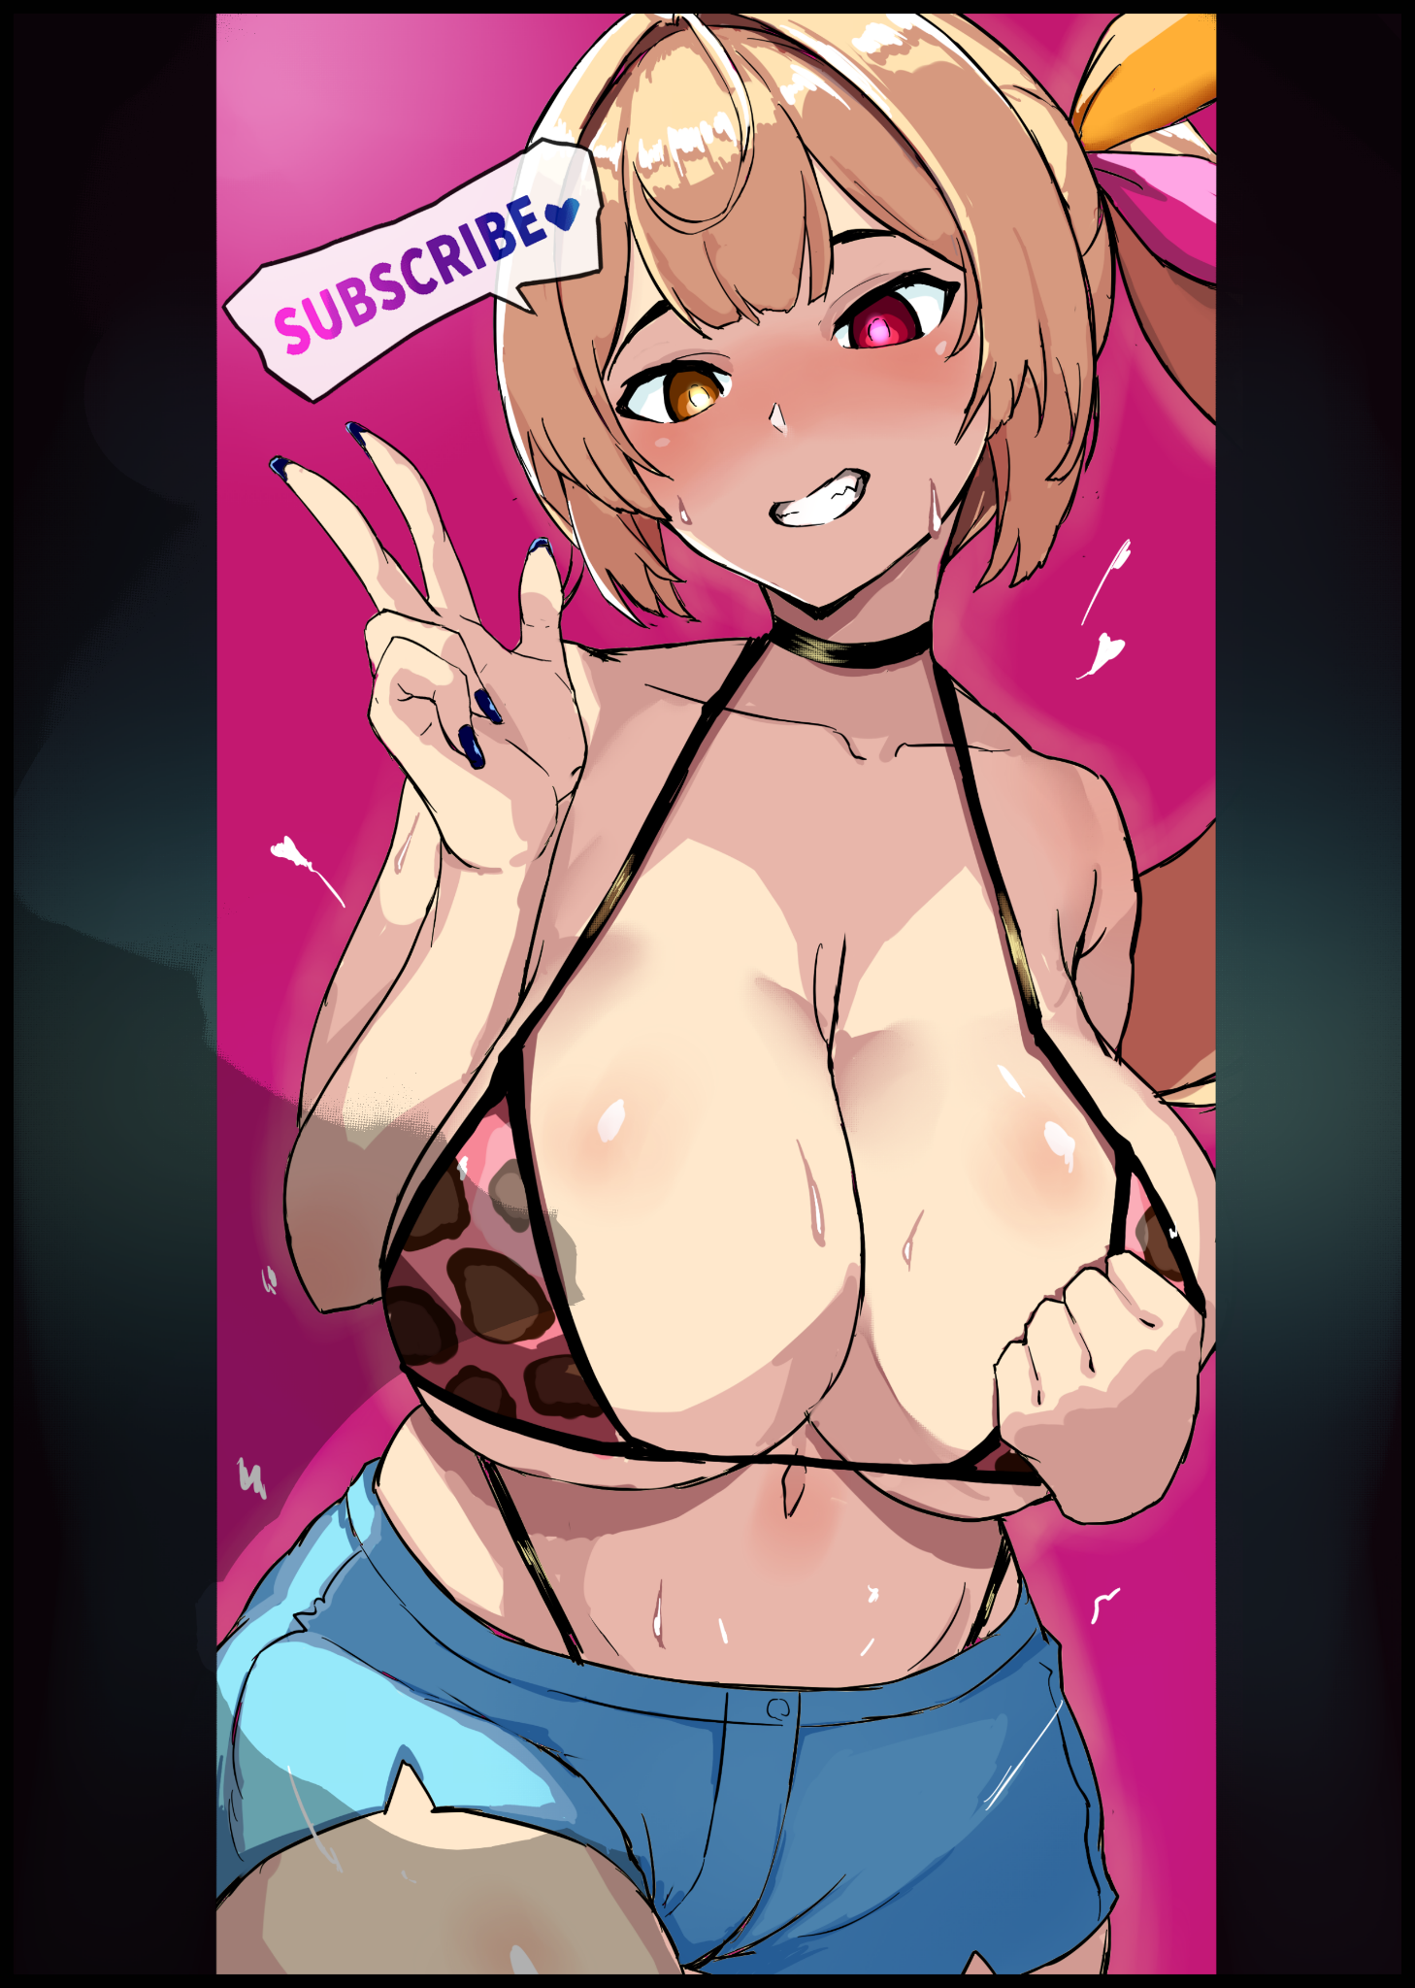
Or rather, it’d be best to say ‘what was left of him’, because try as he might, not even a skilled hacker like James could ever hope to overcome such a barrage. For every bit of new code he had barely a second to read and understand, an entire page’s worth of foreign words would enter the fray, undoing what little progress had been made in overwriting their supernatural effects. And when said effects began to eat away at the core pillars of his very being, all James could do was to delay the inevitable. Holding out even when a sweat soaked singlet morphs into a loose, unbuttoned shirt, allowing for swollen E-cups tipped with delectable strawberry nubs to come tumbling out onto the desk with a wet splat. Impeding slender arms that could no longer type as fast as they once did now that the muscle memory and motor skills to do so had been stripped from the hacker’s being just as effortlessly as the myriad memories of past cyberattacks, leaving plenty of gaps for a stream of perversions to fill. Vulgar memories that quickly do the rest in ensuring James Southerland’s permanent retirement just in time for a final change down between curvaceous legs to seal the deal as the unearthly moan of a wanton slut fills the air alongside a final alteration that sees the facial features of a Caucasian woman shift forevermore into those of an attractive Japanese babe’s. Complete with the slant eyes of a vixen beckoning those who would meet such a gaze with promises of a good time while a tight oral cavity would sing a song most depraved for the many who would lust after her nubile young form. Painting a smile on the newborn woman’s face as vapid, heterochromatic irises flare to life with estrus ire in usurpation of dull amber once a new purpose sets itself in stone over the old in that poor little head of hers. Barely able to remember she had been a victim of another hacker with otherworldly powers until she simply forgets, choosing instead to languish in a feverish daydream featuring a myriad scenarios wherein her emasculated form would be subject to all forms of sexual intercourse…and with each faceless man who would shower her naked body in bitter spunk…for every piping hot load pumped into her womb that would nurture her love for creampies…for every hard thrust of a cock ramming into the back of her esophagus until she could take dick without choking…the life of a criminal hacker who did what they did because they were eager for a challenge just seemed so very…distant…especially when compared to the much more realistic experiences of a Japanese youth who had dropped out of highschool and been disowned by her family for a life of blissful solitude once they had found out just how much of a depraved woman their daughter had become. Choosing to believe in that sinful lifestyle when there were still broken memories and vestigial feelings of the man she once was roaming around disparate and lost in the depths of her mind. Feelings like the one of acceptance and satisfaction at knowing they had finally met their match against a superior foe who had only won through magical means…

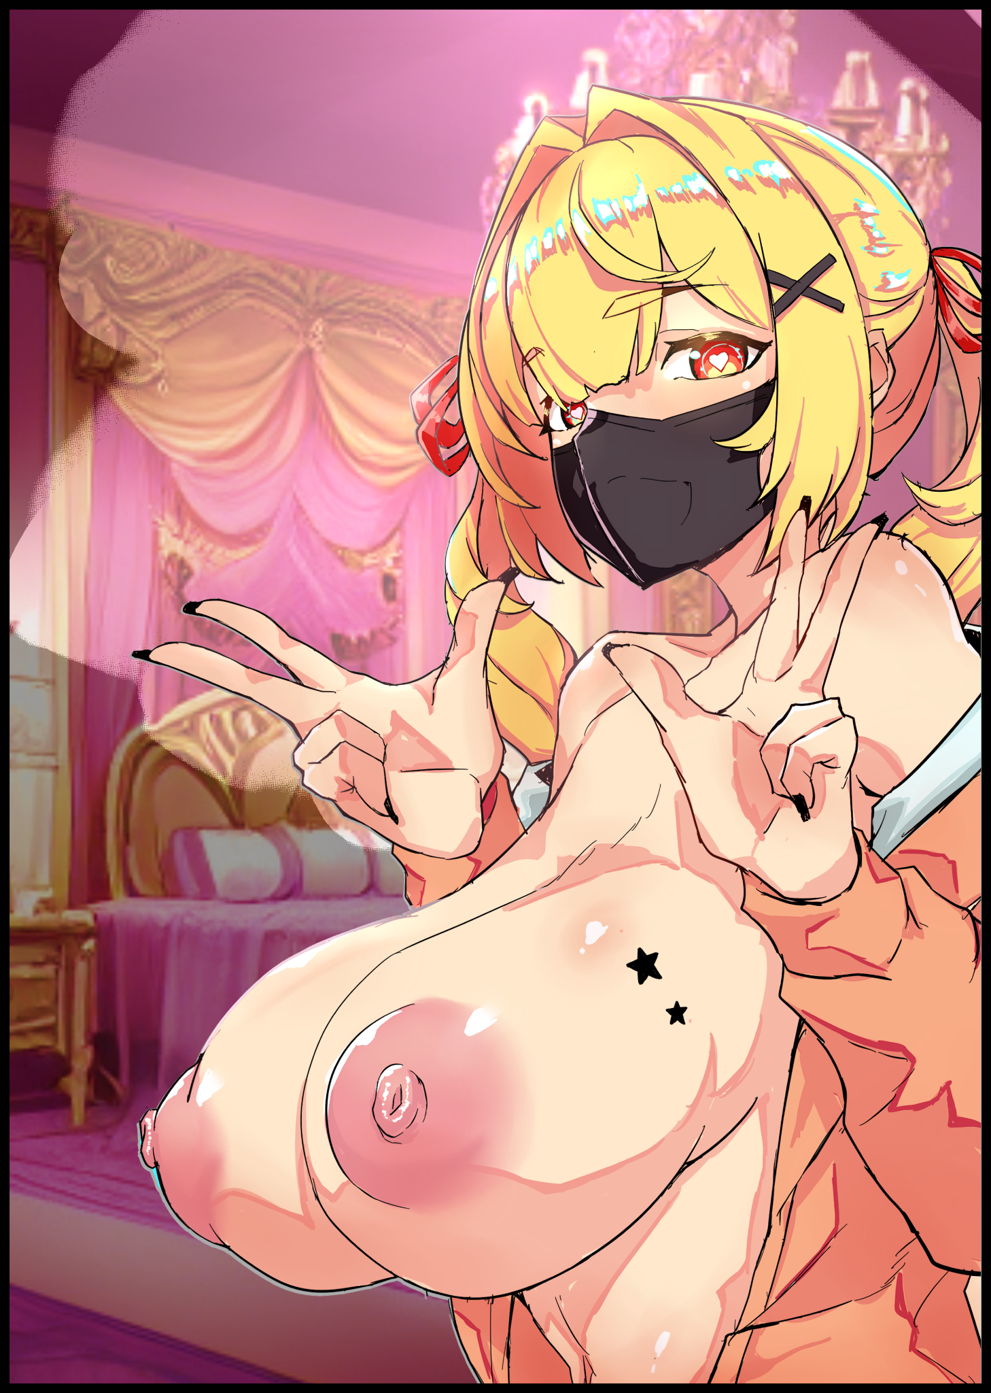
Although scant little of James’ original psyche would persist despite the drastic alterations made to both body and mind, it would do little to change the fact that she was no longer in control; helpless to resist the overwhelming urges and desires that now plagued her like a overpowering hunger, calling for the sinful woman she had been molded into to partake in degenerate acts her former self would never in the light of day be caught participating in willingly. Replacing a desire to be challenged with the overwhelming need for all her bodily orifices to be plugged with the veiny thing she once had not too long ago with an especially strong muscle cramp emanating from the tight, moistened chasm nestled below a warm tummy further enforcing this new eternal craving. Twitching in her seat as a voluminous derriere rubs into the leather with a rubbery squeak while titanic boobs lift themselves off the table just in time for an ordinary keyboard to shift into a rainbow crossed RGB accessory that paled in comparison to the purpose built model it had replaced. A negligible change in comparison to the major overhaul the rest of the hacker’s domain had undergone as if to reinforce the utter defeat of it’s Master who could no longer comprehend basic mathematics as seen when spastic hands could only produce gibberish as they mindlessly wandered across the keyboard now that the brief but fierce memory of a battle against an unbeatable foe had been all but lost to the blonde bimbo’s mind. Frowning as a clearing vision picks up on all the random sentences she had typed into the chat bar of her streaming channel for no apparent reason, muttering an apology to no one in particular in fluent Japanese just as naturally as a drifting hand would pinch and grope at an erect right nipple before returning to whatever it was she was about to do as an idle hand slaps a black mask over her face before reaching out to flick at a switch…

By the time the dark recesses of James’ basement had finished their own transformation into a lavishly decked out bedroom lit with high quality streaming equipment and furnished with resplendent objects. The birth of Izumi Kayako was complete, leaving only a buxom fox in the room, unable to feel even the slightest shred of remorse or shame at her predicament now that powerful mental compulsions and a new desire for all things perverse had clouded her mind. Keeping James dull and compliant as she begins the first steps of living out her new life as that of an E-girl who wouldn’t say no to anything if it meant a hefty sum of money being sent straight into her pockets like the big one attached to a letter in the pre-stream chat. The content’s of which seemed to instill within her a sense of…respect? No matter, she was happy, and that was the only thing she should be caring about right now…

“皆さん、こんにちは！あなたにとって唯一無二の存在であるイズミです！今夜は幸先のいいスタートが切れそうですね。配信開始から1秒も経ってないのに、多額の寄付が集まったんだ！それが何を意味するのか、おわかりですね~”
(Hi everyone! It's your one and only Izumi! Look's like we're starting off really well tonight huh? The stream's been up for less than like, a second and we've got a big dono! And you know what that means~)
And with the loud happy chime of a donation bell being rung, Izumi would hop right into business. Jumping out of her seat with a jiggle to her body and an energetic aura about her as she rises to full height. Not caring a single bit about her naughty bits being exposed for men the world over to ogle at as her body begins to sway and gyrate with primal ferocity, guided by a new knowledge base in carnal dances that emphasized the body of women in favor of grace and beauty in place of all the intellectual skills that had since been lost to her when the transition from cybercriminal to cyberwhore had been completed. Showing off her pliable ass to the camera before demonstrating the flexibility of her lithe body with a multitude of stretches done in an effort to show off her moistened flower between the nooks and crannies of shredded hot shorts that had replaced baggy cargo pants a long time ago. Leaving fair skin glistening with sweat and the heavenly thighs that came out of them exposed for her loving audience to adore. Producing a cacophony of chimes that made Izumi laugh with ecstasy, feeling her vagina quiver in shameless debauchery from all the money she was making just by prancing around her Tokyo apartment half naked…this was just unacceptable now wasn’t it?

“ヤイヤイ 最近、いずみんの調子が悪いから、みんなにいい番組を見せてあげるよ？だから、ちゃんと見ててね！”
(Hey everyone? Izumi's like, been feeling pretty bad lately so I'll give you guys a totes good show alright? So make sure you're watching!)

In truth, this was more to drum up a larger audience than to give her boys a freebie, but it didn’t matter much at the end of the day. Because there was nothing like relishing in the gratifying climax of being watched by a thousand sets of eyes while a leg would be raised sky high after freeing the clasp holding her loose pants together, giggling at the flurry of adoring messages filling the screen of her laptop as men watered at the mouths, begging for her to play with the puckered pussy she was showing them all with unabashed delight. Wanting to do so as well, but holding off until the man who had sent her that large sum of money at the start would come knocking at the door as he said he would in the message she could only remember bits and pieces of thanks to her scatterbrained persona being a terrible memory sponge outside of anything not related to sex, something she could not wait for as her juicy vulva shivers in anticipation for a mighty rod to fill it’s empty depths.
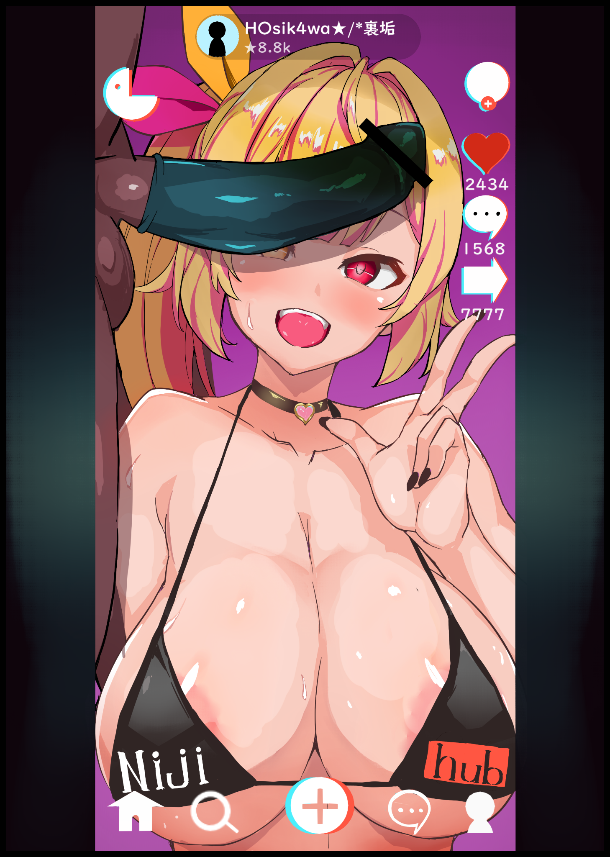
Fueled partially by the acceptance of his loss and a displaced sense of longing to know who had beaten him, Izumi, inheritor of James’ will, would find herself enamored by the man who would greet her at the door as she opens it for him when the time inevitably came for the subscribers-only segment of her stream. He was massive…a herculean beast of a man. Handsome too…but the sight of him made the big breasted gal’s heart skip a beat as she ran her delicate hands over his chiseled abs while meeting his gruff greeting with a soft spoken sentence uttered in broken English. She wasn’t afraid…not intimidated by the least too, and he could sense that . Realizing what Izumi had been struck by as he passes her a new set of titillating attire to change into, the unseen victor whose wide-set shoulders and burly face would never be seen in the camera, moves close alongside the nubile woman, fondling her tits to help them along into a rubbery bikini top while giving her pussy a good tease with a magnum train pistoning in and out between juice-slick thighs. Ending it off with a rather harsh grip around Izumi’s neck that only makes the girl produce a drawn out moan once a heart tipped choker fastens itself around her neck…

By the time the pair would settle down in front of the camera, a rubber would already be loose and secured between Izumi’s teasing lips. Preparing herself for a maneuver her new self could remember pulling off on more than one occasion as she falls to a squat…hands braced on spread legs…planting a loving kiss on the tip of her man’s dick...before aggressively thrusting her head forward, swallowing it’s impossible length with a throaty *UGLURK!* that sends the stream into a frenzy as they observe their Goddess’ erotic display, taking screenshots of the massive bulge spanning the entirety of her fragile neck and the following stream of spittle precum that dangles in the air once they separate after having successfully applied the condom with one swift thrust. Hiding another trickle down below as the euphoria of it all serves to coax a stream of ejaculate out of Izumi’s lustful snatch, eager to feel the same way her throat had as she turns to face the camera, struggling to keep her gaze focused on the lens when that stupidly big, delicious dick was hanging inches away from her face, close enough for her to smell as perky nipples harden in response. A sight that pleases the man greatly as he rubs Izumi’s head with the gentle kindness of a lover.

He had been expecting some form of resistance, or even a relapse. But seeing Izumi as she was right now only served to make the mysterious man soften up and lower his guard, knowing that the job he’d been paid to carry out was done and over. Giving him plenty of time to stop, rest and enjoy the fruits of his labor now that James Southerland, wanted worldwide for his mischief, no longer existed to bother anyone else ever again unlike Izumi Kayako, whose ‘services’ had kept men (and even some women) the world over satisfied…

THE END

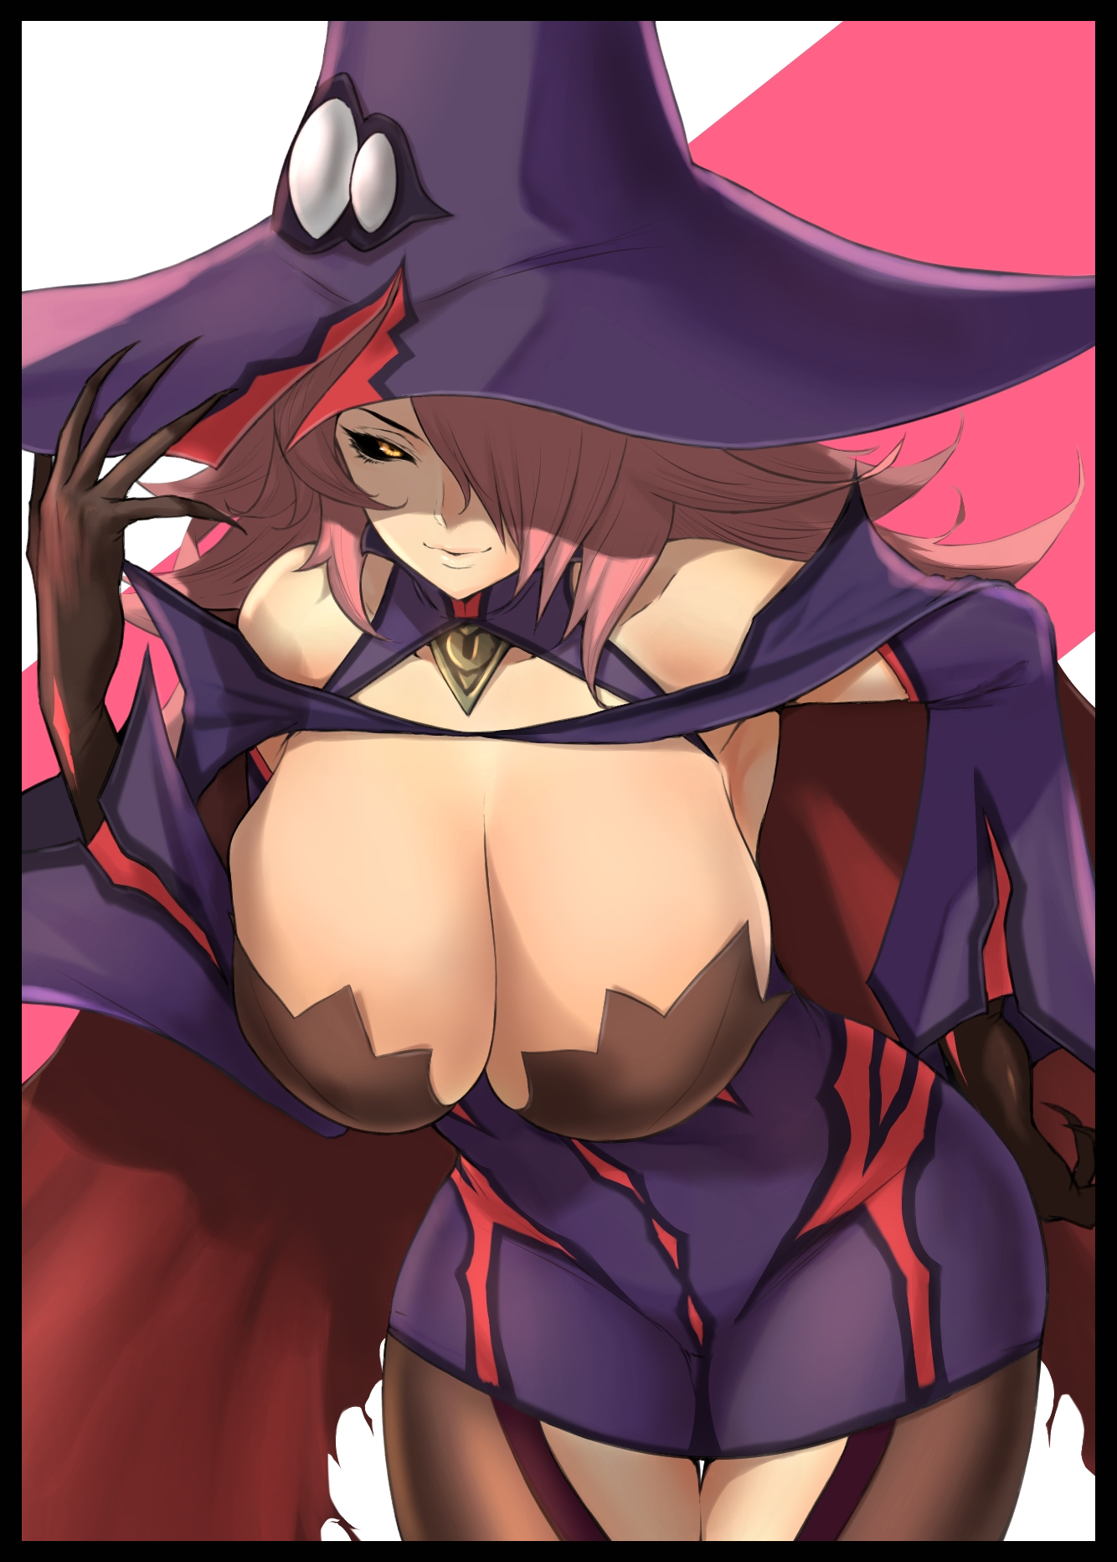
“My, my~ Who exactly do you take me for O great Hero? Was it not you who agreed to the terms we set ? The peace we brought for our people? If you still think me to be a devious, backstabbing goblin, feel free to call an end to the truce. Then we can have that rematch you keep pestering me about. Just think; you’ll get to relive all the times I sent you and your sorry mob packing with a fire to your good-for-nothing bums! Doesn’t that excite you?” Beneath the secluded shade of an exquisitely crafted gazebo stands a stoic man fully suited in gilded armor and a significantly taller (and well-endowed) woman trailing ethereal wisps of magic miasma as she strolls around her companion, adorned in witchly raiments that compliment her brooding disposition nicely as word after taunting word continues to pour forth from a mischievous maw. “You’re awfully stiff on this fine morning Hero~ Has your mistress not loosened the leash at all? That’s awfully strict of her…maybe after this meeting is adjourned, I could help you…loosen up a little…but not out here of course. Word would spread dreadfully quick if people were to see the great Wilhelm himself begging for his life~”

While the rivals apparent continued to feud amongst themselves with a small retinue of confused knights serving as quiet bystanders, another listener would crack a smile over what he could hear a great distance away from the commotion as pointed ears twitch while fanged molars reveal themselves in the form of an amused grin. A look that does not go unnoticed to the human woman sitting before him on the opposite end of a round table laden with warm tea gleaned from the finest leaves and an assortment of simple foods churned out from the Kingdom’s most talented chefs; a breakfast fit for royalty. “Does something catch your interest Milord? You seem awfully peppy today…”

“Hmph, you insinuate a foul temperament as my default mood? I see you’ve inherited your mother’s sharp tongue…but do you have her spirit I wonder? To back the words you proudly proclaim?” A moment of silence passes over another peculiar duo, contrasting appearances as presented by a flowing dress of snow white wreathed around the fair lady and her abnormally tall guest; towering over all with a muscular frame emphasized by a skin-tight weave composed of menacing spikes and organic hide that comes together to give the appearance of a regal beast. Complete with lengthy ears that come to a point alongside irises of fiery red burning like coals in darkened sclera as they narrow in on his gnomish host with analytical precision as if daring her to say something. An unspoken provocation the human woman was nonetheless happy to oblige. “I don’t know if I’ll ever be able to stand on the same level as Mother…but I do know this; I’ll aspire to my own ideals one day. I don’t mind constant comparisons, but if you see my Mother in me, I’m sorry to disappoint…as for the assumption, let’s just say it’s an inkling of suspicion. Your ears don’t betray you, yes? So that must mean you hear them clearly…does it not concern you that they might start something?”

“Hah! Astute as human capability goes…my wife may be unruly…and a little on the whimsical side, true. But she won’t strike out on her own, not without good reason at least. I should know best after all, she was the one to tame my heart…and who knows? Maybe even you might find someone you can trust and confide in one day…” Sighing before another sip of tea runs down her throat, the Princess turns to join her daemonic guest in looking out towards the distant gazebo with an endearing look. “I think I already have Milord…”

With the bi-weekly processions between human and demonic royalty going along nicely, all seemed fine with the world beyond the castle walls as the denizens of both sides continued to live idyllic lives of cooperation and everlasting peace. Building continuous connections between them despite their fundamental differences many had learned to put aside a long time ago when the haze of distant battle was a constant in place of clear blue skies, where passing wyverns had instead laid waste to hapless settlements far beyond the outskirts of the Kingdom’s capital where defenses had been stretched too thin to effect a rescue.

Humanity as a whole should’ve been razed by now, wiped off the face of the Earth entirely. But they hadn’t, all because of the intervention of a certain someone whose efforts to bring an end to the hundred year war had inadvertently led to peaceful coexistence between Man and Demon…

Had things gone according to plan, it was supposed to have been the Demons that would see themselves being scoured from existence instead. A fitting outcome to many, who had seen loved ones and friends lost to the monster’s cruelty, wishing nothing more than to see them all gone. A desire shared by a wizened old sorcerer known only by the title of Morlok after his claim to fame in the titular battle that had given him said title, using it over the one he had been given at birth after a tragedy had seen the loss of his entire family. An all too common tale in the war torn lands of yesteryear.

With an indubitable reputation and a vengeance that demanded fulfillment, Morlok would soon join the Hero’s ragtag group in attempting to staunch this hellish invasion at the heart by claiming the head of the Demon King, killing their leader in the hopes of dealing a major blow severe enough to cripple the Demon’s morale and chain of command after coming to know of the in-fighting between commanders and their subordinates, who would no doubt slaughter each other to the last in an effort to claim the throne once they knew their leader had been slain. A fool proof plan that would work, if only the task of bringing down the ruler of all Demons had been easier said than done.

The Heroes party would predictably struggle to even land a hit on the powerful creature who, unlike his minions, lacked their beastial qualities, yet seemed far stronger to make up for the absence of rending claws and gargantuan extremities with which one could use to pound the opposition into dust. An omniscient terror the humans could not hope to overcome through a head-on battle.

That was when Morlok had unveiled his trump card; a spell of primordial origin. One so strong it would most certainly obliterate anyone and anything, even the Demon King himself for certain. And because of its one-use nature and how easy it would be to backfire, the wise sorcerer had seen fit to keep his life’s work a secret to all, even his companions amongst the Heroes party. Who, like the enemy, was just as dumbstruck when the beaten man had produced a blinding sphere of wild energies just when it seemed like all was lost while muttering a string of profoundly alien words to complete an incantation that would only ever be spoken of in that one final gambit before the heart of the Demon’s capital, rumbling with the rage of the Earth itself, was consumed by the blinding release that would follow a split second after Morlok had uttered the final word with a look of determined grit on his face. Relishing in the look of fear and uncertainty as it twists its way across the visage of his sworn enemy before it all turns white. Marking an end to a revenge plan long in the making…
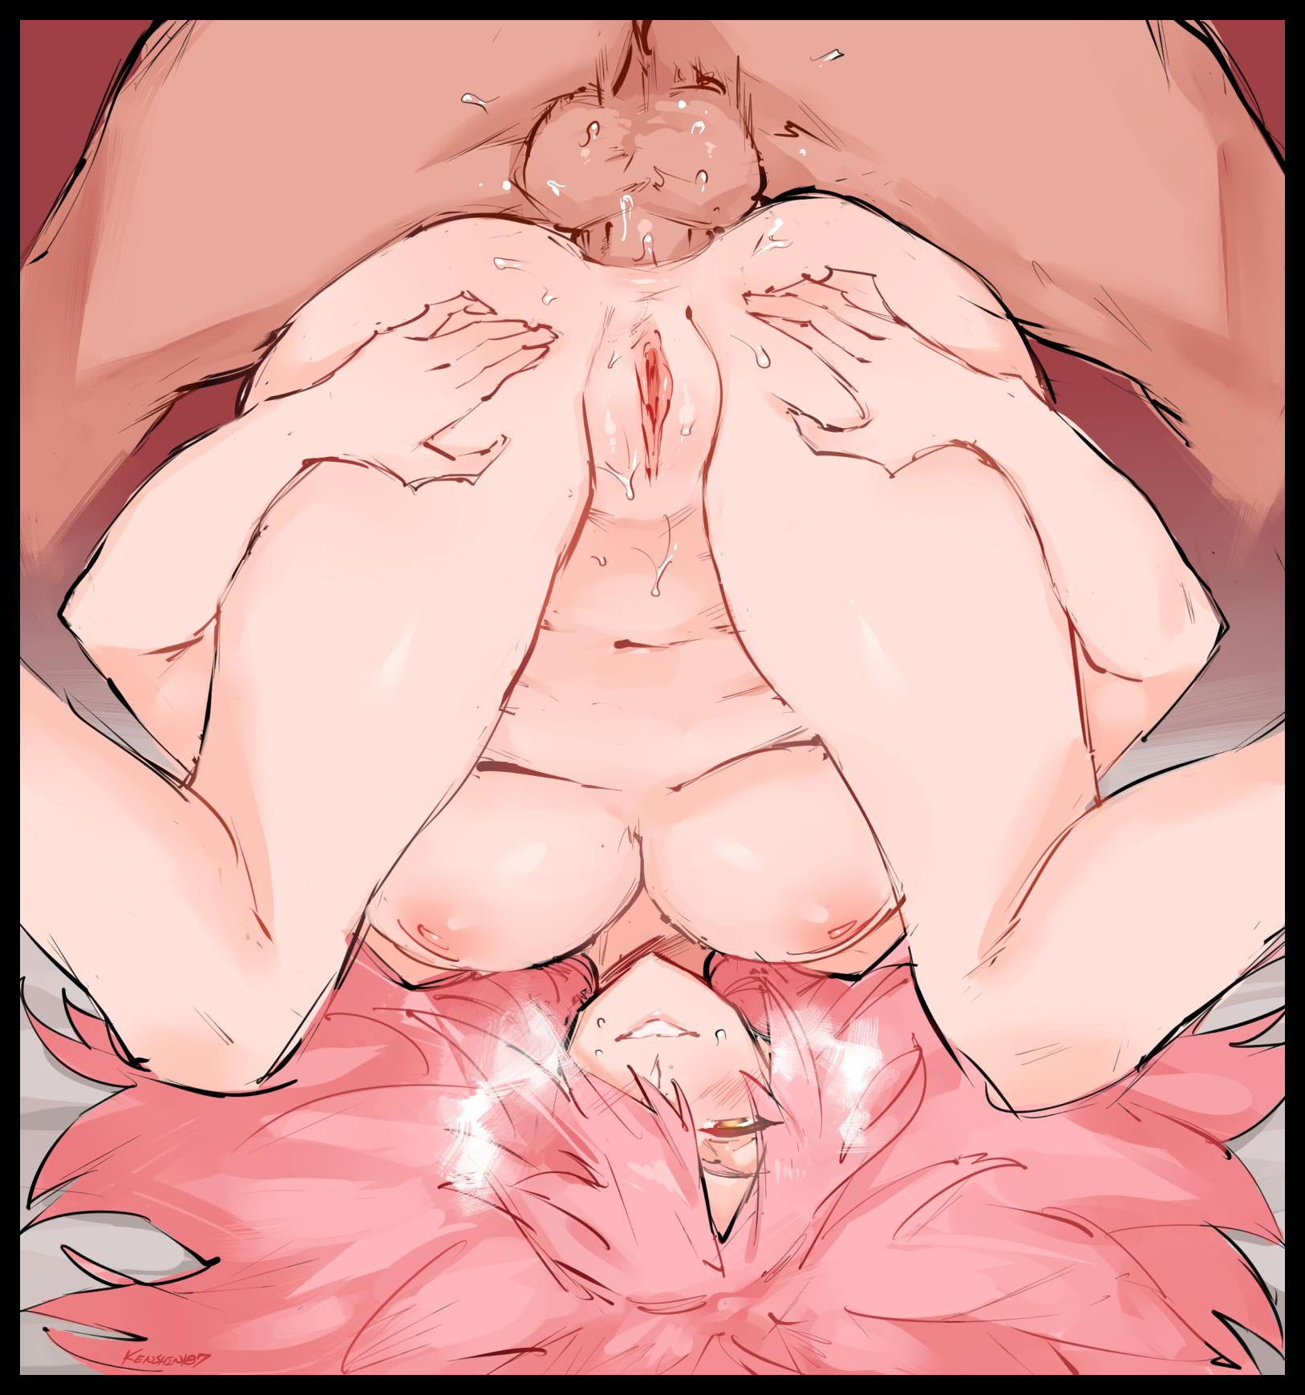
Only for what Morlok had assumed was the brief feeling of being an insensate, disembodied spirit on the way to rejoin his family to be brought to a sudden end when the world around him seemed to have suddenly been flipped around on its head. A cushier world composed of warm sheets and fine bedding in comparison to the uncomfortable layer of shattered ebonstone he had been propped up against during what should’ve been his final moments. Coming to in a warm lit room that looked nothing like the various, rundown inns and flea ridden ruins he could remember living in throughout that arduous journey. A journey whose events would quickly begin to make less and less sense to a revived Morlok when a deluge of sensations, both emotional and physical, arrive to knock him senseless as if he’d been fit by a battering ram. An apt comparison for the impossibly large phallus of the Demon King himself being thrust deep enough inside a virgin asshole to knock at her stomach in such a way that the following, inadvertent blast of ecstatic bliss in the depths of a motherly core alongside a wet spray of vaginal juices would serve to render Morlok dull for only a moment as wide, gray irises go dull within the blackened eyes of a Demon. Numbed to the pain of a stretched anus compensating for a lover’s ferocity and the wanton noise that had slipped free of glistening lips upon penetration, the mind-wiping sensation of a female’s orgasm shooting through a body that was no longer that of a shriveled old man’s before flaring brilliant gold with the onset of a new persona that would overcome Morlok in the blink of an eye. Allowing the reborn sorceress to return her husband’s passion with that of her own, placing trembling hands over pliable asscheeks in an effort to force that virile jackhammer of his deeper. All while the matronly visage of a loving wife would be stained white with concentrated driblets of the Demon King’s freshly sown seed oozing out of a puckered vulva. Blissfully savoring in the overwhelming stench of manhood before a serpentine tongue shoots outward, flicking at the air, eager to lap up her husband’s cum so as to satiate the blood of Succubi coursing through her veins. Just like he worked to relieve his Incubi urges using her tight, fuckable body for the umpteenth time now on the night just after their wedding had concluded…one year after a war to end all wars had seen its end, not through violence…but with peace for both sides.

In his bid for vengeance, the wild spell Morlok had unleashed truly did act on its own accord. And with so much mana fuelling it. Tearing open the fabric of space-time itself was as simple as stealing candy from a child just like the alterations to reality that would come after. And in all the changes made, none were as drastic or important as the edits that befell Morlok.

Instead of a strapping young man from the neighboring village, Morlok’s mother would instead be paired with a wandering Incubus who saw no appeal living with his demonic kin, and in so doing, would find the love of his life in a human woman. Changing the course of history forevermore once his mother had become inseminated with the seed of a demon, transforming Morlok from a simple sorcerer…into Reslamia; half-blood sorceress blessed with her mother’s kindness and understanding interwoven around her father’s yearning for more than just a life of solitude around the ‘same old’, spurring the young lady into joining the demon horde when she had come to quell her grievances with the sadly unavoidable loss of her parents. Killed, not by the Demon King’s armies but rather, their own fellow villagers once paranoia and fear became commonplace.

So instead of vengeance Reslamia would instead seek a means of peace, and with her unique heritage. That path now laid open to her when a lengthy journey of her own had allowed her to discover the truth behind the Demon King and the reason for his invasion….

Armed with that knowledge, Reslamia had begun acting on the Demon King’s behalf after a swift ascension through the ranks. Proving herself time and again through noteworthy accomplishments including successful repulsions of the Heroes party at a rate quick enough for the highest of the highest in the underworld’s court to spread word of a half-blood heretic…and just like that, a meeting with the head himself had become all but certain. Wherein a knot would be intertwined between them after simple talk had become fervent discussion…and when their yearning for one another could not be denied any longer, that was when Reslamia knew she could truly begin work on bringing peace to her parents. A final reminiscence that seals Morlok’s new life as the Demon King’s spouse forevermore as slender arms wrap tight around her lover’s chiseled shoulders, never to recall the bitter life of a vindicated man who could, in some way, find peace at last.

And years later, in the here and now of this brave, if uncertain, new world of theirs, Reslamia’s teasing of her companion-turned-frenemy would halt for a moment as her eyes happened upon those of her husband’s far off in the distance. Painting a warm smile upon her face that quickly fades lest the Hero find something to fire back at her with…and speaking of…

“Say…I know this isn’t my place…but when are you planning to confess to your Mistress? The flames of love require an opportune moment to burst to life! Just like how a well timed swing of the sword can turn the tables of any engagement. And from what I can see; I think you’d best come clean tonight at the latest…” Piquing the man’s interest as he turns to look Reslamia in the eye with an accusing glare through the slits of a heavy visor, the Demon Queen chortles before moving to lean against a cool pillar with a serene look on her face that catches the sunlight across fine locks of strawberry silk, allowing the man this one and only look at her true self while attempting to knot together two flailing ropes on the cusp of becoming one, just like she had done for herself oh so long ago…

“Oh come now Wilhelm…if it’ll bring you any level of assurance…call it women’s intuition or an unshakeable feeling even. But the lady truly does yearn for your presence by her side. And if the sparks of true love are already flying…I think she’d love for you to be the one to light the fire, don’t you agree?”

THE END
Digital Playground

Images by Kemono-O Mujin : https://www.pixiv.net/en/users/5508389

An Unshakeable Feeling…

Image 1 by Anagumasan : https://www.pixiv.net/en/users/61504622

Image 2 by Kenshin187 : https://twitter.com/kenshinx187

