RE:GENERATION II
COMMISSION STORY
BY CHALDEACHANGE
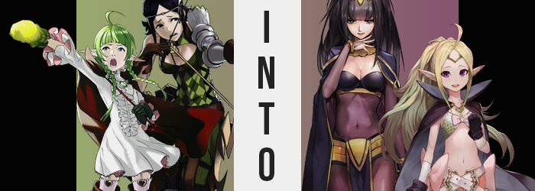

When Lucina had travelled back to the past with the hopes of securing the future of Ylisse, and of her parents, she hadn’t at all gone alone. There was a group of them, all orphans left after Grima killed their parents. All united under the banner of those parents, for they had all been members of the Shepherds that had stood against the dreaded Fell Dragon’s reign in their final moments. They had suffered so much loss, and their world had been already plagued into so much ruin, that it was a ‘risk it all to save it all’ type of plan.

The children weren’t all confident by themselves, but together they felt that they might be able to make some sort of positive change. Could they save their parents? Their world? Considering they all thought their parents to be stronger than themselves, there was no doubt in any of their minds that returning to the past might have been an exercise in futility.

With that anxiety was hope as well, and with both of these things in their hearts they all took the plunge, nonetheless. Lucina herself had been the first to emerge, but her attempt had ended in a failure not a single one of them could possibly have predicted. And, one by one, the rest would fall victim to a similar problem – although it wasn’t as consistent in its execution as it likely should have been.

“Huh? Am I alone? I guess it wasn’t guaranteed that we’d appear together, but…” The Manakete halfling, Nah, was left with a great deal of uncertainty the moment she first regained awareness after their time-traveling stint. She had expected she might show up with the others, but she was all by herself? And in a strange place, to boot!

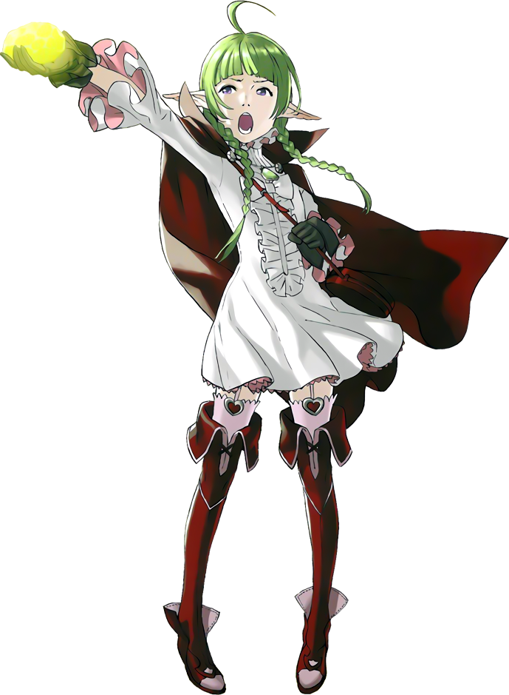
“A tent, clearly, but why is it so dark?” Despite her small stature, Nah was mature and intelligent – cursed only by the lengthened life cycle of her Manakete blood. While she looked closer to eleven or twelve in age, she was actually eighteen much like many of the children that had come to the past. Already, she was breaking down her surroundings to try and come to a conclusion about her location. “A mess of tomes on a worn desk, a messy bed, a cloak dangling from one of the nearby supports…”

She’d already come to a conclusion based on this information alone. Whomever used this tent to sleep was likely of Plegian descent based on the design of the tomes. “But why am I in a Plegian’s tent?” It wasn’t like Nah had anything against the Plegians, one of the friends she’d travelled to the past with was half-Plegian after all.

Plegians were a mysterious people with fair skin and dark hair – for some reason this thought struck Nah a little suddenly, though she didn’t really dwell much on why that might have crossed her mind. In reality though, a darkness not unlike what many considered to dwell within the hearts of Plegians once upon a time had begun to take root… in the girl’s hair.

Beginning with the tips of her green braids, a raven black darkened each and every strand atop her head, seeping higher and higher as time wore on. And as it worked through the braids? Those braids unraveled as the darkened hair itself thickened strangely. Once the black reached the top of Nah’s head itself, this thickening continued while the ahoge atop her head flattened and everything over her shoulders was pulled behind once more.

“I should cast a hex on the one that changed my course so that I didn’t arrive with the others… Huh? Cast a hex? I don’t know any hexes…” Nah wasn’t sure why she’d blurted that out so suddenly, although while doing so her facial structure had been compromised at the very same time. Dark circles appeared under eyes that had darkened themselves, and her nostrils had narrowed to present her nose with a sharper point. What was more astounding was the volume of Nah’s lips, which had rigorously grown plumper to resemble those of a proper adult. But implied age aside? Her facial features and hair now bore more resemblance to a Plegian than anything else.

The half-Manakete eyed the cloak hanging in the tent’s corner once more. What was this impulse? Did she want to try it on? Why would I not? That’s my cloak. N-No it’s not! An internal tug-o-war ensued, Nah insistent that such a dark cloak wasn’t to her fashion standards. And yet, while she refuted that idea? The clothing she was wearing very much bent itself backwards to contradict the reality Nah was clinging onto.

Her white dress pressed against her body as if her clothes alone were being crushed, and as it did the material began to thin and darken. But this wasn’t isolated to her dress, and her thigh high boots followed after, ultimately connecting to the skirt that had been flattened nearby to form what appeared to be a single garment.

A skintight, black body stocking that clung to her lackluster curves, showing off her tiny hips and navel, while a gold belt was fashioned around her waist where darker shorts seemed to exist underneath. Another band of gold wrapped beneath her chest, separating the stocking from a more solid black fabric that caressed her tiny chest, while skintight sleeves connected to and ran from her shoulders. Gold heels and a headdress finalized an outfit that Nah, in all her shame, never would have worn regularly.

Yet now? She didn’t really seem to pay it much mind. “How could I claim it isn’t a match for my sensibilities when I dress like this? What a foolish thing to think.” This came straight from the horse’s mouth to boot, more or less supporting a working theory that the girl’s mind had been compromised in the same manner that her body had. Although her body’s changing state was far from over.

It didn’t take a genius to think ‘Oh, that outfit looks like it would better suit an older woman’ based on Nah’s figure alone, and they’d be right. In fact, the translucent, black stocking began to stretch not long after, whether it was around her arms, her legs, or her tummy. Because Nah herself was being blessed with a height she had always wished to obtain. But probably not like this.

Inches piled onto a frame that was more befitting of a young girl typically, seeing her jump well past the five-foot mark and applying an extra four inches even after that point. The growth did wonders for Nah’s perceived age, particularly with her more Plegian-looking face, which had its lips bloat and cheeks narrow even further to give her a much more naturally beautiful, adult look.

“Ugh, why do I feel so stiff? Last time I fall asleep at my desk reading tomes, I suppose…” With her growth had come a deepened voice that almost sounded like the hiss of a snake in how she enunciated. But had she really fallen asleep reading tomes last night? She couldn’t help but feel like she’d ended up in this tent for a different reason. Something much more important.

As compelling of a train of thought as that might have been though, something else pulled her away from it. A sensual sensation that teased her nipples, even though she hadn’t been touching them at all. “Oh? That’s odd? Have I fallen ill to a hex myself?” Looking down though, even though the front of her top was clearly being pushed forward by breasts swelling larger, the woman didn’t end up seeing it as anything out of place even once they peaked at a pair of Ds that showed ample exposed cleavage in their wake.

Nah was already too far-gone, far too much to even notice that as she put her weight on her right hip, that said hip had stretched several inches outward. It was a phenomenon that had struck both sides, and allowed a more mature weight to plump up her thighs and allow the cheeks of her ass to stretch the nylon of the body stocking so that it wedged itself within the inner workings of her sexy, new rump. In fact, Nah was now quite confident in her looks. It was so easy to sway men that way.

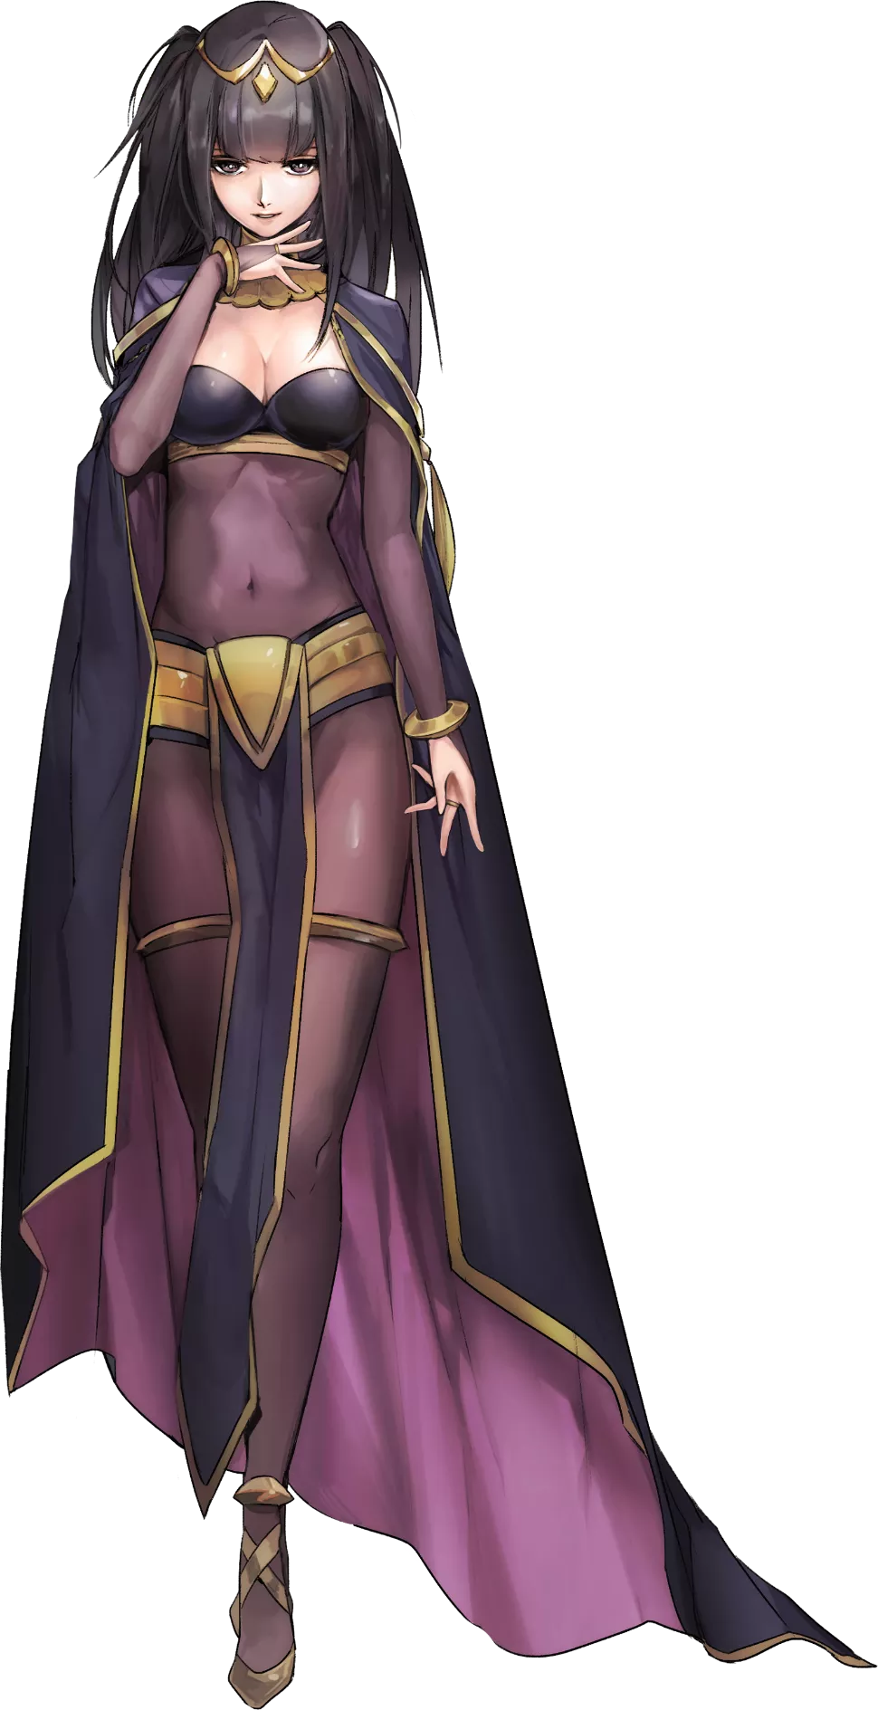
And, as if to finally seal her fate, her long Manakete ears finally shortened and rounder away, leaving her with very normal, human ears.

Tharja’s eyes practically rolled into the back of her head after catching sight of the mess of tomes upon her desk. “Has Henry been rooting around in my things again? What a mess of a man.” Her words came out like a hiss while delicate fingers rearranged the texts in a way that was familiar to her, the woman no longer concerned about her circumstances.

For some reason she had previously thought it strange that she was a Plegian woman, but why? That wasn’t the sort of thought that any person should have about their own identity, much less a woman as confident as this master of hexes was. “Ugh, or maybe it was another perpetrator. That Manakete girl was on stay today along with me, wasn’t she? She has a habit of rooting through things that don’t belong to her.”

She was, of course, speaking of Nah’s mother, Nowi. But she no longer possessed her old sense of self to recognize Nowi as her mother. Instead, she had become someone else’s mother altogether – and that someone else was nearby.

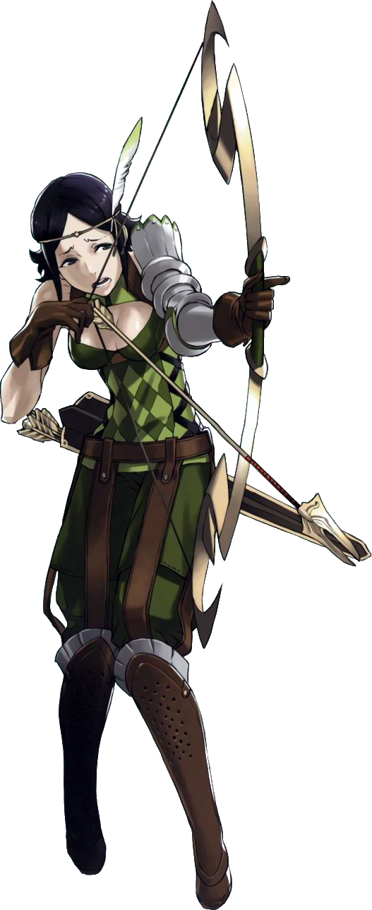
“A-A tent? Why is it so messy?” The future daughter of Tharja, Noire, had actually appeared at the exact same time and in the exact same camp that Nah had. All that had separated them was a few tents, with Noire appearing in one that actually belonged to Nowi. Both parties had ended up in the tent of the other’s mother – and if Nah’s fate was any indicator, they would both end up becoming the other’s mother.

Even though Noire didn’t know this, and even though there was no possible was she could have known this, she was already plenty anxious. She was the sort of young woman that worried over everything while thinking very little of herself. Self-confidence? What was that, exactly? So of course, finding herself alone in an unfamiliar location was more than enough to get her heart beating.

The tent’s layout certainly didn’t help things. Toys and trinkets were tossed about everywhere, and the sole cot in the room looked too small to belong to a normal person. Well, perhaps Nah might fit inside of it? But if she’d said such a thing to her, there was no doubt in Noire’s mind that she would be berated over such a comment.

But don’t I sleep in there every night!?

“N-No, I don’t! I’ve never seen this tent before! That’s a strange thing to think…” A thought that didn’t match her memory triggered a restlessness in Noire, and yet that restlessness wasn’t built entirely from anxiety as one might expect from her. In fact, it partially felt almost as if she had a swelling energy that she couldn’t stifle, bringing her lanky body to twitch at random as she attempted to dissuade the growing impulse.

Dissuade as she could for the time being though, it hardly served to subjugate the irregularities popping up across the young woman’s body. A very noticeable difference could be seen by looking at her head, or at the very least the sides of it. Once round and very human ears were protruding out at the sides, rising into long, inhuman points that could best be described as Manakete ears.

“There’s so much junk in this room… So what would be the problem if I played with some of it? …Huh?” Why had she just said that? She wasn’t a child that could be distracted by such fanciful objects as balls and shiny stones! And yet the longer she lingered, the more appealing it all seemed.

Noire was too wrapped up in the atmosphere of the tent to think critically about the fact that the time she’d appeared in was influencing the nature of her very existence – and signs of that continued even now. After all, the young woman’s height had been in a downward spiral ever since her ears had changed in shape, and she hadn’t even realized!

There hadn’t really been anything subtle about her height loss, either. Plummeting down from five-foot-five, she rounded out at a meager four-foot-three after the fact, and she hadn’t really benefited from a transformed outfit beforehand. This meant that her green archer’s ensemble ended up hanging off of her like a tarp, knees buried in her boots while gloves had fallen off her person entirely thanks to very tiny hands.

On closer inspection, it was clear that it wasn’t a simple loss of height that had occurred though. One look at Noire’s face revealed that a surplus of baby fat had returned to her cheeks, giving her face a much rounder and more youthful glow. She’d largely been stripped of any indicator that she’d once been an adult woman, for lips had lost their luster and her eyes had swollen to be quite round as well… like a child’s.

Much more telling of this fact was Noire’s figure, however. As her height had diminished, so too had the curves she’d inherited from her mother, Tharja. Her breasts had been fairly ample for a woman of her height, only for them to deteriorate until her bosom was more or less non-existent, little more than meager mosquito bites upon her chest. And her hips and rear? They’d all collapsed inwards as well, leaving her with a gait that was still pronounced enough for a girl, but certainly not for an adult woman.

“Am I… smaller!? Huh, no! That couldn’t be possible, right? Haven’t I always been small!?” A much squeakier voice accommodated her shorter stature, but even then Noire seemed to struggle with accepting the possibility that maybe she’d once been taller, or had a deeper voice – even though her oversized clothes seemed to speak truth to that idea. But she legitimately didn’t see herself as being younger. In fact, she understood her age as being much, much older than anyone else in the Shepherds! Over one thousand years old, in fact!

Such was the lifespan of a Manakete.

Her fidgeting had grown much more apparent now, and she was rocking back and forth on her heels in oversized boots. While she did, though? The girl’s eyes had begun to reflect a dark purple that supported a growing innocence within her psyche, and the black of her hair had been compromised by strands of bright green. Piece by piece that color spread, ultimately forcing the black to secede until only green remained.

But it didn’t stop there. The length of Noire’s short cut grew, and significantly at that, tumbling down behind her and turning a darker green near the tips which settled above her flattened rear end. Bangs lengthened as well, parting in the center and flowing around the sides of her face, while a cute little ahoge sprung up from the dead center of her hair. Often considered to be an indicative styling of an ‘idiot’, considering the girl’s mental state now, perhaps that wasn’t too far off the mark…

“Woah! I feel all weird! Or maybe I feel better? I dunno!” The woman – or girl, depending on your interpretation of a Manakete’s lifespan – was spinning around now, oversized clothing peeling off and flying away as she did so. She’d practically jumped out of her boots, only to reveal a pair of boots that actually fit her underneath. They were thigh highs, overlaying a pair of pink leggings that were strapped to a pair of pink shorts that revealed themselves once she stepped out of her big pants with garter belts clasped by hearts.

Clumsily, she yanked the green, checkered top over her head, and in doing so revealed what seemed to be a scaled brassiere covering her chest with a pink bow in the middle, while her tummy (bump and all) was left fully bare. A second pair of pink bows, much larger than the first, had appeared on crossing belts over her shorts, while black gloves kept her tiny hands warm, and a tiara danced across her forehead.

“Brr! It’s always so cold in the morning though!” There was still a small part of Noire that was questioning both what she was doing and what she was saying, but in the end she was more or less powerless to resist just going with the flow. In fact, doing so felt far more than natural, even though once upon a time she was a woman that worried about literally everything. But she couldn’t imagine doing that now! She didn’t want to get wrinkles at her age!

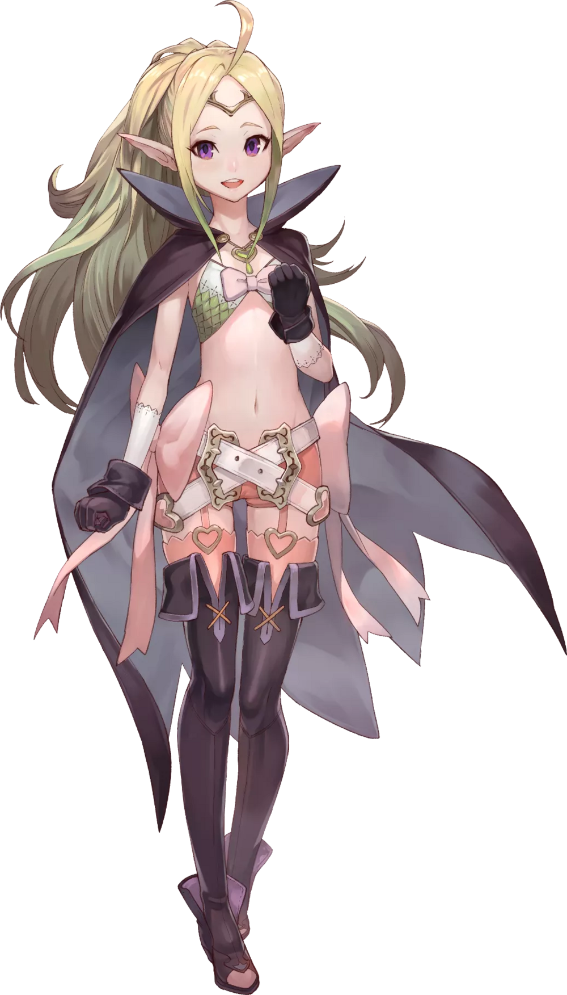
Typical of Nowi, she just couldn’t keep herself still now that the feeling of heaviness that had washed over her was now cleared up. “Why am I all cooped up! I wanna go outside!” There wasn’t even an inkling of anxiety nor self-doubt within her heart now. Only an unbridled energy and lack of care for much of anything; almost as innocent as the young child she appeared to be.

But that wasn’t the case! Nowi was the oldest member of the Shepherds as they were, having lived for thousands of years as her pure-blooded Manakete heritage implied. Despite living for so long, she had only grown this much in that time. Had she really lived that long though? It felt like something deep down spoke to a much shorter life.

“Nah! That couldn’t be it! Nowi is Nowi, right? And Nowi knows Nowi’s life best!” Beaming with innocence, she bolted for the tent’s door with her arms flailing behind her. If she recalled, wasn’t Tharja at camp today too? Maybe she’d play with her!? Though before she got that far, a thought crossed her mind.

“You know, Nah might be a good name for kid!”

