E=ELI²
FEBRUARY 2021 REQUEST STORY
BY CHALDEACHANGE
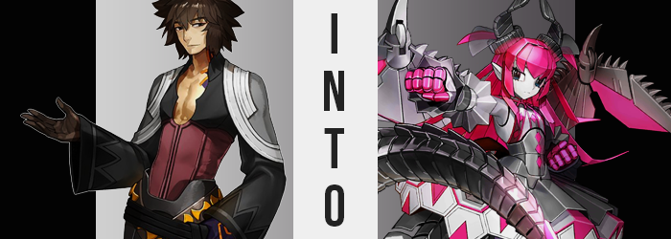

“That stupid lizard. I wish she’d just flip off. Bothering me while I’m working, eating all of my food, constantly babbling! ALWAYS foiling my plans!” It was no mystery that the Caster Servant known by the name of Archimedes hated the young Elizabeth Bathory. Time and time again midst the struggled of the Moon Cell, she had inadvertently foiled his expertly laid plans. How could that idol wannabe brat be the defining factor in whether or not his plans worked or failed?

How was she so far outside his realm of expectation that he could not predict how she would act!?

Archimedes, actually, knew the answer. It was obvious, after all. She was a fool, an idiot, a piece of nonsensical garbage. How do you account for the actions of someone that hardly thinks at all? Clearly, you don’t, because no matter how hard he tried, she always acted outside of his understanding of her behavior.

DO YOU DISLIKE HER AS WELL? I CAN SHOW YOU A MEANS OF DEALING WITH HER.

Away in his hidey hole (a new one that Elizabeth did not know of yet) there shouldn’t have been any means available for anyone to speak to him as that voice that boomed just had. More distressingly, it was a voice that sounded eerily similar to that of Elizabeth herself, albeit a little more robotic and proper somehow. At first, he thought it was some sort of prank. “Not now, Elizabeth! How did you even find this place!?” The response he received? It was venomous.

ELIZABETH? ME? YOU ARE A FOOLISH MAN IF YOU THINK THAT! WHAT WILL IT BE? WILL YOU HAVE ME DEAL WITH HER, OR NOT? I AM SPEAKING ON BORROWED TIME!

As much as they tried to speak properly to not sound like Elizabeth, Archimedes merely rolled his eyes. He was confident that the speaker was her, and that she was just trying to mess with him. So he didn’t even give the proposal any serious thought. “Sure, whatever, just leave me alone and let me work. I don’t have any time for your antics.” As always.

VERY WELL. THE CONTRACT IS BOUND. YOU WILL BE REPURPOSED FOR AN ANTI-ELIZABETH OPERATION.

He arched an eyebrow. “What?” Was this some kind of weird roleplay on the Lancer’s part? He’d been about to roll his eyes and carry on, when something went askew in his Spirit Graph, and it was quickly followed by a sharp pressure crushing down upon his heart. “Guh!?”

The sensation was crushing indeed, but it seemed to work on more than just his chest. Stammering forward, the lab he’d been using appeared to grow larger around him – which was impossible, so naturally something must have been wrong with Archimedes personally. He didn’t need to think too hard about it, even without his genius IQ it would have been obvious. Based on how his clothing was interacting with his body, in the sense that it was beginning to drape off of him, he could ascertain that…

“I’m shrinking!?” A little off balance, he caught himself on a nearby desk before he took a tumble. Between his shoulders and his hips, the man could feel his costume expanding all around him – but it was actually as he’d suspected: his body was collapsing in on itself.

Or, examining his face, it was much more like he was becoming younger. Summoned as a Servant, his body should have been in its twenties. Yet his facial features softened in a way that gave the impression he’d slid back into his teens, particularly with his height nearing a meager 5’1” before all was said and done. Archimedes top was open in the center, typically to show off the muscles of his chest, but now? There wasn’t exactly anything to show off, and the top had slid down one of his shoulders anyways.

“Hey! What the hell are you doing to me!?” Unsure of where the presence that had been speaking to him was located, the Caster yelled at the ceiling of all places – unfortunately to no avail. There was no response, but now he was more convinced that this wasn’t Elizabeth’s handiwork. He was more than certain she didn’t have a power like this, and even if she did? She was far too stupid to use it properly. “I don’t understand the point of making me younger, or how that will lead to Elizabeth’s demise!”

Perhaps he’d spoken too soon though. Not because he’d be given an answer, but because a second wave of changes were now being enacted that would reveal this to be a little more than a mere age regression. After all, his hair was growing rapidly. It spilled over his shoulders and down his back, layered in a way that was soft, but also a little mangey. Archimedes wouldn’t have liked to hear this, but…

Color aside, it looked identical to Elizabeth’s hairstyle, length and all.

This wasn’t the only similarity however, and a number of other wracked up in quick succession until there was an undeniable truth behind it all. For example: his ears stretched until they were long and pointed, an effeminate glow beset his facial features, giving him the round face and big eyes so typically associated with his sworn enemy. Archimedes’ figure also collapsed, sliding into androgyny before his waistline dipped in slight, and his chest erupted into a pair of, well, mosquito bite-sized tits that were hardly noticeable.

His rear plumped up along with his thighs, but only ever so slightly so that a girlishness was evident without being overpowering. As most of this happened beneath his ill-fitted clothing, and he felt as weird as he had during the time he’d shrunk, it had been difficult for the Servant to truly grasp just what was happening. At least until a pain in his groin made him cry out. “Gyah!? What the hell happened to my-!?” A hand had reached down to her crotch, finding nothing in the way of a dick and everything in the way of the female counterpart. But above all, a chill ran up her spine as she caught the sound of her voice. “Elizabeth!? Wait, no… That’s my voice!? How!? Why!!!?”

She couldn’t believe it but looking down at her body it kind of made sense. Her flesh reflected that of a fourteen year old girl in figure, though she hadn’t earned Elizabeth’s infamous dragon features nor hair or eye color. “Is this some kind of sick joke? No, maybe I’m having a nightmare? This doesn’t make sense. It doesn’t make—GRK!?” Her hands were forced to the sides of her head as an immense migraine took shape, and midst the pain she could hear it. A voice echoing from the back of her brain.

ACTIVATING MECHA-ELI.EXE…

Her body seized up as a voice that sounded suspiciously like Elizabeth’s own echoed from within his very being. The pain in his head was not caused by a typical source, but due to a digitalization of her mind that was resulting in her brain disappearing, instead to be replaced by a highly advanced computer. The program that was executed would see to it that her personality was not only overwritten, but that her body? It would properly be reconstructed for the purpose that had she agreed to fulfilling. Her mind was essentially frozen, and would remain as such until the transformation was finalized.

The suspicious absence of a tail and horns were the first areas to be treated, and almost like something burrowing out of the girl’s flesh, an iron tail burst forth from above her tiny ass. Pronged with a hot pink blade tip, the tail itself was broken up into smaller segments that grew bigger and bigger the closer towards the tail’s base they were, each segment sporting a steel spine that looked incredibly painful to jut from one’s flesh while the tail reached a length of several feet. Looking at the skin around the base of her tail though, could that really be called skin? It was no wonder that it had been painless, for the skin had turned to the very same iron as her tail.

As for her pants, the emergence of the tail had completely shredded them in the rear, forcing them to pool at the girl’s ankles.

Atop her head on the other hand, a pair of black horns that looked nearly identical to the authentic Elizabeth’s own grew out, but with one significant difference. It was clear with even the slightest glance that the horns were made of metal and were incredibly hefty. The weight of these new growths, tail included, were all supported regardless of wait though. This could be explained by a change that could not be perceived, as all of the bone in her body had been replaced by a titanium exoskeleton.

From the horns, a strange phenomenon swept through Archimedes’ hair. It gained the pink that was so characteristic of Elizabeth typically, and yet it could hardly be called hair. Strands merged together, binding into large chunks of hot pink iron that connected to one another – clearly designed to resemble hair, but not at all being hair.

Additional pressure built above her shoulder blades, the skin around them hardening into a silver steel before the pressure’s source bore fruit, and a pair of wings erupted from these two pressure points with gusto. One might wonder where they’d come from, for each wing was roughly ¾ the size of her body and was extremely rigid in redesign. They had hot pink fins, but the binding was a dark black – these colors becoming common among her design – with a number of razor sharp spikes protruding from their peaks. Needless to say, their growth completely eviscerated his shirt, leaving the tatters to fall to the ground.

With these key features out of the way, the remaining alterations were swift. Her flesh, typically, hardened and took on a silver tone. Appendages became futuristic and blocky for the most part, particularly in regard to her legs. But when it came to clothes? They were created from the same steel as her body, essentially extensions of it when all was said and done.

From her waist, for example, at all 180 degrees a bulky skirt extended. It certainly didn’t look it, but this skirt was hollowed out and contained a number of slots for missiles of all things. The color of its metal was a black not unlike Elizabeth’s dress, and traveling up her torso was a similarly colored plating that replicated this dress’ design in its entirety, hot pink diamonds, and all.

Her body suddenly sprung upwards as her feet were repurposed to resemble black, heeled boots; they miraculously housed rocket boosters of all things and connected to bulky legs that had pink diamonds lining the sides of her thighs. Otherwise, her fingers brightened to pink and became disjointed, while the hands proper were just as silver as her arms – which vaguely resembled sleeves with sharp, iron cuffs. These hands were actually detachable and could be fired for an epic rocket punch, the usage of which was being programmed into her mind as the transformation carried on.

But all that really remained was her face. Everything else was iron or steel, and as that last, fleshy bastion began to harden into silver, it grew very cold. Blood no longer ran through her body, nor did she have a functioning heart. There was a core in that organ’s place and coolant running through her body in place of blood, but these things were not one and the same.

The ability to properly express herself was entirely removed now that her maw was entirely silver. Her mouth moved of course, but that iron chasm was dry and free of tongue. Any voice she mustered would be completely superficial, created by a voice box in her ‘throat’. The light of her eyes waned too, and they grew both larger and glassier until they were little more than cameras with pitch black irises. Truly, her face was entirely robot, undeniable regardless of possible excuses.

And then? Her mind, completely digitized, rebooted.

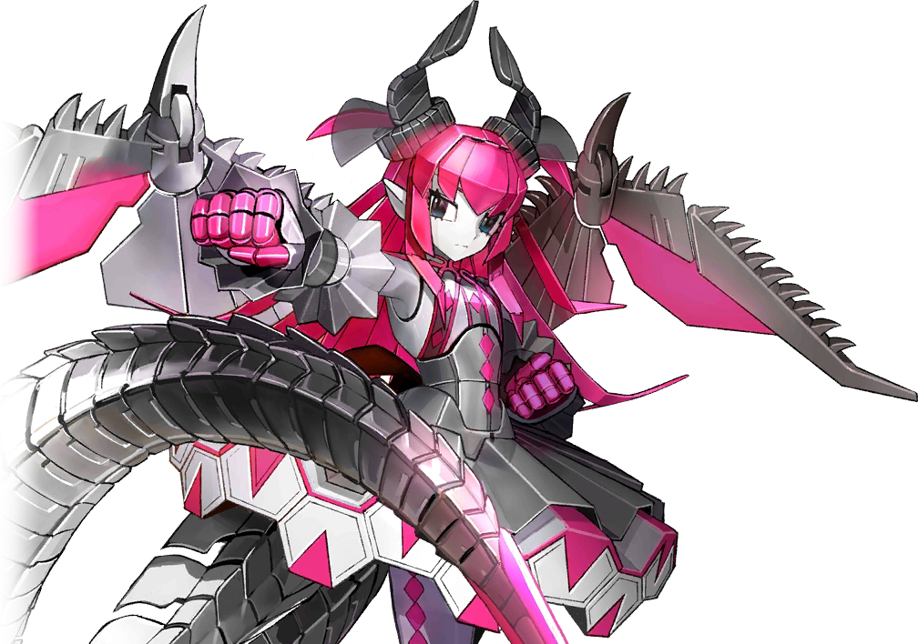
“SYSTEMS ONLINE. MECHA-ELI IS POISED FOR THE UPCOMING OPERATION.” With her physical shell completed, the computer that now acted as her mind saw to it that her systems held absolute dominance. But that didn’t mean that Archimedes’ old ego was gone, but rather that it was being suppressed. For when the system reboot finished, the machine’s expression did portray distress. “I am… What happened to me? I am an Elizabeth? A superior Elizabeth.” She instinctively felt the need to correct herself on that one.

“…This is not right. But it is correct. I am a Mecha Elizabeth in body and programming, but deep down I am— IDENTITY ERROR, ERROR, ERROR, ERROR…” Eyes glowed a dark pink suddenly, and her computers froze up. The moment her eyes dimmed once more; she had completely forgotten the line of thought she’d stumbled upon and stood idle a moment as systems corrected this ‘issue’.

“I must locate the problem child known as Elizabeth Bathory. I must begin the plan.”

Provided she didn’t have any other identity errors along the way.

