First! mod skins NIKKE will not be banned! because it does not touch the core of the game :> !  
If you don't want to be banned:  
1 - Do not show your ID when using mod on social networks!  
2 - You should turn off Nikke launcher before using NMM - Nikke Mods Manager.  
  
How to mod into NIKKE !!!  
1- Create a "Mods" folder in the NMM folder, then copy/paste the mod file into the "Mods" folder.  
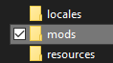  
  
2- open "nikke-modmanager.exe" -> find game folder and select nikke.exe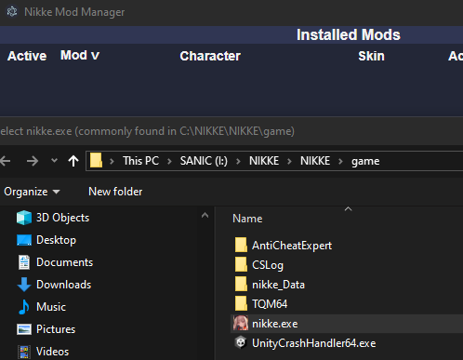  
  
  
3- Select the mod you want to use and follow the steps below.  
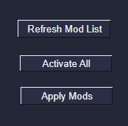  
4- Turn off NMM, enter the game and enjoy !!!  
  
Thank you everyone for reading and support !!!