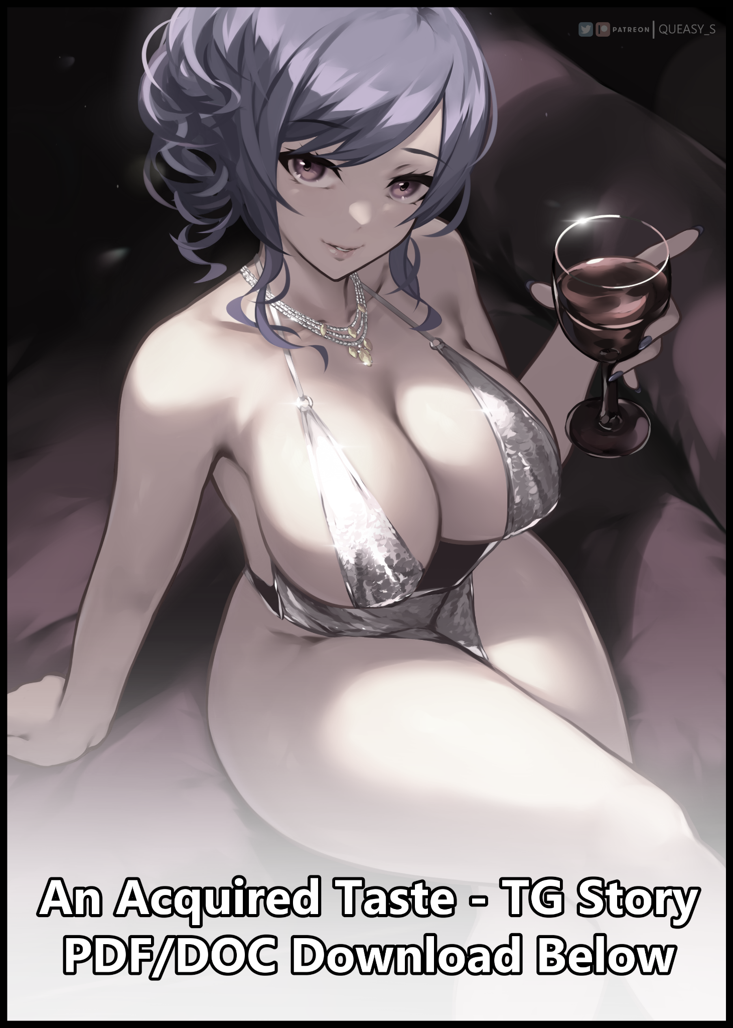

“Seriously man, I’m telling you; it’s for your own good! Now if you’re done sulking, I’ve got a date to catch!”

‘For your own good huh? Says the womanizing piece of crap…why’d I even agree to this in the first place anyway…shit…’

Sulking in the corner of a bustling bar with an evil eye cast over the man taking his leave with pomp and cheer. Samuel scowls at the sight of his careless associate getting robbed blind by the very same women he'd thought to corral like a shepherd would his sheep; throwing handfuls of cash away on expensive drinks and whatever else they wanted just because a pretty face had asked him to do so, being none the wiser to his ‘kindness’ being taken advantage of despite them being dressed in far more fanciful garb than their wannabe suitor was. All while Samuel could do little to busy himself besides watch his fool of a friend get taken advantage of, all while the irritating scent of alcohol and the bitter stench of freshly smoked cigarettes strengthens the bad taste lingering on his tongue.

His being here was definitely a mistake in Samuel’s eyes. But when his colleague had pestered him right then and there in the middle of the streets without taking ‘No’ for an answer toward his invitation for a Friday night romp out on the city streets that had turned out to be a boorish round of bar hopping in an effort to get drunk and hopefully pick up a girl or two, the poor recluse had little choice left but to agree, finding himself locked down halfway across the city without an easy way back home save for an expensive cab or a lengthy walk back to the less ‘expensive’ side of things, sighing as his eyes scanned over the ornate furnishing of the bar’s lavish interior, the well dressed folk in their glittering dresses and dapper suits, chatting amongst themselves while sipping from flasks and goblets filled with precious wine…while he remained all on his lonesome, the odd one out within a fittingly gloomy corner of the establishment, silent and foreboding with a growing desire to just leave right now and take his chances on public transport.

Not one to socialize often, Samuel had always been the loner, the downer of any given group, the one without friends or anyone of the sort to talk to or spend time with. And now that he was in his early twenties as a fresh college grad, the status quo didn't seem like changing anytime soon, a stagnation in life Samuel saw no problems with since everything had been going fine so far.

If there was no need for Samuel to make merry, then the man saw no need for himself to go out of his way to find someone to spend time and make merry with. A philosophy that had been challenged on this very night after his colleague had tried to break him out of his safe space, all while demonstrating the negatives that kept him away from that sort of life in the first place.

Unbeknownst to him, a pair of eyes had locked on to him from the opposite side of the bar, looking Samuel up and down like a predator would a juicy morsel. Appraising his worth before finally settling on a decision as foxy eyes framing crimson irises narrow in mischievous delight while lean lips curl into a smile.

Despite the vast difference in both appearance and personality. The bartender on duty; a redheaded woman with daring poise and subtle flair in her mannerisms had something in common with Samuel, a shared trait she knew all too well; the sequestering of one's self from the public eye. It had been the reason why she had come to work in the Vermilion as a bartender in the first place.

Because in a boring world where the only extraordinary one was yourself? Shana was practically the queen of her own world where no one could question her worth unlike the dreaded realm of magicians and witches she originally hailed from, a place where she was considered an ordinary person without exceptional talent in the eyes of the average practitioner in the arts of magic, an embarrassing fact she preferred to keep hidden through a self imposed restriction on social interaction, being simply known by her workplace title of Scarlet; mysterious bartender with a bewitching aura about her and one of the Vermilion's most sought after women, well beyond the reaches of the average patron.

Even if she didn't necessarily see a need to talk to people besides asking for the occasional order or offering a throwaway line to a cheesy pickup call, Shana loved to use her night job as a cover to bring the most out of her witchy side; practicing magic beneath the notice of the public eye.

Sometimes she'd charm people, twisting untouched ropes into precarious knots between complete strangers for them to unwind or strengthen. While at other times, mischief reigned supreme in the form of a minor behavioral hex, imbuing a faux haze of aloof giddiness in the target that would more than often result in a hilarious display to spice up the evening. Sowing the seeds for a plan leaning on the latter side of her usual shenanigans at the sight of the grumpy young man hiding away from the rest of the bar.

Despite her hidden nature as a magic wielder amongst ordinary men, Shana's aforementioned nature as a fledgling witch with nothing spectacular going for her meant that accidents were prone to happening. And luckily for her, Shana had yet to face the repercussions of her first muck up…until now, that is…

Midway through the casting of an incantation for yet another of her behavior altering spells, a wayward splash of alcoholic juice sloshing into a glass container meant for Samuel blinds Shana momentarily, distracting the witch in the form of a slip of the tongue, causing a fraction of the magic to go off course from its intended effect once her stumble results in an unintentional recital of a sentence derived from transmogrification hexes. A critical error that would go by without notice as the overconfident bartender finishes pouring the charmed fluid into its pristine container before beckoning over toward the server with a crook of the finger, whispering the details of the recipient for her drink before sitting back with a wry smile on her face, eager to watch the results of her magic play out as it always did.

“Umm…excuse me, but I didn’t order this?”

“Don’t sweat it…it’s a treat from Missus Scarlet. Savor it well, few ever get the privilege to catch that redhead’s eye…”

Deciding not to say anything else as he accepts the offering from the very obviously jealous server’s tray, Samuel leans back into his seat, inspecting the dark webs of ebony flowing within the glass goblet before turning his neck over toward the pretty redhead manning the counter, realizing the man hadn’t been pulling his leg as he locks gazes with the mysterious woman, Scarlet, he had called her…she certainly did look the part, but Samuel wasn’t really interested in her appearance more so than he was about the possibility of an ulterior motive…

‘What the heck does someone like her see in me…?’

Dismissing the thought of it after considering both the Vermillion’s renown and Scarlet’s reputation that had men vying to be handed drinks mixed straight from her hand to the point where the servers themselves desired to be treated as such, Samuel simply accepts the gesture of goodwill for what it is without the added baggage of doubt weighing him down as he brings the goblet up to his lips, missing the sight of Scarlet’s eyes narrowing into a leer upon the fulfillment of her wishes as she watches Samuel regurgitate the bittersweet contents of her enchanted cocktail, spitting and gagging with the air of a newbie drinker upon their body’s rejection to the slow burning poison many desired as much as they did their next meal.

And with physical contact being made with the fluid, the first of many in a series of changes would make itself known through Samuel’s lips as they steadily begin to inflate like sponges soaking up liquid, gaining heft and firmness while cracked skin heals over into a glistening layer of pink to form cushions perfect to receive the lips of another. Posh suckers that jut outward to give the appearance of a permanent pucker, masking a lithe tongue and a pristine set of teeth behind them. A change that only begins to intensify as the surrounding skin begins to lose it’s tanned beige coloration in favor of a milky white hue akin to polished porcelain, cleansed of a growing stubble while blemishes in the form of black heads and microscopic scabs ebb and fade, leaving an ever expanding patch of smooth hide behind as it encapsulates the entirety of Samuel’s lower jaw, creeping onward in all directions as a broad neck tightens inward alongside the erasure of heavy eyebags. Laying the groundwork for internal changes to follow suit as baby fat and supple flesh fills in the gaps…

‘Wait…what the heck is going on with his face? That wasn’t supposed to happen?’

Rubbing her eyes in the hopes that what she was seeing was all a simple trick of the light, Shana continues to watch from her cubby behind the counter as Samuel continues to brave the alcoholic bite of the drink she had made for him, daring himself to swallow a mouthful after successfully managing to get a smidgen of it back inside of his mouth without doubling over, never once suspecting that some form of magic was at hand to make the consumption of alcohol an easier process just so it could work him over that much quicker as more of the scarlet liquid begins to enter his body, spreading all over as unseen energies penetrate flesh, carried by the bloodstream and circulated by organs until the entirety of Samuel was encased in a cocoon of volatile magic.

‘Oh crap…don’t tell me…did I mess up the incantation somewhere?!’

‘Mmm…this stuff actually isn’t so bad once you get the hang of the taste…’

Two conflicting trains of thought run parallel while an undeniable metamorphosis begins to ramp up, converting most of Samuel’s formerly moody, overworked visage into one of sensual femininity complete with slant lashes overshadowed by needle thin brows. Both of which serves to perfectly compliment the wide crimson spheres peeking out beneath, brimming with renewed vigor and intelligence as cellular changes creep over the gray matter that was Samuel’s brain, initiating a separate series of alterations working in tandem with the exterior to mold an entirely different person altogether from the natural born loner, consuming him in a matter of seconds as time seems to freeze the moment the charged drink fully enters his system.

By the time an unwashed head of brunette tufts lengthen into a washed head of silken threads taking on an azure color from the roots, Samuel’s head had been completely subsumed in favor of a mature woman’s alluring face coupled with a fragile neck and equally soft sloping contours that were dainty shoulders leading down to supple forearms and dainty hands. All while a cheap suit unwinds itself into a spiral of animate fabric, changing consistency and modifying textures until the unseemly composition of yellowed clothing slowly rebuilds itself into an exquisite dress meant for the express purpose of attending prestigious events as evidenced by the primary use of satin and other such material, coming back together into a piece of clothing that should’ve strained against Samuel’s body, threatening to tear at the seams if a man of his stature attempted to wear it.

Except no man in their right mind would sport as many curves as Samuel did after the magic coursing through him had begun to do away with his semi-skeletal torso while burgeoning flesh bubbling up from the vestiges of untrained pectorals begin to grow past meager B cups, hanging rippling flesh as it flows downward to fill the interior of a toned core centered around a cinched in waist contrasted perfectly by broad handlebars that had since done their part to fill out Samuel’s sides while providing the space needed within a beautified tummy for brand new organs necessary to the fulfillment of the feminizing man’s future functions, shifting in place where he sits just in time for the first pint of wine he had swallowed to hit his core, adjusting his weight with a sidewards slant to his posture, folding exposed legs over each other just in time for bloated buttocks to surge forth, spreading more of it’s fattening effect over toward spindly legs as lean thighs become fattened drumsticks, making the maneuver that much more easier to handle as dangling calves lose their obese sway, replaced by firm pillars tapering off into waifish feet, upon which lies two sets of five pristine shells; smooth plates that were just as well cared for as the nails that tipped dexterous manipulators above…pulling plump lips away from cool glass with an audible smack and an airy gasp of satisfaction.

If one was to ignore the off putting sight of a veiny pecker hanging down just below the woefully short hem of a star speckled gala dress with plentiful cutouts to expose the well fed body of a voluptuous babe nearing her maternity years, then Samuel could very easily be mistaken for a supermodel, sporting a wavy, side hanging ponytail tied to a luscious head of sky blue hair that hangs down her seductive face with a sweeping fringe, seemingly oblivious to her body’s instantaneous and very drastic metamorphosis after taking a singular swig of Shana’s ‘gift’, returning the bartender’s shocked look of horror and surprise with a sultry look beaming with seasoned allure that hadn’t been there before, burning strong beneath glassy red eyes whose striking emotions just couldn’t be ignored…a different one from the faux stare her ‘Scarlet’ moniker was known for…a legitimate one brimming with an honest to God intention of bedding the lucky one who had the benefit of catching her gaze in return…
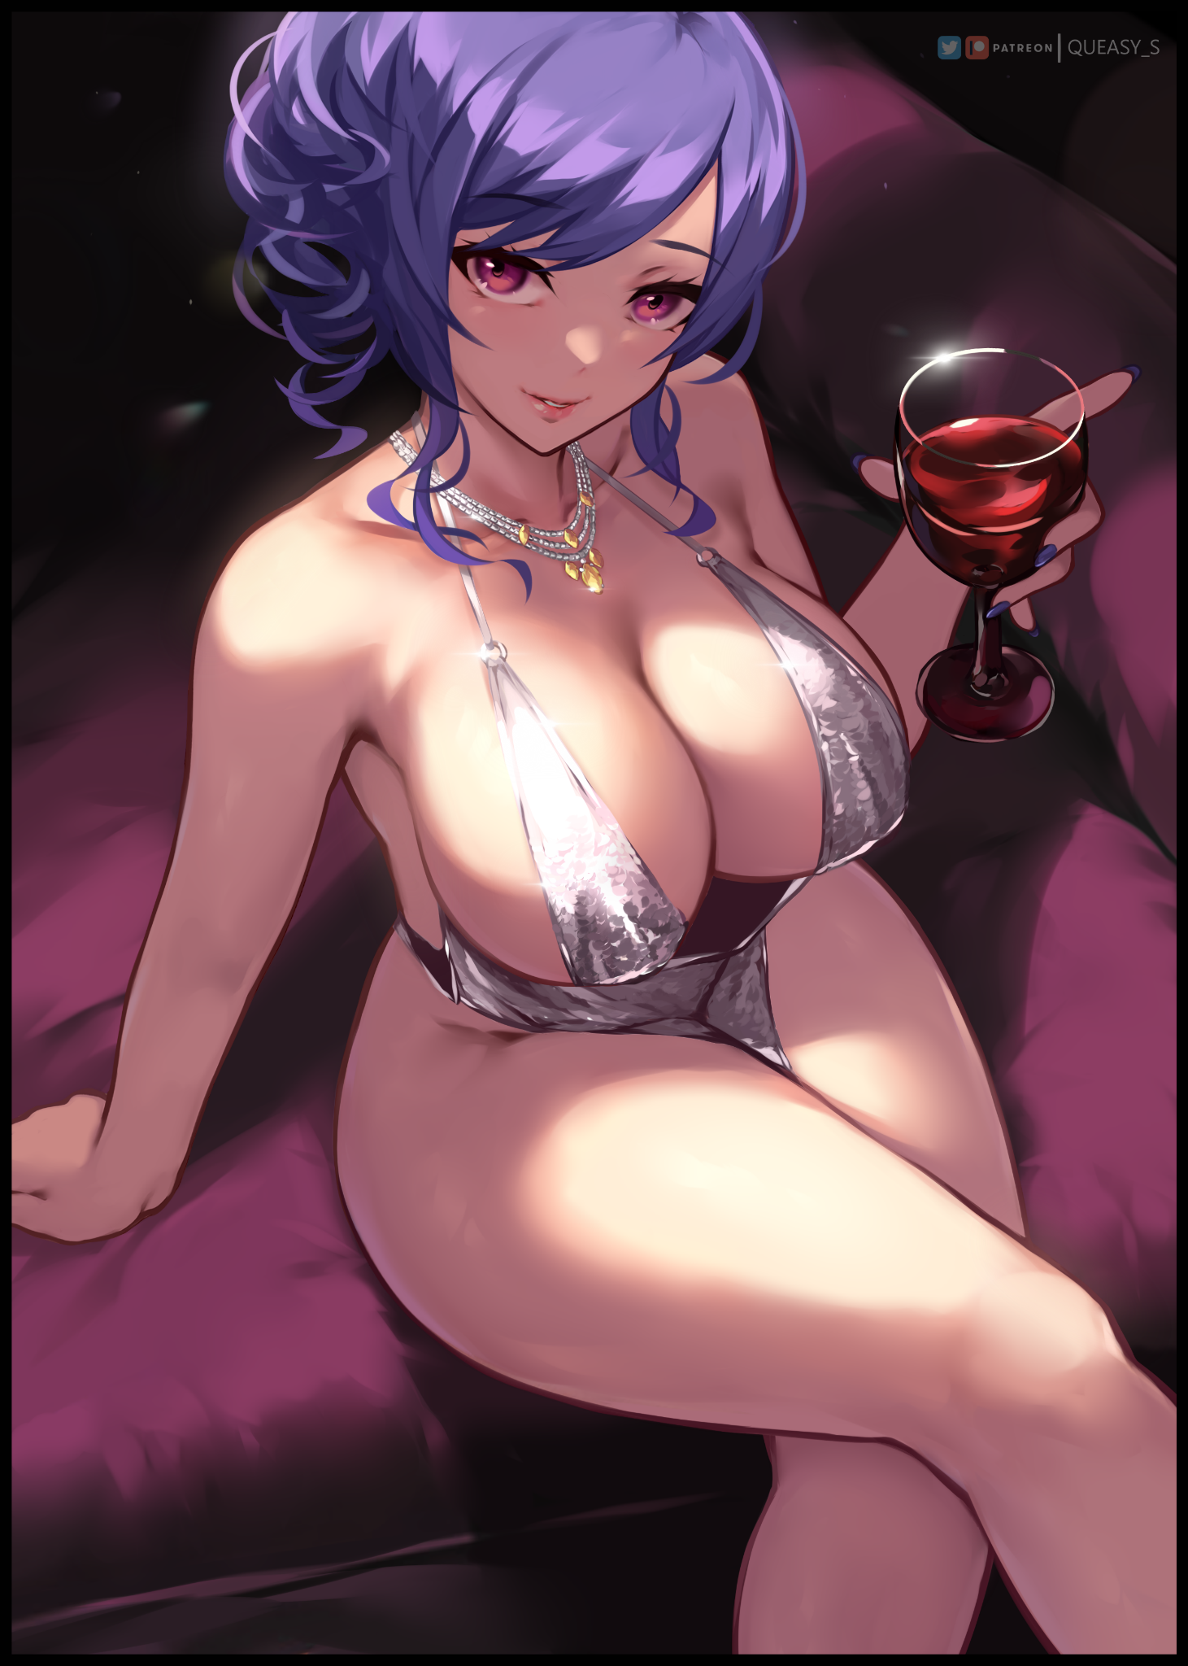
Samuel had been a sheltered hermit. Preferring to blend into the shadows as an unnoticeable average joe with nothing noteworthy about his appearance to pick him apart from a muddied crowd or the obfuscating shadows he had learned for a long time now to blend in seamlessly with ease.

But with another gulp from the tainted fluid in her grip, the bodacious woman, whose sinful body was left readily exposed to the elements and lecherous gazes alike could hardly hope to hide herself anymore once even more rosy layers of juicy meat inserts themselves all over her body, shrinking the phallic rod between her legs until nothing remained to taint the allure of her killer figure, thrusting childbirthing hips instinctually to the feeling of a vagina’s wet folds widening beneath the smooth incline over her loins while a bubble butt grinds into the leather where she sits upon the successful merging of nerves within her brain allowing her to feel the moment her baby incubator, starved of years of experience thanks to her accelerated aging without the proper ‘use’ to justify her motherly form, throbs to life. Implanted with a freshly formed egg as testicles-turned-ovaries work overtime to flood the mature vixen’s body with feel good chemicals and female hormones, making it that much harder for what little remains of her former self’s mannerisms to come to the forefront of her mind as clenched hands adjust into a far more tender grip while a free hand jingles the diamond necklace around her dainty neck to tuck a stray lock of hair behind her ears, taking in the tingling euphoria for the attention she was starting to get once the many eyes around the bar that once neglected that little space in the corner start to take note of the stunning beauty sitting all by her lonesome, enjoying a drink without a partner to share it with…half lidded eyes staring off into the distance as if the soul within was mired in thought…

The bar’s patrons were stunned and stupefied by the fact that they had allowed themselves to easily overlook the presence of a veritable goddess in their midst. Shana was horrified by what her misfired magic had done to the man. But Samuel’s mind was too addled by Shana’s hex and alcohol to realize what had happened, thinking nothing of her sudden genderswap as conscious hands moved to caress her sensitive form, disguising perverted shows by ‘adjusting’ the straps of her dress or a purposefully long and wide adjustment of her legs, exposing the sight of a snow white cameltoe formed from an incredibly tight thong slung around her hips, digging hard into the fleshy cheeks of her ass while the plump folds of her sensitive vagina spasm in need, searing the image of her soaking wet cameltoe into the minds of the horny menfolk beginning to inch closer and closer toward her before someone else surges forward to take the lead, clearly in search of someone else entirely as he, unlike the others, had eyes that wandered all over the place, never once landing on the gorgeous gem lying in plain sight until he was right upon her, tizzied but not intimidated as he reaches out to ask her a question.

Despite her drastic physical overhaul, Samuel was still very much himself behind that undeniably female (and bodacious) exterior. And as her eyes meet with the face of her colleague, that tiny, pre-existing layer of familiarity spurs her current self to lean heavily towards trust as she listens carefully to what he has to say. A stifled part of her failing to make known that it really was Samuel beneath that perverse exterior of hers as she patiently awaits his advances. Influenced by a new train of thought and a logic far removed from her original dull personality and isolationist mindset.

She still remembered the reasoning behind her choices, but now there laid an offering to the alternative; a definitive what-if she had managed to live the extravagant, ‘loose’ lifestyle she used to frown heavily upon as her mind continues to stir with salacious intent, eyeing up the man she once thought to be an idiot as hidden parts of him are brought out into the limelight thanks to the fact that he was now a she, trying not to wiggle in giddy euphoria as her gaze locks on to his mildly attractive visage and the chiseled lines of a well trained body pressed up tight against his clothes…

“E-Excuse me ma’am? Would you mind telling me if you’ve seen someone? A man, about my age but with a more rounded figure, looks really down…he should be here but I can’t seem to find him.”

Giggling with such jovial energy and seductive glee that even the calm, seasoned veteran of women before her couldn’t help but pop a boner to the sound of her lovely voice, the mysterious stranger rises up to full height, standing about a head or so shorter than the man was, not afraid to make physical contact as she comes onto him without shame, placing a hand over his chest while pillowy tits melt and squish against his flesh, providing a first hand glimpse of erect nipples as the fleshy melons slip free of their support, concealed from the rest of the word by the man’s broad figure that had unwittingly become the wall keeping her modesty shamelessly intact…

“M-Ma’am?! What’re you-”

“Ma’am? Really? That’s the second time now. Do I look like a ‘ma’am’ to you, Dear? What a rude thing to say to a lady….especially when you’re asking her a question! No…I haven’t seen whoever it is you’re looking for…but I think I’ve found just the thing I’ve needed for quite awhile now~ So how about it? Do you think this friend of yours can wait for a lil’ while longer while you keep me company for a bit?”

Samuel had never thought herself capable of saying such things, but as she watches Victor, a name she hadn’t bothered to remember or think of until now, go quiet with a not to subtle reaction to her foxy invitation, the thrill of twiddling a man that was now years below her in age stifles any last words attempting to set her mind straight and come clean, doing the opposite instead as she downs the remaining contents of the goblet before pulling her man away deeper into the depths of the bar, locking arms around his neck and relishing in the fact that he wasn’t protesting one bit…admittedly, she was furious that she’d been given a spiked drink by that cheeky red headed bartender, an accusation she was more than certain of, but after seeing how it gave her all the sway and influence over Victor…maybe she might have to thank her for this once she was done playing with him.

With her chosen stud firmly locked to her chest and the rest of the bar’s less than pleased patrons returning to their former banter once the giddy menfolk realized their chances to ask the azure haired maiden out had dwindled away to nothing, Samuel sidles over to her colleagues side, leaning heavily into his shoulders while his burly arms easily shadow her, draping over the nape of her exposed back, curling over her pencil thin waistline before coming back around over her warm, flabby tummy, fingers dangling precariously close to the dangerous hem of her glimmering dress, itching to caress the lips that laid beneath as a visible spout of body heat expels itself from Samuel’s needy snatch, aching folds struggling to contain an overflow of vaginal fluids just begging to be shot out of her in one orgasmic release…

And from her unwitting prison, Shana could only watch through a bird’s eye view of the Vermillion’s exterior as a thoroughly addled, over-exuberant Samuel leads her friend out from the back door and toward the streets, instantly catching the eyes of the public as men eyed up the daring babe who they only assume to the wife or girlfriend of the lucky bastard by her side while burning envy and scorn could only be found in the women, whose irritation at the buxom starlet’s arrival only intensified further when they found their respective partners leering, dropping fierce names and harsh judgment all the way until Samuel and Victor both slip inside the car they had arrived at the bar in, with the man sliding in before his unwitting partner hops in after him, not through the backseat but rather, on top of him, straddling the surprised man before he could say another word before reaching out towards the button that would trigger the one-way blinders. Leaving them stuck in the privacy of a nice steamy car that only serves to heighten their rising libido once sweat begins to trickle down Samuel’s curvaceous form while the heat brings attention to how needy they both were; with Victor’s impressive sausage rising up and beyond full mast to poke against Samuel’s vagina, equally strained to the point of breaking as the string panties that held them prisoner become transparent, soaked through with sweat and other unmentionable juices as her pussy undulates, flexing like the gills of a fish as they rub against the rough fabric keeping Victor’s privates hidden from her.

“I-I don’t usually ask this with any other girl but…why me ma’-I mean…miss? We barely even know each other!”

“Mmfufu~ You might not know about me…but I know alot about you Victor…”

“How do you know my-mngh!”

Stifling his protests with a heated kiss, Samuel thrusts her neck forward, cradling her colleagues head with firm hands while gyrating her lower body, grinding her supple form into the manly wall that was Victor. With all these new impulses and yearnings, thinking ‘straight’ was an impossible task. She felt so light, so free…it was like a heavy iron ball chaining her down by the legs had been broken off, giving her the first taste of freedom she never knew of until now…true, she had become a woman, but it didn’t feel bad at all. And with her ‘mature’ mannerisms and speech patterns, Samuel found little to complain about when she could no longer feel that suffocating ball of hesitation in her throat whenever it came to conversing with total strangers, much less her office companions…yet here she was, parading her sultry body around like there was nothing wrong with it despite how easily most folk could (and had been) catching glimpses of her naughty bits, especially Victor, whose original goal to hook up with a bona fide babe takes precedence, no longer interested in wondering how such a banging woman had even take so much of an interest in him to know his name despite him not knowing hers as he reaches down to brush aside her panties, earning an honest reaction from her body as it let’s loose another squirt, uninhibited this time as it soaks into the fabric of his pants…

But before his swiftly exposed penis could do the deed, Samuel finds the strength inside of herself to protest for a moment, peeling her lips away from Victor’s with a stifled moan, panting with a string of saliva running down her lips, watery eyes of dilated red matching her partner’s equally lustful eyes. If they were to become one…then they needed to seal the deal with proper introductions…

And as she feels her colleague-turned-lover’s grip become hard and controlling once more, Samuel’s head comes up with a simple name that rolls off the tongue just as easily as she sweat that pours down her plump, curvy form…one she didn’t mind losing her purity in if it was her colleague who was going to do the job…

“Samantha…I think we ought to know that much about each other if we’re going to…”

“Samantha…pretty name…sounds an awful lot like my missing friend…”

“Hush now…sour topics ruin the mood Dear…although, if it’ll comfort you somewhat, just know that by the end of the night, you’ll certainly get to know me a whole lot better than that friend of yours…shall we?”

With her gaping vagina already in place right above Victor’s pulsating rod, all it took after a simple nod was for Samantha to lower herself gently, wincing at the feel of her colleagues member kissing the entrance to her flowery folds before a throaty moan bounces around the cramped interior of the car upon the sudden penetration she was left to experience as Victor grabs her hips, shoving her forcefully down over the length of it until only his testicles remained visible, protruding out from the bottom of Samantha’s twitching labia as they squirm in ecstasy, hyperactive urethra spraying out a quick jet of cum in tune to the motherly woman’s orgasmic cries as she begins to bounce herself up and down, milky tits jiggling to the rhythm of her movement, swollen nipples brushing every so often on the clasps of her crumpled dress as it struggles to keep itself on, all while happy Ah!’s and throaty Hyahn!’s slipped free from her vulgar lips to meld with Victor’s manly Hngh!’s and Mnf!’s…

The final thing Shana would see from Victor’s point of view was the beginnings of the newly christened Samantha’s milk producing capabilities taking shape as beads of milk begin to drip from her teats, stimulated no doubt from the powerful, mind shattering pleasures of sexual intercourse, sighing in disdain as she closes off her magic eye just in time for a hefty squeeze from Victor to elicit a mighty spray of sweet honey from her right breast…forcefully reverting to her Scarlet persona as a guest walks up to her counter.

‘Need to get out of here and reverse the hex before it’s too late…’

-A FEW HOURS LATER-

“Finally…where did that skank even run off to?!”

Rushing out of the front door after turning the entirety of Vermillion on its head looking for her runaway plaything turned bimbo, a disheveled looking Shana hurries down the street, looking for the car she had entered into with her ‘boyfriend’ for a spicy romantic moment. But no matter where her eyes darted, the car was gone, gouging an even deeper hole inside of the fumbling witch’s heart as the consequences of her actions began to materialize in her mind.

But before she could dwell any further on the trials that awaited her for causing a mess in the human world where the use of magic was strictly forbidden, a pale hand emerging from the side of a nearby car would break Shana out of her despair if only for a moment as panic consumes her, preparing to fire off a random spell in self defense against this attempted abduction, only to come to a stop once wide eyes catch a glimpse of red and blue, realizing too late that her body was completely pinned…and with her attacker lacking a pair of gonads to knee, it didn’t look like she’d be capable of physically overpowering her anytime soon…although she might not have to if the slightly stained panties, shamelessly promiscuous dress and pretty little face above her was any indication.

“S-Samuel! There you are, i’ve been looking for-”

“I don’t think that name’s necessary anymore Hun…Samantha will do…”

“Samantha? No! That’s not…that’s not your name!”

“Why not? Is it because of what you put in my drink? Did you think it was making me act the way I did? Made me have sex against my will? Far from it honey~”

Pushing herself farther over the seat with an expert use of her legs to slam the door shut behind them, Shana begins to panic as she hears the engines of the car revving up after a snide wink from Samantha, leaving Shana unable to utter an incantation to free herself thanks to an added layer of caution due to her flustered mind, if she made another blunder, who knew what or how severe the consequences this time would be?

But before the witch could resort to reason in an effort to free herself from what she perceives to be an act of revenge, warm lips and a pleasant tingle would instead, serve to calm her down after the initial surge of adrenaline delivered by the kiss of another woman registers in her brain, unable to fight back against Samantha’s deft tongue as it slides into her mouth while a gentle knee prods at her unsoiled vagina through black satin panties, exposing them for the world to see as her lover’s knee lifts the hem of Shana’s raven black dress, loosening the bartender’s top in turn as both Samantha spreads the addictive haze of estrus over to the virgin witch as her protests dissolve into needy moans and sharp gasps, unable to believe the pleasure she was deriving from this unexpected experience as the ladies words fall silent, simply enjoying each other’s company while their chauffeur struggles to keep his eyes on the road with a lesbian makeout going on directly behind him in the rearview mirror…
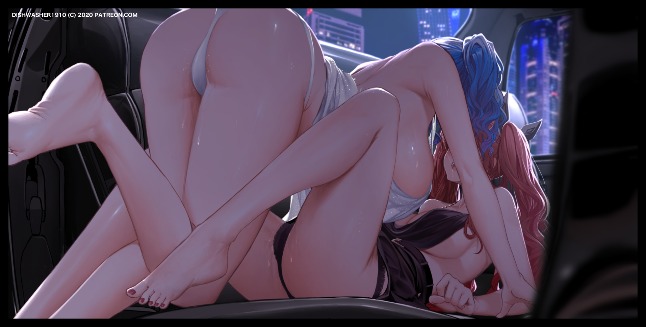
By the time the car comes to a screeching stop at a traffic light, any thought of repercussion from Samantha was scoured from her head as she struggles to catch her breath after the blue haired bisexual bitch formed from her magic relents, smiling from her vantage point above, bubbly butt raised high in the air while pillowy breasts hung low, brushing against the witch’s incomparable assets every so often…and it all came together to form an unexpectedly addictive package that had Shana yearning for more despite her initial protests.

“You’re a virgin aren’t you? I could tell from the way you squirmed earlier…but we’re not done quite yet…”

“S-Screw off…y-you’re one yourself aren’t you? Now let me go! I knew there was something off when I-ieee! N-Not there!”

Ignoring Shana as her buttcheeks clap upon landing back on the leather seat, Samantha peels apart the redhead’s panties, exposing the slim line of her loins before unabashedly sinking her face into them, flicking her tongue, prodding with it, curling around a tingling clit…all while her partner squirms and cries out, unable to help herself before her first ever orgasm shakes her silly, turning the once confident bartender into a quivering mess as Samantha rises up again, her face soaked in Shana’s fluids as she sidles over to join her partner up close, just in time for the car to start rolling down the street again…

“So? How was it? I heard people talk highly about you…and I know I certainly felt that way when I first laid eyes on you…but now? You’re totally adorable hun~”

“W-Why…don’t you wanna…go back to being a man again?”

“After you’ve given me this? A taste for the finer things in life? Not feeling like a complete downer? I’ve never felt any better Scarlet…and I have you to thank for that…I had my doubts but, from what you’ve said, I think it’s safe to say you’re the one behind all this, yes?”

“How did you even know…”

“You weren’t being very subtle honey…and something obviously went wrong or you wouldn’t come looking for me in such a hurry~ But…if me being the way I am now irks you so much, feel free to reverse whatever it is you’ve done…but…on the other hand~”

Only silence would follow before Samantha’s smooth, erotic touch returns to break Shana’s indecision, feeling irritated at how easily she’d been figured out and laid bare (quite literally) by a regular human, wanting nothing more than to teach Samantha her place…while leaning yet further into the well of coital bliss opened to her eyes by her supposed failure as the two women go back to their quiet session of love making at the back of the car, with the poor driver none the wiser to the ticking timer he would have left to enjoy the show before a memory wiping spell was slung his way…

Victor’s colleague would never return to the office, simply filing a notice for resignation before vanishing entirely from the public eye. And as far as anyone could tell, it didn’t seem likely for him to show his face anytime soon…

The Vermillion on the other hand would see a marked rise in patrons as word had begun to spread of another lascivious flower that had appeared in the popular bar. A bold woman of azure to contrast with the ever present Scarlet, whose cold, teasing behavior seemed to have undergone a subtle change ever since the new arrival, becoming more brusque and ‘daring’ alongside her junior, who had since earned herself the nickname of Cerulean amongst those who frequented the bar, taking on a role as server during her initial appearance, quickly rising up the ladder until she was singing, dancing and riling up the patrons whenever it was her turn to man the Vermillion in place of Scarlet, taking her place after the latter had grown confident enough in both her ability to man the counter without her assistance. Noting a subtle decrease in ‘strange occurrences’ at the Vermillion ever since Cerulean had made her appearance, almost as if the randomness that seemed to plague the bar had been tampered by the lustrous woman’s appearance…not like anyone would ever know for sure.

But beneath Scarlet’s notice, her partner had become known as a dangerous little face to fall for, famed by those who had felt her touch up close for a ravenous ‘appetite’ and an unending stamina that could keep her going well past the point where most would faint, citing it as the reason why she would often vanish into the backrooms, sometimes with a customer, before returning looking none the worse for wear…albeit with a certain smell about her that people could only describe as ‘titillating’.

And despite assumptions, the vanished individual from a stuffy workplace downtown once thought to be a stubborn recluse, was enjoying their life, now more than ever. Serving drinks and making merry in more ways than one without a worry to weigh them down…

THE END

Image Sources

Image 1 by Queasy S : https://www.pixiv.net/en/users/30733119

Image 2 by Cait Aron : https://www.pixiv.net/en/users/573302

Image 3 by Dishwasher1910 : https://www.pixiv.net/en/users/13408193

