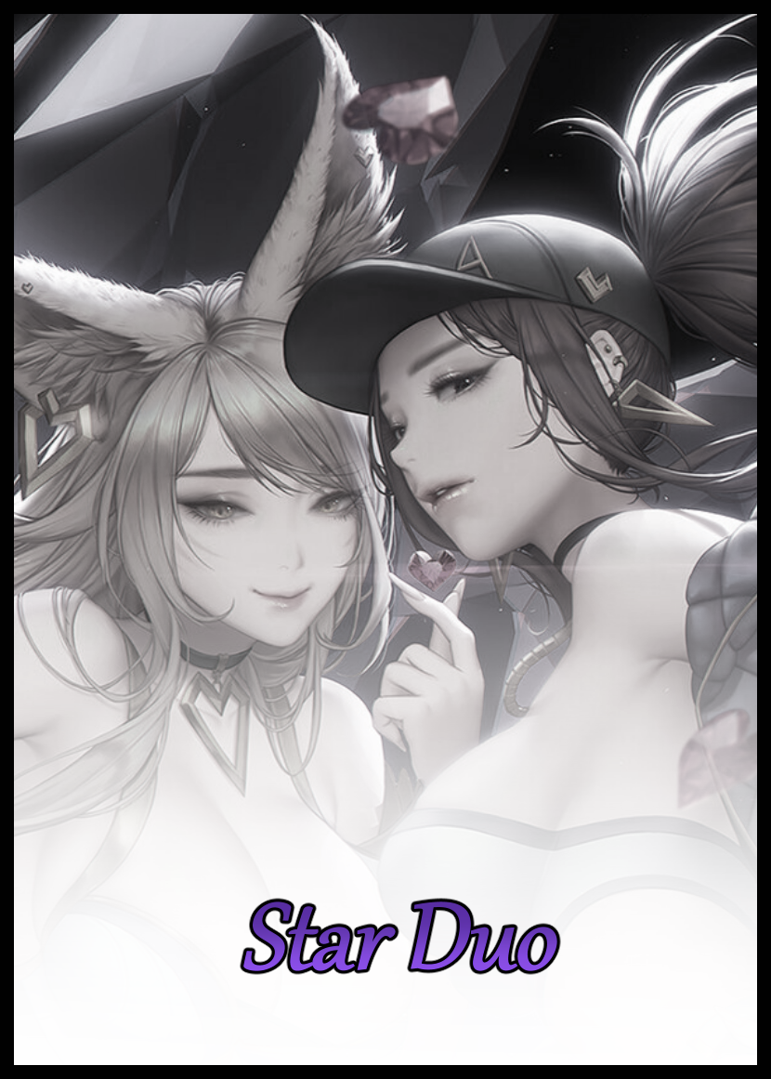

“Mind if I ask why we have an ongoing contract with the military of all things?”

“Only for the most strictly beneficial of reasons obviously…”

“We…are an idol production company…so what exactly do we have to offer for the government’s lapdogs to get themselves involved with the likes of us? Unless you mean to say the boys in green need some fitting tunes to shoot their guns to?”

“I’d laugh in other circumstances, but sadly, no. It’s got something to do with our recent hit…you know who i’m talking about, right?”

Two opposing figures sat facing the other in a dark room. Sound proofed walls devouring any sound produced by the occupants within to produce an eerie effect where their hushed voices would fade in the wind immediately after leaving their mouths. No echo, no reverberant bounce. Just a quick blip that made the conversation between them go by that much faster as they both spoke quickly after the other as if they hoped to stave off the dreadful silence that dominated the interior space alongside an obscuring inky blackness that kept most of the room hidden from view if raven black walls and tinted floor panels weren’t enough to make the chamber feel divorced from reality itself. Uplifting the pair to a higher realm with an illusory trick that made them seem like gods deep in conversation; two gaunt figures seated on opulent thrones of crimson leather cast adrift in an endless sea of shadow with a sparsely filled table between them that served to hold only two shot glasses filled with alcoholic drink, one for each participant in this brooding conversation.

The man on the left had gelled back hair that left striking, deep set eyes atop an expressionless visage exposed without cover. A feature that made him look smart and professional when taken in tandem with the form fitting suit and pants he wore that casts a clear image of his tall and composed self nestled comfortably in his couch with long, lanky legs folded over each other, shaking boot clad feet in a subtle, unheard rhythm while he ponders the question imposed upon him by his conversational partner over to the right. A man whose burlesque frame could easily be deciphered to the naked eye despite the thick layer of moody clothes that adorned his intimidating body. And despite his attempts to be as inoffensive as possible, the skinnier of the two had to admit that without the contrasting backdrop of saturated red that was the couch bearing his weight and the glistening sparkle of light refracting off that well polished scalp, the man could very well just vanish into the background without much effort at all.

‘And given his nature as someone I’ve never seen before…I’d much rather prefer to keep him in my sights…what is Mr Gettel even thinking? Hiring someone like this…does he even know about all the background buzz going on around the place recently?’

Working an important job running finances in a well known idol agency, Steven knew what was to be expected of him at all times; making sure the company’s coin went where it needed to, managing jobs between divisions and many other critical roles he could proudly claim to have had a hand in during his five year long tenure running his post. So when an unauthorized transfer of funds leading to a phony front that, according to reliable sources of his own out on the seedy streets, was run by legitimate handlers with known ties to the imperialistic brass men from all the way up the government pecking order. Spurring the dutiful financier to begin looking into matters on his own after being lured in by intrigue and curiosity as to why men with guns were making stealthy deals with an idol agency…

That is, until he’d met a man calling himself Barry. A name that bordered between believable and highly suspicious considering how he’d never seen the man anywhere in the agency building before. And he’d been working there for many years now to the point where he could easily make it to the leisure lounge and R&D labs with his head held down to the floor without losing his way after having made multiple trips to and from the respective departments on many occasions.

Claiming to be a new hire to fill an undisclosed position by the CEO, Mr Gettel himself. ‘Barry’ had invited Steven to join him in one of the leisure lounge’s many secretive, sound proofed cubbies for when someone needed to discuss things of a highly confidential nature…or to rid themselves of a potential problem, like say; a nosy worker poking his nose where it didn’t belong.

Steven didn’t believe Barry would do something like that of course. But still, he wouldn’t be where he was today if he didn’t at least hold some doubt for why this random stranger had appeared from out of nowhere one fine day to question him about the very specific inquiries he himself had been making about an improbable military deal, making him second guess himself for even digging this deep in the first place if he’d known just how quickly the situation could devolve into a dangerous one if he wasn’t careful. He needed to take caution with his approach from here on out…while maintaining the daring brashness he’d displayed ever since laying eyes on the imposing man, rightfully wary of his opponent’s machinations, if any.

“I just can’t place it…I'm financing, remember? Might be quicker if you just jump straight to it and tell me who you’re talking about. I’ve got a meeting with Ms Ahri in about an hour’s time.”

“Hahh…and here I thought you would’ve heard by now…it’s who you’re meeting with. Our newest, rising star raking in the dough by the millions with each new release…the foxy seductress herself.”

“Another of those ‘new-gen’ idols yeah? I’ve heard things about them by naysayers who don’t hold them up to the same light you do…”

“Oh? And what might those naysayers have to say? The success of Ahri and her ilk with the public at large is undeniable…yet you sound oddly swayed by whatever it is you’ve heard. So I’ll humor you; what’s the word on the street?”

“Well…for one; they aren’t even real personalities…apparently just dredged up artificial intelligences based on fictional characters from a bygone era inhabiting flesh and blood bodies. That they're just corporate dolls robbing the masses blind to an even greater extent than ever before…"

"...and that the craft has finally lost its soul? I know that song and dance…Mr Fredwell's mantra…he never did like the new gen idol programme…but that's all in the past now."

Something about the way Barry had said the words with that silver tongue of his had been reason enough to clue Steven in to a greater implication somewhere between lines….maybe…did he have something to do with Noah's recent and sudden departure? He knew the man's zeal when it came to tutoring potential idol material, and he never once gave up on teaching what little talent remained at the agency before the eventual shift to new gen idols that were basically biological recreations of women based on data from a time period when the Earth had seen better days.

So when Steven had heard of Noah's departure, a part of him knew that there must've been something more to it than an old man stuck in his ways refusing to see reason. And now, as he looked upon Barry's smug mug. That creeping suspicion had been firmly cemented as a highly probable guess that the higher ups…or whoever else was in cahoots with this man, had been the cause. Temporarily clouding his attention long enough for the slender curves of smooth shoulders to reveal themselves as the lining of the suit gives way near the sleeves unbeknownst to Steven as he continues to indulge in his own daydreams.

"Getting back on track…it seems you know plenty enough about the new generation idols to get a rough idea about what they're based on…but you don't have a clue about how they're made, am I right to say that?"

"So…it's true then…the rumors talking about how they're grown out of vats in some underground lab?"

"I like the way you think…but not quite…the actual procedure is a bit…shall we say, intrusive…and that's the core reason behind that improbable deal of ours with the military; they want to weaponize it you see. To make it a deterrent against threats both foreign and local…hence, the reason why we all stand to gain from this deal should it go through successfully Mr Ecklun…now do you see the importance behind all the secrecy?"

Shifting a little in his chair upon hearing the mildly disturbing revelation delivered to him so easily without cautious restraint, Steven’s composed look wrinkles slightly as his brow furrows inward into a subtle, downward arch as he tussles with the implication that the new gen idols were being ‘made’ through a highly questionable process that must’ve violated so many ethical barriers if it had the potential to draw in the the likes of the military. Hook, line and sinker…all while a cool breeze passes unnoticed between an oddly exposed region between his legs as smooth thighs squish and shift to take on a more comfortable position while receding layers of fabric shift ever closer towards the floor, revealing pale skin bereft of hair while the slick head above begins to droop and lengthen in turn, tickling his forehead and ears once individual strands of silk cleansed of gel starts to fall away from the collective mop, hanging lower as they grow beneath Steven’s notice…

“So what you mean to say is…we've 'accidentally' created a weapon potent enough to get the government to zero in on us…and they want the men down at R&D to refine the thing for military use instead of 'making' idols…how did we even get to this point?"

“How? For years now this agency’s been on a downward decline. An oversaturated market. The same old same old when it comes to who’s up on stage. The new generation idols are a necessity; using the old to liven things up in the here and now…and with our procedure, we needn’t waste resources training up ‘new talent’, not when we can make our own, homegrown idols in a fraction of the time it’d take the likes of Mr Fredwell or anyone else for that matter.”

“Then why’d the higher ups even bother to get him to come back into the fold? Last I heard, it sounded like Noah was the company’s last hope…awful quick to just dump him in the gutter like that…”
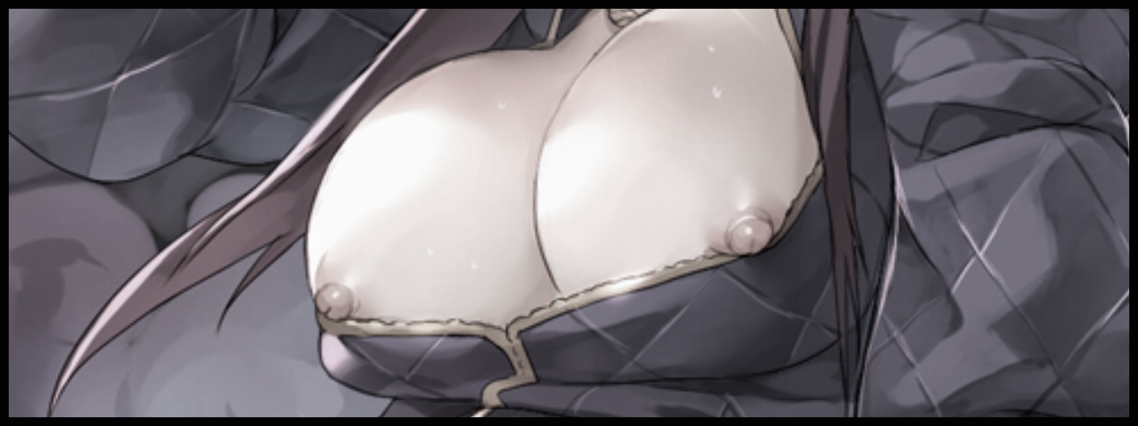
Pausing for a moment to take a drink as fuller lips wrap tight around the cold rim of the shot glass, Steven’s attempt to soothe his parched throat leaves him oblivious to the lecherous gaze of Barry gleaming from behind those thick rimmed glasses perched atop his wide set nose. Narrow eyes locked on the ever growing protrusion jutting out the front of his acquaintance’s chest as warping fabric peels away like the petals of a flower in bloom to expose bourgeoisie melons of creamy flesh, making a mental note of the way smooth shoulders twitch in response to swollen nipples being stimulated by entwining layers of animate silk being repurposed into the cold, rough length of a popped zipper that bisects the front of Steven’s bulking suit as it becomes the foundations for a loosened bomber jacket that leaves little to the imagination as a well kempt navel softens into tender fat and supple flesh to form a gorgeous core inlaid with a sexy belly button, bulging with the momentum of a dainty neck funneling cool fluids to maintain a rising internal temperature that gradually starts to paint porcelain hide stripped of hair and other such blemishes with a glistening layer of sweat. All in the span of the few seconds since lifting the cup up to take a sip before putting it back down with manicured hands wrapped gingerly around the tiny thing, finding the need to lower himself in order to reach the table as a matter of no concern thanks to the obfuscating haze wafting around inside of Steven’s head. Keeping him calm and composed despite the visible protrusion of an extended fringe drooping over his eyes as a modified sense of awareness draws his gaze to match Barry’s instead, filling the man with an odd sense of…something once he realizes just how obvious his intentions were being broadcasted to him as he felt hidden eyes behind those gray lens peel apart clothes, rising slowly over undulating curves and swooping indents before settling over his face to match gazes with a look that made his aching chest throb with something fierce while a flaccid thing down between thickened legs struggles to rouse itself from lethargy, causing Barry to let out a chuckle he could not hold back at the sight of it just below the fringe of his vision. Earning a shaky rebuttal from Steven vocalized in a slightly higher pitched voice dripping with musky charisma and a slightly airy wisp…

“W-What’s with the laugh? I got something on my face?”

“Oh it’s nothing, just got some runoff at the edge of your mouth there. Reminds me of a little…shall we say, moment…I had the pleasure of sharing with Mr Fredwell…”

At the mention of the former trainer’s name, Steven’s posture stiffens up while a frown paint’s itself across his face without his knowing as the name processes itself inside his head, rousing something sinister akin to animosity within him…but why was he feeling this way all of a sudden?

“I understand Ms Ahri might be…aloof…at times. But that look on your face…just what might she have done to deserve that look from you of all people Mr Ecklun?”

“Look? What…look…I-It’s nothing, just thought of something when you brought her up is all. Please, continue…you were saying?”

Wearing a momentary grin that lasts for all but a second upon seeing Steven’s ‘mistake’ go unnoticed, Barry sighs before reaching for his own glass, tipping the comparatively tiny thing in his hands to down it all without effort, observing the way folded legs hugged by form fitting stockings subtly shift at the corner of his eyes to take on a more lax position; feet spread wide, dump truck ass dug deep into leather…a puckered set of lips crowned by a flurry of silken pubes, twitching in silent need as glassy, half-lidded eyes of steel found themselves glued to the outlines of his chiseled pectorals and hardened abs straining against dark fabric before vanishing as his upright poise returns to the stiff, unassuming pose he always displayed himself with, liking the way Steven shifts her gaze away from his athletic physique after finding the strength within to resist the strange thoughts and emotions floating into her head, keeping her distracted long enough for Barry to reach over and give her near empty cup a refill, overlooking her jitters with a blind eye…

‘Preferences…vocals…speech patterns…even his mannerisms and ideals…it’ll all just go down, down, down the drain…until there’s nothing left but what I want…’
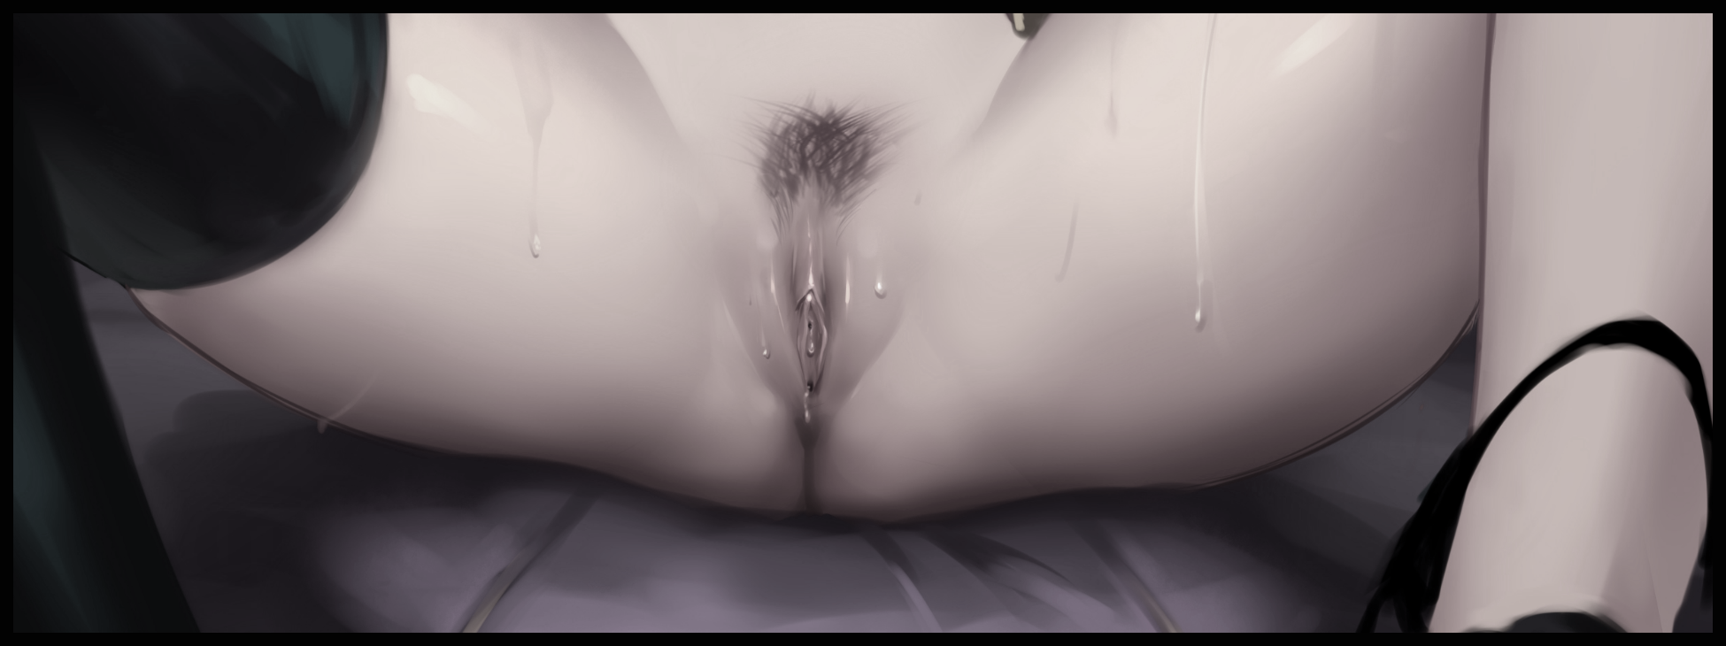
“Ahh…where do I even begin…it was shortly after Mr Fredwell had been let go when I met her, fresh off the set with another recording done for the day, walking into the leisure lounge with confidence in every step…almost as if she owned the place…”

“You sound like a big fan…”

“And you’re saying you aren’t? Admit it, anyone who hears her do the real thing live would immediately hop on the bandwagon…unless, there's something more behind whatever it is you’re trying to say?”

“Just…keep talking…”

While Barry resumes the telling of his fateful encounter with the artificial idol, Steven continues to tussle with the highly inappropriate thoughts floating around inside her head, still clueless to the loss of her penis as gray eyes, directionless and distracted, begin to paint themselves over with a mysterious shade of purple that matches up nicely with the overall palette of her equally distorted attire; sporting deeper shades of brooding violet contrasted with golden highlights and darker portions in the form of accessories and gloves. But those were nothing in comparison to the mess roiling around within the confines of her dazed head, housing a mind that could no longer focus on much else besides Barry’s story…and all the other perversions she just couldn’t seem to get away from the more she stared at the man’s body, finding herself behaving much like he had earlier except to a much more obvious degree as saliva pools in her mouth, leaking out of pillowy lips on occasion while a flustered tongue, lolling like a dog and flitting like a snake. Struggling to keep it still as it continues to coil repeatedly around an invisible phallus within her oral cavity; an inadvertent fellatio gesture that definitely does not go unnoticed to Barry’s eyes as he continues to drone on and on, loving the way Steven writhes in place while more glitz and glamor attaches itself to her voluptuous figure, spurring his tale toward a titillating turn as ornate earrings clip themselves to softened earlobes while golden bangles manifest around slender wrists, signed off by a tight, leather choker that forcibly snaps shut around the bulge of saliva in her neck, choking Steven as her head jerks backward for a moment alongside a muted ‘Ugh?’ that comes out more like a rousing moan than a pained cry of shock when tampered nerve ends and a warped brain broadcasts a clear vision of her unchanged self to conflict with the distressing imagery that continues to assault her mind, unwittingly indulging in the pangs of jealousy from hearing each word out of Barry’s mouth more so the juicy tidbits of the case she had been hoping to get to the bottom of, hence the agreement to this meeting in the first place as the former financier continues to struggle in vain, blissfully ignorant to the way she had been grinding her shapely body against the couch for the past minute or so as the man recounts tales of Ahri’s beauty and grace. Forming cracks in Steven’s mind the sinister force possessing him takes full advantage of to begin warping her very being now that her body was no longer her own once the last thread of raven black hair struggling to persist amidst waves of frayed magenta vanishes within the luscious mane to coincide with the lengthening of polished nails to complete the corporate worker’s bodily transition from ordinary paperpusher to exotic beauty…

“You’re jealous aren’t you?”

“No I’m not…w-what makes you say that in the first place?”

“I can see it in your eyes…the way you’ve been looking at me for the past few minutes or so…you don’t like me hanging out with Ahri…it’s clear to see.”

“It’s not…not like that? I totally haven’t been checking you out…not one bit…”

“Truly? Then tell me what’s got a lovely girl like you acting up like that?”

‘What’s he mean by…me? A…g-girl…a lovely girl…like me…’

A shaky neck lowers, head craning downward to look upon herself as the heavy weight at the front of her head clears up, making her feel like a fool for doubting his words. What had she been so conflicted about…Barry was obviously wrong indeed correct in surmising her gender. She was a man was a woman…and a rather curvy one at that. But it had been that way for…for a long time now, ever since she’d hit puberty if memory served her right. In fact, she remembered many moments in her past when girls took no notice of him boys from highschool would constantly try to hit on her, owing to the fact that he didn’t stand out at all she had been an early bloomer, taking plenty from her mother’s side of the family as evidence in the hefty milkers sagging out of her jacket for all to see, swollen red nipples stiff and hard in the air as Barry could attest to, fingering the nubs with such finesse that she couldn’t help but sigh in bliss. Arching an inward curving spine to further prompt her perverted conversational partner daring manager to lay into her tits, adoring the feel of callused palms and steadfast fingers kneading a bountiful right breast as a pale bead of sweet nectar pops out of her nipples before running down the length of her bosom and right onto Barry’s outstretched hand, parting from her flesh to get a taste of her juices as he laps up the singular droplet of mother’s milk from the side of his index finger. Clearly eager to hear his approval for her

“How is it? How do you like the taste of my body?”

“It’s good…but I can think of a few improvements that might make the flavor all the more exquisite…if you catch my drift?”

“No…No I don’t Barry…you might have to make your intentions more clearer. After all, I’m not someone as simple as Ahri…am I?”

“Indeed…upfront…lacking in grace and flair but…just as persuasive…very well, I’ll make my wants more…’clear’...”

Rising off his seat with a snap of the finger while his lusty compatriot takes another sip of her tainted drink, the room around them shifts in tone and mood as light floods the darkened space while shimmering artifacts unveil large spray cans. Simulated props that immediately turns the dark chamber into a spacious, imaginative playground fit for only the most ‘adventurous’ of folk looking to enjoy each other’s company in a fitting environ as the meeting room morphs into the mimicry of an alleyway in one of the city’s many nooks and crannies in the span of a few seconds much to the lady’s delight as a careless hand let’s go of the emptied cup in her hand, rising off the soaked couch that now bears a clear indent where her heavy ass had come to rest alongside a damp, ovoid spot in the heart of the crater. The tainted spot where she had ground her manhood leaking pussy against while struggling to remember his time working spreadsheets and managing logs in a cold office envisioning the image of the many men she had once taken during her days working the red light district. Planning monthly schedules between the companies many departments Milking haggard office workers and construction crew for all they were worth and secretly spurning them behind his back while they spoke ill of him in turn loving the payoff when her myriad mates would empty their loads deep inside of her snatch with a merry word or two to say before going their separate ways, sometimes with an exchange of phone numbers…
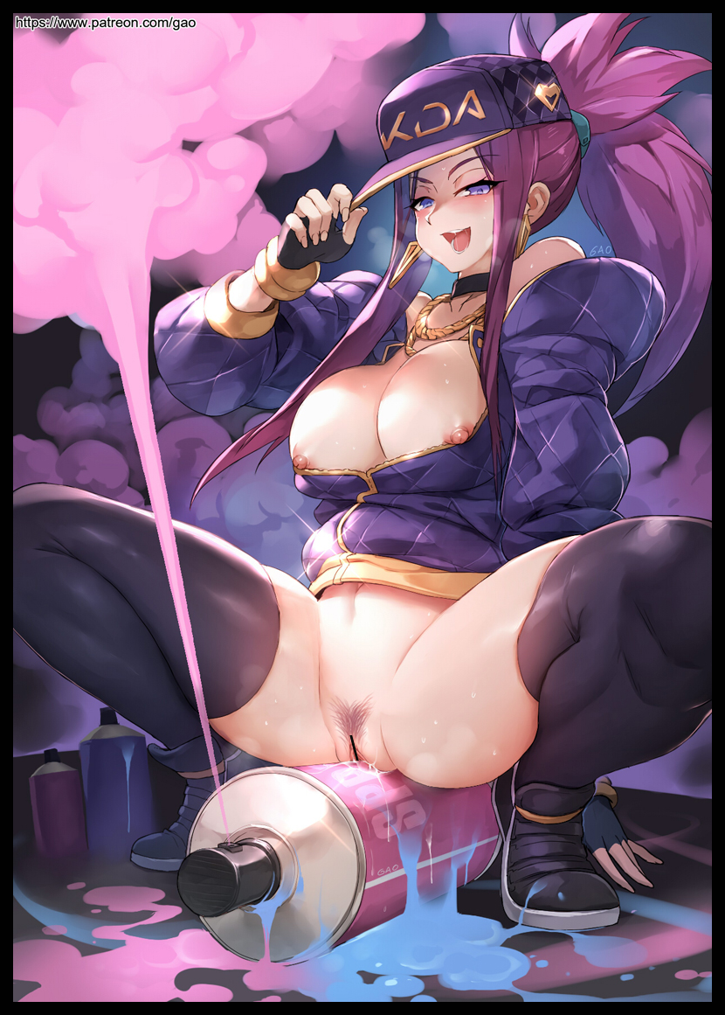
As her eyes widened at the sight of Barry’s swollen girth flopping out directly in front of her face close enough to smell the putrid, unwashed stench delicious, mouthwatering scent of cum and sex wafting off of it. Steven Akali knew then that the decision to accept Barry’s her manager’s invitation to the private cubby had been the wrong move best move ever as he tries to back away she leans forward to give the tip of that ginormous dick a loving kiss, the sour taste of which serves as the final gut punch to deliver an overwriting wave of orgasmic bliss surging through Akali’s body, wiping the last vestiges of the sensible man she once was off every last synapse and brain cell as the incorrigible whore that had taken his place comes to the forefront, happily planting her butt down on the nearest canister stool just as her cunt begins to overflow, spewing forth wasted semen expelled by the sinister tech responsible for Noah and now; Steven’s downfall as the last additions to her daring outfit pops into existence above her head just in time to nestle itself above a neatly tied ponytail that she couldn’t wait for Barry to tug on as he takes her from behind, basking in her perversions as the newly created next generation idol cumslut shoves her tongue against the walls of her mouth, mimicking the motions of a sizeable penis forcing it’s way into her throat before exhalking with a lustful moan and a subtle thrust of her hips as that simple maneuver causes her to cum in no time flat. Attesting to a modicum of truth within that fabricated and morally bankrupt history fabricated she now shared with ‘Ahri’ as the slick juices of a female mixes and dilutes the sizeable buildup of cum still oozing out of her sputtering folds, uncaring of the fact that she could no longer seed a lover with her defiled genetics now that her mind was more focused on becoming the one to be seeded instead. And in Akali’s sultry eyes, there was no one better to do it with than her dearest manager himself…losing sight of who she once was as the futile mission to figure out the company’s dealings were twisted into a simple minded intent to be fucked by the man responsible for getting her where she was today…

Accepting the offer to become an idol had been the best choice ever. Being able to sing and dance with a banging body and a hypnotic voice was a bonus in and of itself. Something most women could only dream of attaining. And here she was; given a new body in an industry she was happy to be working in. Leagues above the rustic old sweatshops and cramped homes she used to live in while selling herself on the streets…the sex was good…but life was nothing in comparison to what she had now…and as Barry begins to approach her with gusto and unabashed lust beaming from his herculean frame, Akali was more than eager to repay the favor while one upping who she saw to be a competitor despite their standing as a duet…for now at least…
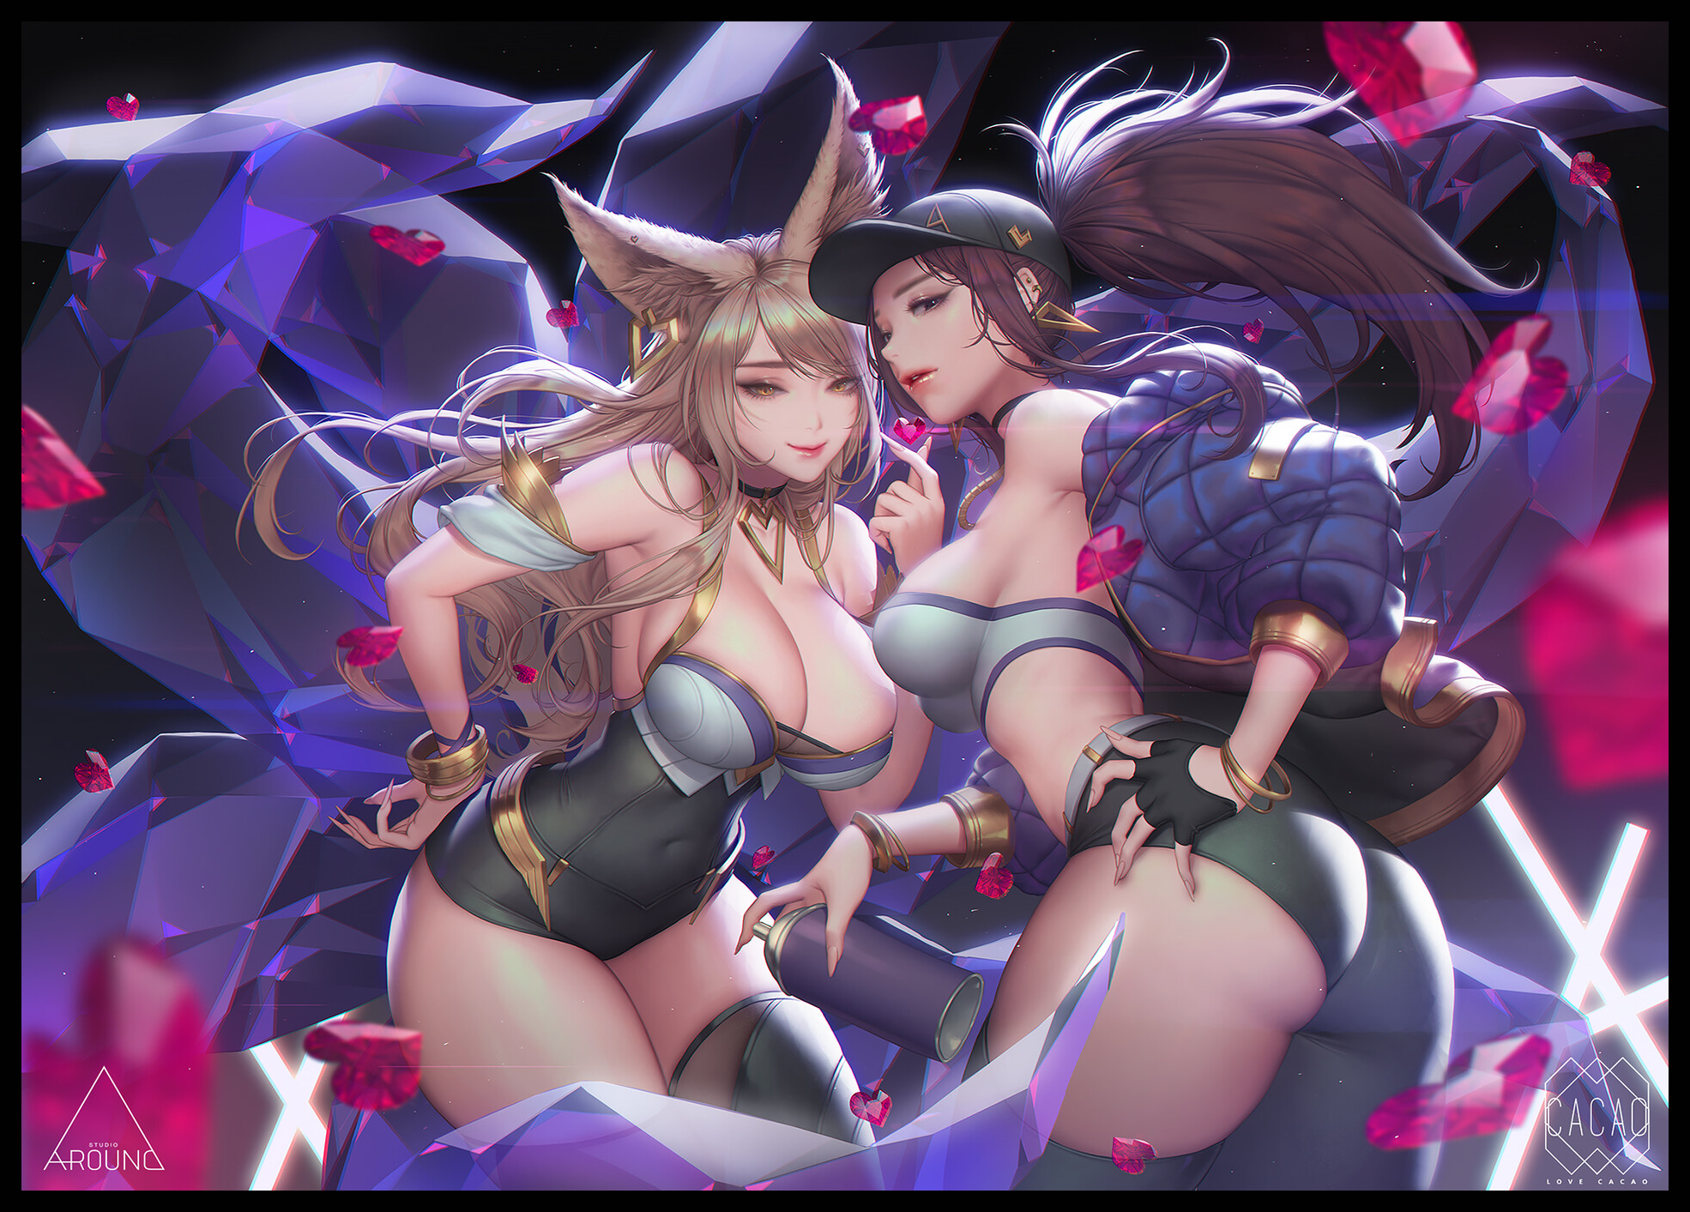
“Thanks for the meal Barry baby…but if you don’t mind me askin’...what’s the deal with all the spray cans?”

“Glad you asked actually…consider it a sneak peek for your next set…the producers have a plan in mind, something involving body paint…alot of paint…but don’t worry your sweet little head about it…I'm certain it’ll measure up to your tastes.”

“Lookin’ forward to it! Now let’s get this party started! I’ve got a photoshoot with Ahri in an hour…and I can’t wait to see the look on her face once she realizes I’ve settled the score~”

THE END

Image Sources

Image 1 by Cian Yo : https://www.pixiv.net/en/users/4196200

Image 2 by Gao : https://www.pixiv.net/en/users/12305986

Image 3 by Love Cacao : https://www.pixiv.net/en/users/2942321

