Study Buddy B&J Violation

“Finally home. Ugh, what a horrendous day…” Vanessa huffed with a weary grunt, leaning all of her weight against the front door of the condo she shared with her mother and younger sister,as if bracing against a torrent of flood waters on the other side. In a way the stress of 4 full time University college classes and related projects, her part-time job working retail in the local mall, holding up the threads of her dwendingling social life and regular trips to the gym, and other related logistics of dealing with the aftermath of the occasional successful hunt, felt like nothing less to the twenty-one year old than a torrential flood. She was thankful to be home and away from it for at least the rest of the night. All she wanted to do was lay in her bed and watch the next episode of the current hood drama she’d been bingeing on her tablet, munching on her favorite ice cream until she fell asleep, which considering how dogged and tired she was, wouldn't take long at all. Getting to her feet, she trudged straight to her bedroom, tossing her bag in the corner an her cloths in the nearby hamper before slipping on a comfortable red shirt and blue lounge shorts and made sure her tablet was charged and downloading the next episode of her show before making her way to the kitchen.

Of course, to her chagrin she found herself staring at her younger sister Garnetta and her unfamiliar friend at the kitchen counter which was covered in textbooks, tablets, cellphones and the decimated debris of various empty snack containers. They hadn't noticed her as the two were giggling and talking loudly enough to make Vanessa's ears ring, a testament to her own exhaustion considering she hadn't noticed such noise when she walked in. For a moment she considered just creeping back to her room and crawling in bed, but to reach peak relaxation she needed her Betty & Jen’s Chunky Cookie Ice Cream from the freezer, so with a deep breath Vanesssa put on the best big sisterly smile and continued on her mission.

“Oh hey girls, studying hard?” Vanessa said with the sweetest fake smile she could muster while B-lining straight for the freezer.

“Oh, Hey Sis. Yea got an exam tomorrow.” Garnetta replied quickly before trying to continue her chat with her friend, who on the other hand jumped up to her feet.

“Hello! My name is Catriana. Nice to meet you!” the girl nearly shouted in greeting.

“Uhh…yea…nice to meet you too,” Vanessa said, looking at the awkward guest oddly, before looking at Garnetta who just rolled her eyes and shrugged. Her interest in this person already waning, she quickly turned back to the task and opened the freezer reaching for her B&J’s Container that she had left on the door rack of the freezer. The container that wasn't there. Now with waning patience she quickly shoved an sifter her way through the rest of the items in the freezer only to find what he already knew but didn't want to admit. Her treasured Betty & Jen’s Chunky Cookie Ice Cream was missing.

“OOHKAY! Where the Hell IS My- Ahhk!!” Vanessa shouted, startled by the presence of Catrina, who was suddenly standing next to her, holding the empty container of B&J’s with a clearly apologetic expression on her face.

“I'm so sorry. Garnetta said I could have a bit while we were studying and we sort of got carried away.” Catrina said, clutching the container in front of her.

“We?” Vanessa prompted glaring at Garnetta who was still on the other side of the counter, her back to them and staring at her phone a bit too intently. Vanessa was still furious but surprised and a bit impressed that this young lady had the courage to come up and admit the truth, compared to her sister who was just as greedy as ever.

“Oh yeah, Garnetta had a good amount of it too…well…probably most of it actually. But it was my idea in the first place!” Catrina answered, seemingly determined to take responsibility.

“What the hell Garnetta!? I told you a thousand times to leave my snacks alone!” Vanessa shouted across the counter to Garnetta’s back, ignoring Catrina.

“Well, um…Maybe you shouldn't leave your snacks lying around.” Garnetta snapped back, looking over her shoulder with a smirk.

“LYING AROUND!?!? IT'S ICE CREAM! IT ONLY GOES IN THE FREEZER!!” Vanessa screamed, the stupidity of her sibling’s retort nearly breaking her already dwindling sanity, before suddenly a white hot calm took over. She looked down at Catrina who was cringing, doing her best to hide behind the far too small empty ice cream container in her hands, and looking into the girl’s nearly teary eyes she took a deep breath and sighed.

“Okay, fine then. If that’s how we’re playing it…” With an expressionless face of sheer calm Vanessa snatchd the box from Catrina’s hands and placed it on the counter. Then licking her lips she clapped both of her hands on Catrina’s upper arms, pinning the smaller woman in place as she leaned in. Confused Catrina barely struggled against her grasp, only watching in confused concern as Vanessa began to open her mouth. It wasn't until it was clear that the mouth was stretching wider and wider until there was a massive gaping cavern over her head did Catrina let out a short squeak of realization, but not soon enough to get away as her entire head was promptly engulfed by Vanessa’s maw.

Vanessa ran her tongue over the girl's face, soaking up the nice flavor of the girls face and head. Unfortunately it wasn't the delicious chunky cookie ice cream flavor she was craving at the moment, but perhaps this’ll due for now.

“Vanessa STOP! Spit her out! '' Garnetta shounted,now apparently her turn to be pissed off. Vanessa looked at Garnetta with an amused raised eyebrow, indicating this is only fair. Lifting the girl up Vanessa slurp her way down the girl's neck and over her shoulders, lifting Catrina’s feet off the floor.

“Dammit Vanessa! Cut it out! We’re studying for an exam tomorrow and I need her help to pass the test!” Garnetta commanded again. In response Vanessa swallowed, bringing her meal deeper into her mouth until Catrina's breasts were being juggled and fondled on her tongue.

“Fine then! I’ll tell mom! I will!” Garnetta shounted, finally threatening her sister with the only thing that would give her pause and pulling out her phone for emphasis. “You remember what mom said last time you swallowed one of my friends! You eat her and you’ll be gut-grounded for a week at least.”

Vanessa froze for a long moment staring daggers at her sister with Catrina’s upper torso and lower body flailing uselessly from her stretched salivating mouth. The thought of spending a week inside her mothers hot cramped stomach for a whole week all the while enduring lectures on proper behavior and what it was like growing up when she was a teenage predator, was not something Vanessa was interested in dealing with over a snack violation. But something had to give, she could not let Garnetta just get away with this rude disregard for what was hers. As she sucked on the girl's body for a few more moments The idea suddenly struck her. This was a matter of principle not necessarily a matter of hunger so what did it matter if this tasty guest didn't go into Vanessa's belly. All that mattered was that she went into…A…belly, to get her point across.

With a quick tug and heave Vanessa dislodged Catrina's now sticky and drool-covered head and shoulders from her maw and placed the shaking girl back onto her feet on the floor. At this point Katrina was bubbling and mumbling. something about this not being real and a bad dream. Vanessa simply patted her head andDraped her arm around the girl pulling her close, almost affectionately before addressing her sister once again

“OK snitch, there you go. Your study buddy here is free and uneaten.” Vanessa said, looking for an opportunity.

“Don't worry Catrina, everything's fine, this was just a stupid elaborate prank…” Garnetta said, reaching her hand out for Catrina across the counter, ignoring Vanessa and jumping immediately into damage control mode. There was nothing their mother hated more than the idea of a potential prey getting away in a way and revealing their eating habits to the world. So in order to keep the secret she had to immediately convince catrina that what had happened just now wasn't what it looked and felt like, so they could continue studying together for the exam. Unfortunately for Garnetta, Catrina and their study plans this was exactly what Vanessa was anticipating.

“What…A…a prank? It was a prank?” Catrina asked, looking up at Vanessa and then over to Garnetta, her eyes showing how desperately she wanted to believe that she was just the butt of a joke, instead of nearly becoming dinner for the woman next to her. Despite the woman who stared down at her with a knowing smirk on her lips and despite her head and shirt were covered in wet sticky saliva.

“Duh, yeah of course it was a prank. You really think my sister would actually be able to eat you? She just has a real weird sense of humor. Now come over here and let's get back to work.” Garnetta reasoned, trying to move past the awkward situation.

Just as Garnetta had reached Catrina's hand to comfort her, Vanessa grabbed her arm, tugging her sister off balance and up onto the kitchen counter. In a series of quick motions Vanessa expertly manhandled her younger sibling and quickly had her back pinned to the counter. With her body pinned down and her arms locked and impotently flailing, Garnetta was helpless when Vanessa snaked her left hand around and hooked her fingers inside her mouth, prying her jaw down and pulling it further and wider by force.

Though not in any particular amount of pain, as being a predator she was more than used to stretching her mouth as wide as it took to get a meal down her gullet, Garnetta still fought despite her disadvantaged position. She figured it was very likely that in her annoyance Vanessa was planning to gobble her up and she was not interested in spending the night in her sister's stomach or however long it took until her mother came home and made Vanessa vomit her up. If anything she was more confused and angry at being handled so roughly by her big sister. If Vanessa just planned on swallowing her up then why let Catrina go, who would likely escape during the tussle and get them all in trouble. And why pull her mouth open so wide by force. It wasn't until Garnetta heard Catrina’s pleas once again as she struggled to get away from Vanessa's right hand that she connected the dot.

“Hey! Let her go! Wha? No No NO! What are you doing!? No, Let me go!! No please! Not again!!"

Garnetta often forgot exactly how horrifically strong her older sister was. This was one of those rare yet poignant reminders. From her prone position she watched helplessly as Vanessa lifted Catrina up over her head by the shirt collar with one arm and with the form of an over-shoulder punch, she slammed the girl headfirst straight into Garnetta’s pried open gaping mouth. With all the accompanying force of momentum assisted by gravity, Catrina’s head and upper body shot straight through Garnetta’s throat, down her esophagus, plowing through the esophageal sphincter only to stop as she face-planted at the bottom of the stomach. Garnetta didn't even have time to taste, swallow or even gag as her stomach was immediately bloated out with Katrina's head and shoulders. And at this point with her throat so full of the rest of the girl's torso with her legs flailing and kicking in the air, all Garnetta could do now was either continue to swallow or suffocate. And considering how with her right hand freed up to assist in this forced feeding of her younger sister, Vanessa didn't seem to have any intention of letting her go. Using her now free hand she shoved Catrina deeper and further inside Garnetta’s mouth, teasing and taunting her sister the whole time.

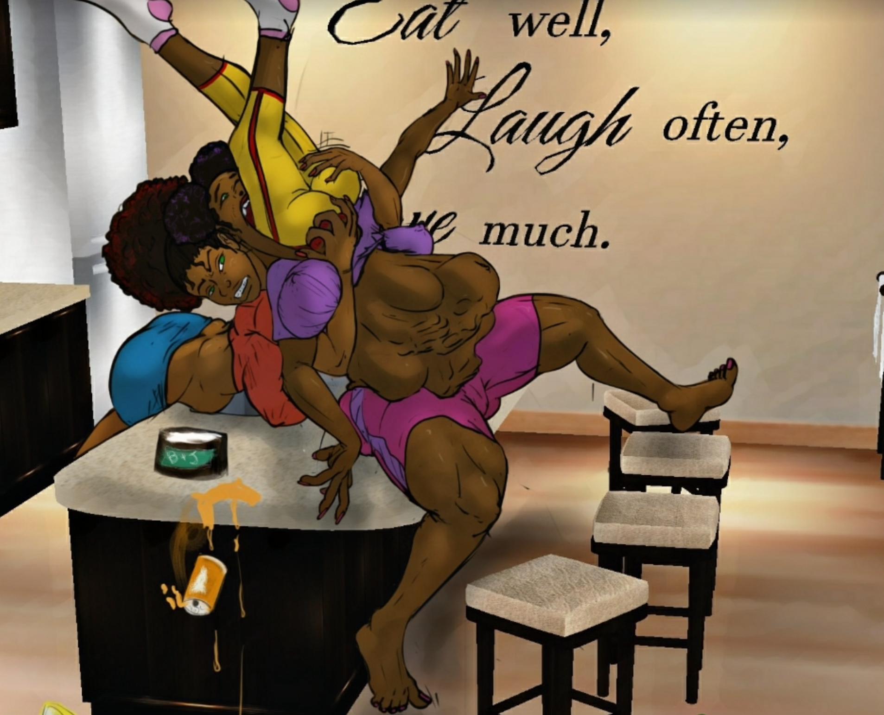

‘Oh wow Garnetta you really outdone yourself girl. Not only do you eat all of the snacks and all of my ice cream but then you eat your study buddy too? tsk tsk. You're so lucky your big Sis is here to help.” Vanessa teased, all the while cramming Catrina’s legs further down her sister's throat.

“Mmaohomna *gulp* Eloahp *ULK* momph!” Garnetta tried to threaten between forced and involuntary swallows,

“Tell mom? Tell mom what, hm? That you pigged out on your own buddy Catrina, here? Sure, tell her. What do I care...It’s not like I'm the one who gobbled up your study buddy. '' Vanessa said with a final shove, pushing Catrina’s socked feet past Garnetta’s lips and down her throat to slide down into the swollen convulsing mass of stretched stomach where the rest of her body was packed into.

Satisfied this outcome and finally releasing her sister from her pinned position, allowing her groaning bloated sibling to flop back fully onto the kitchen counter, Vanessa grabbed a paper towel to wipe her hands of the saliva that had coated them during the recent ordeal and walked around the counter to survey her handiwork from the side. Garnetta lay on the counter flat-backed and panting, the weight of the immense dome of stretched Umber brown belly flesh heaving with the effort of her ragged breaths. Vanessa could hear the muffled cries and pleas emanating from the tightly stretched skin tented over Catrina’s easily decipherable form in Garnetta’s belly, which squirmed and writhed beneath the surface.

“No hard feelings, Catrina. If you gotta blame somebody, blame my greedy little sister. I hope you give her terrible indigestion.” Vanessa said to the squirming girl inside Garnetta’s huge groaning stomach, and gave it a few hearty slaps. In response she got some muffled words she didn't really care to try to interpret, noticed by a few pronounced bulges across the surface and heard a raucous belch from the other side.

“BUH-OUAAAARRRP!...Ooohh, Vanessa…(Ourp)….you’re such an ass (hic)...asshole.” Garnetta growled angrily between labored breaths and belches, still too flustered and stuffed to attempt to move from her prone position up on the counter.

“Uh-huh sure, sis. Look, don’t worry about me hon, I'll let you get back to work. I’ll just snack on these leftover cookies over here. I know you and Catrina got some studying…and digesting to do. Good luck with your exam tomorrow.” Vanessa replied in a mockingly cheerful voice.

Looking over the belly again, suppressing the twinge of jealousy as she wondered if Catrina would've looked this amazing crammed into her own gut as she did in Garnetta’s and ultimately deciding she was more than satisfied with this outcome Vanessa nodded to herself. Then giving Garnetta’s engorged writhing gut and its occupant another hearty smack stirring things up once more, she grabbed a half eaten pack of cookies and walked out of the kitchen and back to her bedroom. This ordeal had taken up way more time than she anticipated but had given her a pretty good adrenaline rush and she wondered if she could binge the rest of the season before falling asleep.

# The End