SEASIDE SIGNAL
COMMISSION STORY
BY CHALDEACHANGE


YoRHa No. 2 Type-B had plenty to be cautious about.

It wasn’t as if she was exploring an unknown area or anything like that though. She had come to this section of the City Ruins numerous times before, and it didn’t necessarily seem like there were more Machine Lifeforms around than normal. In fact, the greatest hazard to her wasn’t an enemy at all. It was what surrounded the building rubble and rooftops that she traversed that was concerning, that she might make a misstep or get pushed into it by an enemy.

The seawater, that was. It was extremely deep, and while YoRHa units were designed to be able to wade through light water or stay out in the rain? To be submerged too deeply was essentially a death sentence for the frame they were using. The moment they swallowed water, or it otherwise got into their bodies, it was just a matter of time before their systems halted their operation.

So, what had brought 2B out to such a risky location in the first place? There had been a distress signal from another YoRHa unit being sent out from the flooded portion of the ruins, and 2B had been the only unit on the ground capable of investigating while 9S was back in The Bunker making a report. “This is the location, isn’t it?” In the end she traveled across all of the buildings until she found herself upon the nearby beach.

But she couldn’t see what had sent the signal. The beach was completely empty from what she could see. “Could it be buried in the sand?” It was possible, but… “What!?” She wasn’t able to confirm or deny it, because there had been a sudden flash of light that felt like she had been struck by a stun grenade.

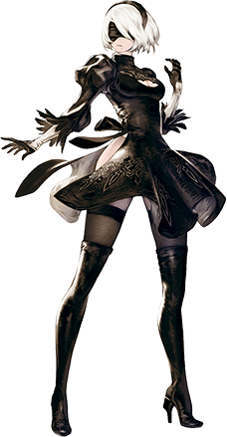
But when her vision eventually cleared? The android was quick to realize that it was far more than that. She was still standing on a beach, but it was much more vibrant than the one she had just been standing upon. The sky was bright and blue, and behind her? There was a bustling, standing city. “Pod? What just… Pod?” Not to mention the fact that her little, floating partner remained to be seen. “It’s like a different world…”

No, it wasn’t just like one. If the readings she was getting, and her inability to contact HQ, were both to be believed? Then this probably was a different world. The location didn’t match any of the map data that she had available for the ruined city, and there shouldn’t have been any human civilization still standing out there. “This requires investigation, however…” Where could she begin? She had never met a real human, and how would they react to her if she did?

Little did she know that the ‘city’ behind her wasn’t exactly occupied by ‘humans’, though. Nor that she would soon be joining the ranks of what they were.

2B suddenly winced. There was no pain, but her cameras and sensors had all suddenly short-circuited? “Wh-What!?” Had something akin to an EMP gone off all of a sudden? No, she had fallen victim to those devices before and they always affected her movement just as much as they did everything else. They likewise afflicted her inner mechanisms with some form of damage. And once again? She couldn’t detect anything like that even without her sensors to guide her. It was as if they had randomly shut off. Only to return about fifteen seconds later as if nothing had happened. “That was certainly… unusual.”

Had it been a mere issue with her hardware? Perhaps her sudden relocation to wherever this was from the City Ruins had interfered with something far more fundamental than she was accustomed to? “Scanning… No errors detected.” But did that mean that the temporary shutdown had occurred without any consequences? That was actually a far cry from the truth of the matter. Because beneath her visor? 2B’s icy blue eyes, well…

The cameras that made out her irises weren’t really icy blue any longer. They had begun to shine with a brilliant amber, the eyelashes that framed them now thicker than they had ever been. It was a change that was actually reflective of what was happening internally, as her innards were subtly changed and reworked to suit the development of an android created with a vaguely different design philosophy in mind. And the more her insides were altered to reflect this, their changes gone unnoticed by her sensors? The more her exterior shifted to reflect that.

“I think it’s time to… show off my beach bod! …Hm?” What was that she had just said? And with such a peppy tone? 2B wondered briefly, but ended up shrugging it off regardless of how much it contrasted her usual personality. Personality and memory data was being subjected to the same phenomenon as everything else, clearly, and those words were being spoken through thickened lips upon a face that looked more and more… typical?

That wasn’t a dig about the beauty of the new form she was taking so much as a testament to just how beautiful YoRHa androids were in the first place. So as her face became fuller, her eyes narrower, and her nose smaller? The type of beautify she possessed was irreversibly altered to resemble a different woman – a different android – altogether. From there? The powers affecting her bled into her short, white bob of hair. White darkened to a dull brown and thickened so that it curled in towards her chin. It would have matched her eyes much more appropriately if her blindfold visor hadn’t been obscuring them.

2B’s previous comment about having a ‘beach bod’ felt more out of place when you considered her body, while sexy, wasn’t really the type of body that would be described that way. At first, anyways. “At the beach I always level up!” This time she didn’t even seem to react to the words she just outlandishly blurted out. But it was getting harder and harder to react… in general? If that hadn’t been the case, then she probably would have reacted to the realization that she could… see clearly?

Not only was her visor gone, but her entire YoRHa uniform had been stripped from her body and replaced in the blink of an eye. A white bikini with square cups, a necklace, sunglasses on her forehead, and an orange jacket were all that covered her body. But while she definitely looked to be more ‘beach ready’ dressed in a swimsuit? It was by and far way too big around her chest. It was all hanging flat against her body. She was so attractive in her own right, but she didn’t have a particularly voluptuous upper half.

Something compelled 2B to stretch and she raised her arm into the air. When she finally allowed her limbs to drop back down to her sides, though? Her chest bounced and she momentarily lost her bare footing in the sand, nearly stumbling forward. “Whoa!?” Was that… normal? She stared down at her own cleavage and arched a brow. Something seemed different somehow. “Am I smaller?”

There was no way that she could have logically concluded that her breasts were smaller. Especially when she had actually stumbled forward in the first place because they’d grown to twice their original size within the bikini top. But she had come to this conclusion because of altered memory data. She recalled that they were even larger, and before her amber eyes they continued to swell until their big-nippled I-cups fit neatly into the strapless bikini top. “Er, wait… That’s the right size, right?” She even arched her back and then pushed forward to make them jiggle. It felt familiar.

Some of that weight was shared with her thighs and ass, but because they were already so weighty their growth wasn’t as dramatic as it was a contributor to these regions jiggling a little more loosely than they had. Mind you, a sudden height drop of three inches made these almost unrealistic curves of the android’s stand out all the more apparently.

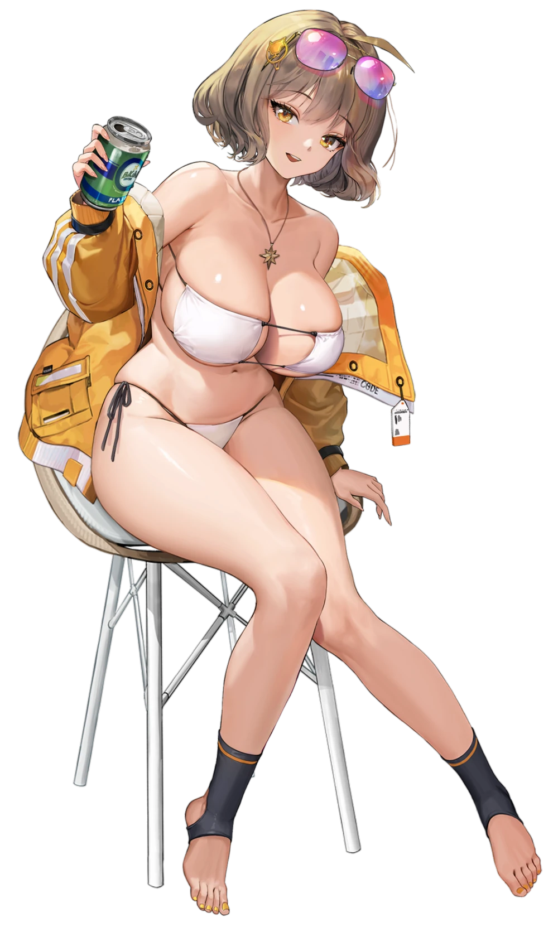
Fundamentally, while she had technically become a different type of ‘being’ altogether, what the big breasted woman was now wasn’t tall that different from a YoRHa android. She was still an artificial individual meant to strongly resemble a human, while technically being a weapon created to fight in a war. A NIKKE was still an android at their core, and Anis was no exception. “A nice, refreshing soda would be perfect right now. I’m parched!”

But there was little point in denying the significantly more relaxed vibes that this NIKKE was giving off compared to who she had been. She was dressed for the beach in that bikini of hers, and seemed intent on moving in a way that made her ampler curves jiggle about. TST! Slender fingers had pulled a can of soda out of a nearby cooler and opened it so that she could take a sip, beads of cold condensation dripping onto her tits as she did.

“That hit the spot!” She exclaimed after drinking her fill and wiping any residue from her thick lips. She looked around, not even realizing that the beach had suddenly become full of other beachgoing NIKKEs who were all on holidays with her. But she seemed confused. “Where is she? She’s taking a while.”

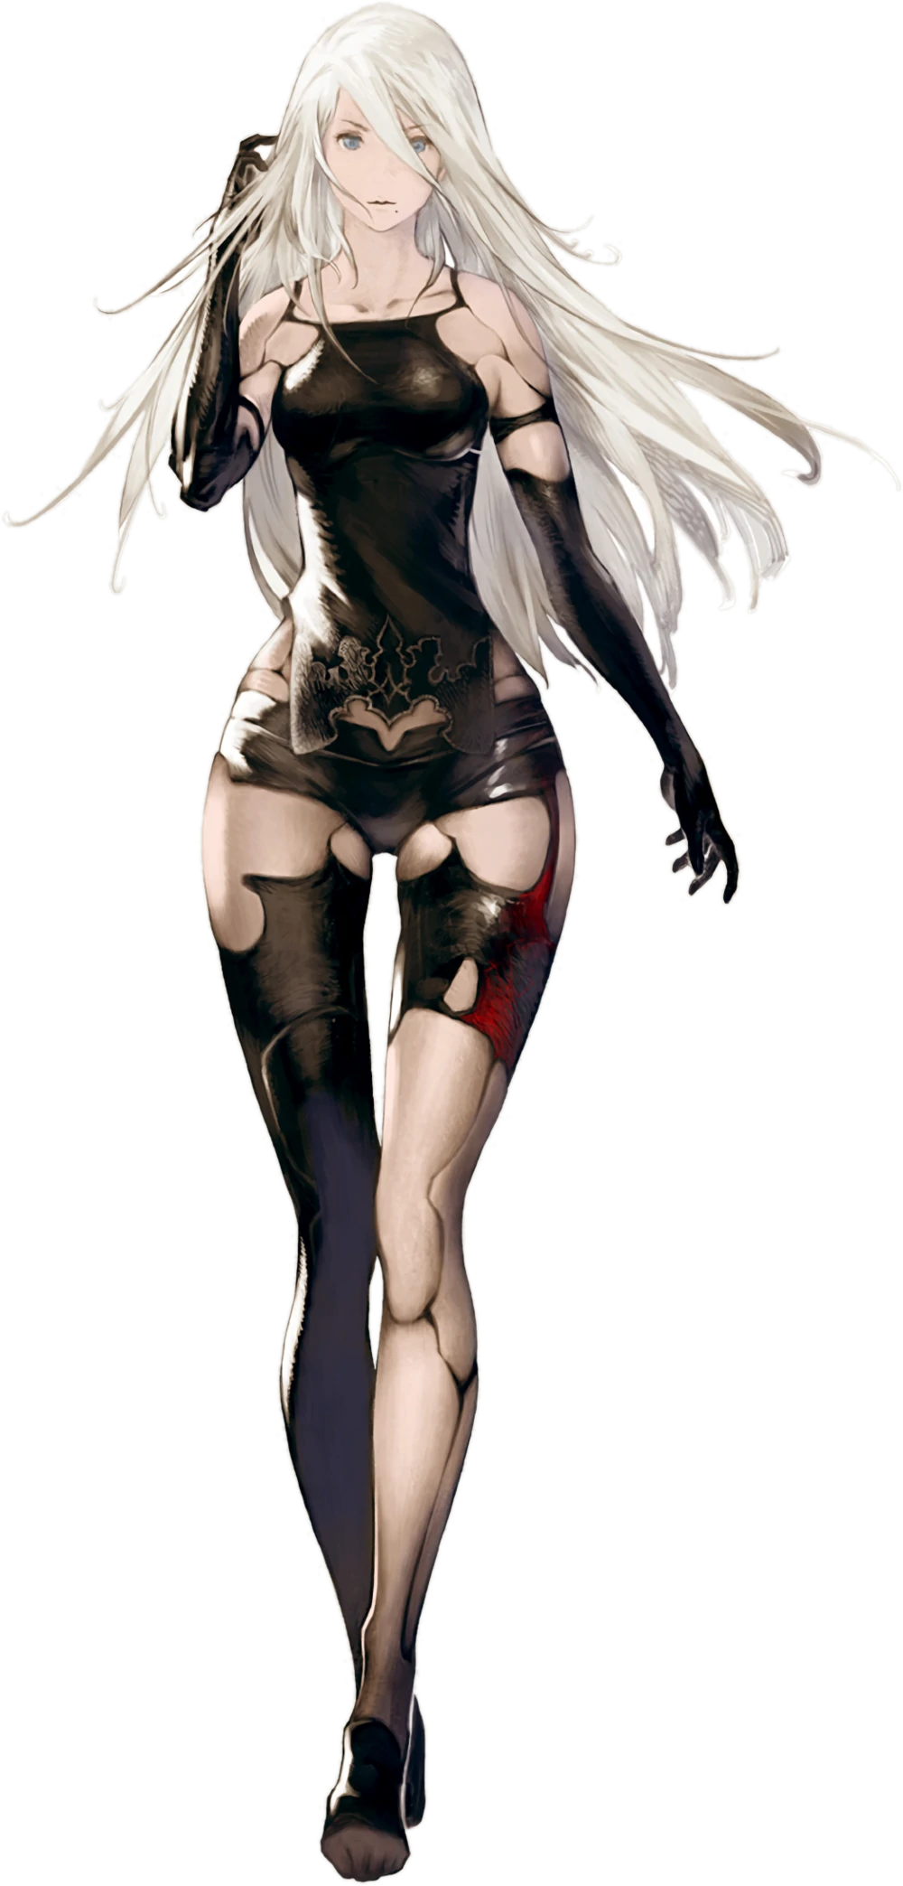
At the time, 2B hadn’t recognized at all that she had been getting tailed. Yet she had been, by the YoRHa unit whom the organization had been hunting as of late: the defector, YoRHa Type-A No.2. It had been a coincidence at first. Her hideaway had been within the outskirts of the city’s submerged portion, and she had caught sight of 2B entering. Out of curiosity A2 had tailed her, now expecting to get caught up in that flash of unknown light.

“…What?” The android had been hiding behind some rubble on the Ruined City’s outskirts, but with that flash of light had completely changed her surroundings. She was still located relative to 2B on the beachside, but she was within a small, wooden room? It was a changing room hut on the outskirts of the new beach that existed beyond the door. “Well, it isn’t like this will contain me.” A2 thought she was being trapped by an enemy and decided she would break out. But the moment she went to swing her sword? “…!?”

…Where had her sword gone!?

As A2 was quick to realize, the absence of her blade wasn’t even the only difference in her equipment that had occurred. Aside from a black cloth piece down her front, the android should have been completely naked. The black on her body was exposed plating where artificial skin had been burned or eroded away otherwise. The problem was that this plating was covered? A one piece swimsuit wrapped around her crotch and rose high on her hips. It was black with white stripes on the sides but seemed far too loose around her chest and butt.

“How did this… COUGH!?” A distortion in the android’s voice led to her coughing – despite the fact that she didn’t need to breathe. Was her voice box malfunctioning? Her voice had sounded different for a moment, adding to her woes. But it did serve as a great distraction, pulling her attention away from her body as all of the exposed plating that had been revealed by damaged skin was hidden once more. Lifelike, artificial skin and flesh was reconstructed in a vaguely different color than it had been previously (although the remaining skin took on the same shade with time), recreating even nipples on her chest and a pussy between her legs beneath the swimsuit.

And from there? The changes became much more extreme. Synthetic tissue accumulate her thighs and ass, pushing her buns and legs well beyond their usual size. This growth gave her hips no choice but to wedge wider, which forced her knees to buckle. “Kya!?” …And so, she made a noise she typically would have never made after almost taking a spill in a voice that was vaguely different from her own. She managed to correct her posture in the end, but…

Her ass was much, much bigger. Cheeks had bounced while extended nearly five inches out behind her. The shapeliness of her lower half stood out indecently while wearing a swimsuit that provided almost no coverage, especially as it hugged the deepened crack of her ass. But contrastingly? The cups of the swimsuit weren’t afforded the same level of boon. A2’s reformed tits did become bigger, and engorged nipples led the charge on that front. But growing up to F-cups wasn’t a change that could be scoffed at, either.

The woman shook her head as if she was trying to blow away a fog. That fog, of course, merely being a side effect of her memory and personality data undergoing their own alterations. “I’d like to shake this strange feeling… Although it might be a good reason to delay leaving…” Since when did she care about leaving the changing room, exactly? Why? Why did the thought of strangers seeing her dressed this way bother her all of a sudden?

Things had been a little tight around the stomach of the swimsuit at first, and once her ass and breasts had grown in, that feeling felt even stronger. She was tugging at it her and there to try and alleviate some of the tension (especially since she was cameltoeing the hell out of the base because of it). “Hm…” The feeling came to pass though, courtesy of her height unwinding ever so slightly. All it took was a loss of two inches or for the one piece swimsuit to fit her frame perfectly. Almost as if the swimsuit had been made for her.

Which it had been, technically. It had at least been made for the woman that she was turning into.

As these thoughts and memories became stronger, the force that was altering the ex-YoRHa android finally focused on rearranging the last remaining traces of her old identity. A2’s face lengthened vertically, and she acquired a sharper chin beneath larger lips. The blues of her eyes were pierced by a magnificent vermillion, although while her personality had changed, her resting face continued to be just as indifferent as it had always been.

It could only have been her hair that was saved for last. A dirty blonde swept through white strands effectively. Her bangs rose on top of her head, but by and large? The woman’s hairstyle didn’t really shift in any sort of significant way. It didn’t seem quite as messy, perhaps, and it was much better taken care of. Because A2 lived out in the wilds of the City Ruins where things like shampoo and conditioner weren’t commonplace. Whoever she was now, she was someone who at least had the means to take better care of things.

Only once her transformation had fully completed did the woman notice a full length mirror in the corner of the room. Had it always been there, or had it been obscured at first to avoid having the victim notice what was transpiring. As she gazed into her reflection at this point? She saw nothing wrong with her crimson gaze, her supple flesh, nor the clothing she— Well, she actually wasn’t a fan of having to wear a swimsuit even now.


“I can’t help but wonder what Commander would think if they saw me dressed like this…” Rapi checked herself and her swimsuit ‘one last time’ in the changing room’s mirror as she spoke, picking the natural wedgie that the nylon was giving between the cheeks of her perky ass in the meantime. Compared to some of the other NIKKEs it wasn’t like she had an especially bombastic body, but Rapi liked to think that she had a very sporty appeal that the one piece swimsuit she had chosen really helped to bring out.

She was just apprehensive about going to the beach with Anis of all people. While the two were part of the same unit, they had rather differing personalities. Rapi was the much more uptight and reserved one of the two and didn’t necessarily like crowded places like the beach. Whereas Anis could be bubbly and social, and really didn’t have any issue showing off her body. And so, Rapi had been stalling her exit from the changing room for a few moments now.

Clearly not recalling her past identity.

But in the end? The past identities of neither NIKKE really mattered now. While they were still android weapons by design, it was clear that the lives they would lead going forward were definitely better. They clearly had time to relax and have vacations like this, and there was a sense of community within the Ark that YoRHa had never had. They also didn’t need to repress their emotions and could just be themselves. Who they wanted to be was up to them.

“HEEEEEEY! RAPI! HURRY UP IN THERE? I WANNA GO HIT ON SOME OF THE OTHER GIRLS!”

The sound of Anis’ voice calling to her from the other side of the changing room door caused a shiver to run down Rapi’s spine. She had been trying so hard to avoid going out onto the crowded beach! …But clearly her friend and squadmate had finally had enough of this ploy. But hit on some of the other girls? Why was she so interested in that all of a sudden? Well, she supposed there was only one Commander. They couldn’t all be the object of their affection, and so it was becoming more and more common these days for NIKKEs to mingle romantically between one another. She let out a defeated sigh.

“Fine. I’m coming…”

In a worst case scenario, she would just disappear into one of the shops on the beachfront, never to be seen again!

Then again, Anis was extremely persistent.

