PETRA-FIED
JUNE 2022 FIRST PERSON STORY
BY CHALDEACHANGE
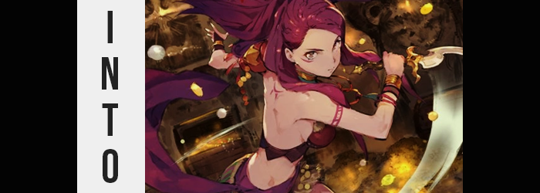

2022 had been a surprisingly dry year for game releases thus far.

Sure, there had been Elden Ring and a number of smaller titles, but there wasn’t anything that had just grabbed me like it should have outside of that. It was already June, and I could only boil down the new games I had enjoyed to two or three releases max. It wasn’t really all that odd for there to be a gaming drought around the summertime, though. Most of the big releases typically came out around the winter or fall.

But there was one glimmer or hope, it had seemed. Only a few months before, Nintendo had announced the arrival of Fire Emblem Warriors: Three Hopes. It was a game based off of the phenomenal Fire Emblem: Three Houses, yet one that used the traditional musou gameplay that they had been putting into spinoff after spinoff. How many years would it before they released Super Mario Warriors, really?

I was, naturally, excited. And thankfully I didn’t have to wait long, because shortly before the game’s release a demo was put up on the Switch store. Finally I’d be able to see what the game was all about! Or at least that had been my hope. So no sooner than it had been announced and released, I had set out to download this demo so I could play it in the evening.

“Huh? It’s still not done downloading?” So you could imagine my disappointment when I booted up my Switch that night to find that the download bar had stopped halfway, and an error message was being displayed on my screen. “Data conflicts with the data from Fire Emblem: Three Houses? What the heck does that mean? They aren’t even the same game!” Cautious as I was (because I didn’t want to accidentally lose my Three Houses save data) I took to the internet before pressing any buttons to see if anyone else had experience with this issue. But as hard as I searched? There didn’t appear to be any reports of the same problem whatsoever. Was I cursed? Or was this just suspicious as hell?

It seemed like I didn’t have a choice but to try and close the prompt and reset the download process, though. My only other choice was resetting the console, but I didn’t want to risk losing all of my data over a demo of all things. No sooner than I pressed the B button to exit out, however? I recoiled, for a sudden jolt of electricity had run from the controller into my hands. “Ow!? What the fuck!?” Thankfully I was holding the controller over my desk, so it didn’t fall and break.

But I was naturally concerned about my Nintendo Switch suddenly zapping me!

What’s more, it appeared that my Switch had turned off in the process. “Crap! I hope I didn’t fry it!” Even though the console was so old now, they were still pretty expensive if I had to buy a replacement! I naturally stood up to try and examine the device but reaching a hand out I couldn’t help but notice something strange. “Wait, what’s up with my hand?” My fingertips almost looked darker? Had I been burned from that electric shock? If only it had been that simple.

Because I was clothed, the fact that strange markings had begun to etch themselves upon my body had understandably flown under my radar. I couldn’t notice things that I couldn’t see, of course, so such was the long and short of it. Nonetheless, markings done up in crimson paint had begun to make their way across my pale skin. Tattoos of some form, to be sure.

Among these markings were two bands around my right arm. One just below the shoulder, and one just before my wrist. Their maroon-ish colors certainly stood out against my very white skin, and that was also true of the one that emerged as an upside down arch between my shoulder blades. And even the curved arch of red beneath my right eye.

But I had not noticed these new adornments, for I was still focused on my fingertips and, with increasing apparentness, the rest of my hands. “Wait, is my skin color getting darker? It must be a trick of the light…” My gaming room was fairly dimly lit, so I could write that off as the case for a time. But this light tan that began at my fingertips ultimately consumed up to my wrists, and then crept up my arms and into my body. “Shit! What is doing the happening!?”

The fact that something had been very awkward about my English there aside, I was also unaware of the fact that the darkening of my skin had been occurring across my body simultaneously. Just as my hands had darkened? So too had my feet, and it had been climbing up my legs. Before long, even my face was fully tanned – a far cry from the sickly white that I had been since birth.

“This can’t be right.. Am I having the dreams?” There it was again. Like something in my mind couldn’t speak my native language properly. Or more like… English was no longer my native language at all. Either way, in terms of severity of issue, that wasn’t even the biggest problem on my mind at the time.

Nope, instead… “Urp!?” For a moment it felt as if I had been punched or kicked extremely hard in the gut, and that forced me to lurch forward as tanned fingers reached down to pat my belly. The issue was that the ample gut that I was accustomed to feeling when I interacted with my stomach was no longer there. Instead? My hand ran into a stomach that was not only flat, but I could feel the grooves of muscles running across them. A six pack? I’d never been muscular in my life.

Feeling understandably overwhelmed, in turn I had become a little woozy. Dizziness beset me, and I placed a hand upon my desk nearby to stabilize myself – in turn missing how my fingers were smaller, but were also decorated with hard callouses and longer, slightly cracked nails. The muscle that I had felt on my tummy was not isolated to that region alone, for strength had rippled through my otherwise thin arms as well. Not to mention my legs, where the muscles were perhaps the strongest.

“The dizzying is bad. My body is not… My voice has done the changing? I am sounding like a woman!” It finally hit me that my voice wasn’t supposed to be quite so feminine, nor were my words supposed to be so strained. I was having more and more issues stringing together functional sentences, but the shock of it all helped the panic from building too excessively. Well, that, but part of me deep down had begun to reassure myself that everything was alright. And that I should just accept this. Whatever this was.

My lashes fluttered, now with greater length than they had before, while the eyes between rounded and brightened. Lost was my biological eye color, a color that would most certainly be seen as normal, and in its place something more abnormal took root. A dull red, not all that different from the tattoos across my tanned skin. These eyes ultimately bore more resemblance to those of a woman, and in turn the rest of my face conformed to this same aesthetic.

My lips grew plumper, my nose fairer, while my cheeks took on a softness that was not born from any excess weight. In general this face was fairer, but there was something astutely exotic about it as well. Well, at least compared to my Caucasian look before. It even extended to my hair, which grew longer, fuller, and was overtaken by a slightly brighter red than that of my eyes. It fell far down my back, strands frayed near the back as if it was commonly pulled into a ponytail.

I pressed my hands together in my lap, responding to a strange feeling in my loins. “Oh, I am not feeling the very good…” It was almost if something had just been squeezed incredibly tightly between my legs, but it had also been accompanied alongside a prompt and significant drop in my height that had dropped my pants and boxers to the floor. Not that it mattered, because since I was now about 5’3”, my already oversized shirt practically worked as a dress. Hiding that, well…

“Have I been becoming a woman!?” Or had I always been a woman? That point was blurry. It almost felt new, yet no small part of me felt certain that this had somehow always been the case? Nonetheless, I now had a pussy between my legs with a very shaggy bush of red hair above it. Evidently, I didn’t shave very often, if at all.

With my biological sex irreversibly altered, it made sense that the rest of my body would follow suit. Hips parting was most certainly a part of it, and thighs that had been rendered burlier by my new muscle strength ultimately found a new, plush softness as a feminine weight saw the raw power disguised. My thighs were left ample, and that ampleness bled into my ass as well. Thinner now, my rear end hadn’t amounted to very much. But now that my sex had changed? It jiggled and bounced into a pleasant peach shape – ripe for the grabbing.

Of course, what happened to my chest could not be understated either. For while I once had a flat chest (maybe a little pronounced due to my previous weight), my nipples had engorged, and breast tissue had begun to develop beneath them. They gradually pushed forward little by little, lifting my top enough that you could see just the base of my pussy, until these breasts were perky, if a little bouncy C-cups.

“This cannot be being real! Have I really been becoming Petra?” As had been the trend over the course of my transformation, my English sounded to be completely broken by the time my body had finally taken the form of a bright, young Brighid woman by the name of Petra Macneary. The very same woman that was a character in the two Fire Emblem games that had given me an error on my Switch. Not that I could really remember what the console was called now.

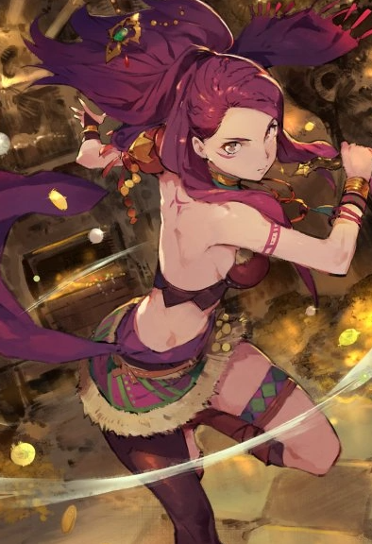
In fact, much of my modern room confused me. From my computer to the furniture, it all looked unfamiliar. As if I didn’t belong there, even though I could remember to the contrary. “I am not doing the understanding. Why is it that everything feels so strange?” Well, the fact that my body had just transformed into that of an attractive young woman was part of it. The fact I was only wearing an oversized t-shirt was another. And the fact that my memory was finally beginning to catch up was, quite frankly, the final nail in the coffin.

The more I stood there, stunned, the more confused I became. I gradually forgot the skills that came with living in a modern era, like using a phone, or even memories of the luxurious foods we were afforded. Instead, I began to become familiar with more… violent things. How to hunt, how to kill, how to wield all matters of weapons. Not that I believed using one would have been of any help at that particular point in time. It became so bad that once my TV began to glow, I had completely forgotten how that was even possible.

“What is it that is doing the glowing? It is very bright!” I guarded my eyes with a tanned and tattooed arm, but I quickly realized that I could not protect myself from the strange glow. Because it was pulling on my very body! “Oh no!” Try as I might, I just couldn’t manage to pull away. And before I knew it? I had been completely absorbed by the television.

Just as the Nintendo Switch whirred back to life.

The next thing I was knowing, I was doing the waking in my bed back in Garreg Mach. It had been five years since Edelgard had done the starting of the war with the Church, and it was seeming like the end was finally going to come soon. As the princess of Brighid, that made me very happy! It would be good for my people, and not to mention all of Fodlan! But there were still battles that we had to do the fighting in, so we couldn’t celebrate just yet.

“Another day! Okay. I must go do the training with Dorothea!”

And nothing felt odd about that to me at all.

