JOINING THE PILGRIMAGE
COMMISSION STORY
BY CHALDEACHANGE
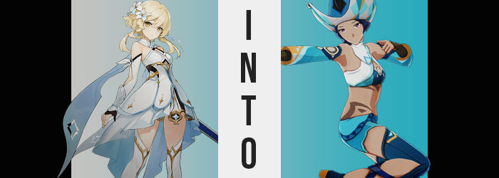

The journey to Natlan had been a long time coming at this point.

Mondstadt, Liyue, Inazuma, Sumeru, and Fontaine had all been visited at this point, which meant that in all of Teyvat there were only really two major nations that the Traveler, Lumine, and Paimon had on their list. Or at least two that were ruled by Archons. Natlan was the first of the two, while the second was the nation where the Fatui were rooted. Snezhnaya would likely be the most perilous of them by far, and despite Lumine’s penchant for working alongside the Harbingers when necessary, potentially the most openly hostile towards her.

But if it was necessary to go there to learn more about what her brother was doing then she wouldn’t shy away from it. Natlan was first on this tour anyways, and she didn’t have the foggiest idea how long their stay there would last. She’d heard that their Archon was warm and welcoming, and so the young woman didn’t really have any worries about that. She’d met Archons of varied personalities by this point anyways (with Inazuma being the most hostile).

Still, it was a little harrowing to arrive in a new nation for the first time. Lumine was unfamiliar with Natlan’s land, food, and culture. There was always a learning curve in the first few weeks or even months, but she was traditionally fortunate enough to encounter people that were willing to help her out. In Fontaine it had been Charlotte, Lyney, Lynette, and Navia.

And in Natlan? She had been lucky enough to meet with Kachina. She was a young warrior from the Children of Echoes tribe; a good kid with what seemed to be a noble and caring heart. Apparently, she had planned on participating in a local Natlan event known as the Pilgrimage of the Return of the Sacred Flame. It was a yearly tournament to determine the strongest warriors possible to participate in the Night Warden Wars, a battle against those of the Abyss that encroached upon Natlan’s safety.

A noble cause to be sure, and one Lumine had been happy to help support her in. But there was one small problem. For round one of the tournament, it was required to participate in a team of three. Kachina’s team members had abandoned her, and while unlikely to be accepted? Lumine had offered herself up as a potential teammate. “Huh. So, I guess that won’t work after all.”

In the end, it hadn’t just been unlikely. The notion had been outright rejected by the woman who handled the team registration, leaving Kachina in a bind once more. “D-Don’t be discouraged!” Surprisingly, it had been Paimon who had chimed up to break the silence after the fact. Evidently even she could read the room once in a while. “Let’s split up and ask around! I’m sure if we scour the arena, we can definitely find new teammates for her!”

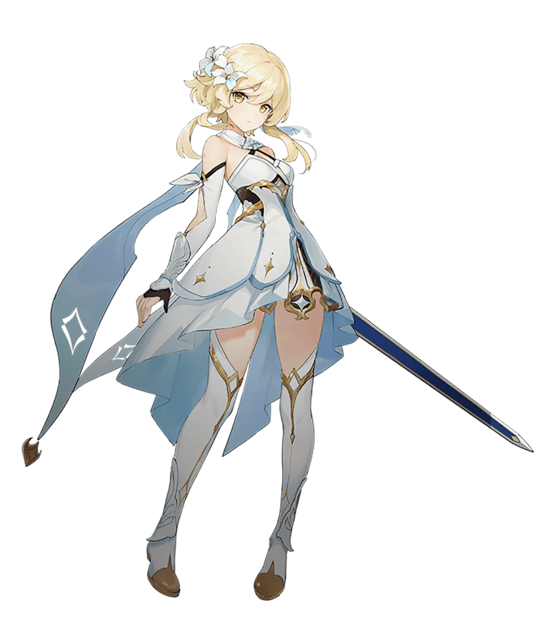
At Paimon’s nudging, the three young women had split up to visit different corners of the Stadium of the Sacred Flame. “It makes sense that only Natlan natives can participate.” Lumine mused to herself after making a number of fruitless inquiries. Everyone who was at the stadium who planned on participating was seemingly already on a team. Time was also running short, as were their options, so she had to hope that Kachina or Paimon were having better luck elsewhere. “I guess it wouldn’t hurt to ask one more person…”

“Girl. Are ya looking for a Natlan native to participate in the tournament?” It was around that time that someone spoke out to her from a shady corner of the stadium. A man that was overly robed, holding out a glimmering, blue orb. “Go take this somewhere private and make a wish. I’m sure if it’s pure enough, you’ll find exactly what you’re looking for.” It was a suggestion that was more than just a little bit shady, but the Traveler was all out of options.

So, she paid for the trinket and took it to an isolated corner of the arena after thanking the man. Lumine had definitely made shadier purchases from shadier people in the past. “Make a wish, though? Is it going to shine as a beacon to bring a Natlan warrior to me or something?” Her imagination wasn’t limitless. In terms of what a mere gemstone could do, that was about the most outlandish outcome that she could possibly think of.

“Do I just hold it in my palm?” Did she have to state her wish aloud? Come to think of it, she should have asked the man for more clarity regarding the instructions. Then again, maybe that was just yet another sign that she had been duped? “Uh… I wish that Kachina had more Natlan warriors for her team?” The Traveler ended up only holding the gem in her palm in the end, and at the urging of her wish? It did begin to glow. “Woah!?” This light was dull at first, but it soon surged brighter and brighter until she had to look away from the shimmering blue.

But amidst this light? She could feel the gemstone crack and crumble in her palm while a tingling sensation reverberated throughout her body. When the light finally faded? Forget breaking. “H-Hey!?” The gemstone wasn’t in her hand at all. Almost like it had been shattered so thoroughly that it had turned to sand and blown away. “And I don’t see any warriors here to help Kachina, either. Guess I was scammed.” Well, she had considered it to be a possibility. Thankfully the gemstone hadn’t cost too much in terms of Mora, or else this would have been a real loss.

There was something strange happening though. It had just been a touch too subtle for it to occur to Lumine in the moments following the gemstone’s collapse. She’d felt a little awkward. Not socially, but as she moved and breathed… it was almost like 1 + 1 didn’t equal 2 like it should have. What was the best way for her to describe it? Almost as if her body wasn’t moving the way she was accustomed to. Or the way she subconsciously expected it to? Had she always been this light and floating? Wasn’t she usually heavier and more muscular?

The young woman shook her head. “That’s weird.” These were rather unusual misconceptions to have about one’s own body, especially when they weren’t true. The Traveler was definitely stronger than she appeared, but that strength wasn’t the product of her muscle mass or anything like that. It was by the merit of her hailing from another world, and even then, that strength paled in comparison to plenty of warriors within Teyvat.

“Maybe it’s nothing…” The young woman attempted to brush the strange feeling off in the end, but unfortunately that was nowhere near enough to stop what had been set in motion. No amount of ignorance would prevent what she had desired when she had made a wish on that gemstone. Kachina would have her Natlanian allies to allow her to enter the tournament. It was just going to unfold in a way that Lumine hadn’t anticipated.

And this wish granting was already beginning to take effect… just in places that were difficult to notice. Take the skin beneath Lumine’s dress, for example. Wrapping around her hips and under her chest? Some very unusual markings had begun to paint themselves into her skin. They weren’t melanin based, but rather a type of permanent dye that etched an ashen shade into what could best be described as a set of tribal markings.

But that was only where a change of coloration began. It wasn’t where it ended, too. This was promptly made evident by the rest of the young woman’s complexion. It didn’t occur in any substantial amount, but with the Traveler’s hair as lightly colored as it was, the contrast between it and what was becoming of the rest of her skin was more obvious than if her hair color had been darker. Aside from the tribal markings? The rest of her complexion had grown a touch more melanin rich. A very light tan was procured, her nipples and lips browning a little more than anywhere else on her body.

The victim of this didn’t seem to notice. “I still feel odd. It’s like nothing is working right.” Lumine had originally intended on reuniting with the others, but her steps felt clumsy. That mismatch between her subconscious and her body had grown stronger. Her reach felt too short, and her steps didn’t go as far as she believed they should? These sensations almost appeared to grow more potent as her hair darkened – away from blonde and to a brown that bordered black. Making matters stranger, this hair became a little coarser and seemingly shrunk into an even shorter, and curlier, bob than she’d ever had before.

Of all things, her appearance was now much more suited the racial profile of a Natlan native. The woman’s bright, golden eyes dulled to a plainer brown, yet their colors weren’t the only part of her that ended up appearing plainer. “I didn’t have anything to drink, so it isn’t alcohol… but I guess it isn’t unlike me to stumble about!” Was that true? And was that… how her voice usually sounded? It was deeper, but there was a little more uncertainty and pep to it simultaneously. It made her sound like a different woman entirely.

...Which appeared to be the point. What ended up looking plainer was her face on the whole. Her features shifted in shape and size until they weren’t particularly remarkable, with a droopy gaze, larger nose, and thicker, glossier lips. There was no way that you could consider this new look ugly, she just didn’t really stand out amongst the people of Natlan like she had before. In fact, there was one tribe in particular she would have fit right in with.

Lumine did look older though. Like a young adult rather than an eternal teenager.

“Actually… I’m starting to feel a little better?” Was she going crazy? She couldn’t even really seem to remember what had been bothering her in the first place. This was the case, though it wasn’t because her mind had adjusted any further. In fact, it was her body that was adjusting to the reach and motions that her subconscious expected. This was largely accomplished through growth and bulk alike. Both of these changes washed over her body in tandem, too.

Lumine’s height sprung up like a freshly watered flower. Standing at roughly 5’3” to start, in truth she had never actually believed she would grow much taller than that. While Lumine probably wouldn’t have in the end, the difference now was that she wasn’t really Lumine, was she? So, she was allowed to grow and grow she did. One inch, two inches, three inches… Her dress definitely wasn’t fitted to accommodate such a sudden growth spurt, for she shot all the way up to 5’8”.

But what her dress likewise wasn’t designed to accommodate was a bulkier build. This was also something that she developed in spades, with basically every muscle in her body growing in strength and abundance to give her build a more defined tone and a strength that, well… was actually weaker than the strength she had possessed before becoming a mortal. At most, she was on par with one of the many grunts she had faced during her travels across Teyvat. Still, there was something sexy about how she was practically bursting out of her outfit.

“Were my clothes always so tight?” This wasn’t a problem caused solely by her muscles, though the victim didn’t seem to realize that she was bulkier or of a darker skin tone. Nor did it really occur to her that her dress was tighter around her chest than anywhere else because her bosom had swollen two cup sizes larger, deepening the cleavage of her neckline while her panties struggled to wrap around an ass that pushed out several inches behind her. Her panties were wedgieing the heck out of her! She didn’t even get a chance to pick that wedgie, however.

Because the discomfort had just gone away? “Huh?” The woman in question couldn’t recall why she had been uncomfortable, just that she had been. Well, she had been, right? But it was hard for her to believe when she was wearing her regular combat attire. A traditional crop top of her tribe fashioned in white with blue cups, bound to her neck whereas matching, detached sleeves overlapped brown, fingerless gloves. Bare pits and her toned tummy were bare, showing off her new markings, but she did wear baby blue shorts and dark blue leggings bound to healed boots. There were cutouts in these leggings up the right leg to show off her skin aside from her thighs, too.

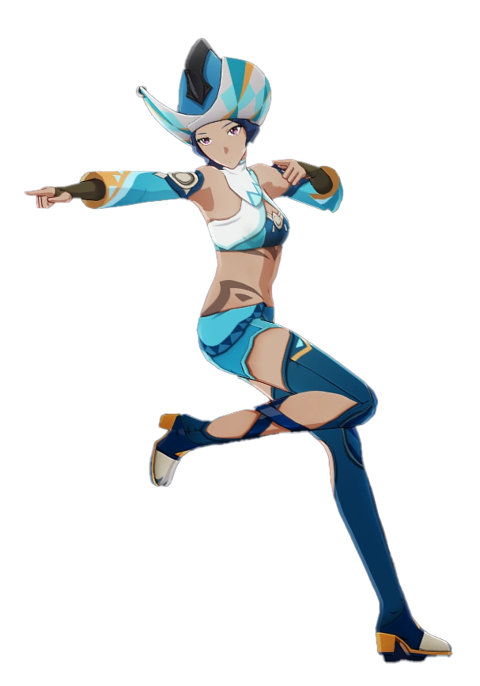
Leilani, a young woman and warrior of Natlan’s People of the Springs tribe, looked around with a look of befuddlement plain across her features. “I’ve come to the Stadium of Sacred Flame as requested, but where is the rest of my team?” Ultimately, it hadn’t been the tanned woman’s intention to participate in the Pilgrimage of the Return of the Sacred Flame at all.

She didn’t consider herself to be an especially accomplished warrior within her tribe, especially when compared to the exploits of her younger sister, Mualani. She was halfway decent at mixing both combat and dance, but she still had a lot to learn. But Mualani had so earnestly requested that she team up with a young girl from the Children of Echoes.

…Or at least that was how she remembered things now, and how history had been adjusted to accommodate her new identity. A traveler from foreign lands? Leilani couldn’t even fathom ever having lived a life like that. She had always been content remaining within Natlan’s borders just as most of its people were. Still, she was confused. Her shortcomings weren’t really isolated to her combat talents alone. “…Is it possible this is the wrong meeting place? I could have sworn… But this stadium all looks the same inside!”

She was notoriously incapable of following directions and had a terrible penchant for getting lost.

By the time she sped off and found this girl she was meeting for the first time, Kachina, another woman was present as well. One from her own tribe, an older warrior named Kainoa. Leilani knew her from home, but it was odd. It almost felt like she had some kind of strange connection with her. Which wasn’t surprising from an outsider’s perspective. Seeing as how she had been Paimon. Lumine’s wish had affected more than just herself.

But none of that was really on her mind at all. “Phew… Sorry about that, we almost missed the registration period because I got lost!” She was just glad that they managed to register in time! She knew full well that there was no way Mualani would have been impressed had her poor sense of direction gotten her young friend disqualified. She’d just have to do her best going forward!

