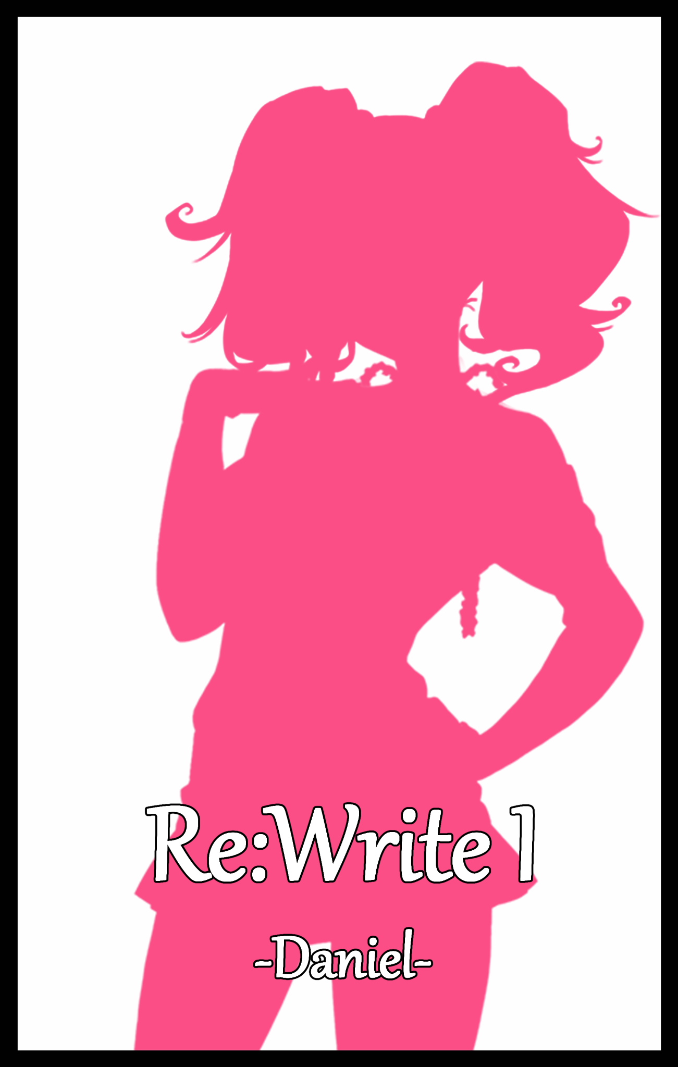

Chapter 1
-Encounter-

Pendleton University, a prestigious institution for learning that served as the last step on the path of education for most of the nation's brightest minds vying for a spot in Pendleton, with less than a fraction of that number getting in thanks to the university's strict selection process involving a multitude of interviews and tests. A filter to sort out chaff from wheat, so to speak.

But despite the high level of intellect and decorum demanded of the few lucky students who manage to earn themselves a place within Pendleton. The men and women running the board high up the chain of command were not as 'clean' as they liked to make themselves out to be. For one, bribes were commonplace throughout the annual admission cycle, leading to 'slipups' where students clearly unfit to walk the halls were allowed entry over other, more deserving spirits just because they had a big stack of green dollar notes, leading to some minor outburst every year that would be go by mostly ignored. Drowned out by all the good words pumped in by their kind hearted benefactors taking precedence over some jealous family who didn't get their sons and daughters enrolled in Pendleton…

At the end of the day however, money could not save failing grades. Whether or not the entitled beats could last against the rigors of university was entirely up to them. At least the board members saw sense there, refusing bribes by snobbish upper class parents to give their children an unfair pass.

Corruption and fraudulent claims aside, there was another curious anomaly roaming the halls, one that seemed exempt from most of the rules that applied to the rest of the student body thanks to the special relationship he had with the person running Pendleton University.

It was a young man that towered over most of the other students there even taking into consideration their similar age range as young adults. Sporting a muscular build and an immense frame, he was an absolute menace, going out of his way to terrorise the weaker population of the university, treating the place like a highschooler's wet dream as he went around name-calling people whatever tickled his fancy while beating down those who protested. He never once attended a class on time, oftentimes just skimping out on them entirely as he went about his own business in and out of campus.

When he wasn't smoking behind the garden shed or out burning his money on expensive women and drink, the crew cut thug could usually be found loitering around the roof or venting his problems in the gym. Everyone knew who he was, and yes, people did fear his brutality. But they all couldn't wait for the day when his father would finally have enough of his shenanigans, kicking him out the door on his bum without the influence of a family name to boast and laze around all day with.

But who was his father one might ask? Well, none other than the Rector of Pendleton University himself; Regis Pendleton. Indeed, for no other student besides one directly connected to the de facto ruler of the university could've gone by for so long without receiving punishment. Unbeknownst to his son, the weary old man had agreed to his crude demands to be admitted into the university only because he wanted to test him, to see if he really could be changed for the better one last time.

Maybe it was because of his duties as Rector, but Regis couldn't help but feel a part of the blame for Kevin Pendleton's regression into a bully unfettered by laws and a moral code was on him. He hadn't been there for his son when his late wife had moved on, and now it was too late, frustrated and ashamed at the way his son had turned out, wondering if his mother was lucky, unable to lay her eyes on the brute her little boy had become.

Enough was enough however, for years now he had behaved like a degenerate who didn't even have the faintest shred of respect towards his elders, much less his own kin. If he was going to continue to resist his efforts to rehabilitate him, then Regis saw no choice, opting to wait till Kevin either showed an unlikely change of heart or messed up big time to decide on what came next.

What was certain however, was that Kevin's days at the university were numbered, and everyone couldn't wait for the day the bully vanished forever…But the hand of fate was a fickle thing, fluctuating between either ends of the moral compass, maintaining neutral ground between good and evil, never truly favoring one over the other.

Unless of course, agents worked to shift the odds to their favor. And in this instance, Regis, Pendleton University and its inhabitants had the misfortune of being caught right in the middle of a web of machinations laid out by forces unknown. Utilizing deceit and manipulation, their will was enacted through the shifting of pawns across the playing field. An unwitting chosen one who would wind up playing into the hands of those who sought to wreak havoc in the realm of man.

And at the center of it all, whether he knew it or not, was a seemingly ordinary Engineering student packing his bag in preparation to leave the lecture hall, looking a little worn out with a sore cheek bulging from beneath a bandage. He would become the instigator behind the following events that would leave him and many other souls changed forever, for better or worse depending on the clashing viewpoints of the various people soon to be embroiled in this one sided event that clearly favored the depraved darkness stirring the calm into a storm just for the fun of it, watching the young man's every move from far beyond the campus boundary with superb vision as he slings his bag over the shoulder before heading out the lecture hall.

None too eager to face a crowd, Daniel Weller was an introvert to the core, preferring to stay in the company of video games and comic books than a fellow human being. Though he did have to leave his den for school, once the day's schedule was over, he would make a beeline straight for home, eager to jump back in front of the computer once more.

Though that didn't mean Daniel was a complete recluse. For he couldn't have earned a spot in Pendleton otherwise, studying and revising whenever he could with a photogenic memory to aid in exams and practical tests. He could very well go further than where he was now, but Daniel wasn't too much of a big dreamer, liking things the way they were now as a slim smile paints itself over his face upon turning the corner and coming face to face with a well kept man decked out in Pendleton's uniform before greeting him with a familial fistbump while a blonde haired lady stands sheepishly to the side, hugging folders close to an unsuspectingly generous bosom masked by the voluminous top of the girls uniform, not joining in on the conversation with shifty glances to the side as if she had done something wrong. If anything, he was more than happy to see his friends, especially after what happened earlier that day, resulting in the swelling bruise on his cheek after stepping in when the campus bully had set his eyes on Alex, still feeling sore around the neck where he’d been grabbed and pulled into a suckerpunch.
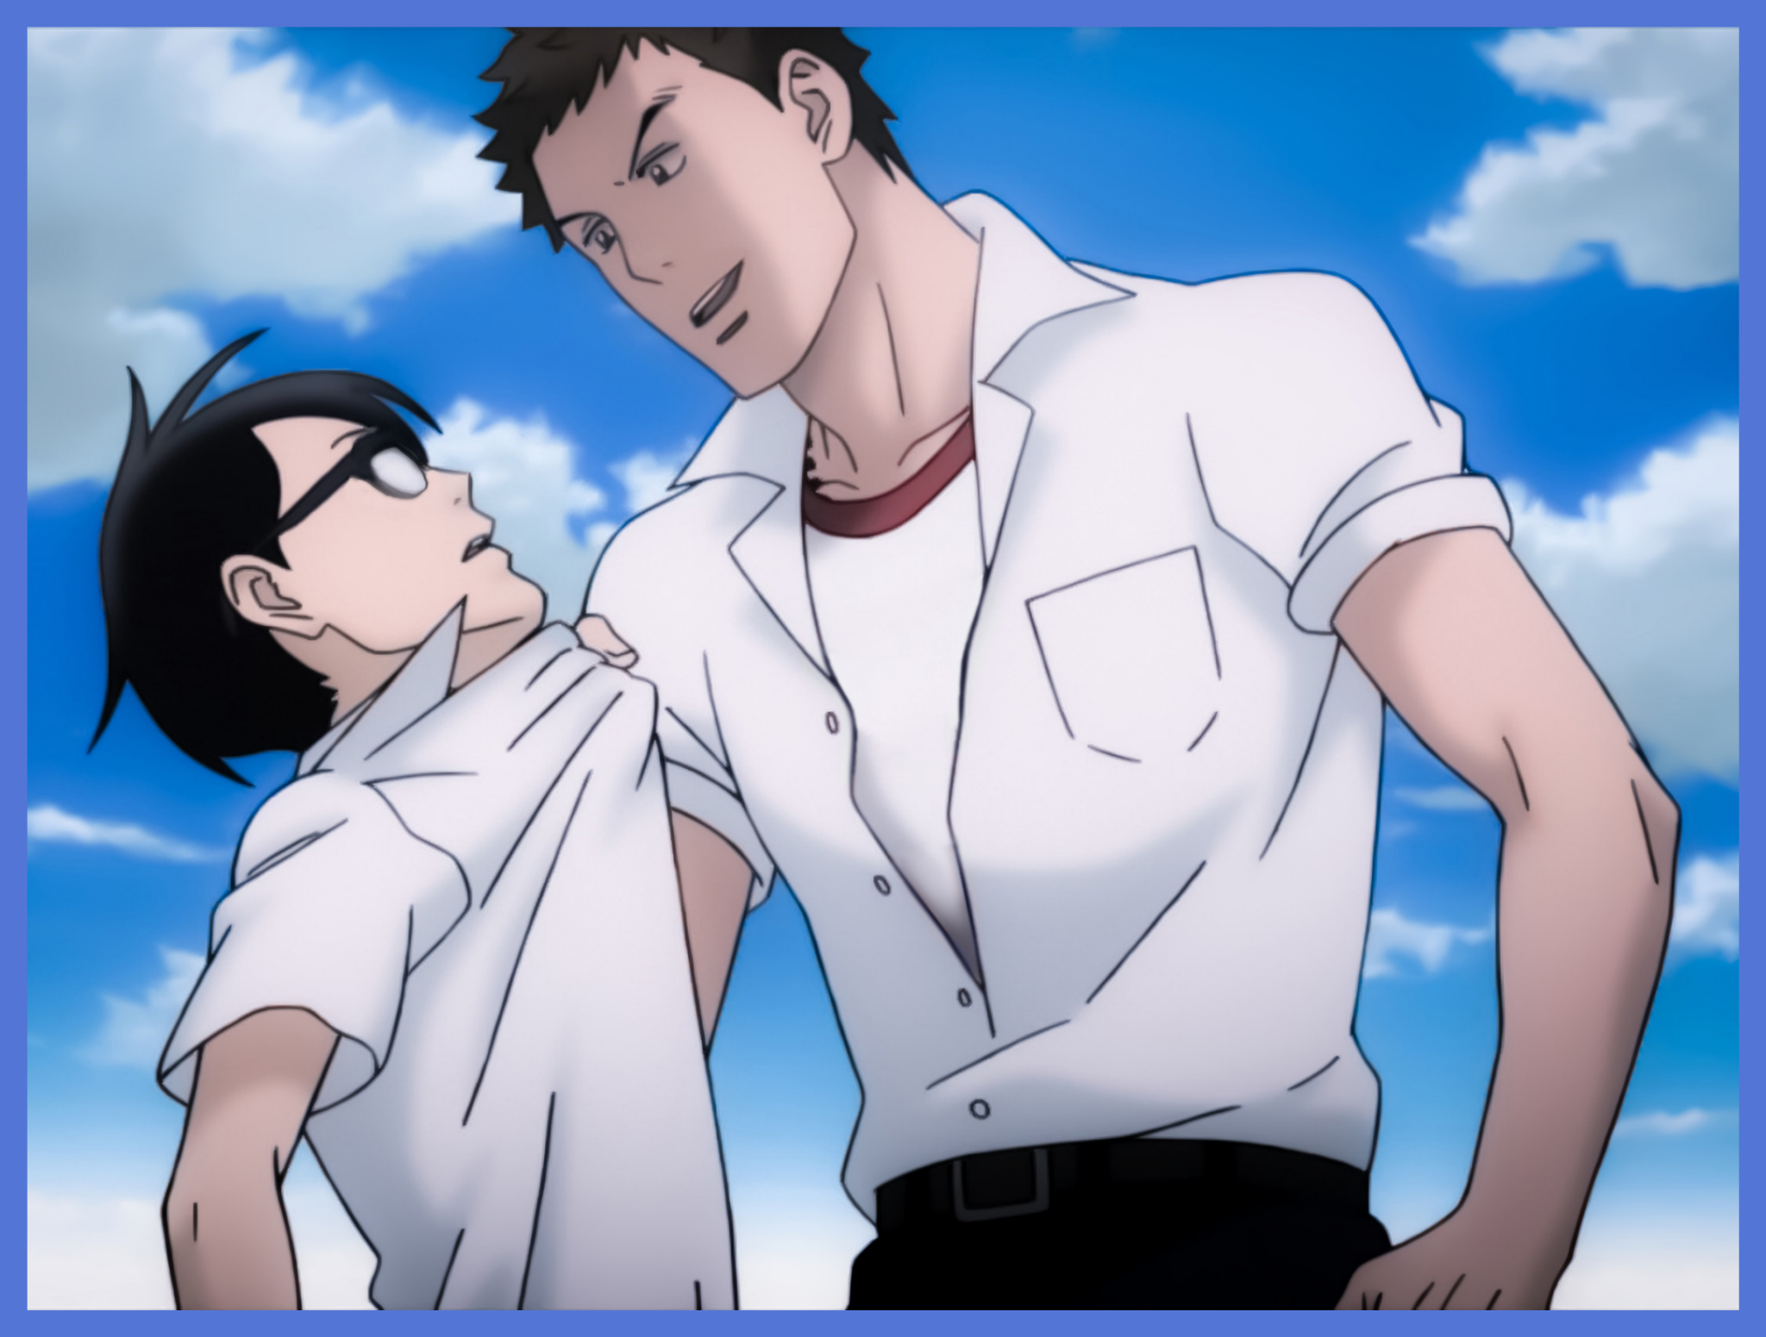
Before him stood Caleb Pendleton, not to be confused with the university itself, a stalwart man who was also the self proclaimed defender of the downtrodden and helpless in Pendleton. Tight knit friends ever since they met as children in kindergarten, Caleb was one of the only few people outside of the family Daniel was willing to stick his neck out for. Especially when he was one of the only few people, lecturers included, who could stand against Kevin and his arrogance, being both nimble and strong enough to stand toe to toe with the lumbering brute.

And over to his left, still shifting her weight uneasily from foot to foot, was Alex Bradford. Arguably even more of a recluse than Daniel was, the girl wasn’t known for being much of a talker, preferring to keep to herself at all times with a book never far from hand. Unsurprisingly, many of the students in the campus had the hots for Alex, whose bodacious figure and maidenly visage betrayed her rather boyish name, an attraction that meant she often times had to face proposals and many other encounters with her adoring fanbase, rejecting them all with flowery words before scampering away, leaving them in the dust none the wiser to her true tastes and hobbies she kept hidden behind closed doors.

Just like Caleb however, Alex was another familiar face from Daniel's childhood, spending a majority of their early years together before a deviation in highschool, only to end up reunited once more within the hallowed halls of the country's best university. Two of the best friends one could ever ask for in a pinch despite their differences and the only folk his introverted shell would break for.

"So? How's the injury? Getting any better?"

"Please…injury? Nah, it's all good…one tiny bruise to tell off an asshole talking down a girl isn't gonna decommission me…how about you? Take any return fire jumping in like that?"

"You know me, dumb ape's too slow to catch me anyway. For all the bodybuilding, he's way too slow with his fists….hey, C'mon Alex, don't make that face, I told you it's not your fault…look, Daniel agrees too, don't you bud?"

"S-Stop treating me like I'm a kid…are you really fine Dan? It looked like Kevin landed a real good hit back there…it sounded bad…"

"Yeap! Told you guys already didn't I? C'mon…give me some credit here…"

"Hah! When you only ever leave home for school? Can't blame Alex for thinking that way…you're lucky I was there when the fists started flying. Jerkwad!"

"Yeah…how much longer do you think the board's gonna stand him? I heard the only reason he's here is because he's the son of the principal or something?"

"Rector…and yeah, his dad's supposedly 'testing' him or something, he's more eager than us to get rid of him for good, one more major slip up and he'll have an excuse to disown him!"

"I-Isnt that…kind of harsh? To cut a blood relative off like that…"

"Alex…sometimes you're too kind y'know that? Kevin's got it coming I say, rotten scumbags like him don't deserve pity."

Moving on in a tightly packed cluster while continuing their discussion about the university's infamous bully, the trio walk off down the hallway full of students and lecturers going about the rest of their day while the conversation amongst themselves soon changes from a dour mood into a jovial one as the three talk about their plans for the rest of the afternoon now that they were free from lectures and practical lessons. Bouncing quips back and forth with Alex soon joining in the banter.

By the time they'd jabbed Daniel with enough quips about his nonexistent social life outside of their little circle, the trio had already reached the gates where they would all part ways since they lived in separate portions of the city, no longer the neighbors they once were over a decade ago as their conversation slowly does down, saying their goodbyes as they prepared to set off for another cozy weekend doing their own thing.

"Thanks again for earlier Cal…"

"Don't mention it man…it's what friends are for…but y'know? You really should be more assertive next time, I think it's good for you!"

"Y-Yeah…I didn't think anyone besides Caleb would jump in front of Kevin like that!"

"Like I said…I can take a hit…just don't show it often is all…alright, I'm outta here, see you guys on Monday!"

Kicking off towards the left side of the street away from Pendleton University, Daniel turns his back on his friends as he makes his way home, the aching in his cheek long forgotten.

But after a few minutes of walking, eventually Daniel would reach a point in the curved winding road his parents had given him a special warning about not to loiter in. Apparently a hot spot for junkies and the like, the place was eerily vacant today, devoid of cars, the homeless, even the animals made themselves scarce with nary a peep from the local cats or chirping from the mynah flocks that usually swept the area for scraps. Not like it bothered Daniel much though seeing as he loved this sort of thing, being alone and all that.

Attributing the newfound peace to police patrols and aid groups cleaning the area out, the unwary student continues on his way, turning another bend before narrowly avoiding a curious old dwarf of an elderly woman dressed in old, oriental clothes poking around near the road, on the lookout for something until her focus was broken by the sight of Daniel swerving out of the way to avoid his knee clocking her in the nose. Beady eyes locking with his, fishlike face beaming with a stiff smile punctuated by comically small lips that jutted out the front like a bright red button. Snickering under her breath as she takes in the bewildered look on Daniel’s face
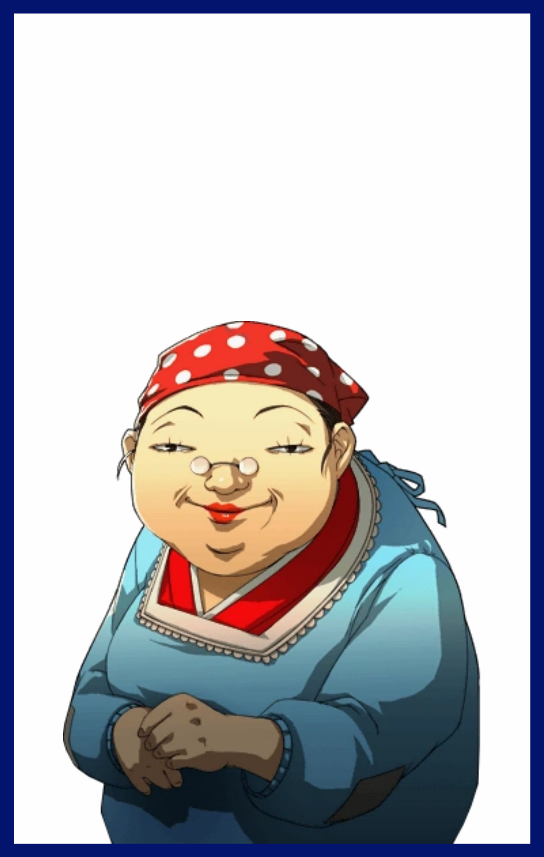
“Oh my…in quite a rush aren’t we? You look like you’ve seen a ghost m’dear~”

“I’m so sorry ma’am! I-I didn’t hit you back there did I?”

Chortling in that gravelly old voice of hers, the diminutive lady hobbles closer, landing a few friendly pats on Daniel’s knees, ignorant to his discomfort as he shifted in place, evidently trying not to take offense from the stranger’s brash familiarity, hoping to get out of this sudden encounter without stirring up trouble.

“I’ve still got it in me to take a hit and come out swinging son…hmm…you don’t look particularly happy there..something the matter?”

“H-Huh? Not happy? No! I mean…I'm not mad or anything, it's just…o-oh…you meant something else didn’t you?”

Either unaware of what Daniel had let slip or uncaring of what others thought about her looks, the old lady simply nods her head, fish eyed stare drilling into his being, leathery lips pressed tight and firmly against each other. She reminded Daniel of a Matryoshka Doll just because of her squat, diminutive nature.

'Or would it be Babushka in this case? Whatever, what's the harm if I tell an old lady anyways…'

Sighing before following along with the strange old lady as she gestures for him to take a seat on a nearby roadside bench, the weary man divulges a shortened account of his time as a student at Pendleton University and the harrowing encounter he recently had with the big bad bully of the campus and how it had earned him the bandage still plastered to the side of his face. All while the old lady listened intently, never once yawning or showing disinterest as she sat there by Daniel's side looking like a grandmother out on a walk with her favorite grandson.

"And that's that I guess…nothing much more I can say or do really…why'd you even want to know ma'am?"

"Hmhm~ Call it a hunch m'boy. I simply saw that tired look in your eyes…and it seems I was right once again!"

"Right? About what?"

Ignoring Daniel for the moment as she turns her rotund form to fish around in her back pockets for a moment, the elderly woman turns back round to face an inquisitive Daniel, handing him a thick, leather wrapped book with golden embossed patterns lining the edges of the book and spine along with a curious title spelled out on its front.

"Re…Write? I'm sorry ma'am but…is this some sort of story book?"

Chuckling a little, the old lady flips open the velvet colored book, perusing page after yellowed page to reveal it was all empty, a diary for one to record their memories and experiences in.

"It's not a storybook but neither is it any old diary, for you see, within these pages, a great-"

"Yeah…about that ummm…I really need to get going ma'am, it's nice you care and all but I've got places to be y'know? Stuff I need to take care of."

"Oh! But I haven't quite…*sigh*...young folk these days…oh well~ His loss I guess."

Watching as Daniel hurriedly makes a swift exit from the scene, the old lady whiskers the book back under her pocket before hopping off the seat, narrowing her eyes as they catch sight of a hulk of a man that looked a year or so older than Daniel was. A predictable choice but seeing as her previous candidate had turned tail and ran away before she could say much else, he would have to do.

Radiating animosity from his very being as he strides by, Kevin misses the fading silhouette of the runt who had stood up to him earlier that day, turning his attention instead to the strange little lady staring up at him from where she stood. Clicking his tongue in disgust.

"Whaddya want granny?! I ain't got no money to give if that's what yer asking for!"

"Ohoh~ Nothing of the sort dear…in fact, it's quite the opposite…might I interest you in something that could help you…consolidate power?"

"C-Consol…soli-what? The hell are you on about?"

"Hmhmhm~ Trust me on this one my boy, I'm sure you'll find this to be more than adequate in your future endeavors!"

-
Chapter 2
-Re:Written-

Saturday, the start to everyone's favorite part of the week (unless they were working unfortunate weekend shifts of course). Despite the heavy downpour, no one could deny that they still had a moment's reprieve from the exhausting rigors of work and studies whether they were stuck at home or in a mall.

But one unfortunate soul was not enjoying his weekend, not when he was currently stuck in some dark corner of the city where few eyes cared to look, stuck in a metaphorical cage with a beast he dreaded to face alone.

'Oh you have got to be kidding me! Why is he here?!'

Daniel was cursing his luck after deciding to head out to the mall to get a physical copy of the latest entry in his favorite game series, traveling by bus, and braving the busy weekend crowd only to find out the closest retailer had run out of stock.

Instead of cutting his losses and simply heading back home however, the persistent gamer had decided to push it, traveling to another mall, smaller outlets, and even shady second hand stores in a desperate bid to claim a copy of the game himself. But after close to an hour's worth of travel here and there, his efforts bore no fruit, leaving him stranded in a rank, sheltered alleyway as a rain shower soon begins to beat down upon the city after losing his way by the time the thought to head home had finally clicked in his mind. Heavy footfalls masked by the pitter patter of rain droplets crashing down upon the creaking roof of rusty panels and mottled wood above.

Add to that an approaching figure who was all too familiar to Daniel, and a lump of dread would begin to build inside his stomach, fearing for his other cheek as he slowly backs away from where he was headed down a split path upon coming face to face with none other than Kevin Pendleton, wearing an obnoxious grin on his face as he forces Daniel down a dead end path with no hope of escape.

"Che! What? Too chicken to say anythin' now that you're all alone?"

"W-What do you want Kevin? You know this isn't school right? I can get you arrested if you try anything funny!"

Fingering the phone in his hand and ready to dial 999, Daniel continues to back up, keeping his distance from the bully even though he currently stood his ground, hands in both pockets, looking strangely exuberant as if he'd just won a lucky draw.

This had to rank among one of the worst moments in Daniel's life. He'd been through random internet fluctuations during critical moments in an online gaming match, suffered burns because a water machine wouldn't stop pouring hot water no matter what he tried. But this scenario was far worse than anything else his nonexistent luck had ever dropped him in.

As much as he hated to admit it, Kevin was right. This wasn't the campus, meaning there was no one around to help should this encounter likely dissolve into a bout of fisticuffs. The only lifeline that remained was the phone in his hand, but even then, this was reality, the cops wouldn't be able to instantly quantum tunnel their way to his location like a badly made video game. He was on his own, prepared to walk out of there with another bruise or maybe, just maybe without a single scratch if he was quick enough to exploit an opening. Swallowing a ball of saliva as he watches Kevin begin to move, hands extracted from pockets, digging around the back before coming round with…

"Isn't that…the book that crazy old lady had? How did you even…no, you didn't do anything to her did you?"

"Hah! So you’re the runt she was talkin’ about! She was right y'know? About the book…gotta say though, I oughta thank ya for giving it to me for free and all…but then I remember how ya messed with me yesterday…"

"W-What the…do you even hear yourself right now? She was a certified nutcase! How can you even-"

"Shut it dweeb! You're gonna regret ever stickin' your nose where it don't belong! But don't worry, I know just the thing for a nobody like you…since y'know? You just love being the center of attention and all…"

Flipping open the book past the first few pages that had evidently seen some use judging by the various scribbles plastered over the paper, Kevin quickly gets to work with his free hand as it flies across the book, pencil head moving so fast it becomes a blur in the man's hands.

And once he was done, the thug held out the book, showing it page first to a confused Daniel before his squinting eyes widened in shock as he caught sight of ethereal new words appearing right below a faint line where his full name had been written down on. Adjusting his glasses to make sure he wasn't seeing things.

But he wasn't, words, written by an invisible hand slowly begin to manifest, burning themselves into the yellowed paper, written in fancy cursive font to spell out a single sentence, a directive;

The Following Individual Shall Be Rewritten As Follows :

Daniel's legs moved forward on their own by the time Kevin had flipped the book back around in his hands to continue writing as time seemed to slow to a crawl around them. He didn't know why, but a cold chill had crept down his spine upon seeing the words blip into existence just like that. Whatever this book was capable of…no, whatever Kevin was capable of, all Daniel knew then was that he couldn't let a man like him write one more word.

Thanks to his earlier retreat however, the distance between the two was vast, too wide for Daniel to do anything in time as he lets out a thunderous roar of denial as his eyes catch sight of Kevin's machine gun arms burning word after word into the book, praying this was just an elaborate hoax using smoke and mirrors to fool him into a panic.

But as his body begins to tingle and contort, Daniel knew then that this was no parlor trick. Watching as an oily brown sheen begins to spread across the skin of the outstretched arm reaching for Kevin, unable to believe the sight of the curious chocolate wave consuming his hands, pumping the stick thin limbs with supple flesh and painting it over with smooth, pudgy skin that seemed a tad too sensitive as the wind flowing by tickles amped up nerves that in turn, shoots a bolt of alien sensations across his body as more of the tawny splotches appear over Daniel's hide, slowly but surely changing him to fit whatever Kevin had in mind for him, skeletal hands already replaced by waifish ones branching off into long dexterous fingers tipped with polished nails free of wear and tear all across its painted surface. Outstretched legs once hidden behind long jeans now exposed for the world to see as an atrociously short leopard print skirt blips into existence, barely hanging down enough to shelter the sight of his rumbling gonads vanishing from view beneath a tight pink latex thong decorated in suggestive floral design as it crushes his testicles, molding the wrinkled sacs into hairless lips that soon begin to drip with a viscous fluid emanating from a new puckered hole just beneath the twitching nub of flesh that had once been a flaccid member, reduced to a hypersensitive nub that further worsens the electrifying feeling of what was undeniable arousal running through Daniel's rapidly feminizing form. Fighting the urge to just drop his hands down between fattened thighs and get to work satisfying that 'itch' through pristine, gritted teeth beneath bloated lips coated over in glossy strawberry lipstick.

By the time platform heels clack loudly against the pavement below instead of the squeaking sneakers that had pushed him into a sprint, the sheltered nerd was barely recognisable. Sporting a low cut, long sleeved woolen top that had once been a simple black t shirt secured by a trendy crimson belt wrapped snugly around child birthing hips, serving to draw the eyes further down where the sight of a cameltoe dripping with a freshly produced batch of ejaculate could be seen slowly dripping from between long, curvy legs bereft of body hair. Starting off with thick thighs at the top that slowly leads downward to firm calves and petite feet that were just as well cared for as her hands were.

While bones shift to offer room for fresh organs of the feminine persuasion and new accessories in the form of a star spangled necklace wrapped snugly around a thin neck devoid of the bulge of an Adam's Apple, piercings studded into creamy lobes and obnoxiously gaudy hair bits appearing to do up lengthened chestnut brown hair magically dyeing itself a blonde peach mix at the roots, Daniel was, at this moment of slowed time, more than aware of what was becoming of him, screaming in defiant rage within his mind, still hoping he could somehow slap that accursed book out of Kevin's hands, even while his next step forces a severe jiggle from a swollen chest as the once flat plains of hairy meat are overcome by oily brown, surging forward into a pair of sizeable D cup breasts that soon tents his shirt from their incredible girth and firmness, tipped with painfully erect nipples shaded a tad bit darker than the surrounding skin.

With the emergence of that last symbol of femininity, Daniel's eyes, the last thing that remained of her old shell begins to tingle as the full might of whatever this was works to erase it, narrowing wide almonds into slant lashes locked into a perpetually sultry gaze, concealing pristine, sky blue pearls emerging from diluted brown and framed by side swept bangs of luxurious pink extending from a well kept head of hair done up into curly twintails dotted with tongues of loose hair that splay out in every direction.

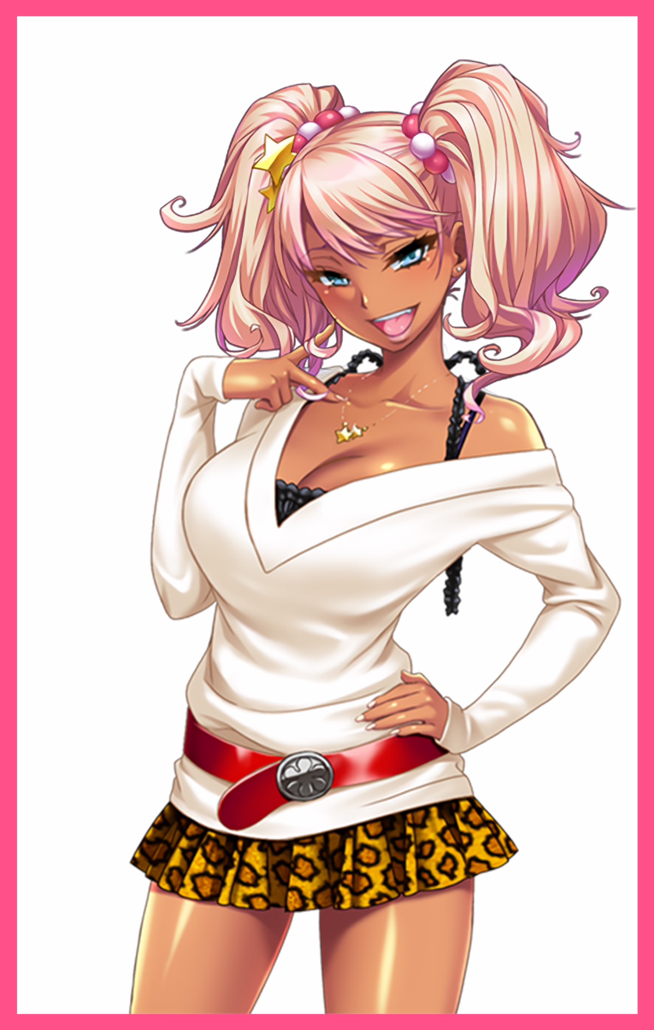
As the changeling’s perception of time returns to normal, Daniel slaps the heavy leather thing from Kevin's hands with a womanly grunt, blushing furiously as she stands her ground despite the mess running down her thighs, oblivious to her girly posture with the hand she used to hit the bully instantly moving to play with a lock of curled hair dangling down by her perfectly sculpted chin, twirling it in her fingers while jutting her heart shaped ass out while slanting her body to the side, accentuating her hourglass figure. Unconsciously drawing attention to her bosom as she jerks her arms in an exaggerated manner just to plant them over her hip, shirking off a sleeve as it slides down a round, creamy shoulder to reveal the straps of a fancy knotted top concealing an equally gaudy yet matching pink bra hugging her boobs tight with the outline of her nips traced clearly across its flimsy surface.

She hadn’t even noticed how her glasses had long since vanished from existence, nor did she bother to question her crystal clear eyesight. Continuing to 'glare' at Kevin with eyes that didn't look the least bit mad. But the bully didn't seem the least bit fazed by Daniel’s pathetic assault that left the book curiously untouched by the dirt or damp conditions. Whistling suggestively at the sight of the smoking hot piece of ass before him with lecherous eyes locked to the gal’s buoyant cleavage of shimmering chocolate, knowing for sure there was sweet nectar to be found within.

Within the span of a few seconds, Daniel, the former, nerdy recluse, a proud student of Pendleton University. Had been reduced into becoming a scantily dressed slut…but the twisted force that had left her this way wasn't done, not quite yet, and as the tanned gal opens her mouth to speak, Kevin could only smile in anticipation for what was to come next as a shadowy figure seeping forth from the open book emerges from behind Daniel, phasing immaterial fingers of wispy darkness through her cranium to begin the final steps that would seal the unfortunate soul's fate forever in accordance to what the thug had already finished writing.

"Stop fuckin' with me and…and…is that my voice? Holy shit, I sound totes hawt! But…this ain’t how I’m supposed to talk and all! What did you do to me? I can't stop cussin’ and shit! I'm talkin’ all funny!”

"What do you mean, Dani? You always talk like that! Ever since we met back during the entrance ceremony, remember? But I mean, even before then, I was sorta surprised to see you made it into my dad's place…when I fucked you all those years ago on the train after you got your sweet ass all over my dick? I thought you were some empty headed bimbo for sure…"

"Mmhm~ I totes remember you inside me after I got you all goin’~ Gawd, did I really just say that?"

"You sure did Dani…so? You all there yet in the head? Or do you need more time to think?"

Daniel had wanted to slap Kevin in the face, to scream at him for being a pervert and call the police for sexual harassment. Instead, she found herself agreeing, smiling vapidly with a stupid leer on her face as her mind begins to fog up, unable to push away the memory of a humid Thursday afternoon years ago back when she was still in highschool. But instead of the usual afternoon spent lazing around at home playing games like she used to, she saw herself boarding the train before her eyes gaze over the surprisingly empty train car, looking for something before catching sight of a younger Kevin listening to music at the far corners. Licking her lips and liking what she sees, she strolls toward him, taking slow steps in an effort to keep her presence hidden, drawing closer and closer…

Until she drops her bag to the floor, hiking up her skirt with both hands before planting her exposed rear in front of Kevin's face. She had half expected to be pushed away or yelled at, as was the case for the bevy of similar stunts she remembered pulling on various folk instead of studying, hanging out with classmates and reading manga. Gradually losing interest in such things as she wallowed in utter depravity, gaining a tendency to flaunt her body whenever and however she saw fit, seeing herself as superior above all else with a few exceptions to her hostility as new memories flourished where old ones withered away, turning a blind eye to it all as the faces of her loved ones begin to blink out within her pleasure addled brain, made worse when Kevin moves to accelerate Daniel’s degradation, picking up the book before it pocketing it back inside his clothes before moving behind the glassy eyed gal, running a hand over her chest before squeezing her left breast hard, eliciting an airy gasp while his other moves down below, brushing aside the immodest skirt to get at sopping wet folds that were no longer pure, tuning her back to the flashback as her womb spasms in tune to her slipping mind, giving in to her new life as the world begins to warp and distort to allow for her very existence.

Once she felt strong hands grab ahold of her buttocks in the dreamy haze, peeling apart the sopping wet panties that hid her tight, hairless pussy before something warm and hard pressed up against them as if to kiss it, a guttural moan escapes Dani Willow as the sensation of having sex with Kevin rocks her body hard in both memory and reality, flung forward and bent over in the privacy of their little train car, the minx giggles in delight once the sensation of a girthy cock throbbing inside of her sets in as she struggles to turn around, glimpsing Kevin’s smug, handsome face while reaching a trembling hand over to spread the lips of her snatch wider, cooing as she arches her back to the feeling of her stud’s meaty member sliding in just a little further before he begins to move, knocking Dani back against the window to brace herself against the mind blasting pleasure of orgasm as a singular thrust forces her to throroughly soil herself, spraying a fine jet of fluids all across the train floor as the duo get into the rhythm.
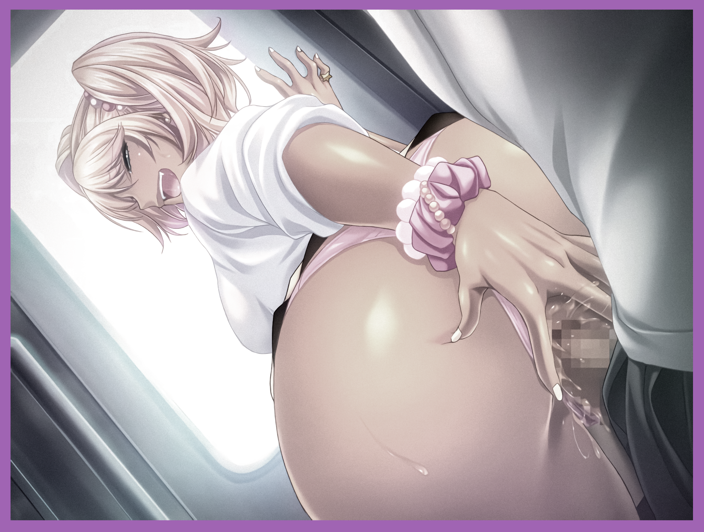
Every time Kevin’s meat knocks against her womb, the vestiges of the young recluse she once was begins to shatter and break apart. Trading the sensation of having a dick to knowing what it was like to have one inside of her. Losing any remaining interests in video games and pop culture entertainment media as a vested love for buying the latest designer handbags and shopping for the sexiest clothes take their place, filling wardrobes in an empty room at the nearby dormitory at Pendleton University that now served as her new home and temporary base of operations until her education was over. Instilling new plans to elope with her beloved once this was all over.

And alongside her family, the faces of other people who once held a close spot in her heart begin to grow strange to her, feeling pissed off the longer she gazed upon the bright face of Caleb while an overwhelming sense of superiority begins to burn within her blackened heart as she glimpses the sight of Alex in her mind. While a measure of hope would be glimpsed as she furrows her brow in uncertainty as to why they seemed familiar, a secondary burst of information would shatter that light as memories of bullying the likes of them and their ilk ingrain themselves within her mind. Popping her synapses and fueling the adrenaline rush of watching innocent faces break down in tears, scowling at her in anger, knowing they couldn’t do anything to stop her, Dani relished in that greatly, made even more satisfying whenever she had her baby Kevin by her side to do it with. These people were no longer friends in Dani’s eyes. Instead, they were her targets, toys to vent her frustrations on and nothing more. They could gawk and talk behind her back all they wanted, but she knew they had no right to talk back to her considering she still had the brainpower to compete with them on level ground when it came to exams and practicals.

Rubbing it in their faces while her lovely boyfriend beat on them…the only greater high than that to the vapid gal whose fashion sense favored the Japanese gyaru stereotype heavily was riding him hard, just the way she liked it. She knew it had to be fate when years later, they would meet once more in Pendleton University ever since they parted ways on the train with Kevin being slightly red in the face and Dani with a belly full of cum. Awakening back in the material world nestled in Kevin’s lap with her legs hoisted high in the air, held tight by her boyfriend’s powerful arms looped under her knees playing with her exposed teats as if waiting for her to snap out of her stupor. Shooting him a foxy look as she leans forward, locking lips with the man she once despised with all her might without hesitation, locking her hand around his head of spiky brown, caressing it lovingly while exchanging saliva as their tongues entwined around each other like snakes.

Parting with a wet pop and a trickle of sweat running down her baby round cheeks, Dani presses her rump in harder against the bulge she could feel pressing against it, prepping herself for another round of rough sex in the privacy of the dark alley they were in as rain continues to pour down above them, giving her the freedom to scream to her hearts content…

“Did I keep ya waiting babe? Soz, i can be a real ditz sometimes when I think too hard~”

“Heh, no worries there, I know how deep you can get whenever you put that big brain of yours to use…but I also know just what to do to snap you out of it…”

With reverberant laughter transitioning into all out moaning and groaning echoing down the alley going unnoticed to the world, no one would ever bat an eye to Daniel’s disappearance as life trudged on around the world as if he had never existed…because he didn’t, not when he was so thoroughly replaced by Dani, who was more than happy to do so, even if she didn’t really know the ‘true’ circumstances behind her birth. With the only evidence pertaining to Daniel Weller’s existence being his name still inscribed upon the latest page of the book tucked away in Kevin’s backpocket, withstanding the combined weight of both its user and Dani as she bounces off of him, screaming all the way as her stud pulls hard on her twintails like the reigns of a horse.
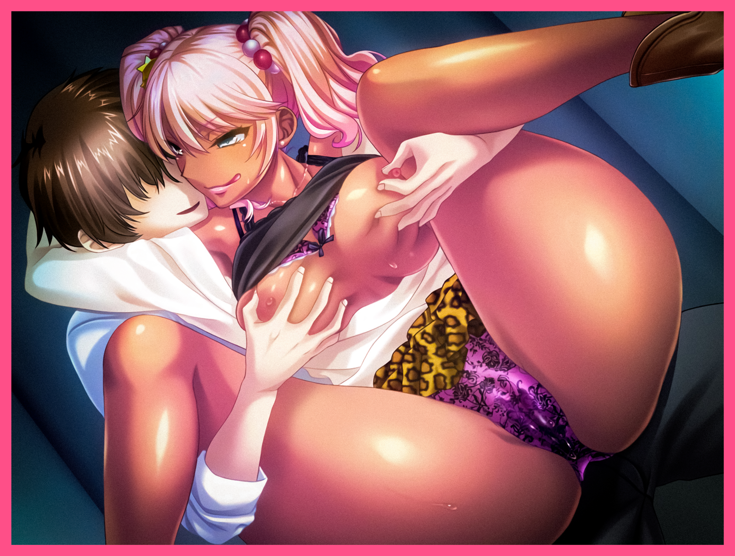
But since Daniel no longer existed, his former home and parents vanished as well, having no logical reason to remain in the city now that their non-existent son who had to attend university was no longer tethering them there, enjoying a vacation together somewhere off in Hawaii instead.

Dani however, was just the start, with this new power at his beck and call, Kevin had big plans in mind for the students of Pendleton University and those who had been foolish enough to stand in his way. That is of course, if he could remember now that he had the girlfriend of his dreams held close at hand…

To Be Continued

