NANOSSIMILATION
BIG STORY #25
BY CHALDEACHANGE


UNKNOWN ENERGY SOURCE DETECTED….

That generally wasn’t the type of notification that the people of the Chaldea Security Organization liked to hear being blasted over their warnings system and in this case it was really no different. It had been the dead of night when the sirens had started blaring, waking up the staff and Servants and prompting them to scramble. Where was it coming from? Were they under attack? No one had answers in the ten minutes that had followed. And yet mysteriously, one by one…?

People within the building began to go missing.

“Was I rayshifted? Just what was that energy?” Ritsuka Fujimaru wasn’t exactly a stranger to suddenly being sent to another world, and that seemed to pay off in the sense that he didn’t necessarily panic when that very same thing had occurred once again. Chaldea’s Master could only stand in the chilly environment, looking around at tall, ruined buildings and destroyed, winding roads. Wherever the city was? It had seen better days.

A thin layer of snow was on the ground, and it lightly fell around him too. “I guess the first order of business would be trying to contact Chaldea…” But the fact that they hadn’t already tried to contact him first was a little concerning. “Or maybe I’m not the only one here?” Checking for others from Chaldea, at least nearby, was also a sound idea. In the end he decided to opt for the latter. The more information he had the better, and knowledge of survivors counting among that.

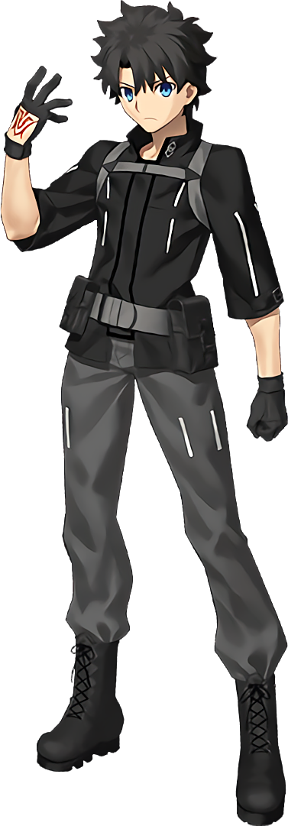
A trail of footprints from his boots followed behind him on the powder of snow. He traveled for about five minutes and yet, in the end? He encountered no one else even after calling out several times. Ritsuka knew full well that he had to be careful about how much noise he made. He didn’t know where he was nor what enemies could be lurking. The surroundings were still, but that definitely didn’t confirm there weren’t foes lurking around.

And that paranoia had been well placed, but there was an issue.

What his presence had stirred was something he could not see. A tiny army that was littered on the streets, so small that you would need an extremely powerful amplification tool to see them. Nanomachines. And nanomachines that had been created with the express purpose of creating new warriors to fight in the war that had led to the city he was in being trashed, in fact. “Why do I feel so warm all of a sudden?” That was the first warning sign. It was far too cold out to be feeling warm.

And really? It could only be explained by a sudden shift in his… internals. Ritsuka couldn’t have fathomed that such a thing would occur, but all of the biological aspects of her body had slowly been shifting to be less so ever since he had arrived in the city. Everything natural had shifted to become something similar yet pointedly synthetic in its nature. His blood? A coolant. His flesh and hair? Fake but convincing. His bones? They were a little weightier, becoming a metallic frame. Even the heart that pushed the coolant through his veins and the brain he thought with had shifted to be artificial – but they retained similar shapes and overall forms.

He squinted. “Is my vision sharper?” The details of the city off in the distance did seem a little clearer to him. Ritsuka’s eyes weren’t normal either, not anymore, and the cameras that composed them could display images in better quality. At the cost of turning his eyes in color from blue to a crimson red. But was misshaping them a necessary side effect? They were longer and wider, and were his eyelashes longer too? It gave his gaze a strangely effeminate impression.

An effeminate impression that was quick to spread through his face as a whole. Thin cheeks took on a gently curvature that likewise saw them soften, his nose shrunk, and his lips became fuller and rosier. The shape of his head was likewise shortened just a touch. By the time all was said and done, and his Adam’s apple slipped away, his facial structure was perfectly feminine… and oddly foreign. Nothing of his old appearance remained and his face’s overall structure had lost its Japanese luster. Instead? He appeared strikingly Caucasian. Even if he wasn’t technically human deep down.

“Maybe I’m… Eh? My voice?” The nanomachines had burrowed into his vocal chords and shifted his voice into a pitch that was strikingly higher, but at the same time the cadence of how he spoke sounded stiffer; more serious? Nothing is wrong with my voice. What am I worried about? “No… Something is…? Huh?” Ritsuka had felt so certain at first, but he couldn’t remember what his voice used to sound like. How it sounded now seemed more correct?

Because little by little, memories of his old life were being archived.

This process proceeded rapidly out of necessity. As the nanomachines housed themselves within his shifting form they required as much calm as possible, and having their victims freak out once the changes worsened would ruin that delicate balance. And so dark spikes of hair flattening, lightening, and lengthening so that they cascaded down his back were all style shifts that he felt but didn’t necessarily register. Nor did a mere two inches being shed from his height overall.

“I’m… confused. Was I sent here on a mission?” Who would have sent him on a mission in the first place? Chaldea? I’ve never heard that name before. His body swayed from side to side because his balance was repeatedly being readjusted. The now not so subtle changes in his body’s build and overall silhouette were the culprits behind that need. After all, you could see through his clothing just how drastic things were becoming in that regard.

His loose, grey pants were becoming decreasingly so for example, especially as far as the regions around his thighs and ass were concerned. Both areas were bulging mightily, cloth being pulled just as tightly around them as his now synthetic skin was underneath. Hips popped wider to accommodate all of the mass that built in these regions in fact, and his boxers were left digging into his crotch as a result.

“Nngh…” It probably would have been impossible not to feel the cloth digging into his dick but suffice to say it wasn’t a problem for more than ten or fifteen seconds. His cock shrunk and his balls deflated, providing less resistance to his undergarments so that they could instead wrap more keenly into a heart-shaped ass that extended out behind her. Because with the way things were trending it had long since been set in stone that she would not retain her masculinity. A pussy took shape instead.

Ritsuka exhaled sharply. “Am I aroused? Is it a side effect of my reconstruction?” Was that how she was perceiving it now? She wasn’t transforming but had instead been reconstructed? If so, that ‘reconstruction’ was really doing a number on her torso. Her waistline pinched in until widened hips felt even wider, and while there had been a time where no excess fat had burdened her chest whatsoever, it then pooled beneath nipples that engorged themselves until they were plump and sensitive – leading the charge of a pair of DD-cup breasts that pushed out and lifted up her jacket.

Her expression didn’t convey any shock but instead an unwavering seriousness. She seemed to be blind to what was happening to her now, and the nanomachines shifting and changing her outfit was no more concerning than the cool breeze to her. It didn’t take long at all before she was left in black boots, translucent black thigh highs, a uniform top with a microskirt, and black and red gloves that matched her new tie and the inside of her jacket. Plump thighs were largely exposed but, at the very least, a little hat kept the top of her head warm.

And there was also the matter of the gun that hung off her shoulders.

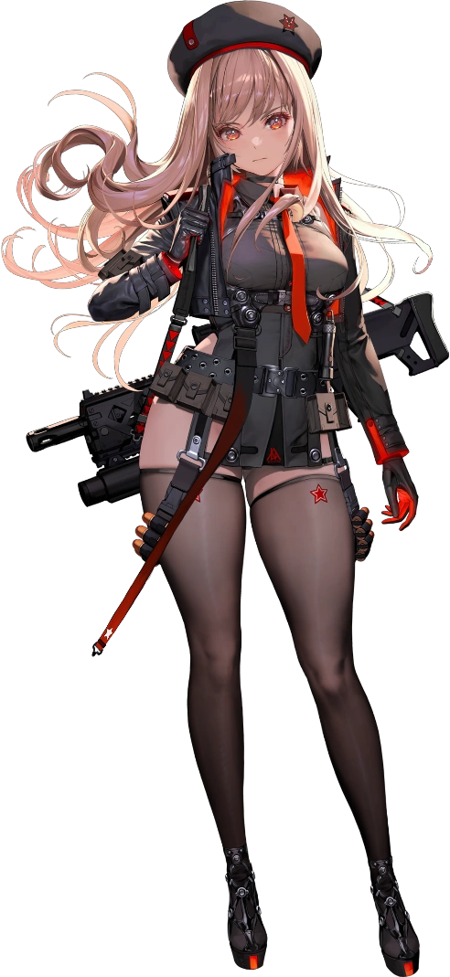
“I need a status report. What am I doing all of the way out here?” Rapi could no longer dwell on the situation that had led to her creation. Stored in her memory bank was data related to having a previous identity, but those memories had been compartmentalized and locked. She couldn’t access them any longer, and so the NIKKE could no longer remember what was encrypted inside. She only knew herself as Rapi and she knew her mission. As a member of the Counters nothing else really mattered.

She spoke over a remote signal only to find static. The nanomachines had worked their magic on her appearance and mind, but the downside was that so long as they were present then communications would be jammed. That meant there were more nearby, but Rapi herself was not aware of their existence even now. “I should be thankful for a new body, but hm…” Was it worth questioning where it had come from? “I suppose I’ll have to see if anyone else is around on foot.”

Hey, at least she had a gun now!

“This is an abandoned office building, but looking outside I can see why it was abandoned.” Mashu Kyrielight ultimately found herself in a situation not too far departed from what had happened to her Master. She had been rushing to the control room within Chaldea’s base of operations when she had suddenly been rayshifted and, in fact, found herself in the exact same ruined city. Rather than appear on the streets though? She had appeared on the second floor of an abandoned building. It kept her clear of the light snow falling outside at least.

She had also gone through similar hoops but, unlike Ritsuka, she had actually attempted to contact Chaldea. Sadly to no avail. “I don’t think anyone else is in the building, and this city looks dangerous…” But she didn’t really have a choice, did she? She had to step outside to better understand her circumstances – and to see if anyone else from Chaldea was nearby.

Unfortunately? Some of the scattered nanomachines had long since found her and had already begun their work.

Without any present threats to deal with, Mashu hadn’t bothered to equip her armor and shield just yet. She was also more or less oblivious to the fact that her internals had already been altered by the plethora of tiny miracle workers that had infested themselves inside of her. She already had vision that was sharper than a regular human’s and so the only sign of that change was an unnoticeable shift in the coloring of her eyes from purple to yellow. If only she’d had a mirror present then she might have noticed.

But that wasn’t to say she didn’t notice anything. Quite the contrary, in fact. Because her sex would be remaining the same, the nanomachines focused there attention elsewhere right off the bat when compared to what had happened to Ritsuka. In fact it targeted one of the last places he’d changed early on in her case. And she immediately felt the weight of that change.

Literally.

“H-Hey!?” She hadn’t been walking anywhere and yet the young woman had suddenly dipped forward almost like she had tripped. Or like someone had dropped a heftily weighted object into her hands. But the issue with that analogy was that her hands were empty. So where was that weight being deposited? Her chest. Mashu’s already larger than average bosom was inflating further, the pillowy masses lifting the skirt of her dress and prompting her to constantly correct her posture until they peaked at G-cups, nipples enlarged just as the mounds had been. “Wh-What just happened!? My tits are so…?” A correction was made mentally before her could even finish that sentence.

My tits have always been this big!

If she was thinking it then it must have been true, right? She didn’t have any reason to argue with that logic! In a similar vein her thighs and ass must have always been nice and plump too, right!? This belief actually predated the transformation to match, though it didn’t take long at all for the nylon of her tights to tear and her panties to wedgie themselves into her ass crack while simultaneously cameltoeing her in the front. The skin around her thighs and cheeks was pulled incredibly taut and overwhelmed her outfit, flesh glistening where it was exposed around thighs, and an ass, that easily eclipsed the width of her waist individually.

Mashu was a little shorter too, which only made the plumpness of her thighs come across as more abundant. “Is something wrong with me? I’m having a hard time… remembering…” Because she was suffering a compartmentalisation of her old memories too. They were being filed away where she could no longer access them, and in their places? Data of her life as a NIKKE was being fed into her mind to replace it – but this only made her confused for the time being.

Regardless of her mental state the changes trooped on. They had slipped into the coloring of her hair by this juncture, and the short pubes above her pussy had shifted to display a dirty blonde rather than the mauve that everyone who knew Mashu knew she possessed. But that color faded in the hair on top of her head too, length and style of her mane shifting to have a very different appearance just as it had a different color. The bob only grew a little bit and took on a full wavy style, but perhaps most notable was how the blonde locks cleared around her bangs. Both yellow eyes were rendered exposed, and they were even clearer once her glasses slid off her nose.

“Ah!” The sight and feeling of those glasses falling off did prompt a reaction from her. But before she could reach for them another correction was made. Glasses!? Since when did I wear glasses!? Her internal voice matched her audible one in terms of bubbliness now. It was also better matching with her face, which was finding itself shaped a touch rounder among other changes like poutier, fuller lips and wider eyes. Ultimately? This rounded out the changes to her body that made her a slightly shorter but significantly curvier NIKKE.

And so all the nanomachines needed to ‘fix’ were her clothes. In ways the uniform that her dress became had some similarities with Rapi’s. She had a matching hat for one, though orange seemed to replace red in the overall outfit’s coloring. She wore black microshorts and thigh highs so tight that exposed thigh meat bubbled over them. And her top? The neckline was so low that most of her massive tits were entirely bare, not at all hidden by her big jacket and with the strap of her new gun sliding in between those tits in the front.
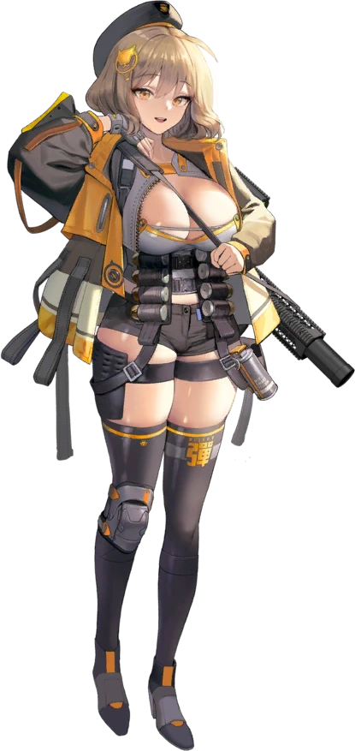
“KYAAAAA!” Clearly much more leisurely about things than Rapi had been, Anis stretched her arms while letting out a girlish squee. It felt nice to stretch like that, and the motion of lifting and eventually lowering her arms led to her overly abundant and bare bust to bounce several times. “So how’d I get here? Commander must’ve had a reason for it, right? Last I remember was getting trashed, buuuut…” So long as she could reunite with her dearest Commander again then she Counter didn’t really care about the details.

Without voicing her intention to do so, the attractive NIKKE opened her communications channel in hopes that she might gleam some sort of information about what had happened. “Static, or… That’s Rapi’s voice, isn’t it?” It was muffled to the point where she couldn’t make out what it said, but that meant she had to at least be nearby, right?

“I gueeeeess I should go find her. Seems like kind of a pain in the ass though.”

Upon the roof of one of the few buildings still standing in the otherwise ruined city, the Rider variation of Leonardo da Vinci had been fiddling with an old broadcasting tower’s panel. “Hmm… That didn’t work either. Is there no way to enhance to signal?” Her intention had been to try and create a means of contacting Chaldea once she had realized that her normal methods weren’t strong enough, but it also seemed like her tinkering had been for nothing.

“Maybe I need to go down to street level after all…” The Rider may have been a Servant, but she was still acutely aware of the fact that she lacked information. She didn’t know what threats lurked in this unfamiliar land. But if she had been tugged into a foreign location then she also wanted to assume that Ritsuka must have been nearby. That was usually the case. “I can just look for him in the meantime and come back to this.”

Of course, invading nanomachines had entirely different plans.

They were quick to address what was perhaps the most obvious issue with da Vinci’s current body, but they didn’t really address it in a way that seemed significant enough. The intention was to address her age it seemed, because the Rider da Vinci didn’t seem like she could be much older than twelve or thirteen. The nanomachines saw it fit to increase her age, and it was definitely apparent in her facial features as she seemed to slide into her late teens, perhaps eighteen or nineteen, but…

She didn’t grow any taller. It hadn’t occurred in a fashion that even made da Vinci aware that she had aged up in the first place. It was possible – and factual – that she was just becoming a very short woman, and at least to compensate for that lackluster gain vertically she at least received some gains of another kind. Gains that were certainly separate from the slow and subtle shift of the pigmentation of her skin from her usual pale to something very slightly darker.

“Hm!?” Her bosom was part of it. The loose, white fabric of the part of her dress that surrounded her bust didn’t hesitate to seemingly inflate as weight gathered beneath and pushed them forward. It would have been wrong to suggest that these gains were significant, but a swell from A-cups to the heftier side of the B-cup range was definitely an increase. “How did that happen? I feel like my firepower has improved! …Huh? Firepower? But I was looking at my boobs! They’re…?” No, they weren’t bigger than she remembered, were they?

Streaks of a white with an oddly purple hue had begun to emerge midst her head of long, brown hair in the meantime. Any strand that succumbed to this color change was promptly shortened only a couple of inches, but it was probably more since it straightened each hair too. This phenomenon spread from one hair to the next until all of the hair on her head had been painted and restyled – and now her forehead wasn’t completely exposed like how she usually wore it.

Yellow mixed with the blues of her eyes as cameras replaced her usual optics as part of her shift into the form of a NIKKE internally. This left them green, and she didn’t exactly notice the thick rimmed glassed that had appeared around her ears. They rested perfectly on a nose that was smaller than it had ever been, above slightly fuller lips that were nestled between thinner lips. Like her peer, da Vinci… didn’t really look like da Vinci anymore.

The blue tights that hugged her legs found themselves hugging them even tighter than before – especially as far as her thighs and the connected ass were concerned. Her breasts hadn’t really grown significantly, but seemingly her lower body had been ready to compensate for that. The fabric of those tights frayed and tore, supple thigh flesh peering through these holes as they doubled in girth while the waistline was tugged down by engorged ass cheeks. She was still short, but she now looked more like the eighteen year old she was supposed to physically represent now.

“Firepower… Firepower…” With her voice shriller she repeated this word a number of times. She really liked the sound of it for some reason? And hey! It distracted her effectively from how old memories were sealed away and new ones took their place. She also didn’t notice the nanomachines repurposing her costume in a white uniform with a frilled skirt, thigh highed boots, gloves, packs, a hat, and a very large gun. There were aspects of this uniform that were similar to both Rapi and Anis’.
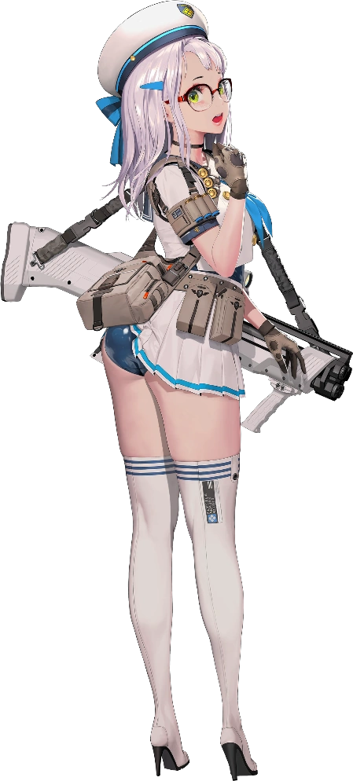
For some reason? Her pack lifting up the back of her skirt didn’t seem to bother Neon at all. According to her new memories, the ones that hadn’t been compartmentalized away, she didn’t really mind exposing herself like that especially if her ‘Master’, the Commander, was around. “Booyah! I feel like a million bucks! I just don’t get why I’m all the way up here buuut… Oh well!” Just like Rapi and Anis, Neon was a member of the Counters squad. But she could also remember their squad being taken out.

She gave a cute little shrug and started for the stairs to the bottom floor while fiddling with her internal receiver. “Rapi’s voice, huh? So I guess she and Anis must be nearby! That’s probably for the best! With the three of us together, nothing can stop our firepower!” Aside from the boss encounter that had literally led to them being destroyed, apparently.

The three would reunite and return to their dorms like nothing had happened. With no memories of Chaldea accessible they couldn’t have possibly considered it. The idea that more people from Chaldea had been brought to this world and, for better or worse, were being turned into NIKKEs just like them.

But that wasn’t really their issue, was it?

