MMO SUMMER FINALE
COMMISSION STORY
BY CHALDEACHANGE
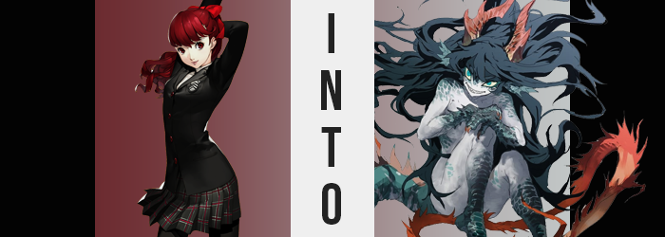

Arriving at the Sakura home rather late, Sumire Yoshizawa was surprisingly chipper.

Well, perhaps it wouldn’t have seemed that unusual to most. Sumire was generally a pretty happy girl despite the suffering she had experienced with the loss of her sister about a year prior now. She always exuded a vibe of positivity and understanding, seldom displaying her negative emotions to others if she could help it. It was just that in this case? Anyone who had talked to her earlier in the day might have assumed she was in a bad mood.

But how could she not be!? Everyone was getting together to help Futaba beat her revived gaming addiction but she’d been left out in the cold! Not that it was the fault of anyone in the Phantom Thieves – or what remained of them now that things had quieted down. It was because of her own dance practice that she’d had to skip out. This fact had soured her mood, and Ann had undoubtedly noted that during their call that morning.

It was evening now with an orange glow cast over the Sakura building. She was still late, but Sumire’s mood had been improved because she was able to help out in the final hour! Her practice hadn’t run as long as it normally did because her instructor had been forced to leave for some sort of family emergency and so she’d taken the first train out to rendezvous with everyone else.

“Hello!?” The girl immediately felt like something was strange though. Not only had no one answered her texts saying that she’d be coming after all, but upon stepping through the front door and calling out? No one replied to her. It was strange, but at first? Sumire wanted to assume that maybe they’d all collectively taken a nap or something! That would explain the silence and why no one had answered her texts, right? It wasn’t like she was going to assume they’d been kidnapped or, like, pulled into a video game.

After calling out several more times to no answer she ultimately decided to climb the stairs and check out Futaba’s room herself. “Um… Is anyone here?” The door was open and so she poked her head in, confusion only growing when she learned that the room was completely unoccupied. Not only were the others not inside but Futaba was missing too. Did this mean that they got her to go out? That was good news if anything!

“Wait… Are those everyone’s phones?” Ultimately she stepped into Futaba’s room because she noticed a number of familiar smartphones on the floor. The phones of all the girls that were supposed to have come ahead of her. Not only that but Futaba’s computer was still on! “Well if they left their phones here they must be nearby. I should probably turn that off though…” Sumire was tech savvy enough to turn off a desktop computer, so after picking up everyone’s phones and putting them on the bed she turned to walk over to the computer.

But… Futaba’s floor was a mess. The desktop computer’s power cable was obviously in the middle of the floor and Sumire hadn’t noticed it. She suddenly felt one of her feet snag and she flew forward. “Ah!?” The cable unplugged and the computer shut off, but the teen didn’t see any of that. She had just fallen forward towards the computer and then?

SPLASH!

Sumire fell into a pool? No, this water wasn’t chlorinated although it was crystal clear. She panicked and swam to the surface, eventually pulling herself to a rocky shore and picking herself up and out of the water. “Wh-What just happened!?” How had she ended up in the water? She’d just been in Futaba’s bedroom and she didn’t even own a pool! Was this the Metaverse? She wanted to assume that it must have been something of the sort.

Looking around nervously, it was easy to see that she was in a cave. An underwater one from the looks of things, seeing as the only exit she could see was the ‘pool’ she had just pulled herself out of. No wonder it had tasted so salty! But the sunlight reflected through the water came out through this hole to illuminate the cave. It was almost magical. “I… AH!?”
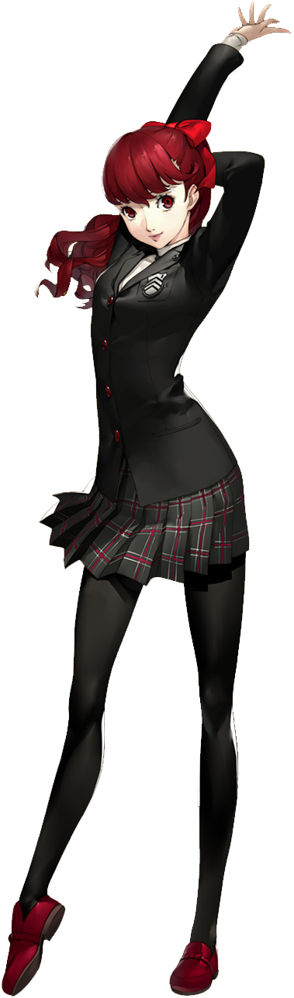
It had taken her a moment to notice since she’d been so shocked to find herself in a different place than she had been just moments prior, but she eventually looked down at herself to find that she was completely butt naked, water droplets dripping down her slender, pale body. “Where did my clothes go!?” Almost wondering if they were in the ocean she’d just come out of, she crawled back to the side of the hole and peered down.

There were no clothes down there, but there were fish, and there was coral, and this wasn’t too far from the beach, was it? It also likely wasn’t all that deep. “Wait, beach? Why do I know that?” How could she have known that a beach was nearby? I beach overcrowded with noisy, disruptive beachgoers… The thought made her angry. But why did it make her angry?

Sumire suddenly snarled at the thought.

“E-Eh!? Why did I…?” Humans hardly ever made noises like snarls; those were typically reserved for beasts. And yet the sound she’d made had been pointedly beast-like. How could she not snarl though? People were so close to her territory, her cave, her— Both of her hands came up to slap herself on her cheeks. “Something is wrong with me…” She’d only found herself in this cavern moments before, and yet her view of it had been becoming increasingly possessive.

Sumire felt scared. She still didn’t know where she was, and yet she felt familiar with it in ways she shouldn’t have. This cavern wasn’t her home, and it certainly wasn’t a place she should have felt strongly about protecting. But there was little point in denying that she truly did feel that way. While grappling with these feelings though? Her body’s appearance began to distort with the goal of giving her a form more suitable to protect it.

While her body’s overall shape nor height changed, at least as first, there was something to be said about her build. Naked as she was, it wasn’t all that difficult to see how Sumire’s arms and legs appeared more swollen. Not with fat or anything cumbersome like that, but with rippling muscle. Arms were inches thicker than they had been because of it, whereas her stomach had become so defined that there were muscle indentations surrounding her bellybutton.

Strong! The thought crossed her mind for a moment, but because she hadn’t taken notice of this strength physically, the girl didn’t really understand it. The thought was far too simple and incoherent. Almost like the power of it was more in its feeling. She felt far more powerful than she had just seconds ago. “I could crrrrrush them! Keke—ke!?” What was she saying!? Why had it sounded like a monster’s growl as she’d done so!?

Truthfully, Sumire was having a harder and harder time making sense of things. It was just becoming more difficult to think of anything more complicated than a word or two, and her stunned gaze visually demonstrated how disoriented that rendered her. Her eyes began to glow a bright green as their shapes stretched into diagonal diamonds with smaller irises. They almost made her look creepy.

Her hair didn’t exactly help with that impression. She swayed to and fro, another growl gurgling up from the back of her throat while crimson locks spilled longer out behind the teen. They became thicker and messier as they fell down as far as her ankles, but aside from the length and their new ropey thickness? Their color was stained a dark, greenish blue that better matched her glowing eyes at the cost of giving her an even eerie aesthetic.

“KRK!?” Sumire almost sounded like she was choking, a sound prompted by the sight of her jaw momentarily unhinging before settling back into place. Her smile spread wider while lips thinned, her mouth taking up more of her face while her nose flattened into just a pair of nostrils above a mouth that was now full of several rows of razor sharp teeth. On some level the girl had tried to stop it, but her tongue suddenly darted from the depths of her maw. Not just once or twice but over and over. Each time you caught a glimpse of it her tongue was longer and greener, a fork evident in the tip.

Like some sort of reptile.

NO! SOMETHING IS WRONG! BUT… BUT…! Sumire’s sirens were going off internally, but regardless of how much sense it made to sound them? Sense had begun to amount to very little in the back of her mind. She felt like she was screaming over thoughts that were louder and simpler – logic she’d developed as a human melting away in favor of things that were more instinctual. Like the desire to eat and sleep, or the desire to protect one’s own territory.

She snarled again as her tongue darted out, much to the dismay of the bit of the girl that held on. True to the look of her reptilian face and maw, she soon collapsed down onto all fours. She could stand on two legs but it felt more comfortable to be closer to the cavern floor like that. Around this time her body began to change more dramatically, while she couldn’t stop herself from lowering her head to a nearby freshwater puddle and licking water up from it with her tongue. Like an animal.

Sumire’s skin appeared rougher and that was because her normal, human skin was being replaces by scales. Her body almost appeared dry as the cracks that separated these scales were etched into her skin, each scale taking on its own sheen and color that painted her body in new and colorful ways.

The bulk of her torso was left a greyish white as a result, though speckles of green could been seen here and there, most notably around her shoulders and hips. If there was any doubt that her body was conforming to the standards of a creature that was no mammal, these scales even covered and obscured her nipples, though the shapes of her breasts otherwise were vaguely retained. Cold blood replaced her warm blood and that lowered her energy levels a touch. This cavern wasn’t exactly heated, and so that lack of energy calmed the growing rage that was communicated through snarls and gargles.

She couldn’t control her body anymore, or at least that was how it seemed. It moved according to impulse, rolling in a puddle to bathe before licking at her own hands. Hands that, like her feet, found themselves clad in dark green scales that differed from the grey. Though to be fair her hands and feet were undergoing more dramatic changes in general.

Thumbs and pinkies (and the corresponding toes) fused with the digits beside them which only thickened. Three green scaled digits were left on either hand or foot, fingernails pushing forward as sharp, yellowed claws that she understood were ideal for hunting her prey. Of course, her overwhelming strength and razor sharp teeth helped in that area as well.

“Grk!” Her stomach rumbled. Thinking of prey made her hunger, but she knew that this hunt had to wait a moment. While her body no longer resembled a flesh and blood human’s whatsoever it was still missing a few traits. Two pairs of them erupted from her head – hooked, crimson horns had erupted behind her forehead and curved backwards, while her ears had stretched into green, scaled, horn-like fins at her head’s sides. With these strange fins she could hear her surroundings more keenly. She could hear as far as the beach at a higher volume, and the noisiness made her anxious.

Claws dug anxiously into the stone beneath her, Sumire arching her scaled ass into the air as a similar pressure mounted above her rear. She knew what was coming, or perhaps it was more like she knew what was missing. It soon erupted and zig-zagged about, scales hurriedly attempting to catch up to the thin tail that jutted out behind her. It was practically twice as long as her body with jagged, red spines. The closer you got to the tip the thinner and redder it became. It was a powerful tool. She could use it to grab things, to propel herself underwater, and to choke her prey.

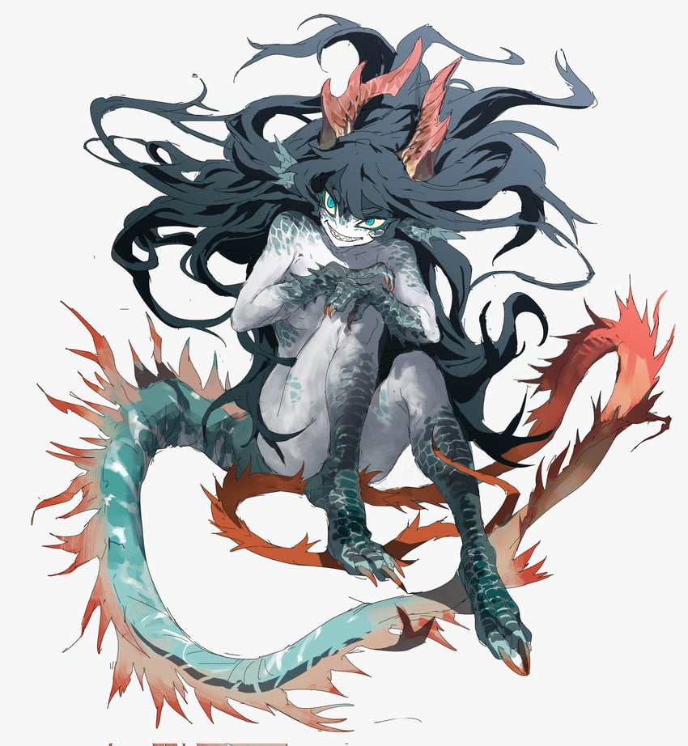
The movements of the scaled creature, still bearing the overall shape of a young woman, were erratic as she crawled about the cavern. Instincts were all that guided her. This cavern was her home, but the beach nearby was noisy. She could hear it from there with her sharp senses. That long reptilian tongue of hers darted out and about between razor sharp teeth as she grew more and more restless, the Sea Dragon’s agitation close to reaching a boiling point.

Its ecosystem was often disturbed by swimmers and food was in short supply already. She eventually darted to the side of the pool and stared down, grabbing a single fish that darted by via a bite when she shoved her head in and pulled it out again. The taste of fishy flesh and blood satiated her hunger temporarily while scaled claws helped force it down her throat. Not even bones were spared from the Sea Dragon’s hunger.

What the beast didn’t understand was that she had a role to play. She was the raid boss for the summer event of this game world, prompted to come out once per day to kill and wreak havoc upon the beach until she was defeated and forced to return back to this cavern. “Grr…” She growled and snarled at the water once more as the sound of fireworks could be heard from the nearby beach.

That was enough to get her to finally jump into the water with a splash. She weaved through the water like a sea serpent, using her tail to propel herself at high speeds. It wasn’t long before she’d reach the beach and then… Then the noises that disrupted her…

She’d make them go away!

Unfortunately there was no hope left for the Phantom Thieves that had been trapped within the game world. Haru had accidentally turned off the toggle that might have returned them to normal, and Sumire had turned the computer off outright. They were all trapped within these new lives with only a vague recollection that they had once been something else. They had to live on as fantasy creatures and monsters within this high fantasy world, and with time they would eventually even forget that this was a game.

To them it would eventually be the only reality that they knew.

But what of the true reality? The girls would all be considered missing with time, only their cellphones remaining as clues about their disappearances. Many would ultimately search for them to no avail, and some would come close to tying the game to these disappearances. But no one, at least for now, could put two and two together. But maybe someday in the distant future? Maybe someone would finally realize?

But it would be too late to save them by then.

