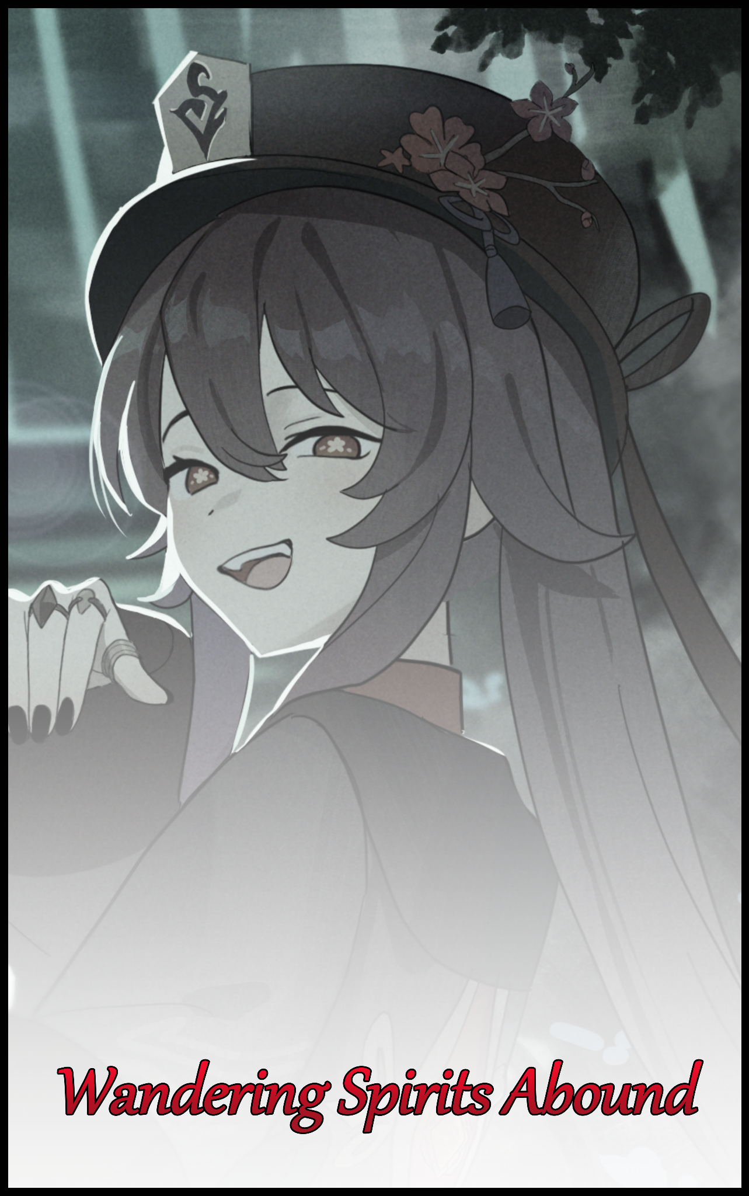

Religious superstition was a sacred concept not many beyond the numerous countries that made up the continent of Asia were familiar with. From their roots to the significance behind them that commanded respect and adherence to those living in the current day, only a few were privy to such things. And even then, most of what they knew were probably derived from twisted myths and high strung tales concocted for use in the ever growing mess that was modern day entertainment media. Using over exaggeration details and an equally lavish level of embellishment to set the stage for tales and world settings heavily based on the supernatural to immerse the audience in, none the wiser to the level of influence fiction could have over those who indulge themselves in it too often to discern reality from that which they had come to learn in popular video games and TV shows. Key amongst them being a standout young man; the focal point of this tale who, after deciding on an ill-advised maneuver that had landed him square in a sticky mire he wasn’t yet privy to, would soon come to learn of the authenticity behind the imaginary tales spun from superstitious warnings taken for granted…

It all began when a group of laid-back Uni studs, bored out of their minds without their phones or computers to while the time away with had been on a cultural visit to a Buddhist temple. And as expected of such hormonal youth with one foot in adulthood and the other lingering in adolescence, had decided to play around in their little circle. Making their own fun where there was none to be found in this most sacred of places that mattered little to them.

So while the rest of the module were listening attentively to the tour guide's hushed explanation as they went from corner to corner in a well mannered bunch, the pranksters would begin to fool around. Cracking inappropriate jokes at every little oddity that catches their eye while ignoring the signs warning visitors and patrons what to avoid or pay special care towards.

Chief amongst the group however, was a brash, hotheaded oaf many knew simply as Max. Eldest son of the Richford family and the most daring of them all, doing what the others wouldn’t dare do themselves despite their boasting. Eager to be the center of attention in any crowd as displayed in the impish manner in which itchy hands steal a bite from offerings laid out on a random altar unfortunate enough to have landed in his sights. Earning the approval of his buddies under the noses of the public, who could only frown and glare at the annoying men making a scene where they shouldn’t.

Offense upon offense would stack like a long trail of dominoes built upon unstable ground, ready to come tumbling down at the slightest mistake. And that error would come in the form of one last act of tomfoolery by the rambunctious fool as a wry smile splits his face upon listening to the suggestion of one of his buddies, unknowingly planning out the last mistake he would ever make in that narrow minded head of his as he leaps off the tiled floor with both legs spread for a stable landing, his torso bent forward in such a way as to be looking down between them when he comes back down to Earth with a mighty thud from is bourgeois form’s sizeable mass.

To the uninitiated, Max’s little dance number looked to be nothing more than a childish thing to be quickly dismissed from one’s mind. But to many in and around the temple, such a thing was a horrid act. An invitation to the unseen; for looking between one’s legs or any such ‘archway’ was like looking through a window into the other side.

And staring into such a window, even if only for the briefest of seconds, was a move that could only invite misfortune upon the one brave enough to test the myths. And when done in a place such as a temple…well, suffice to say ‘misfortune’ seemed too minor a word to describe what had happened to Max the moment the fool’s eyes were graced by what lay beyond.

At first, he could only see the goofy looks on his friend’s upside down faces, evidently amused by his display alongside the usual frowns of disapproval directed his way. Pleased to prove another superstition false and ready to return to normal standing position…before a strange anomaly catches his eye, giving him less than a fraction of a second to take note of the spatial distortion rapidly spreading around what appeared to be nothing more than a black dot in the center of his vision until he was overwhelmed by it’s nauseating spiral. Encompassing the entirety of Max’s field of view until only inky darkness could be glimpsed, going so far as to drown out all noise as the silent murmurs of the crowd and the distant goings-on within the temple fade into muffled obscurity. Leaving the young man trapped in a void that saps the entirety of his being, even the pork belly jutting out the front of his frame, of all its weight before his conscious mind would be the next to go. Losing awareness of his surroundings once all his senses had been dulled. Left insensate within that otherworldly darkness for an indeterminate amount of time with no idea of what was even going on, all while he would remain stuck in a most degrading stance he had initially thought would be a perfect insult against the superstitious. A state one could liken to being ‘put on ice’, giving the unseen forces that had whisked Max away plenty of time to prepare for a delightful series of events they had in mind for the flippant man who had thrown himself right into their waiting hands.

For if he desired to play the fool and refuse to ‘grow up’, then the powers Max had unknowingly crossed could only take it upon themselves to instill the wizened discipline and societal respect for folk from all walks of life and the cultures they followed he should’ve taken to heart a long time ago…and after a quick peek through his mind, the perfect path to achieving their goals were concocted in an instant. Freeing Max from what felt like an eternity spent in dark stasis when only a few minutes had passed in actuality, leaving the addled man to roll down the side of a grassy hill he had been deposited on after being whisked away from the temple grounds.

And as he comes to a stop in a dew soaked mess trailing a few dark blades of grass that had come loose in the tumble, Max's waking mind would blank out once again at the sight of his otherworldly surroundings and the ghostly sprites that filled the air flitting in and out of existence like waning lamplight. Disparate shades composed entirely of blue fiery energy wandering between the trees or hovering in place without purpose, almost as if to represent the countless souls that had lost their way in the depths of this gloomy forest consumed by the darkness of night and enshrouded by an overhanging layer of soupy mist so thick barely any moonlight could pierce it. But there was also something else about his surroundings that made it all stand out from anything Max had ever seen before in his twenty or so years of living as he comes to sit upright on trembling haunches with a dazed look on his face.
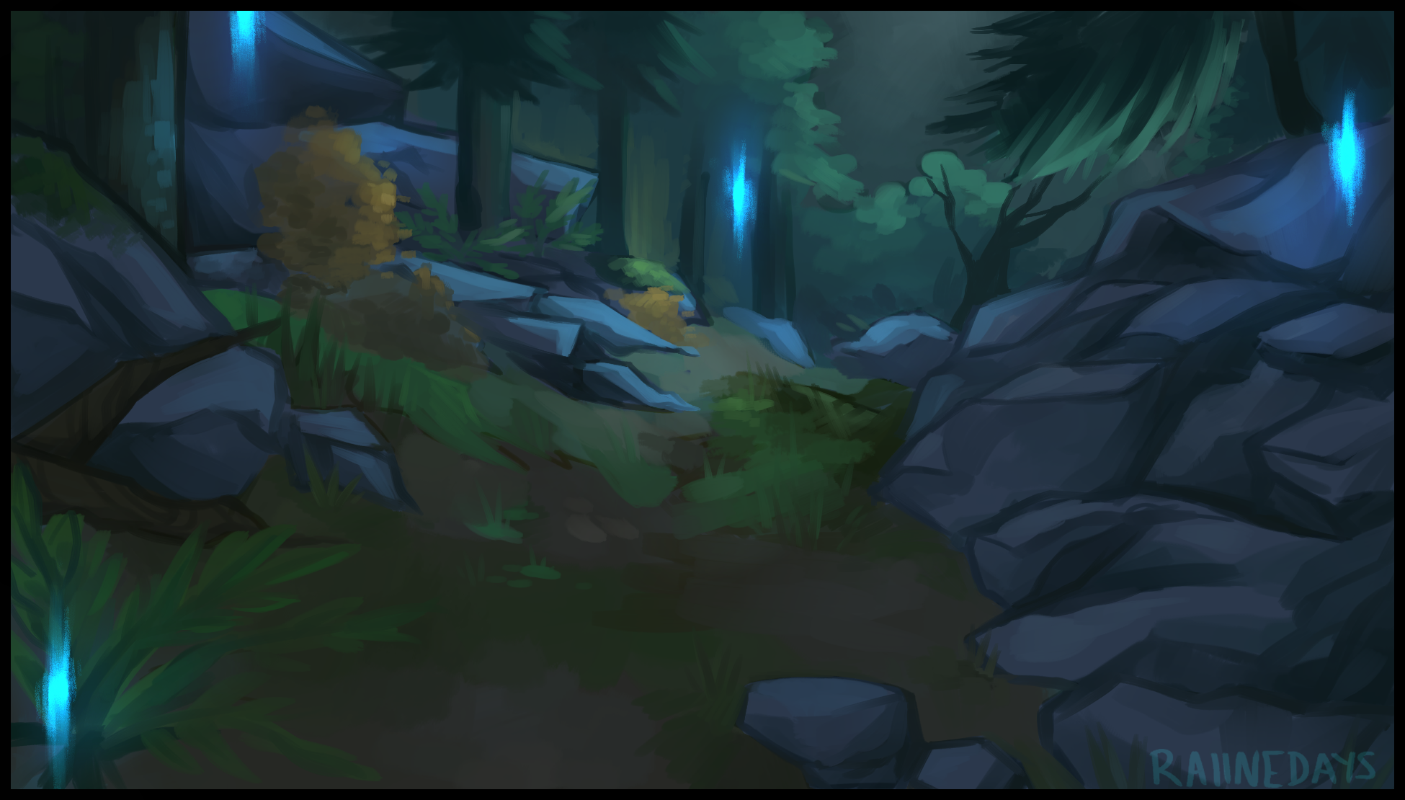
Simply put, it was the way everything had been put together that gave the craggy pit of sloping soil and gaunt trees an artificial yet grounded look. As if something like this could not simply exist anywhere else on Earth, a rare and isolated haven he had been given the privilege of bearing witness to…although it wasn’t as if all that had successfully registered itself in Max’s bewildered head when the only thought he had in mind as of right now was to find some way out of this place after realizing this wasn’t just some lucid dream conjured forth by all the weird smelling incense he had been forced to breathe back at the temple…just another misinformed assumption to correct in the foolish man as unseen eyes kept watch over the silent forest and the sole human inhabitant beginning to set out from where he had come to a stop at the base of a small hill, calling out for his friends without an assuaging response besides the constant hum of a commotion somewhere not too far away.

But as he begins his trek through the dark wood, past a still, silent pond dotted with slabs of weather worn stone and a bevy of strange aquatic dwelling plants. The ambient buzz would soon begin to have some sort of an effect on Max’s taxed psyche as careful steps take him around the circumference of the area while spastic eyes and a head on a swivel dart to and fro. Being wary of the nearby ledge leading to what appeared to be a steep, rocky slope with a bottom that was just as obscured as the skies were, not needing a second glance or a clearer look to know just how painful a fall it would be if he were to make a wrong move so close to the edge. Encouraging him to stick near the water’s edge where there didn’t seem to be anything large and dangerous dwelling within.

That is of course, until a pale shimmer flickering across the water’s clear surface catches in the corner of Max’s eyes, shocking him into a rabid spin that ends with the panicked man taking on a defensive posture with hands outstretched. As if he were confident in his arms being capable of withstanding the bite force of a pouncing crocodile or other such carnivore about to leap out at him from beneath the pond’s relaxed surface after an early warning in the form of dim light glancing off of the camouflaged creature’s eyes had alerted him to its intention.

After a few tense seconds of waiting however, nothing would come to pass. No snarling animal bounding for its cut of meat, no explosive burst of water to herald its attack…solemn nothingness and the continual emergence of the fiery wisps that called the forest their home. Catching Max's attention as shivering arms gradually fall back down to his sides, reflecting their azure glow in ebony hued irises while he watches each one with renewed interest , finding himself thinking about what they really were and their significance to the locale, wherever it was.

And while his mind continues to simmer with new lines of speculation gleaned from sneakily seeded tidbits of knowledge worming their way through tingling synapses stimulated through alien means, the golden head of fuzz sprouting like an unkempt bush from Max’s scalp would begin to take on a darker, more pleasant shade of toasty browns. Seeping forth from the roots as if a titanic painter’s brush had been suspended over the unwary man’s head, dripping with splotches of ink that lands without a sound, Irrevocably shifting Max’s gaudy, artificially dyed shade of dirty blonde over to a natural brunette highlighted by burgundy hues near frayed edges that, like the color, begins to change. Assuming a far more delicate, yet healthy make as years of degradation seeded by dyes and terrible life choices are washed away in seconds. Leaving tender threads of ironed silk to curl and twist as they travel slowly, inch by inch down the sides and back of Max’s cranium until bangs that looked like the crooked maw of a beast had been replaced by a gentle, side sweeping fringe. Highlighting a face that begins to show signs of falling to the subtle affliction that had claimed the unwary man’s head of hair, all while he would come to the satisfactory if unsettling conclusion that those lights were none other than the lingering remnants of the human spirit.

In other words; ghosts…trapped in the realm of the living by lingering regrets or unfulfilled desires…

What was more surprising than the established existence of the supernatural however, was the lack of an empathetic remark that should’ve left the lackadaisical man’s mouth right about now as he had earlier displayed in the temple; joking amongst his buddies at every little thing he could twist into a sick joke. A habit that had evidently sealed itself away due to a lack of said, like-minded company to languish in the depravity of such a 'joke' with…or thanks in part to the influence of something greater as it's work continues unabated beneath Max's nose as he too, continues down the path with a notable sense of level headedness about him in place of the panicked wariness bleeding through the confident mask he no longer had a need for.

And with the pond behind him, the next leg of Max's forest trawl would take him to an even more wooded neck of the region. Choked with fog that makes traversal a harrowing experience when his vision had become so obscured by the bone chilling clouds to the point where he could only see a few inches in front of him. Using the bridge of his nose like a guiding point, even as it too, begins to contort and shift around. Supple skin wrapping tight around compacted cartilage until a broad, snoutlike peak had become little more than a cute, arching bridge. Rising up between eyes that were also beginning to shift around in warping sockets, adjusting to fit wider slits framed by lashes that would undergo the same cleansing treatment as the hair above has before it until nothing remained of its formerly brutish appearance. Healed of heavy eyebags earned through sleepless nights spent gaming across a myriad live services whose names no longer remained in Max's bedazzled mind as it continues to falter and make way for an endless stream of neural information that supplants what had already been established. Essentially uprooting the experiences of a short lived life for another of equal length, yet with so much more to reminisce and ponder about that makes the experience a pleasant one that goes by unnoticed. And with more pressing concerns like navigating such low visibility environs, Max could not afford to dull his attention even for a fraction of a second if he didn't want to end up suffering another fall that could end with more than just getting mud and grass all over himself. Sighing at the reminder of it with a voice that sounded a few octaves higher.

By now however, the university student barely looked his age once the physical alterations had reached the point where their effects were no longer 'subtle' in any stretch of the word. Not when his hair, sporting a faint luster, had already grown long enough to tickle the nape of a daintier neck and the equally shapely shoulders it sprouted from. And when combined with a shortening in height from slimmer bones that had been reformed through a strenuous cycle of destruction and rebirth that leaves them feeling slightly more burdened with weight alongside a fresh coat of sweat over smoothened skin from the resulting heat of the biological processes going on within Max’s body, leaving the man with a rather…effeminate look about him the further along this ‘mutation’ progresses.

Whether it be the increasingly shapely outline of cycling legs taking step after steady step through the silent forest hidden beneath baggier cargo pants that had begun to fuse with the overlaying belt and flimsy shirt up top or the balled fists giving way to relaxed digits cut down into slender extensions tipped with polished nails painted over in shades of midnight gloom. It was undeniably clear by now that the phenomenon grabbing hold of Max was serving to strip him of the qualities that made him the man he was. From a thorough emasculation of a body relieved of obese layers that once hung off it like buoys to the total replacement of memories that would serve him no good in this new world he was only starting to become slightly aware thanks to all the new information that had since come into being within his ailing mind. From a vague name that started with a W to the tragic tale surrounding the entire forest and the beginnings of what looked to be ruins stemming from a series of ancient man-made structures whose original form had been washed away by the ravages of time. Leaving only the jagged, splintered edges of split wooden struts and shattered cobble as vague hints toward the dilapidated village that once stood around the clearing Max could barely get a better look at thanks to the ever present fog blinding him to the sight. Glimpsing nothing but the skeletal remains of houses jutting out from the mists like shadowy hulks while tattered banners hung limp without a wind to coax them to life. But the cloth had been eaten through by hungry insects and left to fester for so long, it looked like the slightest bit of stimuli would lead it to crumble away into nothingness…just like the remains of the good folk who once called the place home. Back before disaster had struck and left only ghosts to tell the tale…a morbid thought that would, like all the rest, go unheeded as Max reaches the center of the ruined village, cresting in a downward fashion towards a small body of water that had probably gathered there over time. Acting as a makeshift mirror clearer than even the larger pond a short distance back where the weary young man had come from.

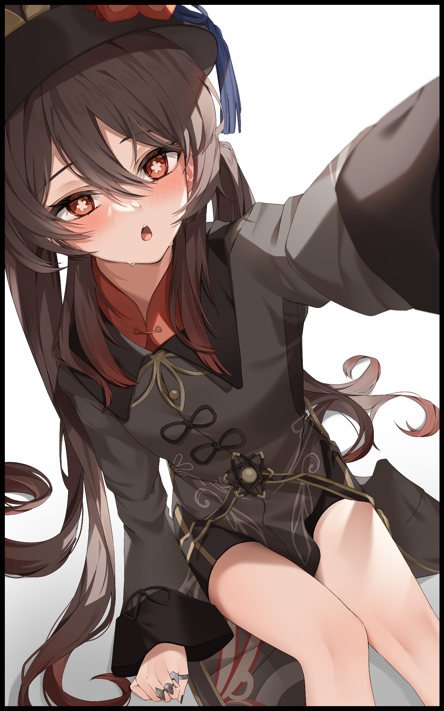
And within the waters, cast back at him was the reflection of someone foreign yet strangely familiar all the same. Coaxing Max to bend the knee to lower himself just a tad bit now that his height had dropped to a rather average 5 foot something, glimpsing a grayish-blue backdrop of fog surrounding the petite frame of a young Asian lady dressed in gloomy garments with lengthy trails of hair done up into high hanging twintails swaying to and fro with every little shift of her body, while dark rings contrasted pale beige as they clung to petite hands jutting out adorably from beneath large cuffs. But all that held Max’s attention little in comparison to the odd, blossom shaped pupils glowing strong within irises of shaded amber that were in turn, sheltered within half-lidded eyes overhanging bubbly cheeks burning with a feverish blush, a warmth he could also feel upon his face as dainty fingers move to trace their pudgy length, recoiling in shock with his feminized mirror image doing the same. Replicating his confusion upon her fantastical visage without blemish or over exaggeration. Just like the lengthy locks hanging down from his own head.

Left perturbed, Max would back away from the water before turning to look himself over with a deepening of the browline at the sight of his own body, barely missing the sight of animate string formed from repurposed fabric doing itself up into a pair of neatly tied bow knots securing the front of a traditional coat masterfully crafted by the hands of Chinese…no, Liyueren artisans skilled in weaving together fine clothes that weren’t too flamboyant in design but lavish enough to serve as fitting garments for those with the most important of professions or seats in high places. And in this case, that same level of polish had been in the minds of those responsible for crafting the current rendition of this staple uniform of sorts emblematic of whoever was the current one occupying the position of Director…for the…Wangsheng Funeral Parlor? Why didn’t that sound right?

With only the weight of doubt building at the forefront of his mind to tell him that something was wrong and no credible mental reminder to tell her the reason behind her reaction to the passing thought of where her clothes had come from. Max could only assuage her unwarranted fears by shoving them into the recesses of her mind, blinking away the limited experiences gleaned from a time as a childish dolt wasting away his time in university just as quickly as new ones arrived to take their place. Giving no room for suspicion or further doubt to take root as they reinforce the initial belief in the Wangsheng Funeral Parlor alongside all the associated mental replays and images blooming forth to paint the picture of someone who could not have been Max…which also meant that she couldn’t have been this person at all, quizzing herself as to why she was even responding to that name when it didn’t fit her in the slightest. Standing still while the finalized length of gilded tailcoats flutter in the midst of a building gust that gradually begins to clear away the enshrouding fog. Just like her own mind serves to scrub away the conflicting ‘obstruction’ she would happily do away with without a second thought.

Because firstly, the name Max, probably a truncated form of the name Maximillian, was a name mostly associated with men. And as far as she could remember, she’d been born and raised in Liyue a bona fide lady even if her childish looks spoke otherwise, caring not one bit about her apparent lack of mature charm or feminine wiles when she had the smarts and the pluck to make up for them all. Paying not even a bit of attention to the tingle in her loins as a small nub twitches before settling into place atop a tightly sealed pair of velvety lips nestled within similarly dark shorts streaked with gold. Clean shaven and pure unlike the wrinkled sacs and perverted sausage that had given way for the former’s emergence.

And all those ridiculous experiences? Prancing around like a monkey for others' enjoyment? Always eager to insert oneself into the center of any crowd? That sounded nothing like what she remembered of herself! Sure, she might’ve had the tongue and cheek to offer a few scathing words that might’ve come off the wrong way to some…and she wasn’t exactly what one would call a ‘normal girl’, especially for one of her talents and profession. But horsing around that hard, and to a point where one's immediate goals for the future were tossed aside along with the innate respect for others decent folk like herself had was just out of the question! She was the Wangsheng Funeral Parlor’s 77th Director after all, not the next up and coming street clown ready to tear a hole in everyone’s guts at the expense of their modesty. Not to mention of course, that there was no way such an ingrate would’ve been able to produce such literary marvels like the texts penned under her well known title as the versemonger of Liyue Harbor’s darkest alleys. A title she herself had coined just like the many other short and eloquent pieces of art that had given her such a good rep around and beyond the harbor city for more than just the funerary services she and the undertakers under her and a great many client’s tutelage provided.

And as a searing orb of pure flame bursts into life behind the collar of the rousing young lady’s coat while slender arms rise to adjust an ebony shaded porkpie hat boasting the funeral parlor’s logo at its front, so too would the psyche of someone totally divorced from the likes of Max awaken in place. Completing an irrevocable transformation of both body and spirit once the coughing flames centered around the Liyueren’s back coalesces into a cuboid emblem composed of unknown make but glimmering with all the glory of the divines as was to be expected of a Vision personally bestowed by Celestia’s eye taking note of their worthiness, a chance to ascend to godhood themselves if they wished. Just like the heroine who had given her all to liberate Mondstadt from a distant past of tyrannical rule…
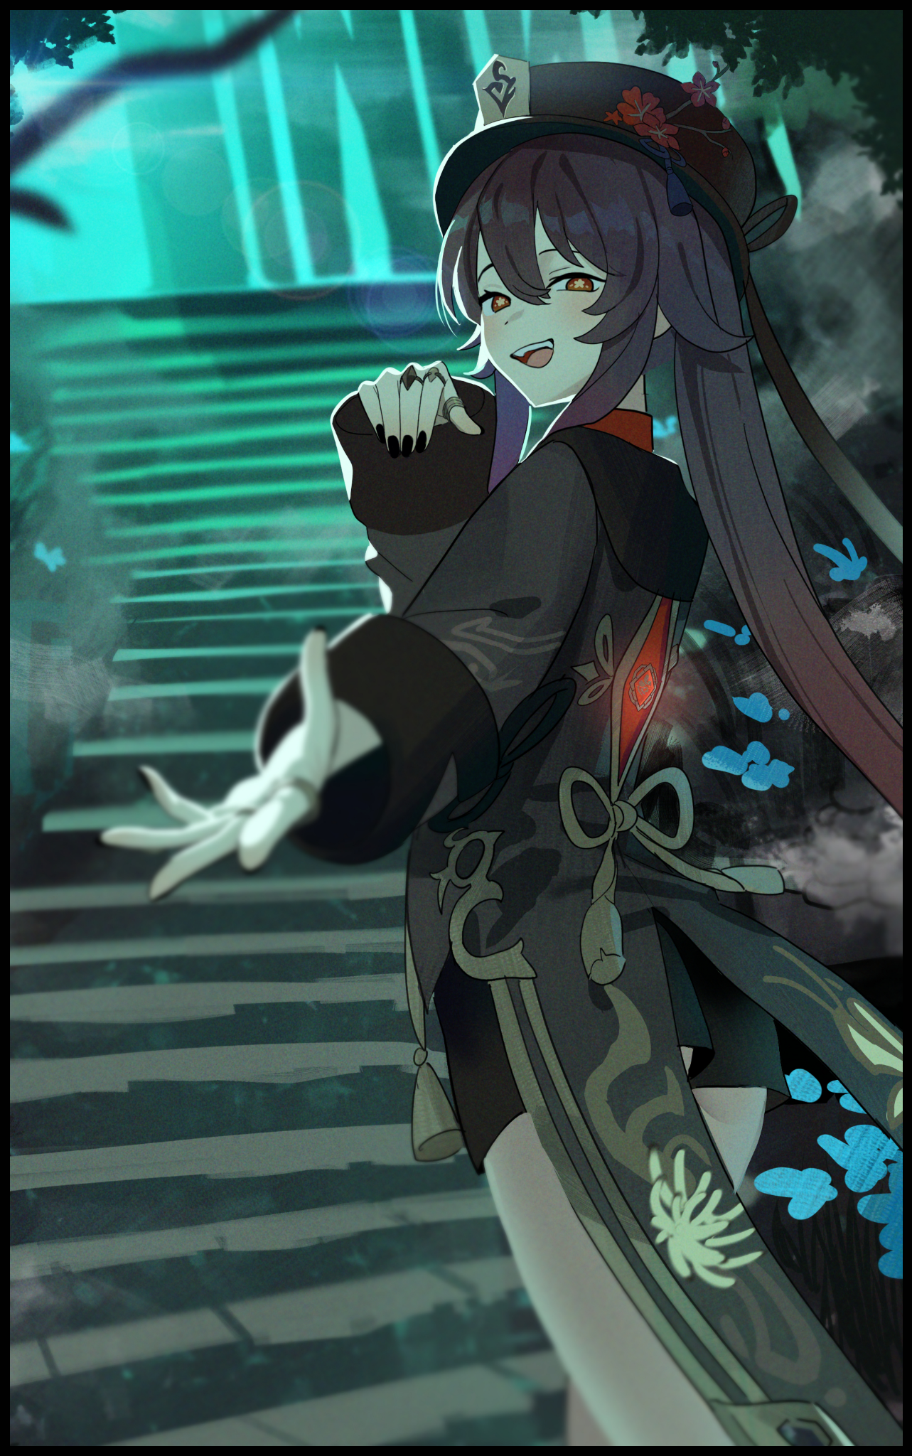
But Hu Tao had no desire to attain a cozy spot high up amongst Celestia’s ranks. She knew her place in the world plain and simple with no greater aspirations beyond them, content with her lot in life and intent on enjoying it all to the best of her ability at the Wangsheng Funeral Parlor and spouting out whatever epiphany might come to mind at a seconds notice so that it might be taken to heart for use later in the many discussions she would often participate in with those in her tightly knitted poetry circle, with one such meeting coming to mind just as the aloof lady puts a finger to her lips in a gesture of thought at what it was she felt like she was missing out on once all memory of the sudden black out and reawakening in the depths of Wuwang Hill vanishes from her mind. Unable to recall ever being anyone else but herself just in time for keen eyes to catch sight of a pale bolt trailing faint orange energy zipping between the trees at a speed that instantly sets it apart from the surrounding ghost lights. Only needing a precise hand to reach out and grab ahold of the flying blob as it thinks to do a stealthy flyby, ending up with an adorable specter flailing around in Hu Tao’s embrace. It’s wispy tail, caught between the director’s dexterous fingers with a panicked look on its simplistic face. Giving way to submission upon it’s apparent mistress’ tenacious laughter as a swift clap of the hand causes the blob to vanish in a instant, leaving Hu Tao standing alone in the middle of the Wuwang ruins, as silent and cold as it always was with nary a living soul in sight, just the way it should be…once she was done ‘mopping up’ with the last little intruder she could sense lurking a few feet away behind a shaded brush, peering at her with shaken curiosity in fearful eyes…

“And rightfully so~ For those possessed of an adventurous heart might find themselves losing out on more than they bargained for in places none should ever walk alone…isn’t that right boy? Now what’s a kid like you doing all the way out here, hm? O-ya? A dare you say? Well that just won’t do…I say we show those naughty friends of yours a thing or two, maybe then they’ll learn not to play around when it comes to such things…after all, you don’t have to come all the way out here if you wanna meet a ghost. Just play around near a headstone! And who knows, you might just get a response…now let’s get going shall we? Any longer around these parts and you’re gonna end up looking paler than a ghost~”

Leering down at the naive kid who had thought to accept a dare in such a dangerous place, the mischievous director could only depart down the unsteady steps with her charge in hand with relief and concern hidden behind the carefree and slightly morbid air she always carried herself with. For as much as she respected the ‘natural cycle of life and death’, there were a few points in her life where that philosophy would find itself challenged like in this instance…for she could have just as easily left the boy to share in the fate of Wuwang Hill’s ancient inhabitants instead of reaching out to him and coaxing him off the path to certain death. Chastising herself for it before focusing on the return trip back down the hillside. Passing the time and filling the silence with recounts of her most recent experiences alongside the occasional word of wisdom that made her the famed poet most people knew her to be. Never displaying any signs of relapsing back to a persona that had been thoroughly replaced by everything that made her Hu Tao; 77th Director of the Wangsheng Funeral Parlor. Knowing full well that her words would serve to entertain more than just the attentive ears of the fledgling spirit in her midst…for in a place so highly attuned with death and resonant ley lines that had picked up on the departed’s last wishes, plentiful spirits abound who were more than eager to listen in on the head undertaker’s wondrous stories and all they had missed in the millenia since their passing…

THE END

Image 1 by Raiinedays : https://www.deviantart.com/raiinedays

Image 2 by Awaki224 : https://www.pixiv.net/en/users/59107396

Image 3 by Jiki : https://www.pixiv.net/en/users/22042240

