Dawnisha - A win win offer

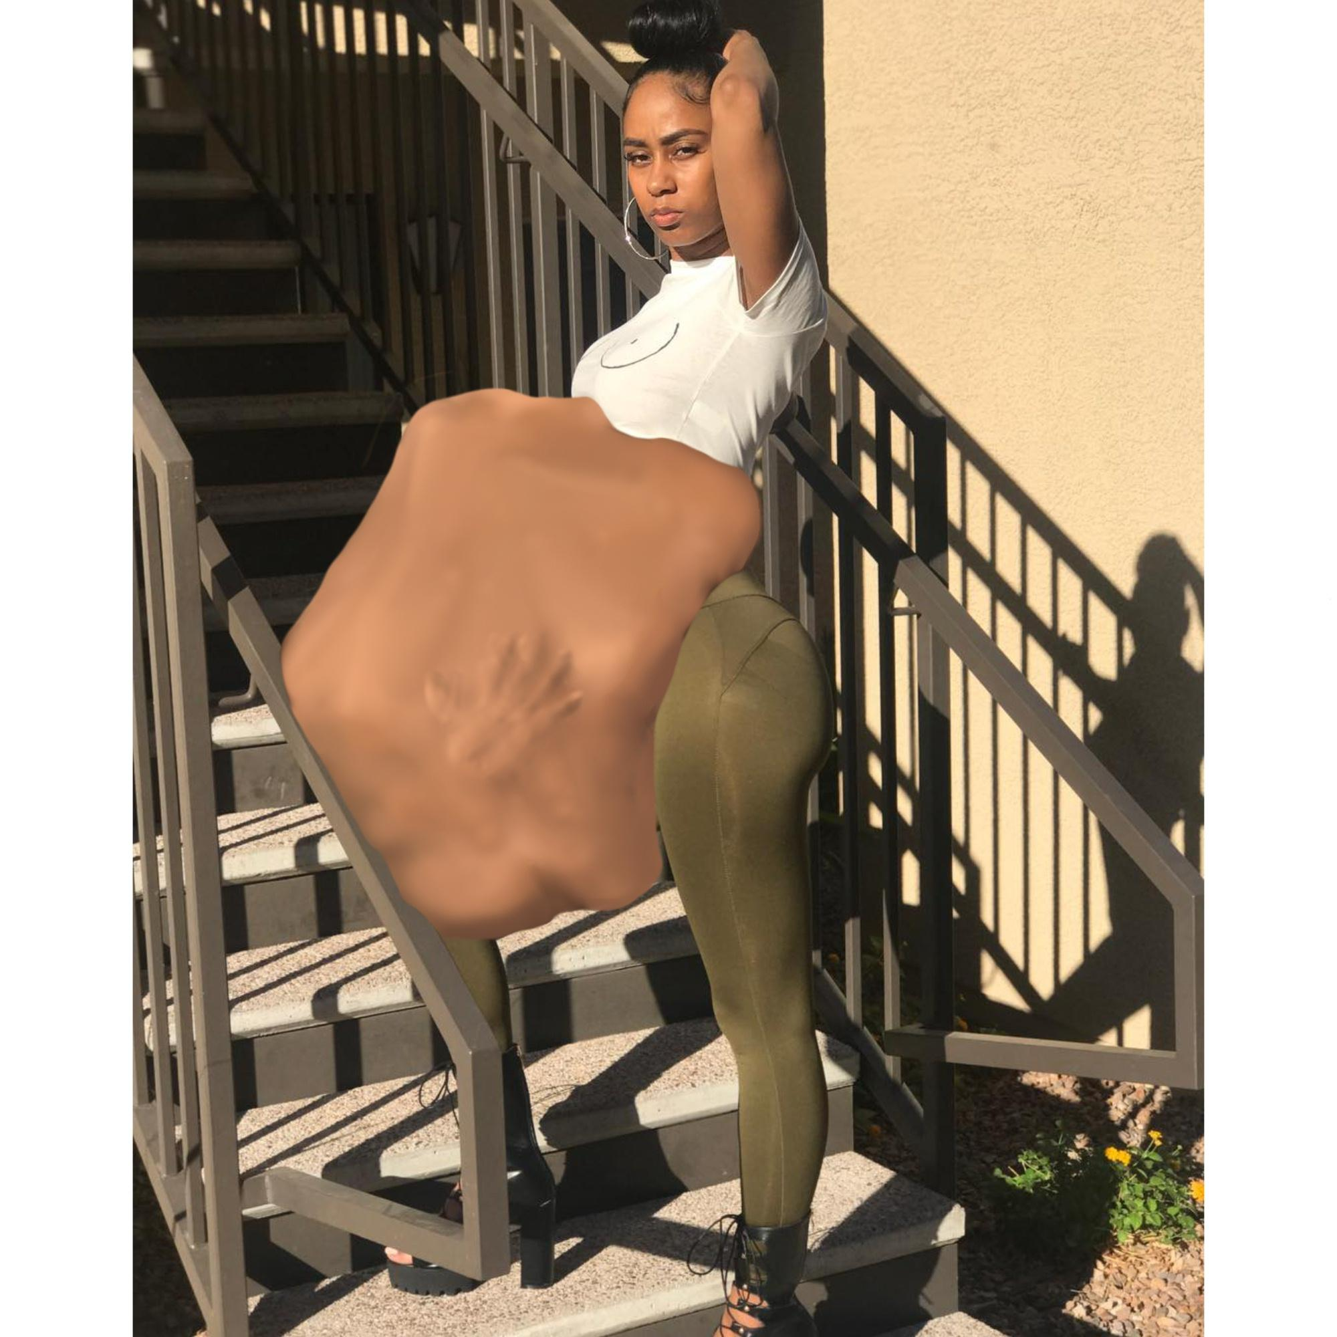

Dawnisha nearly stumbled out of the bus doors when they opened to let her out at her stop. Her workday had been unbearably long due to the fact her coworker called in sick just as Dawnisha was about to clock out, leaving her with a double shift and the workload to match. Now twenty hours and 2 missed lunch breaks later Dawnisha was exhausted, aggravated and near delirious with hunger.

Luckily for the gods of gluttony provided a perfect opportunity in the form of a forlorn lonely looking woman standing alone on the corner sitting on a suitcase.

“Hey there. Rough day, Hon?“ Dawnisha asked gathering every bit of her sanity she could muster to speak softly as she approached the sad woman.

“You could say that” the woman said looking up with puffy mascara streaked eyes. “ I just caught my boyfriend cheating on me with his ex. And then he ended up kicking me out of our apartment. So yeah, a rough day about cover it.”

“oh wow. That's really… that's too bad…” Dawnisha said weakly trying to empathize. She never had a boyfriend last long enough to dump her before she ended up “dumping” what was left of them. “I know the feeling. I was stuck with a double shift today and I haven't eaten anything since 6:30 this morning. I'm Dawnisha by the way. “

“ yeah, that is not really the same thing, but okay. Sure. I'm Gwen. “, the woman introduced herself. “

“So Gwen, mind if I ask what you think of doing? I doubt you'll wanna stay on this corner all night. “

“yea you're right. I sent for an uber. Stupid driver got lost on the way here but it's on the way. I'll probably go crawling back home to my mother's house. She's gonna love this. Ugh.” Gwen said clearly cringing at the idea of going to her mother's home.

“hmm I see… “ Dawnisha said feigning deep thought while of course she already knew her play. Dawnisha did not like to beat around the bush. “hey I've got an idea. It'll solve both of our problems.”

“both our problem? “ Gwen repeated skeptically curios. “ how so? What is it?”

“How about. Since you have no place to go, and I'm completely famished, you let me eat your fine ass for dinner. We'd both be better off. It's a win-win. ”

“do what now? Hold up ho’, are you seriously coming on to me?” Gwen sneered suddenly increduos.

“What? No i'm not coming onto you. I'm trying to get you into me. I’m starving and you need a place to stay. I get you may be nervous but my stomach will strec-”

“Holy shit lady. You’re crazy as hell. I should’ve known. I always attract the crazies. Just get away from me. My uber is coming.”

“But...but…” Dawnisha stammered taken aback by such a rude response. She had offered a mutually beneficial opportunity and this homeless skank had just thrown in back into her face.

‘bye bitch. Don't make me call the police wit ya crazy ass.” Gwen added with just enough sas it sent Dawnisha over the edge.

‘Oh i see. So you think you better than me? Fine then, I know exactly how to deal with raggedy, no-home-training ,rude-ass, stuck up skanks like you.” Dawnisha snapped. With a blinding fast movement she slammed her palm into Gwen’s cheek, slapping the woman so hard she spun around 180 degrees.

Grabbing her disoriented prey’s shoulders and lifting her in the air, Dawnisha opened her mouth wide enough it looked like an open manhole. Gwen let out a momentary squeal as she was dropped backwards and headfirst into Dawnisha’s salivating gaping maw and crammed down her udulating throat. Her arms pinned and shoulders quickly sliding into the moist tunnel Gwen was only able to kick her airborne legs while shaking and thrusting her hips and body as she was devoured whole and alive. Dawnisha didn't waste any time removing clothing from her meal except for the pointed high heel pumps as Gwen’s uselessly twitching feet approached the gateway of her lips. With a few more deep satisfying gulps Dawnisha buried Gwen deep within her body, cut off from the outside world- except for the massive gwen-shaped belly bulge that protruded from her torso, pushing her shirt up under her breasts.

“See that’s not so bad is it? Ya see Gwen, the problem is while I was trying to be nice, you were going in my stomach one way or another. You just picked the hard way. Now get nice and comfy in there and I'll take good care of ya’ ungrateful ass.”

“Let me out you psycho bitch! HELP! It smells like shit in here! OMG! It fucking burns! help!!” Gwen screamed and kicked inside of Dawnisha’s grotesquely distended stomach. Her futile cries sounded like nothing more than muffled gurgles to anyone who didn't have an ear pressed directly the to the stretched mass.

“Geez, just settled down in there.” Dawnisha said as she began to waddle away from the corner, leaving the now ownerless suitcase and dropped cell phone unattended.

“ I -\*hic\* ...I get you didn't have the best day of your life, getting cheated on , dumped, kicked out and then devoured. But hey, it could be wou-URP\* ugh..worse. Did i tell you I had to work a double shift today and I had to skip two lunch breaks? TWO!! Hmph...count yourself lucky. I was starving before I ran into you. So see, things can get better.”

Dawnisha patted and massaged her swollen belly as another onslaught of gastrointestinal disagreements to her statement rocked her bulging stomach. She grinned at her rude guests dismay and made her way leisurely to her apartment. As she approached the steps that led up to her apartment she heard a car pulling up.

“Excuse me, miss. Have you seen any other women around here? I'm supposed to pick up a...Gwen.” Said the late uber driver, checking his phone to confirm the missing customer’s name.”

“Hmm...Oh yes! Gwen!” Dawnisha said pretending she just remembered the name. “Yes, i’ve seen her. I believe she doesn't need a ride anymore. She made \*BWORP\*...other plans.”

With that Dawnisha waved as she heaved her engorged body up the stairs. With dinner taken care of and churning away violently in her gut all she wanted to do was take a hot shower go to bed.

The end