Witches
A Short Story
By Maryanne Peters

You do not choose your religion, almost all adopt the religion of their parents. And sometimes the religion that you are born into cannot be described by a word. So, I have always said that I was raised as a wiccan. I can call myself a wiccan. But that is not quite true.

The truth is that wicca is modern paganism, and the origin of my mother’s and my grandmother’s religion go back much further than that. They have told me that goes back beyond the birth of Christianity, and all the great religions, to Celtic Europe. Wicca can describe elements of the belief, but for many followers the horned god is given too much prominence. For my forbears, he was nothing more than a mischief maker, as the supreme power and the creator of all things, is the Earth Mother. The White Goddess. The Sacred Feminine.

I say it was my mother’s and my grandmother’s religion because my father was not interested, and my grandfather, while a practising wiccan, was of no consequence. The power that carries through this belief system lies with women, not men. I am talking about witches.

Now you can choose to think of this as nonsense, but nonsense does not live on for centuries. I have seen things, but it is not my purpose to convert anybody to our beliefs, just to explain what happened.

My grandmother was dying, and my mother and aunt were both no longer young women, and there were no girls of my generation. I was the youngest of three brothers, and my cousin Fergus was the third child of four, but his older sister had died in a car crash and his younger sister of leukemia, both years ago. The youngest generation was five young men.

When my grandmother first became ill, my cousin and I were both instructed not to cut our hair. I had no idea what it was about at the time, but as it was my grandmother’s request I did as I was told.

I loved and respected my grandmother. She always struck me as a woman of great wisdom and of the strongest personality imaginable. She believed in encouraging the eight virtues of strength, power, reverence, honour, humility, compassion, mirth and beauty. The last two she kept even until the day she died. When she did, aged 78, she was still an attractive woman and was seldom seen without a smile on her face. I often wished that I could lead a life as fulfilling as hers.

Her life was not just fulfilled by her family, but in her working life. She worked in forestry and travelled the world promoting afforestation and reforestation well before global warming made this a hot topic. She would say: “Trees are sacred things. They live in the earth, fed by the fire of the sun, the water of the rain, and the carbon in the air, and from those things they build the spirit of a massive living thing.”

Earth, fire, water, air and spirit. The five elements at the core of our faith. The five points of the pentangle.

I did not learn it until later, but both my mother and my aunt had been trying to have another child. Basically, my aunt had already reached menopause, and my mother had some problems with her uterus which were beyond my knowledge or care at the time. There was no real prospect of a grand-daughter.

There was a wider family, but my grandmother had a tradition that needed to be preserved. The day before she died she had asked me to promise, on my honour, to do all that I could to preserve those traditions. I did just that. I loved and respected that woman.

And so, I found myself facing an horrific decision after she died. Honour my deathbed promise to my dear grandmother and revere the traditions that I believed in heart and soul (honour and reverence) or keep my male genitals.

Somewhere in the discussions of the ancient practices of my religion I was aware that castration had been practiced, even self-castration, to allow men to become witches. These people were called “werdunwitch” or “man become witch”. It was said that these people were more powerful than regular witches. Perhaps because they still retained some residual male strength, but more likely because of the absence of a womb. It is said that childbirth lessens the power. Even my grandmother said that by having my mother and aunt, her potency was reduced. Werdunwitches do not face this problem.

“I cannot do it,” I said to my mother. “I have a girlfriend for crying out loud. We are having sex. I have all my friends at school. I would be a freak. I would sooner lose my arms.”

“Your cousin has been asked to do the same thing,” she said. “One of you must. Fergus too, has a girlfriend, and it is his last year at high school. He is on the football team. A man’s man. But he is the other candidate. There is no one else. Both of your brothers are married and beyond the call, and Fergus’s brother has left the faith. One of you two will accept the fate ordained. I know it will happen.”

I called my cousin, who was sort of my hero at school. We had both being growing our hair for more than a year now, down below shoulder length, but while it looked stupid on me, fair like my father’s, it made him look like a Samson-type warrior, thick and dark.

“I feel bound by tradition to do it,” he said. “It is not lack of courage. But it is just wrong for me now.”

“They are telling me it must be now, while Gran’s spirit still lingers with us,” I explained. “For me, it is the courage that is the problem. Not the physical pain, but knowing that I will be leaving a normal life forever.”

“Devoting yourself to the craft can be a good thing,” he said. “As men, the greatest part of the power of our faith is denied us. That appeals to me. But there is a world outside wicca, and that is where I am right now.”

It is very hard for me to explain why I agreed, other than what you have heard. There was honour and reverence, as I said, but Fergus was right, power and beauty rest with women in our belief system. Men are included but they are lesser beings. Everything stems from the mother goddess, and it brought forth only by women. And that includes werdunwitches.

“It does not need to be a knife on an altar, Aiden,” my mother said to me. “We live in a modern world. It can be done properly – surgically. We offer up what has been removed afterwards, when we pass over your grandmother’s spirit to you.”

“Where?” I asked. “When?”

“It is not easily done here in this country,” she said. “They have rules requiring assessment by psychologists. But we have booked surgery for you in Thailand. There they will not only remove your maleness without too much question, but they will also give you functioning female parts.”

“Why would I want that?”

“To be more perfectly feminine in the eyes of the goddess is a great thing,” she said. “It will allow you to pursue beauty as well as power.”

So how do you do this? It was only the day after my grandmother had died, so the school was told that I was going to be absent for a while – a period of mourning. Fergus had to be back for football, but I would be away for some time. There was no warning of what I might be like when I returned.

My girlfriend Nola had called me when she got the news of my grandmother’s death. It was big news as she was so well known in our town. She was the “Tree Lady” who had travelled the world and who was involved in environmental issues. Everybody knew her strong voice and her long grey hair. Nola said that she was a great lady and that I must be very sad.

“I am sad,” I said. “I am sad for many reasons.” How could I tell her that I was going away and would never be back - at least as Aiden. I could not explain to her what I barely understood myself. When she saw me again I would be as Ariana. That was the name I would be given. It is Celtic and means “oath kept”, as I was to keep the promise that I made to my grandmother.

My mother and I travelled together. When we got to the clinic that I was booked into the first thing that I realised is that I was totally out of place there. There were plenty of guys that I met – guys who wanted to be girls. They were at various stages in the process, or some succeeding better than others, but they were all trying to be feminine. Apart from my long blonde hair I was just a guy. I wore my usual clothes and I looked and sounded like a guy.

“You are going to make a very pretty girl,” one of my co-patients told me. “You have lovely hair and good bone structure on your face. Your body is not too big where it shouldn’t be. And you have small hands and feet.” I had not even thought about it. Prettiness was less important that what was between my legs. That was why I was here.

The surgeon spoke good English, but he was no interested in why I was there, so long as I signed the consent forms. His only comment was regarding the desire to keep the amputated bits. He said: “Most people don’t want them.” We did, for reasons which we could not easily explain to him.

My mother stayed with me until the anaesthetic took me away, and she was with me again when I came to. I remember her first words to me, even in that haze. She said: “Welcome to the Coven, daughter.” She wanted that it should be clear to me that I had surrendered something of what I had thought of before as having the highest value, in exchange for something beyond value.

There was pain, yes. It was lessened to some extent because of those around me. Those “girls” – transwomen in states of high excitement all of them. But not quite for the same reason as me. One of them offered to give me a makeover, and everyone clapped their approval. How could I say no.

There seemed to be some real skills in this group. I received a body waxing to complete the work done before surgery on part of my body. My hair was shampooed and put in curlers. Makeup artists and manicurists did their work. The hair was unfurled and combed and teased into shape with my eyes closed for the big reveal.

When I opened my eyes I honestly thought that it was a trick. The woman did not look like me at all. I had always thought of myself as a virile looking young man, and I had assumed that this might be hard to disguise. There was no man visible in the mirror, except maybe in some of the girls standing behind me.

All I could think to say was: “Thank you. I love it.” I started to cry. I cannot remember the last time I had done that. Definitely before I was 8.

“It’s just the hormones, Sweety,” one of them said. No, it wasn’t. Up until them I had not taken any.

That was to change. Without testicles, no post op transwoman had male hormones to worry about, but oestrogens were still needed to promote female characteristics. We all got jars full of the local cheap but effective generic drug. I was the latest starter. Most of my co-patients had been on hormones for years, with the effects obvious. A sad few had been on for just as long with much less effect. I wondered how the world would treat them – men with vaginas pretending to be women. Somehow that idea did not apply to me.

Those vaginas needed to be unpacked, checked, lubricated and stretched. We all did it, with the encouragement of those who no longer found it painful, and those who were beginning to find it pleasurable. For me the vagina was not necessary, but my mother told me that I should treasure it and protect it, not as a virgin but as a sexual person.

When my mother and I left the clinic, I swapped names and email addresses and promised to stay in touch. I never thought I would keep that promise, but for some of them I did, much later.

We headed home well in advance of the formal ceremony to have me join the Coven as a woman and a witch. Part of the ceremony would be women only, and then I would be brought out to face the wicca community as a true witch, with the burnt offering of what was left of my maleness for all to witness. I feel I remain bound to keep secret the details of the closed ceremony, but I will not conceal its effect on me.

There was a moment where I truly became a woman. I am under no illusion that orchidectomy, penectomy and vaginoplasty are surgical procedures to give a male body the appearance of a female one. If there was one thing I learned at the clinic it was that my co-patients were not truly male, but they did start with male bodies. So did I. But when I appeared before the wicca I had been changed.

Our belief system has no dispute with science. We have no creation myth. We are only concerned with the world we have. We believe that spirit can be separated from the body at death, and can live on in other people or other creatures, but we have no heaven or hell. The findings of science about nature – the age of the earth, the creation of life, DNA, the Y chromosome – these are all undeniable. But what sex is a spirit? Mine was male. Then it became female.

People saw the change the moment I stepped through the curtain. My first glance in a mirror I saw it too. I had become beautiful. There was no perceptible change in my face, except that any trance of a man was gone. There might have been a change in my body that defied science. I had only been on hormones for a week, but my naked body showed definite breasts. The work of the surgeon in my genital area seemed unchanged, but somehow enhanced.

My mother and aunt then moved to cover me with a robe, and to place the pentangle around my neck, pulling my hair through the thong and around my shoulders. People told me that my blonde hair shone like an aura. People looking on gasped. Everybody was moved. But I remember seeing Fergus in particular. He dropped to his knees.

When I spoke I found that a female voice came out. That surprised me as well. I had not trained it like the girls at the clinic had. It seemed to have changed without me. I thanked everybody for their support given and to be given, as I was to make my change known.

There was a feast afterwards. It was not just for me. My initiation had been timed to coincide with Yuletide. But I was definitely the guest of honour. Everybody came to me and kissed me.

My father said to me: “I never wanted this for you. Not until tonight. But now I think I see you as you were meant to be, Ariana.”

“That’s exactly how I feel, Daddy,” I said. I had not called him “Daddy” since I was a toddler, but that was my name for him from now on.

The following day I went back to school. My mother went with me, and we met with the principal.

“You should have given me some warning,” He said. “There may be issues with some students who are less understanding of these issues. There could be parents who may be opposed to ‘her’ using the girls toilets. If we had time, we could make things much easier for Ariana.”

“I feel that I can deal with anything, My Gartrell,” I said. “Now that I am female, all other things do not matter to me.” That was exactly the way I felt. People would say that I had been rendered impotent. Emasculated has the same meaning. But for me, the loss of my maleness in Thailand, and being imbued with a female spirit at the ceremony, empowered me.

“I must say, it’s quite a change. Quite remarkable. In only a few weeks ...”.

I passed his note to my first period teacher. She read it and then looked at me in disbelief. She hesitantly queried me: “Aiden?”

“Ariana”, I corrected her, loudly, so everybody could hear. “I am Ariana now.”

I took my seat. The one I always had was vacant.

Nola was at the desk next to me, but I looked straight ahead. She just burst into tears and had to leave the room. Everybody just stared during the lesson. I raised my hand and spoke in a clear feminine voice. People were amazed. I think I was too.

I am not say that the changes in me were supernatural. There is a scientific basis for all the physical changes, although my doctor told me later that the speed of my breast growth through hormones only was “unprecedented”. It was the non-physical changes that made people understand that Ariana was truly female – mannerisms, attitude, beauty coming from the inside. For many people it seemed almost mesmerising. Boys in particular.

“How could you?” Nola screamed at me in our first private encounter. “How could you not tell me what you were feeling? Do you still have a penis?”

“I have a vagina just like you,” I said, knowing that the tears would flow. It was clear that she was missing my penis more than I was. I now had a completely new arrangement between my legs, and I was moderately interested in testing its potential.

I suppose that the other important change that the ceremony seemed to have brought about, was that it totally flipped my sexual preference. Even after I had gone through the surgery I had assumed that I was still attracted to women, although my mind was clearly on other things. Now I felt differently. I found myself looking at boys and wondering how well they were hung. Not all the time. Not like boys think about girls, as I had done, almost all the time. Just sometimes.

And I was aware that I had some kind of power over boys. Nobody ever called me names. I think sometimes when a group of boys were talking together and saw me walking down the hall they might have been saying among themselves: “There is that trannie fag” but if I said to one of them: “Hello Johnny” I was bound to get “Oh, hi there Ariana”. Maybe a blush, but almost always a leer.

That is the spell that a powerful and confident woman can cast over a man. I was now of the sex that has that power, and all males seemed as drones, available to my purpose.

Fergus noticed it too. Then he amazed me after the end of football season by telling me: “I am going to change too. I am going to surrender my cock and become a witch.”

“But why?” I asked. “I have done it for both of us. You can lead a normal life.”

“Maybe, but not the normal life you think,” he sighed. “You see, I’m gay. Nobody knows except you and my girlfriend, now my ex-girlfriend. In fact, more than just being attracted to men, I feel that my heart is female. I just never believed that I could change into a woman. I am too big and masculine. But when I saw the craft applied to you as you stepped through the curtain that night, I began to realise the power that we have, and that I can be a true witch, just as you are.”

I took his hands in mine and looked into his eyes. He was right. It was woman to woman.

“I have chosen my name,” He said. “I will become Fianna. Form Fergus to Fianna. Fergus means “manly” and Fianna means feminine. I have the operation booked at the same place you went to in Bangkok. And I have the initiation lined up for next month – at the Ostara gathering.

And at that gathering I witnessed what had happened to me, happen to Fianna. But even more so because in her case the change was so huge. When Fergus left for Bangkok he was a big masculine footballer, but what stepped out from behind the curtain was a buxom raven-haired goddess, with her power and beauty washing over all of us like a tidal wave.

Later I came to understand that my grandmother’s spirit never passed to me. It passed to Fianna. She became to lead witch of the Coven, overtaking her mother and me, but also assuming authority for other covens and wicca across the nation. Her imposing size, personality and her stunning beauty made her a bit of a celebrity. She developed as a healer and as somebody with powers of magic.  Magic? My grandmother said that the word just means nothing more than its original meaning: “What the wise can do”. She said that a witch has the power to make things happen by the force of her will. We all do to some extent. I say: “I want the glass to rise off the table” and I can use my hand to do it. A witch may lift it with the hand of another. She could make it rise without outside help, but why place the laws of physics in question if it can be done another way? That is magic.  So now you see, that is how witches do it. By force of will. That is how I am with my husband. I have found my place among women, and I am using all the power that I have to build a life of wealth and influence, full of reverence, honour, humility, compassion, mirth and beauty.  The End | 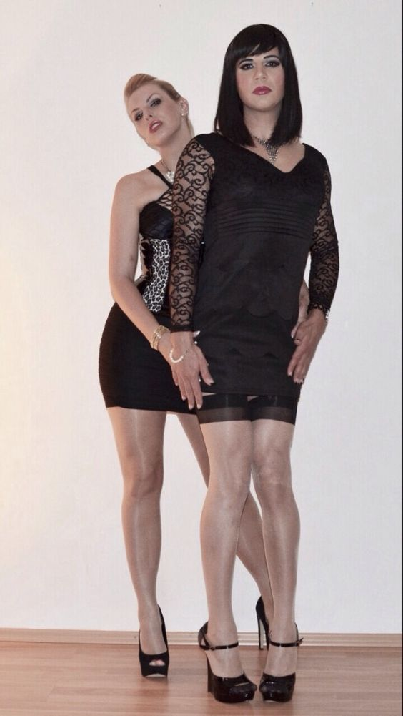  Fianna and I going out on the town
© Maryanne Peters 2018

