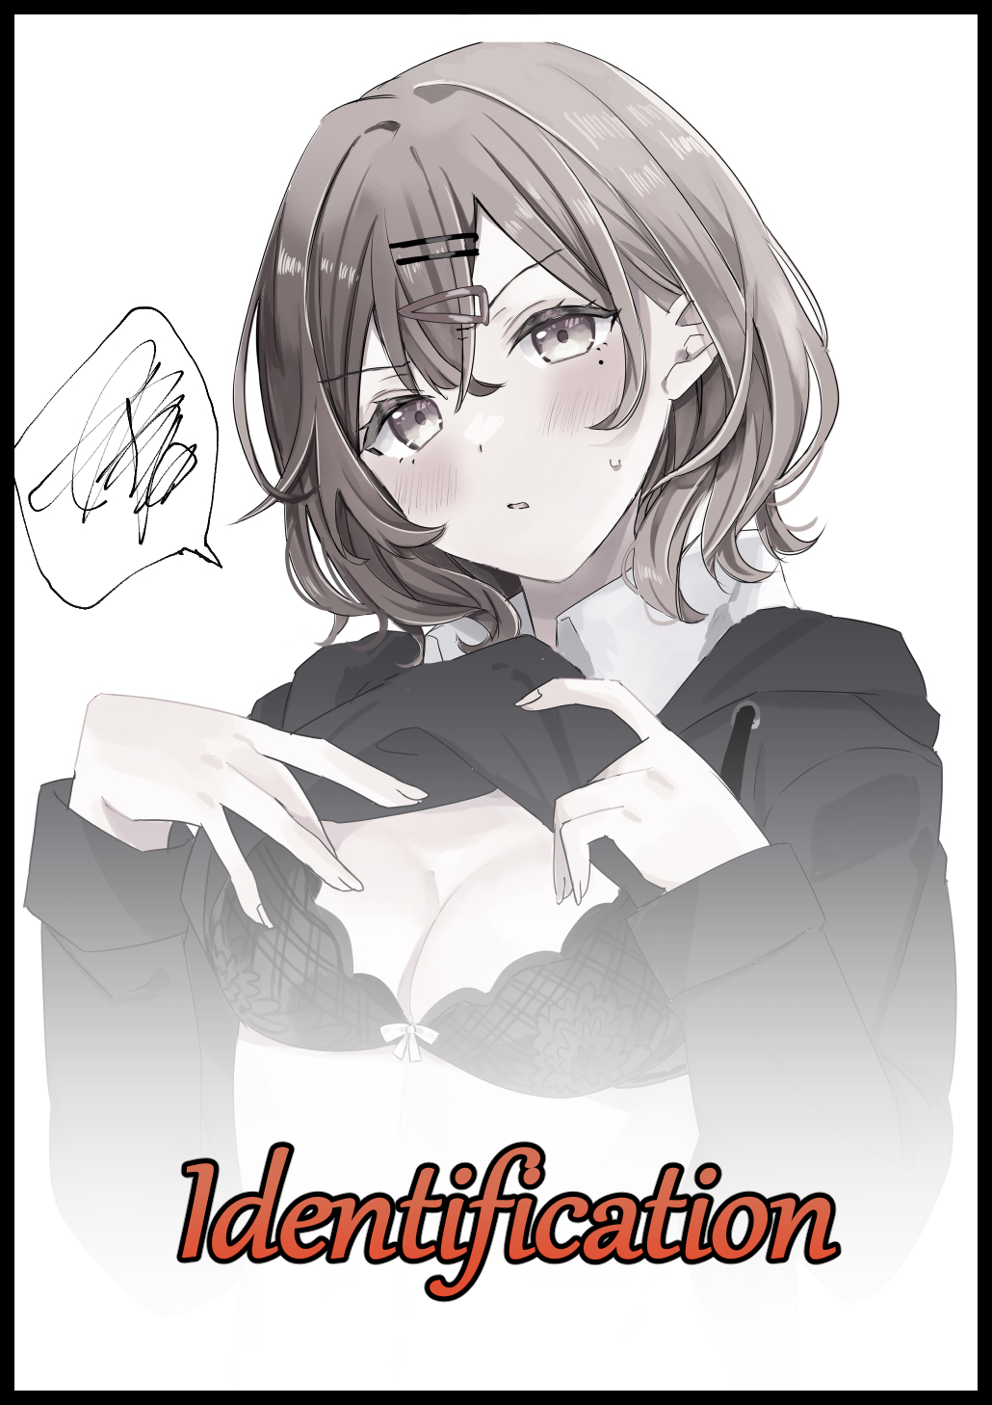

Life had been particularly stingy with its blessings as of late, from a bad string of run-ins with the course supervisor for failing grades and a streak of late arrivals to a worsening inferiority complex in the wake of it all. You couldn't help but lean into that incredulous notion despite it all just being the result of speculative anxiety, keeping your brain in a constantly stressed out state that only serves to feed into the endless mire of bad circumstance you find yourself knee deep in. Making you rethink your decision to study for a university diploma and whether it was all worth it.

No matter where you were, not a single moment could offer reprieve. Finding solace only in the cold comforts of blissful sleep where nothing could disturb you until the next time you awoke. And with the problems piling on, those sweet retreats were steadily becoming harder and harder to attain. Especially when a certain spot of trouble had begun to stir close to home within the messy bunk you had all to yourself, trouble that wouldn’t have existed were it not for shoddy construction and cost-cuts across the board resulting in walls that were barely soundproofed. Allowing you to listen in to whatever your neighbors in the university dorms might be up to, including matters that should’ve been kept to the privacy of a proper bedroom…
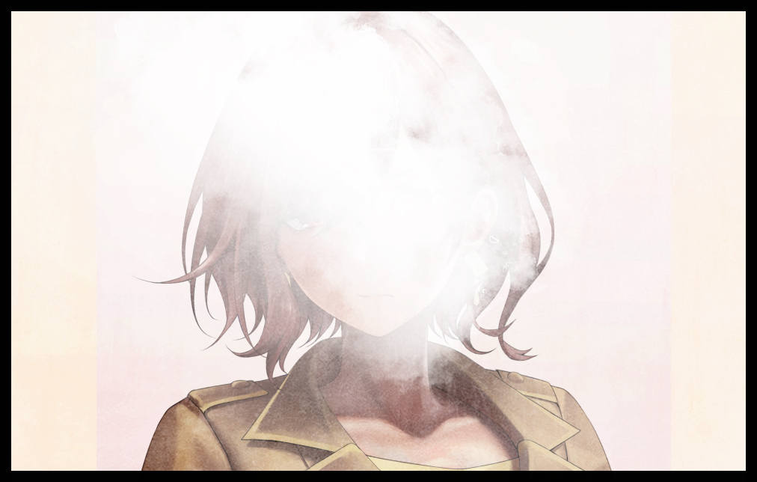
You didn’t mind the ‘noise’ at first, being the hormonal man you were back then. But after those repeat raunchy meetups began to grow more frequent, you found yourself unable to sleep. Not when the muffled voices of man and woman wound in union plagued your eardrums non-stop while the accompanying orchestra of flesh banging against flesh hard enough to rock the legs of an unlucky bed kept your taxed mind too busy to rest. An issue you were too tired and wimpish to do anything about, consigning yourself to the cards fate had dealt…that is of course, until you stumble upon a badly damaged ID card, it’s make and coloration cluing you in to it being a misplaced relic belonging to a careless senior, whose face could not be made out behind all the smudging, flaking and whatever other form of neglect and abuse the poor thing had been put through. But from what little detail there was, you guessed it to be a woman. Or maybe an androgynous man considering the exceptional width of the shoulders you could see in the frame.

The first course of action would’ve been to turn it into Lost And Found, but when the owner’s name and course number had come out intact despite the dreadful conditions faced by the rest of the card, you knew how easy it’d be to simply take a little walk and do the right thing. Besides, you didn’t feel like returning to the dorms so early, so you welcome the notion and take an immediate u-turn back towards the main building, setting course for the fifth floor labs where you knew the students in Computer Science mainly congregated at. Planning to drop the card off at room 5-B as designated on the back of it with faded marker ink.

Beneath your notice however, a series of anomalous changes had begun to take hold of you ever since those curious hands of yours had graced the forgotten card. Not paying heed to the subtle lengthening of wiry lashes as they extend and smoothen out into fine highlights perfect for the final form warping slits would take. Cleansing heavy eyebags from existence that does wonders for your steadily rejuvenating complexion as a building breakout of festering calluses do the same; retreating under rippling until nothing remains to tarnish the buttery smooth skin left behind in the wake of the warp. Continuing on past a throng of students and faculty without a mind cast toward the steadily growing number of eyes being cast your way while an unkempt clump of bed-mashed hair curls into fine locks before extending out into fine threads consumed shortly after by a swift dash of polished brunette shooting out from the roots. Leaving a now effeminate visage far removed from what it once was, gravitating toward the faceless portrait within the ID card bouncing around in your pocket with each passing second as more changes seed themselves across the rest of your rapidly malforming body. Taking steps up a flight of stairs that ends with more and more of a notable ‘jiggle’ to legs pumped up with renewed layers of flesh and firm fat that provides plenty of tone and heft to the once skeletal pillars. Energizing you with vigor never before experienced as you find your steps becoming far more lighter, losing the dreadful weight that characterized your depression. Straightening up in an act that brings notice to an unusual weight hanging off the front of a lithe torso stripped down and rid of sagging rings borne of your troubles. Light enough for you not to feel burdened but strangely sensitive in a way that could not be ignored. Stopping at the third floor to brush at your chest before a subtle crease crosses a striking browline upon the sensation of waifish digits and cushioned palms sinking into squishy fruits cradled by a secondary layer of cloth that had materialized beneath a darkened outer layer, gelatinous mounds that bounce right back into shape as your hands recoil in shock, reacting in a way ordinary flab wasn’t supposed to. Sighing in an audibly effeminate voice when you realize what the problem was as a brief flash of bioelectronic lightning zips between addled synapses, easing the tension in slender shoulders as the subtle hills protruding from your front take the chance to add a little more height to their already noticeable presence.
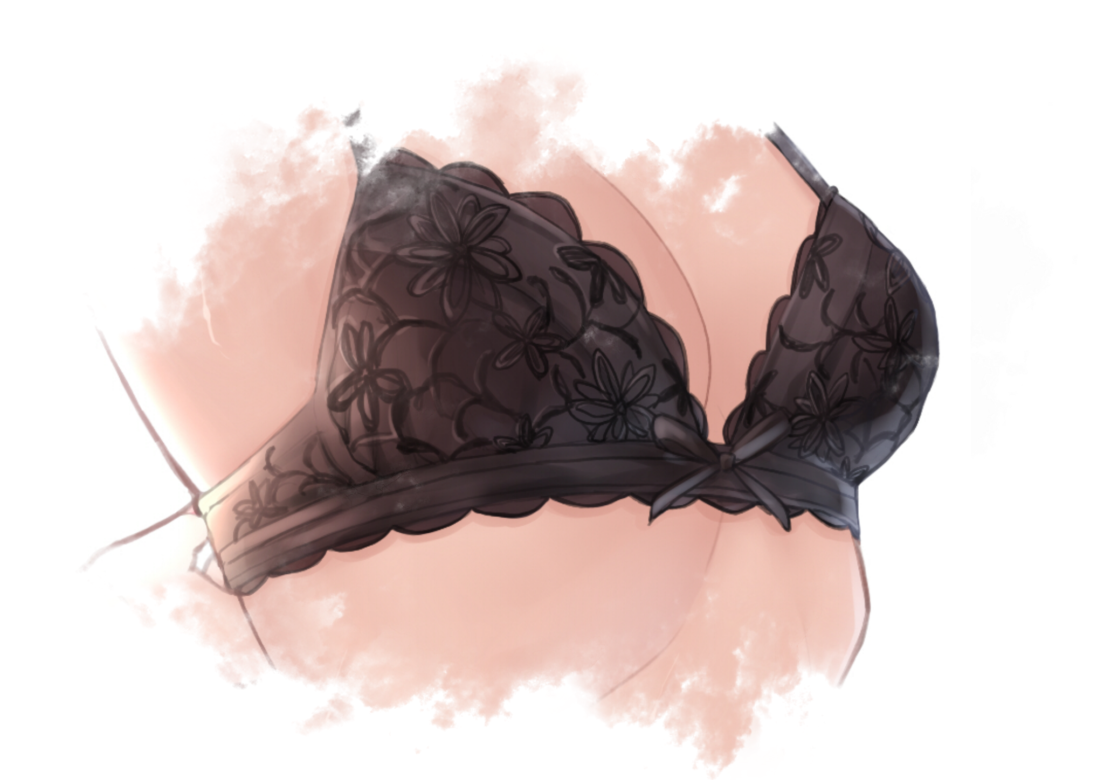
Setting down your bag, you take a cautious look around before retreating to the corner of the stairwell where no one passing by upstairs or downstairs would be able to catch sight of you raising your shirt up to get at the loosened clasp holding a bra of moody magenta together. Tightening the thing up before it could slip loose any further than it already had as manicured fingers tickle the sensitive nape of an alluring spine that arches inward to accentuate your petite bust. Spurring efforts to fix this little wardrobe malfunction of yours before anyone could catch sight of your toned tummy and lascivious tits hugged by racy underwear hanging out in the open. Dusting yourself off once you feel the bra’s signature pinch calling an all clear before doing another quick scan of the surroundings as you resume your journey uphill with a little sway to tight hips wrapped up in twisting fabrics extending out from the bottom of the baggy jacket that replaced your shirt. Showcasing glimpses of pale beige glistening from between peering light shafts alongside the undulating folds of flesh bunching up and relaxing to the movement of firm thighs squishing against the ample meat present around a softened core as you cross the threshold to the fifth floor, losing sight of yourself as a broad nose tightens into a cute bridge rising between two unwavering eyes that were no longer scrunched up with the permanent look of a feeble minded worrywart. Displaying only calm determination as was to be expected of the individual you were inches away from becoming as you turn the corridor with a soft squeak from polished black sneakers molded from frayed boots that would’ve been inadequate to sheathe the dainty little feet supporting you as you move toward classroom 5-B. Not even missing a beat as you respond to someone’s afternoon greetings with a short wave of the hand and a slim smile as if they were a known associate…
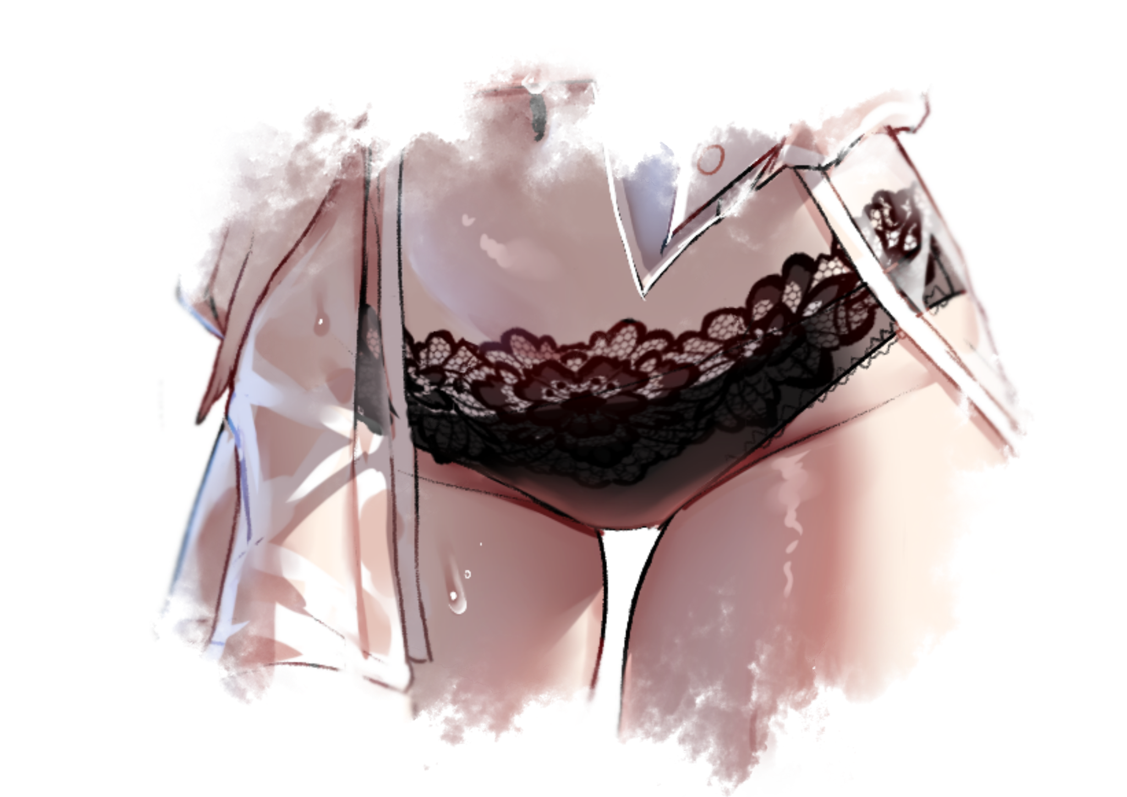
But before you could cross the tiny distance left toward your goal, a sudden cramp in the region near your groin causes you to flinch. Nearly collapsing right then and there were it not for the nearby walls offering you their unwavering support as your back slams into knobbly concrete. Knocking the air out of flushed lungs as you clutch at your stomach in agony, gritting pristine teeth while the handsome visage of a tomboy furrows in response. Beading sweat trickling down all over as an unnatural heat overwhelms your very being, spreading out in throbbing waves from the sudden fire that had broken out inside of you as you struggle to stay conscious. The mind numbing sting of it all numbing you to the way your hips snap outward just a teensy bit more while diminutive testicles undergo a morbid alteration; splitting down the center like an animate flower until your groin sports a velvety gash. The framework for something more as what little remains of a flaccid dick is consumed, pulled and tucked away until all that remained of it was a twitching little head sticking out above a tiny hole that wastes little time in producing a driblet of women’s nectar, a collection of hypersensitive nerves that forces a hushed sound out from saliva soaked lips upon being brushed and stimulated by morphing threads unwound from fading boxers that wouldn’t have been appropriate for your classmates to hear as you cup your hands over that naughty mouth of yours before it could get you into trouble. Holding back the sudden onset of a minor orgasm as you feel your insides shift and contort, widening into a meaty canal that puckers and folds against the muscle memory being seeded into their being. Replicating a fabricated set of mental images that steadily takes over reality itself as your pleasured face contorts into a look of hesitant frustration. Finding a new face to blame for yesterday’s sleepless night, a culprit who was also responsible for the reason behind why you found it incredibly hard to walk straight as you felt your asshole swell from the harsh experience it had endured the night before. Carelessly glancing over the fact that you now had a matching set of lace panties cupping the oozing lips of a fat, juicy vulva jutting out between steamy cushions while riding up tight between the pliable cheeks of a certifiable ass worthy of being manhandled. Tucking the decorated straps into place just like you had done for your bra earlier before realigning the hem of a pleated miniskirt that had just finished taking shape from what remained of vanished pants alongside form-fitting leggings that aids in showing off every last curve and dip displayed in alluring legs formed from meaty thighs and sturdy calves as you push off from the wall. Determined to finish what it was you came here to do, none the wiser to a misplaced beg whisking itself out of existence alongside the last bits of physical evidence as to your degrading identity. Inhaling a hurried breath in an effort to gather shaken nerves while tucking loose strands of hair behind soft ears as if it were second nature.

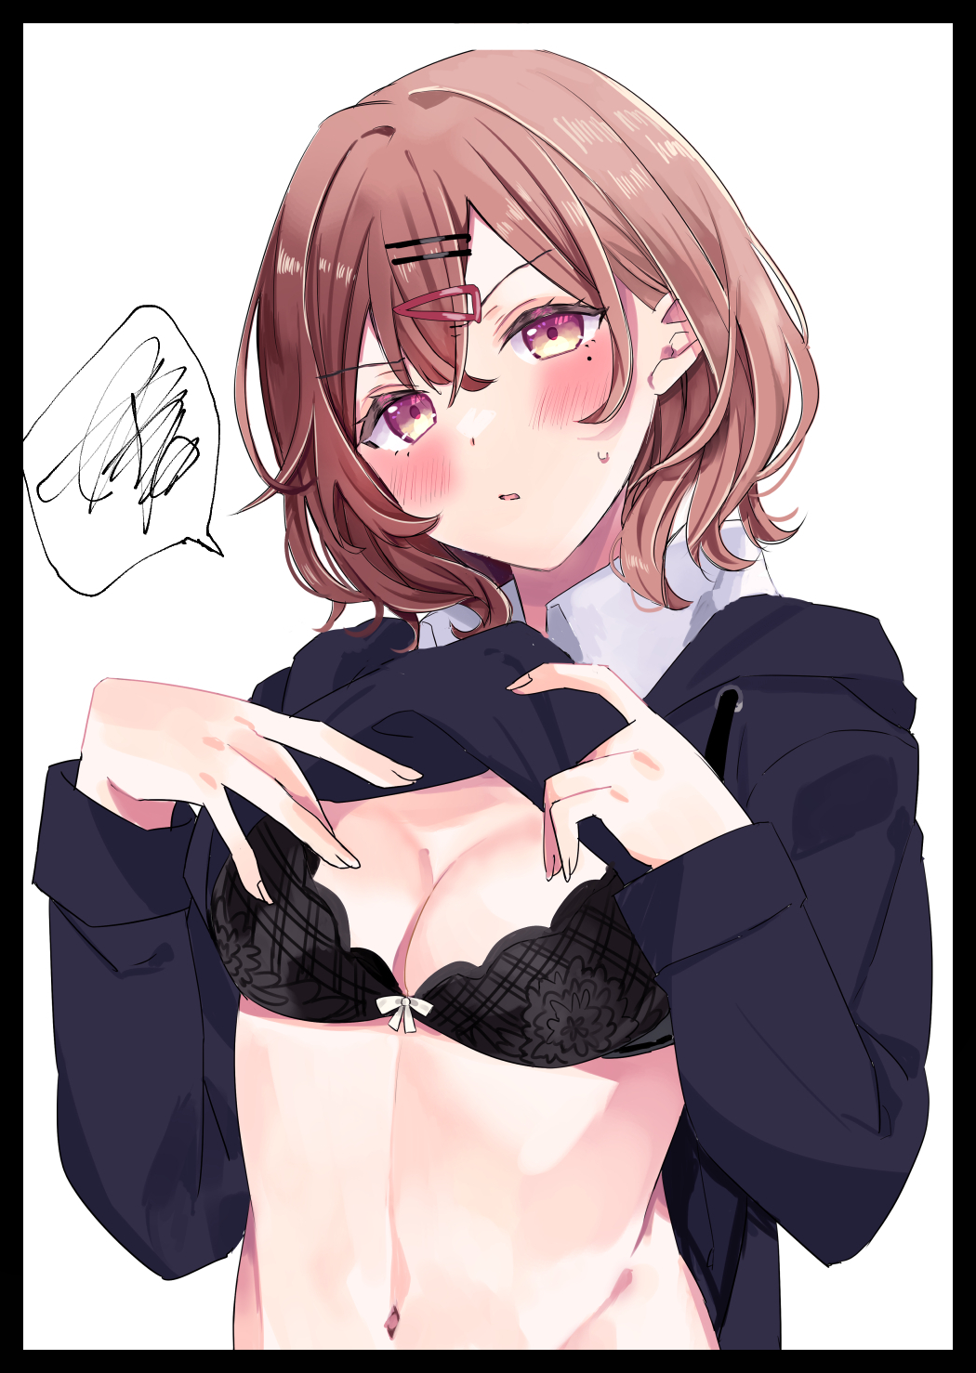
Pushing open the doors to 5-B before your eyes lock on to a young, familiar fellow standing in the corner of the room, alone…and from the look of excitement overcoming his dull expression…had he been waiting for you? “Finally, I thought you weren’t gonna show! You lost your way or something? I was gonna start searching for you if you hadn’t come soon…so? You wanna get this show on the road or do I have to take the lead again? ”

Encouraged by a sudden burst of childish anger, you give in to the new urges spurring salacious actions you’d never think to do before now as a swift hand unflinchingly lifts the front of your jacket. Giving the handsome stud standing tall in front of you a good show as you angrily tell him of, saying how he couldn’t have expected you to move so fast had he not fucked you the way he had last night. Chastising him for the act with mild embarrassment despite the way you had egged him into doing so with not so subtle signs during last night’s kerfuffle as rosy cheeks flare, doing away with subdued ocher irises as iridescent amber floods it all. Signing off on your irrevocable transformation into the young lady in the ID card you had thought to return with a beauty mark seared just beneath the length of your left eye. Sealing the last memories to come into fruition within a thoroughly tampered brain that could no longer recall the time it spent as the core of a depressed youth going nowhere in his life. Instead, all you could remember was yourself, finding no need to withdraw the renewed ID tucked safely away in the pocket of the crumpled skirt that had fallen down to your ankles as you allow your soon-to-be fiance to undo the buttons holding it together, shivering in silent anticipation as you feel his warmth encapsulate you from how close he was, close enough for the rough fabric of his coat to brush against swollen nipples after you had freed those milk laden puppies. Dulling your eyes into half lidded slits just like you had seen many porn actresses do a while back when you were still a stranger to intimate relationships doing ‘research’ in preparation for this very day, thinking to please your stud as you shift slender arms to wrap around his waist once you feel his own manipulators sink into the soft flesh of your derriere, making you moan in unadulterated lust from the sensation of his thumbs poking against your cock addicted butt hole while itchy pinky fingers play with a pudgy cameltoe through the soaked fabric of your underwear. Leaving you ready and waiting by the time he lays you out over the lecturer’s desk with his erect dick hanging out. Stiff and swollen with anticipation to let loose inside of you after last night’s confession; made after many years of getting to know this bull and how he would shape up to be an excellent husband, just like how he knew you were the one and only woman to live the rest of his days with. Forgetting each of your individual worries as you loosened your vaginal folds in preparation for what was soon to come in the silent depths of a now empty 5-B. Counting your lucky stars and the inadvertent encouragement provided by those noisy roommates of yours that had ultimately led to your first ever taste of sex late last night when you had asked your boyfriend to come visit you in your bunk, only to find your confession interrupted when the two horndogs next door started singing that vulgar song of theirs…inspiring the two of you in turn as you thought back to the moment when you found yourself on all fours, panting like a dog while sweat proliferates across the entirety of your nubile young body as you felt your lover’s prick penetrate your virgin behind. A primer that had left you with a limp to your step and an excitement to see the second half through right here and now less than a day after as you grunt in pain, eyes rolling into the back of your skull from the immense pain wrought by your hymen being torn by a sturdy head that goes deeper and deeper…until all you could feel was the white hot delights of love and nothing else, losing yourself in the moment as you scream your happiness with fiery delight while locking lips with your beloved. Never to look back from this moment onward as you share in the moment with nothing to distract you from the best time of your life. A life you felt strongly for and would never make a single change to even if the chance was available…

THE END

Image 1 by Suwa : https://www.pixiv.net/en/users/61838844

Image 2 by Kijibatou 1-2-3-Gou : https://twitter.com/atto_silia

Image 3 by Tikkeworld : https://www.pixiv.net/en/users/16273440

Image 4 by Atto Silia : https://twitter.com/atto_silia

