SLUGGISH MELODY
MARCH 2021 REQUEST STORY
BY CHALDEACHANGE
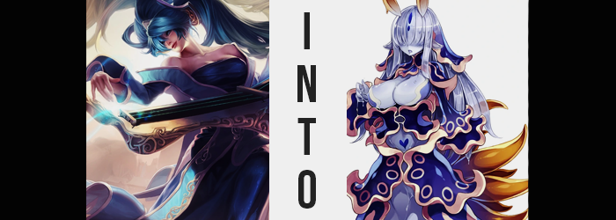

It certainly wasn’t unusual for Sona Buvelle to have to travel by ship. The world was a big place, much of it covered by lakes or oceans. And with different cities scattered amongst them, as a musical performer of her renown it went without saying that she was expected to travel all over the place. At times she had to travel aboard great passenger ships, and at others via ships reserved for her alone.

This incident had occurred during the latter, making it extremely difficult to locate her if anything were to happen, and it had.

DRIP, DRIP, DRIP, DRIP…

“Nn…?” Sona was mute, but she was still able to make the most basic of noises like groaning if she had to. In this case, it was because she was rudely awoken by the feeling of water splashing against her cheek from above. Upon opening her eyes, she realized the world around her was only dimly lit, and the surface she was laying upon was hard.

After pushing herself up slowly, she was quick to realize the reason for both of these things. She was laying within a damp cave, extremely cramped in size, with the only exit and source of light being a hole of ocean water in the center that evidently went outside. How had she ended up down here? Hadn’t she been on the ship!?

No…

Memories came flooding back. There had been a terrible storm, the ship hadn’t made it. She could remember sinking and sinking beneath the violent waves above, thinking herself doomed. Before she had passed out completely, she’d felt it. Something incredibly soft had taken her hand, but she’d fallen unconscious due to the lack of air right after.

Had whatever had taken her hand saved her? Is that how she’d ended up in this tiny cavern? Now that she was moving around, she realized she had been stripped down too. Because her clothes had been too heavy? It wasn’t impossible.

Could she swim up to the surface from here? It was the question that came to mind first and foremost to the musician. She would die down here, if not of starvation then of dehydration, but blindly swimming had its risks as well. How deep was she? If it were too deep, she could drown before reaching the surface and this second chance would be for naught.

But even though she weighed this opportunity? Something deep within her…

It told her to wait. She would be able to leave soon.

Sona didn’t have the foggiest idea what it was though. A voice? No, it was more like a feeling… an instinct? But it was accompanied by something. A feeling that made her a little uncomfortable, yet she wasn’t beset by panic thanks to that instinct. All she knew was that she felt a chill, and as she brought herself up to her feet? Her body felt… Had she always been this jiggly?

Sparing a glance downward to her naked form, her breasts almost looked fuller than she remembered. So much that she reached a hand up and pressed fingers into their flesh. But shockingly… “…!?” Her fingers sank into them, far deeper than they ever plausibly could have before. Usually there was some resistance, but now it felt more like she was digging her digits into a sea of gelatin.

The moment she removed her fingers from the depths of her breast, the indentation even lingered as it slowly rebuilt itself back to its previous shape, and her fingers? They were blue. Sona hadn’t been sure if it was a trick of the light in the beginning considering how dimly lit the tiny cavern was, but by holding them up to the flesh of her tit it was much more evidently. Not only was it evident, but it was spreading. Her hand had succumbed to this color, which resembled a pale sea, within a matter of moments. It was something that plagued both of her hands, and then her arms, and then her torso.

But it wasn’t merely a change in color. As her flesh blued, so too did it become better adjusted to the cavern’s temperature. While it had been exceptionally cold to her when she had first woken up, she now at least felt comfortable. And once the color ran through her legs and dyed her toes? Something shifted in the woman’s posture. It felt as if she were sagging in slight, like the weight of her body had grown more abundant, and flesh, which was incredulously softer, had begun to sink.

Almost like there wasn’t a single bone in her body any longer.

The though struck Sona, but a flexing of her fingers found she could still move them. Maybe it was a trick of her imagination? Or maybe it was something… else. Invertebrates found different ways to move even in the absence of bones, so perhaps she was held in a single piece by muscle alone? That would make sense, perhaps, if she’d thought about it.

But, incidentally, it was becoming quite difficult for Sona to think at all. Had her intellect dulled? No, not yet. But the lightning fast thought processes so typical of the human mind seemed to be going at almost half speed. She’d experienced a similar phenomenon when intoxicated in the past, but this didn’t really feel like that either. Not that Sona was even really thinking about it. Her body was comfortable now in its pale blueness, and she was having difficulty focusing on more than one thing at a time.

What prevailed in terms of mental focus was an interest in her changing body, for something had spurned her arousal and blue fingers, strangely nail-free, reached up to grab both of her tits at once. They had sunk back into the flesh (though not with the same tenacity as they once had) and begun to tease them. Her nipples were hard, but a darker blue than the flesh beneath them, and they flesh beneath them?

The musician could actually feel it swelling beneath her touch. It hadn’t been a mere trick of the mind previously that her bosom had looked a little larger, but it had been just the beginning, laying the foundation. Because this time? The growth was playing for real.

Sona’s soft tits expanded around the equally soft hands that were groping them, the pressure from the two forces colliding forcing both parties to temporarily misshape before she gently pulled her hands away a little to make room. And slow was the keyword here, for they were actually moving faster by means of the fatty tissue they were holding pushing them forward. Much like her mind, her movements were becoming sluggish.

And things were about to unfurl in a way that would add a literal meaning to that word.

Still playing with her bosom, which was an activity that she could do idly – enamored by the sensual feeling of dipping her fingers into tits that were quite easily F-cups now (with still a little bit of room to grow) – the musician wasn’t fixated on the idea of walking. Rather, slowly, she was wondering what it might be like to stick something else into her soft flesh. Having her boneless body wrap around it, taking it as her own…

She’d fallen into corruption so easily.

But it was ideal that she had not tried to walk, because there was absolutely no way it would have been possible. Rather, her feet were stuck to the ground is if bound by glue, and her legs? They were, what looked like at a glance, perspiring. It wasn’t sweat dripping from her blue skin though, it was too goopy. That goop collected around and between her toes and continued to drip… drip… drip… Each sticky drop sliding over the next before hardening, becoming one with the drop beneath it. The process was slow at first, but before long Sona’s feet were seemingly cemented to the ground with the excess spilling out behind her.

The time that passed before her feet had becoming completely swallowed was not a long one, and the perspiration of soft goop ramped up to the point where several cups of this goo were created over just a short five second period, crawling down her legs from as high up as her thighs, and freezing in place further down. Bit by bit, the gap between her legs was filled, and the perspiration soon began to pour more prominently down from her ass, sloping out behind her towards the ground.

It might not have been clear to Sona what was happening had she even taken notice of the fact with her dulled awareness, but to an onlooker it eventually became clearer, at least once the front had filled in fully. It looked as if this goop was actually becoming a part of her body, excess tissue building to present her lower half with an appearance that wasn’t at all human. The best comparable likeness might have been that of a snake tail, but there was no ‘belly’ to speak of, and the bottom lipped over the ground like someone had just splatted it there.

Her pussy and ass crack alike eventually became clogged by this excess blue tissue, though at least the former could be salvaged if she wished to part a flap in front of it. As if to mark where it was, a bright blue heart was dyed into the skin a short way above it. A pleasurable treasure hunt to say the least. At least in regard to the musician’s ass it seemed more like it had become one with whatever her lower half had morphed into, and what that was?

Was the lower half of a slug. Suddenly, her lack of bones made sense, with much of this slug body sloping out beyond her like the robe of a dress. If she tried, Sona would be able to crawl along the cavern floor at a terribly slow pace. But she still wasn’t even remotely interested in such a thing. While much of what this lower segment had molded into was the same pale blue as the rest of her body now was, near the base the blue was darker with a trim of darker dots looping around the outskirts.

But her soft and jiggly body began to perspire once more, the goop in this instance of a brighter set of colors than what her slug tail was composed of. What took form was a number of royal blue fins that wrapped around her figure, holding up her breasts like a corset, or wrapping around her arms like sleeves, or cupping her crotch to conceal the flap that led to the goods, and otherwise covering up the tail behind her. This royal blue, regardless of where it appeared, was done up with an almost golden trim, a series of Os cut out in the same color peppered here and there.

From the moment her lower half had begun to perspire, back when she still had legs, until now? Three whole hours had passed. But according to Sona’s perception, it felt as if it had only been a few minutes. This discrepancy was a testament to just how slow her brain had become, and she had grown almost completely unconcerned with where she was in that time as well. This place? Home? It felt? Home? Her thoughts were simpler too, and it was unlikely she would be able to think of anything more complex than what her instincts and impulses guided her to consider.

In the meantime, the color of her blue hair was shifting. It didn’t stop being blue, but the shade? As her locks took on a slimier texture, and more translucent in color, the blue itself lightened to become similar to the color of her body. The only exception were the dark blue fins that jutted out of either side as this hair pulled into twintails similar to Sona’s infamous hairstyle, as well as a pair of dark blue dots down the center of her head. On the sides of her head, her blue ears elongated, looking almost elvish by design.

She suddenly found her vision impaired, for her bangs had grown to cover her eyes; not that any of this actually registered in a timely manner, and not that her sense of sight was truly relevant regardless. In fact, the light in her eyes was slipping, and her ability to perceive through vision alone was dwindling. Within a matter of moments she was effectively blind, but before her sluggish brain could process that fact, a solution had already settled into place.

This solution rose from two points atop her head, a pair of pointed feelers that jutted about six inches outward, with blue bases and golden tips. They wriggled around in response to everything in the gave, from the dripping of nearby stalagmites to the ‘scent’ of this space. They acted as a guide for one without eyes, allowing her to sense smell and movement at an intensity no human could ever imagine. But they were also sensitive to the mana of a woman. A helpful took for seeking out a potential partner.

And she wanted to seek one out. A woman was what she wanted to let sink into her body. She wanted a woman to sink into her, and to make that woman hers. For she could extract their DNA, and mother a child.

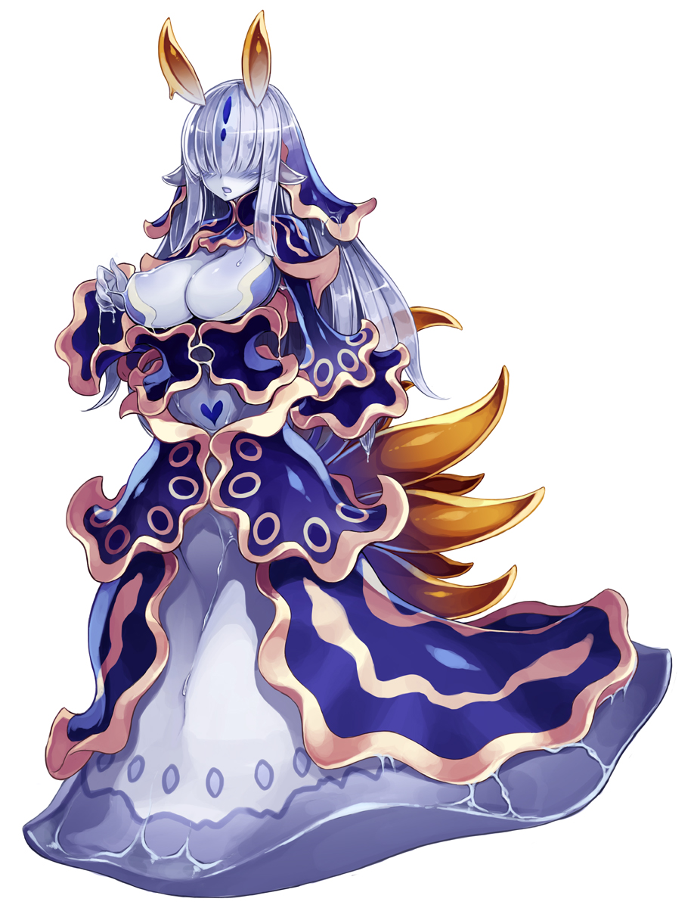
The feelers didn’t sprout without company though, and from her back? A series of tentacles sprouted, each one outside of Sona’s own control. Roughly ten of them were birthed, each one hardwired to snatch up anything that might approach her from behind and bring it into her body. For example? Perhaps a stray fish that she could make her lunch, or a man whom she could jack off with them. Either way, these tentacles could not be felt by her. They simply existed, acting to keep her alive.

Sona’s face, despite it all, had remained relatively the same structurally. There was just one major difference: age. Her features appeared softer, but not in a way that supported a youthful glow. Rather, they made her look older, more mature. Perhaps like a middle-aged mother, or with those huge ass tits of hers? Like a needy MILF with those big, plump lips that looked like they would suck someone off at the drop of a pin. And it would surely be pleasurable considering how long it would take her to do.

The slug-like woman was known as a Tritonia, but beyond that she could not remember much else. Did she have a… name? No, that was something people possessed. Not a monster such as herself. Perhaps she could one day be given one, perhaps by whichever man she was able to draw into her soft flesh, by that man she would one day make hers.

While she aesthetically resembled a mature woman that might have had children in terms of age, the Tritonia was actually quite young by human standards. Monster girls tended to age at different speeds than humans, and as a slug’s life cycle was shorter than a human’s, the Tritonia reached maturity at twice their speed. She would not die before a potential mate, however. Now that she had aged to this point, she would not appear to age any more until she died.

The feelers upon her head reacted to the pool of water in the cavern’s center that served as an exit. She was… hungry, and she knew the ocean was of no issue to her. She would hunt for nourishment, and then she would hunt for a man. His semen would satisfy her more than any fish ever would. This instinct was all she had. Her thoughts were so slow. In the time it had taken her to reach this conclusion, a full ten minutes had passed since her transformation had completed.

And so, she dropped into the cold ocean below, unknowingly leaving a better life behind.

Just… it took her about twenty minutes to reach that hole, despite being only a few feet away in the beginning.

