OFF TO THE RACES III.
COMMISSION STORY
BY CHALDEACHANGE
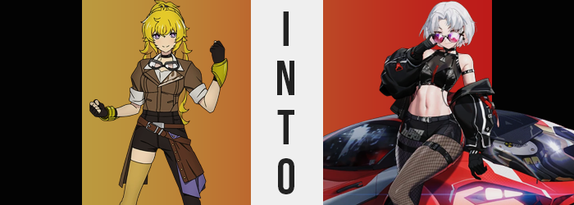

“This is not the kind of place I expected to find in one of Weiss’ dreams, not gonna lie.”

Yang Xiao Long didn’t really have any reason to communicate this aloud seeing as she was by herself, but she did like to hear the sound of her own voice. The space she was in was dimly lit, but light filtering through small windows more or less made her aware of the scenery in its entirety. She was nestled in a garage, and not a little one. It was large enough to horizontally contain eight vehicles and had that many doors.

While she couldn’t count that many vehicles inside, there was a bright red sports car not even a few feet from where she had picked herself off the floor. “Weiss didn’t really strike me as a sports car girl! But I guess she is rich? Maybe she was just hiding that side of her from us. Crafty…” The blonde had been so surprised because this didn’t at all seem like the kind of thing Weiss was into from experience. But she also didn’t claim to be a Weiss Schnee expert so she supposed it was within the realm of possibility.

“Weren’t the others supposed to show up with me? Are they outside of the garage or what?” Alright so there was one reason that Yang would talk to herself aloud. She had a tendency to do it when she was nervous or uncomfortable. The teen was wearing a smile but the truth of the matter was that she was unsure about what was going on. Hearing her own voice at least brought her some reassurance where nothing else was. “RUBY!? BLAKE!? YOU OUT THERE?”

No reply. And there wasn’t a very obvious way for her to leave the garage either. She had already investigated one of the electronic doors and found that there was no way to open it manually. There must have been a control system installed somewhere, but where would the button be? You’d think a garage designed this way wouldn’t be approved for safety reasons. “There’s gotta be a regular door somewhere, right?” In all likelihood she wouldn’t know for sure until she checked the ends of the eight car garage. And she was between doors four and five.
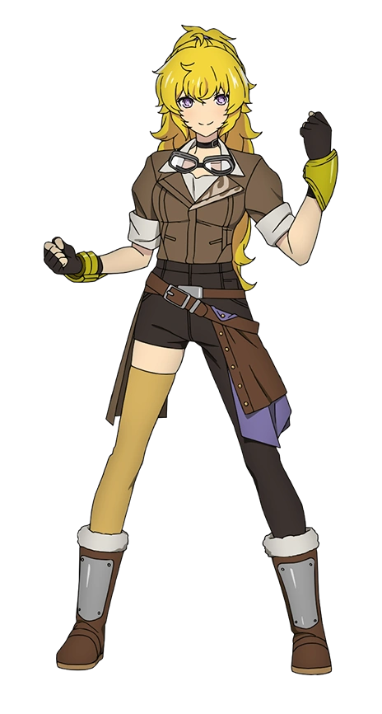
It was kind of a bummer, too. If the circumstances had been different then Yang would have loved to hop in one of the vehicles to go for a spin. The red car that she had woken up beside specifically almost felt like it was calling her name. Even though red wasn’t really her color. “It sure is a beaut, though.” So shiny. It looked fast! She wondered what the interior was like. Was it leather?

Despite only just recognizing that it wasn’t the time to obsess over the sweet rides in the garage, for some reason the girl went against that understanding not even a second later. “Oh!” She had tried to open the door to the driver’s seat assuming that it was locked – thus deterring her from pursuing this desire of hers any further. But much to her surprise the opposite happened. The door to the car opened with ease.

Revealing a leather interior that she scooted inside to savor. “Dang, this thing is comfy!” The seat felt nice on her plush rump and she took the wheel with both of her (still attached) hands to roleplay what it might feel like if she was driving it. Of course that was a fantasy she couldn’t engage in as things were. Even though she could play with the wheel and shift the stick, there were no keys in the engine. It wouldn’t start. But even if she could start it what was she going to do, steal it?

“What am I, a moron? Why would it be stealing to take my own car for a drive?”

Those words didn’t sound like they could have escaped Yang’s lips. They were undeniably spoken with her voice, but the harsh and belittling tone she had spoken them with didn’t sound like her at all. Not to mention it made no sense. She didn’t own a car! There was no real reason for her to believe that the red vehicle was hers whatsoever. Despite how enticing the car’s interior was? “That was… weird.” After blurting out that confusing statement she decided to get out for her own good.

“If the actual owner came by I’d get in some real trouble if I got caught.” After stepping out she stretched, trying to push to the back of her mind that she still felt a little like the car was hers. That thought gave her an odd hunch, and before she realized what she was doing she was investigating a shelf right behind the vehicle. “Aha!” She had reached behind a paint can and found… the keys? “Wait, that wasn’t luck. How did I know… those were there?” The more she thought about it the stranger things were.

And yet before she could think too critically of any of those realizations she ended up distracted by something new.

“Huh? What’s going on her? I feel kind of… weak. And off balance?” Yang looked down to examine herself with renewed interest, not exactly sure what she was sensing in the moment. Nothing really seemed out of place to her. Was she getting sick? Had she just felt a sudden wave of fatigue? But if she was in a dream world then were either of those things even really possible? Maybe they should have gotten some more information from Shion before taking the plunge to avoid confusion like this?

But the young Huntress-in-training just didn’t seem to realize it. Something really was wrong with her body, and somehow her purple gaze hadn’t quite caught it. But then again it was a change that was highly obscured by her clothing. The feeling of weakness that plagued her was not at all a matter of fatigue, but a case of her muscles literally becoming weaker. This meant that her arms, legs, and pectorals all became thinner and softer. Yet to the contrary of this? Her abs tightened to give Yang and even better defined tummy than she’d had before.

Of course, a very toned tummy did not make up for all of the lifting strength that had just been taken away.

Changes to one’s muscle build could bring about a feeling of imbalance, but that wasn’t the sole reason she felt the need to adjust her posture, either. A surprisingly big part of it was a sudden chopping away of Yang’s hair. Those golden locks were something that she prided herself in, and upon arriving in this dreamworld they had been pulled up into a high ponytail. Yet whether it was related to the tail or not, it was suddenly all chopped off just above her shoulders to grant her a rather messy bob.

Albeit not messy for all that long. While the sundered hair appeared to disappear into nothingness before it even hit the ground beneath her, the hair that remained fastened to her skull straightened. Her bangs parted and lifted in the center so that they were incredibly stylized, and if that hadn’t been bad enough? The golden color she had inherited from her father lightened away to a silver that bordered white, beginning at the roots and seeping all of the way to each individual tip. This color change was replicated elsewhere, including in thinned brows and bushier pubes.

The hair changes were a literal weight off her shoulders. “Wait, my hair is…? Nah, my hair always looked this way, right? What am I being an idiot for?” Like both Weiss and Ruby she had come so close to actually stumbling upon the truth when she noticed silver bangs in the upper corners of her eyes, but the force that was assimilating her into the dream was prompt in its efforts to steer her down a path of acceptance even despite her prior attachment to those long, golden locks.

Realistically there were far more dire changed for her to have grappled with anyways. Well, if she’d been able to. This truth was no clearer than it was upon her torso. Not her tummy for tensed muscles were all she’d receive there, but in the region just above. There was no denying the fact that Yang had the largest breasts among Team RWBY. It was a fact that she was aware of, but simultaneously not one she held above anyone’s heads. They couldn’t help how big their breasts were, right?

That was just as true for Yang herself. She didn’t decide how big her tits were, and so she couldn’t help that they were… shrinking? Beneath her brown tanned jacket and undershirt her breasts were deflating, their abundance compacting and nipples shrinking a touch in kind until those breasts were far more comparable to Blake’s in size. That didn’t make them small by any means and they now possessed a greater level of perkiness than they’d had prior, but a loss was still a loss.

“Huh?” She tugged at her top, seemingly confused by its fit. Her bra wasn’t settling where it should have? Well hell. Did I put on the wrong sized bra for this costume? Was that the issue? And for what reason did she perceive her clothing as a ‘costume’? It was just a quick explanation her shifting mind had come up with to justify things, to keep her off course from understanding what had happened. Even though her ‘costume’ was gradually becoming even more ill fit.

Where losses had been tallied upon her chest, Yang’s lower half was not plagued by such a depressing turn of events. To begin with? Her hips shifted wider, and as such the black, one-legged pants she was wearing dug into them and even lost a front button that popped off. It was really fortunate for her that the button had flown off because it freed up even more space within those pants.

Space that was highly necessary. Required, even. Because whereas her thighs may not have been as thick with muscle now, a softer tissue soon inflated them and simultaneously highlighted the muscle that remained. Those thighs widened until the one leg that was designed like shorts leg was gripping around muffining flesh, while in the meantime the proper pant leg to the left began to struggle to contain her swollen upper leg. Tiny tears eventually formed so that her skin could be exposed.

Because Yang’s pants were wrapped around her waist, however? They weren’t yanked down all that much while it became obvious from the rear that her ass cheeks were flourishing, the ass of those pants digging more and more into the crack of her ass until the pants almost seemed skintight with how defined that crack was even while dressed. Not to mention how her panties had dug way into them, prompting her to struggle to try and pick a wedgie while picking at the exterior. “That is not comfortable.”

She didn’t need to weather that discomfort for long, but before her clothing change was addressed some attention needed to be paid to her face. Yang was in her late teens, but along with a deeper voice her facial profile had gradually been aging until she was in her twenties. What’s more? She didn’t really quite look like Yang? Not unless Yang’s lips had always been twice their original size, or her face a more oval shape? Violet eyes lit up with a fierce crimson and were narrower when it came to her lids. But she very much looked like a woman in her twenties.

A woman in her twenties who looking convincingly human despite her interior having shifted to something artificial without anyone’s notice. She was a NIKKE. Something akin to an android. But at least she was fashionably dressed? As in the end her costume transitioned into something else. A sleeveless, black crop top and skintight short shorts overtop fishnet stockings. She had black boots with crimson highlights that could also be seen on her top, shorts, and a puffy black jacket that now hung from her shoulders so that they were otherwise bare.

Complete with leather gloves and a pair of glasses on her forehead, she was very sporty. She looked like someone who would not only own but drive a sports car. Like her crimson sports car. The one whose keys had ended up in her pockets at some point over the transformation’s course. But she pulled them out again now that her transformation had reached its inevitable conclusion.

“What was I doing again?” It was odd. Drake felt very certain that she had known what she was doing up until just a moment ago, but the past few minutes were just a blank. That was a thing though, right? Sometimes you got too into something and didn’t notice the time passing, or maybe you were daydreaming. It probably wasn’t worth concerning herself over. In the end nothing seemed to be wrong, and the race wouldn’t be starting until Miku’s concert was over anyways.

Then it hit her. “Oh! The race! Right, I’m the villainess! I’ll be the one playing dirty tricks on the track today!” Playing into the dramatics of what she was saying, the silver-haired woman pulled down her rose colored shades from her forehead and onto the bridge of her nose. There was one tiny issue with that declaration she had just made though.

Drake was not the villainous type. And in fact she wasn’t really a villain at all. It was a role she had been given by the stadium’s management. The racetrack didn’t just have ordinary races. Everyone on the track was playing a character in some way or another, and during each show the racers may be given the same or different roles. This was the first time that this woman had been cast as the villain – and she had been chosen solely on the fact that she had a villainous cackle.

She leaned against her car with a huff. “Hopefully I’m good enough. Maybe I can sell it on my laugh alone. …AHAHAHAHAHA!” Her brow furrowed. It was probably fine, right? The shows weren’t usually that elaborate. You could only do so much with speeding vehicles and microphones. The people in the stadium always at it up though. But could they even be considered people? They were all shadowy and stuff.

Eh, Drake never really thought too hard about it.

Tossing her keys up into the air and catching them, she popped up the hood of her car and peered inside. Despite everything she looked cool, and there was nothing cooler than a hot chick looking into her sportscar’s hood, right? Of course there was a small issue with making this look authentic. With her shades on, she was squinting down at the engine. “I don’t know what any of this crap does.” And she said it so confidently, too.

…Wasn’t that a problem? For a racecar driver to not know basic vehicular maintenance skills?

