UNDERSTANDING AI
COMMISSION STORY
BY CHALDEACHANGE
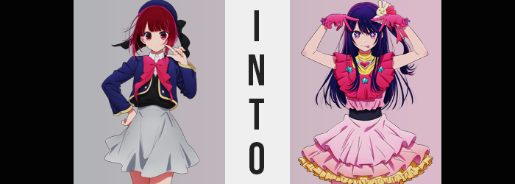

“Ugh. Why am I doing this? It’s such a pain!”

Kana Arima cursed her own luck, skipping up the steps to the small studio that Ichigo Productions had rented out for the express purpose of the beginning of this little stunt of theirs. Well, the teenaged girl could realistically curse her luck all she wanted. In the end? Luck hadn’t really had anything to do with it. She had agreed to take this step, to involve herself in this mess. Even despite the fact that she had absolutely no experience in this field, she had been willing to at least try.

The girl had been a child actress, you see. In her youth she was extremely popular, getting gig after gig and almost always knocking it out of the park. That was the prime of her life, really, where everything was always going extremely well. But there was an issue with being a child actor specifically. A lot of the actors’ or actress’ charm relied on them being cute, and when they got older? They became… less so.

By the time most child performers reached puberty they had fallen out of favor with the audience in favor of newer, younger, up and coming talent. And Kana’s life after her prime had been more or less the same. It eventually got harder and harder for her to get jobs, and there were the ones she got like a certain baking soda commercial that she really would rather pretend hadn’t actually happened. Not that she really could, all things considered.

“Who knows? Maybe a fresh direction is all I needed…” Passing through the studio’s doors and up the stairs, her opinion of the matter swung back into the positive. After all of her failed attempts as an actress? She had ended up begrudgingly accepting an offer from her production company to be featured in an idol group. And not just any idol group.

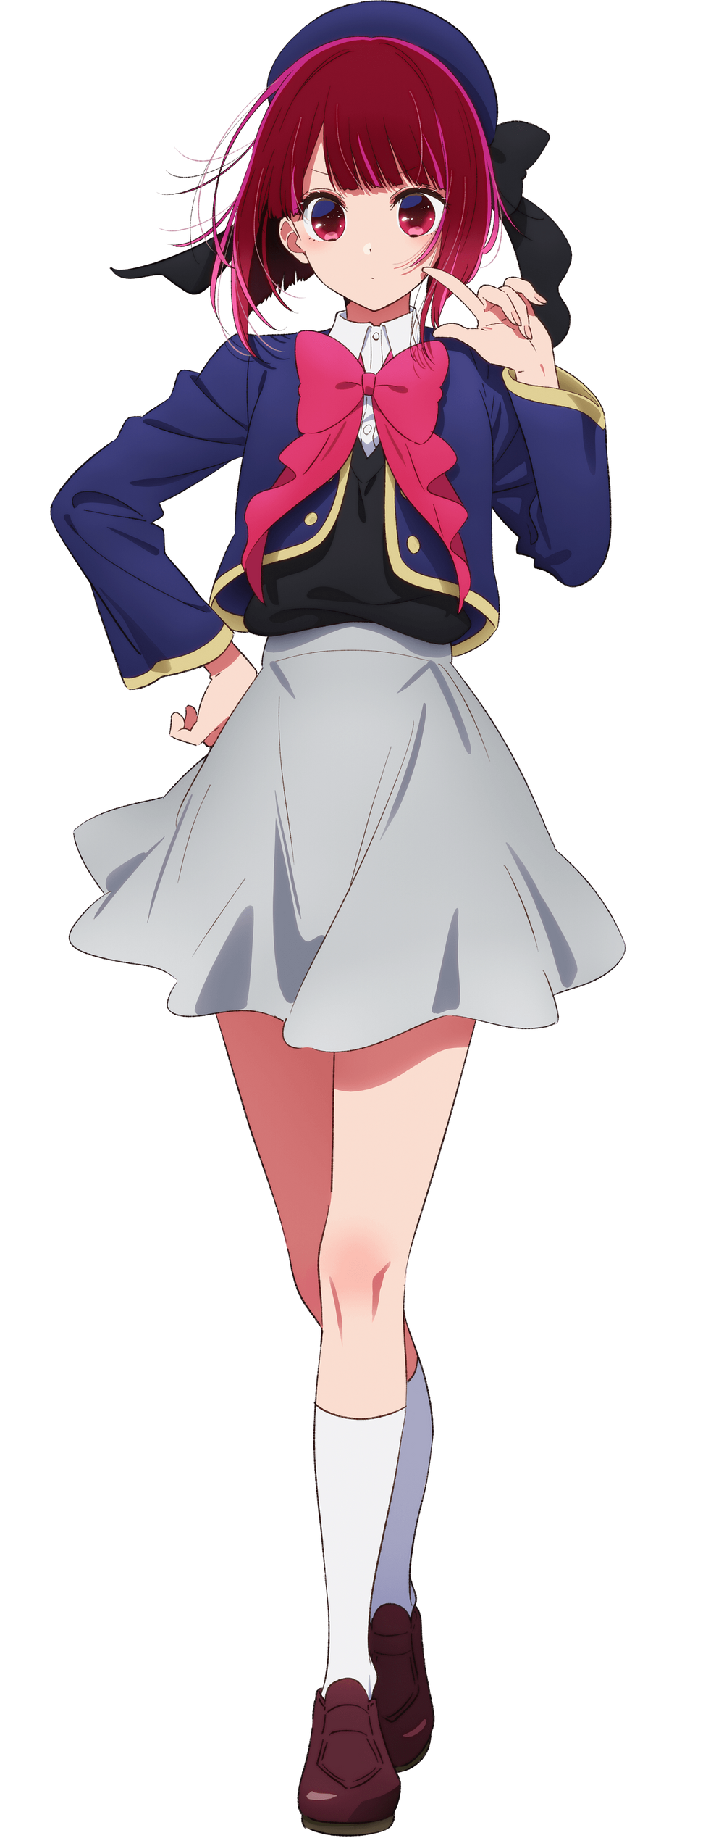
But one carrying the same name as the idol group of the late Ai Hoshino, B-Komachi. At first? Kana had naturally been resilient to the idea. She had sung a little in the past, but she hardly considered her talents enough to be able to perform properly on stage. She didn’t have much experience dancing or hyping up an audience. In that sense, Ruby was probably the better choice. There was just something about that girl that reminded her of the late Ai Hoshino.

It had all led to a downward spiral of self-loathing where Kana had been very close to not entertaining the idea whatsoever. But in the end, she had caved, and their first performance was going to be any day now. With a sigh, she pushed the door to the small studio room that B-Komachi would be using open. “No one else is here yet… Well, that’s to be expected, right? I’m the one who showed up early.” And purposefully so, in fact.

The girl looked like she hadn’t slept a wink, and that was more or less the truth. Uncertain of how to proceed with her own training, she had spent the night rewatching anything she could find about the girl whose group she was about to be the new face of: Ai Hoshino. The girl had died tragically over a decade ago, but there were still plenty of videos out there that documented her behavior. Just what made her so popular? That was the question that the red head had asked herself heading into the viewing session.

And before she had known it, it was 3am.

But now it was 8am. The trio of ‘idols’ had agreed to meet up at 10am, but Kana had decided to show up two hours before anyone else. Partially because she wanted to try replicating Ai’s mannerisms while they were still fresh in her mind, and partially because she couldn’t sleep. Her anxiety really was getting the best of her. Kana took a moment to loosen herself with some stretches, and eventually moved over to the performance floor. These were always surrounded by mirrors on the walls so that anyone practicing could make sure they were doing it properly.

“Starting with the way she carried herself… Her movements were usually pretty bouncy on stage, right? Kind of like this?” The aspiring idol allowed her shoulders to drop and gave her arms a good shake. It seemed like a silly thing to do at the time, but with a bit of proper muscle management? She managed to perfectly replicate the movement style that Ai had exhibited in the videos. “As I thought! Easy for a pro like me!” The cute little wink she made at the mirror didn’t have the same charm as Ai’s did, however.

That said… There was something odd about the eye she had closed and opened again. Something that Kana herself couldn’t even notice, because it wasn’t a trait that could be observed. It was more symbolic than anything. Her black iris in that eye? An iris that was completely expected and utterly normal in every capacity? Even though it would be perceived normally by anyone who saw her, including herself? To the audience of this ‘show’?

It had changed into a white star.

Don’t I look the cutest!? …Was certainly a thought that immediately crossed Kana’s mind. It wasn’t a thought that really ever crossed her mind these days; at least not with the confidence she had exuded in that moment. But this confidence became more apparent in other ways. Her dancing became more consistent even though it was just a routine of Ai’s she was attempting to copy, and she was nailing it down to an almost eerie degree as arms swung and her feet kicked. I just hope this gig makes enough to help me support…

“…Eh!?” Kana didn’t stop dancing. She couldn’t for some reason. But she had cut that thought off before it finished. Support who? She was only really supporting herself, right? And she wasn’t that poor at the moment! Around this time, a second invisible, white star appeared in the eye that had yet to be affected. Things only got weirder from here on out, too.

The clothing the teen had been using to practice in wasn’t the dress she’d be wearing for the performance. It was just a tank top and a pair of trackpants that would let her move about more easily, but… FWOOSH! “…FWOOSH?” The girl murmured the feeling aloud as her attention moved downward in her reflection. Her legs felt kind of breezy all of a sudden? And it made sense once she examined the area in question.

Except it also didn’t make any sense at all.

Her pants were gone, and instead below the waist, what she had been wearing had pulled up and fluttered out into a pink, frilled skirt with yellow trim. No, not just that. Her sneakers and socks had also merged, pulled up, and tightened into a pair of hot pink, thigh high boots that felt a little uncomfortable at first. “Wh-Wh-What!?” But she still couldn’t stop dancing. And where had she seen this outfit before? Kana wasn’t even aware yet of how beneath the skirt, she was also wearing a pair of lace panties that weren’t her own though. Like the peaks of her boots, those undergarments fit a touch too loosely for some reason, too.

If the dancer wasn’t already alarmed enough by all of this, then the sight of her flesh changing next certainly didn’t help calm her down. She hadn’t even been certain of it at first, and honestly all of the moving around she was doing was making it difficult to feel it. But the weight of her thighs as legs swung, kicked, and stepped appeared to stretch. Those thighs became a little bouncier, and before long they fit properly into the boots. The same could be said of her feet, but because they shrunk a little instead.

“A-Am I sick!? What’s wrong with me!?” I’m just looking my cutest! Was that a thought that she should have been having in that moment? Even though she had noticed her thighs changing, she didn’t really notice how her panties ended up fitting a little more snugly in the end. Her hips wedged an inch wider, while mass was distributed into the cheeks of her butt so that they extended about three inches further behind her. This naturally made the back of the skirt lift up a little, while any nearby hair was actually dyed… dark purple? Before it was shaved away smoothly, at least.

Kana pulled her attention away from her lower body for a moment and looked at her face in the mirror. It was here that she noticed something equally concerning. Not only had her eyes darkened to a familiar purple, but a similar shade was darkening the red of her hair too. Hair that was growing longer. To her shoulders, then past them, until it was at the base of her back with bangs swept to the left. Pair that with eyes that were rounder shaped than they had been prior, lips that were fuller, and a facial shape that was much cuter. Even though she did look cuter, she could tell. Her face looked older. Around twenty or so?

“I… I look like Ai Hoshino!?”

She made a strange noise right after, likely becoming aware of how she sounded like her, too. Why had she winked so cutely at her reflection while saying that? Did she feel proud? No, why would she feel that way!? It was almost like the real Ai’s personality and quirks were rooting themselves within her as well. A hair ornament with a rabbit on it appeared in her now full head of purple hair, and Kana finally realized where she had seen the skirt before. On one of Ai’s most infamous outfits as a member of B-Komachi.

“I don’t get why this is happening, but I really do feel more confident…” Almost as if she had been performing as an idol for a very long time. But the girl also knew not to be too complacent. This wasn’t a good thing. There were a ton of things wrong with it, in fact. “Ah!?” She still had no choice but to continue her dance as she watched her tank top flutter out into a pink, lace top overtop a black undershirt. It fanned out farther into a hot pink upper layer, one with blue stars and a yellow neckline with a heart accessory rooted in it. She remained sleeveless, but pink gloves appeared on her hands.

Initially? She was met with similar feelings to when her pants had become a skirt. Her gloves felt too tight, but the tops felt much too loose. The former was easily rectified by a shrinking of her hands, however. It was just a little bit, making her fingers shorter and her nails a little longer in the process. The gloves fit like, well, a glove in the end. The looseness of her tops required a much different type of change, however.

“Oh, uhm…?” Kana’s outbursts had stilled, calmed by Ai’s quieter demeanor as she looked down at her chest. Because she couldn’t stop committing to the dance routine, she couldn’t reach down and touch around that area like she might have wanted to in that moment even if it would have been indecent. Nonetheless, she could still feel what was happening. Her A-cup bosom was swelling up in size. Before long they were Bs, almost Cs, much more in line with Ai’s while also remaining hidden by the frills of Ai’s costume. “It seems I’ve become all of her, huh?”

She did feel a little calmer, but it was partially because she’d accepted what was happening to her. She was Ai’s spitting image now, and in her mind there might not have been any going back. There were also areas where her body had changed that had been much more discreet that she hadn’t even noticed at the time. Her muscles had become much more toned, for one. Much more like a teenaged girl that was accustomed to performing long dance routines, rather than an actress who only did the bare minimum to stay in shape.

Which Kana had always insisted wasn’t actually her fault. She didn’t have a lot of free time these days! So, in that regard she could at least see this as a ‘win’? Not that she was aware of the damage that had been done to her plumbing… from birthing twins.

“Wait a second! If I’ve really become her, then…” The Ai Hoshino in the mirror’s mouth moved as Kana’s did, of course because they were one in the same. It wasn’t a trick, not in the least. She looked identical to, and was behaving like, the long deceased Ai Hoshino. But still dancing in the mirror, she was plagued with a number of questions. “How am I going to move forward with my life!? Ruby and Memcho are going to be so confused when they show up to practice and find Ai Hoshino!”

And she didn’t know just how surprised Ruby would be compared to a normal person, really.

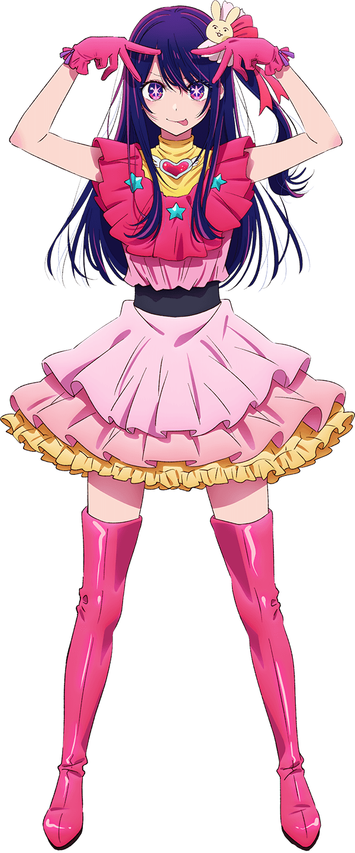
Somehow, she just felt fortunate that underneath she was still Kana. She didn’t have any of Ai’s memories – which was good since she would have immediately recognized Ruby’s ties to her and made things much more difficult for Ai’s children going forward. “But is anyone even going to believe me!? What am I even going to tell my parents!?” That thought in particular shocked her out of it. ‘Ai’ stopped dancing and dropped her arms to the side.

But that’s when it happened. The moment the girl stopped there was a flash of light, and when that light cleared? Kana was standing where ‘Ai’ had. “I-I changed back!? Thank goodness…” But then the thought struck her. No, perhaps it wasn’t really a thought. She just seemed to know this fun little tidbit. “If I perform again then I’m going to turn into Ai again!?” What was this? Like an idol performing magical girl power!?

Regardless of what it was, that seemed to be the case. All she had to do was dance a little bit and she changed back into Ai. And when she stopped? She once again returned to normal. “Wh-What am I supposed to do about this? Actually, is this worse or is it better?” At least in this case she could demonstrate to other people this weird ‘turning into Ai’ power that she suddenly had, but did it mean she was going to get experimented on for science or something!? Kana was probably getting just the slightest bit ahead of herself on that one.

“Maybe I should just start with Ruby and Memcho first…?” Provided she wasn’t dreaming, then that was probably the best bet, right? If anyone would be understanding over this weird situation then it would be her two new friends? At least that what she hoped, but again… She didn’t know of Ruby’s ties to the real Ai Hoshino.

Nor Aqua’s, for that matter.

